Department of Computer and Software Engineering – ITU
SE200T: Data Structures & Algorithms

Course Instructor: Usama Bin Shakeel | Dated:
Teaching Assistant: Raza Dastagir & Afaq Khawar | Semester: Fall 2025
Session: 2024-2028 | Batch: BSSE2024

Assignment 4. Implementation of Merge Sort

Name | Roll number | Obtained Marks/35

Checked on: ____________________________

Signature: ___________________________

Submission:
• Email instructor or TA if there are any questions. You cannot look at others’ solutions or use others’ solutions, however, you can discuss it with each other. Plagiarism will be dealt with according to the course policy.
• Submission after due time will not be accepted.

In this assignment you have to do following tasks:

Task 1: Ensure that you have installed all three softwares in your personal computer (Github, Cygwin & CLion). Now, accept the assignment posted in the classroom (e.g Google, LMS etc) and after accepting, clone the repository to your computer. Make sure you have logged into the github app with your account.

Task 2: Open Cygwin app, Move to your code directory with following command “cd <path_of_folder>”, <path_of_folder> can be automatically populated by dragging the folder and dropping it to the cygwin window.
Run the code through Cygwin, use command “make run”, to get the output of the code

Task 3: Solve the given problems, write code using CLion or any other IDE.
Task 4: Keep your code in the respective git cloned folder.
Task 5: Commit and Push the changes through the Github App
Task 5: Write the code in separate files (as instructed). Ensure that file names are in lowercase (e,g main.cpp).

Task 6: Run ‘make run’ to run C++ code
Task 7: Run ‘make test’ to test the C++ code
Write code in functions, after completing each part, verify through running code using “make run” on Cygwin. Make sure to test the code using “make test”.

Extend the implementation of the Sort class from Lab 3 by adding the Merge Sort algorithm to sort the elements of a 2D dynamic array. Additionally, the addElement function implemented earlier in the lab should resize the array when it becomes full
Class Name: Sort
Data Members:
- int size: Number of elements currently stored in the array.
- int capacity: Maximum elements that can be stored in the array.
- int* array: A 1D dynamic pointer that will point to the array data.
Additional Member Functions:
- Merge Sort Function: Sorts the array using Merge sort
void mergeSort(){
}

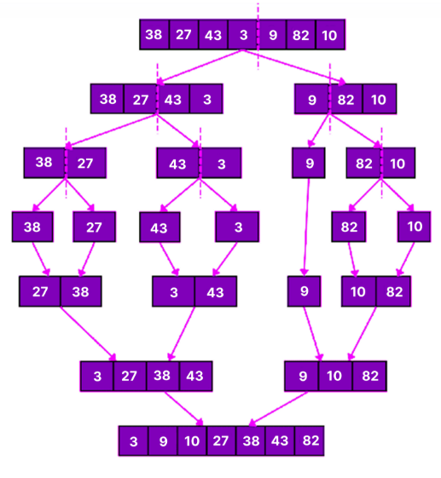

Assessment Rubric for Assignment

Performance metric | CLO | Able to complete the task over 80% (4-5) | Able to complete the task 50-80% (2-3) | Able to complete the task below 50% (0-1) | Marks
- Realization of experiment | 3 | Executes without errors excellent user prompts, good use of symbols, spacing in output. The testing has been completed. | Executes without errors, user prompts are understandable, minimum use of symbols or spacing in output. Some testing has been completed. | Does not execute due to syntax errors, runtime errors, user prompts are misleading or non- existent. No testing has been completed.
- Conducting experiment | 2 | Able to make changes and answer all questions. | Partially able to make changes and few incorrect answers. | Unable to make changes and answer all questions.
- Computer use | 4 | Document submission timely. | Document submission late. | Document submission not done.
- Teamwork | 4 | Actively engages and cooperates with other group member(s) in an effective manner. | Cooperates with other group member(s) in a reasonable manner but conduct can be improved. | Distracts or discourages other group members from conducting the experiment
- Laboratory safety and disciplinary rules | 2 | Code comments are added and do help the reader to understand the code. | Code comments are added and do not help the reader to understand the code. | Code comments are not added.
- Data collection | 2 | Excellent use of white space, creatively organized work, excellent use of variables and constants, correct identifiers for constants, No line-wrap. | Includes name, and assignment, white space makes the program fairly easy to read. Title, organized work, good use of variables. | Poor use of white space (indentation, blank lines) making code hard to read, disorganized and messy.
- Data analysis | 3 | Solution is efficient, easy to understand, and maintain. | A logical solution that is easy to follow but it is not the most efficient. | A difficult and inefficient solution.
Total (out of 35):

