Department of Computer and Software Engineering – ITU
SE200T: Data Structures & Algorithms

Course Instructor: Usama Bin Shakeel | Dated:
Teaching Assistant: Afaq Khawar | Semester: Fall 2025
Lab Engineer: Raza Dastagir | Batch: BSSE2024

Lab 13. Open Ended Lab (Implementing a mini-git)

Name | Roll number | Report  (out of 35)

Checked on: ____________________________

Signature: ________________________________

Objective
The objective of this lab is to provide hands-on experience in implementing a simplified version control system, similar to Git. Students will practice applying data structures and algorithms to a real-world problem, including commit tracking, branching, merging, and file versioning.

Equipment and Component
Component Description | Value | Quantity
Computer | Available in lab | 1

Conduct of Lab
- Students are required to perform this experiment individually.
- Students should implement the solution using C++ and execute it through the terminal/command line.
- In case the lab experiment is not understood, students are advised to seek help from the course instructor, lab engineers, assigned teaching assistants (TA), or lab attendants.
- Use of external version control libraries or frameworks is strictly prohibited.

1.4 Theory and Background
Version control systems are essential tools in software development for tracking changes in files, maintaining multiple versions, and enabling rollback to previous states. Git is one of the most widely used distributed version control systems and is built using efficient data structures and algorithms.

- At its core, a version control system:
- Stores snapshots of file states
- Identifies changes using hashing techniques
- Maintains commit history in a structured manner
- Allows restoration of files from previous versions

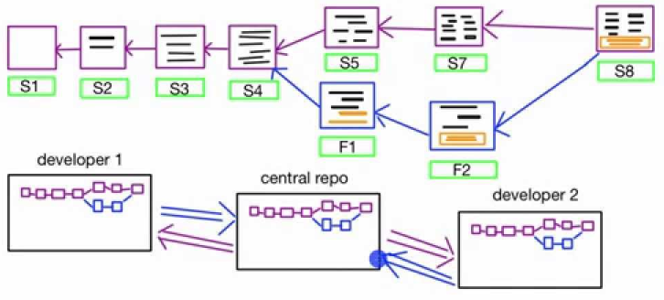

1.5 Lab Objectives

In this lab, students are required to implement a simplified version control system similar to Git. The following activities outline the tasks to complete:

Initialize a repository:

Create a command (e.g., init) that initializes your system.

Requirement: The command must accept a folder path.

Input: init ./my_project

Behavior: Your program should only look at files inside this specific folder. It should ignore everything else.

Use Hashing Mechanism to track file changes and commits:

You can use std::hash or use any library from the internet for hashing.

Commit Changes:

Create a commit command.
- This should save the current state of all tracked files.
- A unique Commit ID (you can just use an auto-incrementing integer).
  - The commit message (e.g., "Fixed bug").
  - Timestamp.

Each commit should have a unique identifier and reference its parent commit(s).

View commit history:

Traverse and display the commit history of any branch.

Use appropriate data structures (linked lists, trees, or graphs) to store and navigate commits efficiently.

Experiment with file operations:

Add, edit, and delete files in the repository.

Ensure that changes are tracked across multiple commits and branches.

Demonstrate functionality in terminal:

Use terminal commands to initialize the repository, commit changes and view history.

Verify that all operations work correctly and maintain internal consistency.

1.6 Recommended Libraries

Since this is an open-ended lab, you may use the following standard or third-party C++ libraries to simplify the implementation:

For Tracking Folder Structure (Standard):

std::filesystem (C++17): This is built into modern C++. Use it to iterate over files in a directory, check if files exist, and get file sizes/timestamps.

Docs: std::filesystem::directory_iterator, std::filesystem::exists.

For Hashing (Choose one):

std::hash: Built-in, simple, but non-cryptographic.

picosha2: A tiny, header-only C++ library for SHA-256 (very easy to use, just one header file).

For Delta/Diffing (Choose one):
  - dtl (Diff Template Library): A lightweight C++ library that calculates the difference between two sequences (strings, vectors, etc.). It can generate the "Delta" for you.
  - Manual Implementation: If you prefer, you can write a simple function or use other libraries/functions that compares two files line-by-line and stores the indices of lines that differ.

Note: Apart from the above libraries, you are free to use any libraries/functions from the internet. As this is an open-ended lab therefore there is no restriction for using the internet although you have to know each and every line of your code during viva .

1.7 Lab Tasks

1. Track Folder Structure (Add/Delete Detection)

Requirement: Your system must scan the initialized folder path.

Logic:

Compare the list of files currently on the disk against the list of files in the previous commit.

Identify files that are Newly Added (present now, absent before).

Identify files that are Deleted (absent now, present before).

2. Track Individual File Changes (Hashing)

Requirement: For every file that exists in both the current folder and the previous commit, you must check for modifications.

Logic:

Calculate the hash of the live file in the folder.

Compare it with the hash stored in your "Staging Area" or previous commit.

If Hash_Current != Hash_Stored, the file is Modified.

3. Delta Computation and Storage

Requirement: When a user commits a modified file, do not save the whole file.

Logic:

Load the content of the original file (from the previous commit).

Load the content of the new modified file.

Find the Delta (the difference) between them (using a library like dtl or your own logic).

Store ONLY the Delta in the Commit Node.

Hint: To restore a file later, you would take the original file and apply the Delta "patch" to it.

4. Terminal Demonstration

Demonstrate the following flow:

init ./docs

Create file.txt with text "Hello World".

commit "Initial" (Stores full file as base).

Change file.txt to "Hello World Updated".

status (Detects "Modified" via hash).

commit "Update" (Calculates Delta: "Change line 1").

Show that the second commit stored the change, not the full text.

Assessment Rubric for Lab

Performance metric | CLO | Able to complete the task over 80% (4-5) | Able to complete the task 50-80% (2-3) | Able to complete the task below 50% (0-1) | Marks
- Realization of experiment | 1 | Executes without errors excellent user prompts, good use of symbols, spacing in output. The testing has been completed. | Executes without errors, user prompts are understandable,minimum use of symbols or spacing in output. Some testing has been completed. | Does not execute due to syntax errors, runtime errors, user prompts are misleading or non- existent. No testing has been completed.
2. Conducting experiment | 1 | Able to make changes and answer all questions. | Partially able to make changes and few incorrect answers. | Unable to make changes and answer all questions.
3. Computer use | 2 | Document submission timely. | Document submission late. | Document submission not done.
4. Teamwork | 3 | Actively engages and cooperates with other group member(s) in an effective manner. | Cooperates with other group member(s) in a reasonable manner but conduct can be improved. | Distracts or discourages other group members from conducting the experiment
5. Laboratory safety and disciplinary rules | 3 | Code comments are added and do help the reader to understand the code. | Code comments are added and do not help the reader to understand the code. | Code comments are not added.
6. Data collection | 3 | Excellent use of white space, creatively organized work, excellent use of variables and constants, correct identifiers for constants, No line-wrap. | Includes name, and assignment, white space makes the program fairly easy to read. Title, organized work, good use of variables. | Poor use of white space (indentation, blank lines) making code hard to read, disorganized and messy.
7. Data analysis | 4 | Solution is efficient, easy to understand, and maintain. | A logical solution that is easy to follow but it is not the most efficient. | A difficult and inefficient solution.
Total (out of 35):

