Software Engineering Department - ITU
SE200L: Data Structures & Algorithms Lab

Course Instructor: Usama Bin Shakeel | Dated:
Teaching Assistant: Raza Dastagir & Afaq Khawar | Semester:4
Lab Engineer: | Batch: SE24

Lab 3. Implementation of Bubble Sort , SelectionSort and Insertion Sort

Name | Roll number | Report  (out of 35)

Checked on: ____________________________

Signature: ________________________________

Objective
The objective of this lab is to practice the implementation and manipulation of 2D and N-D arrays using pointers and dynamic memory allocation.

Equipment and Component
Component Description | Value | Quantity
Computer | Available in lab | 1

Conduct of Lab
- Students are required to perform this experiment individually.
- In case the lab experiment is not understood, the students are advised to seek help from the course instructor, lab engineers, assigned teaching assistants (TA) and lab attendants.

Lab Tasks
Task 1
Task 1: Class Implementation and Main Menu
- Your task is to create a C++ program that demonstrates various sorting algorithms. To do this, you will implement a class named Sort. This class needs to manage a dynamic array of integers and provide methods for sorting this array using different techniques.
  - Private Members:
    - int *array: A pointer to an integer. This will be used to dynamically allocate memory for the array of numbers.
    - int size: An integer representing the current number of elements stored in the array.
    - int capacity: An integer representing the maximum number of elements the dynamically allocated array can hold.
  - Public Members (Methods):
  - Default Constructor Sort():
    - Initializes the array pointer to nullptr.
    - Initializes size and capacity to 0.
  - Parameterized Constructor Sort(int cap):
    - Takes an integer cap as an argument, representing the desired capacity of the array.
    - Sets the capacity member to cap.
    - Initializes size to 0.
    - Dynamically allocates an integer array of size cap and assigns its address to the array pointer
  - void addElement:
    - Implements the addElement method to insert a new integer into the Sort class's dynamic array.
  - void bubbleSort():
    - Implements the Bubble Sort algorithm to sort the elements currently stored in the array.
  - void insertionSort():
    - Implements the Insertion Sort algorithm to sort the elements in the array.
  - void selectionSort():
    - Implements the Selection Sort algorithm to sort the elements in the array.
  - void displayArray():
    - Prints the elements of the array to the console.
  - int getSize():
    - Returns the size of array (no. of elements)
  - int* getArray():
    - Returns the integer array.
  - Destructor ~Sort():
    - Deallocates the dynamic memory previously allocated for the array to prevent memory leaks.
Task 2: Implement Bubble Sort
- void bubbleSort():

Pseudocode:  procedure bubbleSort(list)  n = length(list)  for i from 0 to n-1  for j from 0 to n-2  if list[j] > list[j+1]  swap(list[j], list[j+1])  end if  end for  end for  end procedure | 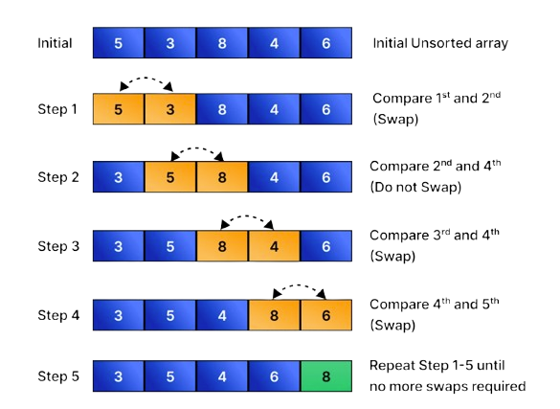

Task 3: Implement Insertion Sort
- void insertionSort():
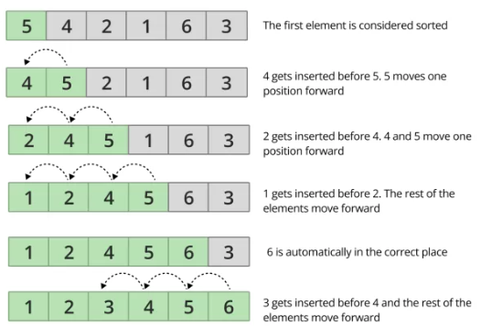

Task 4: Implement Selection Sort
- void selectionSort():
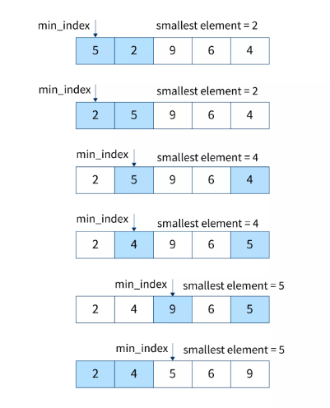

Assessment Rubric for Lab

Performance metric | CLO | Able to complete the task over 80% (4-5) | Able to complete the task 50-80% (2-3) | Able to complete the task below 50% (0-1) | Marks
- Realization of experiment | 1 | Executes without errors excellent user prompts, good use of symbols, spacing in output. The testing has been completed. | Executes without errors, user prompts are understandable,minimum use of symbols or spacing in output. Some testing has been completed. | Does not execute due to syntax errors, runtime errors, user prompts are misleading or non- existent. No testing has been completed.
2. Conducting experiment | 1 | Able to make changes and answer all questions. | Partially able to make changes and few incorrect answers. | Unable to make changes and answer all questions.
3. Computer use | 2 | Document submission timely. | Document submission late. | Document submission not done.
4. Teamwork | 3 | Actively engages and cooperates with other group member(s) in an effective manner. | Cooperates with other group member(s) in a reasonable manner but conduct can be improved. | Distracts or discourages other group members from conducting the experiment
5. Laboratory safety and disciplinary rules | 3 | Code comments are added and do help the reader to understand the code. | Code comments are added and do not help the reader to understand the code. | Code comments are not added.
6. Data collection | 3 | Excellent use of white space, creatively organized work, excellent use of variables and constants, correct identifiers for constants, No line-wrap. | Includes name, and assignment, white space makes the program fairly easy to read. Title, organized work, good use of variables. | Poor use of white space (indentation, blank lines) making code hard to read, disorganized and messy.
7. Data analysis | 4 | Solution is efficient, easy to understand, and maintain. | A logical solution that is easy to follow but it is not the most efficient. | A difficult and inefficient solution.
Total (out of 35):

