Department of Computer and Software Engineering – ITU
SE200T: Data Structures & Algorithms

Course Instructor: Usama Bin Shakeel | Dated: 22/11/2025
Teaching Assistant: Afaq Khawar | Semester: Fall 2025
Lab Engineer: Raza Dastagir | Batch: BSSE2024

Lab 8. Implementation of Binary Tree

Name | Roll number | Report  (out of 35)

Checked on: ____________________________

Signature: ________________________________

Objective
The objective of this lab is to practice problems related to binary tree implementation.

Equipment and Component
Component Description | Value | Quantity
Computer | Available in lab | 1

Conduct of Lab
- Students are required to perform this experiment individually.
- In case the lab experiment is not understood, the students are advised to seek help from the course instructor, lab engineers, assigned teaching assistants (TA) and lab attendants.

1.4 Theory and Background
A binary tree is a hierarchical data structure in which each node has at most two children, referred to as the left child and the right child. Binary trees are are widely used in various applications such as expression parsing, sorting algorithms, and data storage.
Tree Properties:
- Height: The length of the longest path from the root to a leaf node.
- Depth: The distance of a node from the root, measured in edges.
- Degree: The number of children a node has.
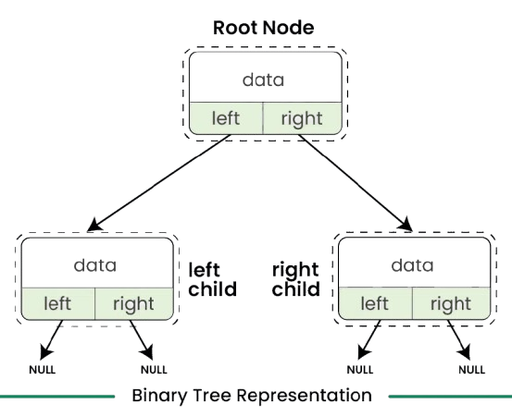
Traversal: Various traversal methods can be used to visit nodes in a binary tree:
- In-Order Traversal: Visits the left child, the parent node, and then the right child, resulting in sorted order for binary search trees.
- Pre-Order Traversal: Visits the root before its subtrees (left then right), useful for creating a copy of the tree or generating prefix expressions.
- Post-Order Traversal: Visits the subtrees (left then right) before the root, ideal for deleting the tree or generating postfix expressions.

Lab Tasks

Task 1:

Implement the TreeNode class
Data Members:
- int data: The value stored in the node.
- TreeNode* left: Pointer to the left child.
- TreeNode* right: Pointer to the right child.
Member Functions to Implement:
- TreeNode(int value): Constructor to initialize the node with a given value.
- TreeNode* getLeftChild(): Returns a pointer to the left child.
- TreeNode* getRightChild(): Returns a pointer to the right child.
- int getData(): Returns the data stored in the node.
- void addLeftChild(TreeNode* node): Adds a left child to the current node.
- void addRightChild(TreeNode* node): Adds a right child to the current node.

Task 2:

Implement the Tree class
Data Members:
- TreeNode* root: Pointer to the root node of the tree.
Member Functions to Implement:
- Tree(): Constructor to initialize the tree.
- void insertNode(int value): Inserts a node into the tree using level order traversal.
- int getTreeHeight(): Returns the height of the tree.
- int getHeight(int data): Returns the height of a given node.
- TreeNode* getRoot(): Returns the root node of the tree.

Implementation Instructions:
- TreeNode Class:
- Implement the TreeNode class with its members and functions.
- Ensure proper memory management when adding or removing child nodes.
- Tree Class:
- Implement the Tree class.
- insertNode:
  - Use a queue for level order traversal to insert a new node.
  - Ensure that the tree maintains its structure as a binary tree.
  - You can modify and use the queue class from the last assignment which would be helpful

Assessment Rubric for Lab

Performance metric | CLO | Able to complete the task over 80% (4-5) | Able to complete the task 50-80% (2-3) | Able to complete the task below 50% (0-1) | Marks
- Realization of experiment | 1 | Executes without errors excellent user prompts, good use of symbols, spacing in output. The testing has been completed. | Executes without errors, user prompts are understandable,minimum use of symbols or spacing in output. Some testing has been completed. | Does not execute due to syntax errors, runtime errors, user prompts are misleading or non- existent. No testing has been completed.
2. Conducting experiment | 1 | Able to make changes and answer all questions. | Partially able to make changes and few incorrect answers. | Unable to make changes and answer all questions.
3. Computer use | 2 | Document submission timely. | Document submission late. | Document submission not done.
4. Teamwork | 3 | Actively engages and cooperates with other group member(s) in an effective manner. | Cooperates with other group member(s) in a reasonable manner but conduct can be improved. | Distracts or discourages other group members from conducting the experiment
5. Laboratory safety and disciplinary rules | 3 | Code comments are added and do help the reader to understand the code. | Code comments are added and do not help the reader to understand the code. | Code comments are not added.
6. Data collection | 3 | Excellent use of white space, creatively organized work, excellent use of variables and constants, correct identifiers for constants, No line-wrap. | Includes name, and assignment, white space makes the program fairly easy to read. Title, organized work, good use of variables. | Poor use of white space (indentation, blank lines) making code hard to read, disorganized and messy.
7. Data analysis | 4 | Solution is efficient, easy to understand, and maintain. | A logical solution that is easy to follow but it is not the most efficient. | A difficult and inefficient solution.
Total (out of 35):

