Department of Computer and Software Engineering – ITU
SE200T: Data Structures & Algorithms

Course Instructor: Usama Bin Shakeel | Dated: 28/11/2025
Teaching Assistant: Afaq Khawar | Semester: Fall 2025
Lab Engineer: Raza Dastagir | Batch: BSSE2024

Lab 9. Implementation of General Tree

Name | Roll number | Report  (out of 35)

Checked on: ____________________________

Signature: ________________________________

Objective
The objective of this lab is to practice problems related to binary tree implementation.

Equipment and Component
Component Description | Value | Quantity
Computer | Available in lab | 1

Conduct of Lab
- Students are required to perform this experiment individually.
- In case the lab experiment is not understood, the students are advised to seek help from the course instructor, lab engineers, assigned teaching assistants (TA) and lab attendants.

1.4 Theory and Background
A General Tree is a hierarchical data structure in which each node can have an arbitrary (unlimited) number of children (zero or more). General Trees are widely used in various applications such as modeling file systems, representing the structure of a web document , and organizing taxonomies or organizational charts.

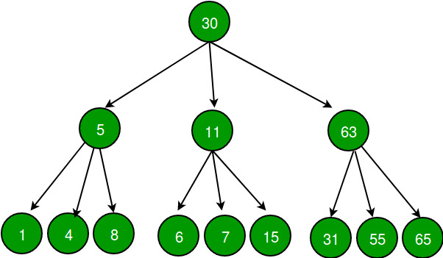

Lab Tasks

Task 1:

Implement the TreeNode class
Data Members:
- int data: The value stored in the node.
- TreeNode** children: Dynamic array pointer.
- int childrenCount: Current children count.

Member Functions to Implement:
- TreeNode(int value): Constructor to initialize the node with a given value.
- TreeNode* getChild(int index) Returns a pointer to the child.
- int getData(): Returns the data stored in the node.
- void addChild(TreeNode* node): Adds a new child. Must handle array **resizing** (doubling capacity) if childrenCount reaches capacity.

Task 2:

Implement the Tree class
Data Members:
- TreeNode* root: Pointer to the root node of the tree.
Member Functions to Implement:
- Tree(): Constructor to initialize the tree.
- void insertNode(int parentData, int value): Finds parent node, and adds the new node as its last child.
- TreeNode* findNode(int data): Finds and returns the node with the data otherwise return nullptr.
- TreeNode* getRoot(): Returns the root node of the tree.

Assessment Rubric for Lab

Performance metric | CLO | Able to complete the task over 80% (4-5) | Able to complete the task 50-80% (2-3) | Able to complete the task below 50% (0-1) | Marks
- Realization of experiment | 1 | Executes without errors excellent user prompts, good use of symbols, spacing in output. The testing has been completed. | Executes without errors, user prompts are understandable,minimum use of symbols or spacing in output. Some testing has been completed. | Does not execute due to syntax errors, runtime errors, user prompts are misleading or non- existent. No testing has been completed.
2. Conducting experiment | 1 | Able to make changes and answer all questions. | Partially able to make changes and few incorrect answers. | Unable to make changes and answer all questions.
3. Computer use | 2 | Document submission timely. | Document submission late. | Document submission not done.
4. Teamwork | 3 | Actively engages and cooperates with other group member(s) in an effective manner. | Cooperates with other group member(s) in a reasonable manner but conduct can be improved. | Distracts or discourages other group members from conducting the experiment
5. Laboratory safety and disciplinary rules | 3 | Code comments are added and do help the reader to understand the code. | Code comments are added and do not help the reader to understand the code. | Code comments are not added.
6. Data collection | 3 | Excellent use of white space, creatively organized work, excellent use of variables and constants, correct identifiers for constants, No line-wrap. | Includes name, and assignment, white space makes the program fairly easy to read. Title, organized work, good use of variables. | Poor use of white space (indentation, blank lines) making code hard to read, disorganized and messy.
7. Data analysis | 4 | Solution is efficient, easy to understand, and maintain. | A logical solution that is easy to follow but it is not the most efficient. | A difficult and inefficient solution.
Total (out of 35):

