In this task, you have to implement the CNN and LSTM methods on the given data set to evaluate their performance based on the given measurement matrices. The data sets should be splited in to training (80%) and for test phase (20%). The CNN and LSTM models should be tune by adjusting it parameters to give its better performance by consider overfitting and under fitting of the model.

The detail description about model input data and expected results are given below:

* 1. **Model input data sets**

**Table 1: Input combinations for CNN and LSTM**

|  |  |  |  |
| --- | --- | --- | --- |
| **Data** | **Model input sets** | **Input structure** | **output** |
| Daily | $$M1$$ | $$Q(t-1)$$ | $$Q(t)$$ |
|  | $$M2$$ | $$Q\left(t-1\right),Q(t-2)$$ | $$Q(t)$$ |
|  | $$M3$$ | $$Q\left(t-1\right),Q\left(t-2\right),Q\left(t-3\right)$$ | $$Q(t)$$ |
|  | M4 | $$Q\left(t-1\right),Q\left(t-2\right),Q\left(t-3\right),Q(t-4)$$ | Q(t) |
|  | $$M5$$ | $$Q\left(t-1\right),Q\left(t-2\right),Q\left(t-3\right),Q\left(t-4\right),Q(t-5)$$ | $$Q(t)$$ |
| Weekly | $$M6$$ | $$Q(t-1)$$ | $$Q(t)$$ |
|  | $$M7$$ | $$Q\left(t-1\right),Q(t-2)$$ | $$Q(t)$$ |
|  | $$M8$$ | $$Q\left(t-1\right),Q\left(t-2\right),Q\left(t-3\right)$$ | $$Q(t)$$ |
|  | $$M9$$ | $$Q\left(t-1\right),Q\left(t-2\right),Q\left(t-3\right),Q\left(t-4\right)$$ | $$Q(t)$$ |
|  | $$M10$$ | $$Q\left(t-1\right),Q\left(t-2\right),Q\left(t-3\right),Q\left(t-4\right),Q(t-5)$$ | $$Q(t)$$ |
| Monthly |  |  |  |
|  |  |  |  |
|  |  |  |  |
|  | M14 |  |  |
|  |  |  |  |

* 1. **Model evaluation criteria**

The performance of the models (CNN and LSTM) are evaluated on training and testing data sets. Correlation coefficient (R), mean absolute error (MAE), root mean square error (RMSE) and mean square error (MSE) are commonly used for assessing the outcomes of time series forecasting. The following statistical score matrices are defined as follows:

1. Correlation coefficient (R) expressed as:
$$R^{2}= \frac{\sum_{t=1 }^{n }{\left[\left(Q_{for}\left(t\right)- {\overline{Q}}_{for}\left(t\right)\right) \left( Q_{obs}\left(t\right)- {\overline{Q}}_{obs}\left(t\right)\right)\right]}}{\sqrt{{\sum_{t=1}^{n}{\left( Q_{for}\left(t\right)- {\overline{Q}}_{for}\left(t\right)\right)}}^{2}{\sum_{t=1}^{n}{\left( Q_{obs}\left(t\right)- {\overline{Q}}_{obs}\left(t\right)\right)}}^{2}}}$$

2. Mean absolute error (MAE) expressed as:
$$MAE=\frac{1}{N}\sum_{t=1}^{n}{ \left|Q_{for}\left(t\right)-Q_{obs}\left(t\right)\right|}$$

3. Root mean square error (RMSE) expressed as:
$$RMSE= \sqrt{\frac{1}{N}\sum_{t=1}^{n}{{\left(Q_{for}\left(t\right)-Q_{obs}\left(t\right)\right)}^{2} }}$$

4. Mean square error (MSE) expressed as:
 $$MSE=\frac{1}{N}\sum_{t=1}^{n}{{\left(Q_{for}\left(t\right)-Q_{obs}\left(t\right)\right)}^{2} }$$

  1. **Results**

Table 1: CNN approach performance evaluation criteria for different time scale ‘daily’, ’weekly’, and ‘monthly’

|  |  |  |  |  |  |  |  |  |  |  |
| --- | --- | --- | --- | --- | --- | --- | --- | --- | --- | --- |
| Time scale | Models | Training/calibration data | | | |  |  | Test/Validation data | | |
|  |  | $$R^{2}$$ | River flow ($m^{3}$/s) | | |  | $$R^{2}$$ | River flow ($m^{3}$/s) | | |
|  |  | MAE | RMSE | MSE |  | MAE | RMSE | MSE |
| Daily | $$M1$$ | 0.79 | 165.26 | 271.32 | 73613.10 |  | 0.90 | 184.85 | 315.15 | 99317.73 |
|  | $$M2$$ | 0.80 | 162.56 | 265.07 | 70261.23 |  | 0.99 | 189.80 | 296.87 | 88132.95 |
|  | $$M3$$ | 0.81 | 153.02 | 241.06 | 58107.62 |  | 0.99 | 170.27 | 272.26 | 74124.67 |
|  | $$M4$$ | 0.96 | 50.62 | 91.72 | 8413.28 |  | 0.99 | 135.26 | 246.67 | 60844.72 |
|  | $$M5$$ | 0.96 | 47.17 | 85.83 | 7366.75 |  | 0.99 | 129.12 | 228.08 | 52020.50 |
| Weekly | $$M6$$ | 0.94 | 60.70 | 104.21 | 10859.08 |  | 0.91 | 74.80 | 161.35 | 26034.40 |
|  | $$M7$$ | 0.96 | 45.49 | 86.03 | 7401.98 |  | 0.93 | 63.41 | 151.12 | 22837.94 |
|  | $$M8$$ | 0.95 | 56.34 | 97.99 | 9601.84 |  | 0.92 | 66.91 | 151.64 | 22995.18 |
|  | $$M9$$ | 0.96 | 47.71 | 86.17 | 7425.06 |  | 0.92 | 68.89 | 159.98 | 25593.69 |
|  | $$M10$$ | 0.96 | 45.91 | 81.71 | 6677.15 |  | 0.93 | 64.48 | 142.39 | 20275.45 |
| Monthly | $$M11$$ | 0.77 | 133.81 | 187.61 | 35196.82 |  | 0.7 | 177.74 | 262.76 | 69043.49 |
|  | $$M12$$ | 0.94 | 59.86 | 100.36 | 10072.11 |  | 0.88 | 101.37 | 185.80 | 34522.10 |
|  | $$M13$$ | 0.98 | 38.84 | 62.74 | 3936.08 |  | 0.89 | 94.57 | 174.53 | 30461.69 |
|  | $$M14$$ | 0.97 | 44.92 | 76.99 | 5927.05 |  | 0.9 | 94.66 | 175.25 | 30713.68 |
|  | $$M15$$ | 0.95 | 59.93 | 94.65 | 8958.5 |  | 0.87 | 103.91 | 185.76 | 34506.01 |

Table 2: LSTM approach performance evaluation criteria for different time scale ‘daily’, ’ weekly’, and ‘monthly’

|  |  |  |  |  |  |  |  |  |  |  |
| --- | --- | --- | --- | --- | --- | --- | --- | --- | --- | --- |
| Time scale | Models | Training/calibration data | | | |  |  | Test/Validation data | | |
|  |  | $$R^{2}$$ | River flow ($m^{3}$/s) | | |  | $$R^{2}$$ | River flow ($m^{3}$/s) | | |
|  |  | MAE | RMSE | MSE |  | MAE | RMSE | MSE |
| Daily | $$M1$$ | 0.70 | 181.86 | 234.45 | 54964.79 |  | 0.96 | 70.88 | 118.06 | 13937.5 |
|  | $$M2$$ | 0.72 | 179.40 | 226.14 | 51139.87 |  | 0.97 | 51.48 | 90.35 | 8163.89 |
|  | $$M3$$ | 0.72 | 179.28 | 225.42 | 50815.28 |  | 0.97 | 50.44 | 91.37 | 8349.28 |
|  | $$M4$$ | 0.50 | 247.00 | 392.15 | 153785.09 |  | 0.96 | 305.63 | 491.78 | 241849.02 |
|  | $$M5$$ | 0.71 | 182.80 | 227.93 | 51952.63 |  | 0.97 | 59.86 | 105.94 | 11222.88 |
| Weekly | $$M6$$ | 0.96 | 55.30 | 88.05 | 7752.50 |  | 0.94 | 66.49 | 140.96 | 19870.14 |
|  | $$M7$$ | 0.96 | 55.23 | 87.41 | 7641.33 |  | 0.92 | 64.81 | 165.18 | 27284.38 |
|  | $$M8$$ | 0.96 | 50.65 | 82.78 | 6852.25 |  | 0.9 | 71.89 | 179.59 | 32252.12 |
|  | $$M9$$ | 0.96 | 230.63 | 364.21 | 132646.48 |  | 0.84 | 292.96 | 480.74 | 231107.77 |
|  | $$M10$$ | 0.96 | 51.51 | 81.36 | 6619.52 |  | 0.85 | 89.72 | 210.25 | 44203.34 |
| **Monthly** | $$M11$$ | 0.98 | 35.11 | 55.46 | 3075.37 |  | 0.87 | 125.31 | 189.70 | 35985.77 |
|  | $$M12$$ | 0.99 | 32.11 | 47.78 | 2282.85 |  | 0.83 | 114.59 | 238.50 | 56884.38 |
|  | $$M13$$ | 0.91 | 95.06 | 142.81 | 20395.34 |  | 0.82 | 127.82 | 235.50 | 55460.85 |
|  | $$M14$$ | 0.99 | 51.35 | 76.93 | 5918.30 |  | 0.8 | 125.91 | 233.07 | 54322.44 |
|  | $$M15$$ | 0.99 | 31.34 | 40.24 | 1619.50 |  | 0.63 | 140.37 | 301.78 | 91068.95 |

Table 3:The comparison of CNN and LSTMELM relative error indicator for the peak ﬂows for the testing phase

|  |  |  |  |  |  |
| --- | --- | --- | --- | --- | --- |
| Time scale | Observed peak(m3/s) | CNN | LSTM | Relative Error (%) | |
| CNN | LSTM |
| Daily | 2990.0 | 1049.6866 | 1661.2329 | 64.9 | 44.4 |
|  | 2990.0 | 1257.5203 | 1981.4595 | 57.9 | 33.7 |
|  | 2990.0 | 1337.1537 | 2131.975 | 55.3 | 28.7 |
|  | 2990.0 | 1433.6765 | 133.8551 | 52.1 | 95.5 |
|  | 2990.0 | 1558.2302 | 1804.1687 | 47.9 | 39.7 |
| Weekly | 2667.0 | 1302.6655 | 1629.1277 | 51.2 | 38.9 |
|  | 2667.0 | 1374.4867 | 1047.8279 | 48.5 | 60.7 |
|  | 2667.0 | 1408.8518 | 1010.9355 | 47.2 | 62.1 |
|  | 2667.0 | 1470.4729 | 71.780426 | 44.9 | 97.3 |
|  | 2667.0 | 1526.6850 | 757.3177 | 42.8 | 71.6 |
| Monthly | 2014.7 | 811.8762 | 1269.9917 | 59.7 | 37.0 |
|  | 2014.7 | 922.0559 | 736.4098 | 54.2 | 63.4 |
|  | 2014.7 | 1039.9474 | 725.6019 | 48.4 | 64.0 |
|  | 2014.7 | 964.7313 | 1008.9539 | 52.1 | 49.9 |
|  | 2014.7 | 909.7303 | 91.7556 | 54.8 | 95.4 |

* Plot a trend graph to comparison between observed and forecasted stream-ﬂow for one-step-ahead (testing phase) using CNN and LSTM methods. a Daily. b Average weekly. c Average monthly

CNN:

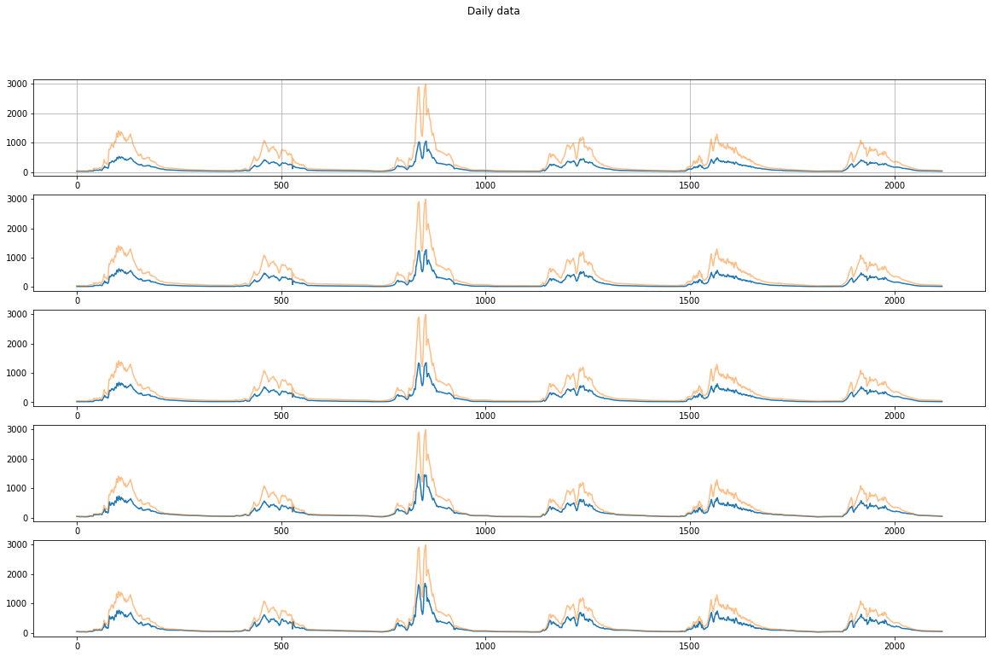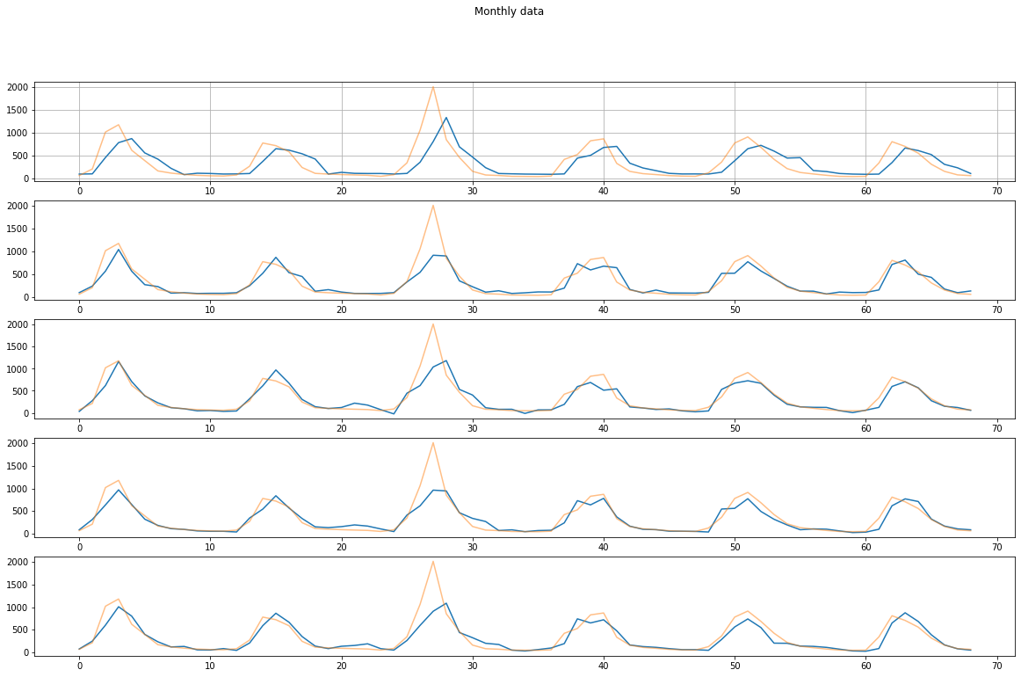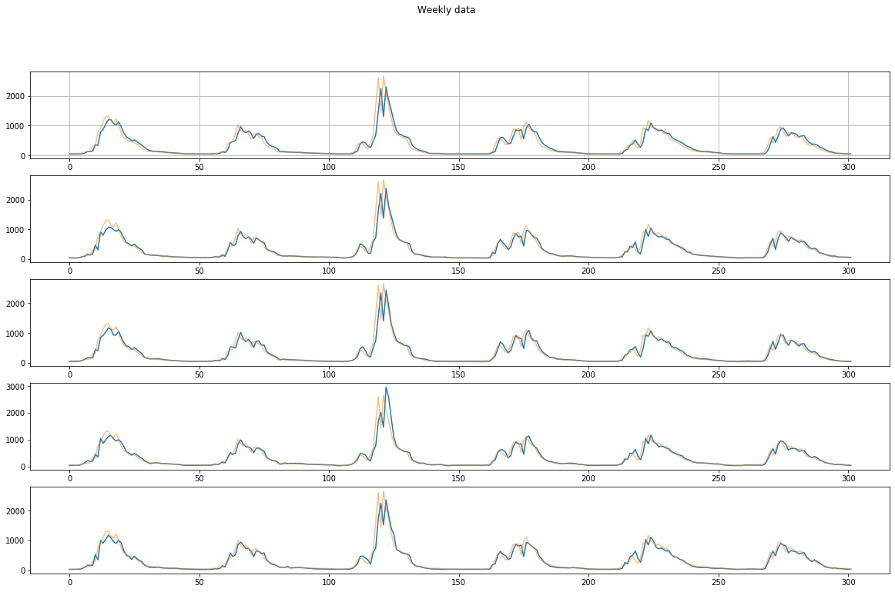

LSTM:

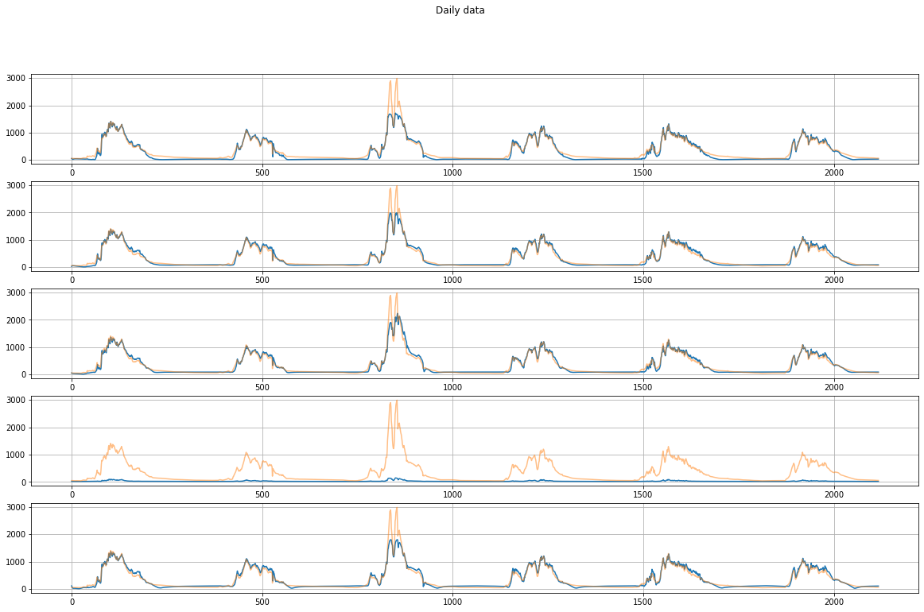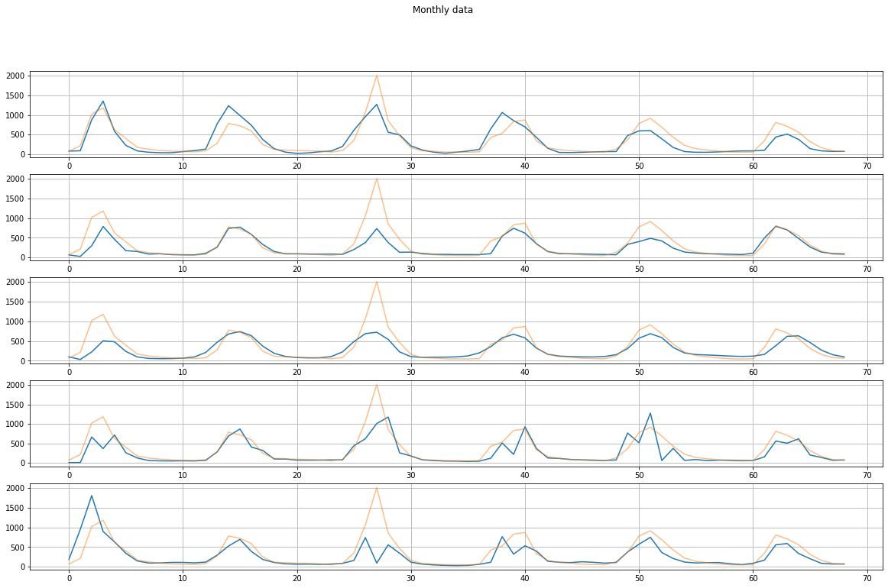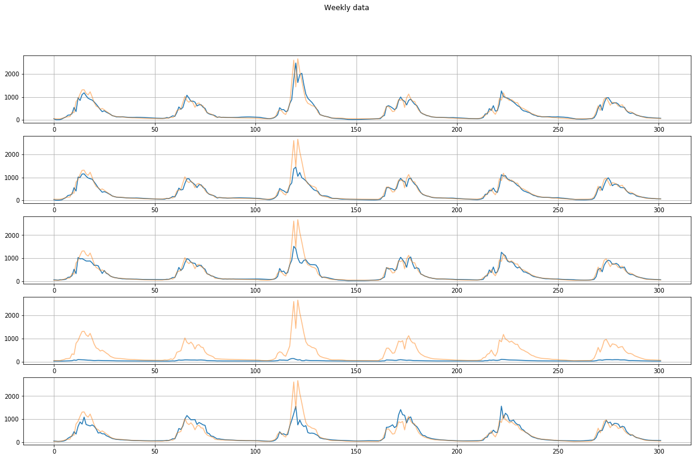

* Scatter plot for the observed versus the simulated stream-ﬂow for the testing phase using CNN and LSTM models, for daily, average weekly, average monthly, respectively

CNN

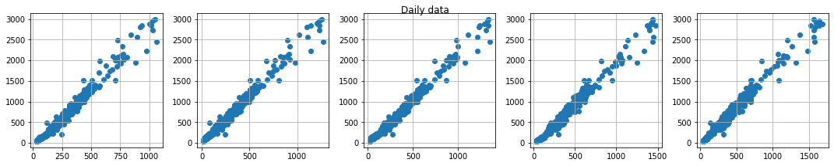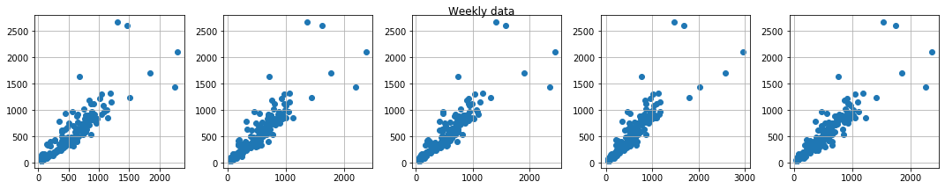

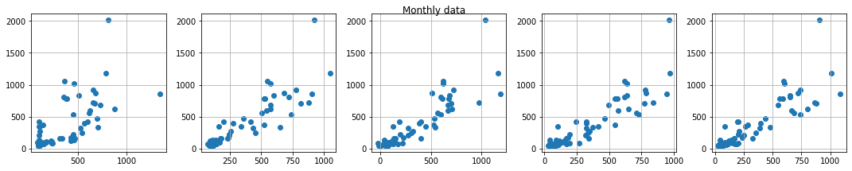

LSTM

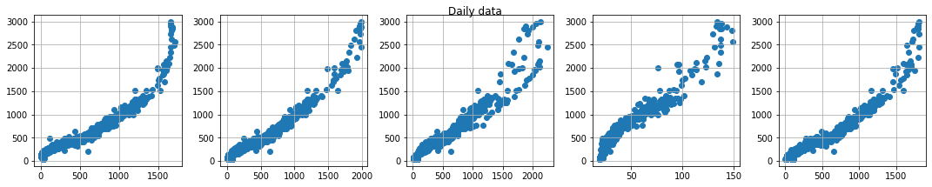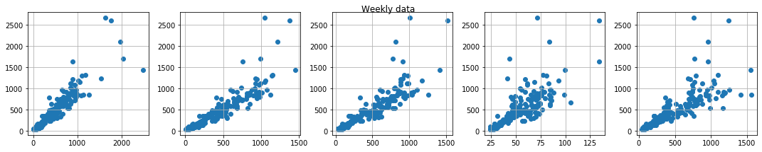

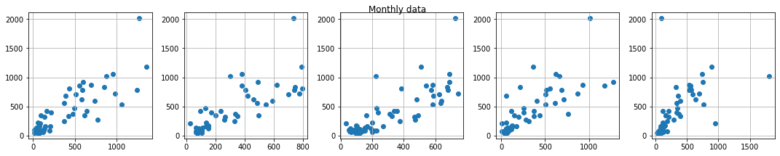

* Relative error distribution for the testing phase using CNN and LSTM methods, for daily, average weekly, and average monthly, respectively

CNN:

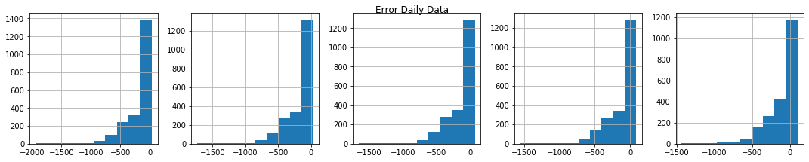

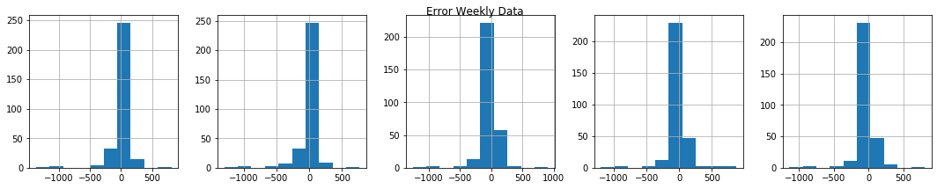

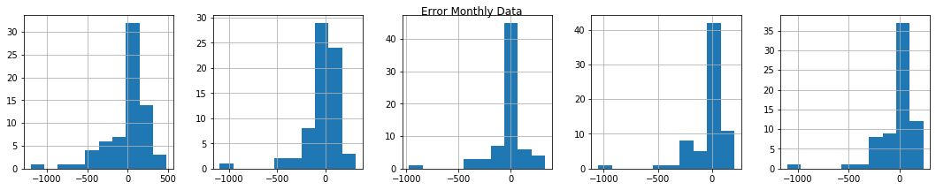

LSTM:

