
Whac-A-Mole
ENGS 31 Final Project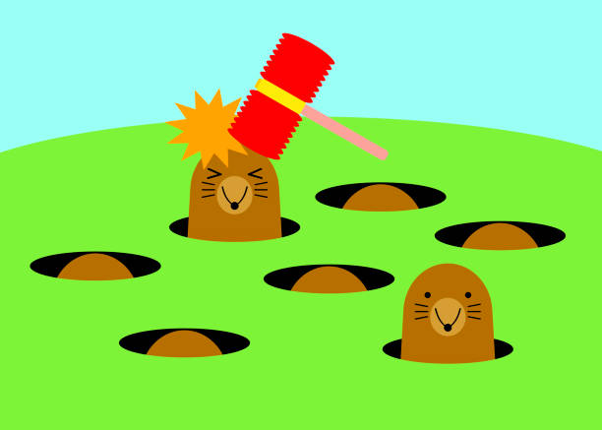
Tahjae Jackson , ENGS 31 , 22X
Dartmouth College

Engs 31 / CoSc 56
Final Project Report

Abstract: For this final project, I have decided to design and implement the popular arcade game Whac-A-Mole using the basys3 FPGA hardware.

The digital system consists of several key components: a LED display controller powered by a linear feedback shift register (LFSR), a Datapath for game logic, a clock divider to control the system clock, a tick generator that increases the frequency of the moles (represented by LED’s as you hit more moles) and a button interface that of pressure-sensitive buttons to simulate the act of hitting the moles. The LED display controller generates the moles in the form of LED’s. The Datapath of the project manages the game's logic, handling moles' random appearance, player input, scoring, and timing.

The Whac-A-Mole game's implementation involved programming the FPGA with a hardware description language (HDL) to realize the system's components and their interconnections.

To evaluate the system's performance, rigorous testing was conducted. Functional testing ensured that moles appeared and disappeared correctly, and that player inputs were accurately registered. Additionally, performance testing measured the game's responsiveness, aiming for smooth animation and real-time interaction. Testing was done for the LFSR component to ensure that the moles were generated randomly.

The results demonstrated a successful implementation of the Whac-A-Mole game on the FPGA platform. The game provided an engaging experience, accurately replicating the original arcade game's dynamics. Players could interact with the FPGA-based system in real time, experiencing responsive gameplay and consistent performance.

In conclusion, this project showcases the design, implementation, and testing of a Whac-A-Mole game on an FPGA platform.

- System Overview
This project aimed to create a digital version of the Whac-A-Mole arcade game using an FPGA platform. The FPGA served as the hardware that runs the game. The goal was to replicate the fun and challenge of the original game, where players use a mallet to hit moles as they pop up from holes, with the moles appearing more frequently as you hit more moles, thus increasing the difficulty of the game.

The design includes several main parts:

1. Game Display: the game is started by a switch, and then one out of five LED’s is generated at random
2. Game Logic: The rules of the game, such as moles randomly popping up and players earning points by hitting them.
3. Player Interaction: Allowing players to "hit" moles by pressing buttons. As players hit the moles, their score is displayed on the seven-segment display. The system also keeps track of the highest score, which is displayed when the game is off.

The FPGA was programmed using VHDL to create these components and make them work together.

The successful design achieved the following specifications:

1. Accurate Gameplay: The moles appeared randomly and at a reasonable speed, closely resembling the original game's challenge.
2. Responsive Controls: When players pressed the buttons, the corresponding moles were successfully "whacked" without noticeable delays.
3. Scoring System: The game kept track of players' scores, incrementing points for each successful hit. The game also effectively keeps track of the highest score.
4.Varying levels of difficult: The more moles one hits, the game progressively gets harder by speeding up how fast the moles appear

In essence, the project successfully created a digital Whac-A-Mole game on the FPGA. Players could interact with the game using buttons to hit moles that appeared on the screen, with accurate scoring and a visually pleasing experience. This project showcases the potential of FPGA technology in recreating classic arcade games and highlights the importance of achieving accurate gameplay, responsiveness, and smooth graphics for an enjoyable gaming experience.

  - Top-level Block Diagram
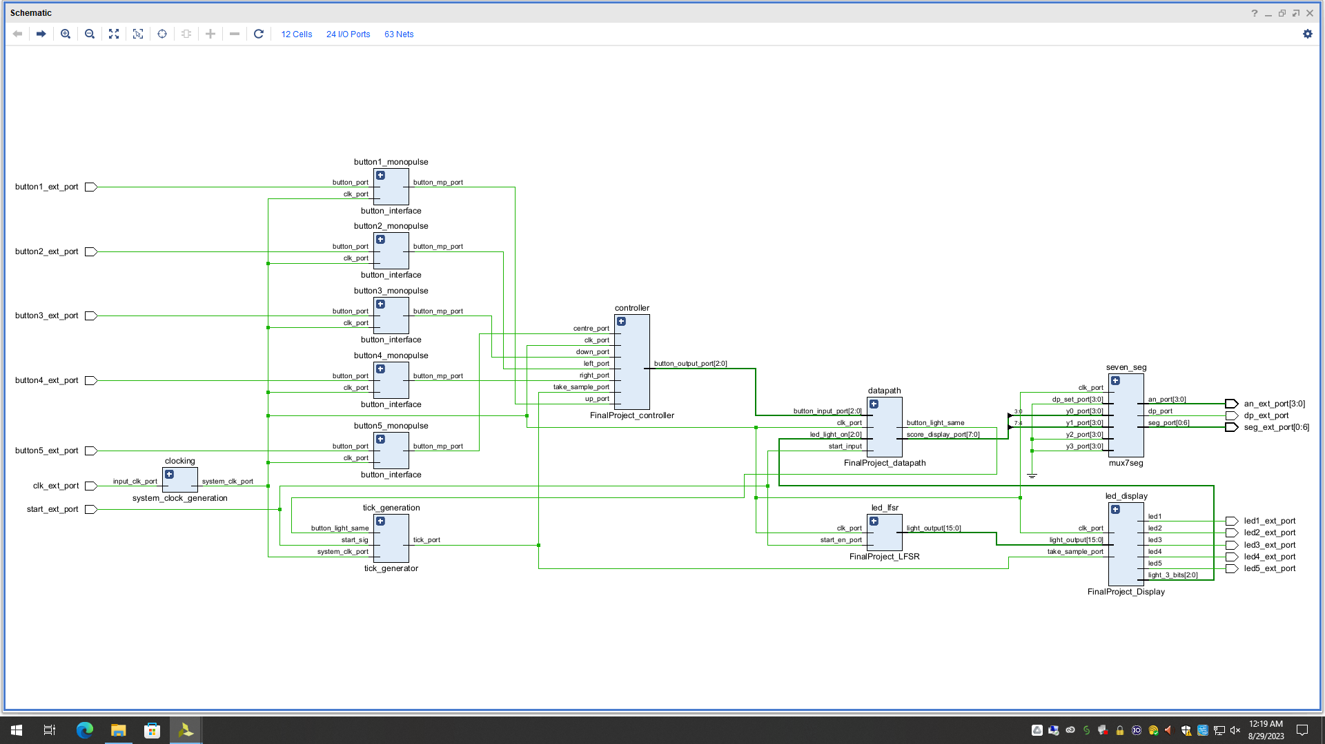

  - TOP LEVEL DIAGRAM

  - Description of Ports

NAME OF PORT | TYPE OF PORT | FUNCTION
clk_ext_port | Input (std_logic) | This takes the input clock of the system which is then sent to the clock divider so that the game runs as a different frequency
Button1_ext_port | Input (std_logic) | This takes a signal from a button on the FPGA and coordinates to a hit to mole 1.
Button2_ext_port | Input (std_logic) | This takes a signal from a button on the FPGA and coordinates to a hit to mole 2.
Button3_ext_port | Input (std_logic) | This takes a signal from a button on the FPGA and coordinates to a hit to mole 3.
Button4_ext_port | Input (std_logic) | This takes a signal from a button on the FPGA and coordinates to a hit to mole 4.
Button5_ext_port | Input (std_logic) | This takes a signal from a button on the FPGA and coordinates to a hit to mole 5.
start_ext_port | Input (std_logic) | This receives the input of a switch from the FPGA which tells the system if the game has been initiated
Led1_ext_port | Output (std_logic) | This port is connected to an LED which represents mole 1 being displayed.
Led2_ext_port | Output (std_logic) | This port is connected to an LED which represents mole 2 being displayed.
Led3_ext_port | Output (std_logic) | This port is connected to an LED which represents mole 3 being displayed.
Led4_ext_port | Output (std_logic) | This port is connected to an LED which represents mole 4 being displayed.
Led5_ext_port | Output (std_logic) | This port is connected to an LED which represents mole 5 being displayed.
seg_ext_port | Output (std_logic_vector ) 7 bits | This outputs the current score or the highest score depending on if the game is currently being played
dp_ext_port | Output (std_logic) | Used the display of the current score and highest score
An_ext_port | Output (std_logic_vector) 4 bits | Used the display of the current score and highest score

  - Description of Components

Button1_monopulse: This component generates a monopulse signal saying that mole 1 was attempted to be hit.
Button2_monopulse: This component generates a monopulse signal saying that mole 2 was attempted to be hit.

Button3_monopulse: This component generates a monopulse signal saying that mole 3 was attempted to be hit.

Button4_monopulse: This component generates a monopulse signal saying that mole 4 was attempted to be hit.

Button5_monopulse: This component generates a monopulse signal saying that mole 5 was attempted to be hit.

**All button components implement the same button interface**

System_clock_generation: This component creates a new frequency that the game is ran on.

Tick_generation: This component controls the frequency that the moles appear. As you hit more moles, the moles appear quicker, increasing the difficulty of the game.

FinalProject_Controller: This component is responsible for identifying what button was pressed (which mole was hit)

FinalProject_Datapath: This component is where the game is implemented. It also checks if the mole has been hit in time and updates the current score and highest score.

FinalProject_LFSR: This is a 16-bit implementation of the Galois feedback register or more commonly known as the Linear Feedback Register. It generates a random 16-bit binary number which is then used to decided which LED is turned on.

FinalProject_Display: This component behaves as an FSM and turns on an LED depending on what number is generated by the LFSR.

Mux7seg: This component is responsible for displaying the current score and the highest score.
- Technical Description
Now you want to go into detail into each component in the top-level file. List each component one-by-one and fully describe its composition and operation. Sometimes a component will contain subcomponents. Keep this overall structure and dive one level deeper if needed.

  - Button Interface
This interface is used for all five buttons and outputs a monopulse signal depicting that which button has been pressed, whether it may be button1, button2, button3, button4 or button5. A button being pressed represents the act of hitting a mole in the popular arcade game. This follows a similar format to the button interface that has been used in previous labs.

    - Description of Ports
- clk_port (input) (std_logic) : This port takes the system_clock_period (frequency used for the game)
- button port (input) (std_logic) : This port takes an input value depicting if a button has been pressed
- button_mp_port (output) (std_logic): This port outputs a monopulse signal of the button being pressed. This is what is used in the controller of the project.

- button_dp_port (output) (std_logic): This port outputs a debounced signal of the button being pressed.

    - Register Transfer Level (RTL) Diagram
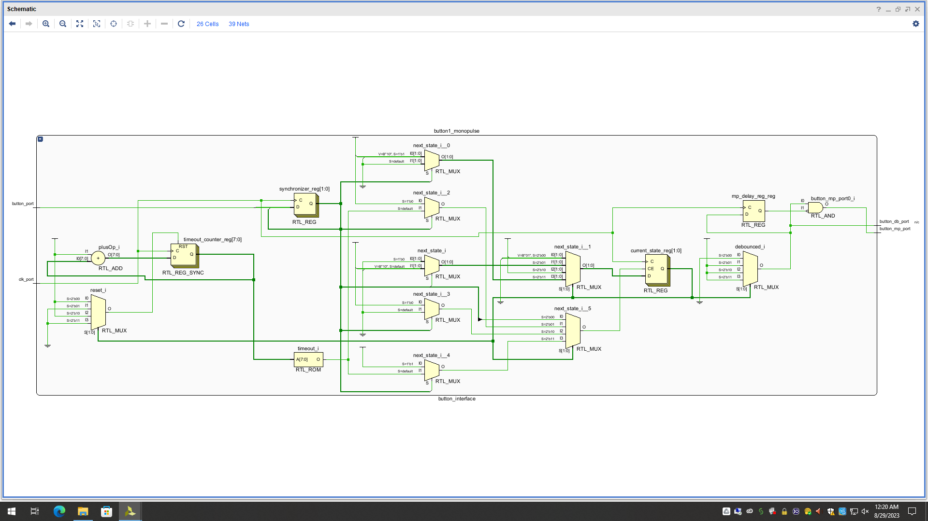
    - RTL DIAGRAM

  - System Clock Generation
This component creates a new frequency that the game is ran on.

    - Description of Ports
- input_clk_port(input) (std_logic) : takes the input clock frequency which is 100MHZ.
- system_clk_port (output) (std_logic) : outputs the clock frequency that the game should run on. This is set to 10MHZ.
- fwd_clk_port (output) (std_logic) : output used to update the frequency.

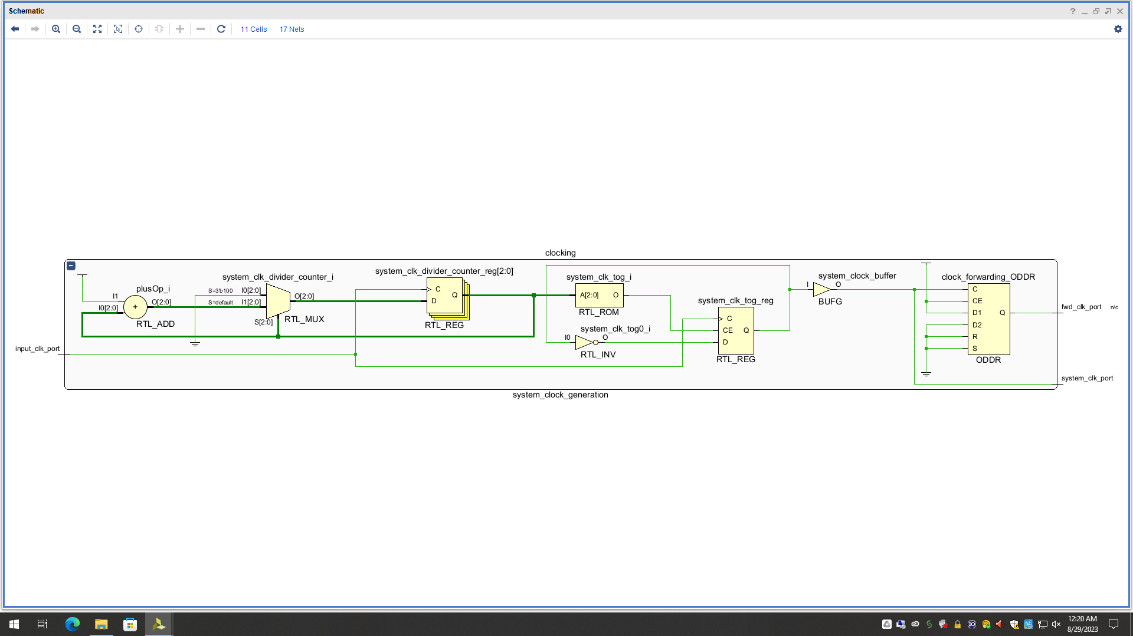
    - RTL DIAGRAM
    - Register Transfer Level (RTL) Diagram
This RTL follows the schematics for the prior clock dividers used in the previous labs.

  - Tick Generation
This component is responsible for the output of the LED’s. It is used to update the frequency of the moles appearing, thus increasing the difficulty of the game. Also, if the game is ran on the frequency of the clock divider, the moles would be appear to face and would all appear to be on at the same time.

    - Description of Ports
- start_sig(input) (std_logic) : this port takes the start signal depicting that a new game has started and is current going. It is used to reset the frequency of the LED’s.
- system_clk_port (input) (std_logic): takes the frequency generated by the clock divider
- button_light_same(input) (std_logic): this is a signal received from the datapath that tells if a mole has been hit, so that the frequency of the tick generator can be updqate appropriately.
- tick_port(output) (std_logic): this provides a one bit signal that updates with the desired frequency and is sent to the LED display to adject how fast they are displayed

    - Register Transfer Level (RTL) Diagram
(a picture of this diagram has been uploaded separately to the drive)
  - Final_Project Controller
This is an implementation of a Finite State Machine that is responsible for deciphering what button has been pressed and outputting a corresponding signal.

    - Description of Ports
- clk_port (input) (std_logic) : This port takes the system_clock_period (frequency used for the game)
- up_port (input) (std_logic) : This port takes a signal depicting whether button 1 has been pressed.
- left_port(input) (std_logic): This port takes a signal depicting whether button 2 has been pressed.
- down_port (input) (std_logic): This port takes a signal depicting whether button 3 has been pressed.
- right_port(input) (std_logic): This port takes a signal depicting whether button 4 has been pressed.
- centre_port (input) (std_logic): This port takes a signal depicting whether button 5 has been pressed.
- button_output_port (output) (std_logic_vector) 3 bits: This port outputs a 3 bit signal depicting which button has been pressed.

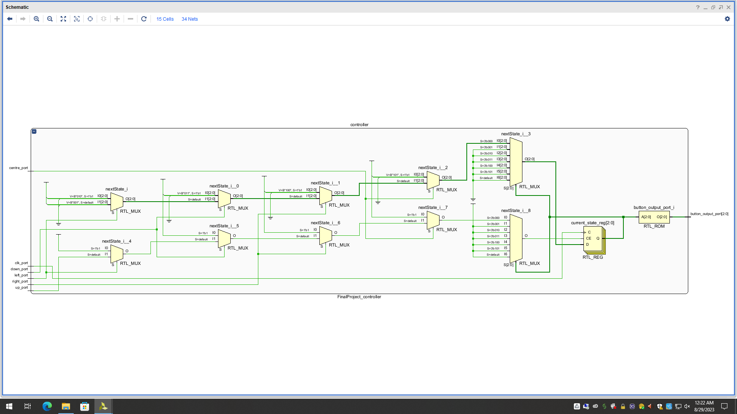
Brief Explanation: There is a current state register that is updated every clock period depending on the button inputs (up, left, down, right, centre)
    - RTL DIAGRAM

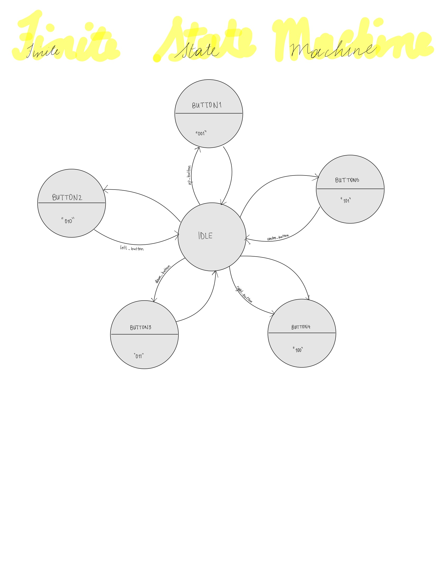
    - Finite State Machine (FSM) Diagram
“101”
“100”
“011”
“010”
“001”
“000”
Description: In this finite state machine there are six states: IDLE, BUTTON1, BUTTON2, BUTTON3, BUTTON4, BUTTON5. When in the IDLE state, the next state can be BUTTON1 (if the up button has a high signal), BUTTON2(if the left button has a high signal), BUTTON3(if the down button has a high signal), BUTTON4 (if the right button has a high signal) or BUTTON5(if the button has a high signal). For all other states, the next state is always the IDLE state. When in the IDLE state a 3-bit signal of “000” is sent to the button output port. When in the BUTTON1 state a 3-bit signal of “001” is sent to the button output port. When in the BUTTON2 state a 3-bit signal of “010” is sent to the button output port. When in the BUTTON3 state a 3-bit signal of “011” is sent to the button output port. When in the BUTTON4 state a 3-bit signal of “100” is sent to the button output port. When in the BUTTON5 state a 3-bit signal of “101” is sent to the button output port.

  - Final Project Datapath
This is where the main functionality of the game is. It is responsible for checking if a mole has been hit, and updating the current score and the highest score.

    - Description of Ports
- clk_port (input) (std_logic) : This port takes the system_clock_period (frequency used for the game)
- button_input_port (input) (std_logic_vector)(3 bits): This port takes the input of what button has been pressed.
- button_light_same(input) (std_logic): This is a 1-bit signal that goes high if the button input signal and the led light signal are the same, indicating that a mole has been hit.
- led_light_on(input) (std_logic_vector) (3 bits) : This is a 3-bit signal that tells which mole is being displayed (which LED light is on)
- start_input (input) (std_logic) : This is a signal that tells when a game is initiated and whether to output the highest score or the current score
- score_display_port (output) (std_logic_vector) (8 bits): This is a BCD representation of the score. It may be the current score or the highest score, depending on the signal of the start input.

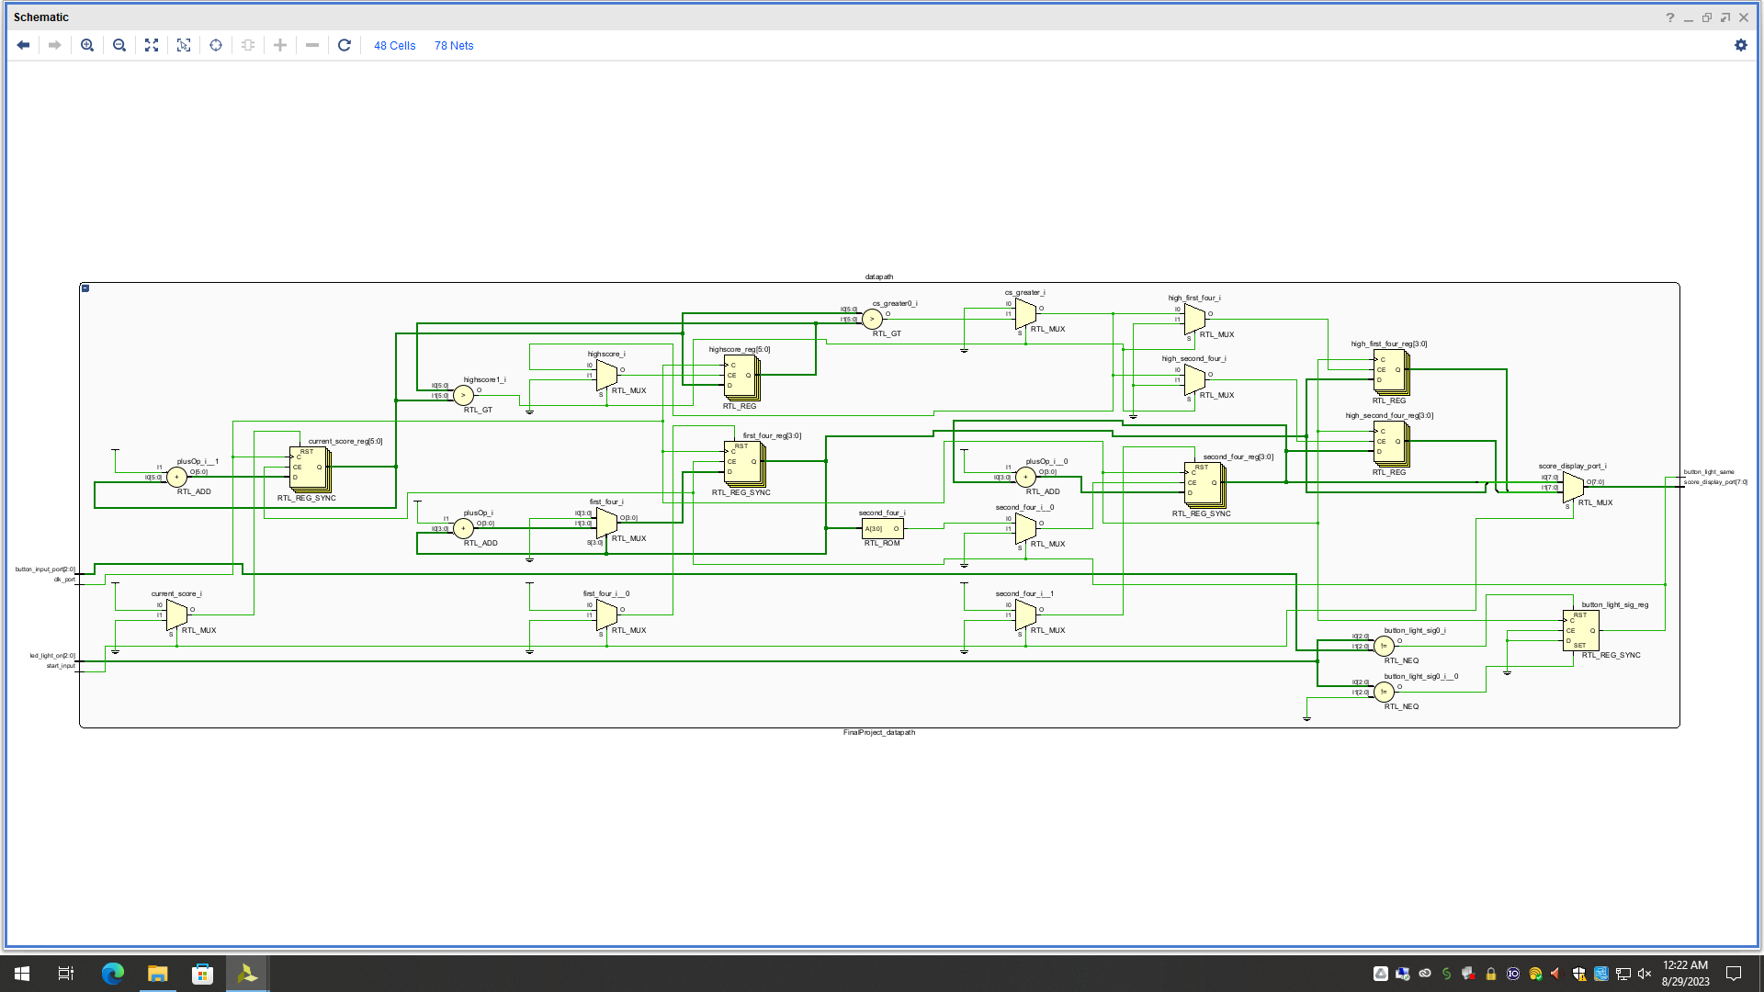
Brief Explanation: There are two main registers used here. There is one to store the highest score and another to store the current score while the game is played. A 2x1 mux is used to select which one is displayed using the start signal as the select bit. There are other minor registers used to store the BCD conversion of the highest score and current score. For the current score, it is updated with an adder if a mole has been hit. If the game has been restarted, it resets to 0.
    - RTL DIAGRAM

    - Memory
The main type of memory used in this component is a register. There are many registers used but the primary ones are two 6-bit registers used to store the current score and the highest score. The register follows the principle of a standard register where it is update every cycle and is volatile. If the FPGA is switched or reprogrammed, the stored values are erased

  - Linear Feedback Shift Register
This component is responsible for randomly generating and 16-bit signal which correspond to one of the five LED’s.

    - Description of Ports

- clk_port (input) (std_logic) : This port takes the system_clock_period (frequency used for the game)
- start_en_port (input) (std_logic) : This is a signal that tells when a game is initiated.
- light_output (output) (std_logic_vector)(16 bits) : This is a 16-bit signal that will be used to determine what LED light should be turned on (which mole should be displayed).

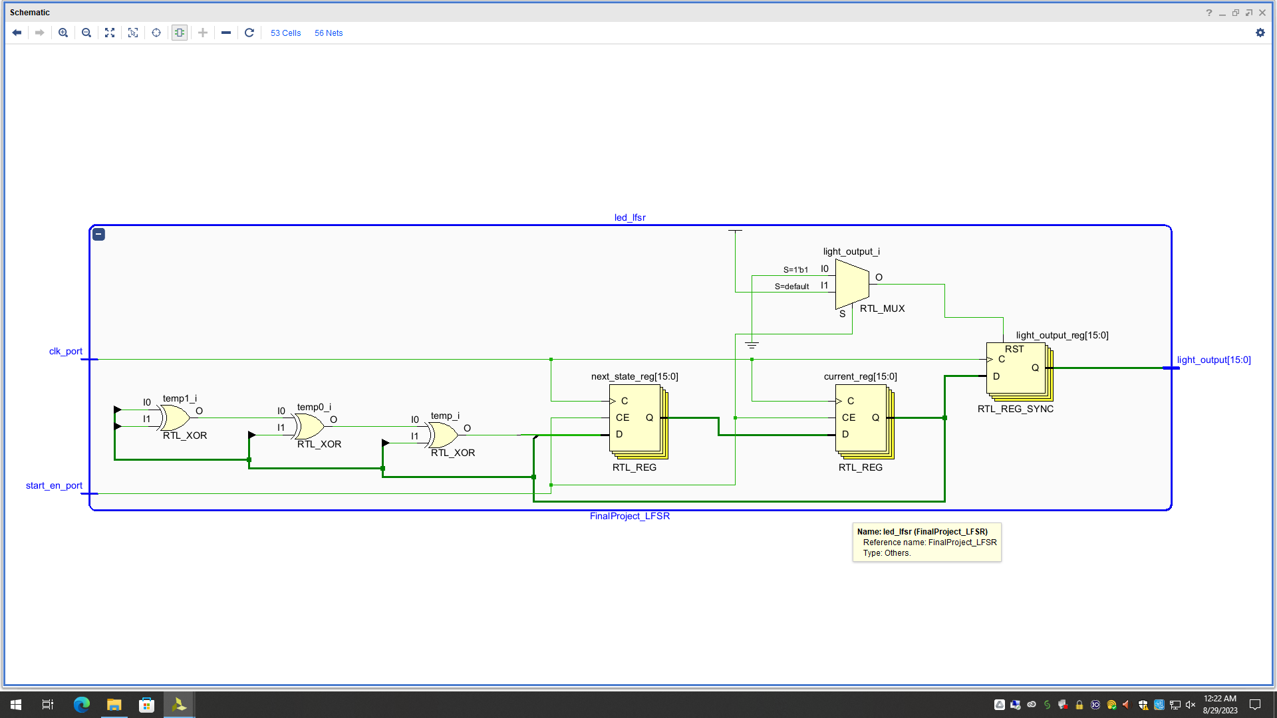

Brief Explanation: The XOR gates represent the taps being used to generate a random number and being fed into the next state register. A register is used to keep track of the output.
    - RTL DIAGRAM

    - Description of Memory
The main type of memory used in this component is a register. There are three 16-bit registers used to store the current state, next state and output of this FSM. The register follows the principle of a standard register where it is update every cycle and is volatile. If the FPGA is switched or reprogrammed, the stored values are erased.
  - Final Project LED Display
This is an FSM that is responsible to switching between LED’s to depict moles appearing.

    - Description of Ports
- clk_port (input) (std_logic) : This port takes the system_clock_period (frequency used for the game)
- start_en_port (input) (std_logic) : This is a signal that tells when a game is initiated.
- light_output (input) (std_logic_vector)(16 bits) : This is a 16-bit signal that will be used to determine what LED light should be turned on (which mole should be displayed).
- led1 (output) (std_logic) : This port outputs a high value when LED1 is switched on.
- led2 (output) (std_logic) : This port outputs a high value when LED2 is switched on.
- led3(output) (std_logic) : This port outputs a high value when LED3 is switched on.
- led4 (output) (std_logic) : This port outputs a high value when LED4 is switched on.
- led5 (output) (std_logic) : This port outputs a high value when LED5 is switched on.
- Light_3_bits(output) (std_logic_vector)(3 bits) : This is a 3 bit signal depicting what LED light has been switched on.

    - Register Transfer Level (RTL) Diagram
Include an RTL diagram with clearly labeled ports, signals, and components. Use text to describe the RTL diagram and how the different components work together.
(this will be uploaded separately to the drive link )

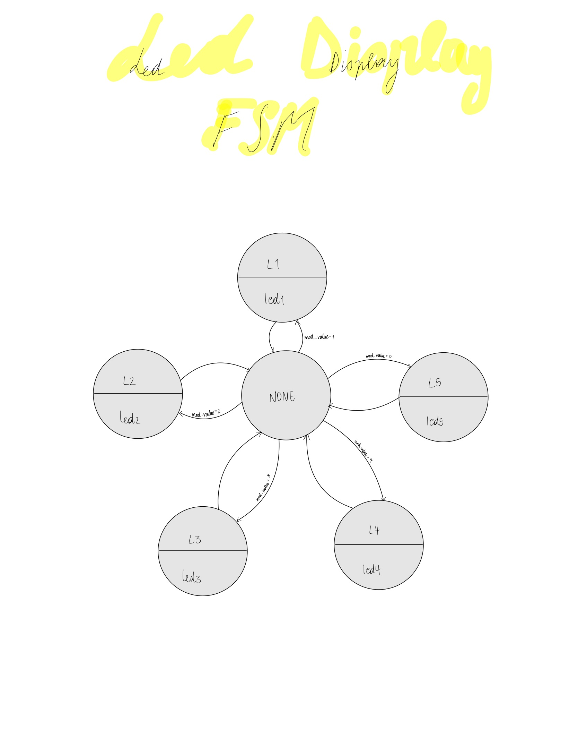
    - Finite State Machine (FSM) Diagram

Description: In this finite state machine there are six states: NONE, L1, L2, L3, L4, L5. When in the NONE state, the next state can be L1 (if the mod value is 1), L2(if the mod value is 2), L3(if the mod value is 3), L4 (if the mod value is 4) or L5 (if the mod value is 0). The mod value is found by finding the calculating light_output (as an integer) mod 5. There is no output update when in the NONE state. For all other states, the next state is always the NONE state. When in the L1 state, the led1 signal outputs a high. When in the L2 state, the led2 signal outputs a high. When in the L3 state, the led3 signal outputs a high. When in the L4 state, the led1 signal outputs a high. When in the L5 state, the led5 signal outputs a high.
  - 7 segment display
This component is responsible for displaying the score.
    - Description of Ports
- clk_port (input) (std_logic) : This port takes the system_clock_period (frequency used for the game)
- y3_port (input) (std_logic_vector) (4 bits): receives the first set of four bits of the BCD
- y2_port (input) (std_logic_vector) (4 bits) : receives the second set of four bits of the BCD
- y1_port (input) (std_logic_vector) (4 bits) : receives the third set of four bits of the BCD
- y0_port (input) (std_logic_vector) (4 bits): receives the third set of four bits of the BCD

- dp_set_port : (intput)(std_logic_vector)(3 bits) : this port receives the decimal points
- seg_port( output) (std_logic_vector) (7 bits): This port displays the segments to depict a digit.
- dp_port (output) (std_logic) : this port outputs if there should be any decimal points
- an_port(output) (std_logic_vector) (4 bits) : this port outputs the anodes
    - RTL DIAGRAM

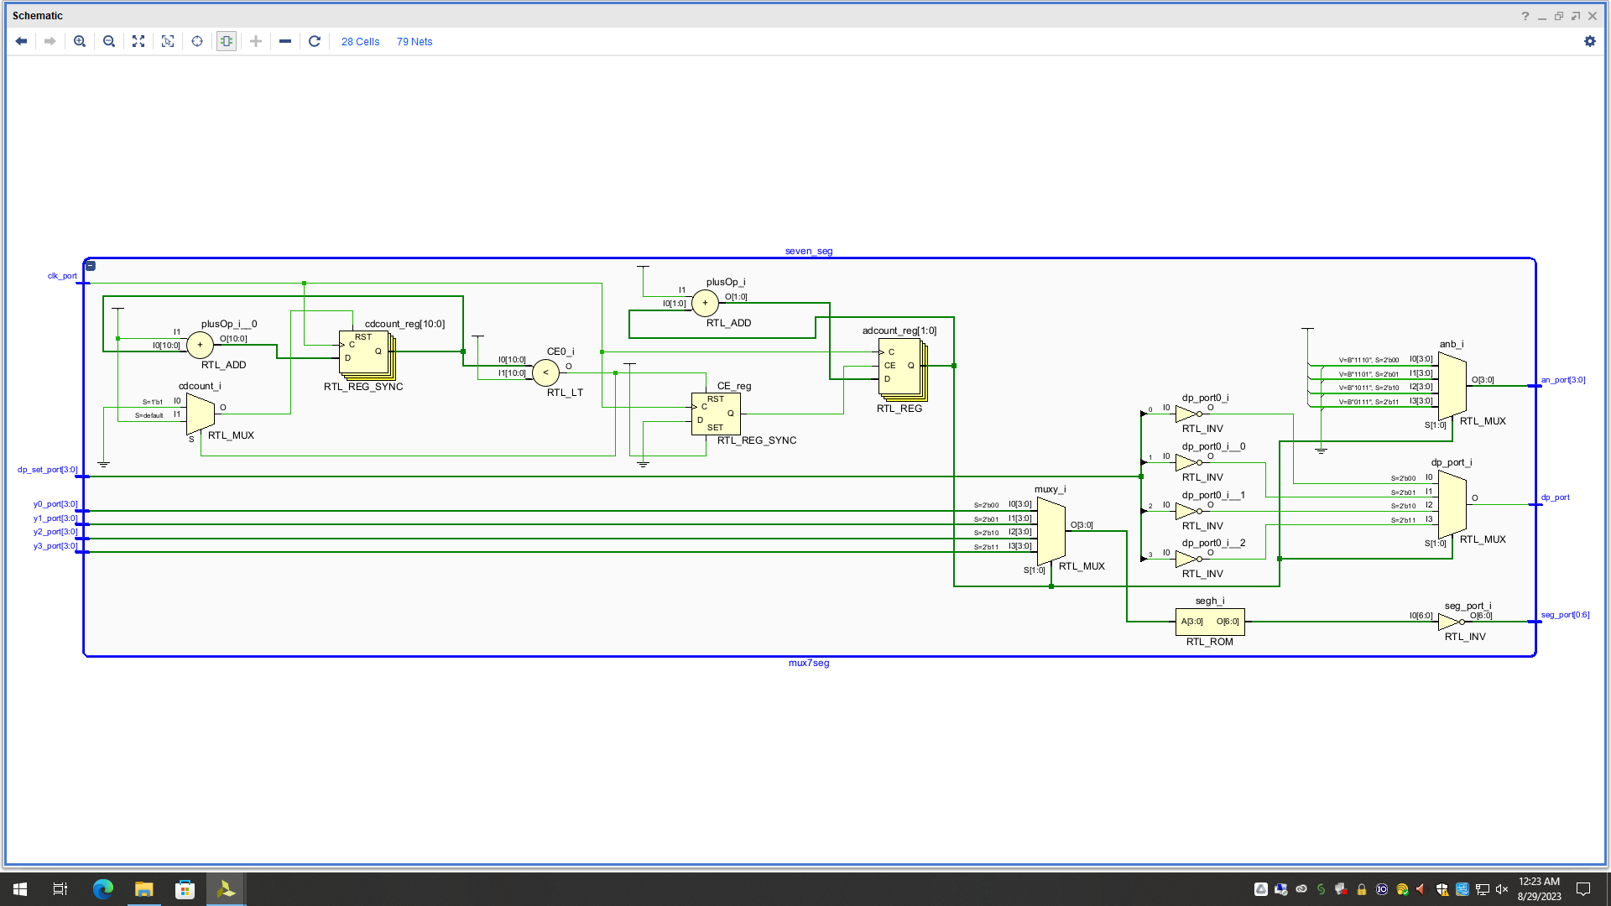
    - RTL DIAGRAM

- Design Validation

  - Button Interface

For this test, the button signal must show that it is accurately being monopulsed. I will simulate a button going high for one period which would replicate what would happen with the working model. Success in this test will depict that the button components are functioning well.
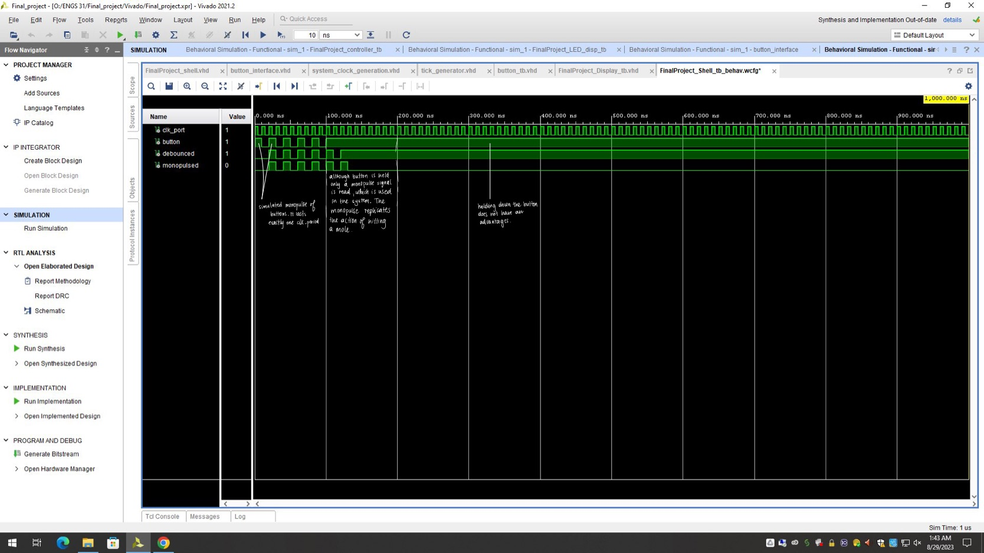


    - Behavioral Simulations

    - SIMULATION

  - Tick generation

For this test, the priority is seeing that frequency is updated appropriately as more moles are hit or if the game has been restarted. The simulation can be seen on the next page.
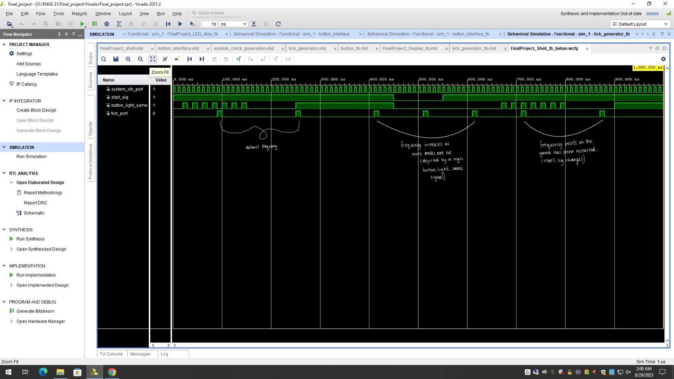

    - SIMULATION

  - Clock Divider

Giving that this component is the same as the clock divider used in lab6, there is no need to test this component as it no adjustments have been made.

  - Final Project Controller

This test will be a test to show that the accurate button signal is being sent as an output. Due to the minor nature of this component, only a simulation is needed to show functionality. A successful test means that the system is accurately identifying the buttons (the right moles are being attempted to be hit). The simulation can be seen on the next page.
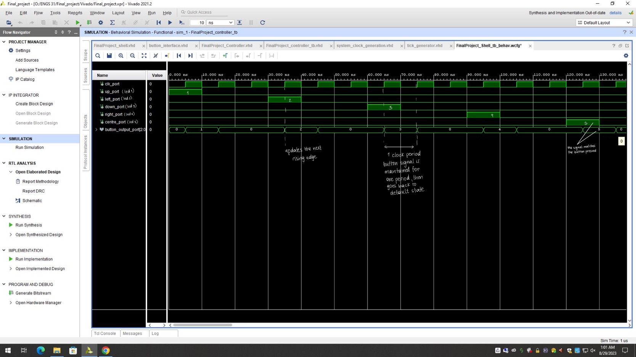
    - SIMULATION

  - Final project LFSR

For this test, the Linear feedback shift register is tested to see is it is randomly generating numbers. Success in this test means that the moles are being randomly generated.
The simulation can be seen on the next page.
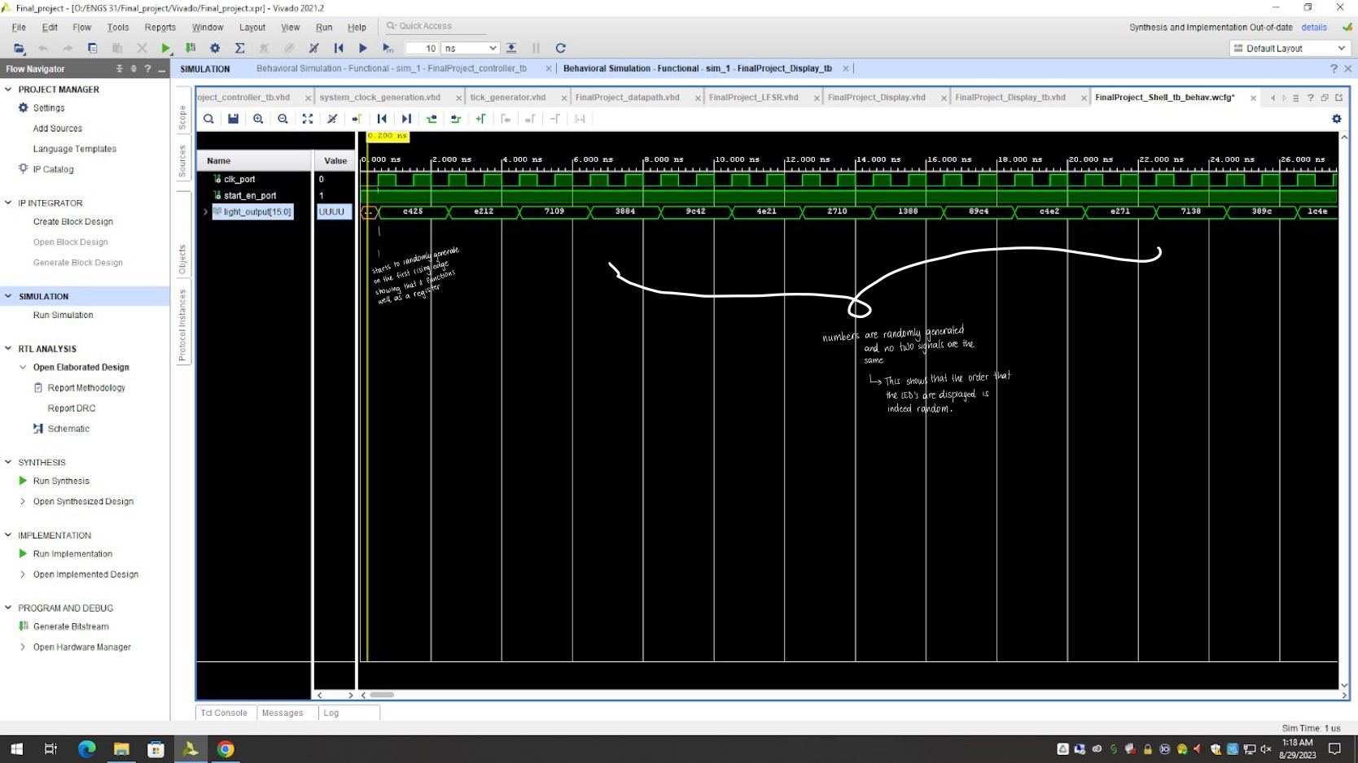
      - SIMULATION
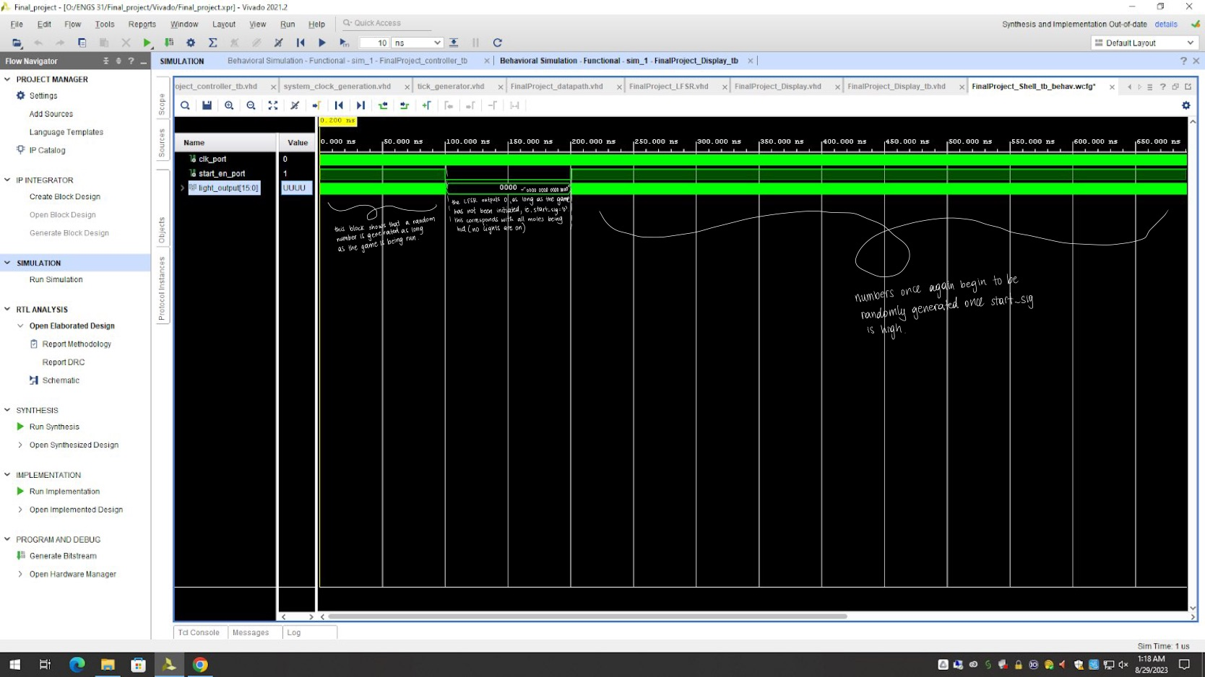
      - SIMULATION

  - LED display

In this test, the FSM responsible for the output of the LED’s is tested. A random signal is passed to see that the right light is turned on. Success in this test means that the right LED’s are being turned on.
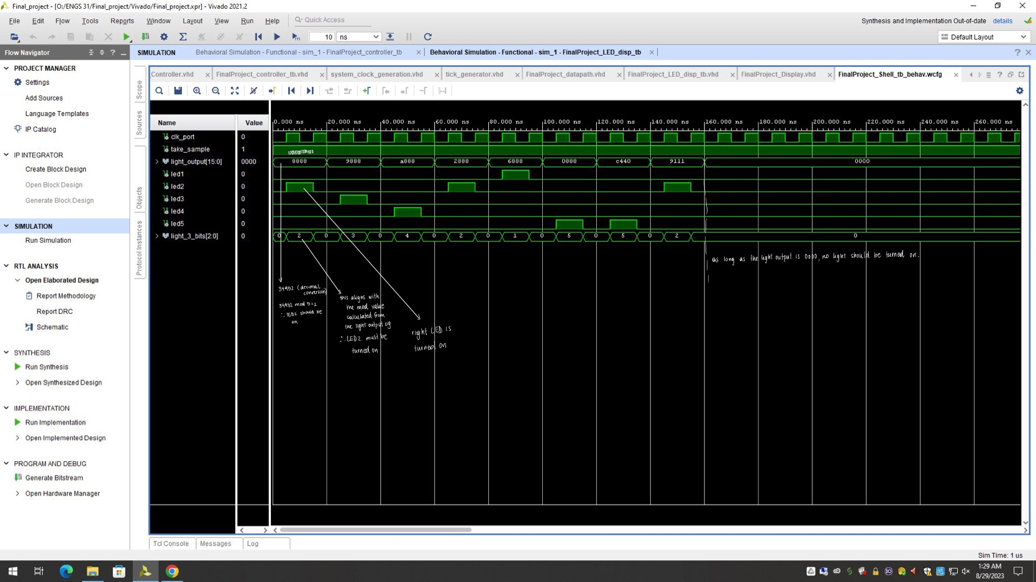
    - SIMULATION

  - Datapath and Seven segment display components

Giving that these components heavily rely on the other components to work. It was decided to check if they are working well by testing the overall design. If the test of the overall design is successful then both of these components are functioning

  - Overall Design
Once you demonstrate that each individual component has proper operation, demonstrate the correct operation of the overall design.
    - Behavioral Simulations (see pages below)
    - Hardware Validation (check drive)

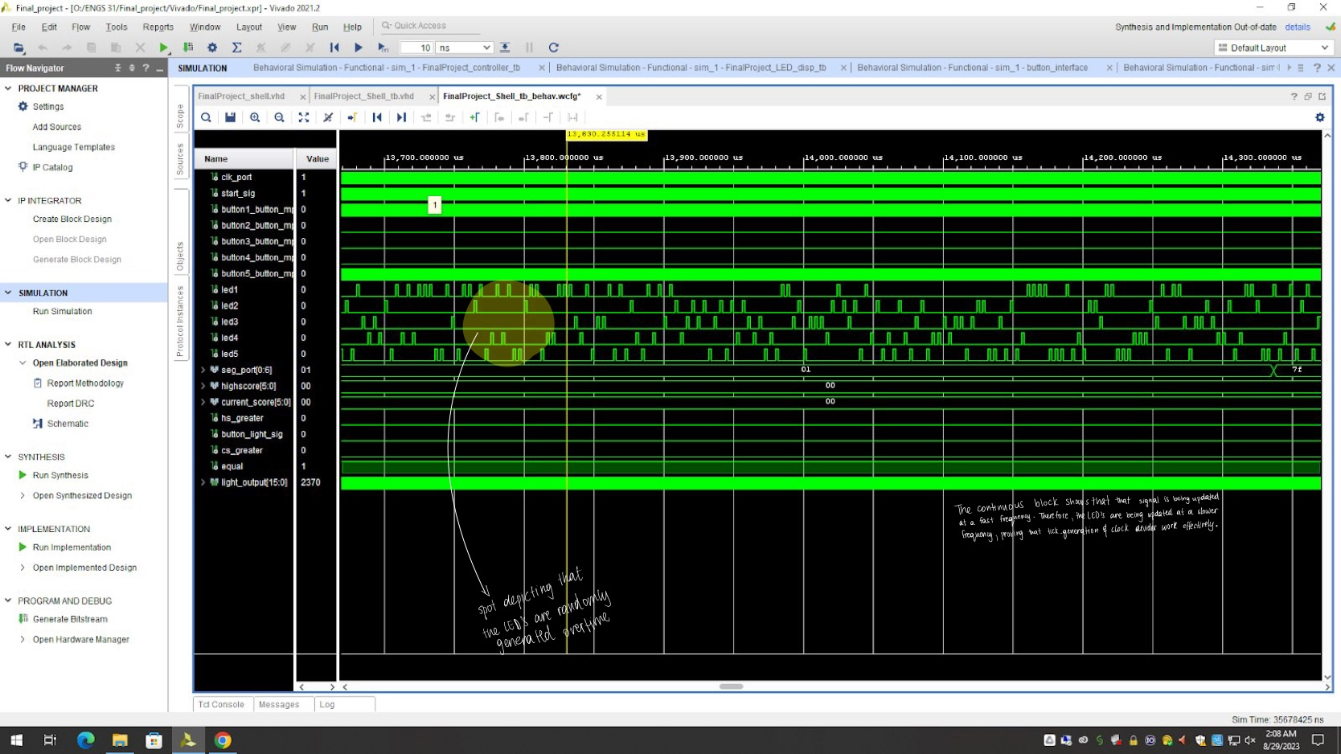
3.8.1.1.. SIMULATION
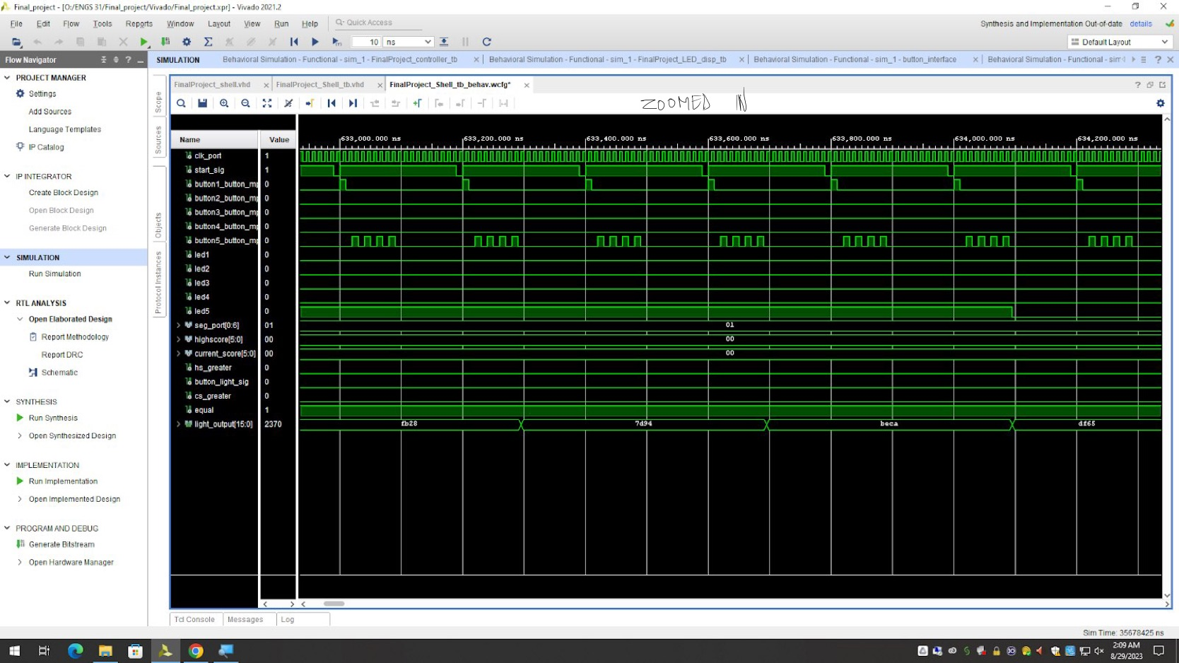
3.8.1.2. SIMULATION

- Analysis of the Design
The outcome of the Whac-A-Mole project was largely successful, achieving the primary objectives and delivering an enjoyable gaming experience. The game mechanics worked well, with moles popping up randomly, players being able to hit them accurately, and the scoring system updating both the high score and current scores reliably. Additionally, the implementation of increasing levels of difficulty added an extra layer of challenge, enhancing the game's engagement factor.

The project largely followed the planned trajectory, and the main components, including game logic and player interaction, were successfully integrated into the FPGA-based system. However, there were a few challenges and considerations that future students pursuing a similar project should be aware of:

  - Resource Utilization
My design utilized several resources on the Basys3 FPGA for the implementation of the Whac-A-Mole game:

- Logic Elements (LEs): The logic elements on the FPGA were used to implement the core game logic, including the generation of random mole appearances, tracking player input, managing scoring, and controlling the increasing difficulty levels.

- Flip-Flops: Flip-flops were employed to store and manipulate the state of the game, such as the current score, the high score, and the status of different game elements like moles and player interactions.

- Multiplexers (MUX): Multiplexers were utilized to manage the selection and display of different game elements on the screen, such as which mole hole is active and which player input is registered.

- Clock Signals: The FPGA's clock signals were crucial for coordinating the timing of game events, ensuring accurate gameplay and synchronization between different components.

- Input/Output Pins: FPGA pins were used for player input, allowing players to hit the moles, and for output to control the display and show game-related information.

- Counter Modules: Counter modules were implemented to track time intervals, helping to manage game speed and difficulty progression.

- Registers: Registers were used to store temporary data and control signals, aiding in the flow of data between different components.

The utilization of these resources relates directly to the total capacity of the Basys3 FPGA. The FPGA's capacity is measured in terms of logic cells, flip-flops, memory blocks, and other resources. My design aimed to make efficient use of these resources while implementing the game's functionality. Balancing the utilization of resources is important to ensure that the design fits within the FPGA's capacity and operates efficiently. It's also important to consider that the remaining resources can potentially be used for future enhancements or additions to the game's features.

By effectively managing the utilization of resources on the FPGA, the design could achieve its intended functionality while optimizing the use of the Basys3's available capacity. This approach ensures that the design can be implemented successfully within the constraints of the FPGA platform.

  - Residual Warnings
There are no eerors shown in the log
7 Infos, 0 Warnings, 0 Critical Warnings and 0 Errors encountered.
link_design completed successfully
link_design: Time (s): cpu = 00:00:06 ; elapsed = 00:00:08 . Memory (MB): peak = 1237.930 ; gain = 0.000
Command: opt_design
Attempting to get a license for feature 'Implementation' and/or device 'xc7a35t'
INFO: [Common 17-349] Got license for feature 'Implementation' and/or device 'xc7a35t'
Running DRC as a precondition to command opt_design
Starting DRC Task
INFO: [DRC 23-27] Running DRC with 2 threads
INFO: [Project 1-461] DRC finished with 0 Errors
INFO: [Project 1-462] Please refer to the DRC report (report_drc) for more information.
Time (s): cpu = 00:00:02 ; elapsed = 00:00:01 . Memory (MB): peak = 1237.930 ; gain = 0.000
Starting Cache Timing Information Task
INFO: [Timing 38-35] Done setting XDC timing constraints.
Ending Cache Timing Information Task | Checksum: 13827af0d
Time (s): cpu = 00:00:08 ; elapsed = 00:00:09 . Memory (MB): peak = 1642.418 ; gain = 404.488
Starting Logic Optimization Task

  - Future Work
The following areas should be considered when enhancing the game:

- Hardware Limitations: While the game mechanics worked smoothly, the project lacked a visual aspect. Incorporating a VGA (Video Graphics Array) module to display the game grid and animations would greatly enhance the gaming experience by providing a more immersive and visually appealing environment. In the future, implementing the visual aspect of the game through VGA integration should be a priority. This would involve creating a VGA controller that can display the game grid, moles, and other visual elements on a screen. Integrating VGA requires careful synchronization and coordination with the game logic and player interaction to ensure smooth animations and gameplay.

- Testing and Validation: Comprehensive testing and validation are crucial. While the core game functionality worked well, future students should ensure rigorous testing to catch any potential bugs, timing issues, or unexpected behaviors.

- Acknowledgements
In the process of designing and implementing the Whac-A-Mole game on the FPGA platform, I would like to acknowledge the following external sources of information that were instrumental in enhancing my understanding and guiding specific aspects of the project:

Wikipedia Article on Linear Feedback Shift Register (LFSR):
Title: "Linear-feedback shift register"
Source: Wikipedia
URL: https://en.wikipedia.org/wiki/Linear-feedback_shift_register

EETimes Tutorial on Linear Feedback Shift Registers (LFSRs)
Title: "Tutorial: Linear Feedback Shift Registers (LFSRs) Part 1"
Source: EETimes
URL: https://www.eetimes.com/tutorial-linear-feedback-shift-registers-lfsrs-part-1/

Research Paper on FPGA-Based Game Design:
Title: "FPGA Based Whack a Mole Game Design"
Source: [Institution/Website]
URL: https://www.uobabylon.edu.iq/eprints/paper_1_17528_649.pdf

I would also like to express my appreciation to Professor Tad for their valuable contributions and support throughout the project. Your guidance and insights have been invaluable to the successful
completion of this endeavor.

- Conclusions
In conclusion, the Whac-A-Mole project achieved its main goals, providing a functional and engaging gaming experience on the FPGA platform. The successful integration of game mechanics, scoring system, and difficulty levels laid a strong foundation for future enhancements. The primary area for improvement lies in implementing the visual aspect of the game through VGA integration, which would greatly enhance the user experience. This project offers valuable insights for future students to create an even more immersive and polished Whac-A-Mole game on an FPGA.
Reflecting on the project, I would certainly choose the same project again. It provided a hands-on opportunity to apply the concepts learned in digital electronics in a creative and engaging manner. The project not only reinforced my understanding of digital systems and FPGA programming but also allowed me to explore the challenges of game design. For future students considering a similar project, I strongly recommend considering collaboration with a partner. Developing such a project requires a significant time commitment, and having a partner can facilitate the implementation process and lead to more elaborate enhancements.
Overall, this project served as an excellent final project choice, demonstrating a profound understanding of the concepts learned throughout the course. Creating a functional game while incorporating hardware design principles was not only educational but also enjoyable. The Whac-A-Mole game project offers a valuable experience for any student seeking to showcase their in-depth understanding of digital electronics in a playful and practical way.

Appendix A: VHDL Source Code
Source Code may be found in the drive. They are found in a folder called VHDL

Appendix B: VHDL Testbenches
Testbenches may be found in the drive. They are in a folder called Testbench.

