K.M. Tahlil Mahfuz Faruk

Islamic University of Technology

Name: K.M. Tahlil Mahfuz Faruk

Student ID: 200042158

Department: CSE(SWE)

Course: CSE 4410

**Database Management System II LAB 1**

**Table Creation:**

The table and their cardinality is given below-

* Franchises - many to many – customers
* Branches - many to one - franchises
* Branches - one to many – chefs
* Chefs – one to many – cuisine
* Cuisine – many to many – franchise
* Cuisine – many to one – orderlist
* Customers – one to many – orderlist

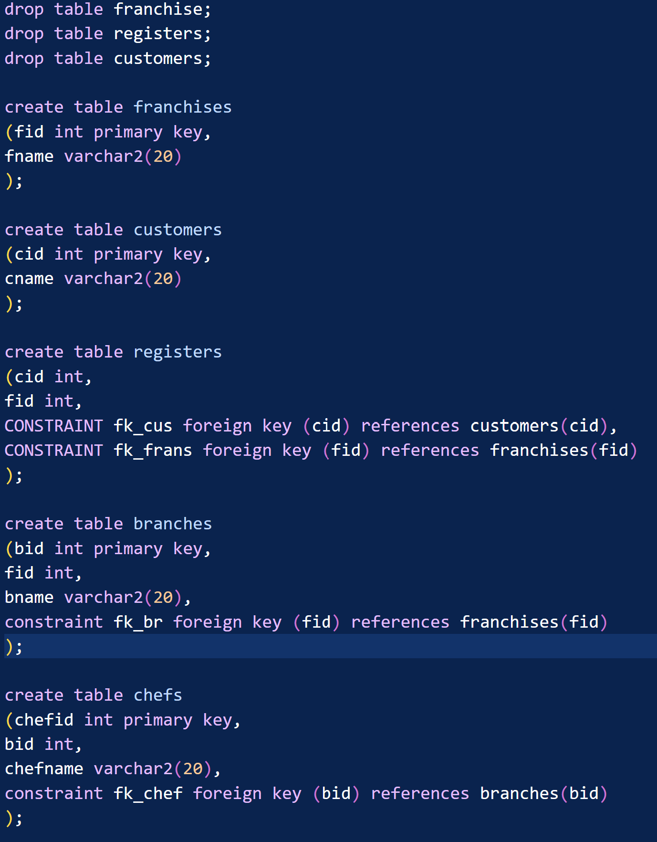

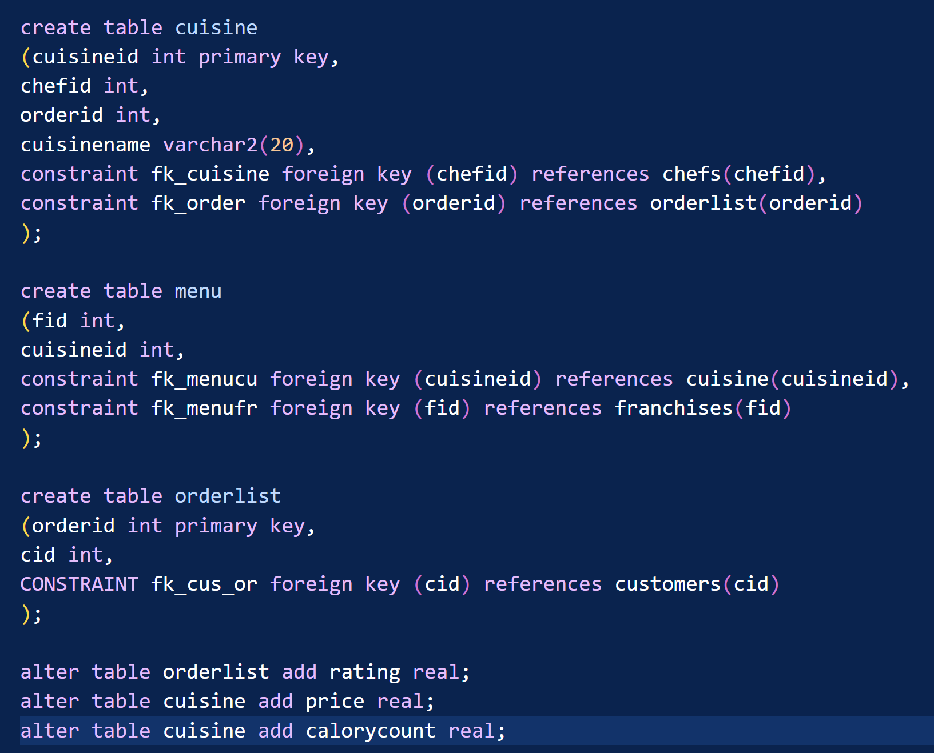

**Tasks:**

In task 1,

**Explanation:**

* Natural join registers, customers, franchises
* Count(cid)
* Group them using their franchise name and id

In task 2,

**Explanation:**

* Natural join cuisine and orderlist
* Take the average rating
* Group them using cuisine name and id

In task 3,

**Explanation:**

* Natural join cuisine and orderlist
* Take the top 5 cuisines using rownum
* Group them using the number of cuisines

In task 4,

**Explanation:**

* Make a subquery to find out the number of franchises a customer is registered
* Then using where clause apply a condition on the total franchises number greater than 2.

In task 5,

**Explanation:**

* Subtract the customers of orderlist table from the customers table.
* That will provide us the customers id who has not ordered an at all.
* Natural join the subquery table (t) with customers table

Selecting cid and cname will provide their name

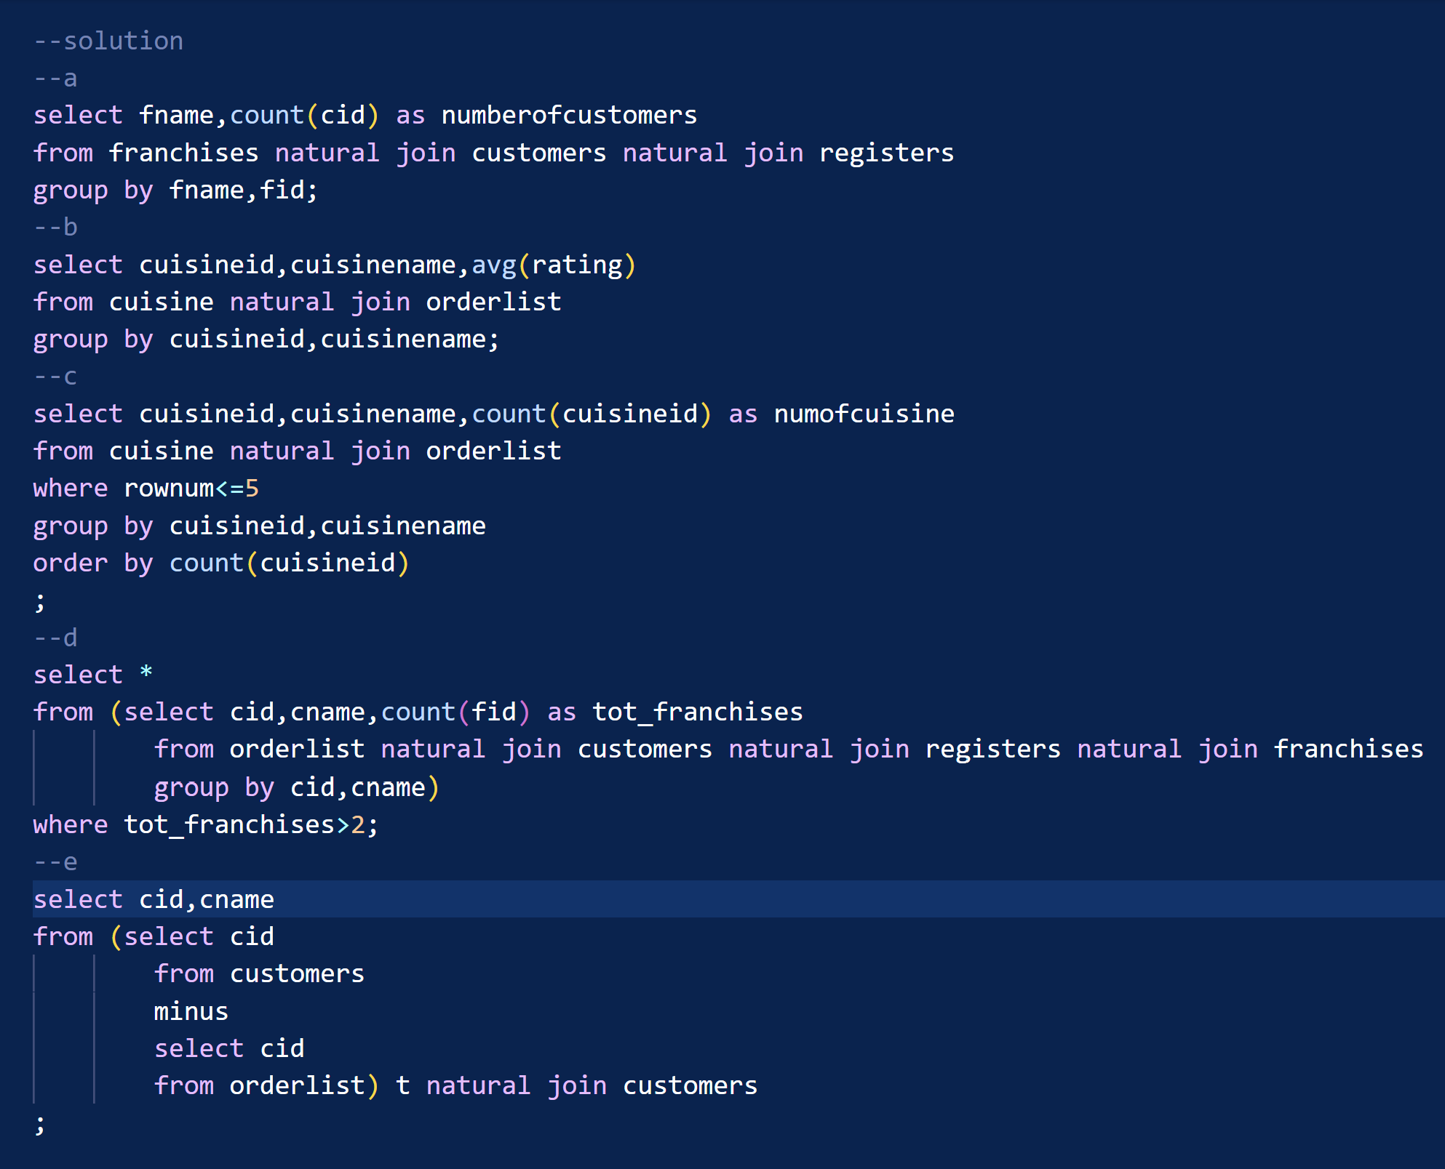

**Problems:**

During the lab confusions between menu and cuisine appeared.

**Solution:**

If we take menu a particular table and create a relation between franchise and cuisine using many to many cardinality that will solve the problem. Now the design have multiple menus for multiple franchises. Though they might have the same name but their menu is different in this design.

Other than that no significant problem caused during the lab task.