K.M. Tahlil Mahfuz Faruk

Islamic University of Technology

Name: K.M. Tahlil Mahfuz Faruk

Student ID: 200042158

Department: CSE(SWE)

Course: CSE 4410

**Database Management System II LAB 2**

**SQL Commands:**

In task 1,

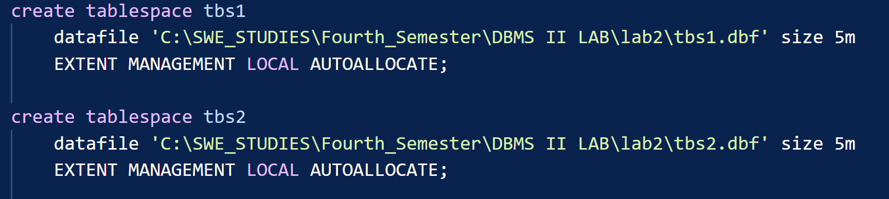

**Explanation:**

* Use create tablespace
* Set the datafile location
* Set the size
* Extent the management to local autolocate

In task 2,

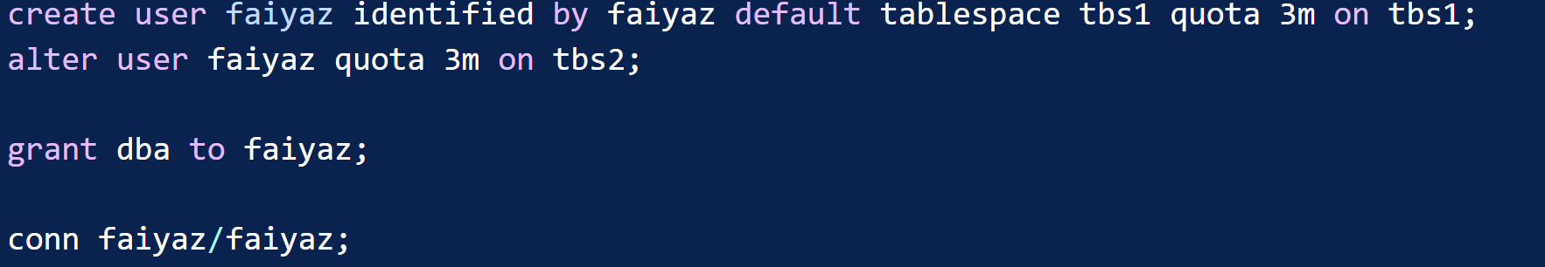

**Explanation**

* Create a new user identified by a password
* Assign a tablespace tbs1 with 3Mb of quota
* Using alter user also assign 3Mb quota to tbs2 to that particular user

In task 3,

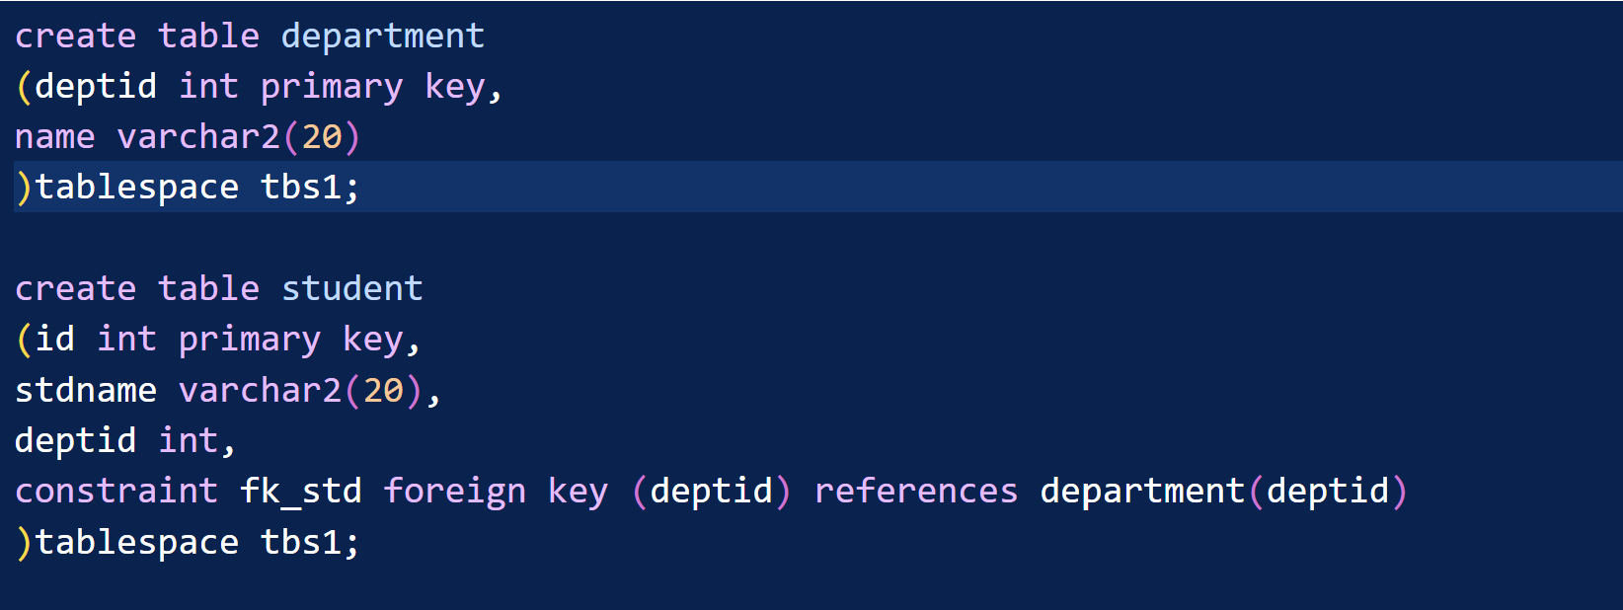

**Explanation:**

* Create the tables with proper cardinality using foreign key.
* Assign tablespace tbs1to this table.

In task 4,

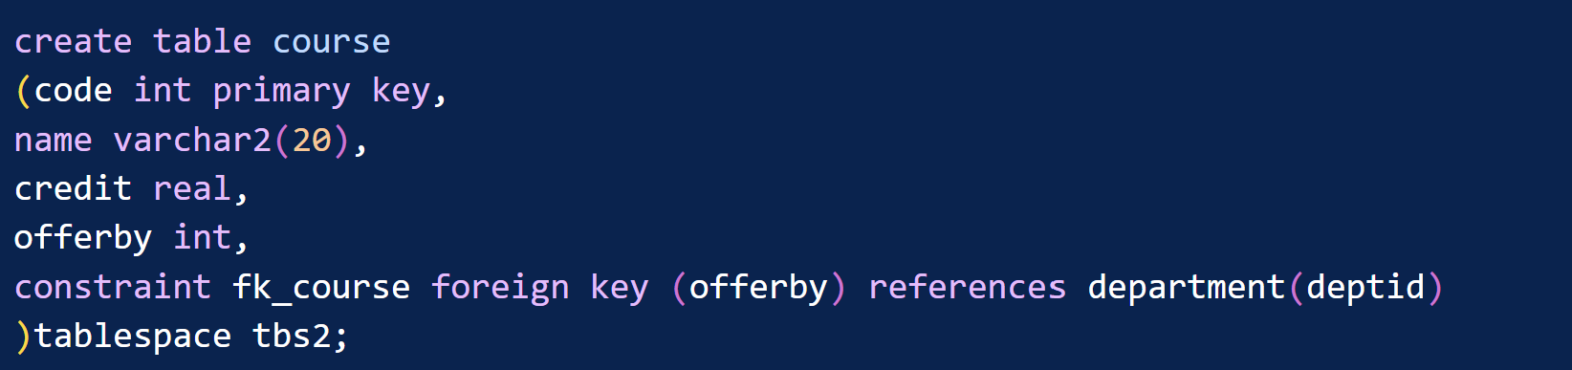

**Explanation:**

* Create another table course
* Assign tablespace tbs2 to this table.

In task 5,

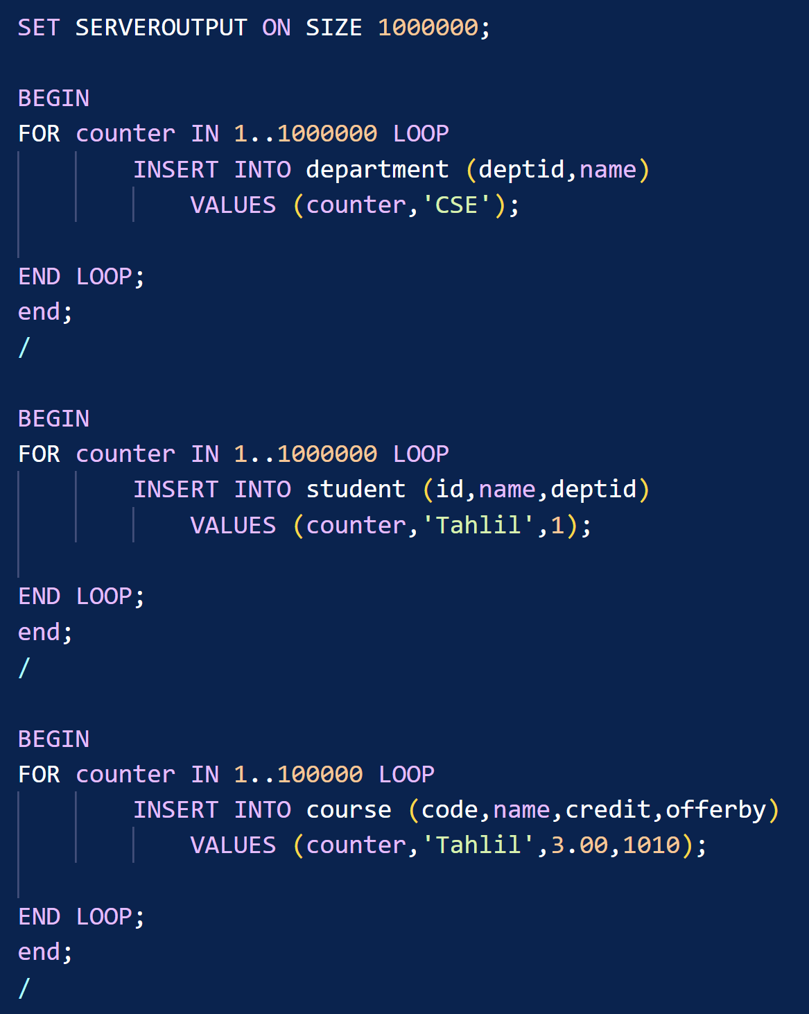

**Explanation:**

* Insert large amount of data to the tables using PLSQL.
* This will show error while inserting the data because the tablespace doesn’t possess that amount of memory allocation.
* To minimize this problem we need to extent the tablespace.

In task 6,

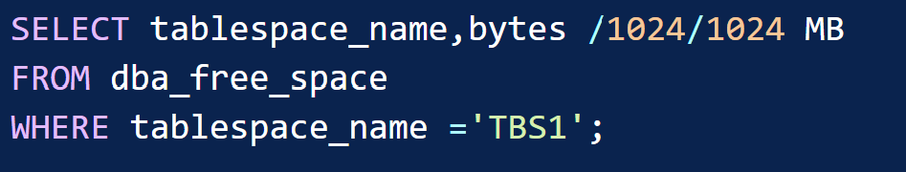

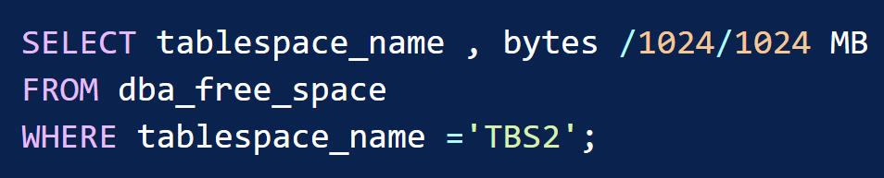

**Explanation:**

* The dba_free_space provided the free space for a particular tablespace.
* Tablespace_name should be in uppercase letters.

In task 7,



**Explanation:**

* Using alter command we can extent the tablespace
* This command will add a datafile to the given path
* Size needs to be mentioned also

In task 8,



**Explanation:**

* Using alter command we can extent the tablespace.
* This command will add a datafile to the given path.
* Size needs to be mentioned also.

In task 9,



**Explanation:**

* Use from dba_ts_quotas
* Apply condition where the username will be in uppercase
* Max_bytes attribute will provide the max size of a particular tablespace

In task 10,

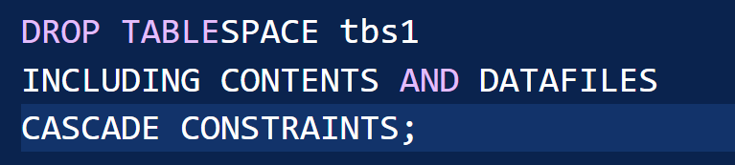

**Explanation:**

* Use drop condition and tablespace name tbs1
* Including contents and datafiles will delete the tablespace and also the datafiles

In task 11,



**Explanation:**

* Use drop condition and tablespace name tbs2
* Including contents keep datafiles will delete the tablespace but the datafiles will not delete the datafiles

**Problems:**

* Task 6 was returning 0 rows while the tablespace name was in lowercase letters.
* Same for task 9 username.
* Using the keep datafiles won’t delete the datafile. But If we force stop oracle and delete the datafile, oracle crashes. It won’t connect to the server. It will show and error that will say oracle is shutting down or in process of another task. But actually oracle can not find the deleted datafile that’s why it crashes and can not start.

**Solution:**

* In database, tablespace and user’s username is saved in uppercase letters.
* For the last problem I had to uninstall oracle, delete registration, environment variable path then reinstall oracle. At last it worked.