K.M. Tahlil Mahfuz Faruk

Islamic University of Technology

Name: K.M. Tahlil Mahfuz Faruk

Student ID: 200042158

Department: CSE(SWE)

Course: CSE 4410

**Database Management System II LAB 4**

**Create tables:**

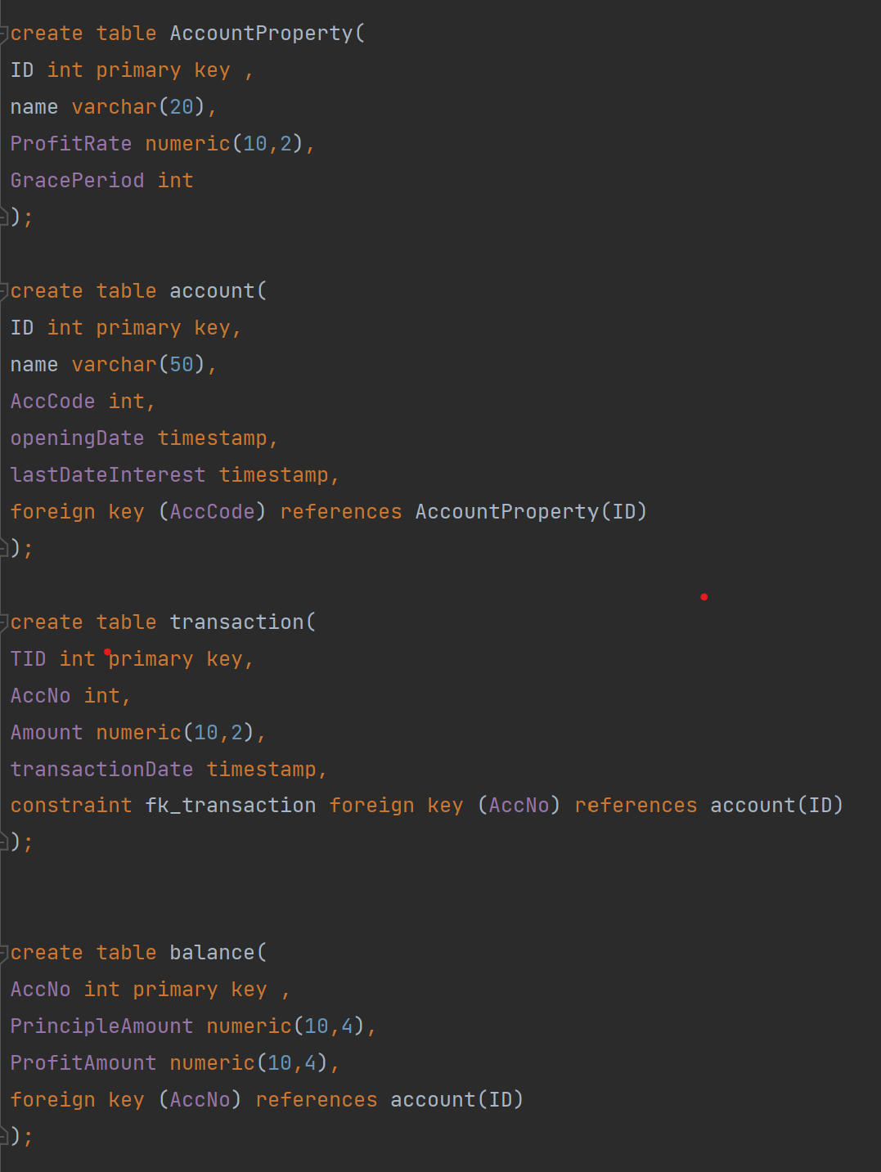 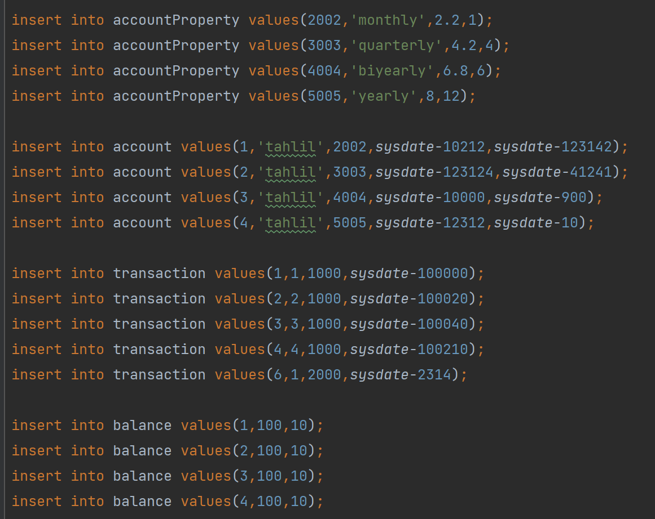

**SQL Commands:**

In task 1,

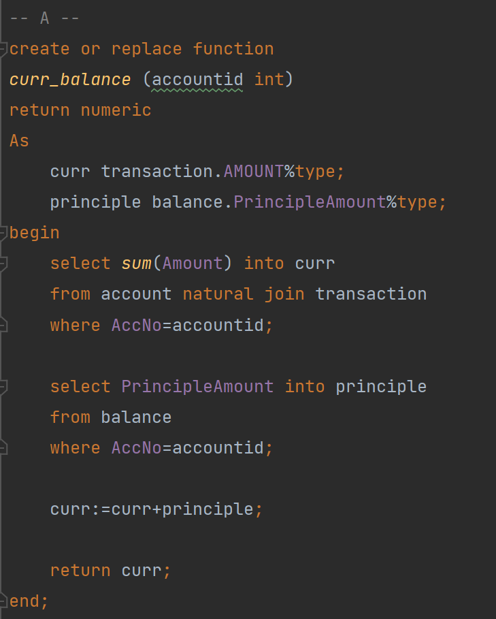

**Explanation:**

* First find the cum of transaction amount that occurred by joining account and transaction.
* Then fetch principle amount from balance in principle variable.
* Just return the sum of principle and the current amount of transaction.

**Difficulties:**

* No significant difficulty appeared.

In task 2,

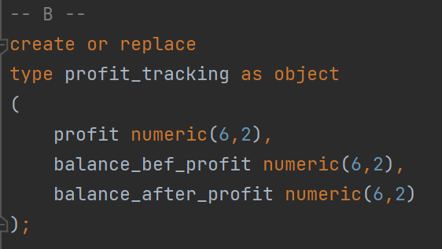

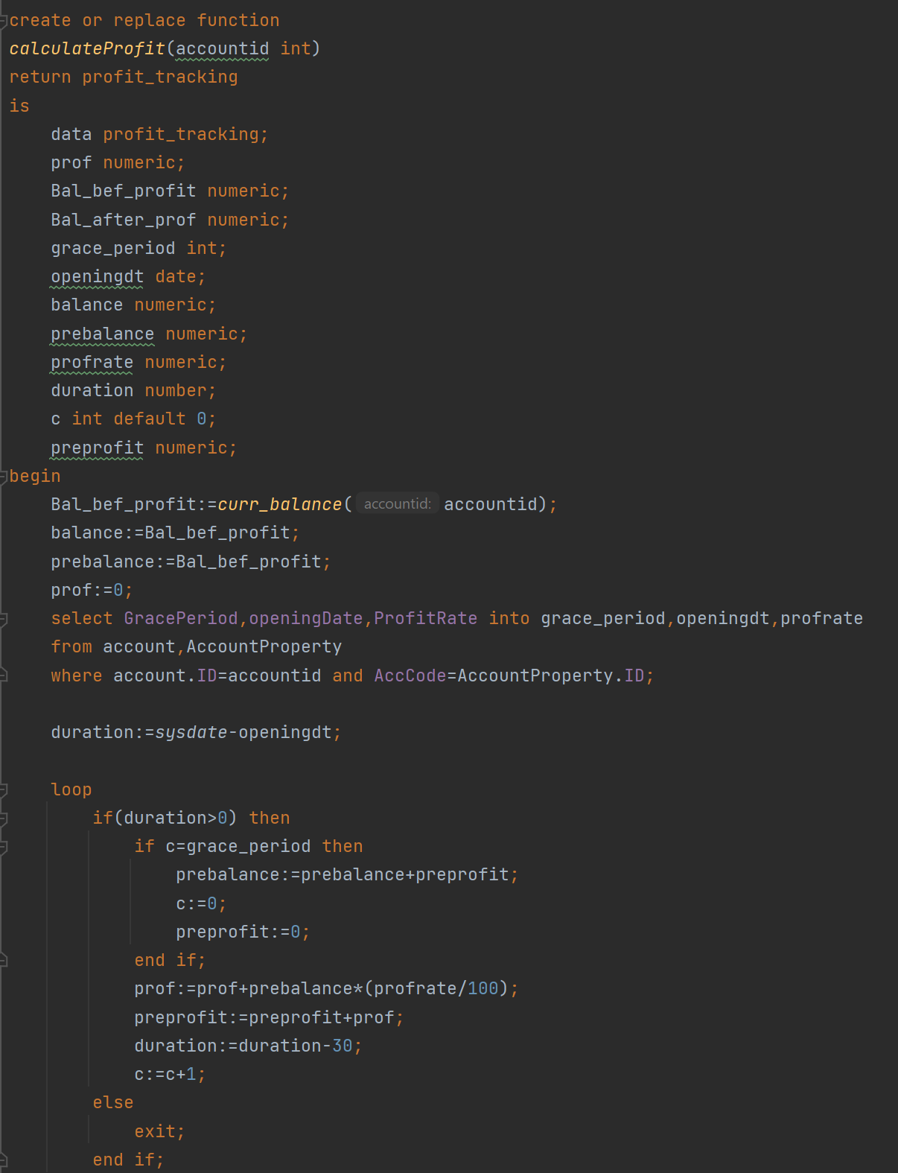

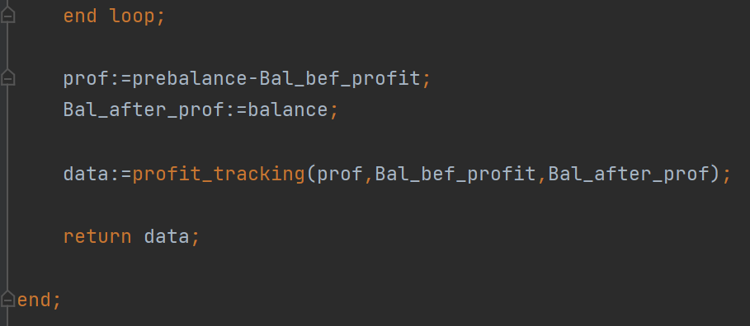

**Explanation:**

* First create profit_tracking as object.
* Find the opening date, grace period and profit rate from account and accountproperty table.
* Then find the duration by substracting the current data and the opening data.
* Then use a for loop until the duration is grater than 0.
* Each time the profit will be calculated in a variable called preprofit.
* After the grace period the profit amount saved int prof variable will be added to prebalance.
* Now save the values into data variable.
* Now send the data variable that is a profit_tracking variable needs to be returned.

**Difficulties:**

* To understand how the profit system works was the main challenge.
* The data variable was not returning if that is not initialized in the shown manner.

In task 3,

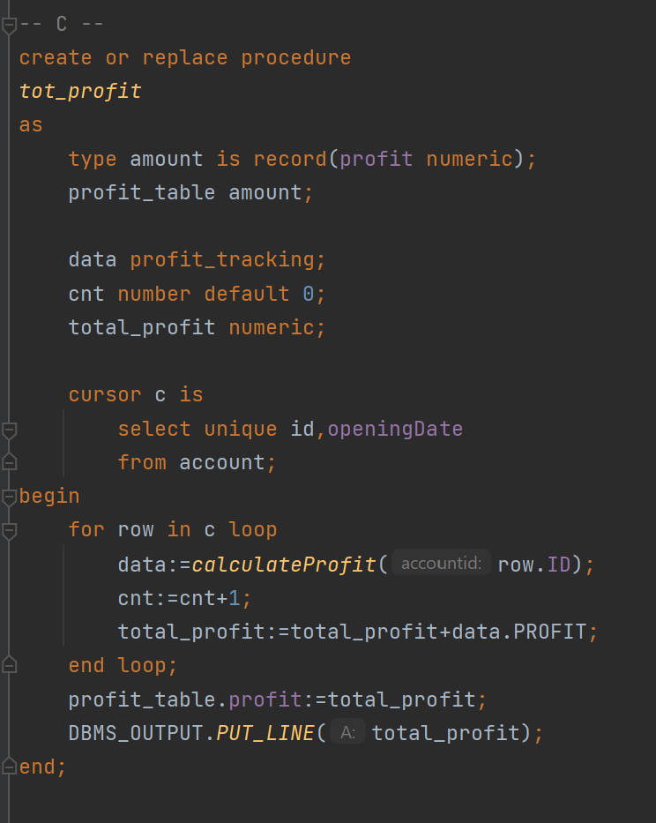

**Explanation:**

* First find the account number from account table.
* Then run a loop calling the calculateProfit function for each account number that will return profit_tracking object.
* Just extract the profit portion for the object and add each time with total_profit variable.
* Output the total_profit variable.

**Difficulties:**

* No such difficulties occurred during the task.