K.M. Tahlil Mahfuz Faruk

Islamic University of Technology

**Insertions:**

Name: K.M. Tahlil Mahfuz Faruk

Student ID: 200042158

Department: CSE(SWE)

Course: CSE 4410

**Database Management System II LAB 7**

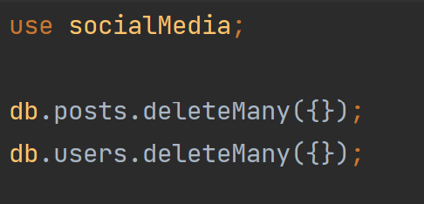

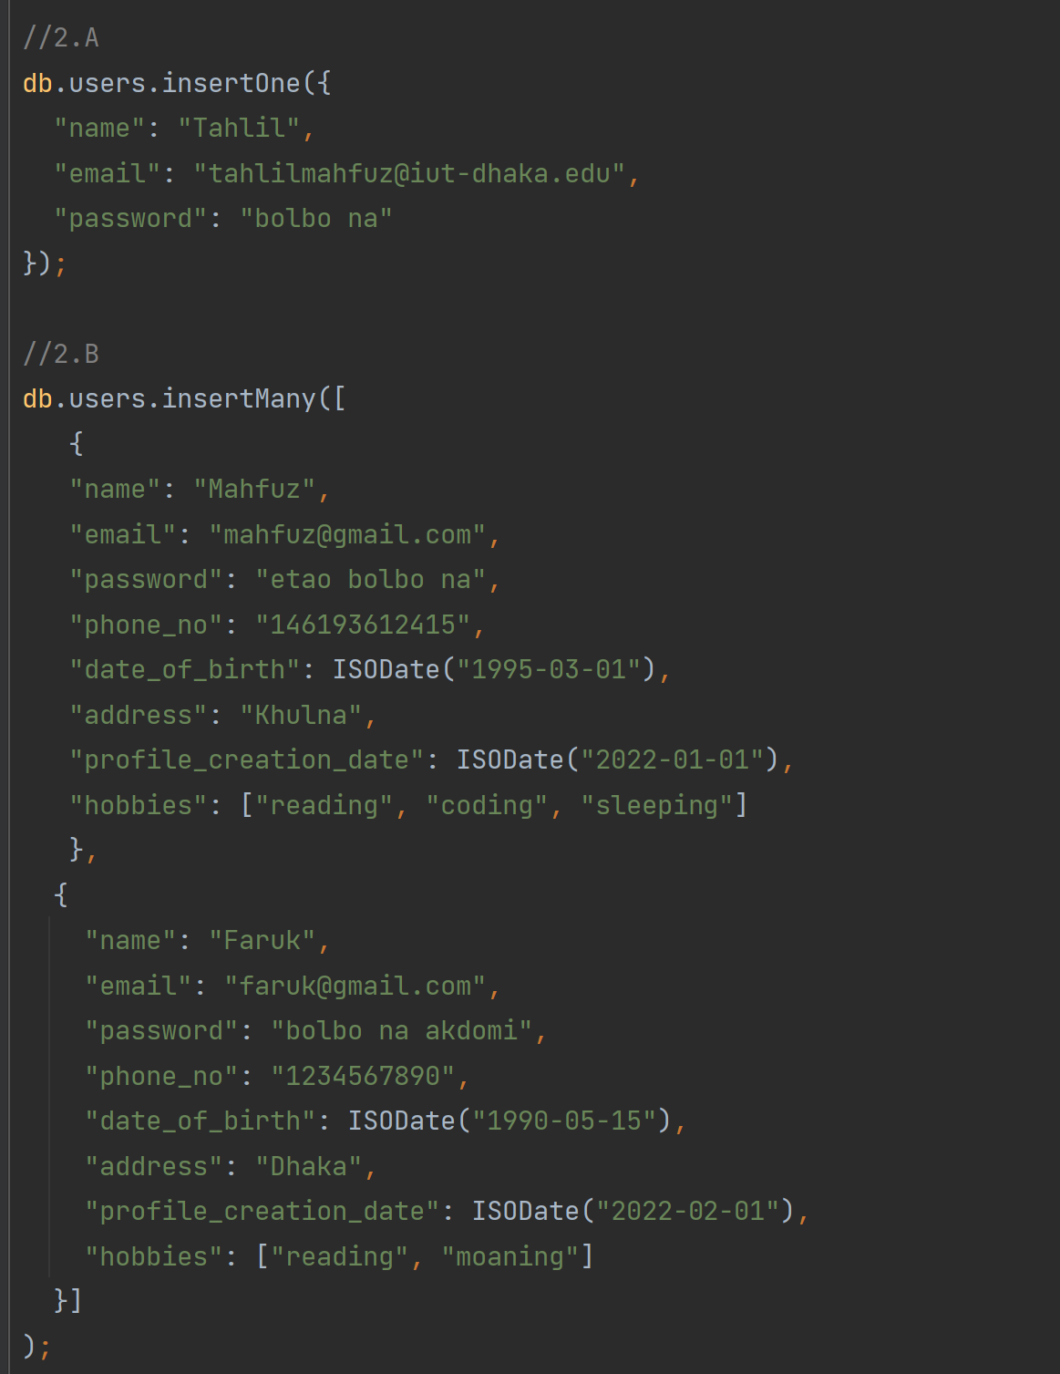

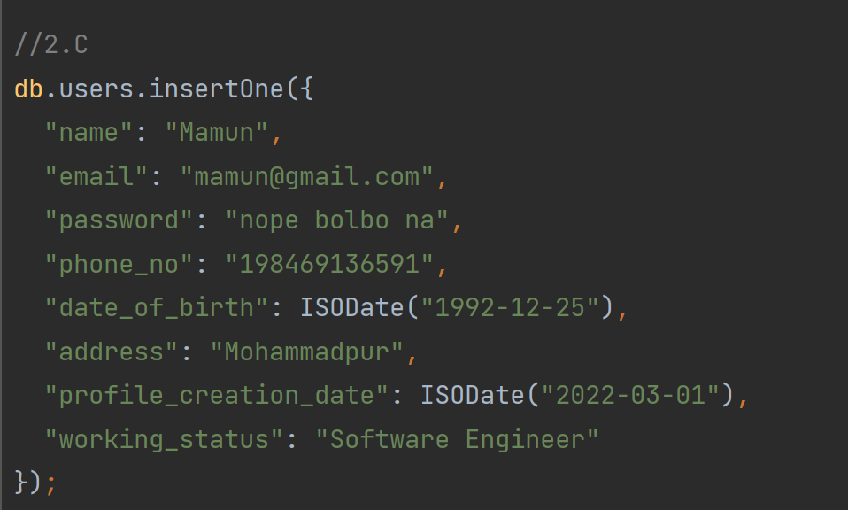

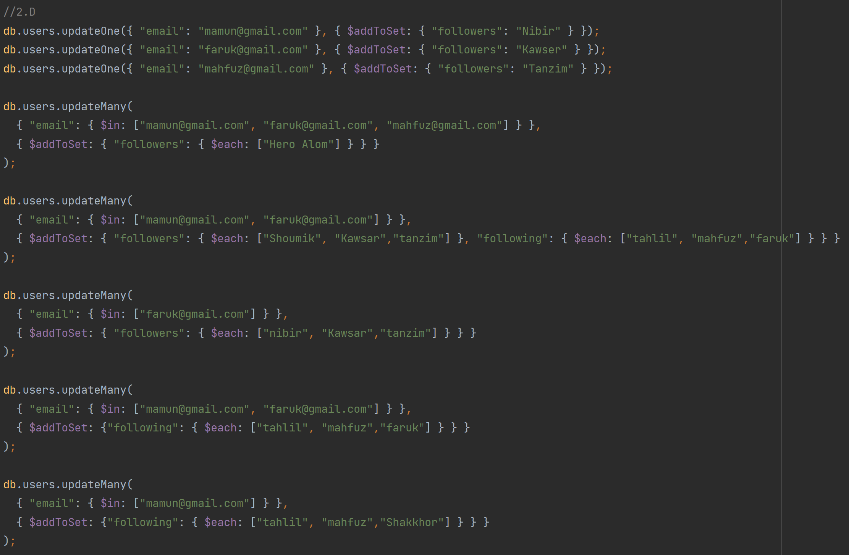

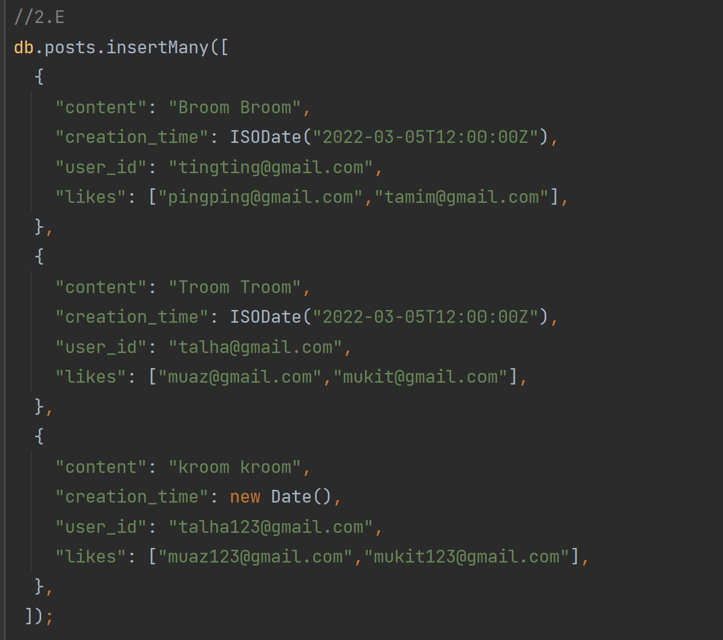

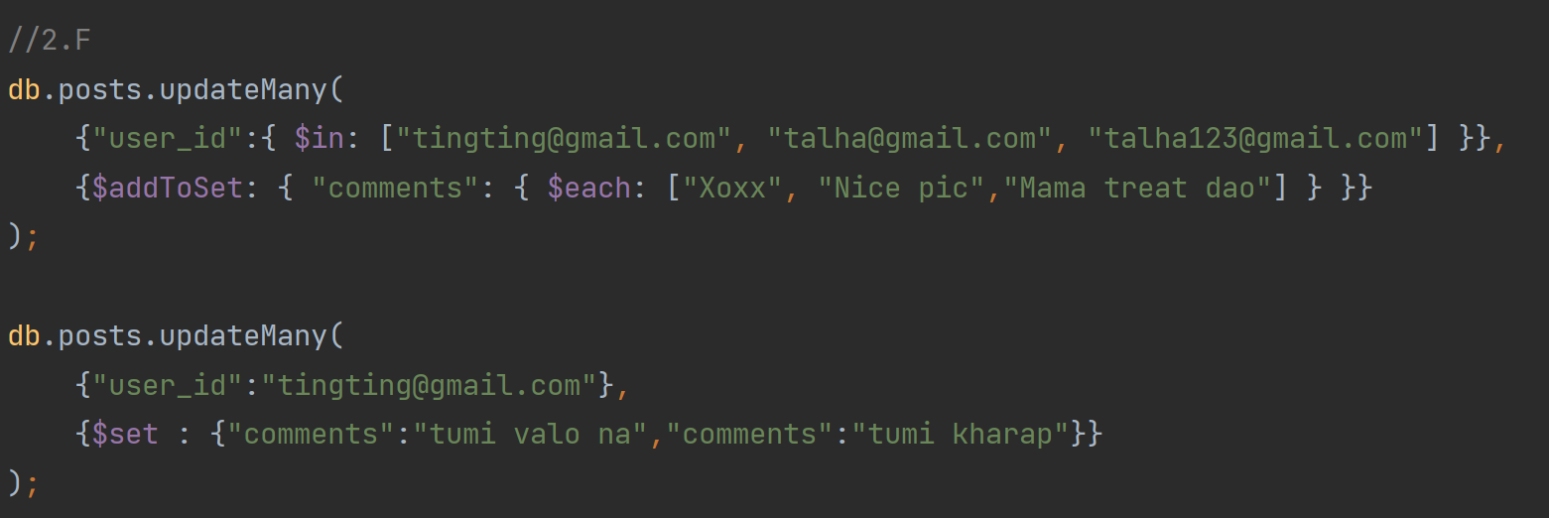

**Queries:**

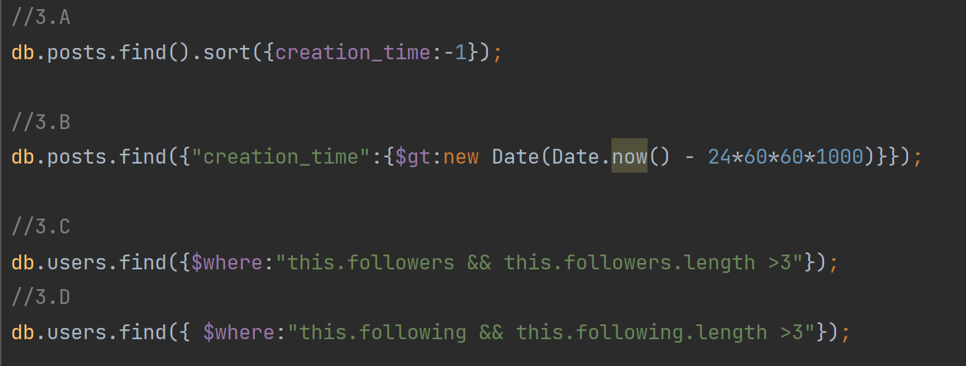

**Query Results:**

**2.A**

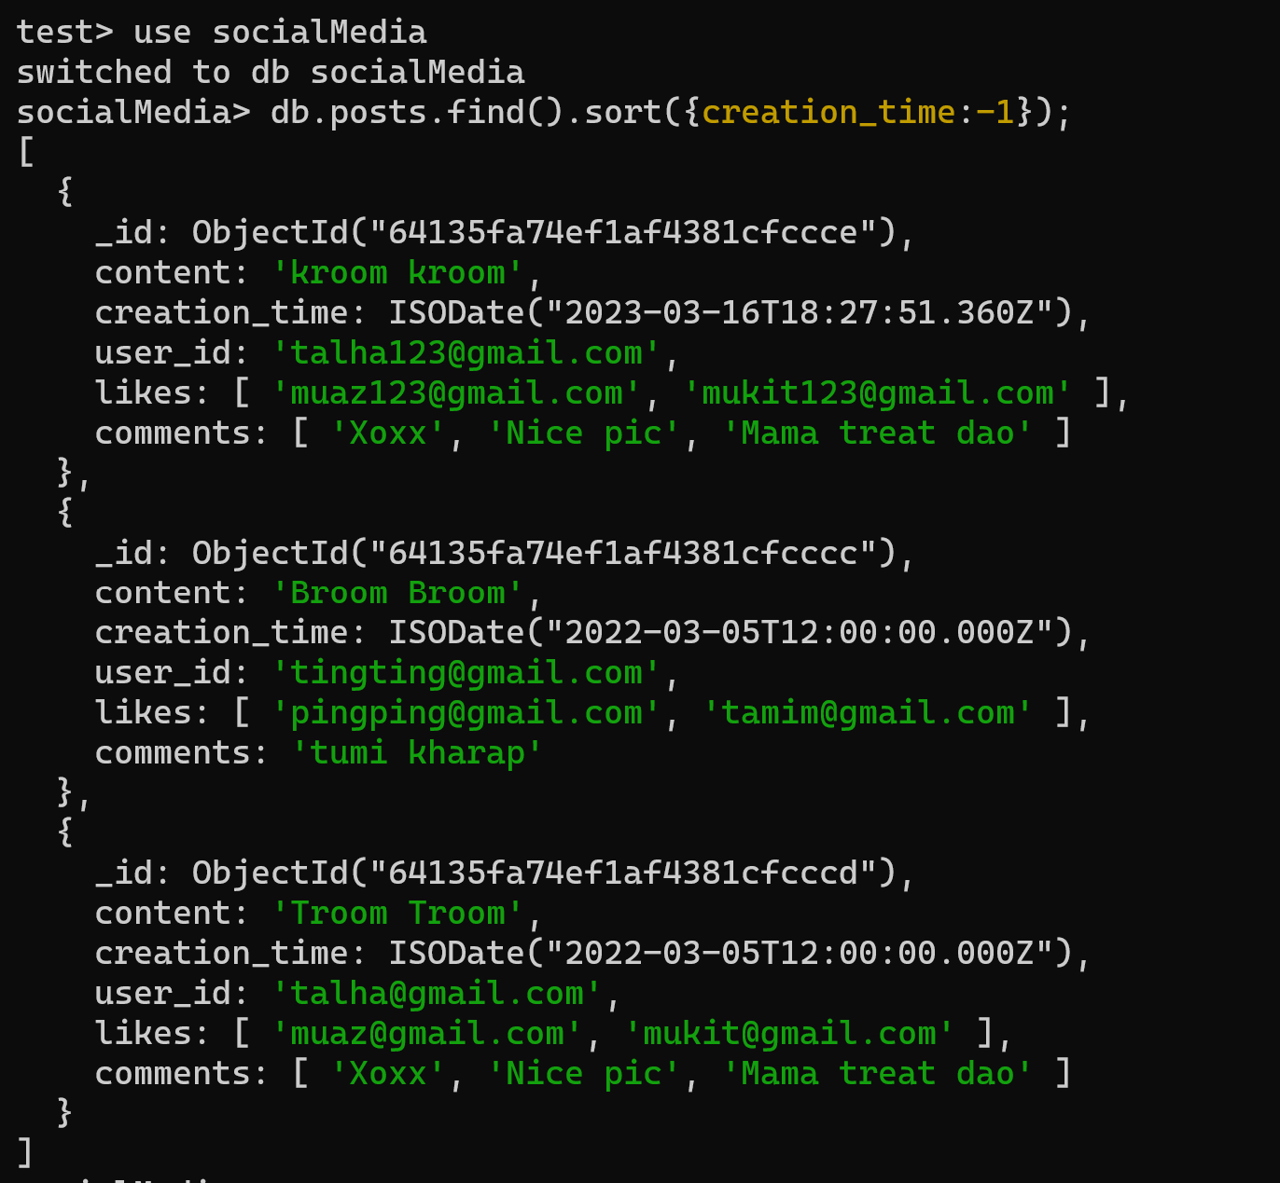

**Explanation:**

Here creation time -1 will return the result according to the creation_time in descending order.

**2.B**

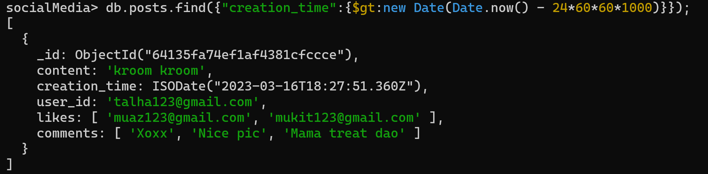

**Explanation:**

Here we used the find() along with sort(). Then we convert it into 24 hour behind from the current date. 1000 needs to be multiplied because the date.now() returns current date on milliseconds. We convert it into seconds by multiplying 1000.

**2.C**

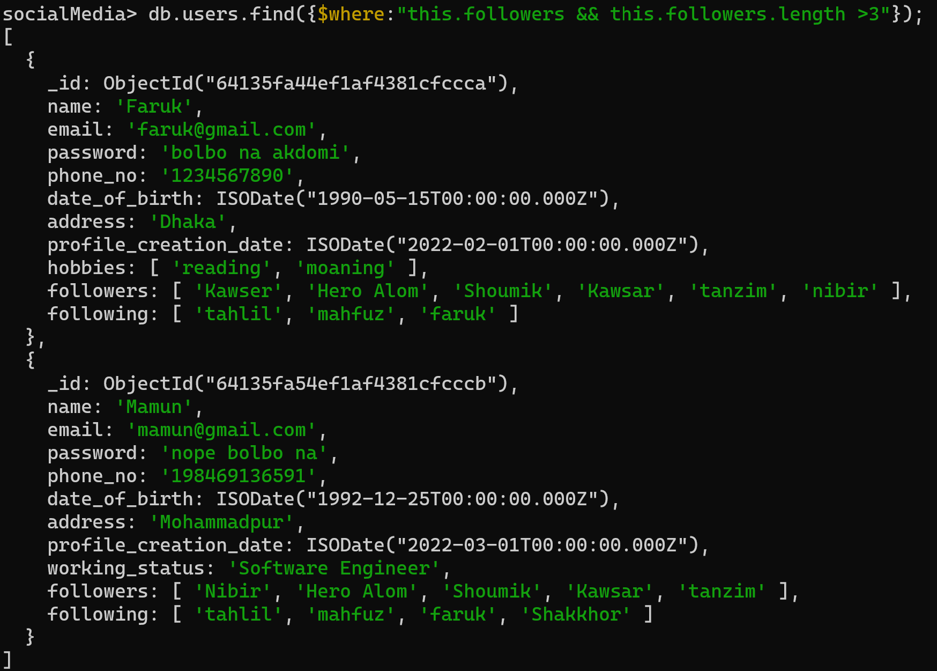

**Explanation:**

Here $where operator is used. This.followers will return the followers in users collection and this.followers > 3 will apply condition on the returned result set.

**2.D**

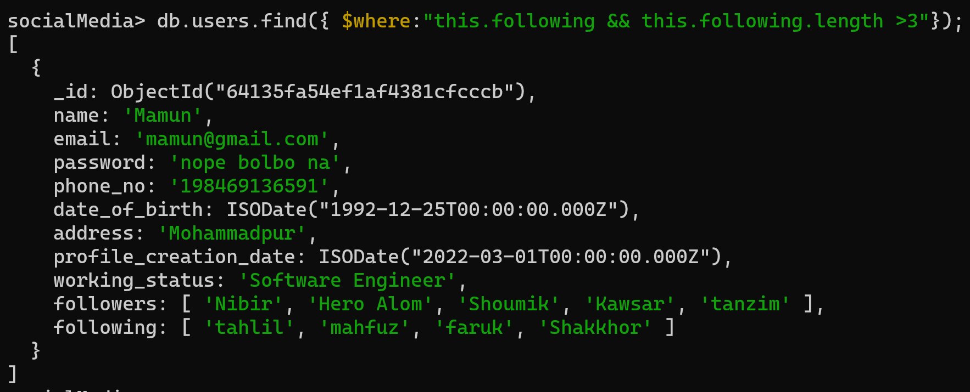

**Explanation:**

Here $where operator is used. This.following will return the followers in users collection and this.following > 3 will apply condition on the returned result set.