K.M. Tahlil Mahfuz Faruk

Islamic University of Technology

Name: K.M. Tahlil Mahfuz Faruk

Student ID: 200042158

Department: CSE(SWE)

Course: CSE 4410

**Database Management System II LAB 9**

**Creation of graph and relationships:** 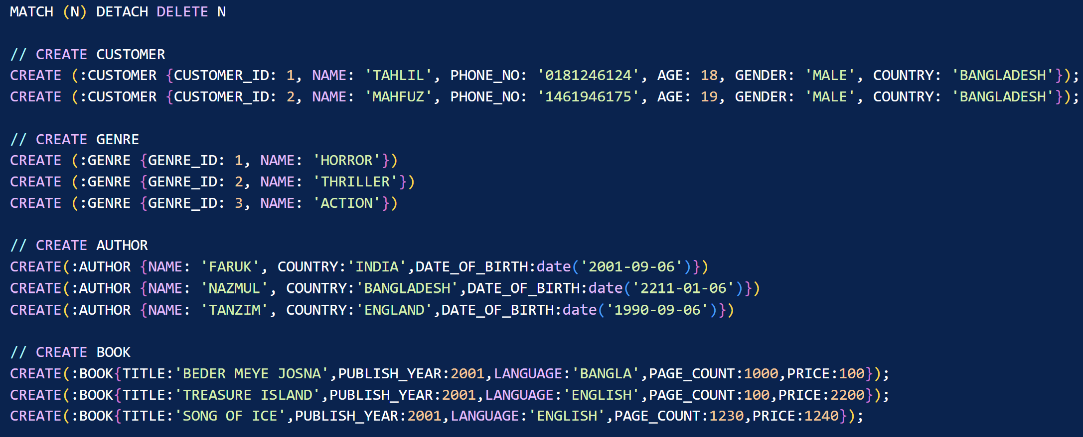

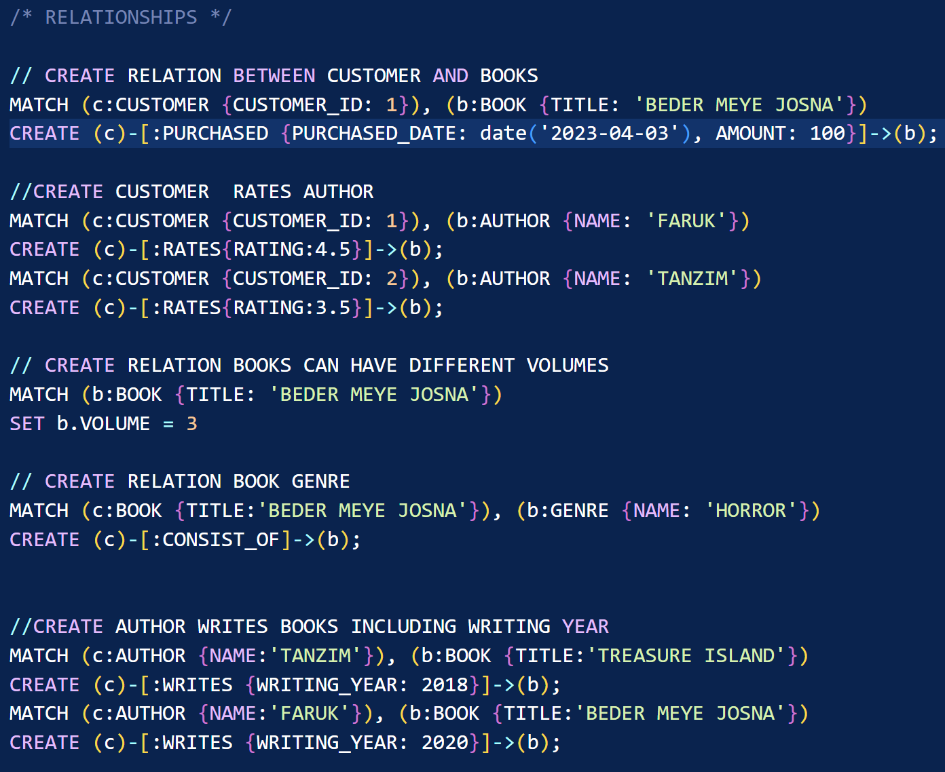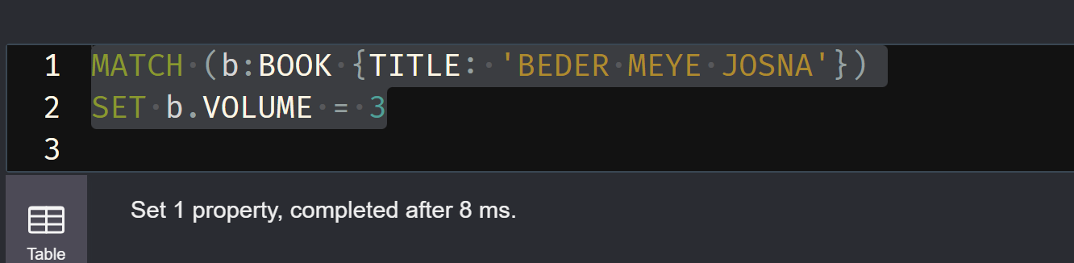

**Queries:**

**A.**

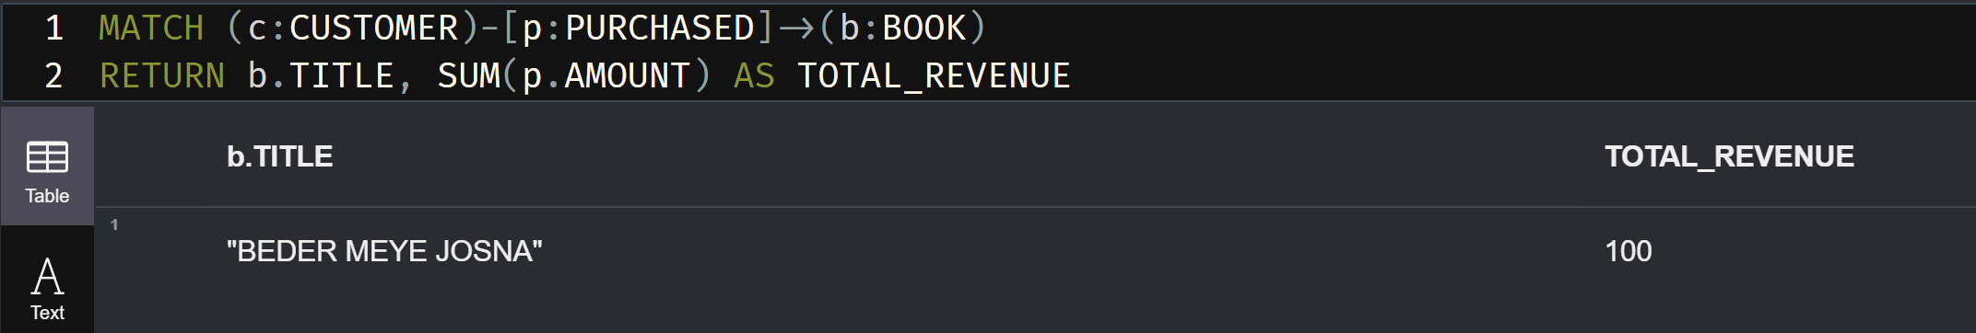

**B.**

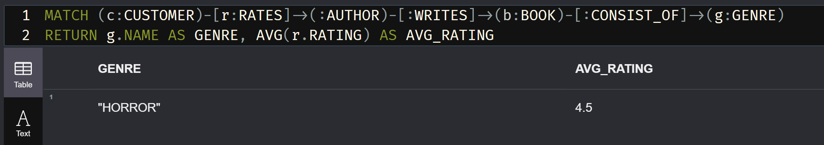**C.**

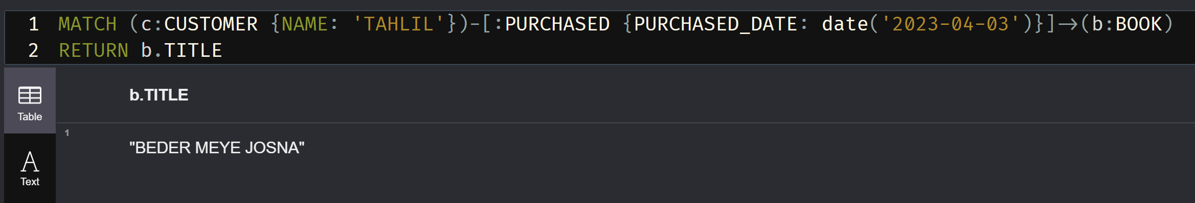

**D.**

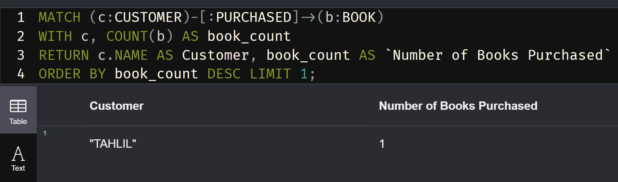

**E.**

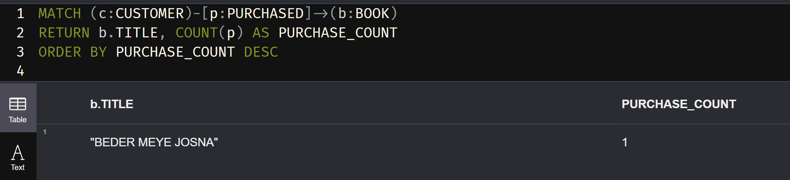

**F.**

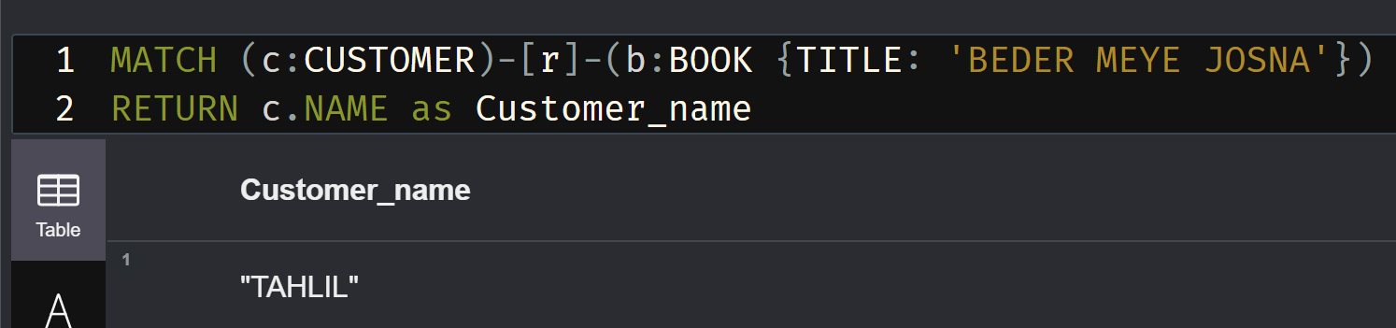

**G.**

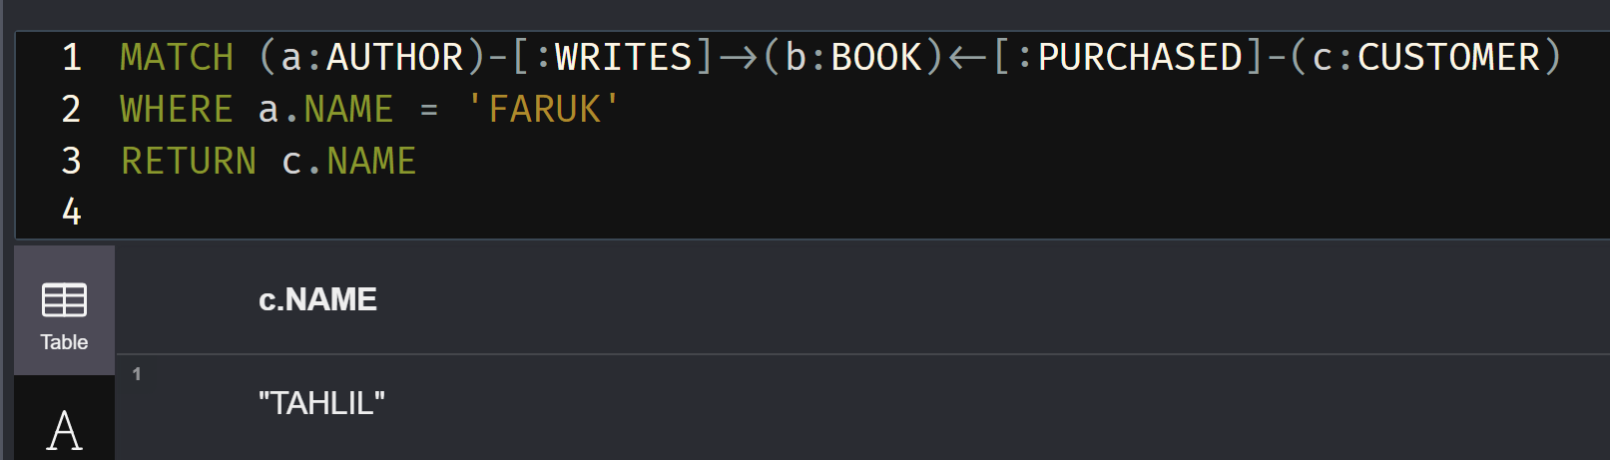

**h.**

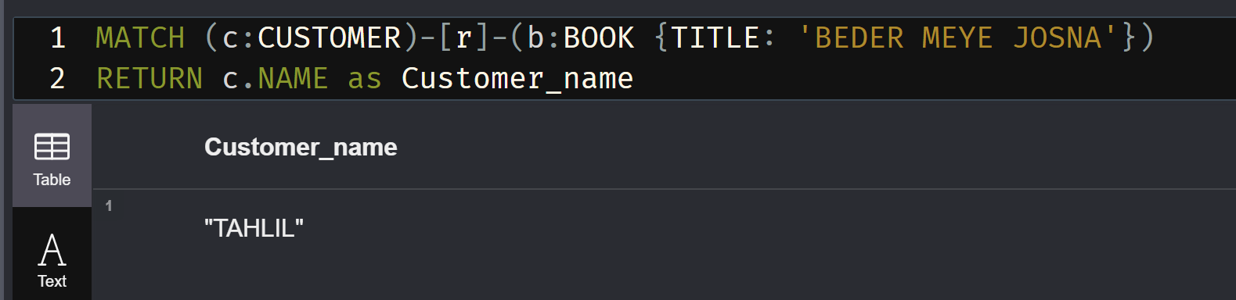

**Graph:**

