Wes Ackerman

Taylor Archibald

Part 1

Figure 1: Probability of a connected graph given ratio of attraction radius (R) to world size (M) [1]

|  |  |  |
| --- | --- | --- |
| **R/M** | **20 agents**  **P(connected)** | **50 agents**  **P(connected)** |
| 0 | 0 | 0 |
| 0.1 | 0 | 0 |
| 0.2 | 0 | 0 |
| 0.3 | 0 | 0 |
| 0.4 | 0 | 0.28 |
| 0.5 | 0.06 | 0.88 |
| 0.6 | 0.26 | 0.97 |
| 0.7 | 0.71 | 1 |
| 0.8 | 0.85 | 1 |
| 0.9 | 0.97 | 1 |
| 1 | 0.98 | 1 |

From the table above, we confirm that increasing the attraction radius or number of agents increases the likelihood our graph is connected.

Figure 2: Probability of a connected graph given ratio of attraction radius (R) to world size (M)

Additionally, as R/M increases[2], we expect every graph to be connected. Similarly, as R/M approaches 0, we expect no graphs to be connected. Consequently, we might try to fit this using some kind of hyperbolic function with asymptotes at 0 and 2. One option is a 4 parameter logistic regression, which in the 20 agent case, gives the equation:

P(connected) = 0.977716 + (0.000421369 - 0.977716)/(1 + ( R/M /0.6507162)^11.43886)

We perform a similar analysis when using a **Nearest Neighbor** approach.

|  |  |  |  |  |  |  |
| --- | --- | --- | --- | --- | --- | --- |
| **Neighbors** | **20 agents** | | | **50 agents** | | |
| **P(connected)** | **Farthest Neighbor** | **Std. Dev.** | **P(connected)** | **Farthest Neighbor** | **Std. Dev.** |
| 1 | 0 | 12.50 | 7.14 | 0.00 | 7.52 | 4.26 |
| 2 | 0.34 | 19.04 | 8.11 | 0.01 | 11.59 | 4.75 |
| 3 | 0.94 | 24.91 | 8.76 | 0.65 | 14.51 | 5.07 |
| 4 | 0.97 | 29.46 | 9.40 | 0.96 | 17.26 | 5.42 |
| 5 | 1 | 33.68 | 10.32 | 0.99 | 19.72 | 5.86 |
| 6 | 1 | 38.15 | 10.38 | 1.00 | 22.15 | 6.01 |
| 7 | 1 | 42.09 | 10.82 | 1.00 | 24.22 | 6.42 |

The equation for 20 agents is:

P(connected) = 0.9947752 + (-0.0007777613 - 0.9947752)/(1 + (**Neighbors**/2.159721)^8.483766)

Connectivity greatly depends on your choice of N or R, and the number of agents. As the number of agents increases in the metric model, so does the likelihood the graph is connected. As we might expect, we observe the opposite effect for Nearest Neighbor.

To the extent Nearest Neighbor generates connected graphs more often (for small numbers of agents), it is probably linked with the fact that we implicitly require some degree of connectivity, as even remote agent have N neighbors. With lots of agents, this works against connectivity, because we may have extremely proximate agents, but only the nearest N are connected.

Part 2

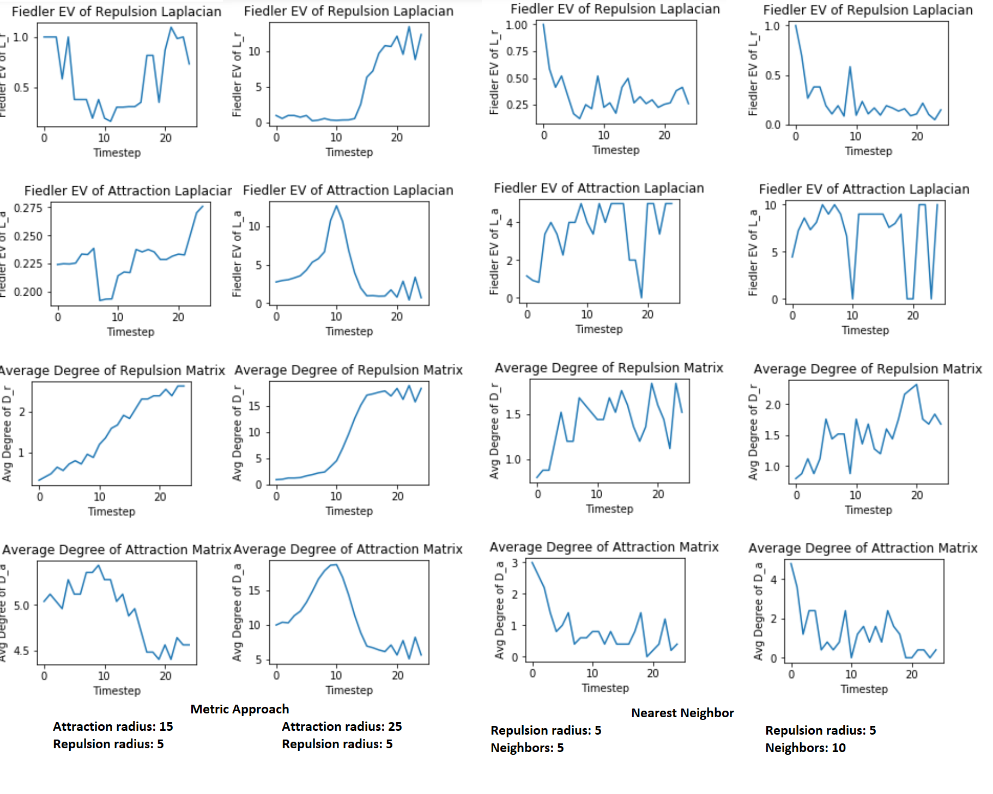

The difference between the two methods is that in the metric approach, an agent is attracted to or repulsed by all agents within a certain radius, as opposed to only the nearest N. Consequently, we might expect to see the average degree of the attraction matrix initially increasing through time in the metric approach as agents cluster near each other; as agents get too close (in the repulsion zone), we might expect this value to taper off. Similarly, the repulsion matrix might see higher degrees as agents cluster and are more connected. As the system coalesces, the repulsion connectivity increases, and we might expect the repulsion Fiedler eigen values to increase.

With the topological approach, the degree of the repulsion and attraction matrices are bounded to be at most the number of neighbors. Because the connectivity of the graph never increases beyond a certain threshold, the Fiedler eigen values similarly won’t increase beyond a certain amount. Whereas in the metric version, we saw that agents’ attraction to other agents could over-power their repulsion criterion, in the nearest neighbor version, agents keep their distance, since they are iteratively either moving toward or away from their neighbors (as soon as a neighbor is too close, it starts moving away). Interestingly, the group tends to repel or attract at the same time—this makes sense, given that if 2 agents move too close in one timestep, both agents will be repelling in the next. Consequently, the Fielder eigen values and degrees are more variable/jagged. As the agents converge spatially, they are more likely to bouncing away from other agents than being attracted to them, which explains the decreasing attraction degree and increasing repulsion.

1. 100 trials. M is ½ the world size since it spans from -M to M.
2. Approaches 2√2