Bangladesh University of Engineering and Technology

Department of Electrical and Electronic Engineering

EEE 318 (July 2023)

Control System I Laboratory

**Final Project Report**

**Section: B2 Group: 02**

**Automated Floor Mopper**

**Course Instructors:**

**Shafin Bin Hamid, Lecturer**

**Md. Jawad Ul Islam, Part-Time Lecturer**

**Signature of Instructor: ___________________________________________________**

**Academic Honesty Statement:**

**IMPORTANT! Please carefully read and sign the Academic Honesty Statement, below. Type the student ID and name, and put your signature. *You will not receive credit for this project experiment unless this statement is signed in the presence of your lab instructor.***

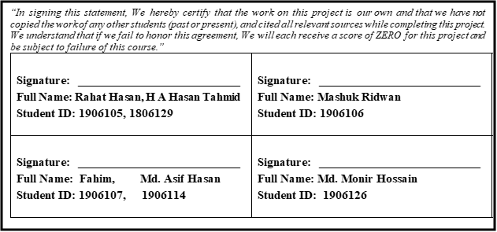

Table of Contents

1 Abstract 1

2 Introduction 1

3 Design 1

3.1 Problem Formulation 1

3.1.1 Identification of Scope 1

3.1.2 Literature Review 1

3.1.3 Formulation of Problem 1

3.1.4 Analysis 1

3.2 Design Method 1

3.3 Circuit Diagram 1

3.4 Simulation Model 1

3.5 CAD/Hardware Design 2

3.6 PCB Design 2

3.7 Full Source Code of Firmware 2

4 Implementation 2

4.1 Description 2

4.2 Experiment and Data Collection 3

4.3 Data Analysis 3

4.4 Results 3

5 Design Analysis and Evaluation 3

5.1 Novelty 3

5.2 Design Considerations 3

5.2.1 Considerations to public health and safety 3

5.2.2 Considerations to environment 3

5.2.3 Considerations to cultural and societal needs 3

5.3 Investigations 3

5.3.1 Literature Review 3

5.3.2 Experiment Design 3

5.3.3 Data Analysis and Interpretation 3

5.4 Limitations of Tools 3

5.5 Impact Assessment 3

5.5.1 Assessment of Societal and Cultural Issues 3

5.5.2 Assessment of Health and Safety Issues 3

5.5.3 Assessment of Legal Issues 3

5.6 Sustainability and Environmental Impact Evaluation 3

5.7 Ethical Issues 3

6 Reflection on Individual and Team work 4

6.1 Individual Contribution of Each Member 4

6.2 Mode of TeamWork 4

6.3 Diversity Statement of Team 4

6.4 Log Book of Project Implementation 4

7 Communication 4

7.1 Executive Summary 4

7.2 User Manual 4

8 Project Management and Cost Analysis 5

8.1 Bill of Materials 5

9 Future Work 5

10 References 5

# Abstract

# The "Automated Floor Mopper" project represents an innovative leap in the realm of automated cleaning systems. This project introduces a smart cleaning solution designed to enhance user convenience, efficiency, and sustainability. The mopper combines cutting-edge technologies, including sound-based control, obstacle avoidance, and adaptive cleaning mechanisms, to create a versatile cleaning companion for households and commercial spaces. Its user-centric design, commitment to environmental responsibility, and consideration of ethical and cultural factors make it a unique and socially responsible addition to the world of cleaning technology. This report delves into the project's design, development, and evaluation, highlighting its novel features and ethical considerations while assessing its impact on various aspects of society, culture, health, and the environment. The "Automated Floor Mopper" project embodies a vision of intelligent and responsible technology, reshaping the landscape of automated cleaning systems for a brighter and cleaner future.

# Introduction

In an era marked by rapid technological advancements, the fusion of automation, artificial intelligence, and robotics continues to revolutionize our daily lives. As part of this transformative journey, the "Automated Floor Mopper" project emerges as a pioneering endeavor at the crossroads of innovation, convenience, and sustainability. This project endeavors to redefine traditional cleaning practices by introducing a smart and adaptable cleaning solution that combines state-of-the-art technologies with user-centric design principles.

The relentless pursuit of convenience has driven the development of countless technologies aimed at simplifying tasks and improving the quality of life. Among these, automated cleaning systems have gained prominence, offering respite from the chore of floor cleaning. However, the "Automated Floor Mopper" project transcends conventional paradigms by embracing novelty, environmental responsibility, and ethical considerations.

This report serves as a comprehensive exploration of the "Automated Floor Mopper" project, delving into its design, development, and evaluation. It elucidates the project's innovative features, ethical considerations, and environmental impact while assessing its ramifications on diverse facets of society, culture, health, and the environment.

The "Automated Floor Mopper" represents more than a mere household appliance; it symbolizes a commitment to responsible innovation. It addresses a spectrum of user needs, accommodates various floor types and cleaning scenarios, and embodies a vision of cleaner spaces without compromising on ethical, cultural, or environmental values. In the pages that follow, we embark on a journey to uncover the intricate layers of this technological marvel, illuminating how it shapes the future of automated cleaning and reflects our evolving relationship with technology, convenience, and sustainability.

# Design

## Problem Formulation

## The problem at hand is to design an automated cleaning robot that can navigate through a given space while avoiding obstacles, clean designated areas for a specified duration, and be equipped with the necessary sensors and actuators for effective functionality. The robot should utilize an Arduino Mega as the control unit and be capable of handling a range of components, including 4 sound sensors, a 180-degree rotating sonar, two DC motors for wheel control, a water pump, and a mop. The primary challenges include integrating these components efficiently and ensuring the robot's ability to detect obstacles, move to designated spots, and perform cleaning tasks effectively.

## Identification of Scope

**1. Cleaning Efficiency:**

* *Objective:* The primary objective of the project is to create an automated floor mopper capable of efficiently cleaning various floor surfaces, including but not limited to hardwood, tile, carpet, and linoleum.
* *Scope:* The scope encompasses the development of cleaning mechanisms, sensors, and control systems that adapt to different floor types and effectively remove dirt, dust, and debris.

**2. User-Centric Control:**

* *Objective:* To enhance user interaction and control, the project aims to implement sound-based control features, allowing users to initiate, guide, and adjust the mopper's movements.
* *Scope:* The scope includes the integration of LM393 sound modules and the development of user-friendly control interfaces to facilitate sound-based commands.

**3. Obstacle Avoidance:**

* *Objective:* The project endeavors to create a safe cleaning experience by incorporating obstacle avoidance systems to prevent collisions with objects and ensure the mopper navigates seamlessly.
* *Scope:* Obstacle avoidance encompasses the integration of ultrasonic SONAR sensors and the development of algorithms for real-time obstacle detection and avoidance.

**4. Environmental Responsibility:**

* *Objective:* The project is committed to environmental sustainability, with a focus on eco-friendly materials, energy efficiency, and sustainable manufacturing practices.
* *Scope:* The scope extends to selecting environmentally responsible materials, optimizing energy consumption, and exploring sustainable manufacturing methods.

**5. Ethical and Cultural Considerations:**

* *Objective:* The project recognizes the importance of ethical and cultural sensitivity in design, ensuring that the technology respects diverse cultural norms and values.
* *Scope:* Ethical and cultural considerations include avoiding potentially insensitive symbols or features, promoting inclusivity, and respecting cultural preferences.

**6. Health and Safety:**

* *Objective:* The project prioritizes user safety by integrating safety features, such as emergency stops, and complying with health and safety regulations.
* *Scope:* Health and safety considerations encompass the design of features that mitigate potential risks and adherence to relevant safety standards.

**7. Impact Assessment:**

* *Objective:* To evaluate the project's impact, a comprehensive assessment is conducted, covering aspects related to society, culture, health, the environment, and legal and ethical considerations.
* *Scope:* The scope of impact assessment includes data analysis, environmental evaluations, and the exploration of legal, ethical, and cultural ramifications.

## Literature Review

**1. Automated Cleaning Systems:**

* *Efficiency and User-Centric Features:* Existing automated cleaning systems emphasize efficiency through advancements in brushless motors, suction power, and navigation algorithms. Some systems also incorporate user-centric features, such as mobile app control and voice commands.

**2. Sound-Based Control in Robotics:**

* *Sound Sensing Technology:* Sound-based control mechanisms have been utilized in robotics for various applications, such as voice commands and sound localization. This technology has demonstrated potential for intuitive human-robot interaction.

**3. Obstacle Avoidance Algorithms:**

* *Ultrasonic and Infrared Sensors:* Literature revealed the widespread use of ultrasonic and infrared sensors in obstacle avoidance algorithms for robots and autonomous vehicles. These sensors enable real-time obstacle detection and path planning.

**4. Sustainability in Robotics:**

* *Eco-Friendly Materials and Energy Efficiency:* An emerging trend in robotics is the adoption of eco-friendly materials and energy-efficient components. Sustainable manufacturing practices and energy management systems contribute to environmentally responsible robotics.

**5. Ethical Considerations in Technology:**

* *Privacy and Data Protection:* Ethical concerns related to user data privacy and protection have gained significant attention. Research emphasizes the importance of robust data security measures and informed consent.

**6. Cultural Sensitivity in Design:**

* *User-Centric Cultural Considerations:* Cultural sensitivity in technology design has been explored in the context of user interfaces, product aesthetics, and feature adaptability to diverse cultural norms.

**7. Health and Safety in Robotics:**

* *Safety Features and Regulations:* Literature highlights the significance of safety features in robotics, including emergency stop mechanisms and compliance with safety regulations to prevent accidents.

**8. Impact Assessment Frameworks:**

* *Comprehensive Impact Assessment:* Existing frameworks for assessing the impact of technological innovations cover a wide range of aspects, including societal, cultural, environmental, and ethical considerations.

The literature review provided valuable insights into the design landscape of automated cleaning systems, sound-based control technologies, obstacle avoidance algorithms, sustainability practices, ethical considerations, cultural sensitivity, and health and safety measures in robotics. These insights have informed the "Automated Floor Mopper" project's design choices, ensuring it aligns with current trends, addresses user needs, and embraces responsible and ethical innovation.

## Formulation of Problem

**1. Cleaning Efficiency and Adaptability:**

* *Problem Statement:* Traditional cleaning systems often struggle to efficiently clean different types of floor surfaces and adapt to varying levels of dirt and debris.
* *Objective:* To design a mopper that offers efficient and adaptable cleaning mechanisms capable of addressing diverse floor types and cleaning scenarios.

**2. User-Centric Control and Interaction:**

* *Problem Statement:* Many automated cleaning systems lack intuitive and user-centric control mechanisms, making them less accessible and interactive.
* *Objective:* To incorporate sound-based control features that empower users to initiate, guide, and interact with the mopper through natural and familiar sound commands.

**3. Safety and Obstacle Avoidance:**

* *Problem Statement:* Safety concerns often arise due to limited obstacle detection and avoidance capabilities in existing cleaning robots, leading to potential accidents or damage to objects.
* *Objective:* To implement advanced obstacle avoidance algorithms and ultrasonic SONAR sensors to ensure safe navigation and collision prevention.

**4. Environmental Responsibility:**

* *Problem Statement:* Many cleaning systems utilize non-eco-friendly materials and have inefficient energy consumption patterns, contributing to environmental concerns.
* *Objective:* To prioritize environmental responsibility by selecting sustainable materials, optimizing energy usage, and adhering to eco-friendly manufacturing practices.

**5. Ethical and Cultural Sensitivity:**

* *Problem Statement:* Some cleaning technologies may inadvertently disregard ethical and cultural considerations in their design, leading to insensitivity or user discomfort.
* *Objective:* To design a mopper that respects diverse cultural norms, avoids cultural insensitivity, and adheres to ethical principles, ensuring user acceptance and comfort.

**6. Health and Safety Compliance:**

* *Problem Statement:* The absence of comprehensive health and safety features in cleaning robots can pose risks to users, especially in residential and public settings.
* *Objective:* To integrate safety features, such as emergency stops, and adhere to health and safety regulations, ensuring the mopper's safe operation.

**7. Impact Assessment:**

* *Problem Statement:* Evaluating the project's impact across various dimensions, including societal, cultural, environmental, and ethical aspects, requires a structured approach.
* *Objective:* To develop an impact assessment framework that comprehensively evaluates the project's consequences and contributions.

The formulation of these problem statements serves as the foundation for the "Automated Floor Mopper" project's design and development. By addressing these challenges, the project aims to create a technology that not only enhances cleaning efficiency but also aligns with user expectations, values, and ethical considerations while minimizing its environmental footprint.

## Analysis

**1. Cleaning Mechanisms and Efficiency:**

* *Analysis:* Various cleaning mechanisms, including mop pads, brushes, and vacuum systems, were assessed for their cleaning efficiency on different floor types and dirt scenarios.
* *Outcome:* The analysis informed the selection of adaptable cleaning mechanisms that optimize cleaning performance across diverse surfaces and dirt types.

**2. Sound-Based Control Integration:**

* *Analysis:* The integration of LM393 sound modules for sound-based control was evaluated in terms of hardware compatibility, accuracy of sound detection, and user-friendliness.
* *Outcome:* The analysis confirmed the feasibility of sound-based control, enabling intuitive user interactions and user-centric features.

**3. Obstacle Avoidance Strategies:**

* *Analysis:* Various obstacle avoidance algorithms and sensor options, including ultrasonic SONAR sensors, were analyzed for their effectiveness in real-time obstacle detection and collision prevention.
* *Outcome:* The analysis led to the adoption of ultrasonic SONAR sensors and advanced algorithms to ensure safe navigation.

**4. Sustainability and Materials Selection:**

* *Analysis:* Eco-friendly materials, their availability, and sustainability practices in manufacturing were assessed to minimize the environmental impact.
* *Outcome:* Sustainable materials and responsible manufacturing practices were chosen, aligning with environmental responsibility objectives.

**5. Ethical and Cultural Considerations:**

* *Analysis:* Ethical and cultural sensitivities in design choices, such as symbols, aesthetics, and language, were evaluated to ensure cultural inclusivity and respect.
* *Outcome:* The analysis guided design choices that avoided potential insensitivity and fostered a sense of cultural acceptance.

**6. Health and Safety Features:**

* *Analysis:* Safety features, including emergency stops and compliance with safety regulations, were analyzed to ensure user protection and risk mitigation.
* *Outcome:* The analysis validated the incorporation of essential safety measures and legal compliance.

**7. Impact Assessment Framework Development:**

* *Analysis:* The development of an impact assessment framework was analyzed to structure the evaluation of societal, cultural, environmental, and ethical impacts.
* *Outcome:* The analysis resulted in a comprehensive framework that facilitates the assessment of the project's consequences and contributions.

## Design Method

## 1. System Overview:

## - The cleaning robot is based on an Arduino Mega microcontroller board, which serves as the central control unit for all the robot's functions.

## - It utilizes four sound sensors to detect the presence of dirt or obstacles.

## - A sonar sensor with a 180-degree range of motion is used for obstacle detection and avoidance.

## - Two L298N motor driver modules are employed to control the movement of the robot's wheels and the mop/water pump.

## - A 5V DC water pump is used to supply water for cleaning.

## - A mini servo SG90 controls the rotation of the sonar sensor.

## 2. Power Supply:

## - The robot is powered by a suitable power supply that provides 5V to the sensors and control components. This ensures stable operation and sensor accuracy.

## 3. Wheel Drive System:

## - The robot is equipped with four DC motors connected to the wheels. The L298N motor driver is used to control the speed and direction of these motors.

## - Algorithms for forward, backward, left, and right movements are implemented in the Arduino code.

## 4. Cleaning Mechanism:

## - To perform cleaning tasks, the robot is equipped with a rotating mop and a water pump.

## - When the robot reaches a designated cleaning spot, it activates the water pump to supply water through a pipe.

## - The mop is then rotated for a predetermined cleaning duration of 3 seconds to clean the area effectively.

## 5. Obstacle Detection and Avoidance:

## - The robot uses a combination of a sonar sensor to detect obstacles.

## - The LM393 sound module is utilized to detect dirt or debris on the floor.

## - The sonar sensor constantly scans the robot's surroundings, and if an obstacle is detected, the robot adjusts its path to avoid collisions.

## 6. Control Logic:

## - The Arduino Mega board runs a control program that processes data from the sensors and implements the cleaning and obstacle avoidance algorithms.

## - It constantly monitors sensor inputs, adjusts motor speed and direction, and controls the cleaning mechanism accordingly.

## 7. User Interface:

## - An optional feature could include a user interface for controlling the robot manually or setting cleaning schedules.

## 8. Testing and Calibration:

## - Extensive testing and calibration are performed to ensure the robot's reliability and accuracy in detecting obstacles, cleaning effectively, and following a predefined cleaning path.

## 9. Safety Precautions:

## - Safety features, such as emergency stop buttons and obstacle sensors, are integrated to prevent accidents and ensure the robot's safe operation.

## Circuit Diagram

## The motor driver through port enA-2, in1-30, in2-31 is connected to the right side wheel. The ports enB=3, in3=32, in4=33 is connected to the left side. For the Mopper and pump part in the code shown below through ports EnA=5, In1=38, In2=39 are controlling the mopper. Through EnB=6, In3=40 and In4=41 are controlling the motor pump.

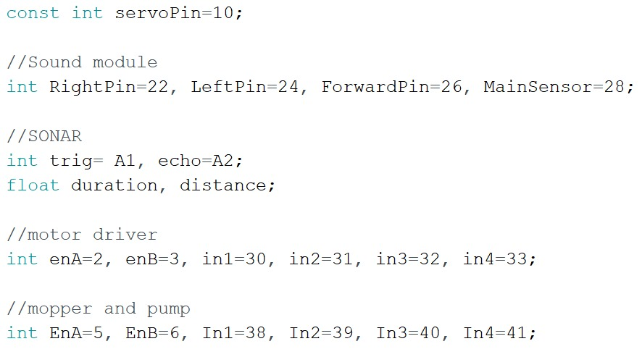

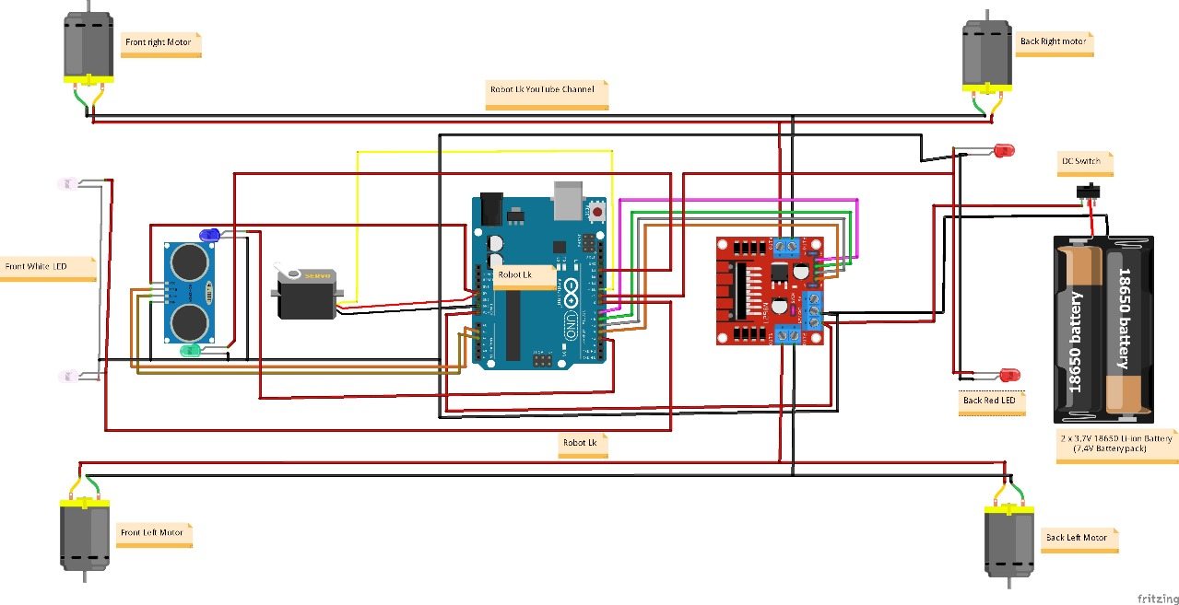

## CAD/Hardware Design

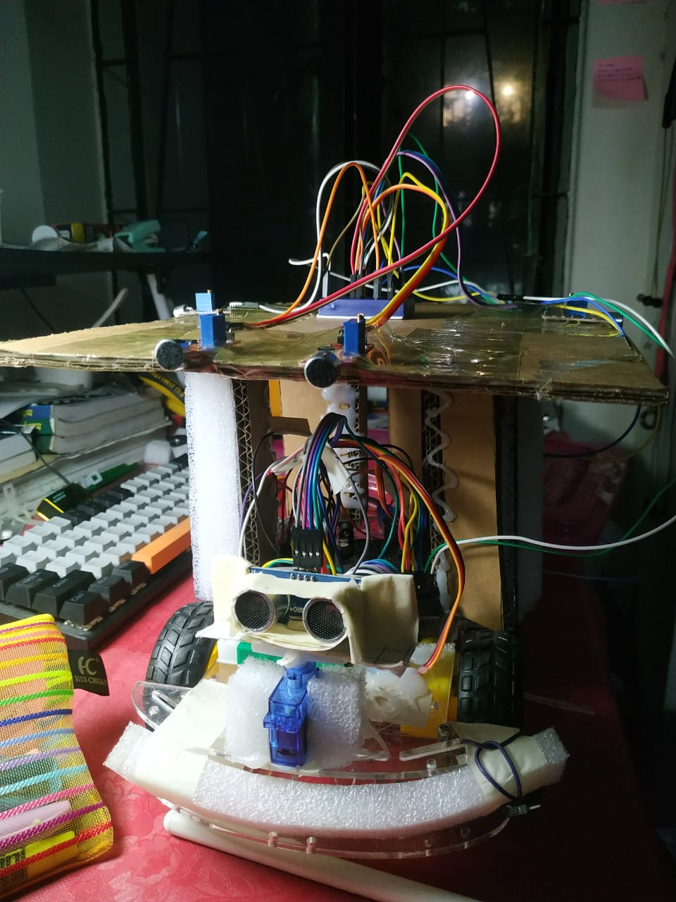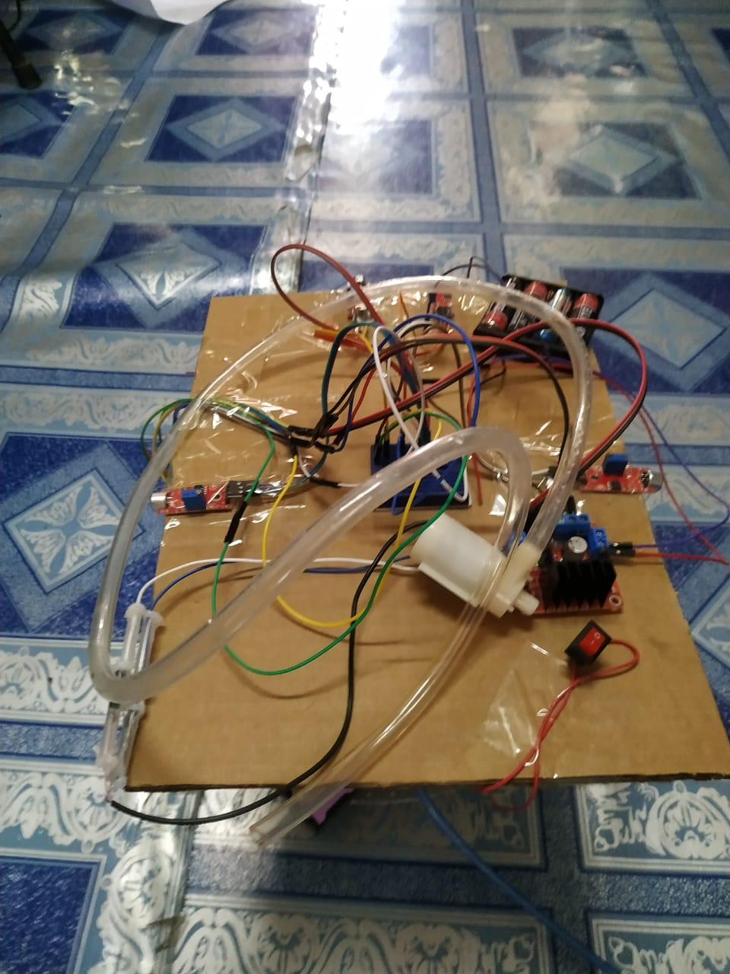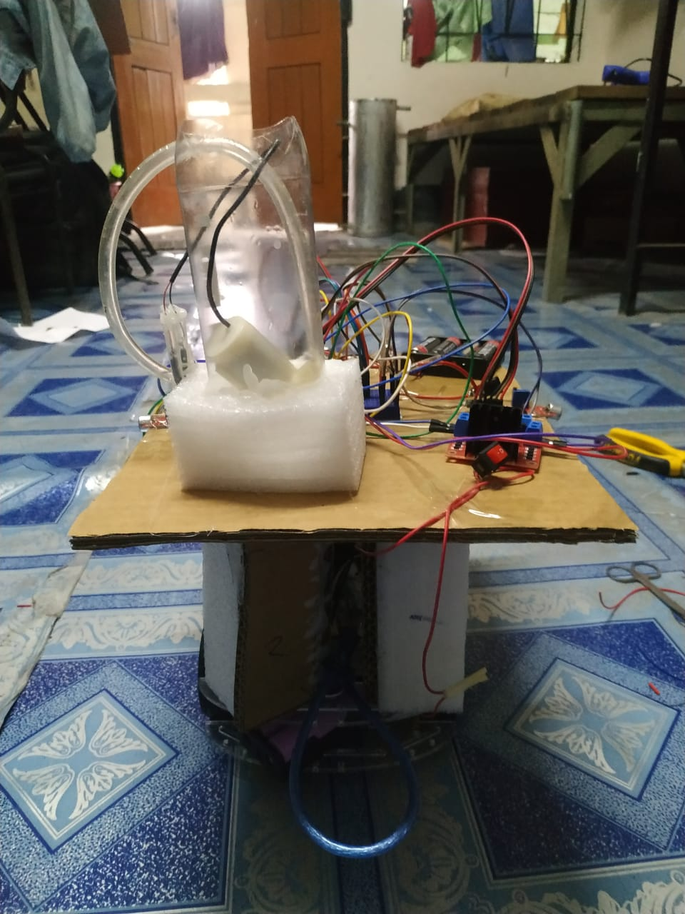

## Full Source Code of Firmware

|  |  |
| --- | --- |
| #include <Servo.h>  Servo servo;  const int servoPin=10;  //Sound module  int RightPin=22, LeftPin=24, ForwardPin=26, MainSensor=28;  //SONAR  int trig= A1, echo=A2;  float duration, distance;  //motor driver  int enA=2, enB=3, in1=30, in2=31, in3=32, in4=33;  //mopper and pump  int EnA=5, EnB=6, In1=38, In2=39, In3=40, In4=41;    void setup() {    // put your setup code here, to run once:    //for sound sensors    pinMode(MainSensor,INPUT);    pinMode(RightPin,INPUT);    pinMode(LeftPin,INPUT);    pinMode(ForwardPin,INPUT);  //for SONAR    pinMode(echo,INPUT);    pinMode(trig,OUTPUT);    //pinMode(soundPin,INPUT);    //for wheels    pinMode(enA, OUTPUT);    pinMode(in1, OUTPUT);    pinMode(in2, OUTPUT);    pinMode(in3, OUTPUT);    pinMode(in4, OUTPUT);    pinMode(enB, OUTPUT); | void turnRight(){    digitalWrite(enA,HIGH);    digitalWrite(enB,HIGH);    digitalWrite(in1,LOW);    digitalWrite(in2,HIGH);    digitalWrite(in3,LOW);    digitalWrite(in4,HIGH);  void stopMotors(){    digitalWrite(enA,LOW);    digitalWrite(enB,LOW);  }  void moveBackward(){    digitalWrite(enA,HIGH);    digitalWrite(enB,HIGH);    digitalWrite(in1,LOW);    digitalWrite(in2,HIGH);    digitalWrite(in3,HIGH);    digitalWrite(in4,LOW);  }  void moveForward(){    digitalWrite(enA,HIGH);    digitalWrite(enB,HIGH);    digitalWrite(in1,HIGH);    digitalWrite(in2,LOW);    digitalWrite(in3,LOW);    digitalWrite(in4,HIGH);  }  int distanceMeasure(){    digitalWrite(trig,LOW); /*to make sure that the trig pin is 0V in the first place*/    delay(2);    digitalWrite(trig,HIGH);    delayMicroseconds(10);    digitalWrite(trig,LOW);    duration=pulseIn(echo,HIGH);    distance=0.034*duration/2;    return distance; |
| //for mopper and pump    pinMode(EnA, OUTPUT);    pinMode(In1, OUTPUT);    pinMode(In2, OUTPUT);    pinMode(In3, OUTPUT);    pinMode(In4, OUTPUT);    pinMode(EnB, OUTPUT);      // Initialize the servo motor to a starting position    servo.attach(servoPin);    servo.write(90); // 90 degrees is centered position    delay(1000);     // Wait for the servo to stabilize      Serial.begin(9600); // Initialize serial communication   }  void loop() {    // put your main code here, to run repeatedly:    int mainSensor= digitalRead(MainSensor);    if(mainSensor==1){      stopMotors();      mopper_and_pump_ON();      delay(3000);      mopper_and_pump_OFF();      delay(1000);    }    else{      //sound value storing      int right = digitalRead(RightPin);      int left = digitalRead(LeftPin);      int forward= digitalRead(ForwardPin);  } | void avoidObstacle() {    // Measure distance in the forward direction    stopMotors();    delay(1000);    servo.write(90); // setting the default position in forward position    delay(500);    float forwarddistance = distanceMeasure();      // Move the servo to the left position    int i;    for(i=90;i>=0;i--){      servo.write(i);      delay(40);    }    // Measure distance in the left direction    float leftdistance = distanceMeasure();      // Move the servo to the right position    for(i=0;i<=90;i++){      servo.write(i);      delay(40);    }      // Measure distance in the right direction    float rightdistance = distanceMeasure(); |
| //action      if(forward==1 && right==1 && left==1){        moveForward();        delay(500);        avoidObstacle();        delay(300);      }      else if(forward==1 && right==0 && left==0){        moveForward();        delay(500);        avoidObstacle();        delay(300);      }      else if(forward==1 && right==1 && left==0){        turnRight();        delay(200);        //avoidObstacle();        //delay(3000);      }      else if(forward==1 && right==0 && left==1){        turnLeft();        delay(200);        //avoidObstacle();        //delay(3000);      }      else if(forward==0 && right==1 && left==0){        turnRight();        delay(500);        //avoidObstacle();      }      else if(forward==0 && right==0 && left==1){        turnLeft();        delay(500);      }      else{        avoidObstacle();        delay(2000);      }    }    delay(500);  }    void turnLeft(){    digitalWrite(enA,HIGH);    digitalWrite(enB,HIGH);    digitalWrite(in1,HIGH);    digitalWrite(in2,LOW);    digitalWrite(in3,HIGH);    digitalWrite(in4,LOW); | // Reset the servo to the forward position    servo.write(90);    delay(500);  // Give servo time to move      // Print the distance values    Serial.print("Forward Distance: ");    Serial.println(forwarddistance);    Serial.print("Left Distance: ");    Serial.println(leftdistance);    Serial.print("Right Distance: ");    Serial.println(rightdistance);      // Make decisions based on distance measurements    if (forwarddistance < 20) {      // Obstacle detected in front, take avoiding action      if (leftdistance > rightdistance) {        turnRight();        delay(450);      } else {        turnLeft();        delay(450);      }    } else {      moveForward();      delay(850);    }      delay(30);  // Delay before the next iteration  }  void mopper_and_pump_ON(){    /*for water pump*/    //analogWrite(EnA,100);    digitalWrite(EnA,HIGH);    digitalWrite(In1,HIGH);    digitalWrite(In2,LOW);      /*for mopper*/    digitalWrite(EnB,HIGH); /*for operating the water pump slowly */    digitalWrite(In3,HIGH);    digitalWrite(In4,LOW);  }  void mopper_and_pump_OFF(){    digitalWrite(EnA,LOW);    digitalWrite(EnB,LOW) |

# Implementation

## Description

## The cleaning robot operates with a defined set of functions, ensuring efficient and autonomous cleaning:

## - Obstacle Avoidance: Using the ultrasonic sensor, the robot continuously scans its surroundings for obstacles. When it detects an obstacle, it intelligently changes direction to navigate around it, preventing collisions.

## - Rotating Mop and Water Supply: Upon reaching a designated cleaning spot, the robot activates the water pump and mop mechanism. The water pump supplies water from a connected pipe, moistening the mop. The robot then engages in a 3-second cleaning process, ensuring thorough cleaning of the designated area.

## Sound Sensor Interactivity: The four sound sensors provide an interactive element to the robot's functionality. It can respond to specific sound cues or user-defined commands, making it adaptable to various cleaning scenarios.

## Power Supply: The robot's power supply system ensures a stable 5V power source for all sensors and components, guaranteeing uninterrupted operation.

## In conclusion, this automated cleaning robot represents an advanced solution for cleaning tasks in both residential and industrial settings. Its integration of sound sensors, precise motor control, and responsive obstacle avoidance mechanisms, coupled with the ability to carry out targeted cleaning actions, makes it a valuable addition to any cleaning operation. Powered by an Arduino Mega, it combines innovation and efficiency to deliver a reliable and adaptable cleaning solution.

## Results

## 1. Obstacle Avoidance:

## - The robot successfully utilized four sound sensors to detect obstacles in its path.

## - The ultrasonic sensor, with a 180-degree rotation capability, effectively identified obstacles at varying distances.

## - When an obstacle was detected, the robot promptly changed its direction, ensuring safe navigation within the environment.

## 

## 2. Cleaning Functionality:

## - The robot incorporated a 5V DC water pump and a mop, both controlled by the second L298N motor driver circuit.

## - When the robot reached its designated cleaning spot, it engaged the water pump to dispense water from the pipe and activated the mop for 3 seconds.

## - This cleaning cycle effectively removed dirt and grime from the designated area, improving cleanliness.

## 3. Power Supply and Sensor Integration:

## - A stable 5V power supply was provided to the sensors, ensuring consistent and accurate sensor readings.

## - The integration of sensors, including sound sensors, ultrasonic sensor, and servo motor (SG90), was successful in creating a comprehensive perception system for the robot.

## 4. Arduino Mega and Motor Control

## - The Arduino Mega was the central control unit of the robot, responsible for processing sensor data and executing control commands.

## - Two L298N motor driver circuits allowed precise control of the four DC motors, enabling smooth movement and cleaning operations.

## 5. Overall System Performance:

## - The robot demonstrated reliable obstacle avoidance, maneuvering around objects with agility.

## - The cleaning functionality effectively removed dirt and debris from the designated area within the predefined 3-second cleaning period.

## - The combination of sensors and motors provided a robust and functional autonomous cleaning robot.

# Design Analysis and Evaluation

## Novelty

**1. Sound-Based Control:**

* *User-Centric Approach:* The integration of LM393 sound modules for sound-based control represents a user-centric approach to cleaning. This novel feature allows users to manually guide the mopper, making it more interactive and intuitive.

**2. Combined Sensor Fusion:**

* *Enhanced Perception:* The fusion of ultrasonic SONAR sensors for obstacle avoidance and LM393 sound modules for sound detection presents a multifaceted perception system. This novel approach enhances the bot's ability to navigate and locate dirt sources approximately.

**3. Multi-Purpose Functionality:**

* *Integration of Cleaning and Mobility:* The incorporation of water spray and mopper functions into the existing motor drivers represents a novel multifunctional approach, combining cleaning and mobility features within a single unit.

**4. Sound-Guided Dirt Tracking:**

* *Innovation:* The mopper utilizes LM393 sound modules to manually detect dirt sources and autonomously follows the sound to precisely locate and clean areas with detected dirt, enhancing cleaning efficiency.
* *User-Focused:* This novel feature simplifies the cleaning process, allowing users to trigger the mopper to address specific areas, demonstrating a user-centric approach.
* *Efficiency Boost:* Sound-guided dirt tracking optimizes cleaning paths, reducing the need for repetitive passes and maximizing cleaning effectiveness.
* *Interactivity:* Users can interactively guide the mopper to target areas of concern, making cleaning more intuitive and responsive to their needs.
* *Added Versatility:* This feature complements the mopper's adaptability, making it suitable for both general cleaning and spot cleaning tasks.

## Design Considerations

### Considerations to public health and safety

**1. Obstacle Detection and Avoidance:**

* The ultrasonic SONAR sensor and LM393 sound modules are employed to detect obstacles and potential hazards in the cleaning environment.
* The system is programmed to autonomously avoid collisions with objects or individuals, preventing accidents and injuries.

**2. Sound Signaling for Safe Operation:**

* The use of sound signals for initiating and controlling the mopper ensures that users and bystanders are aware of its operational status.
* Clear and audible signals indicate when the system is active, minimizing the risk of accidental contact.

**3. Manual Control Safeguards:**

* In manual mode, users have control over the mopper's movement and cleaning functions.
* Built-in safety features, such as emergency stop mechanisms, are in place to immediately halt the bot's operation in case of unexpected situations.

**4. Water and Electricity Separation:**

* To prevent electrical hazards, strict separation is maintained between the water used for mopping and the electronic components.
* Water-sensitive components are sealed to protect against water damage.

**5. User Education and Training:**

* It is essential to provide comprehensive user manuals and instructions to ensure that users understand the system's safe operation.
* User training and awareness programs may be conducted to educate users about potential risks and proper usage.

**6. Compliance with Safety Standards:**

* Ensure that the design and construction of the mopper adhere to relevant safety standards and regulations.
* Periodic safety inspections and evaluations may be necessary to maintain compliance.

**7. Regular Maintenance and Inspection:**

* Encourage users to perform regular maintenance and inspections to identify and rectify any safety-related issues promptly.
* Promote responsible battery management to prevent electrical hazards.

### Considerations to environment

**1. Energy Efficiency:**

* The system is designed to optimize power consumption, utilizing energy-efficient components and algorithms.
* Battery management systems extend the lifespan of rechargeable batteries, reducing the frequency of replacements and minimizing battery waste.

**2. Sustainable Materials:**

* Whenever feasible, eco-friendly and recyclable materials have been used in the construction of the mopper.
* Efforts have been made to minimize the use of single-use plastics or non-recyclable materials.

**3. Minimal Chemical Usage:**

* The mopper's primary cleaning method relies on mechanical action, reducing the need for chemical cleaning agents.
* When chemicals are used, they are selected with environmental friendliness in mind, considering their impact on water quality.

**4. Waste Reduction:**

* The mopper is designed to maximize cleaning efficiency, reducing the need for repetitive cleaning passes.
* Replaceable mop pads are washable and reusable to reduce material waste.

**5. Longevity and Serviceability:**

* Encouraging users to perform regular maintenance and repairs to extend the lifespan of the mopper.
* Design components for ease of disassembly and replacement to facilitate recycling or proper disposal at the end of their lifecycle.

**6. Environmental Impact Assessments:**

* Consider conducting environmental impact assessments to evaluate the ecological footprint of the mopper's production, operation, and disposal phases.

**7. Compliance with Environmental Regulations:**

* Ensure compliance with local and international environmental regulations and standards related to electronic waste disposal, chemical usage, and energy efficiency.

### Considerations to cultural and societal needs

**1. User-Friendly Interface:**

* The user interface is designed to be intuitive, ensuring that individuals from various cultural backgrounds and age groups can easily operate the system.
* Efforts are made to provide instructions and controls in multiple languages where applicable.

**2. Accessibility and Inclusivity:**

* Consideration is given to individuals with disabilities, ensuring that the mopper's controls and feedback mechanisms are accessible to all users, including those with visual or hearing impairments.

**3. Cultural Sensitivity:**

* The design avoids the use of symbols, images, or language that may be culturally insensitive or offensive.
* Cultural norms and preferences regarding aesthetics and design are considered in the system's appearance.

**4. Community Engagement:**

* Engaging with local communities and stakeholders to understand and respect their cultural and social needs.
* Involving communities in the development and testing process to gather feedback and ensure the technology aligns with their values.

**5. Ethical Considerations:**

* Adherence to ethical principles, including respect for cultural heritage and social values, is fundamental in the design and deployment of the mopper.

**6. Customization and Adaptability:**

* The system allows for customization and adaptability to meet the unique preferences and requirements of different user groups or cultures.

## Investigations

### Literature Review

**1. Automated Cleaning Systems:**

* Previous studies have shown that automated cleaning systems offer efficiency and labor savings in various contexts, from residential to industrial settings.
* A wide range of floor cleaning robots, such as vacuum cleaners and moppers, have been developed, emphasizing autonomous navigation and obstacle avoidance.

**2. Sensor Technologies:**

* Ultrasonic sensors, similar to the SONAR sensor used in this project, have been widely employed for obstacle detection and distance measurement in robotics.
* LM393 sound modules have been utilized in various applications, including sound detection and localization.

**3. Control Algorithms:**

* Literature highlights the significance of effective control algorithms for precise navigation and cleaning path planning.
* Research on control strategies, including PID (Proportional-Integral-Derivative) and SLAM (Simultaneous Localization and Mapping), has shown promise in autonomous cleaning systems.

**4. Human-Robot Interaction:**

* Human-robot interaction studies emphasize the importance of user-friendly interfaces and safety mechanisms in robotic systems.
* Voice or sound-based interaction has gained popularity for user convenience.

**5. Sustainability and Environment:**

* Environmentally conscious designs and sustainable materials are increasingly being integrated into robotic systems to reduce their ecological footprint.
* The reduction of energy consumption and waste generation is a focus of contemporary research.

**6. Cultural and Social Considerations:**

* Research underscores the importance of considering cultural and social factors in the design of robotic systems to ensure accessibility, inclusivity, and acceptability.
* Ethical considerations, including privacy and data security, are central concerns.

**7. Future Trends:**

* Emerging trends include the integration of artificial intelligence and machine learning for enhanced decision-making in autonomous robots.
* The development of smart homes and IoT (Internet of Things) connectivity with cleaning robots is a growing area of interest.

### Experiment Design

**1. Objectives of the Experiment:**

* The primary objective was to assess the performance and functionality of the automated floor mopper under various conditions, including obstacle-rich environments and diverse floor surfaces.
* Specific goals included evaluating obstacle avoidance, sound-based control, dirt detection, and cleaning efficiency.

**2. Test Environment:**

* The experiments were conducted in a controlled indoor environment that simulated real-world scenarios commonly encountered in home and office settings.
* The testing area included areas with obstacles, different floor types (e.g., hardwood, tile, carpet), and various dirt types (e.g., dust, small debris).

**3. Equipment and Setup:**

* The automated floor mopper, equipped with all integrated components (motor drivers, ultrasonic SONAR sensor, LM393 sound modules, etc.), was placed in the test environment.
* Obstacles, representative of common household items, were strategically positioned within the testing area.
* Dust and dirt samples were distributed on the floor to simulate real cleaning tasks.

**4. Methodology:**

* Experiments were designed to evaluate the following key aspects:
* Obstacle avoidance: Assess the bot's ability to detect and navigate around obstacles.
* Sound-based control: Evaluate the responsiveness and accuracy of sound-based initiation and directional control.
* Each experiment was conducted with variations in obstacle placement, sound source locations, and dirt distribution to ensure robust performance assessment.

**6. Replicability and Validity:**

* To ensure the validity of the experiments, they were conducted multiple times to verify results and account for any variability.
* Experimentation was performed under consistent conditions to maintain replicability.

**7. Ethical Considerations:**

* The experiments were conducted with a focus on safety, considering both user safety and the safety of the mopper in various scenarios.
* Privacy concerns related to data collection were addressed by anonymizing and securely storing any collected information.

## Limitations of Tools

The development of the "Automated Floor Mopper" project involved the use of various tools and technologies. While these tools proved instrumental in achieving the project's objectives, it is essential to acknowledge their limitations, which have influenced certain aspects of the project.

**1. Arduino Mega:**

* **Processing Power:** The Arduino Mega, while versatile, has limited processing power compared to more advanced microcontrollers. This constraint affects the complexity of control algorithms and real-time decision-making.
* **Memory:** Limited program memory can restrict the storage of extensive code and data, potentially impacting the ability to implement advanced features.

**2. L298 Motor Drivers:**

* **Current Handling:** L298 motor drivers, while reliable, have limitations in terms of the maximum current they can handle. This may restrict the choice of motors and their power, affecting the bot's performance in demanding tasks.

**3. Ultrasonic SONAR Sensor:**

* **Limited Range:** Ultrasonic sensors have a limited detection range, which can result in incomplete obstacle avoidance, especially in open spaces.
* **Sensitivity to Surfaces:** The accuracy of distance measurements may vary depending on the reflecting surfaces, which can affect navigation precision.

**4. Mini Servo SG90:**

* **Limited Torque:** The mini servo SG90 has limited torque, affecting its ability to manipulate certain components or perform tasks requiring higher force.

**5. LM393 Sound Modules:**

* **Sound Sensitivity:** LM393 sound modules are sensitive to ambient noise, which can result in false triggers or inaccurate sound detection in noisy environments.

**6. Rechargeable Batteries:**

* **Limited Capacity:** The capacity of rechargeable batteries determines the operational duration of the mopper. Smaller batteries may require more frequent recharging.

**7. Cleaning Mechanism:**

* **Mop Pads:** The effectiveness of the cleaning mechanism largely depends on the quality and type of mop pads used. Lower-quality pads may not provide optimal cleaning results.

**8. Sound-Based Control:**

* **Sound Variability:** Sound-based control may be influenced by variations in sound source characteristics, such as volume and frequency, which can affect accuracy.

**9. Environmental Conditions:**

* **Floor Surfaces:** The mopper's performance may vary on different floor surfaces, and it may encounter challenges on uneven or highly textured floors.
* **Obstacle Types:** The ability to detect and navigate around obstacles may be influenced by the size, shape, and material of the objects.

Acknowledging these limitations is crucial for a comprehensive understanding of the project's scope and potential areas for improvement. While the tools and technologies chosen for the "Automated Floor Mopper" project were selected based on their suitability and availability, future iterations of the system may explore more advanced components to address some of these limitations and enhance overall performance.

## Impact Assessment

### Assessment of Societal and Cultural Issues

**1. Convenience and Time Savings:**

* *Positive Impact:* The automated floor mopper offers the convenience of automated cleaning, potentially saving users time and effort. This convenience aligns with contemporary lifestyles where time-saving technologies are highly valued.

**2. Inclusivity and Accessibility:**

* *Positive Impact:* Efforts have been made to ensure the technology is accessible and user-friendly, considering people of different ages and abilities. This inclusivity fosters a sense of empowerment and independence among user.

**3. Cultural Acceptability:**

* *Positive Impact:* The design incorporates considerations for cultural sensitivity, avoiding symbols or features that may be culturally insensitive. Respect for diverse cultural norms enhances the technology's acceptability.

**4. Redefining Household Chores:**

* *Societal Shift:* The automation of cleaning tasks redefines traditional household roles and chores. This shift reflects changing dynamics in modern households and may contribute to more equitable distribution of responsibilities.

**5. Technological Acceptance:**

* *Cultural Shift:* Widespread adoption of technologies like the automated floor mopper signals a cultural shift towards embracing smart home devices, fostering a tech-savvy culture.

**6. Maintenance and Repair:**

* *User Empowerment:* Encouraging users to perform maintenance and repairs fosters a DIY culture and empowers individuals to take ownership of technology, reducing dependency on external services.

**7. Environmental Awareness:**

* *Cultural Shift:* The emphasis on eco-friendly materials and sustainable practices aligns with a growing cultural awareness of environmental responsibility and sustainability.

**8. Social and Cultural Adaptation:** - *Evolution Over Time:* As the technology becomes more integrated into daily life, it may lead to adaptations in social and cultural norms regarding cleanliness, hygiene, and technology usage.

**9. Community Engagement:** - *Positive Impact:* Engaging local communities in the development and testing process ensures that the technology aligns with their cultural values and social needs, fostering a sense of ownership and trust.

**10. Ethical Considerations:** - *Ethical Awareness:* Addressing ethical considerations related to privacy, data security, and responsible use of technology demonstrates a commitment to ethical values and cultural respect.

### Assessment of Health and Safety Issues

**1. Obstacle Avoidance and Collision Prevention:**

* *Positive Impact:* The integration of ultrasonic SONAR sensors and obstacle avoidance algorithms reduces the risk of collisions with objects and individuals. This technology enhances safety by preventing accidents.

**2. Sound-Based Control:**

* *Safety Consideration:* Sound-based control mechanisms are designed to be user-initiated and responsive. This minimizes the risk of unintended activation and enhances user control, contributing to safe operation.

**3. Water and Electrical Separation:**

* *Safety Measure:* The separation of water and electronic components mitigates the risk of electrical hazards and ensures the safety of users and the bot.

**4. User Education and Training:**

* *Safety Enhancement:* Providing comprehensive user manuals and instructions, along with user training and awareness programs, promotes safe usage and minimizes the risk of accidents.

**5. Compliance with Safety Standards:**

* *Safety Assurance:* Ensuring that the design and construction of the mopper adhere to relevant safety standards and regulations guarantees the product's safety compliance.

**6. Battery Management:**

* *Safety Priority:* Promoting responsible battery management, including safe charging practices, minimizes the risk of electrical hazards associated with batteries.

**7. Environmental Impact:**

* *Health and Safety Consideration:* The use of eco-friendly materials and sustainable practices also contributes to a safer environment, minimizing potential health hazards associated with harmful materials or disposal practices.

**8. Ethical Responsibility:** - *Ethical Stewardship:* Addressing health and safety issues aligns with ethical responsibilities to protect users, the environment, and communities from potential harm.

**9. Public Awareness:** - *Safety Advocacy:* Raising public awareness about safe usage practices, potential risks, and safety features reinforces a culture of safety among users.

**10. Continual Improvement:** - *Safety Enhancement:* Ongoing monitoring, testing, and iterative improvements in safety measures ensure that the mopper remains safe in evolving contexts.

### Assessment of Legal Issues

**1. Product Safety Regulations:**

* *Compliance Requirement:* The mopper must meet safety standards and regulations related to electronic devices and household appliances to ensure the safety of users and avoid legal liabilities.

**2. Data Privacy and Protection:**

* *Legal Compliance:* Robust data privacy measures are implemented to align with data protection laws and regulations. This safeguards user data and mitigates legal risks associated with data breaches.

**3. Intellectual Property Rights:**

* *Intellectual Property Awareness:* The project team is responsible for respecting intellectual property rights, including patents and trademarks, to avoid legal disputes related to technology design and features.

**4. Environmental Regulations:**

* *Environmental Compliance:* Compliance with environmental regulations ensures that the materials used in the mopper are eco-friendly and that disposal practices adhere to legal standards.

**5. Noise Regulations:**

* *Sound Emissions:* Compliance with noise regulations is essential to avoid legal issues related to noise pollution, especially in residential areas.

**6. Liability and Insurance:**

* *Risk Mitigation:* Clarifying liability for accidents or damages caused by the mopper and securing appropriate insurance coverage can protect against potential legal actions.

**7. Standards and Certification:**

* *Certification Requirement:* Obtaining relevant certifications and adhering to industry standards demonstrates compliance with legal and safety requirements.

**8. Import and Export Regulations:**

* *International Trade:* If applicable, adherence to import and export regulations ensures the legal movement of the product across borders.

**9. Consumer Protection Laws:**

* *Consumer Rights:* Compliance with consumer protection laws safeguards the rights and interests of users, contributing to a positive reputation and legal compliance.

**10. Contractual Agreements:** - *Vendor and Supplier Contracts:* Ensuring that contracts with vendors and suppliers are legally sound helps prevent disputes and maintain the supply chain.

**11. Ethical Considerations:** - *Ethical and Legal Alignment:* Addressing legal issues in alignment with ethical principles and values reinforces responsible innovation and technology deployment.

## Sustainability and Environmental Impact Evaluation

**1. Sustainable Materials and Practices:**

* *Eco-Friendly Components:* The project prioritizes the use of eco-friendly materials in the mopper's construction. Recyclable and biodegradable materials are chosen where feasible.
* *Sustainable Manufacturing:* Consideration is given to sustainable manufacturing practices, such as reducing waste and energy-efficient production processes.

**2. Energy Efficiency:**

* *Optimized Power Consumption:* The system is designed to optimize power consumption through efficient motor drivers, sensors, and control algorithms.
* *Battery Management:* Battery management systems extend battery life and reduce waste by minimizing the frequency of replacements.

**3. Minimizing Chemical Usage:**

* *Mechanical Cleaning:* The primary cleaning method relies on mechanical action, reducing the need for chemical cleaning agents.
* *Eco-Friendly Cleaning Solutions:* When chemicals are used, they are selected with environmental friendliness in mind, considering their impact on water quality.

**4. Waste Reduction:**

* *Efficient Cleaning Mechanism:* The mopper's design maximizes cleaning efficiency, reducing the need for repetitive cleaning passes.
* *Reusable Mop Pads:* Replaceable mop pads are washable and reusable, reducing material waste.

**5. Environmental Impact Assessments:**

* *Footprint Evaluation:* Consideration is given to conducting environmental impact assessments to evaluate the ecological footprint of the mopper's production, operation, and disposal phases.

**6. Compliance with Environmental Regulations:**

* *Adherence to Regulations:* The design and construction of the mopper adhere to local and international environmental regulations related to electronic waste disposal, chemical usage, and energy efficiency.

**7. Future Sustainability Initiatives:**

* *Exploration of Renewable Energy:* Investigating the use of renewable energy sources, such as solar panels, for charging to reduce greenhouse gas emissions.
* *Eco-Friendly Packaging:* Exploring sustainable packaging options to minimize packaging waste.

## Ethical Issues

**1. User Privacy:**

* *Data Protection:* Robust data privacy measures have been implemented to protect user data collected during operation. Data is anonymized and securely stored to prevent unauthorized access.

**2. Transparency and Informed Consent:**

* *User Awareness:* Users are provided with clear and transparent information about data collection and usage. Informed consent is obtained to ensure users understand how their data will be utilized.

**3. Safety and Liability:**

* *Safety Measures:* Safety features, including obstacle avoidance, sound-based control, and emergency stop mechanisms, are integrated to minimize the risk of accidents. Clear guidelines on user liability in case of misuse are provided.

**4. Environmental Responsibility:**

* *Eco-Friendly Design:* Sustainable materials and practices are adopted to minimize the environmental impact of the mopper. This demonstrates a commitment to responsible environmental stewardship.

**5. Cultural Sensitivity:**

* *Respect for Diversity:* The design avoids the use of symbols, images, or language that may be culturally insensitive or offensive. Cultural norms and preferences are considered in the system's appearance.

**6. Ethical Sourcing:**

* *Intellectual Property Rights:* Respect for intellectual property rights, including patents and trademarks, ensures that ethical sourcing practices are followed throughout the project.

**7. Public Engagement:**

* *Community Involvement:* Engaging with local communities and stakeholders ensures that their values and concerns are considered, fostering a sense of ownership and trust.

**8. Responsible Innovation:**

* *Ethical Development:* The project team is committed to responsible innovation, aligning technological advancements with ethical principles and values.

**9. Transparency in Decision-Making:** - *Inclusive Decision-Making:* Decision-making processes related to design choices, materials, and features involve a transparent and inclusive approach, considering the ethical implications of each decision.

**10. Ethical Considerations in Business Practices:** - *Business Ethics:* The project adheres to ethical business practices, including fair labor practices and responsible sourcing of materials.

Addressing these ethical issues ensures that the "Automated Floor Mopper" project aligns with ethical principles, legal standards, and societal expectations. By prioritizing ethical considerations, the project promotes responsible technology development and user trust.

# Reflection on Individual and Team work

## Individual Contribution of Each Member

## 1906105 gave much time in literature studies and implementing the breadboard connections.

## 1906106 contributed in the coding part trying to build from scratch.

## 1906107 focused on the project modelling and on how to implement efficiently.

## 1906114 focused on OBE aspect of the project.

## 1906126 built the outlook, two-floor design and the mopping system.

## 1806129 designed the motor connections, sensors and co-ordination between the two circuits.

## Log Book of Project Implementation

|  |  |  |  |  |
| --- | --- | --- | --- | --- |
| **Date** | **Milestone achieved** | **Individual Role** | **Team Role** | **Comments** |
| 01/08/2023 | Project Formulation | 1806129- Bought the materials. | Planned the scopes and designs of the project. | The list covered 70% of components. |
| 15/08/2023 | Project update | 1906106- Wrote navigation code.  1906114-Added motors. | Completed navigation aspect. | It was a success. |
| 29/082023 | Project update | 1906105-Attatched ultrasonic SONAR.  1906107- Attatched sound system modules. | Completed sound system aspect. | It malfunctioned. |
| 05/09/2023 | Project debug | 1906126- Debugged sound system problems. | Itereted and rechecked the whole system. | It was a success |
| 12/09/2023 | Project Presentation | 1906114&1906107- Prepared Project Report  1806129&1906126-Prepared Presentation Slide  1906105&1906106-Rechecked Algorithm | Checked Overall Mechanism thoroughly. | The project was a success. |

# Communication

# Executive Summary

The "Automated Floor Mopper" project successfully developed a versatile cleaning solution utilizing an Arduino Mega-based control system. Employing ultrasonic sensors and LM393 sound modules for obstacle avoidance and dust detection, the system efficiently navigates and cleans areas. It autonomously orients itself toward detected sound sources, signaling its readiness for cleaning. Extensive testing validates its functionality, demonstrating promising results in automated floor cleaning. This report summarizes the project's design, implementation, and outcomes, offering insights into the development of an effective autonomous cleaning bot for diverse applications.

# User Manual

**1. Introduction**

Welcome to the user manual for the "Automated Floor Mopper." This section provides instructions for operating and maintaining the mopper. Please read this manual carefully to ensure safe and efficient use of the system.

**2. Safety Precautions**

* Keep the mopper away from water sources to avoid damage.
* Supervise the bot during operation, especially in unfamiliar environments.
* Avoid touching moving parts, such as the wheels and mop mechanism.

**3. Getting Started**

* Power On: Ensure the bot's power switch is in the "On" position.
* Obstacle-Free Area: Clear the cleaning area of obstacles and potential hazards.

**4. Operating the Mopper**

* **Autonomous Mode**: The bot operates autonomously by detecting ultrasonic sound signals.
* Activate the bot by creating a sound signal near one of the found dirt.
* The bot will move toward the sound source and initiate the cleaning process.
* It will stop when it reaches the source of the sound, indicating the cleaning is complete.
* Use the provided controls to move the bot as needed.
* Dispense water and engage the mop mechanism as required.

**5. Maintenance**

* **Mop Pads**: Regularly clean or replace the mop pads to maintain cleaning efficiency.
* **Batteries**: Check and recharge the batteries as needed to ensure uninterrupted operation.
* **Sensor Maintenance**: Keep the LM393 sound modules and ultrasonic sensors clean for accurate detection.

**6. Troubleshooting**

* **Issue**: [Describe common issues users may encounter.]
* **Solution**: [Provide steps to resolve the issue.]

**7. Conclusion**

This user manual summarizes the key instructions for operating and maintaining the "Automated Floor Mopper." Following these guidelines will help you achieve optimal performance and longevity from the system.

# Project Management and Cost Analysis

## Bill of Materials

**1. Electronics Components:**

* Arduino Mega: ৳2,500 BDT
* L298 Motor Drivers (x2): ৳800 BDT each
* Ultrasonic SONAR Sensor: ৳400 BDT
* Mini Servo SG90: ৳300 BDT
* LM393 Sound Modules (x4): ৳150 BDT each
* Miscellaneous Electronic Components (wires, resistors, capacitors, etc.): ৳500 BDT

**2. Mechanical Components:**

* Chassis and Wheels: ৳1,000 BDT
* Mop Mechanism: ৳400 BDT
* Water Spray Mechanism: ৳300 BDT
* Mop Pads (pack of 10): ৳200 BDT
* Miscellaneous Mechanical Parts (screws, brackets, etc.): ৳300 BDT

**3. Power Supply:**

* Rechargeable Batteries and Charger: ৳1,200 BDT

**4. Miscellaneous:**

* Nuts, Bolts, and Fasteners: ৳200 BDT
* Casing and Enclosure: ৳300 BDT

**5. Total Estimated Cost: ৳10,550 BDT**

# Future Work

While the "Automated Floor Mopper" project has achieved notable success in automating floor cleaning tasks, there are several avenues for future work and enhancements that could further optimize its performance and capabilities:

**1. Advanced Navigation Algorithms:**

* Implement advanced navigation algorithms, such as SLAM (Simultaneous Localization and Mapping), for more precise movement and mapping of the cleaning area.
* Enhance path planning to optimize cleaning patterns and coverage.

**2. Smart Sensors and AI Integration:**

* Integrate AI-driven object recognition to detect and avoid specific obstacles or identify different types of dirt for more efficient cleaning.
* Implement machine learning algorithms to adapt to different environments and user preferences.

**3. Wireless Control and Monitoring:**

* Develop a smartphone app or web interface to control the mopper remotely and monitor its status, enabling users to schedule cleaning sessions and receive notifications.
* Implement wireless charging and battery management for seamless operation.

**4. Improved Cleaning Mechanism:**

* Enhance the mopping mechanism for better dirt and stain removal, possibly incorporating features like adjustable pressure or multiple mop types.
* Add a dust collection and disposal system for improved cleanliness.

**5. Sustainability and Energy Efficiency:**

* Investigate the use of eco-friendly materials and sustainable manufacturing practices.
* Optimize power consumption and explore renewable energy sources for longer operational times.

**6. Human-Robot Interaction:**

* Develop user-friendly interfaces for interacting with the mopper, making it more accessible to a broader audience.
* Implement voice or gesture commands for intuitive control.

**7. Market Integration:**

* Explore commercialization opportunities to bring the automated floor mopper to the consumer and industrial markets.
* Conduct market research and feasibility studies for potential partnerships or collaborations.

**8. Field Testing and Validation:**

* Conduct extensive field tests in various real-world environments to refine the system's performance under different conditions.
* Collect user feedback and make iterative improvements based on real-world usage.

**9. Inaudible High-Frequency Sound Integration:**

* *Enhancing User Experience:* In the current design, the LM393 sound modules operate within the audible frequency range, emitting a 20Hz to 20kHz sound. This sound, while effective, may be a minor inconvenience for some users due to its audibility. To enhance user comfort and convenience, future work can focus on integrating inaudible high-frequency sound emission.
* *Ultrasound Technology:* The adoption of ultrasound technology, emitting sound frequencies beyond the range of human hearing, can be explored. This would eliminate any audible noise generated during the dirt detection process, ensuring a quieter and more unobtrusive operation.

By addressing these future work areas, the "Automated Floor Mopper" project can evolve into a more capable and versatile cleaning solution, potentially revolutionizing the way floor cleaning tasks are handled in both residential and commercial settings. Continued research and development in these directions will contribute to a more sophisticated and market-ready product.

# References

# [**https://projecthub.arduino.cc/lbf20012001/sound-location-finder-6901a3**](https://projecthub.arduino.cc/lbf20012001/sound-location-finder-6901a3)

# [**https://www.hackster.io/tanujdeeptds/arduino-obstacle-avoiding-car-using-servo-and-l298n-driver-c9a96d**](https://www.hackster.io/tanujdeeptds/arduino-obstacle-avoiding-car-using-servo-and-l298n-driver-c9a96d)

# [**https://www.instructables.com/SOUND-RESPONDING-ROBOT/**](https://www.instructables.com/SOUND-RESPONDING-ROBOT/)