Tahmid Sarwar

Fo7483

CSC 4996

14 January 2018

Todo Application

Functional Requirements:

1. Add tasks
2. View tasks
3. Delete tasks
4. Display total tasks in system
5. Display count for each status type
6. Redirect to new page with filtered tasks based on status

Non-functional Requirements:

1. Easy to add features
2. Simple interface
3. Clean design
4. Easy to use
5. Retrieve data from database within 10 seconds
6. Display tasks within 10 seconds

System Architecture Diagram:

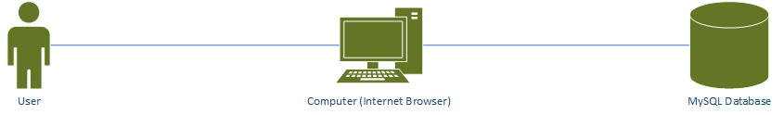

Data Flow Diagram:

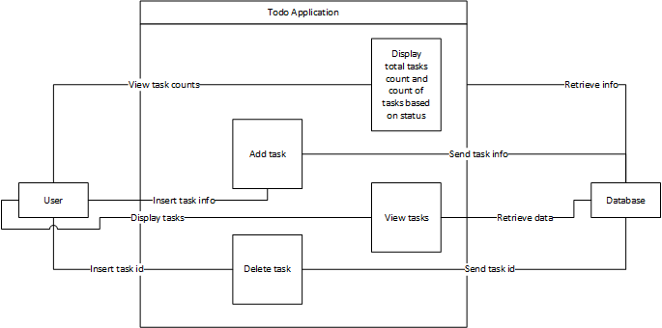

Use Case:

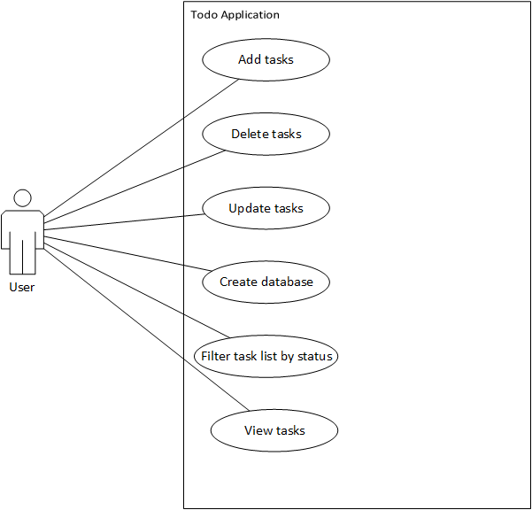

Sequence Diagram:

Initialize Database/Table:

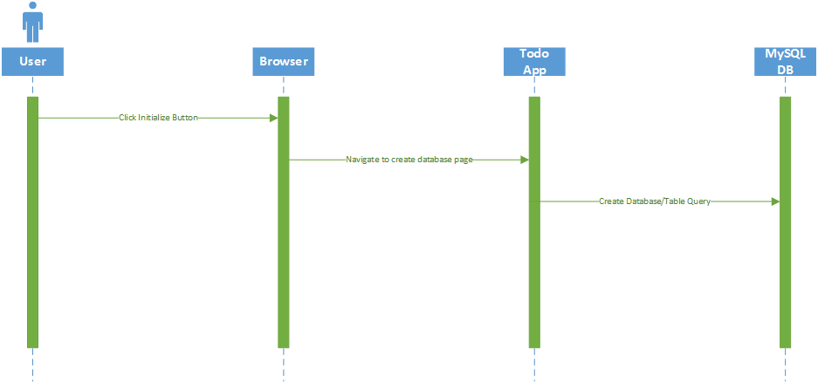

Add Task:

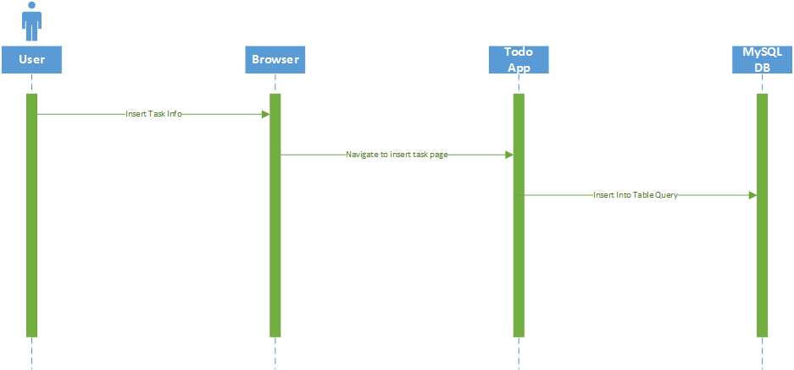

View Tasks:

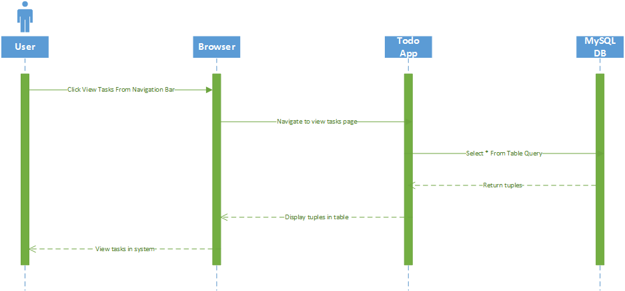

Filter Pending Tasks:

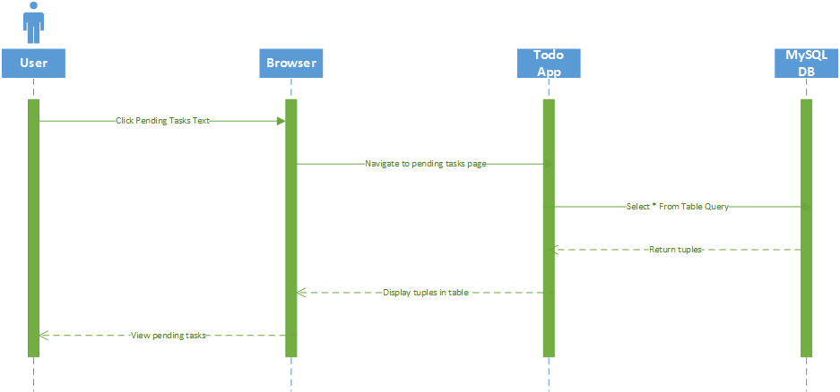

Filter Late Tasks:

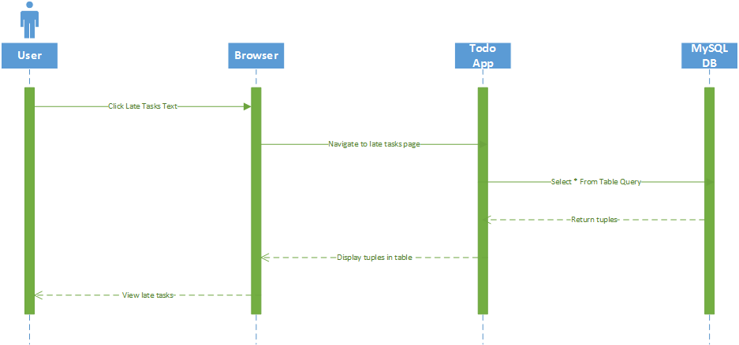

Filter Started Tasks:

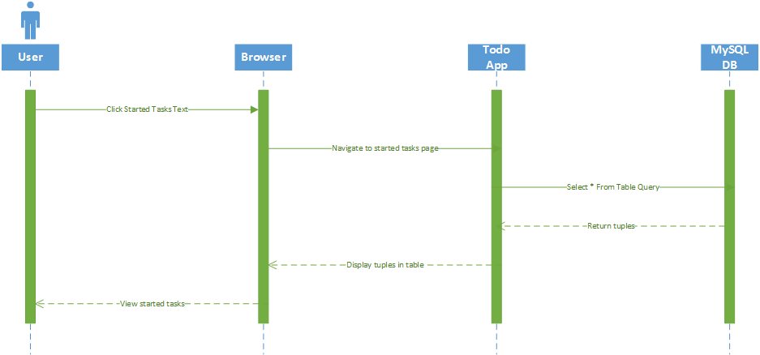

Database Design:

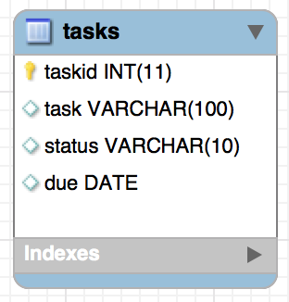

Class Diagram:

No classes used.

Test Case:

1. Add task with correct and incorrect parameters
2. Delete task with existing task id and non-existing task id
3. Update task using correct and incorrect parameters
4. Create Database by clicking the initialize button
5. Filter tasks by status by clicking on text associated with status count display
6. View tasks by clicking view task item in navigation bar and tasks in system text

Work Breakdown:

Name of the task: Create Database

Estimated No of hours: 2

Actual time spent: 1 hours

Notes: Most of the time spent was learning how to set up a database using php

Issues: I had some connection issues at first due to syntax errors

Name of the task: Add New Task Functionality

Estimated No of hours: 2

Actual time spent: 1

Notes: Most of the time spent was learning php syntax

Issues: no issues

Name of the task: Add View Tasks Functionality

Estimated No of hours: 1

Actual time spent: 20 minutes

Notes: Most of the time spent was learning php syntax

Issues: Connecting to DB initially

Name of the task: Add Delete Task Functionality

Estimated No of hours: 1

Actual time spent: 30

Notes: Most of the time spent was learning php syntax

Issues: no issues

Name of the task: Add Update Task Functionality

Estimated No of hours: 45 minutes

Actual time spent: 15 minutes

Notes: Most of the time spent was learning php syntax

Issues: no issues

Name of the task: Add Task Status/Count On Home Page Functionality

Estimated No of hours: 1

Actual time spent: 30 minutes

Notes: Most of the time spent was learning php/html syntax

Issues: Use of incorrect html syntax