Case I: Understanding Business Information Through Dashboards

Questions:

1. What could be some ways that Habib can improve profitability?

ANS: using business Intelligence BI tool like Tableau Habib can improve his sales and services . Creating a stromg mis team.

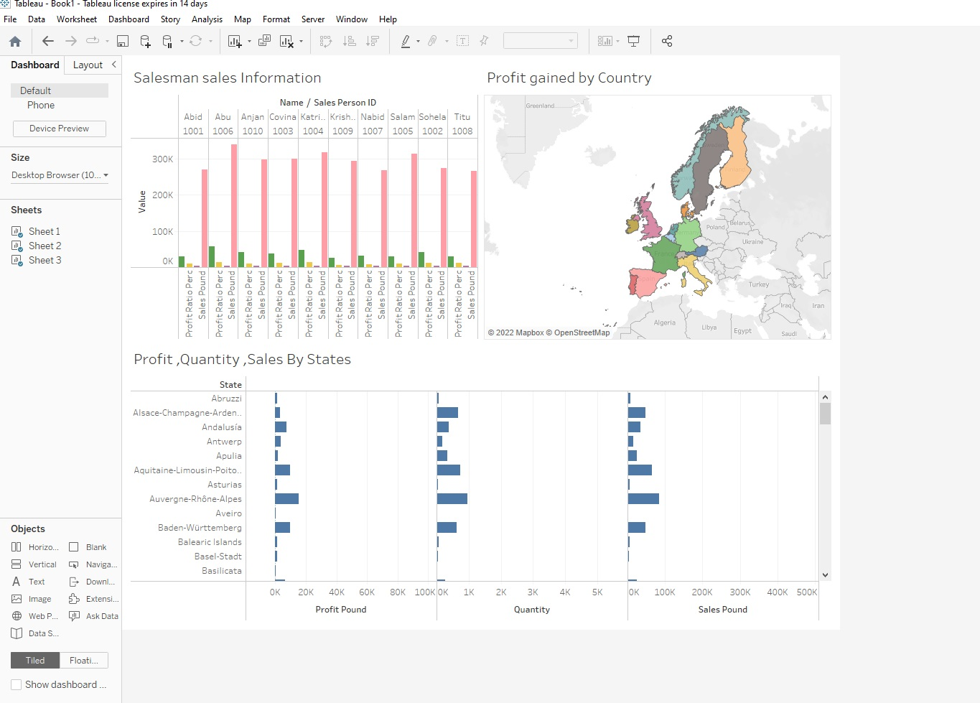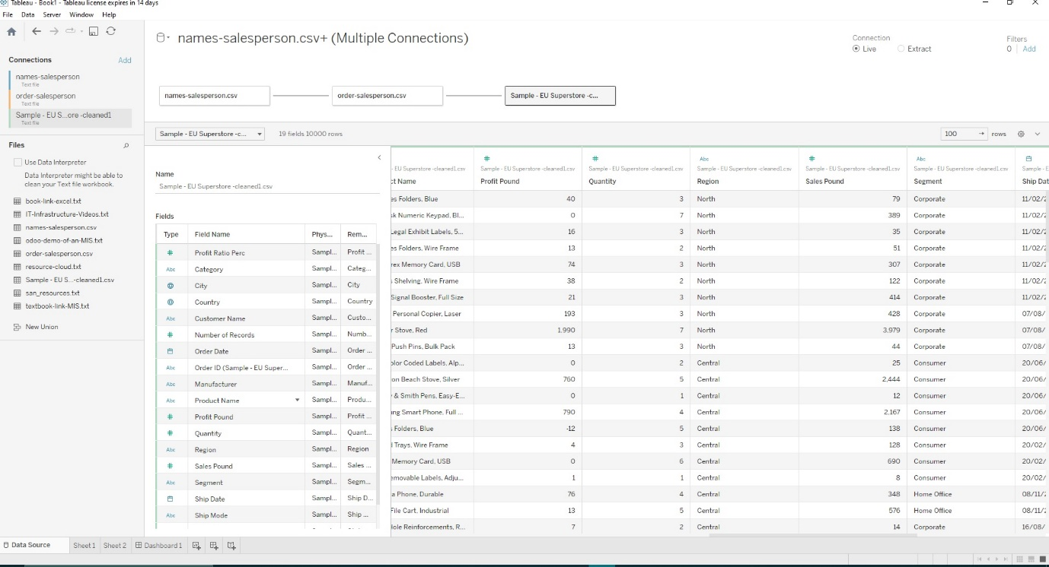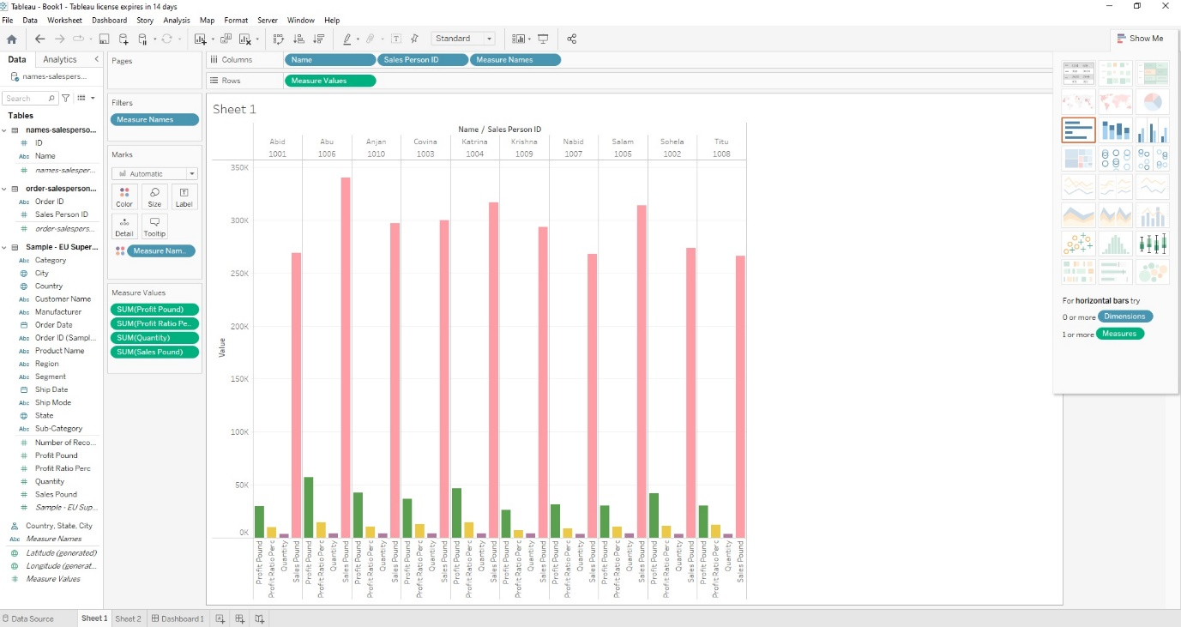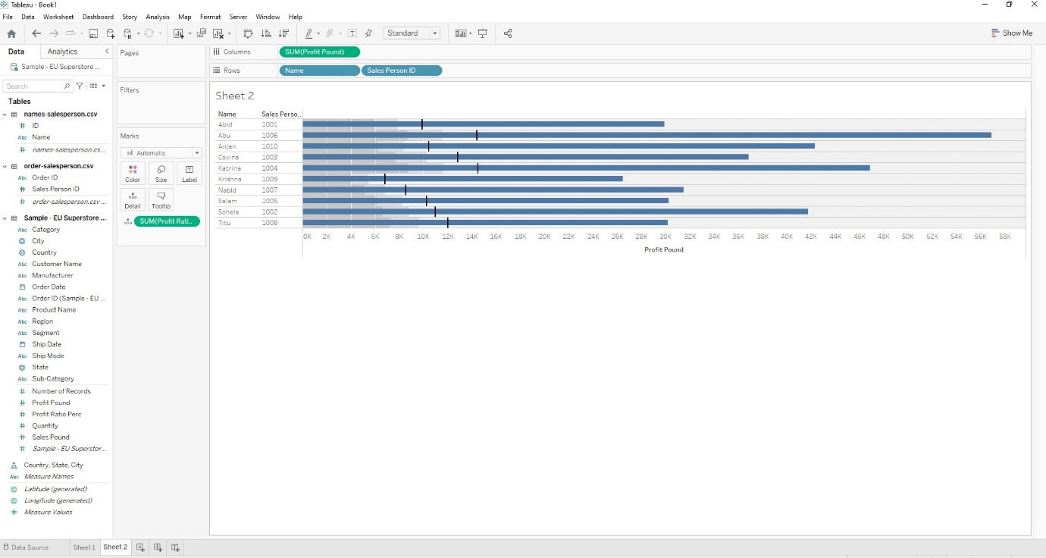

1. What do we mean by measures?

Ans: a plan or course of action taken to achieve a particular purpose.

1. Which three sales persons are the worst performing?

Ans:

Here we can see Krisna , Abid and Titu is worst performing salesman.