Form for DKE Student Project Websites

**Type of project (e.g. Bachelor thesis, Master AI thesis, Master OR thesis, Master AI internship project, Master OR internship project, Master AI semester project, Master OR semester project):**

Master Research Project

**Year of project:**

2018-2019

**Key words (5 max):**

Optimization, feasibility, initial estimator, Newton Method, Ariadne

**Name(s) of student(s) who participated in the project:**

Martyna Mikos, Tahmina Begum, Casper Hogenboom, Demet Demirkiran and Edwin van der Vegt

**Name(s) of supervisor(s):**

Pieter Collins

**Title of the project:**

Checking for Collisions: Validating Optimality/Feasibility

**Download link for additional content (at least 1 image/figure, report, final presentation, maybe some movies):**

<https://www.dropbox.com/sh/u519vsysfr532pk/AADrUdOYrLUaLtnUIHCImJ6Sa?dl=0>

**Captions of images/figures. Enter your images (in low resolution if needed) here as well with appropriate captions:**



Source: http://ensco.com/avionics/display-application-development-safety-critical-sectors

Fig. 1. Safety critical systems (SCS)

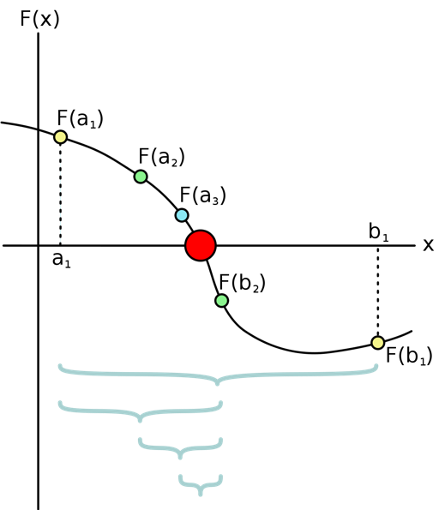

Source: <https://scondemth361.wordpress.com/root-finding-method/>

Fig. 2. Bisection method

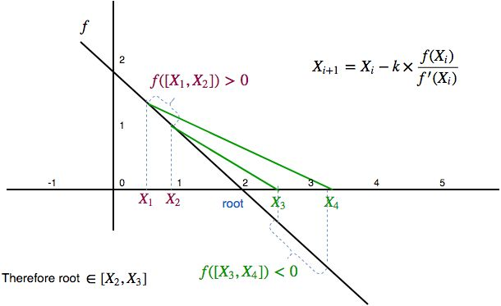

Fig. 3. Initial estimator

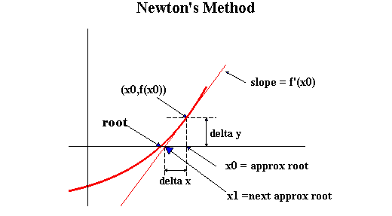

Source: <http://www.ms.uky.edu/~carl/ma123/kob98/kob98htm/chap15e.html>

Fig. 4. Newton method

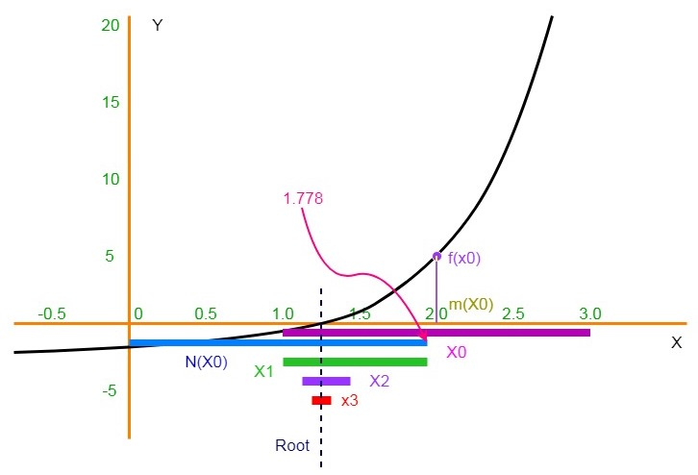

Source: <https://www.researchgate.net/figure/The-Moore-Newton-interval-method-geometrical-interpretation_fig1_323747154>

Fig. 5. Newton interval method

**Problem statement and motivation. Please provide a general description of the problem that you worked on, a short description of why this is relevant, and a few sentences that state precisely what you aimed at:**

In safety critical systems (SCS) (Figure 1), it is of particular importance that the risk of errors is made negligible. Such systems are used in a broad area of applications, including medical devices, railway brake systems, aircraft-controls, traffic lights, weapons and nuclear systems. In general, all new technological applications have some form of SCS built in. The level of risk differs in these applications: financial loss or human life can be a result of a wrong assessment in SCS. The liability of such systems implies the importance of maintaining high quality by constant improvement. In SCS, the prior goal is to find an accurate solution in least computational time possible. Existing rigorous algorithms are able to provide an exact solution however, they require a high computational cost. Therefore, in order to decrease the time taken to generate the solution, non-rigorous algorithms are most often used. The non-rigorous algorithm should maintain high accuracy by validating the approximate solution and in the same time remain efficient in terms of the time taken to execute.

Therefore, we aim to develop an algorithm that verifies, whether an approximate solution is sufficiently close (nearby) to the exact root (real solution), in order to take advantage of time efficiency of non-rigorous algorithms and the accuracy of rigorous methods. To accomplish this not only it is desirable to proof that the true solution is in the neighborhood of the approximation but also to obtain the interval that is small enough. To achieve the latter, method called contracting will be used. This method allows to make bounds of an interval tighter, without changing the solution.

Software was developed using open-source C++ library Ariadne (<http://www.ariadne-cps.org>) and can be used in the Python interface, that has a functionality for verifying solutions and provides us with rigorous numerics . Ariadne allows to perform calculations with double precision floating-point, which means that with the use of this library we will be able to accurately store 15-17 significant digits in the decimal part. Consequently, this tool will let us to perform calculations very accurately, which is crucial for SCS.

One of the methods that was studied for root finding was the bisection method (Figure 3) that takes a function defined on an interval, for which function evaluated for the upper and lower bound takes the opposite signs. According to the intermediate value theory, in such case there need to be the root somewhere in that interval. This method repeatedly divides the interval in two, hence “bisects” the interval by computing the middle point, for which function is evaluated and depending on its sign at that point, the new interval (subinterval) is established for the next step. Therefore, the interval is reduced by 50% every time. These steps are repeated until the interval is sufficiently small, that is we converged to the root.

Unfortunately, despite the fact that this method is quite simple and robust it is very time inefficient for our purpose. Therefore, the method that we decided to implement selects the initial bound first and then by contracting converges to the root. Methods used for this algorithm are Newton Method (Figure 4) and Newton Interval Method (Figure 5), which are the approximate and the rigorous methods, respectively. Initial bound estimator algorithm is shown in the Figure 3. This method allows a user to provide a point, for which the function is evaluated. Using a simple equation (the Newton step) provided on the graph, second point is calculated and the sign of the function is evaluated for this point. If the sign is the same for both, we project the points using the Newton step again, for *k* greater than 1. In the figure, evaluating function for X3 and X4 shows, that function is strictly negative for that interval. Therefore, according to previously mentioned intermediate value theorem, the root must be somewhere between X2 and X3, yielding the initial bound, for which we are able to use the contractor and eventually converge to the root. This way we perform the validation of the provided approximation and proof that the root is indeed, nearby.

**Research questions and/or hypothesis: explain the questions/hypothesis that you addressed during your project:**

Main research problem that will be examined is:

*Can we validate a given approximation by proving the existence of a real solution ’nearby’?*

In the project we aimed at answering the following research questions:

* How will we identify an initial estimator or initial box for the true solution?
* What is an appropriate notion of "nearby"?
* How can we find the approximations of one dimensional cases?
* How can we use our method in multidimensional cases?
* How can we improve the initial bounds on the solution?

**Major outcomes of your project. Please provide up to seven major outcomes of your project. These should be formulated in a clear but compact way:**

* Implementation of the dimensional method that validates the exact/real solution near the approximate solution. Part of that method is designing the algorithm that provides the initial estimator (input) to the contractor. Therefore, by contracting we will be able to improve the initial bounds by finding a smaller interval that contains a root.

**References: Provide possible references you are using in your text in the APA standard. Use e.g. Google Scholar to obtain references in the correct format:**

Jaulin, L., Kieffer, M., Didrit, O., & Walter, E. (2001). *Applied interval analysis*. Springer-Verlag London.

Cais, Š. (2015). *Assessing and improving quality of safety critical systems.* Západočeská univerzita v Plzni.

Moore, R. E. (1966). *Interval analysis*. Prentice-Hall, Inc.

Burden, R. L., & Faires, J. D. (2010). *Numerical analysis*. Cengage Learning, 9.

**To be filled by supervisors (dear supervisors: delete what you do not want):**

◻ I agree that this project is posted on the DKE student projects webpage. (Feel free to make any modifications to the text/material provided by your students.)

◻ I agree that the final project report is uploaded to the DKE student projects webpage.

◻ I agree that the final presentation is uploaded to the DKE student projects webpage.

◻ I agree that movies provided by the students are uploaded to the DKE Youtube channel and shown on the DKE student projects webpage.