**Table-1 (bugresistance)**

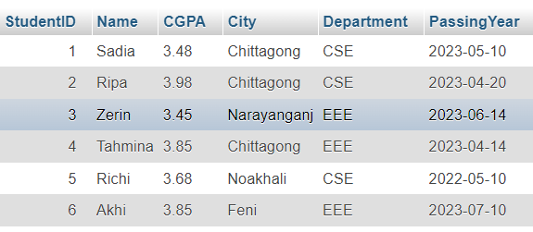

**Table-2: (bugresistance_teacher)**

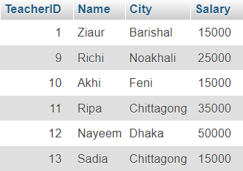

**Inner Joint Query**

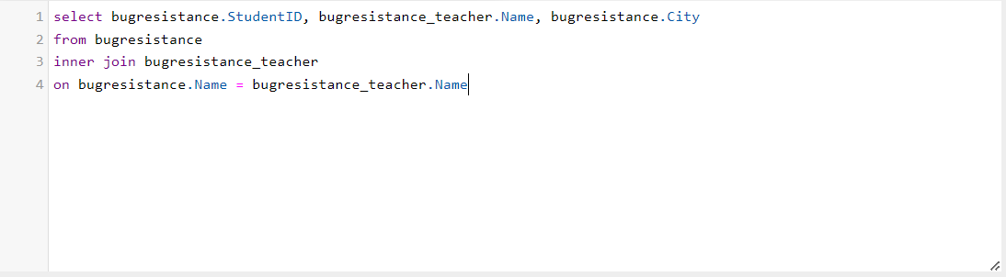

**Output**

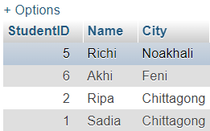

**Left Joint Query**

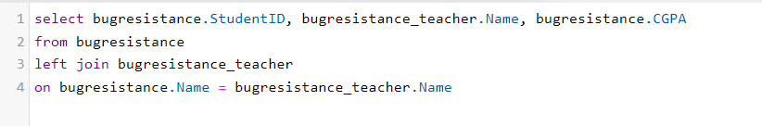

**Output:**

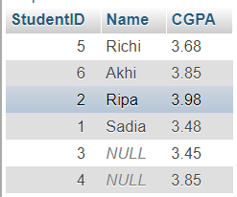

**Right Joint Query:**

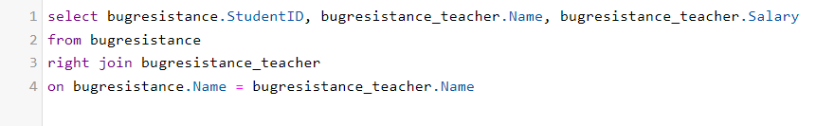

**Output:**

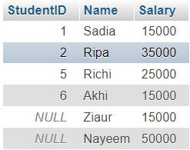

**Full Outer Joint Query:**

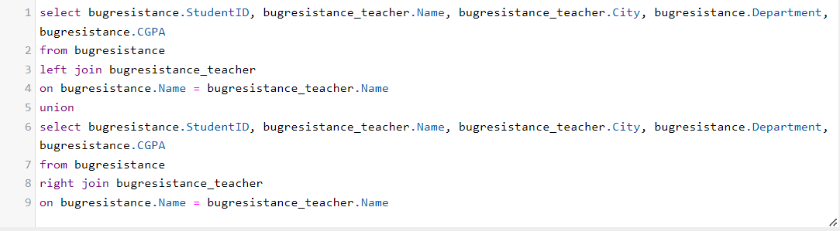

**Output:**

