**DS 501: STATISTICAL AND MATHEMATICAL METHODS FOR DATA SCIENCE**

REPORT FOR ASSIGNMENT 03

ROLL No.:18L1863

**CASE 1:** Diagonal covariance matrix Σ1 = Σ2 = I

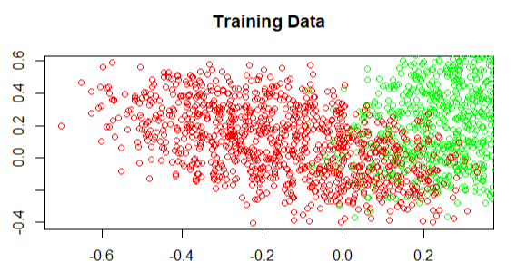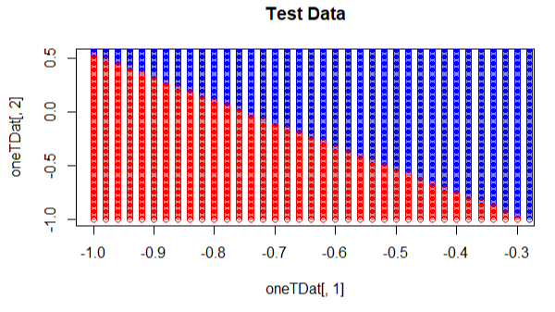

Figure 1(a): Plot of training data, for class 1 Figure 1(b): Plot of decision boundary

and class 2 and the mistakes

Here the table shows the MAP probabilities and predicted labels for the first 3 test points

|  |  |  |  |
| --- | --- | --- | --- |
| **No.** | **MAP probability:**  P(C=0|**x**) | **MAP probability**  P(C=1|**x**) | **Predicted label** |
| 1 | 0.385604 | 0.614396 | 1 |
| 2 | 0.8086006 | 0.1913994 | 0 |
| 3 | 0.5325342 | 0.4674658 | 0 |

Table 1: MAP probabilities for case 1

**CASE 2:** Common covariance matrixΣ1 = Σ2 = Σ

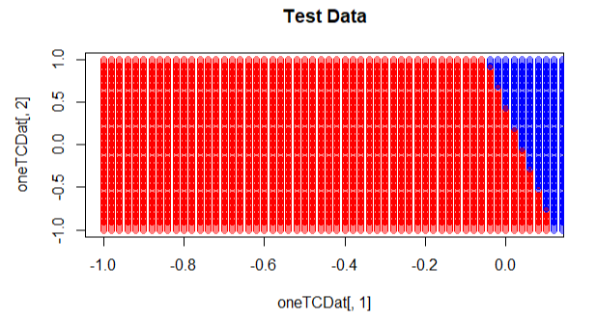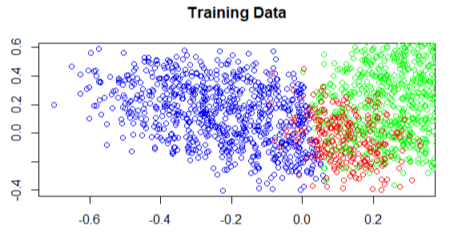

Figure 2(a): Plot of training data, for class 1 Figure 2(b): Plot of decision boundary

and class 2 and the mistakes

The table shows the MAP probabilities and predicted labels for the first 5 test points for case 2

|  |  |  |  |
| --- | --- | --- | --- |
| **No.** | **MAP probability:**  P(C=0|**x**) | **MAP probability**  P(C=1|**x**) | **Predicted label** |
| 1 | 0.008802201 | 0.991197799 | 1 |
| 2 | 0.9881458 | 0.01185418 | 0 |
| 3 | 0.05099577 | 0.9490042 | 1 |
| 4 | 0.8129269 | 0.1870731 | 0 |
| 5 | 0.788086 | 0.211914 | 0 |

Table 2: MAP probabilities for case 2

**CASE 3:** Full covariance matrix for both classes

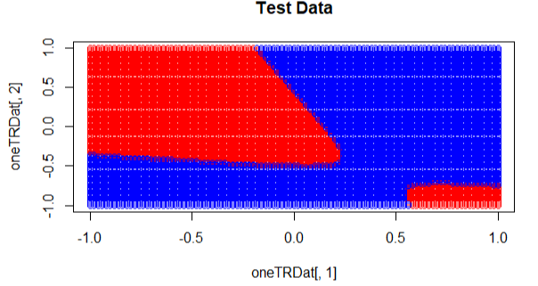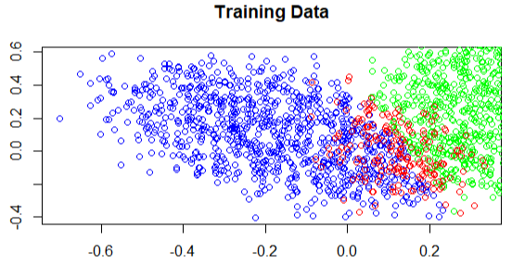

Figure 3(a): Plot of training data, for class 1 Figure 3(b): Plot of decision boundary

and class 2 and the mistakes

Here the table shows the MAP probabilities and predicted labels for the first 4 test points

|  |  |  |  |
| --- | --- | --- | --- |
| **No.** | **MAP probability:**  P(C=0|**x**) | **MAP probability**  P(C=1|**x**) | **Predicted label** |
| 1 | 1.000000e+00 | 5.861444e-10 | 0 |
| 2 | 1.000000e+00 | 8.687032e-20 | 0 |
| 3 | 1.426095e-05 | 0.9999857 | 1 |
| 4 | 0.570659 | 0.429341 | 0 |

Table 3: MAP probabilities for case 1

**Discussion/comparison of results for all cases**

When we used the Identity Covariance, the decision boundary is quite visible and clear. Also, when using the Common Covariance, the decision boundary is also very clear. However, when we used respective Covariance matrices, we can see from the plot that the label = 1 points are on either side of label = 0 points. Thus, in this case we can easily say using Identity Covariance or Common Covariance is more suitable due to a more clear decision boundary in separating both classes for this case. Also, the mistakes are more on Training Data for the Identity Matrix as compared to the other two. In my opinion, using a Common Covariance is the best solution in this case.