Please delete all the italic text before submission. It is here just for your reference.

Further: data set – DS, research question – RQ

The mark (x words) after each subchapter states the word count limit. This indicates the expected amount of information which you can exceed by 10% without losing the mark.

7COM1079-0901-2025 - Team Research and Development Project

Final report title: A Comparison of Mean CWUR( Center for World University Rankings) Scores Between Universities in Asia and Europe

Group ID: A 28

Dataset number: DS 276

Prepared by: Khant Zwe Naing (24073150),
[Name and ID of other group members]

Please make sure the document spelled correctly (including image labels, section headings, and table of contents). Please use correct punctuation.
Make sure your report is grammatically correct.

University of Hertfordshire
Hatfield, 2025

Table of Contents add page numbers from here

- Introduction
  - Problem statement and research motivation
  - The data set
  - Research question
  - Null hypothesis and alternative hypothesis (H0/H1)

- Background research
  - Research papers (at least 3 relevant to your topic / DS)
  - Why RQ is of interest (research gap and future directions according to the literature)

- Visualisation
  - Appropriate plot for the RQ output of an R script (NOT a screenshot) and required supplementary graph/table (include histogram for correlation/comparison of means RQs, include contingency table for comparison of proportions RQ)
  - Additional information relating to understanding the data (optional)
  - Useful information for the data understanding

- Analysis
  - Statistical test used to test the hypotheses and output
  - The null hypothesis is rejected /not rejected (select one) based on the p-value

- Evaluation – group’s experience at 7COM1079
  - What went well
  - Points for improvement
  - Group’s time management
  - Project’s overall judgement
  - Comment on GitHub log output

- Conclusions
  - Results explained.
  - Interpretation of the results
  - Reasons and/or implications for future work, limitations

- Reference list
Harvard (author, date) format.
- Appendices
- R code used for analysis and visualisation.
- GitHub log output.

1. Introduction
  - Problem statement and research motivation (100 words)
University rankings are important tools for evaluating performance and offer valuable information for policymakers and potential students. There are empirical findings that regional differences in geography and economic status affect university quality performance in different regions worldwide (Altbach, 2016; Marginson, 2017). Furthermore, studies suggest that discrepancies in terms of budget, instruction, and worldwide interaction between Asian and European institutions can affect their position in university rankings worldwide (Shin & Kehm, 2013). In this study, using the CWUR(Center for World University Rankings) Scores of universities in Asia and Europe, performance differences between institutions in different continents can be highlighted to contribute to knowledge about inequalities in worldwide higher education.

  - The data set (75 words)
This research uses a CWUR dataset, which has been produced by a third-party institution, categorizing universities worldwide in terms of education quality, employment of their graduates, research production, and worldwide reputation. This data set has variables like institution, world rank, publications, region, and CWUR Score. For this research, Region (Asia and Europe) will be the independent variable, with CWUR Score as the dependent variable. This data set provides a sufficient sample for a comparative study between Asia and Europe.
  - Research question (50 words).
The research question for this study is: “Is there a difference in the mean CWUR Score between universities located in Asia and universities located in Europe?” This question aims to examine whether geographic region is linked to measurable changes in overall university performance, using CWUR Scores as a standardised indicator of institutional quality and global standing.
State your RQ (50 words)
  - Null hypothesis and alternative hypothesis (H0/H1) (100 words)
To address this research question, the study defines two hypotheses.
H0 (Null Hypothesis): There is no difference in the mean CWUR Score between universities in Asia and universities in Europe, suggesting regional factors do not influence overall ranking performance.
H1 (Alternative Hypothesis): There is a difference in the mean CWUR Score between universities in Asia and Europe, indicating region may play a role in institutional outcomes.

Because CWUR Score is continuous and the region variable has two groups, a comparison-of-means test is required. Depending on normality, this will be either a t-test or Mann-Whitney U test.

- Background research
  - Research papers (200 words)

A number of studies in recent years used the CWUR data set to examine regional inequalities in university rankings. Kumar and Rajani in 2025 compared India’s top 10 universities with world leaders in various university systems, including CWUR. The authors found that CWUR rankings showed a small performance divide between Indian and foreign universities, proposing that CWUR lean towards emerging regions in their rankings, given their emphasis on education quality and job readiness.

Zeng, in a study from 2024, analyzed a period of a decade for CWUR rankings for top Asian universities like Tsinghua, NUS, and Tokyo. He found that though these universities experienced improvement in QS and THE rankings, their performance in CWUR rank improvement was relatively modest. This, of course, has to do with the distinct set of priorities in CWUR.

A study published by World Bank authors Demirgüç-Kunt and Torre in 2022 analyzed how country-level CWUR rankings differ in a European and Central Asian perspective. Their results showed that, in CWUR rankings, European nations, especially the Netherlands, scored higher than Asian nations. This indicates a comparative advantage in CWUR ranking in favor of Europe.

Cumulatively, these studies suggest that CWUR reflects true but subtle regional variations, making it a good data set for investigating differences in average performance between Asia and Europe.

  - Why RQ is of interest (research gap and future directions according to the literature) (100 words)

Although studies of world rankings are common, there are very few that compare regions based on CWUR data. Most studies were done using QS, THE, and/or ARWU data. There are also different metrics used in CWUR rankings, including alumni job and education quality, which result in different values for different world regions. Recent studies indicate that Asian institutions are making progress in certain world rankings, yet their improvement in CWUR rankings remains insignificant. This raises a question of whether there are significant differences in the average scores of Asia and Europe aggregated from CWUR data.

- Visualisation
  - Appropriate graphs for the RQ output of an R script (NOT a screenshot) (50 words)

In relation to a means/medians type of research question, we would employ a boxplot of CWUR Score vs. Region, as well as a histogram of CWUR Score with a normal curve distribution. While a boxplot will pair a comparison of the two groups, a histogram will facilitate a determination of normality in order to select an appropriate test.

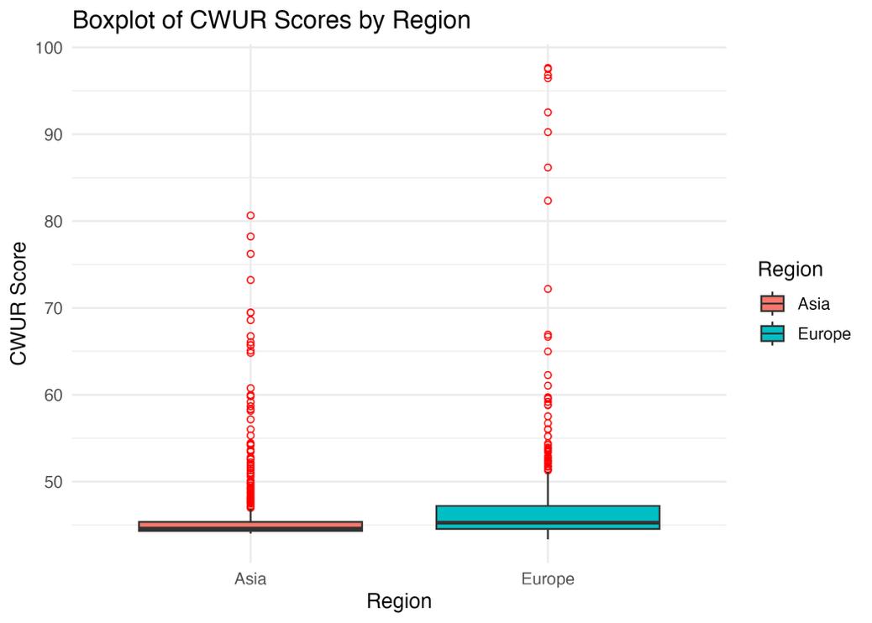
Figure 1 Boxplot of CWUR University Scores by Region (Asia and Europe).
The figure shows the distribution of CWUR Scores for universities in Asia and Europe. The median and upper quartile are higher for European universities, suggesting that they tend to achieve higher overall CWUR Scores than Asian universities. Outliers indicate very high-scoring institutions in both regions.
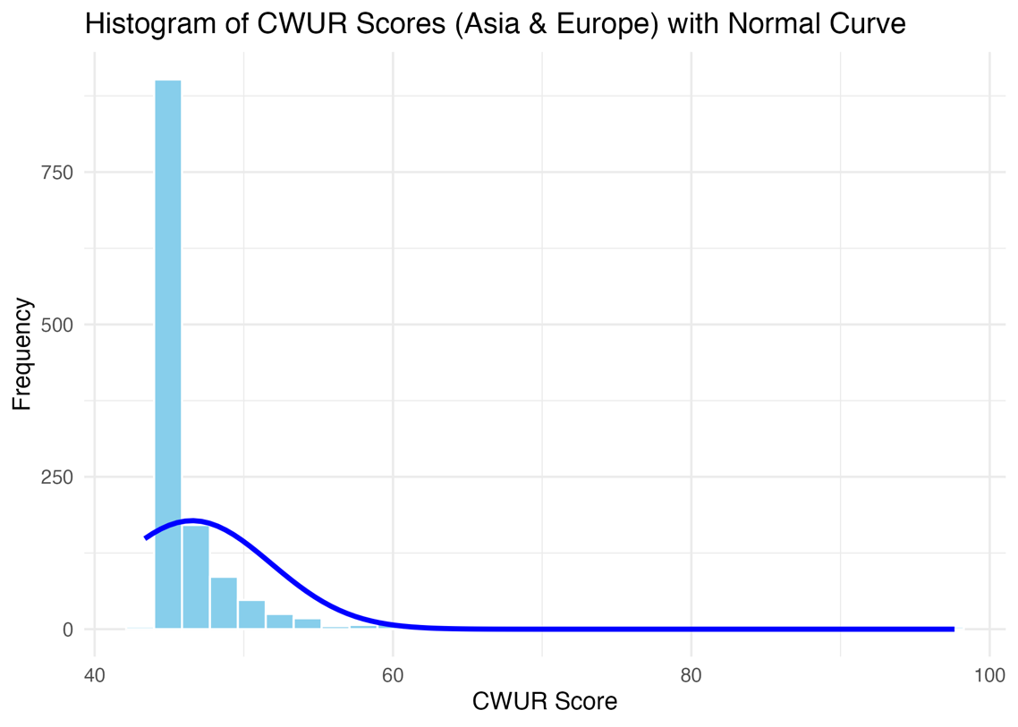

- Explain the choice of the plot.
- Include your main plot relevant to the RQ type.
- Include histogram or contingency table (think what is suitable) in addition to the main plot.
- Anything on the plot from R is not counted towards word count limit (e.g. legend, axes titles, name).
- Make sure that the plot is from output of an R script (NOT a screenshot).
- Make sure that the plot has a caption or title, X and Y-axis labels with units where appropriate, and legend.
- Make sure the title or caption and axis labels are informative and written in English.

  - Additional information relating to understanding the data (optional) (50 words)
- Per plot: explain the purpose and insights.

  - Useful information for the data understanding (50 words)
- Summarise key observations from the plot.

- Analysis
  - Statistical test used to test the hypotheses and output (75 words)
This research compares the differences in CWUR Scores between two independent groups of institutions, those in Asia and those in Europe. Since CWUR Score is a continuous data type, it would be analyzed using means and/or median values. Also, from a graph consisting of a histogram with a normal curve, it appears that this data distribution has a significant skew, which suggests that a non-parametric test alternative to the t-test, using the Mann-Whitney U test, would be most relevant in this analysis. The value of U for Score by Region was found to be about 146,660.5, with a p-value of 1.16×10^-19.
- Explain the choice of the statistical test.
- Make sure the test is appropriate for the RQ and data.

  - The null hypothesis is rejected /not rejected based on the p-value (100 words) (interpret the results)

The null hypothesis states that there are no differences in CWUR Scores between institutions in Asia and those in Europe. Although the research question refers to mean CWUR Scores, the Mann-Whitney U test compares the distributions (medians) of the two groups, which is appropriate when the data are not normally distributed. The p-value given by the Mann-Whitney U test result is about 1.16e-19, which is less than 0.05. Therefore, we conclude that there are differences in CWUR Scores between the two continents by rejecting the null hypothesis in favor of the alternative. Since a higher minimum value corresponds to a better performance in ranking, it can also be inferred from a box plot in R that European institutions are able to secure higher CWUR Scores than Asian ones.

- Evaluation – group’s experience at 7COM1079
  - What went well (75 words)
A number of components of this project went as planned. We began with a research question that matched “comparison of means/medians” concepts and stayed with it. We utilized a rubric with a report template regularly to verify that it contained all necessary components and stayed under the allocated words. Collaboration occurred in regards to data preparation, R-code writing, and text composition in a fair manner, with members assisting in understanding concepts of CWUR variables, Region categorizing, as well as understanding Mann-Whitney U test findings.
  - Points for improvement (75 words)
Although it has been a positive experience, some points are to be improved. A lot of time was spent on honing in on the research question and analyzing data, which left little time for writing and editing of the report. The incorporation of checks for assessing project progression and preliminary proofreading would also be helpful. Moving forward, for other projects, we would set internal deadlines for the completion of every component, delegate tasks earlier, and dedicate additional time for testing additional visualizations, as well as different techniques for determining regions and variables.
  - Group’s time management (50 words)
There has been improvement in time management as the project progressed. The early activities were undertaken in a reactive manner, but then there has been a focus on tasks including data handling, R programming, literature review, and writing. Although there were a few analyses and editing tasks close to deadlines, deadlines were met for all necessary plot preparation, testing, and report writing.
  - Project’s overall judgement (50 words)
On a whole, this project served its purpose. We focused on a specific research question using the prescribed CWUR dataset, produced relevant visualizations, and identified a proper test for our data that was non-parametric and matched our data distribution. This project has boosted our knowledge in forming a research question, identifying a statistical test, and presenting data in an organized way.
  - Note any changes to group since original allocation if applicable. Add new or amended GitHub Ids for new members (75 words, write only if applies to your group arrangements)
There were no changes in the group members from the original plan, and no new GitHub ID was introduced. Every group member actively contributed to data exploration, R programming, result interpretation, and editing of the final report.
  - Comment on the GitHub log output (50 words)
Please comment on the GitHub log output, and refer to it as being placed into Appendix B.
From your Git log, select three most significant commits during this project and include the following for each:
- Commit Message: [Insert Commit Message] Brief explanation of the broader impact of the change
- Commit Message: [Insert Commit Message] Brief explanation of the broader impact of the change
- Commit Message: [Insert Commit Message] Brief explanation of the broader impact of the change

- Conclusions
  - Results explained (75 words)
This study focused on a comparison of CWUR Scores between Asian and European universities. Box plots reveal that European universities score higher. Since it follows a skewed and non-parametric distribution, a Mann-Whitney test needs to be used. Result: U =~146,660.5; p =~1.16e-19.
  - Interpretation of the results (75 words)
- Interpretation of what the results mean in terms of your RQ and the effect this may have on your population and the wider context of your topic.
The very small p-value means we reject the null hypothesis and conclude that CWUR Scores for Asian and European universities are significantly different. The boxplot suggests that European universities tend to achieve higher CWUR Scores than Asian universities in this dataset. This finding is consistent with literature that reports regional differences in higher education performance and resources. It suggests that regional context, such as funding models and historical academic development, may influence how universities perform in global ranking systems like CWUR.
  - Reasons and/or implications for future work, limitations of your study (50 words)
This study is limited to one ranking system, one time period, and a specific selection of Asian and European countries, so the results may not generalise widely. Future work could include other regions, compare multiple rankings, add further variables, and investigate which factors drive regional score differences.

- Reference list (not included in the word count)
Harvard (author, date) format.

- Appendices
- R code used for analysis and visualisation (not included in the word count)
Analysis.R code with the appropriate statistics to test the hypotheses.
- No word count, but ensure the code is without redundant lines, well-commented and produces the correct output.
- Make sure it runs (look in Rscript.log for output from a statistical test)
- It should compute appropriate statistics to test the hypotheses
- GitHub log output.

