BlinkStick is an USB-controlled smart pixel. It is an easy and fun way to build a notification light for your computer. You control your Blinkstick by using programming commands.

## YOU’LL NEED

* BlinkStick kit
  + Circuit Board (1)
  + Diodes (2)
  + Resistors (3)
  + Capacitor (2)
  + USB Plug (1)
  + IC socket (1)
  + ATTiny85 Chip (1)
* Soldering Iron
* Solder
* Cutters

## STEP 1 – SOLDER DIODES

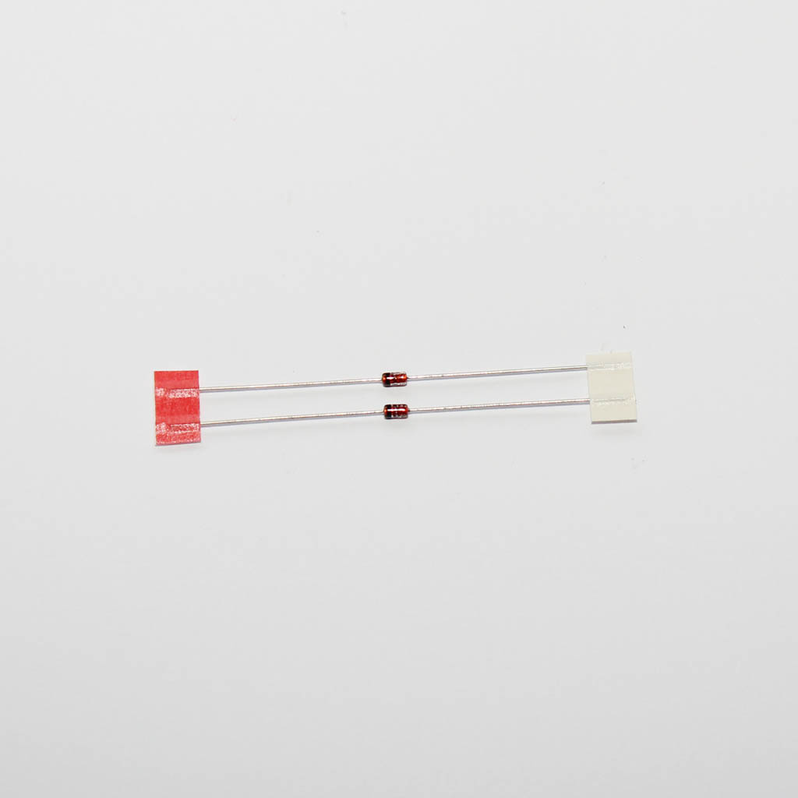Solder zener diodes D1 and D2. Make sure the polarity is correct! The black stripe on the diode is represented by a white stripe on the component's symbol.

Bend diode pins as close to the diode as possible and then bend the pins outwards once inside the board so that they stay secure in the location when soldering.

Solder the diodes and cut the excess wire near the solder joint. Use the same technique when soldering the rest of the components.

## STEP 2 – SOLDER RESISTORS

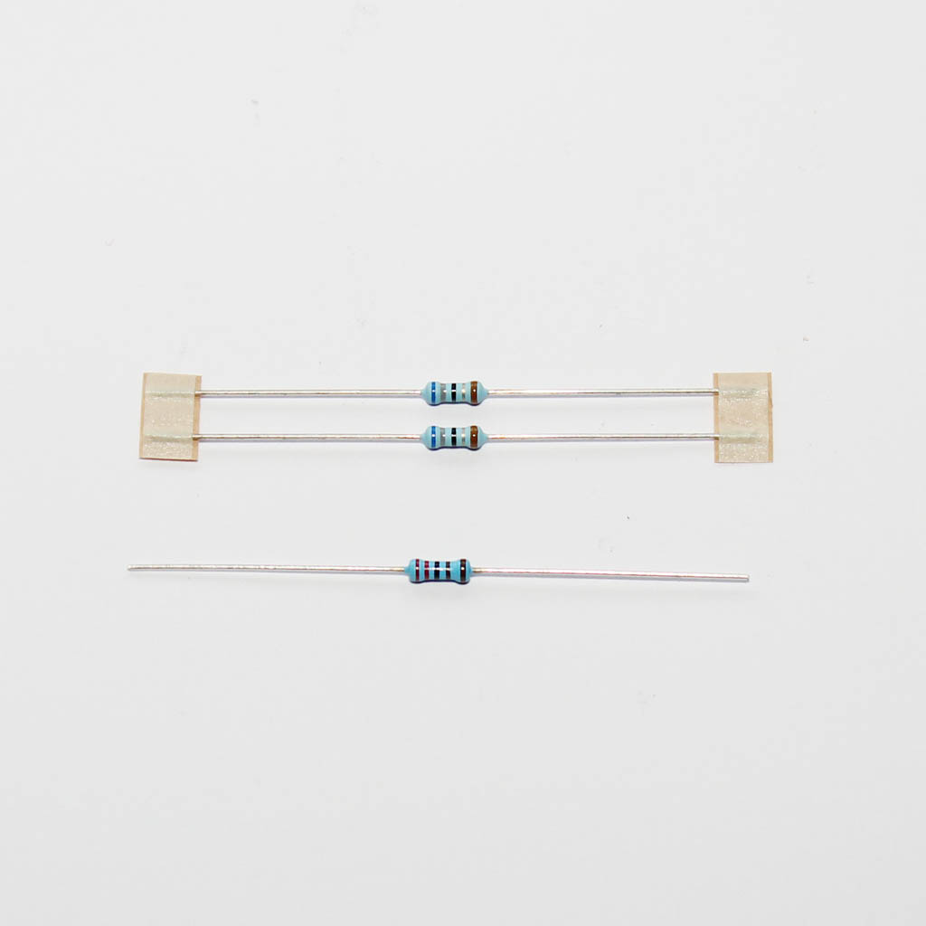There are 2 types of resistors:

R1, R2 (68 Ohms) banded with blue, gray, black, gold, brown

R3 (2.2 kOhms) banded with red, red, black, brown, brown

Remember to bend resistor pins outward so that they stay in their locations.

## STEP 3 – SOLDER CAPACITOR C1

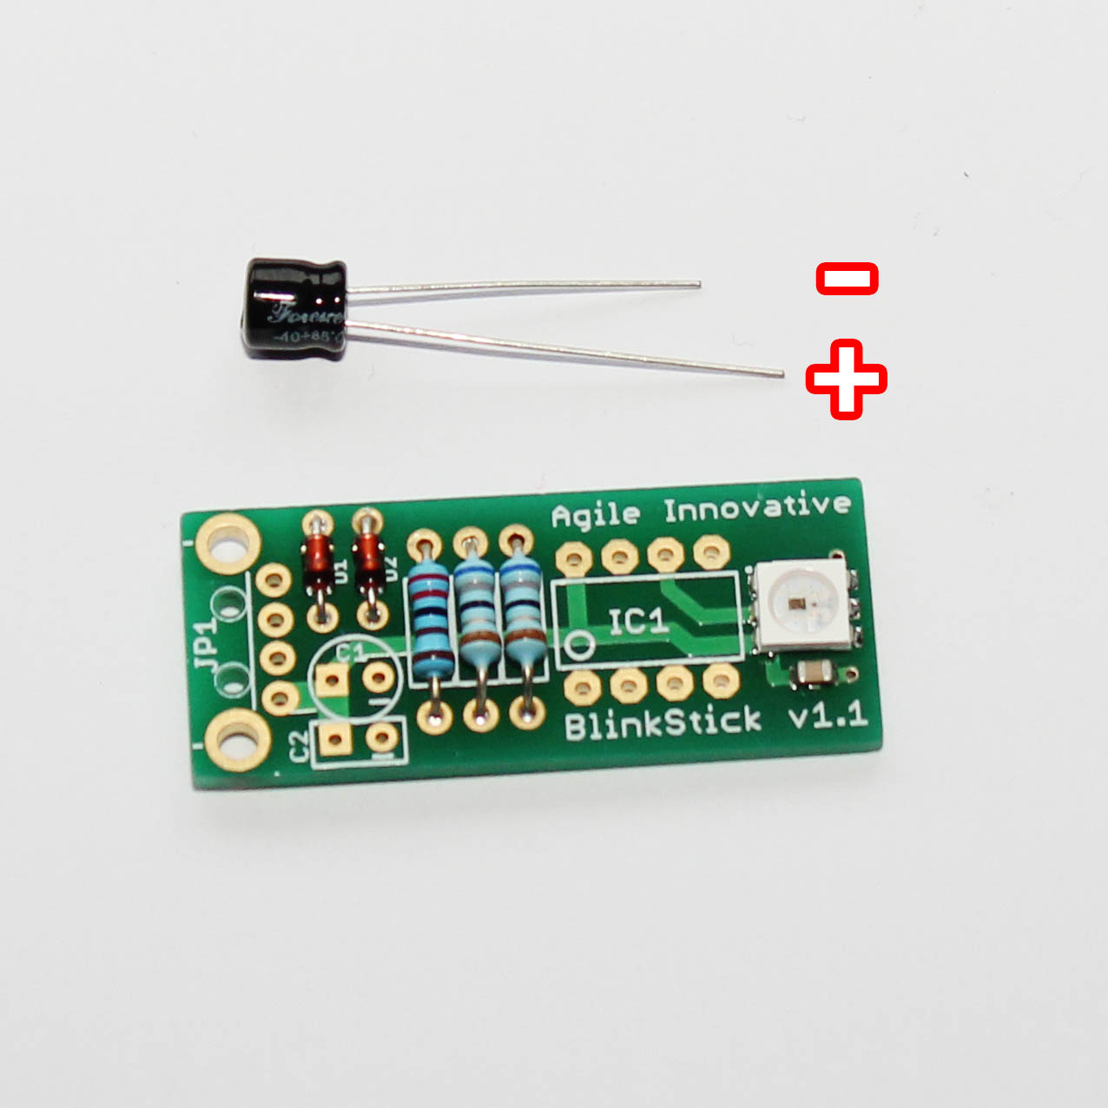Solder the electrolytic capacitor C1.

Capacitors have polarity and the longer pin is positive.

The negative pin is displayed on the board with a minus sign next to it.

## STEP 4 – SOLDER CAPACITOR C2

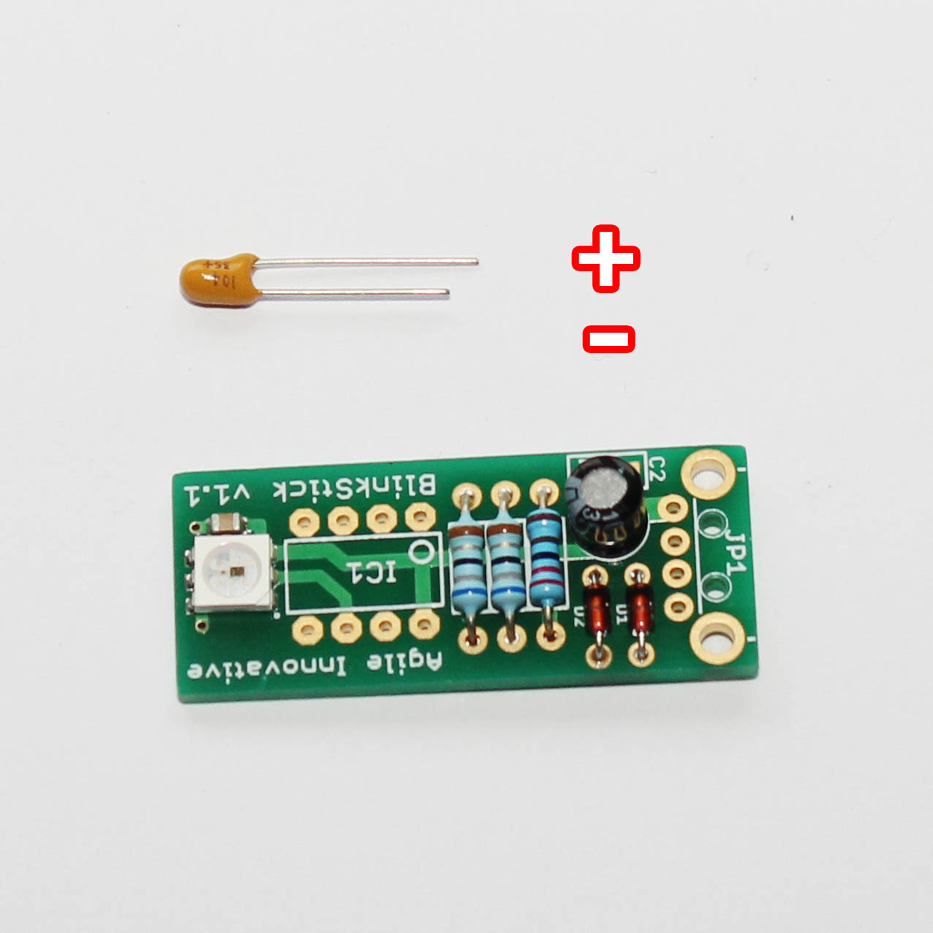Solder the tantalum capacitor C2.

It also has polarity as displayed in the picture with longer pin being positive and shorter - negative.

## STEP 5 – SOLDER USB PLUG

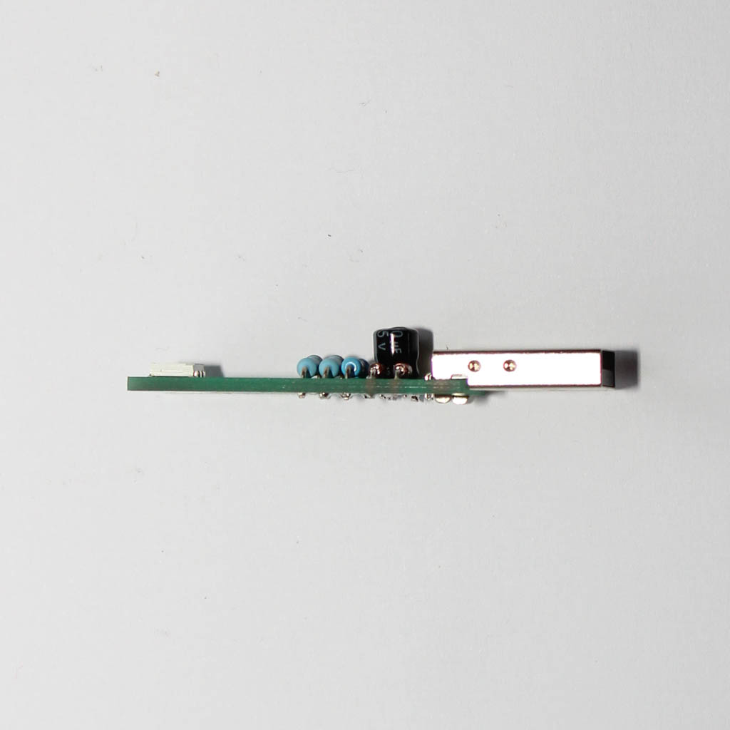Solder USB plug JP1.

The board and the plug should be nice and straight.

## STEP 6 – SOLDER IC SOCKET

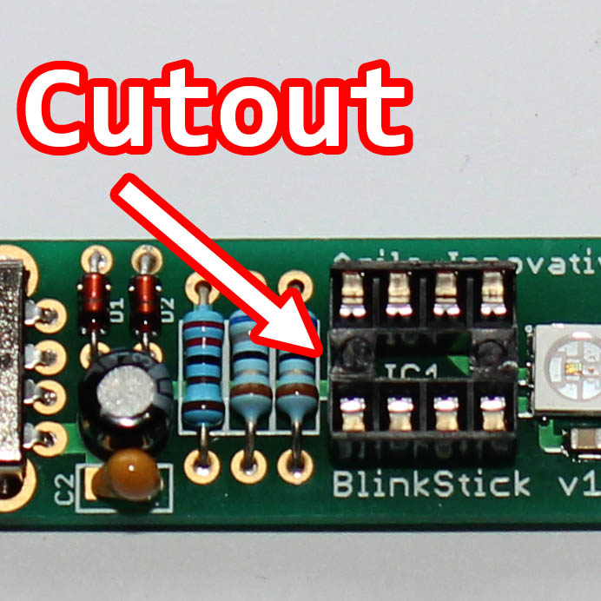The socket has a cut-out on one edge. It should be aligned as displayed in the image.

The ATTiny85 chip will be placed into the socket at a later step.

## STEP 7 – PLUG IN ATTiny85

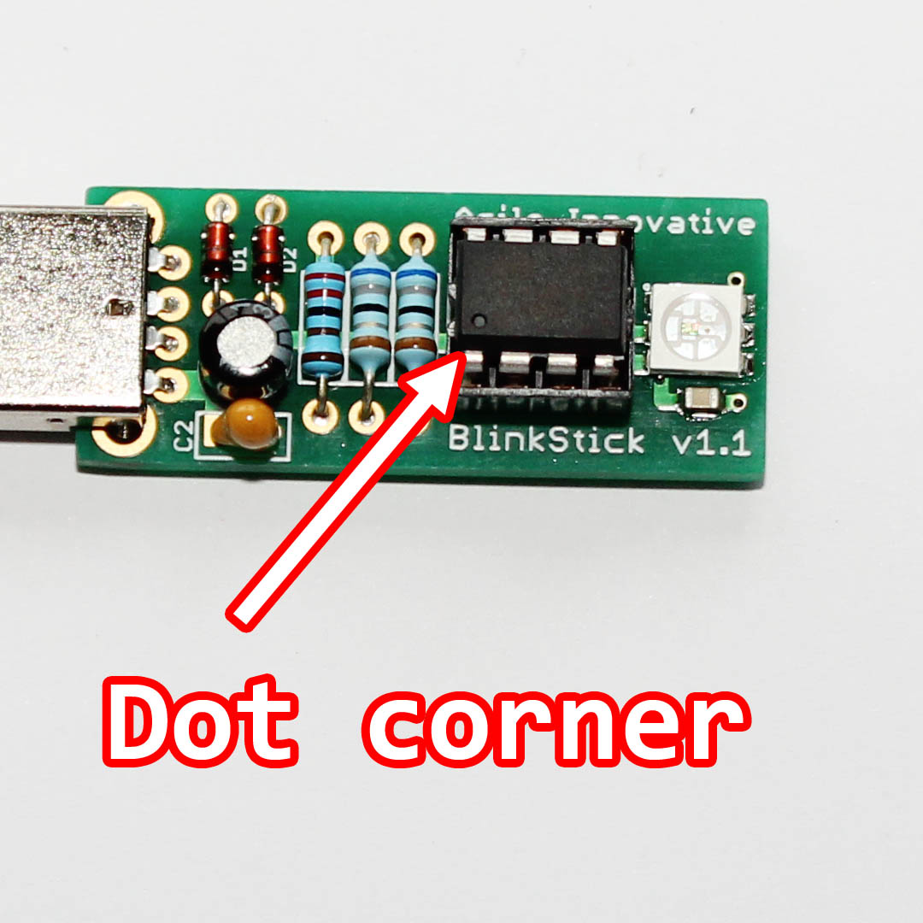Plug in the ATTiny85 IC into the socket. Make sure that you plug the chip correctly!

The dot on the chip should match the second image.