**Learner’s Academy**

1. **Introduction**

**Project objective:**

As a Full Stack Developer, design and develop a backend administrative portal for the Learner’s Academy. Use the GitHub repository to manage the project artifacts.

**Background of the problem statement:**

Learner’s Academy is a school that has an online management system. The system keeps track of its classes, subjects, students, and teachers. It has a back-office application with a single administrator login.

1. **Project Planning**
   * + - The project is to be completed in two sprints.
       - The resources available for this project is (2):

1 Developer & 1 Tester.

1. **Technologies & Concepts used in Project**
   * + - Java EE
       - Servlets
       - JSP
       - Hibernate
       - MySql
       - HTML5
       - CSS3
       - JSTL
       - JSP EL
       - Listeners
       - Exception Handling
       - OOP
       - Collections
       - Streams
       - Data Structures

and more...

1. **Application Entities**

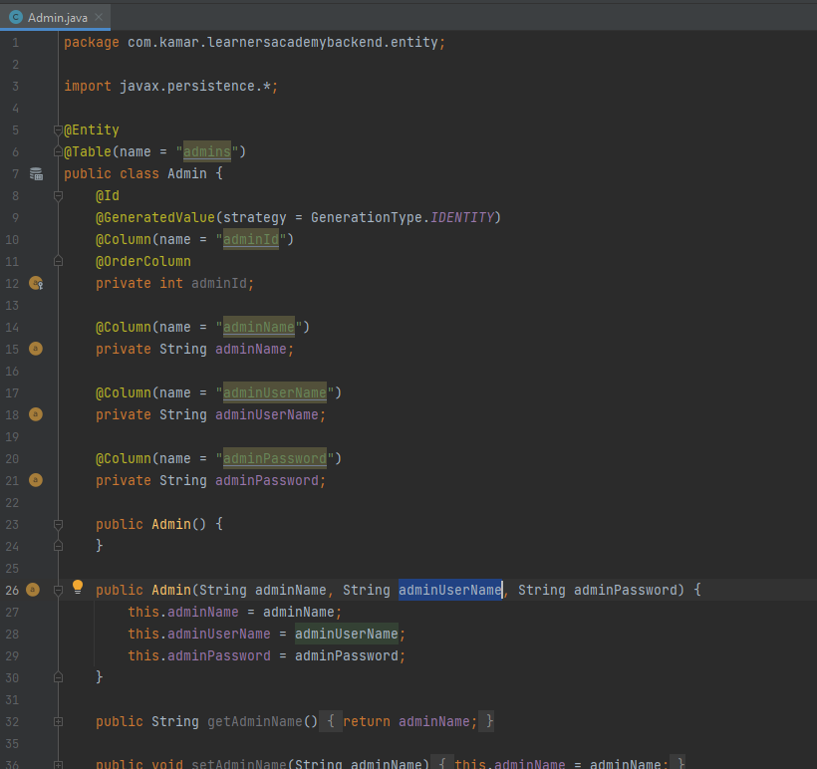

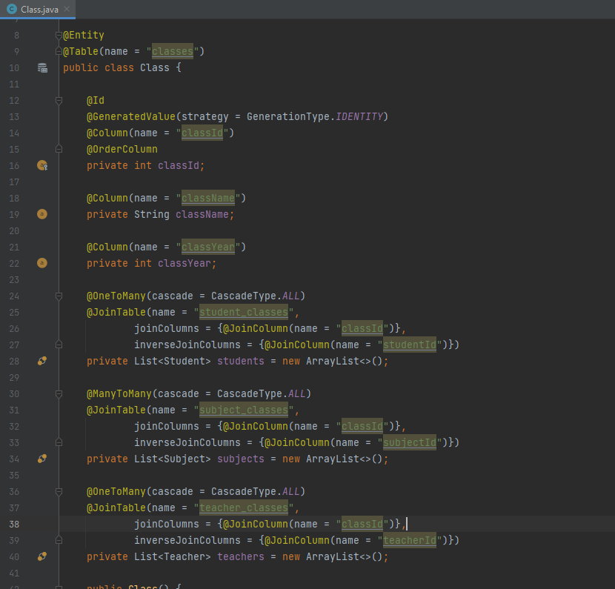

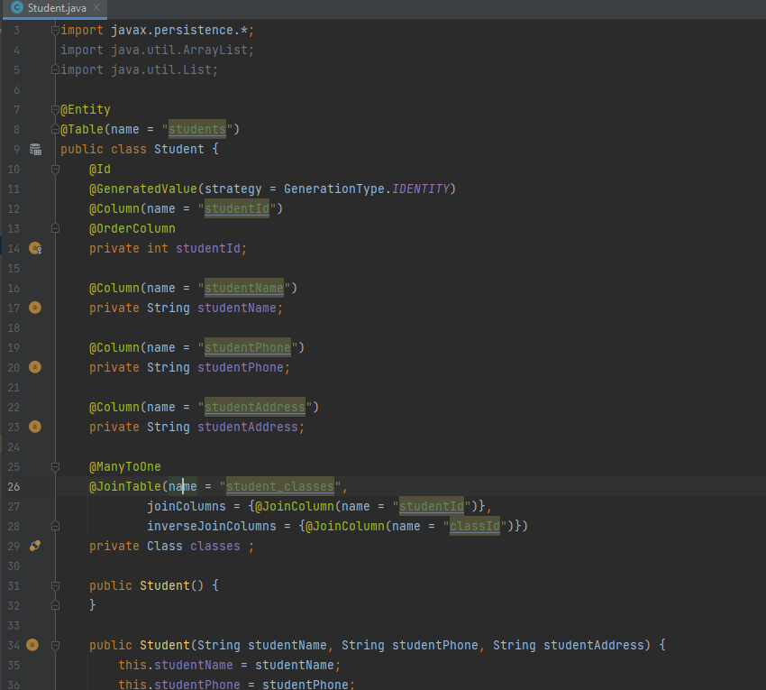

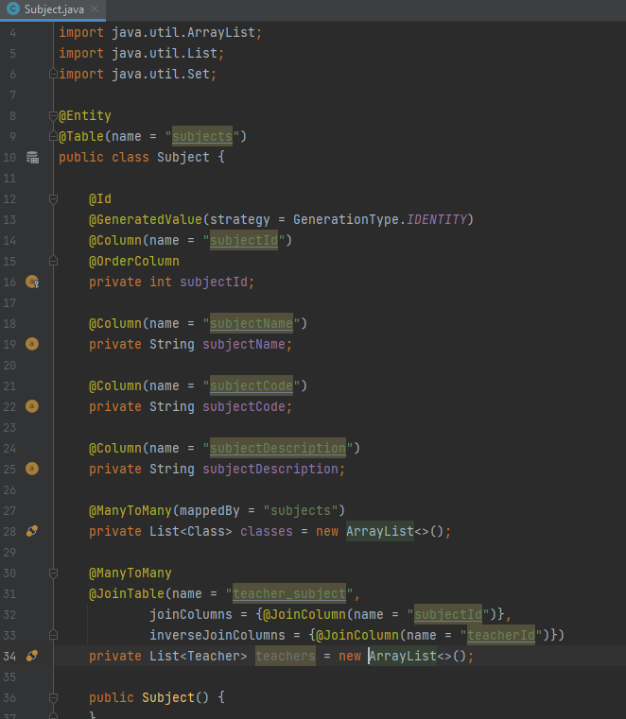

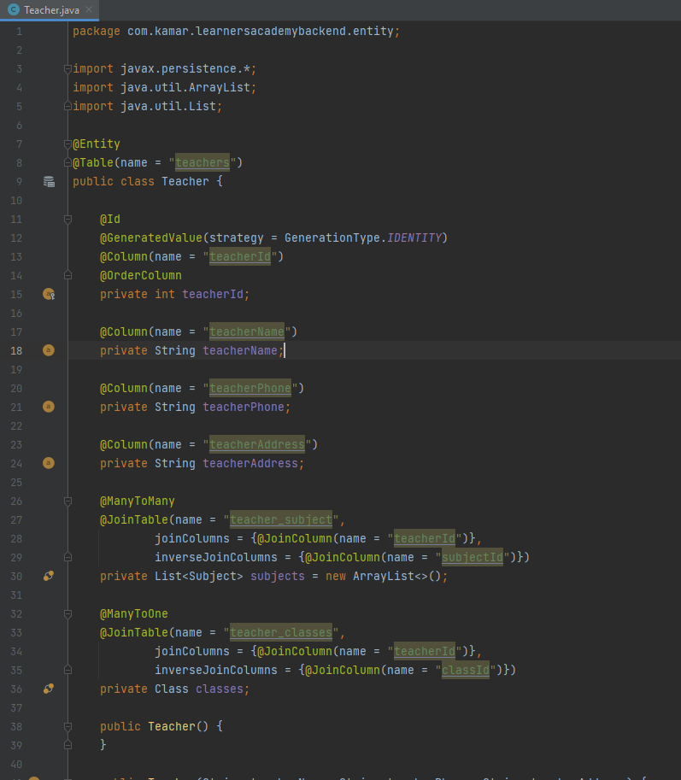

1. **ERD**

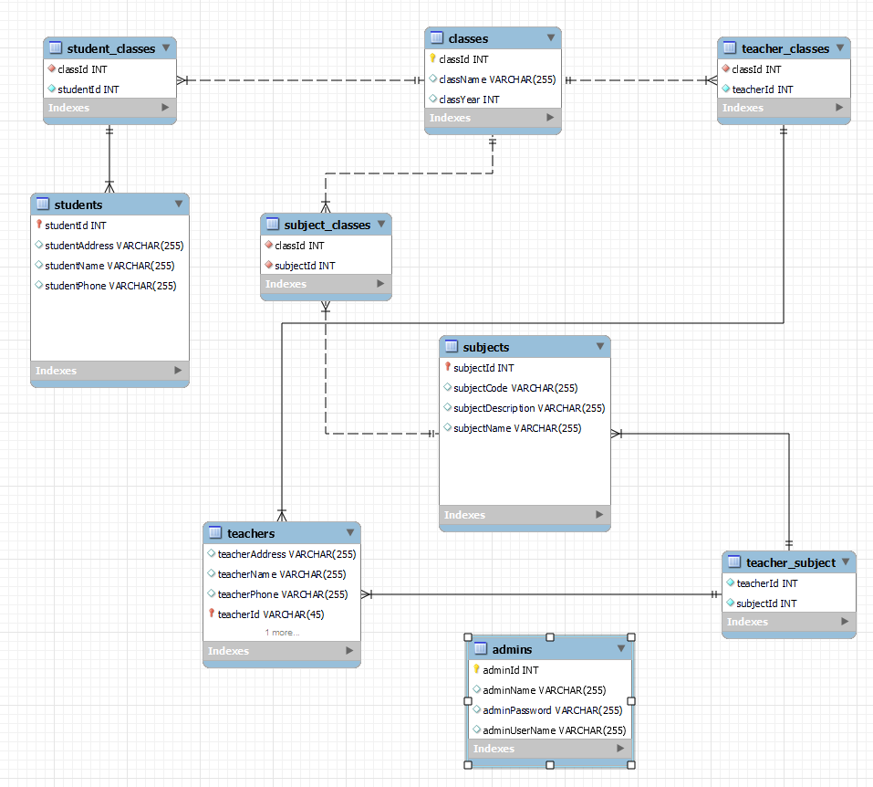

1. **Create Admin user If does not exist**

