SUPERSTORE SALES ANALYSIS
Exploratory Data Analysis & Power BI Dashboard Report
DEVIXO SOLUTIONS | DATA SCIENCE INTERNSHIP
Project focus: Retail sales, profitability, customers, products, regions, discounts, and shipping performance.

KPI Summary
KPI | Previously reported value | Calculation
Total Sales | 1,064,046.04 | Sum of Sales
Total Profit | 120,000.72 | Sum of Profit
Total Quantity | 17,407 | Sum of Quantity
Average Discount | 15.67% | Average of Discount
Profit Margin | 11.28% | Total Profit / Total Sales
Note: These are previously shared summary figures, not independently recalculated here. Verify them against the final refreshed Power BI dataset. Currency/unit was not specified.

1. Executive Summary
This project analyzes a Superstore-style retail dataset to understand sales, profitability, product quantity, discounts, customers, regions, and shipping patterns. Data preparation and exploratory analysis support the development of an interactive Power BI dashboard.
The summary figures previously shared for the working dataset are Total Sales of 1,064,046.04, Total Profit of 120,000.72, Total Quantity of 17,407, Average Discount of 15.67%, and an overall Profit Margin of approximately 11.28%. These figures must be checked against the final cleaned Power BI model before submission. The currency or unit was not specified.

2. Project Objectives
Inspect dataset structure, fields, data types, missing values, and duplicate records.
Clean order and shipping dates and validate numerical fields.
Summarize sales, profit, quantity, discounts, orders, and customers.
Compare performance by category, sub-category, region, customer segment, product, and month.
Examine shipping duration and unusual observations.
Build a Power BI dashboard for business performance monitoring.

3. Dataset Overview
The working dataset includes order, shipping, customer, geographic, and product information. Fields discussed include Row ID, Order ID, Order Date, Ship Date, Ship Mode, Customer ID, Customer Name, Segment, Country, City, State, Postal Code, Region, Product ID, Category, Sub-Category, Product Name, Sales, Quantity, Discount, and Profit.
Each row represents a product line in an order. An Order ID can appear on multiple rows when an order contains multiple products; repeated Order IDs are not automatically duplicates.

4. Data Cleaning and Preparation
Recommended preparation steps in Power Query include checking column names, assigning correct data types, reviewing missing values, checking exact duplicate rows, trimming and cleaning text, and validating date conversions.
Use Date for Order Date and Ship Date; Text for IDs and Postal Code; Decimal Number for Sales, Profit, and Discount; Whole Number for Quantity and Row ID; and Text for descriptive fields.
Interpret dates consistently with the source file. The sample values such as 11/8/2016 follow the US date convention (November 8, 2016). Confirm the source locale before converting all dates.
Keep unverifiable Postal Code values blank. Do not replace missing business measures with zero or guessed values. Remove duplicates only when the complete records are duplicates.

5. Feature Engineering
Shipping Days = Ship Date minus Order Date. Order Year and Order Month can be derived from Order Date.
Profit Margin = Profit divided by Sales. In Power BI, use DIVIDE([Total Profit], [Total Sales], 0) and format the result as Percentage. Do not multiply by 100 when using Percentage formatting.

6. KPI Definitions
Total Sales = SUM(Sales). Total Profit = SUM(Profit). Total Quantity = SUM(Quantity). Total Orders = distinct count of Order ID. Total Customers = distinct count of Customer ID. Average Discount = average of Discount. Profit Margin = Total Profit divided by Total Sales. Average Order Value = Total Sales divided by Total Orders.

7. Power BI Dashboard Design
Recommended KPI cards: Total Sales, Total Profit, Total Orders, Total Quantity, Profit Margin, and Average Discount.
Recommended visuals: monthly sales line chart; sales by category and sub-category; sales by region; profit by category or region; sales by customer segment; Top 10 products; and a product table showing Sales, Profit, and Quantity.
Recommended slicers: Order Date, Region, Category, Segment, and Ship Mode. A separate Profit Analysis page can show profit by sub-category, products with negative total profit, and Discount versus Profit.

8. Preliminary Findings
The previously supplied figures indicate positive total profit and an overall profit margin of approximately 11.28%. Average discount was reported as approximately 15.67%, assuming discounts are stored as decimal fractions such as 0.15.
The reported total quantity is 17,407. These summary figures do not establish which category, region, segment, or product performed best. Such conclusions must be based on actual Power BI charts or grouped tables.

9. Business Recommendations
Monitor sales and profit together because high sales do not always mean high profitability.
Review products and sub-categories with negative total profit for potential pricing, discount, or cost issues.
Compare discount levels with profit to assess whether promotions support profitable sales.
Track monthly sales to identify stronger and weaker periods for inventory and campaign planning.
Compare regions and customer segments to identify areas needing attention.
Monitor shipping duration and shipping modes to identify possible delivery delays.
Use dashboard slicers to investigate performance by date, region, category, segment, and shipping mode.

10. Limitations and Validation
This report is based on project details and summary metrics previously shared. The complete cleaned source file and final Power BI grouped results were not available for independent recalculation while preparing this report.
Before submission, refresh the Power BI model and verify KPI totals against the final dataset. Confirm row count, missing values, duplicate count, date range, currency/unit, and category and region rankings. Add screenshots of the final charts and use only findings supported by those visuals.

11. Conclusion
The Superstore dataset supports retail sales and profitability analysis because it includes transaction dates, customer and product details, geographic fields, sales, quantity, discount, and profit. Power Query supports data preparation, while Power BI presents results through interactive KPIs, charts, and slicers.
The report is ready for final validation once the KPI totals are reconciled with the refreshed Power BI model and category-, product-, region-, and month-level conclusions are supported by actual results.

Appendix: Suggested Power BI DAX Measures
Total Sales = SUM('Superstore'[Sales])
Total Profit = SUM('Superstore'[Profit])
Total Quantity = SUM('Superstore'[Quantity])
Total Orders = DISTINCTCOUNT('Superstore'[Order ID])
Total Customers = DISTINCTCOUNT('Superstore'[Customer ID])
Average Discount = AVERAGE('Superstore'[Discount])
Profit Margin = DIVIDE([Total Profit], [Total Sales], 0)
Average Order Value = DIVIDE([Total Sales], [Total Orders], 0)

Dashboard 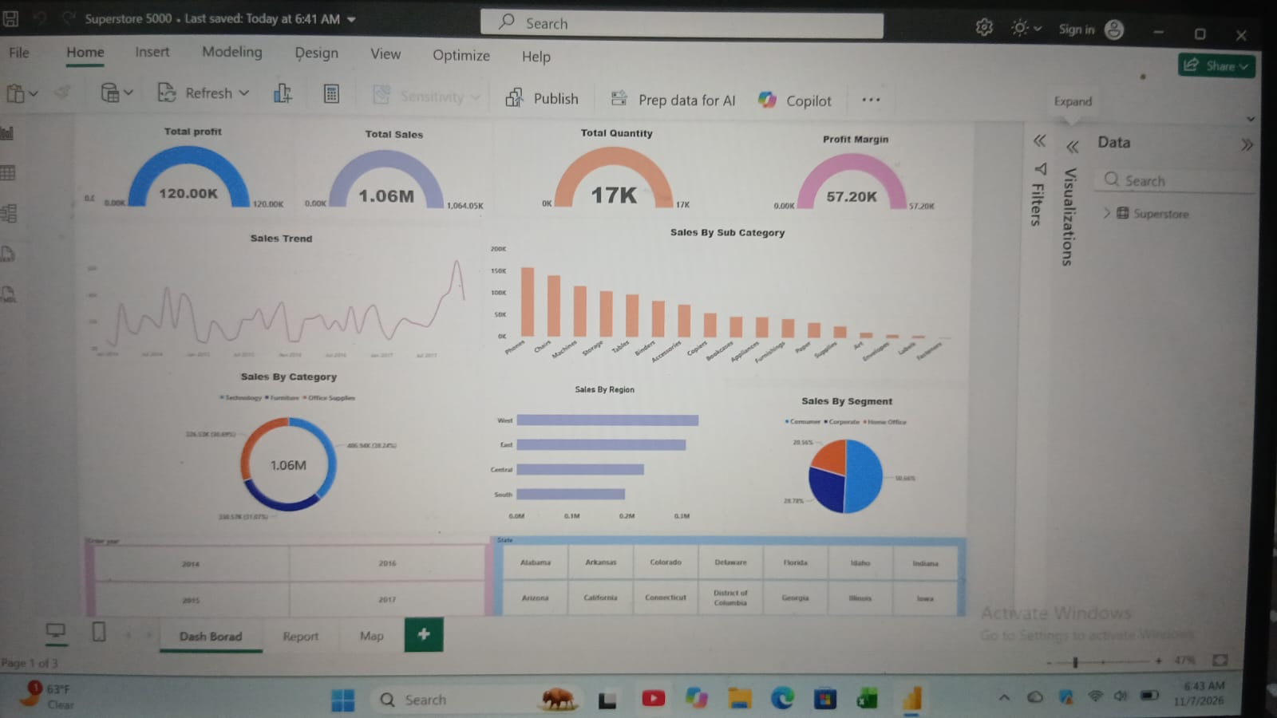

Summary
"This Superstore Dashboard analyzes 1.06M in sales from 2014 to 2017. Technology is the leading category with 38.48% sales, Phones are the top-selling sub-category, and the West region performs best. Consumers contribute 50.64% of total sales, making them the key segment. Despite strong sales, profit is only 120K, which highlights a need to improve profit margin and control costs in Furniture and Office Supplies."

