PROJECT REPORT

Superstore Sales
Exploratory Data Analysis
Python Analysis and Power BI Dashboard Plan

Program | Data Science Internship
Organization | The Sky Gen
Task | Task 03 Sales Dash Board
Tools | Python, Pandas, NumPy, Matplotlib, Seaborn, Power BI
Report prepared from the dataset metrics and project details shared by the user. Category-level and time-series findings should be completed from the final Power BI visuals.

1. Executive Summary
This project applies Exploratory Data Analysis (EDA) to a Superstore sales dataset to understand sales performance, profitability, product quantities, discounts, customers, regions, and shipping patterns. Python is used for data inspection, cleaning, descriptive analysis, and visualization. Power BI is planned as the interactive reporting layer for business users.
The summary metrics provided during the analysis are shown below. These figures should be rechecked against the final cleaned dataset before formal submission; the currency and unit are not specified here, so the financial totals are presented in the dataset's recorded units.
KPI | Reported Value | Calculation / Note
Total Sales | 1,064,046.0419 | Sum of Sales
Total Profit | 120,000.7178 | Sum of Profit
Total Quantity Sold | 17,407 | Sum of Quantity
Average Discount | 15.67% | Mean of Discount; source values appear to be decimal fractions
Profit Margin | 11.28% | Total Profit divided by Total Sales

Key takeaway
The provided totals indicate an overall positive reported profit and an approximate 11.28% profit margin. This is an overall result only; category, product, region, and monthly findings must be based on the finalized analysis output.

2. Project Objectives
- Inspect the dataset structure, columns, data types, missing values, and duplicate records.
- Clean date and numerical fields without inventing or guessing data values.
- Summarize sales, profit, quantity, discounts, orders, and customers.
- Explore performance by category, sub-category, region, customer segment, product, and month.
- Use charts to identify patterns, unusual observations, and questions for further analysis.
- Design an interactive Power BI report that helps users explore business performance.

3. Dataset Overview
The dataset is a Superstore-style retail order dataset. Columns shown in the working data include order details, shipping details, customer and geographic information, product classifications, and sales values. The following fields are relevant to this project:
Field / group | Purpose in analysis
Order ID, Customer ID, Customer Name | Count distinct orders and customers; explore customer-level sales.
Order Date, Ship Date, Ship Mode | Monthly trend analysis and shipping-duration checks.
Category, Sub-Category, Product Name | Compare product groups and identify high/low sales or profit.
Region, State, City | Compare geographic performance.
Segment | Compare sales and profit across customer segments.
Sales, Profit, Quantity, Discount | Core performance metrics and numerical relationship analysis.

4. Methodology and Data Preparation
- Load the CSV in Python or Power BI and inspect the available columns and row count.
- Convert Order Date and Ship Date into date types; convert Sales, Profit, Quantity, and Discount into numerical types where those columns exist.
- Check missing values and duplicates. Investigate invalid dates or data type conversion failures before making changes.
- Do not fill missing Profit, Quantity, or Discount with zeros or random values. Recover the original values from a trusted source when possible.
- For monthly analysis, exclude rows with missing Order Date from the time-based visual only; retain the rows for analyses that do not depend on Order Date.
- Calculate KPIs using measures or group-by summaries and compare the final values with the report.
Data-quality warning
Earlier calculations returned zero or NaN for Profit, Quantity, and Discount after empty columns were created. Later totals were provided for these fields. Before submitting, verify that these later values came from genuine source data and that the final Power BI file uses the same cleaned dataset.

5. Exploratory Analysis and Visualizations
The project uses the following visualizations. Each visual should be accompanied by a short interpretation based on the actual chart generated from the final dataset.
Visualization | Fields / design | Question answered
Sales distribution histogram | Sales; histogram with optional KDE | Are sales values concentrated in lower ranges or spread evenly?
Area chart | Order Date by month; Sales by Category | How do category sales move over time?
Violin plot | Category vs Sales | How are sales values distributed within each category?
Boxplot | Category vs Profit | What are the median, spread, and potential profit outliers?
Pair plot | Sales, Profit, Quantity, Discount | Which numerical variables appear to vary together?
Line chart | Month on axis; Total Sales as value | Which months have stronger or weaker sales?
Bar charts | Sales / Profit by Category, Sub-Category, Region, Segment | Which groups contribute most to sales or profit?
Product table | Product Name, Sales, Profit, Quantity | Which products have the highest sales or lowest total profit?
Shipping duration | Ship Date minus Order Date | How many days pass between order and shipment?

6. KPI Definitions for Power BI
KPI | Recommended DAX measure | Notes
Total Sales | Total Sales = SUM('Superstore'[Sales]) | Sum of sales values.
Total Profit | Total Profit = SUM('Superstore'[Profit]) | Requires reliable Profit values.
Total Quantity | Total Quantity = SUM('Superstore'[Quantity]) | Requires reliable Quantity values.
Average Discount | Average Discount = AVERAGE('Superstore'[Discount]) | Format as percentage if values are decimals such as 0.15.
Total Orders | Total Orders = DISTINCTCOUNT('Superstore'[Order ID]) | Counts distinct order IDs.
Total Customers | Total Customers = DISTINCTCOUNT('Superstore'[Customer ID]) | Counts distinct customer IDs.
Profit Margin | Profit Margin % = DIVIDE([Total Profit], [Total Sales], 0) | Format as percentage.
Average Order Value | Average Order Value = DIVIDE([Total Sales], [Total Orders], 0) | Sales divided by distinct orders.

7. Power BI Dashboard Design
The recommended Power BI report is a single-page overview with a consistent, uncluttered design. A second detail page can be added later if deeper drill-down is required.
Page area | Visual | Configuration
Top row | KPI cards | Total Sales, Total Profit, Total Quantity, Profit Margin %.
Top / side filter area | Slicers | Order Date, Region, Category, Segment.
Main left | Line chart | Monthly Sales Trend; Order Date by month on X-axis; Total Sales on Y-axis.
Main right | Bar chart | Sales by Category or Sub-Category.
Lower left | Column chart | Profit by Region.
Lower right | Donut chart | Sales by Segment.
Bottom | Table or matrix | Product Name, Sales, Profit, Quantity; sort by Sales descending and optionally filter to Top 10.

Suggested styling: navy or dark blue headings, white canvas, one accent color, consistent number formatting, readable titles, and aligned visual edges. Avoid too many visuals on one page.

8. Preliminary Findings
- The supplied total sales figure is 1,064,046.0419 in the source dataset's units.
- The supplied total profit figure is 120,000.7178 in the source dataset's units.
- The supplied total quantity is 17,407 units or line-level quantity units as recorded.
- The average discount is approximately 15.67%, assuming the source stores discounts as fractions such as 0.15.
- Using the supplied sales and profit totals, Profit Margin = Profit / Sales is approximately 11.28%.
These are confirmed only as values shared during the analysis conversation. Specific statements such as “Technology is the most profitable category” or “West is the top region” have not been included because the actual grouped results were not provided.

9. Recommendations
- Review category and sub-category performance to understand which product groups generate sales and which generate profit.
- Compare sales and profit by region rather than relying on sales alone; investigate areas with high sales but relatively low profit.
- Evaluate the relationship between discount levels and profit. Treat correlation as an association, not proof that discounting causes lower profit.
- Use monthly sales patterns to support inventory planning and promotional calendars, after confirming the date fields are valid.
- Review products with negative total profit using pricing, discounts, and cost information before deciding on corrective action.
- Improve data-quality procedures by checking missing dates, invalid numeric values, duplicate records, and unexpected shipping durations.
- Use Power BI slicers so stakeholders can compare dates, regions, categories, and customer segments interactively.

10. Limitations and Validation
- The exact dataset version, currency, and complete schema were not confirmed in the material provided for this report.
- The final values for Profit, Quantity, and Discount should be checked against the original source file after earlier empty-column issues.
- Monthly and group-level findings depend on valid Order Date, Category, Region, and other relevant fields.
- Potential outliers in boxplots should be investigated, not automatically removed.
- Profit margin calculations assume Sales and Profit are comparable and use consistent units.

11. Conclusion
This project demonstrates a practical workflow for using Python and Power BI to explore Superstore sales data. The analysis covers data quality checks, descriptive metrics, visual exploration, group comparisons, and dashboard planning. The figures provided indicate total sales of 1,064,046.0419, total profit of 120,000.7178, 17,407 units of quantity, and an average discount of approximately 15.67%, with an approximate profit margin of 11.28%.
The Power BI dashboard can turn these metrics into an interactive view of business performance. Before submission, the final dataset should be validated, the category- and region-level chart results should be described in the report, and the Power BI report should be saved as a .pbix file alongside the notebook and cleaned CSV.

Appendix A. Suggested Submission Files
File | Purpose
README.md | Project overview and instructions for GitHub.
Superstore_EDA.ipynb | Python notebook containing cleaning, analysis, and visualizations.
Superstore_Cleaned.csv | Final validated dataset used in analysis.
Superstore_Sales_Dashboard.pbix | Editable Power BI report.
Superstore_EDA_PowerBI_Report.pdf / .docx | Written project report.

Business Question
Are sales values concentrated in lower ranges or spread evenly?

According to this Histogram  Most sales are small (under 500). Only very few big sales up to 20000 | 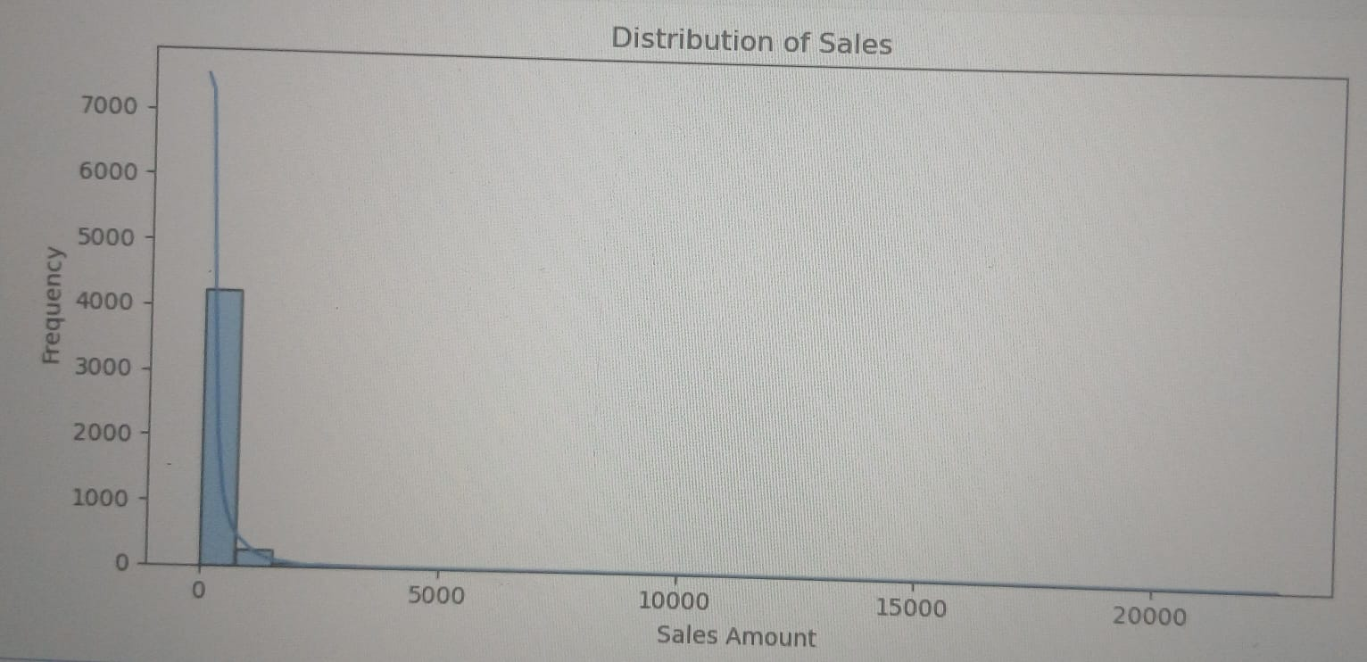
How do category sales move over time?

All 3 categories fluctuate up and down, but Technology dominates the peaks.  Simple movement: Technology (green) - has the biggest spikes. One very high spike ∼25k at start of 2014 and another huge spike ∼30k at end.  It drives total sales. furniture (blue) - also spiky. Has a 20k+ peak in mid of 2014 -11but mostly stays 0-10k  Office Supplies (orange) - most stable but lowest. Usually 0-5k with few spikes to 10k.  Overall trend:  Sales are not stable month-to-month. There are seasonal peaks, and all 3 categories peak together at the end - Dec sales are highest for all. | 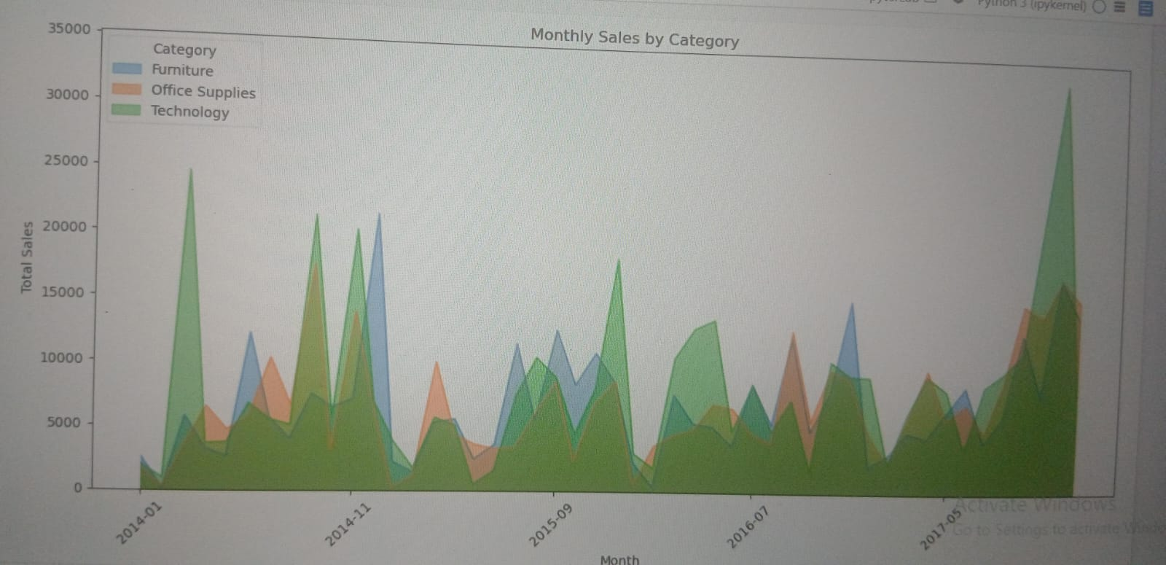

How are sales values distributed within each category?

According to the violin plot  In each category sales are concentrated at low values. Technology has the highest variance and highest single sale, followed by Office Supplies. | 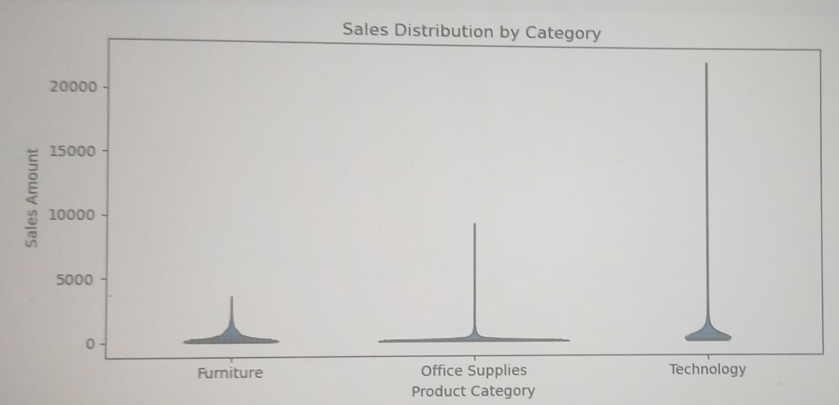

What is the median, spread, and potential profit outliers?
According to the Box plot  Median profit ∼0 for all. Spread is small but Technology has widest spread. Technology and Office Supplies have many high-profit and high-loss outliers, Furniture has almost none. | 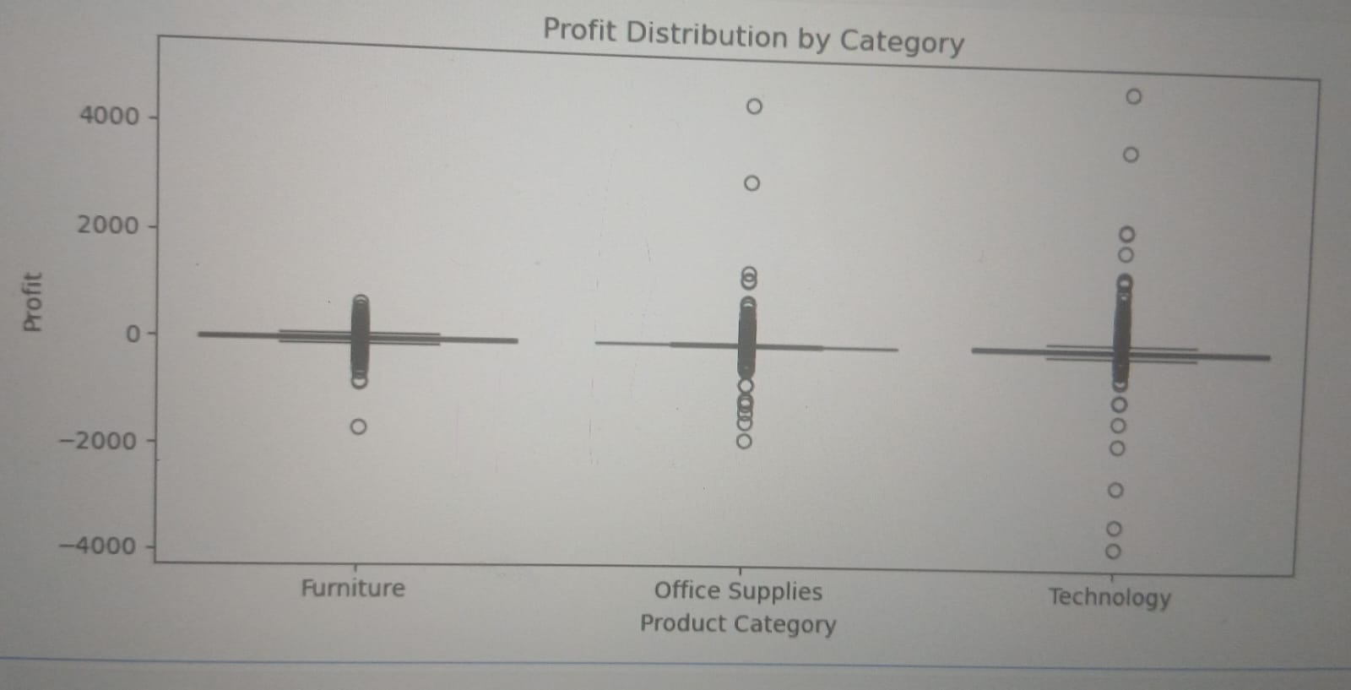

Which numerical variables appear to vary together?
According to these graph  Relationships (scatter plots):  Quantity vs Sales:  Slight positive - when Quantity goes up, Sales also goes up a bit.  Discount vs Profit:  Negative relation - High discount = more negative profit. See bottom-right, as discount goes to 0.8, profit goes down.  Sales vs Profit:  Weak - High sales does NOT mean high profit. You have -2500 loss even on 8000+ sales.  Quantity vs Discount:  High quantity orders often have high discount - bulk orders get discount.  Conclusion  No strong linear correlation between variables. Most important finding is Discount hurts Profit and Sales are not a good proxy for Profit. | 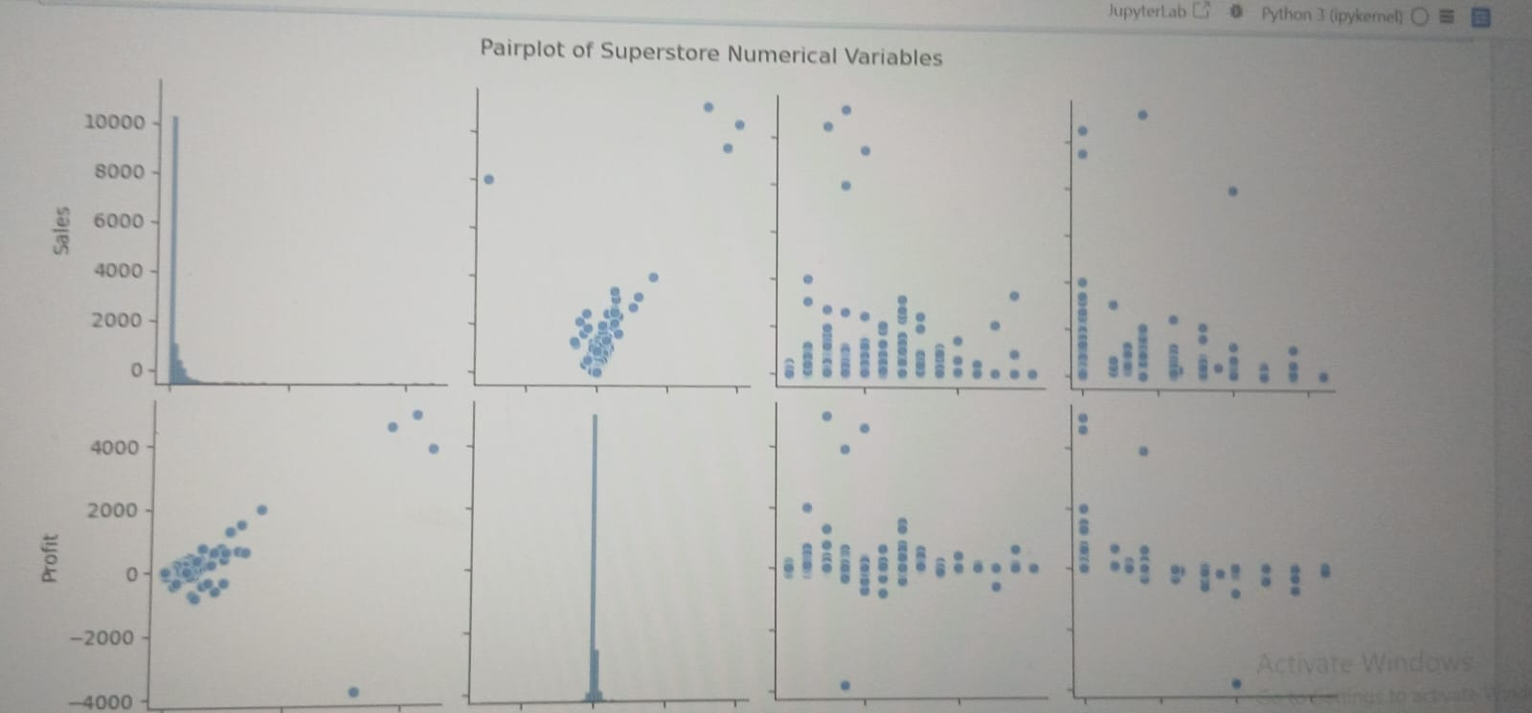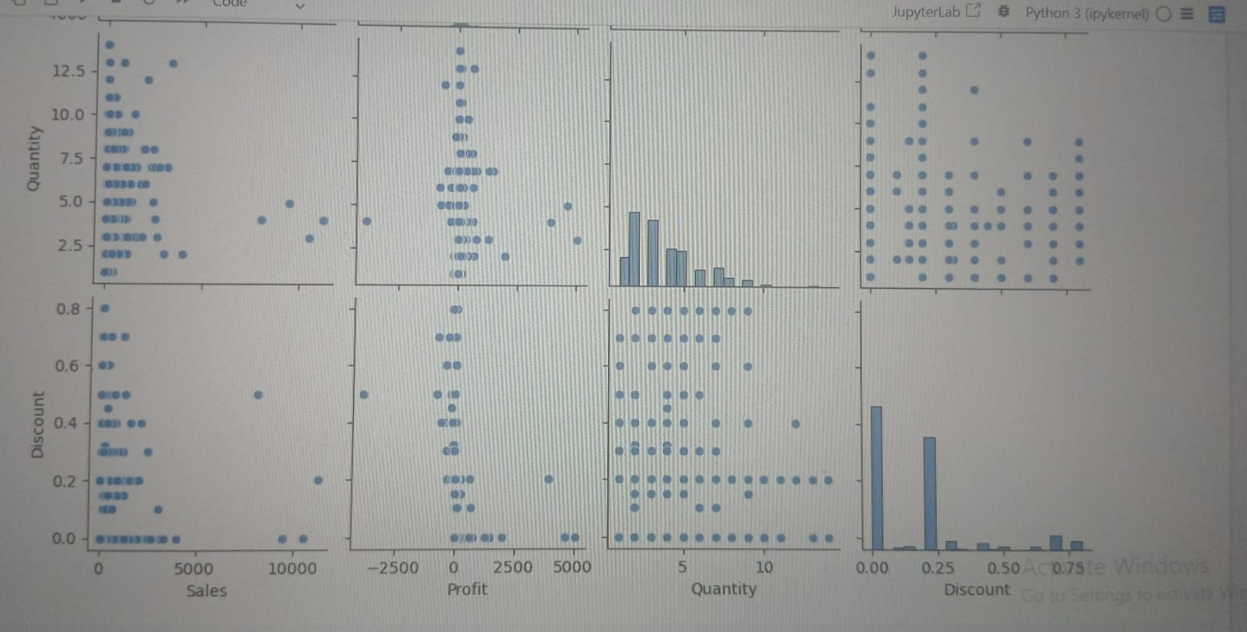

Which months have stronger or weaker sales?
According to this line chart  Sales are seasonal.  Q4 (Oct-Dec) is strongest,  Q1 (Jan-Mar) is weakest  . Customers buy most at year-end. | 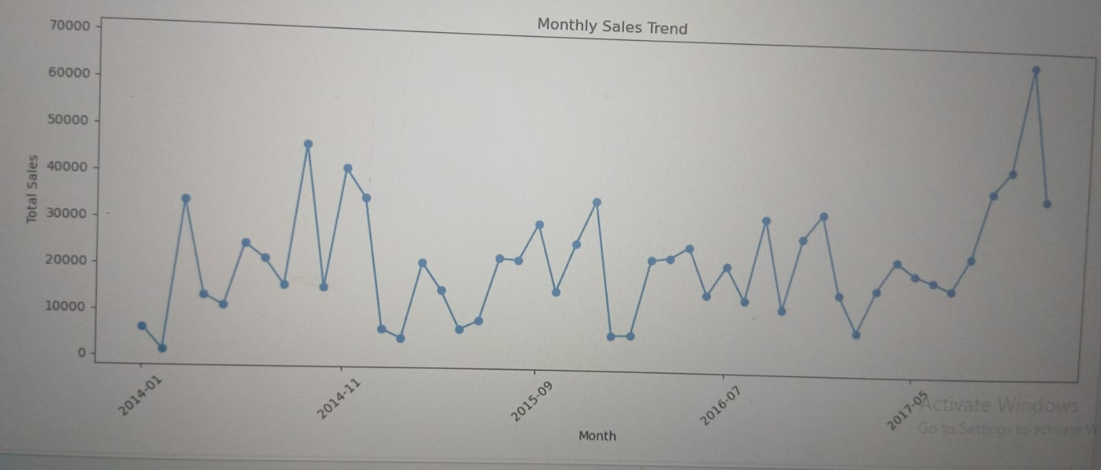

Which groups contribute most to sales or profit?
According to the Bar Chart  Technology drives Sales, but Office Supplies drives Profit. Furniture has good sales but almost no profit | 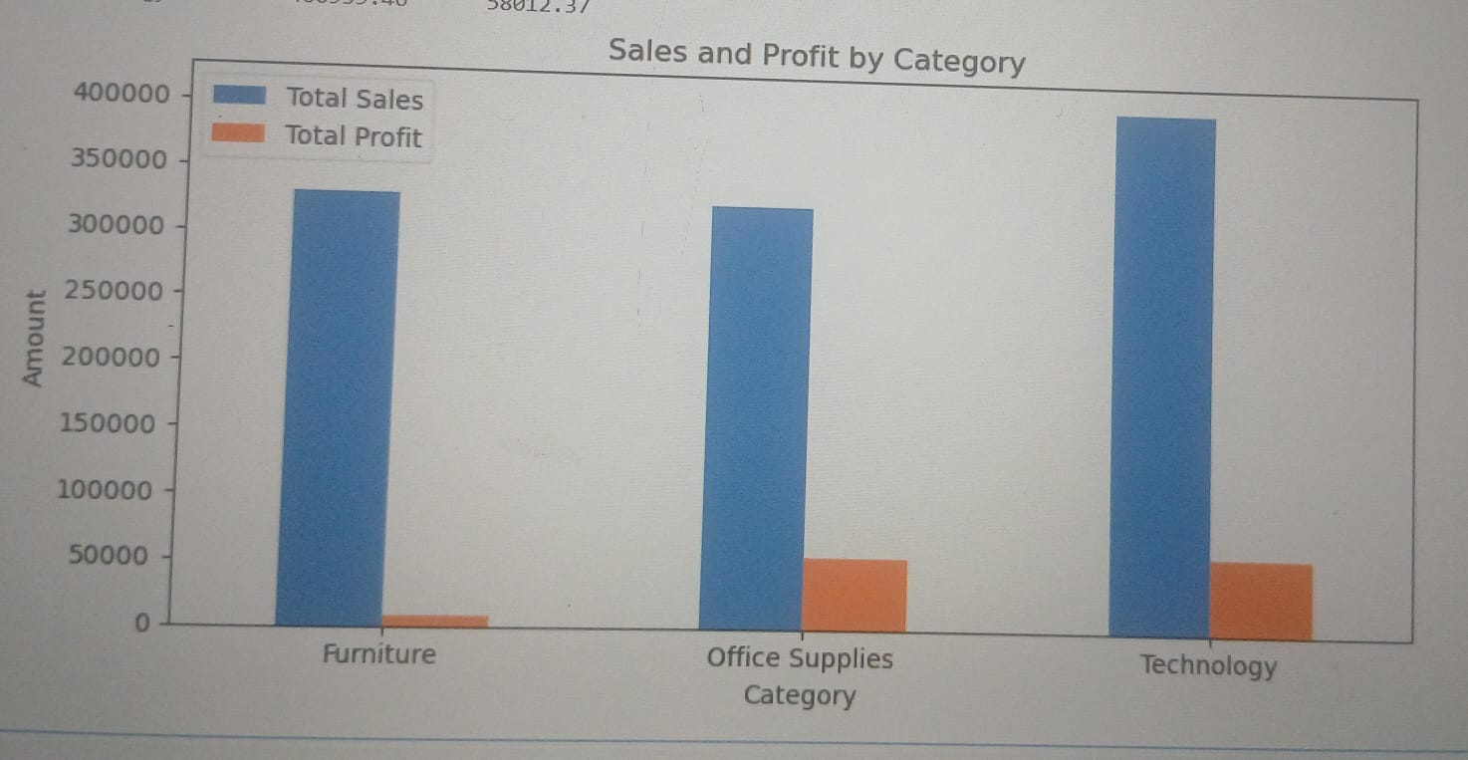

Which products have the highest sales or lowest total profit?
According to the table  Highest Sales = Technology (406k)  Lowest Sales = Office Supplies (326k)  but close to Furniture  Profit = Technology (58k)  Lowest Profit = Furniture (only 7.9k) –  makes almost no profit despite 330k sales | 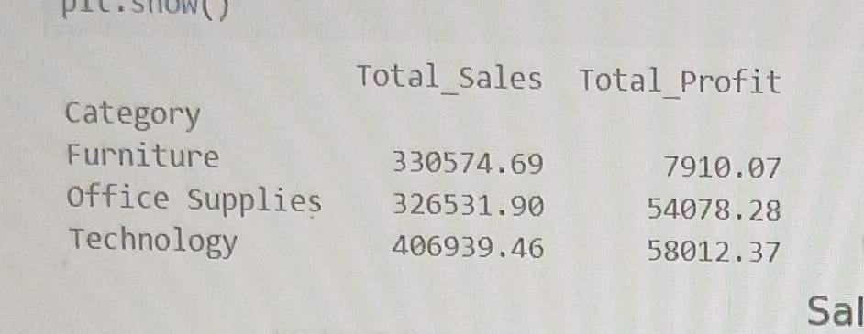

How many days pass between order and shipment?
According to the Shipping Duration  0 to 7 days.  But most common is 4 days.  Breakdown from your last graph:  4 days: ∼1180 orders –  most common5 days: ∼1000  orders2, 3, 6 days: 400-600  each0, 1, 7 days: only 180-240 each –  rare Average = ∼4 to 4.5 days between order and shipment. | 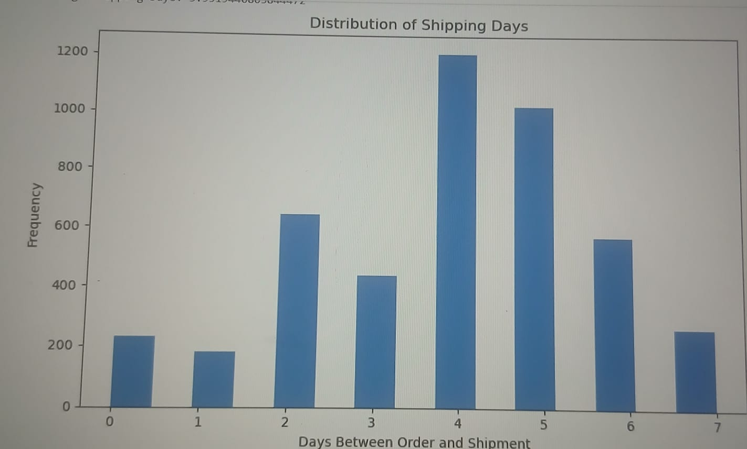

EXECUTIVE SUMMARY - Superstore Sales & Profit Analysis
Project Overview:
This EDA was performed on the Superstore dataset covering Sales, Profit, Customer Segments, and Shipping from 2014-2017 to identify revenue drivers and profitability issues.
key Findings from 13 Visuals:
Sales Performance:
Technology is the top Category (∼$836k) and Tables is the top Sub-Category (∼$94k). The single highest product is Canon image CLASS 2200 Copier ($61,599). Consumer segment drives 50.6% of sales ($539k) and West is the top Region. Standard Class shipping dominates with 56.8% of sales.
. Sales Distribution & Seasonality:
Sales distribution is highly right-skewed; 90% of orders are under $1,000 with a frequency of ∼9,000 orders, while few outliers reach $20k+. Monthly trend shows strong seasonality with volatility - Q4 (Oct-Dec) consistently peaks, with Dec 2017 hitting ∼$30k. Overall growth trend from 2014 to 2017. Violin plot confirms Technology has the longest tail up to $21k, while Furniture is most consistent.
Customer Concentration Risk:
Business is highly dependent on few customers. Sean Miller is the VIP customer with $24k sales, almost double the 2nd customer. Top 10 customers all purchase >$7.5k. Losing top customers would cause major revenue loss.
Critical Profit Issue (Most Important):
Correlation heatmap shows Profit vs Discount is -0.24 (negative). Discount strategy is failing - Sales vs Discount is -0.01 (no relation) and Discount vs Quantity is 0.01 (no relation). Box plot shows median profit is near zero for all categories. Technology has highest profit volatility from -$4000 to +$4500. Office Supplies has most loss-making orders.
Overall Conclusion:
The business runs on high volume of low-value orders with dependence on few high-value Technology products and few VIP customers. While sales are growing, profitability is threatened by ineffective discounting. Recommendations: Stop Blind Discounting: Enforce minimum margin rule. Discounts are reducing profit without increasing sales. protect VIPs: Create loyalty program for Sean Miller and top 10 customers + Consumer segment inventory Planning: Stock Technology & Tables before Q4 peak. Bundle slow movers like Fasteners, Labels, Envelopes with top sellers Logistics: Optimize Standard Class as core service and promote First Class for high-value orders. pricing: Use Median instead of Mean for sales reporting due to extreme outliers.
Dash Board Power BI


