# Department of Computing

**CS344: Web Engineering**

**Class: BESE – 4AB**

# Assignment#03

**Date: 26th December, 2015**

# Instructor: Fahad Ahmed Satti

**Tahreem Saleem 05983**

# 

# Assignment#03

## Requirements:

Design and Develop an Interactive Development Environment for PHP, using web as a platform.

The IDE should be developed using Laravel, and should have 2 use cases.

1. A user, after authentication should be able to add PHP code and get its results(after executing it from the server)

2. A Moderator user, after authentication should be able to view code by all USERS.

Ensure security of this application, so no user should be able to affect the server, your application or your database.

Do NOT Copy!! Any attempts at plagiarism wil lead to 0 grade and the case will be forwarded to higher authorities, irrespective of the reasons behind it.

## Description:

I made 2 view. One for moderate user and the other for regular user. I named the moderator Tahreem. Hence when Tahreem is logged in the controller displays the view where it retrieves the names of the regular users who logged in and tested the code. By clicking on the names of the user their codes are displayed. To retrieve respective code of the regular user, name of the user clicked is sent through url to route and then to controller. Where I finds the code from the database entered by the person.   
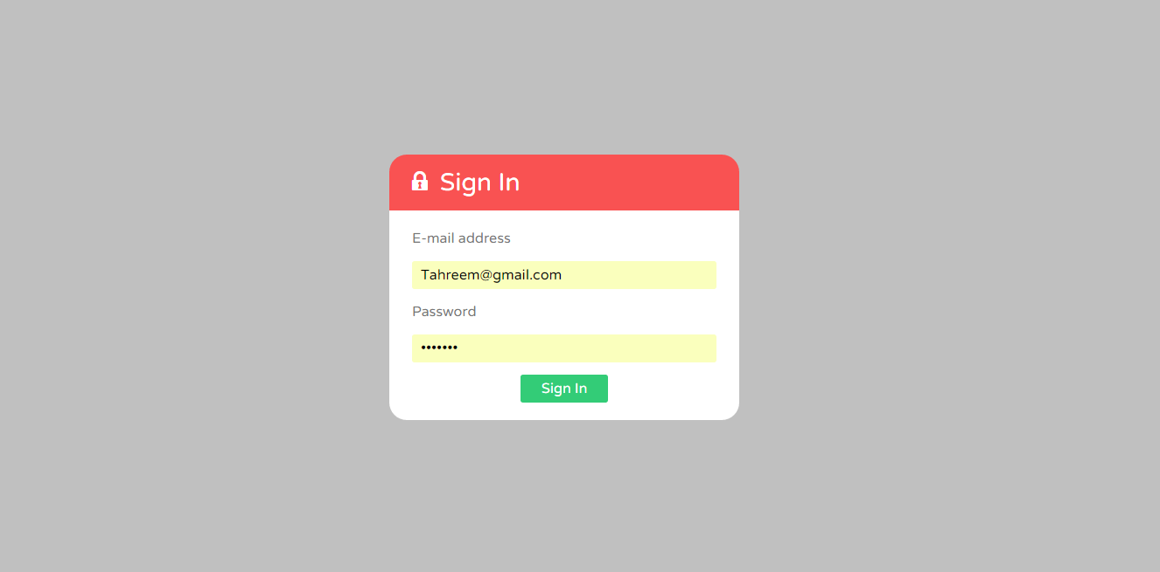

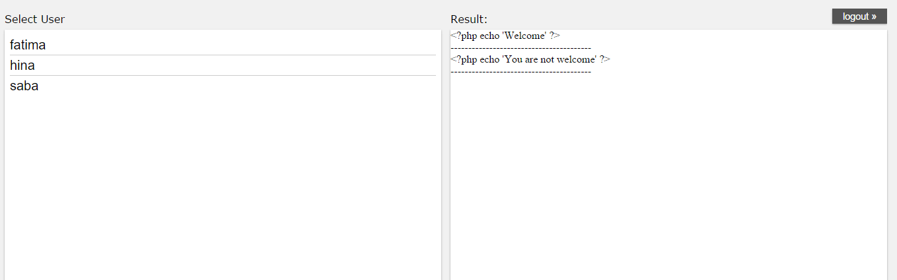

If you log in as a regular user. Then you can edit your Php code and see the results.  
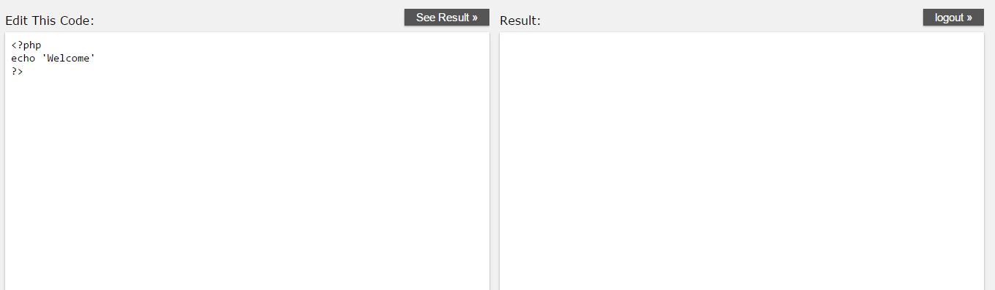

I made a new table “allCode” when the user enters the code and clicks see result.I used migration to use this table. The data is posted to the controller through post route. In the ‘mycontroller’ I have made a method of ‘Form’ which picks up the code in the text area and stores is in the database with the user name. It then sends the evaluated code to the view to display. I used eloquent to retrieve and update data in the database. I used CSS of w3schools.

## Github link:

https://github.com/TahreemSaleem/lab8.git