**Mahmudullah**

> Mahmudullah<-c(0,6,30,0,0,41,0,38,0,0,128,51,0,51,314,26,0,0,50,0,0,0,65,0,0,0,0,0,0,0,0,0,87,138,0,4,0,0,13,7,140,137,0,0,0,63,0,0,109,0,0,0,0,0,110,0,156,0,0,44,0,36,0,0,84,190,47,0,0,0,0,0,0,0,76,0,0,0,0,0,0,0,0,0)

> print(Mahmudullah)

[1] 0 6 30 0 0 41 0 38 0 0 128 51 0 51 314 26 0 0 50 0 0

[22] 0 65 0 0 0 0 0 0 0 0 0 87 138 0 4 0 0 13 7 140 137

[43] 0 0 0 63 0 0 109 0 0 0 0 0 110 0 156 0 0 44 0 36 0

[64] 0 84 190 47 0 0 0 0 0 0 0 76 0 0 0 0 0 0 0 0 0

> Mahmudullah <- ts(Mahmudullah,start = c(2014,1),frequency=12)

> print(Mahmudullah)

Jan Feb Mar Apr May Jun Jul Aug Sep Oct Nov Dec

2014 0 6 30 0 0 41 0 38 0 0 128 51

2015 0 51 314 26 0 0 50 0 0 0 65 0

2016 0 0 0 0 0 0 0 0 87 138 0 4

2017 0 0 13 7 140 137 0 0 0 63 0 0

2018 109 0 0 0 0 0 110 0 156 0 0 44

2019 0 36 0 0 84 190 47 0 0 0 0 0

2020 0 0 76 0 0 0 0 0 0 0 0 0

> plot.ts(Mahmudullah)

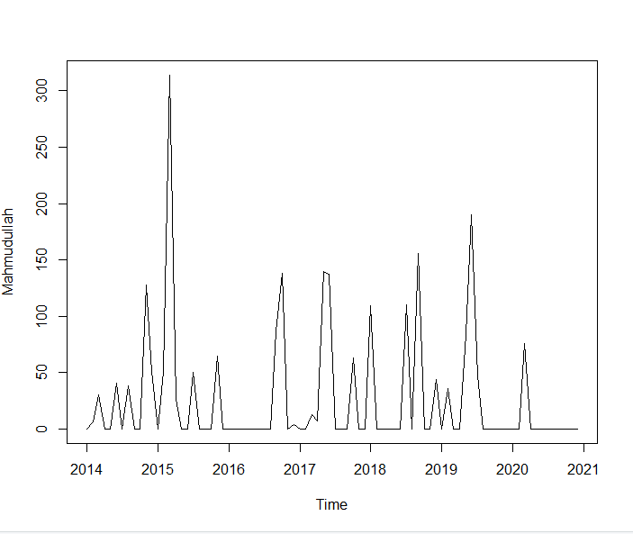

> library(TTR)

> Mahmudullah_timeseris_SMA<-SMA(Mahmudullah,n=3)

> plot(Mahmudullah_timeseris_SMA)

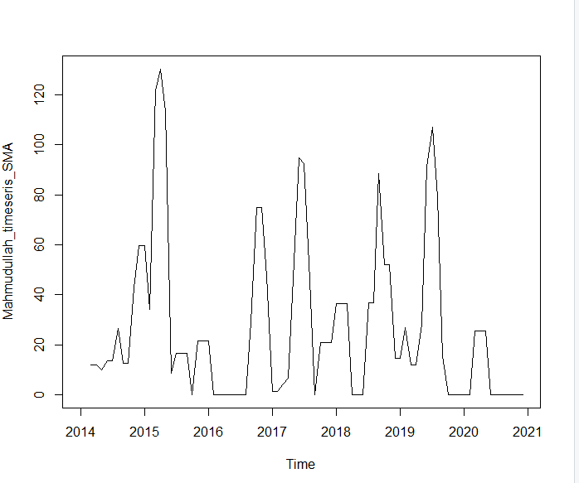

> Mahmudullah_timeseris_components<-decompose(Mahmudullah)

> plot(Mahmudullah_timeseris_components)

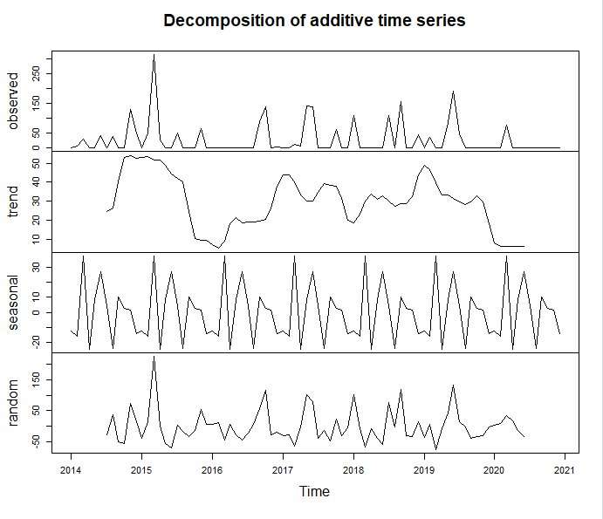

**Mushfiqur Rahim**

> Mushfiqur<-c(0,253,78,0,0,70,0,90,0,0,202,11,0,107,191,220,0,69,24,0,0,0,156,0,0,0,0,0,0,0,0,0,44,112,0,42,0,0,1,0,116,163,0,0,0,178,0,0,142,0,0,0,0,0,110,0,302,83,0,133,0,46,0,0,166,327,215,0,0,0,0,0,0,0,74,0,0,0,0,0,0,0,0,0)

> print(Mushfiqur)

[1] 0 253 78 0 0 70 0 90 0 0 202 11 0 107 191 220 0 69 24 0 0 0

[23] 156 0 0 0 0 0 0 0 0 0 44 112 0 42 0 0 1 0 116 163 0 0

[45] 0 178 0 0 142 0 0 0 0 0 110 0 302 83 0 133 0 46 0 0 166 327

[67] 215 0 0 0 0 0 0 0 74 0 0 0 0 0 0 0 0 0

> Mushfiqur_timeseris<-ts(Mushfiqur,start = c(2014,1),frequency = 12)

> print(Mushfiqur_timeseris)

Jan Feb Mar Apr May Jun Jul Aug Sep Oct Nov Dec

2014 0 253 78 0 0 70 0 90 0 0 202 11

2015 0 107 191 220 0 69 24 0 0 0 156 0

2016 0 0 0 0 0 0 0 0 44 112 0 42

2017 0 0 1 0 116 163 0 0 0 178 0 0

2018 142 0 0 0 0 0 110 0 302 83 0 133

2019 0 46 0 0 166 327 215 0 0 0 0 0

2020 0 0 74 0 0 0 0 0 0 0 0 0

>plot.ts(Mushfiqur_timeseris)

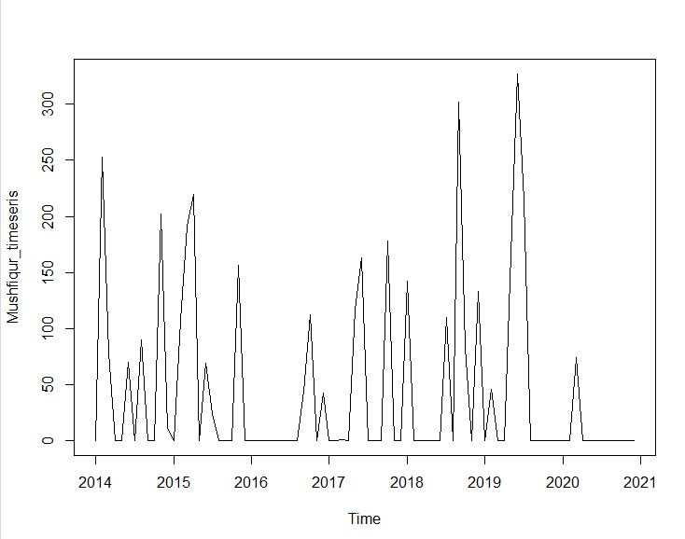

>library(TTR)

>Mushfiqur_timeseris_SMA<-SMA(Mushfiqur_timeseris,n=3)

>plot(Mushfiqur_timeseris_SMA)

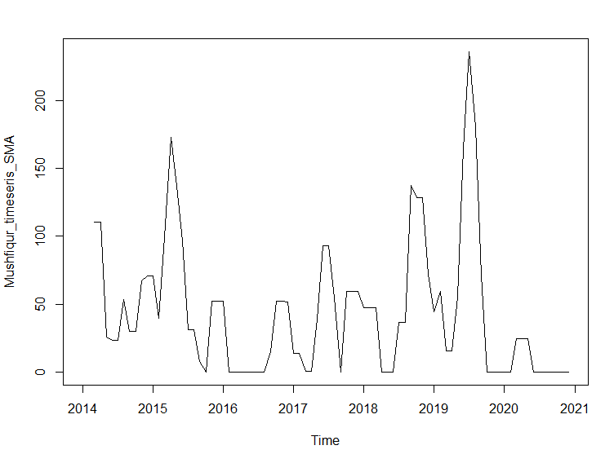

>Mushfiqur_timeseris_Components<-decompose(Mushfiqur_timeseris)

>plot(Mushfiqur_timeseris_Components)

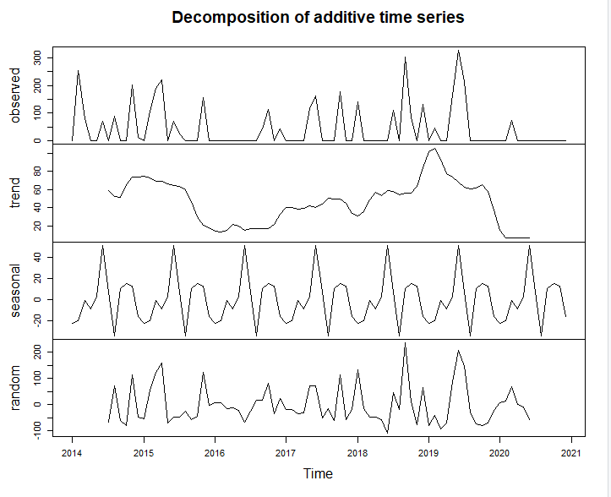

**Tamim Iqbal**

>TamimIqbal<-c(0,0,0,0,0,4,0,118,0,0,137,29,0,19,135,312,0,78,67,0,0,0,132,0,0,0,0,0,0,0,0,0,100,194,0,114,0,0,127,4,199,293,0,0,0,23,0,0,252,0,0,0,0,0,287,0,2,0,0,143,0,10,0,0,176,205,51,0,0,0,0,0,0,0,310,0,0,0,0,0,0,0,0,0)

>print(TamimIqbal)

[1] 0 0 0 0 0 4 0 118 0 0 137 29 0 19 135 312 0 78

[19] 67 0 0 0 132 0 0 0 0 0 0 0 0 0 100 194 0 114

[37] 0 0 127 4 199 293 0 0 0 23 0 0 252 0 0 0 0 0

[55] 287 0 2 0 0 143 0 10 0 0 176 205 51 0 0 0 0 0

[73] 0 0 310 0 0 0 0 0 0 0 0 0

>TamimIqbal_timeseris<-ts(TamimIqbal,start = c(2014,1),frequency = 12)

>print(TamimIqbal_timeseris)

Jan Feb Mar Apr May Jun Jul Aug Sep Oct Nov Dec

2014 0 0 0 0 0 4 0 118 0 0 137 29

2015 0 19 135 312 0 78 67 0 0 0 132 0

2016 0 0 0 0 0 0 0 0 100 194 0 114

2017 0 0 127 4 199 293 0 0 0 23 0 0

2018 252 0 0 0 0 0 287 0 2 0 0 143

2019 0 10 0 0 176 205 51 0 0 0 0 0

2020 0 0 310 0 0 0 0 0 0 0 0 0

>library(TTR)

>TamimIqbal_timeseris_SMA<-SMA(TamimIqbal_timeseris,n=3)

>plot.ts(TamimIqbal_timeseris)

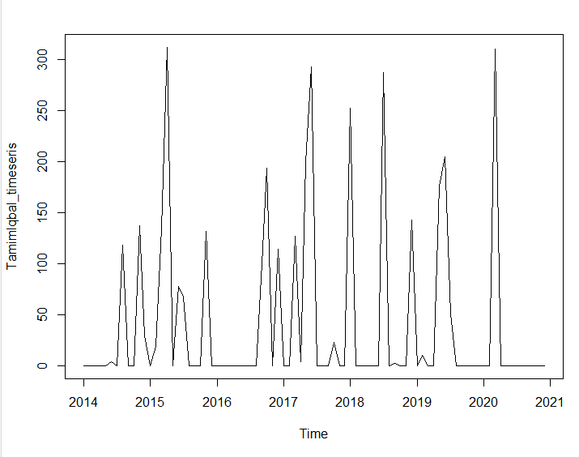

>plot(TamimIqbal_timeseris_SMA)

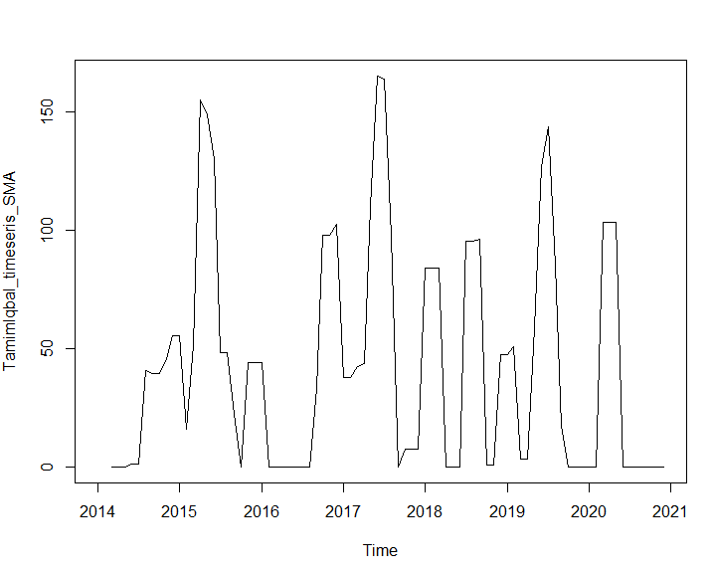

>TamimIqbal_timeseris_components<-decompose(TamimIqbal_timeseris)

>plot(TamimIqbal_timeseris_components)

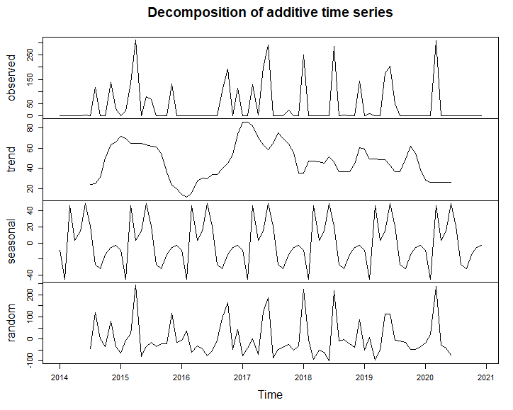

**Shakib Al Hasan**

>Shakib<-c(0,0,0,0,0,0,0,88,0,103,0,170,0,302,108,94,55,0,17,0,0,0,0,31,0,0,79,0,0,0,0,0,0,0,0,0,0,27,64,0,0,56,0,0,0,0,142,0,0,109,87,38,0,123,48,0,0,0,16,0,0,0,0,0,0,0,0,0,65,103,0,84,0,0,72,54,39,168,0,0,0,97,0,0,63,0,0,0,0,0,190,0,49,0,0,95,0,0,0,0,140,476,130,0,0,0,0,0)

>print(Shakib)

[1] 0 0 0 0 0 0 0 88 0 103 0 170 0 302 108 94 55

[18] 0 17 0 0 0 0 31 0 0 79 0 0 0 0 0 0 0

[35] 0 0 0 27 64 0 0 56 0 0 0 0 142 0 0 109 87

[52] 38 0 123 48 0 0 0 16 0 0 0 0 0 0 0 0 0

[69] 65 103 0 84 0 0 72 54 39 168 0 0 0 97 0 0 63

[86] 0 0 0 0 0 190 0 49 0 0 95 0 0 0 0 140 476

[103] 130 0 0 0 0 0

>Shakib_timeseris<-ts(Shakib,start=c(2014,1),frequency = 12)

>print(Shakib_timeseris)

Jan Feb Mar Apr May Jun Jul Aug Sep Oct Nov Dec

2014 0 0 0 0 0 0 0 88 0 103 0 170

2015 0 302 108 94 55 0 17 0 0 0 0 31

2016 0 0 79 0 0 0 0 0 0 0 0 0

2017 0 27 64 0 0 56 0 0 0 0 142 0

2018 0 109 87 38 0 123 48 0 0 0 16 0

2019 0 0 0 0 0 0 0 0 65 103 0 84

2020 0 0 72 54 39 168 0 0 0 97 0 0

2021 63 0 0 0 0 0 190 0 49 0 0 95

2022 0 0 0 0 140 476 130 0 0 0 0 0

>plot.ts(Shakib_timeseris)

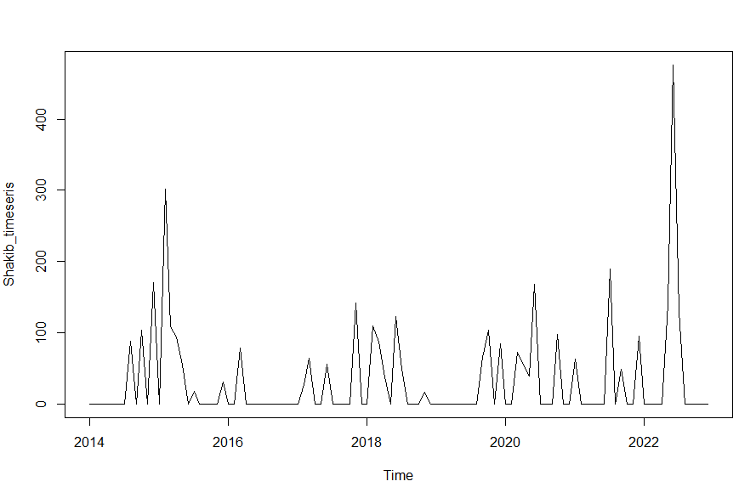

>library(TTR)

>Shakib_timeseris_SMA<-SMA(Shakib_timeseris,n=3)

>plot(Shakib_timeseris_SMA)

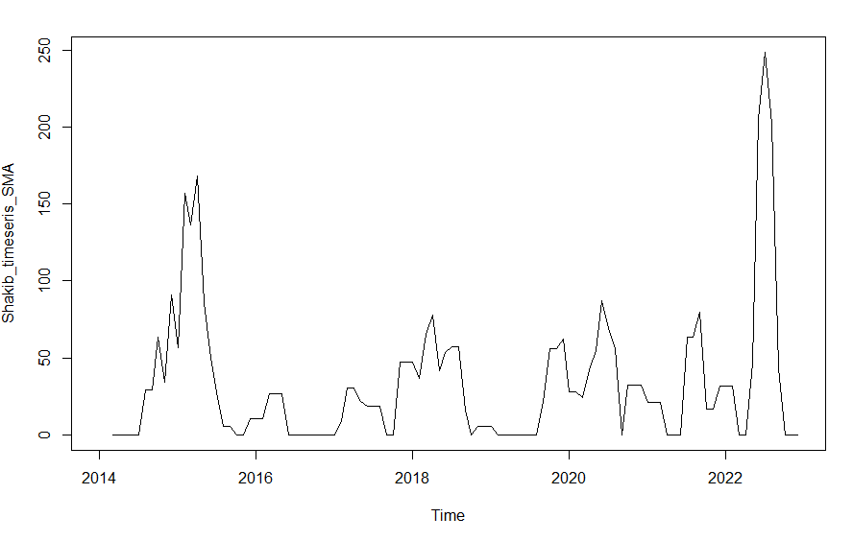

>Shakib_timeseris_components<-decompose(Shakib_timeseris)

>plot(Shakib_timeseris_components)

