HillGo
Platform Architecture Compendium
Four Mobile Applications · Admin Operations Panel · Public Website
Laravel Backend · Database Architecture · Security Model · System Integration
Confidential — Client Architecture Deliverable
Version 1.0 · August 2026

Contents
1. Executive Overview
2. Architecture 1 — Customer Application
3. Architecture 2 — Rider Application
4. Architecture 3 — Merchant Application
5. Architecture 4 — Courier Application
6. Architecture 5 — Admin Panel
7. Architecture 6 — Public Website
8. Architecture 7 — Database
9. Backend Architecture
10. End-to-End System Integration
11. Security Architecture (Layered)
12. Appendix — Feature Coverage Matrix

1. Executive Overview
HillGo is a Bangladesh multi-service logistics and lifestyle platform spanning ride-hailing, food delivery, parcel courier, merchant commerce, hotels, and rentals. The platform is delivered as seven primary architecture surfaces: four Flutter applications (Customer, Rider, Merchant, Courier), an Admin operations panel, a Public marketing website, and a unified relational database — all coordinated through a single Laravel API backend.
All monetary and operational framing uses Bangladeshi Taka (৳). Clients authenticate with role-scoped Sanctum tokens. Shared domain services enforce Region Lock, pricing, wallet ledger settlement, OTP custody, dispatch, notifications, and auditability.
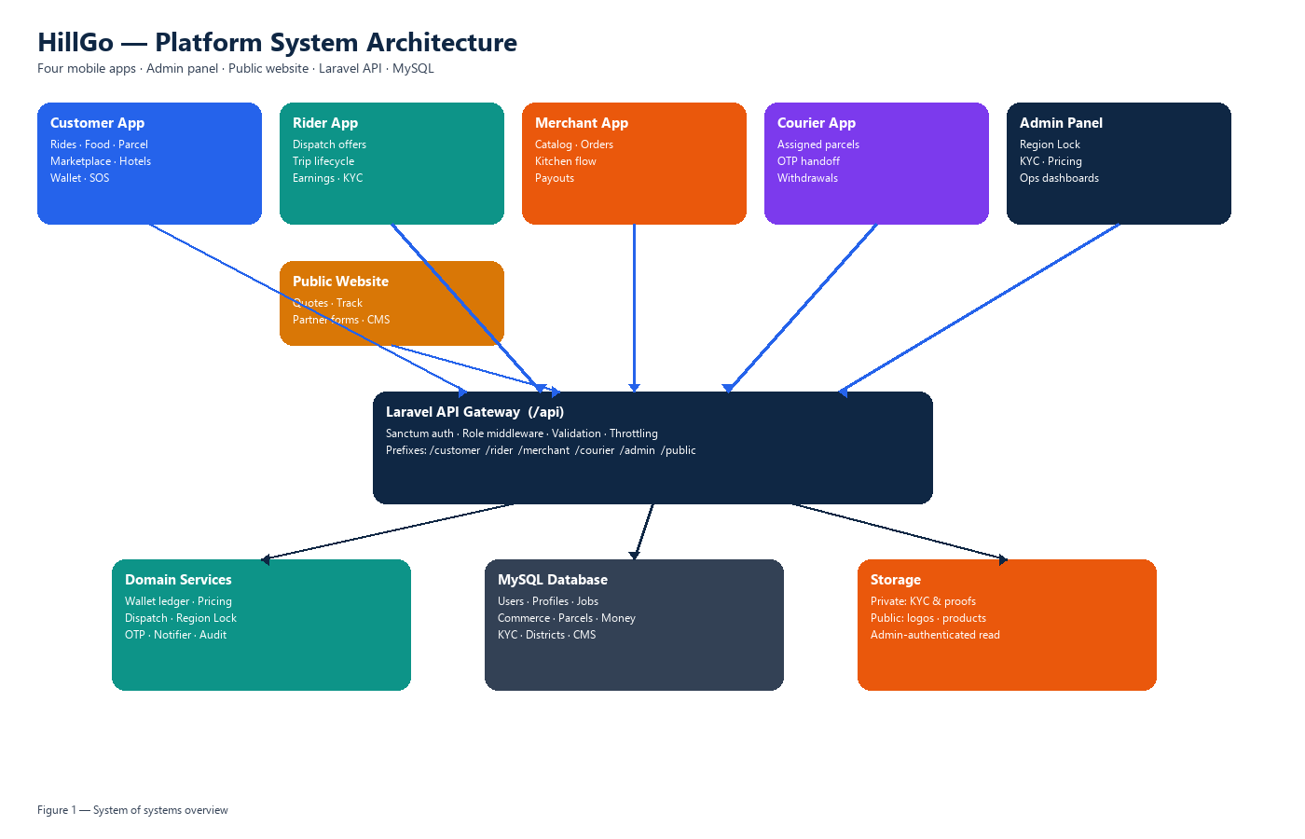
Figure 1. Platform system-of-systems overview.

1.1 Architecture inventory
# | Architecture surface | Technology | Primary consumers
1 | Customer Application | Flutter | End customers
2 | Rider Application | Flutter | Driver / delivery partners
3 | Merchant Application | Flutter | Store operators
4 | Courier Application | Flutter | Parcel agents
5 | Admin Panel | HTML/JS SPA | HillGo operations
6 | Public Website | Static web | Prospects & partners
7 | Database | MySQL / InnoDB | All services via API

2. Architecture 1 — Customer Application
The Customer application is the consumer super-app. It presents a unified shell for mobility, food, parcels, marketplace, hotels, rentals, wallet, loyalty, and safety (SOS).

2.1 Structural layers
- Presentation: feature screens, main shell navigation, theming, shared widgets.
- Application: route map and feature orchestration for booking and tracking journeys.
- Integration: ApiClient with secure Sanctum token storage; modular API services per domain.
- Network: HTTPS calls exclusively to /api/customer/* (plus shared public helpers where needed).
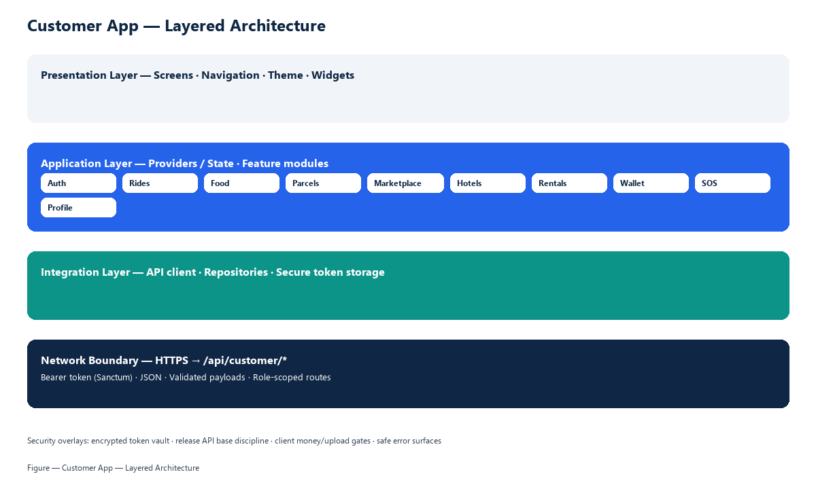
Figure 2. Customer application layered architecture.

2.2 Capability map
- Identity: registration, login, OTP verification, profile, addresses, payment methods.
- Mobility: fare quote, ride booking, live tracking, rating.
- Food & commerce: restaurant browsing, cart checkout, marketplace products, order history.
- Parcels: quote, book, track.
- Lifestyle: hotels and rental vehicle bookings.
- Money & loyalty: wallet top-up/history, rewards, promos.
- Safety: SOS contacts and alerts; notifications inbox.

2.3 Data flow
The customer authenticates under /api/customer/auth/*, persists the bearer token in the device secure vault, then executes all domain actions through role-scoped customer endpoints. Server-side pricing and Region Lock decide eligibility and amounts; the app never acts as the source of truth for settlement.

3. Architecture 2 — Rider Application
The Rider application enables driver partners to complete KYC, go online, receive dispatch offers (ride / food / parcel jobs), navigate active trips, and cash out earnings.
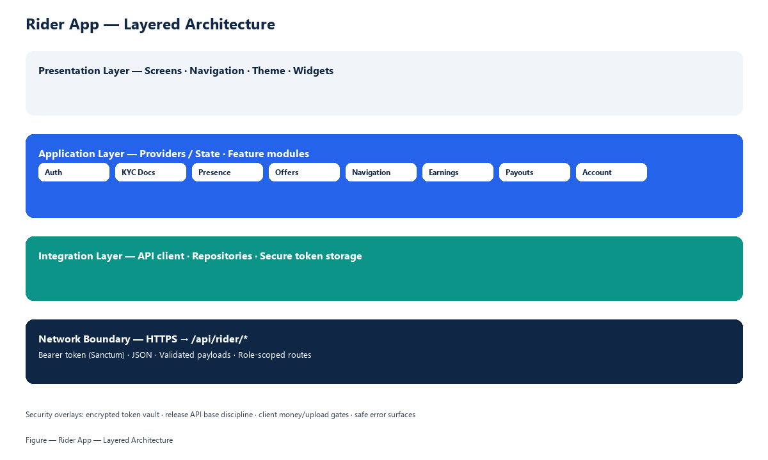
Figure 3. Rider application layered architecture.

3.1 Capability map
- Onboarding & KYC: personal info, vehicle info, document upload, verification status.
- Presence: online/offline toggle and location updates for dispatch.
- Trip lifecycle: incoming offer, accept/decline, navigate, complete.
- Earnings: balance, history, payout / cash-out requests.
- Account: profile and operational preferences.

3.2 Data flow
After /api/rider/auth/* login and KYC submission, the rider posts presence to the backend. Dispatch creates trip offers; the rider advances trip state via /api/rider/trips/*. Routing guidance is obtained through the HillGo API route proxy so live coordinates remain within the HillGo trust boundary.

4. Architecture 3 — Merchant Application
The Merchant (Vendor) application covers store onboarding, catalog management, kitchen order flow, branding assets, reviews, and payout operations.
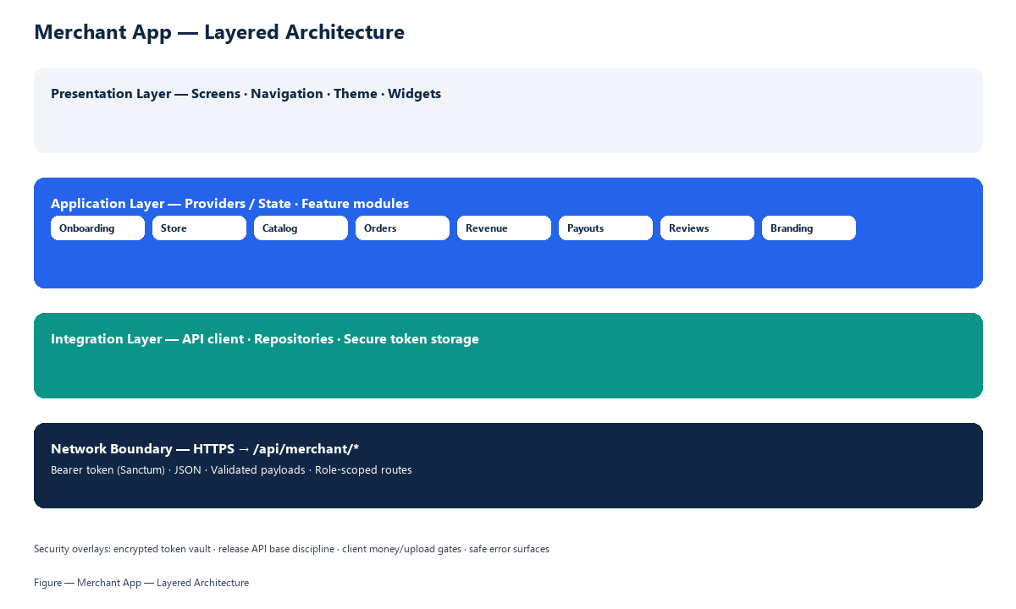
Figure 4. Merchant application layered architecture.

4.1 Capability map
- Onboarding: business profile, trade license / NID, storefront and logo media.
- Store hub: open/accepting status, hours, branding updates.
- Catalog: categories and products with image upload.
- Orders: accept → prepare → ready → delivered / reject.
- Revenue: summaries, transactions, early payout requests.
- Reviews: read and reply; settings synchronized to the server.

4.2 Data flow
Merchants authenticate at /api/merchant/auth/*, submit onboarding for admin review, then manage store and catalog through /api/merchant/*. Product and branding images land on the public disk; KYC documents remain on the private disk for admin review only.

5. Architecture 4 — Courier Application
The Courier application equips parcel agents with assignment queues, OTP-secured pickup/delivery, optional proof capture, earnings, incentives, and withdrawals.
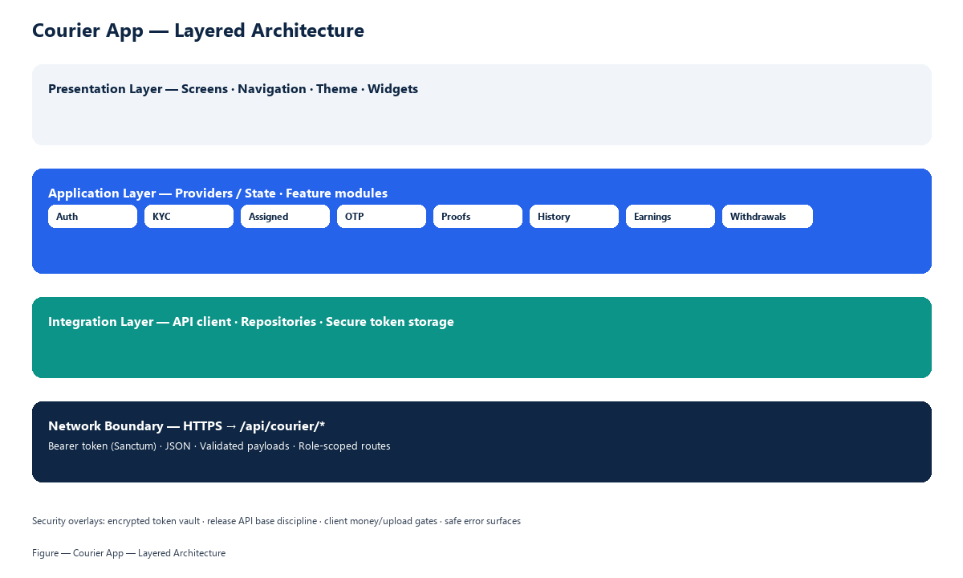
Figure 5. Courier application layered architecture.

5.1 Capability map
- Registration & KYC document upload (license, NID, registration).
- Assigned parcel queue and parcel detail.
- Pickup / delivery OTP confirmation with attempt controls.
- Delivery proof photo/signature when required.
- History, earnings dashboard, incentives, withdrawal requests.
- Vehicle, bank, and notification preferences.

5.2 Data flow
Agents authenticate under /api/courier/auth/*, receive assignments from /api/courier/parcels/*, confirm custody with OTP, and may upload private proof files. Earnings and withdrawals settle through courier earnings endpoints under admin oversight.

6. Architecture 5 — Admin Panel
The Admin Panel is a hash-routed single-page application used by HillGo operations. It provides Region Lock control, KYC queues, live operational dashboards, pricing governance, payouts, and public-web inbox/CMS tools.
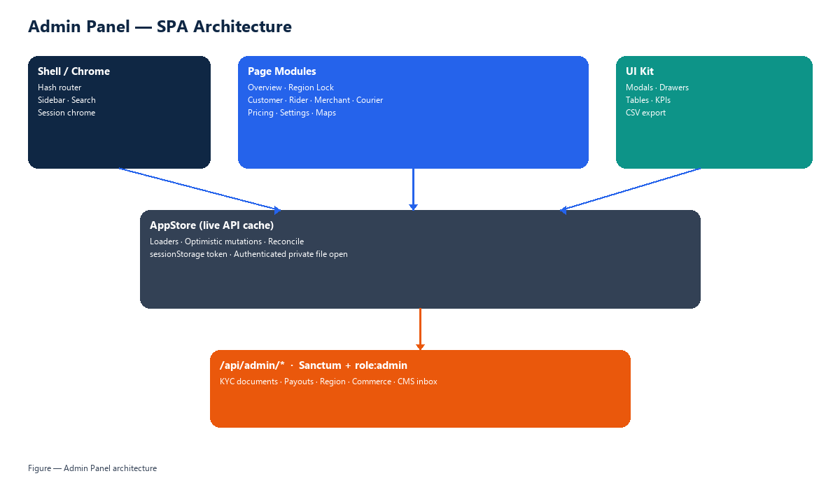
Figure 6. Admin Panel SPA architecture.

6.1 Structural pattern
- Shell: sidebar navigation, global search, session chrome.
- Router: client-side hash routes for overview, region, customer, rider, merchant, courier, settings.
- AppStore: in-memory cache with optimistic updates reconciled against Laravel responses.
- UI toolkit: tables, KPIs, drawers, modals, map overlays, CSV export.
- Private media: authenticated open of KYC and proof files (Bearer-protected).

6.2 Operational domains
- Region Lock — divisions/districts open/closed and per-role allow flags.
- Customer ops — directory, rides, food orders, parcels, SOS, wallet adjustments.
- Rider ops — KYC, trips, live map, salary/payouts, rider pricing.
- Merchant ops — onboarding review, stores, orders, payouts, merchant pricing.
- Courier ops — agent KYC, parcels, withdrawals, incentives, courier pricing.
- Platform — settings, activity log, overview KPIs, public web content inbox.

7. Architecture 6 — Public Website
The Public Website is the marketing and discovery surface for HillGo services and partner acquisition. It is a static front end calling unauthenticated, rate-limited public API endpoints.
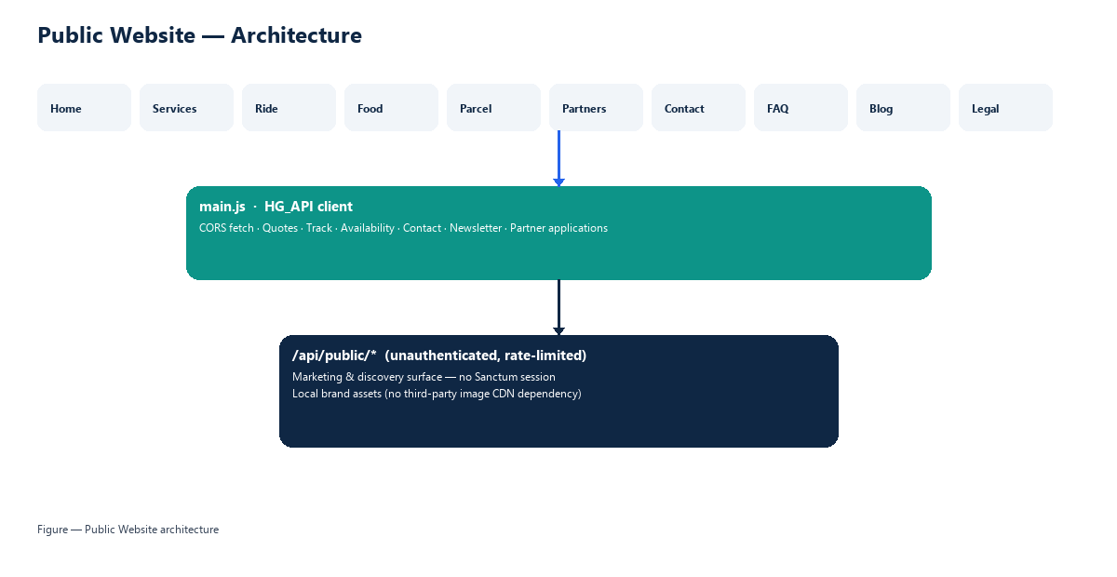
Figure 7. Public Website architecture.

7.1 Surfaces
- Service storytelling: home, about, services, ride, food, parcel.
- Partner acquisition: merchant and driver registration funnels.
- Trust & content: FAQ, blog, terms, privacy.
- Interactive tools: fare quote calculator, parcel tracking, city availability, contact, newsletter.

7.2 Data flow
Browsers invoke /api/public/* with CORS-aware JSON fetch. No Sanctum session is established. Content aggregates (testimonials, contact strip, pricing display) and operational utilities (quotes, track, availability) are served by the public controller layer.

8. Architecture 7 — Database
HillGo persists operational state in a MySQL (InnoDB) relational schema. The schema is organized by domain rather than by client, enabling one source of truth for identity, jobs, commerce, money, KYC, geography, lifestyle bookings, safety, and CMS.
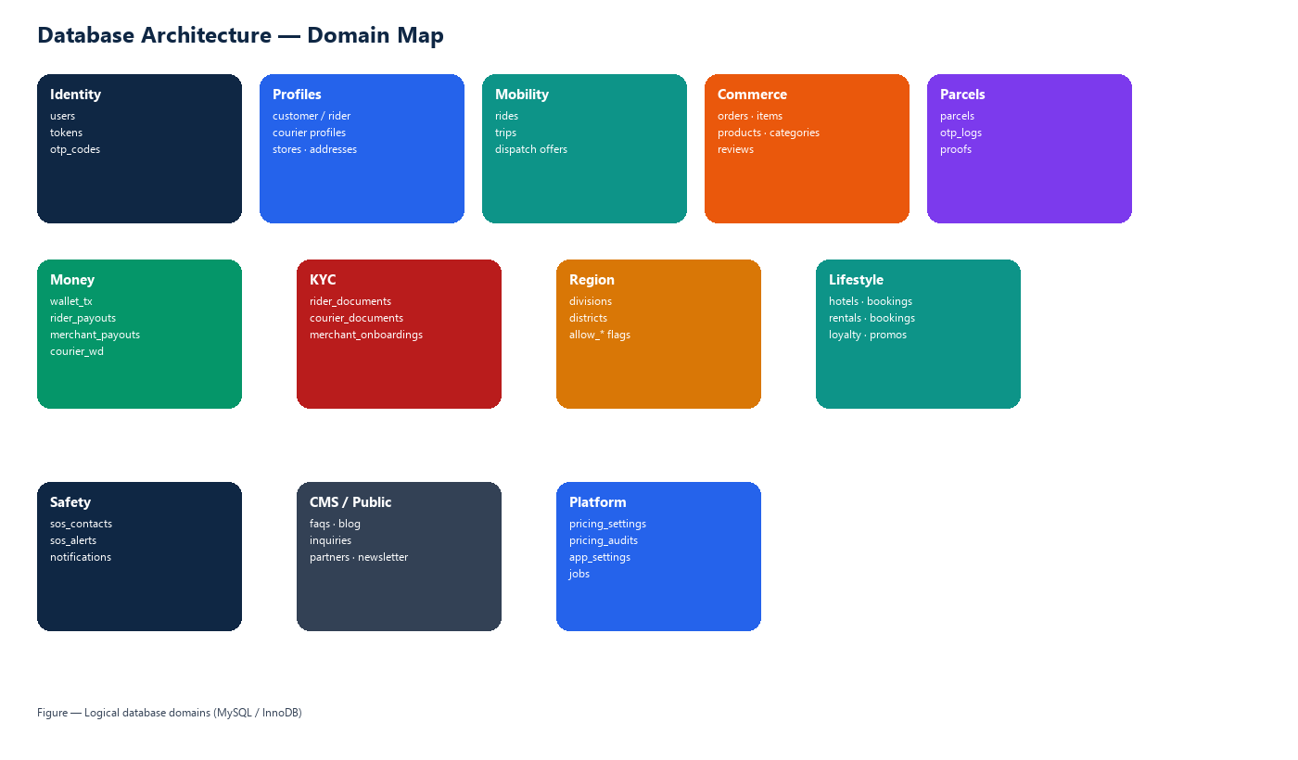
Figure 8. Database domain map.

8.1 Core domains
Domain | Representative tables | Purpose
Identity | users, personal_access_tokens, otp_codes | Accounts, sessions, OTP
Profiles | customer_profiles, rider_profiles, courier_profiles, stores, addresses | Role-specific master data
Mobility | rides, trips | Customer rides and partner job offers
Commerce | orders, order_items, products, product_categories, reviews | Food & marketplace
Parcels | parcels, parcel_otp_logs, parcel_proofs | Courier logistics
Money | wallet_transactions, *_payouts, courier_withdrawals, pricing_* | Ledger & tariffs
KYC | rider_documents, courier_documents, merchant_onboardings | Partner verification
Region | divisions, districts | Geographic enablement (Region Lock)
Lifestyle | hotels, hotel_bookings, rental_*, loyalty_*, promos | Ancillary services
Safety/CMS | sos_*, app_notifications, faqs, blog_posts, inquiries | Safety & public content

8.2 Integrity principles
- Role is an attribute of the user record and is enforced server-side on every request.
- Wallet mutations occur through a single ledger path (balance + wallet_transactions + audit).
- District flags (status + allow_customer/rider/merchant/courier) gate product availability.
- Soft-delete and audit trails support operational forensics without losing history.
- Hot-path indexes support list/search workloads for trips, parcels, orders, and KYC queues.

9. Backend Architecture
The backend is a Laravel API that exposes a single /api surface partitioned by role. Controllers are thin HTTP adapters; domain rules live in dedicated services (Wallet, RegionLock, OtpService, PricingService, Dispatch, Notifier, Audit).
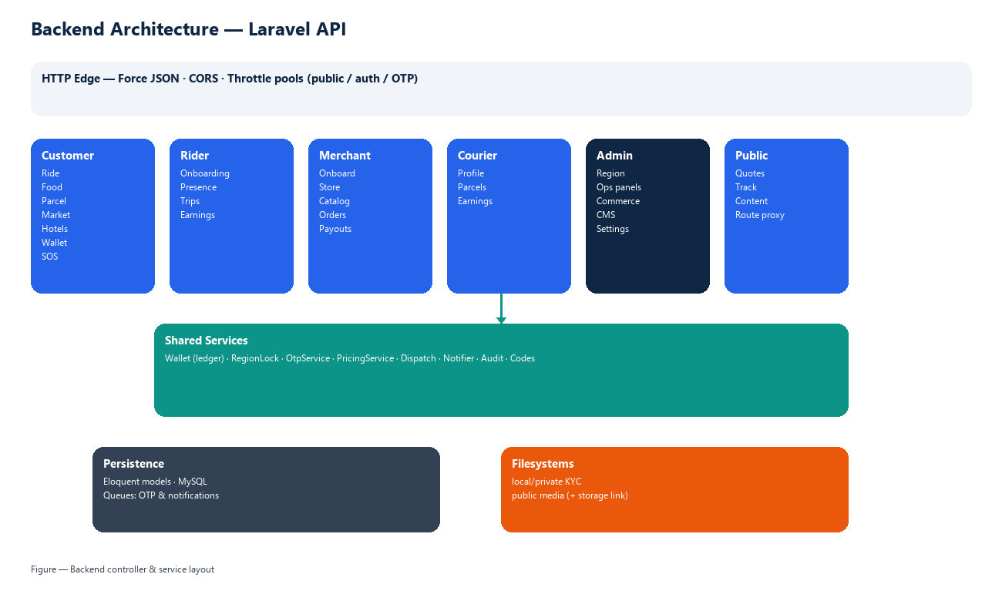
Figure 9. Backend controller and service layout.

9.1 Cross-cutting mechanics
- Authentication: Laravel Sanctum personal access tokens.
- Authorization: role middleware binds the authenticated user to admin/customer/rider/merchant/courier_agent.
- Validation: request payloads validated before persistence.
- Queues: OTP delivery and app notifications executed via queued jobs.
- Filesystems: private disk for KYC/proofs; public disk for storefront/product media via storage link.
- Observability: activity log and pricing audit records for governance.

9.2 Storage architecture
Sensitive identity documents and delivery proofs are written to the private local disk and are never exposed by a public URL. Admin download routes stream files only after Sanctum + admin role checks. Merchant logos, banners, and product images are stored on the public disk and served through /storage/… after the storage link is established.

10. End-to-End System Integration
Although each client has its own architecture, runtime value is created when they collaborate through the API and database. A customer intent becomes a priced, region-checked record; dispatch allocates a partner; partners advance job state; wallet settlement and notifications close the loop; admin governs KYC, pricing, and payouts.
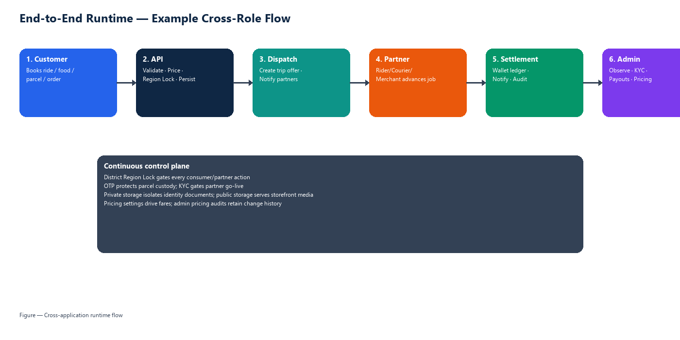
Figure 10. Cross-application runtime flow.

10.1 API prefix map
Prefix | Client | Access gate
/api/public/* | Public Website (+ shared utilities) | Throttle only
/api/customer/* | Customer App | Sanctum + role:customer
/api/rider/* | Rider App | Sanctum + role:rider
/api/merchant/* | Merchant App | Sanctum + role:merchant
/api/courier/* | Courier App | Sanctum + role:courier_agent
/api/admin/* | Admin Panel | Sanctum + role:admin

10.2 Shared control plane
- Region Lock decides where each role may operate.
- Pricing settings decide fares and fees displayed and charged.
- Dispatch links customer demand to rider/courier supply.
- Wallet ledger is the only path that mutates balances.
- OTP protects parcel custody transitions.
- KYC status gates partner go-live across rider, merchant, and courier.

11. Security Architecture (Layered)
Security is expressed as concentric operational layers — from the device edge to identity, application controls, sensitive data isolation, and operations. The following diagram is the security architecture drawing for this platform.
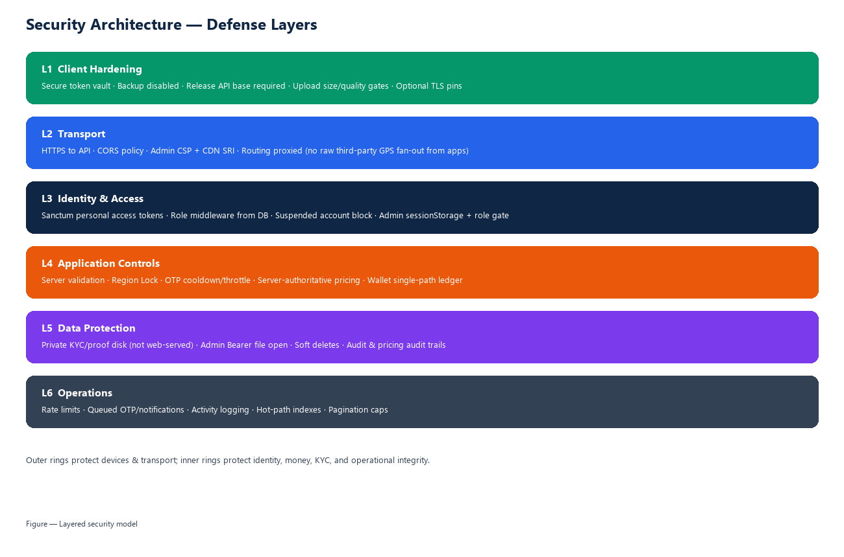
Figure 11. Layered security model.

11.1 Layer summaries
- L1 Client hardening — secure token storage, backup restrictions, release configuration discipline, upload limits.
- L2 Transport — HTTPS, CORS, admin content security policy / SRI, proxied routing.
- L3 Identity & access — Sanctum tokens, DB-backed roles, suspension enforcement, admin session controls.
- L4 Application controls — validation, Region Lock, OTP throttles, server pricing, wallet ledger.
- L5 Data protection — private KYC/proof disk, authenticated admin file access, soft deletes, audits.
- L6 Operations — rate limits, queued notifications, activity logs, pagination caps, indexing.

12. Appendix — Feature Coverage Matrix
Capability | Customer | Rider | Merchant | Courier | Admin | Public
Authentication / OTP | Yes | Yes | Yes | Yes | Yes | —
Region Lock awareness | Yes | Yes | Yes | Yes | Controls | Availability
Ride / trip jobs | Book/track | Execute | — | — | Oversee | Quote
Food / marketplace | Order | Deliver jobs | Catalog/kitchen | — | Oversee | Story
Parcels | Book/track | Optional jobs | — | Execute + OTP | Oversee | Track
Wallet / payouts | Wallet | Cash-out | Payouts | Withdraw | Approve/adjust | —
KYC documents | — | Upload | Onboarding docs | Upload | Verify + view | —
CMS / marketing | — | — | — | — | Inbox/CMS | Publish

Document close
This compendium defines the seven architecture surfaces of HillGo together with the backend integration fabric and the layered security model. It is intended as the reference blueprint for stakeholders reviewing how the mobile applications, admin panel, public website, database, and API operate as one platform.

