

Sukkur Institute of Business Administration University
Department of Computer Science
BS – V(CS) 2026
Web Engineering
LAB#012
Instructor: Sir Junaid

STUDENT PROFILE
Name: | Tahseen Ahmed
CMS ID: | 023-24-0195

Class Activity-A

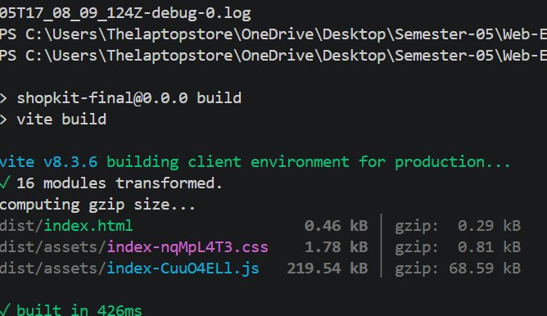

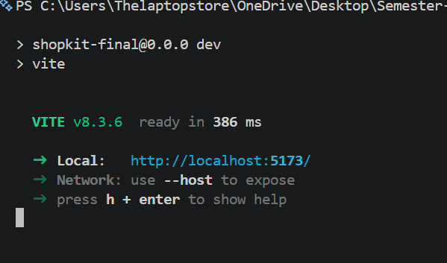
- 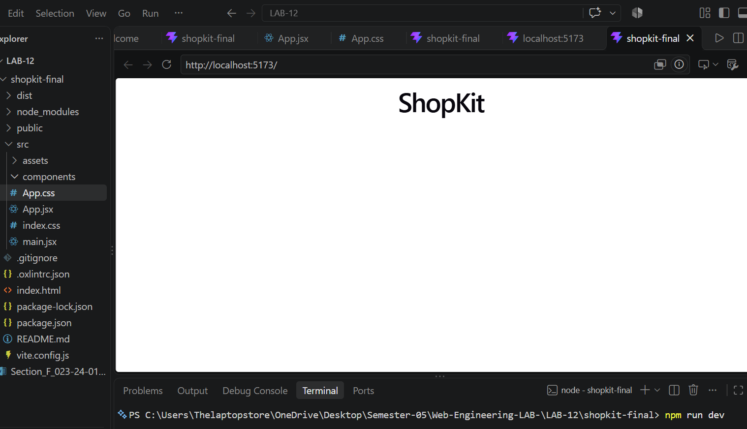

Class Activity -B

Components:

Header.jsx
function Header() {
return (
<header>
<h1>ShopKit</h1>

<nav>
<a href="#">Home</a>
<a href="#">Products</a>
<a href="#">About</a>
</nav>
</header>
);
}

export default Header;

Footer.jsx
function Footer() {
return (
<footer>
<p>Copyright © 2026 ShopKit</p>
</footer>
);
}

export default Footer;

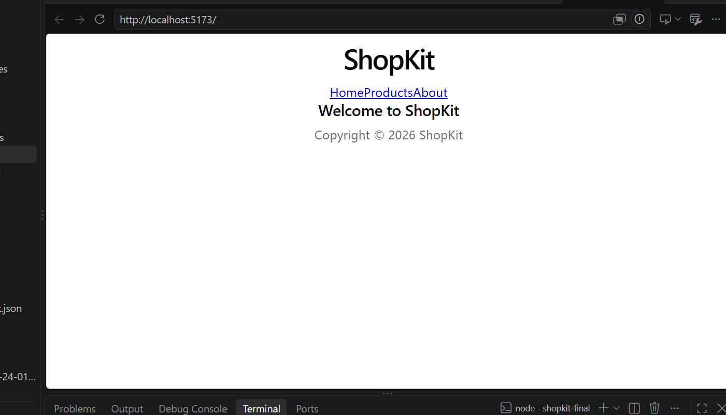

Class Activity:C

Hero.jsx
function Hero() {
const heading = "Welcome to ShopKit";
const description = "Find the best products at affordable prices.";

return (
<section>
<h1 className="hero-title">{heading}</h1>
<p>{description}</p>
<button>Explore Products</button>
</section>
);
}

export default Hero;

Output:
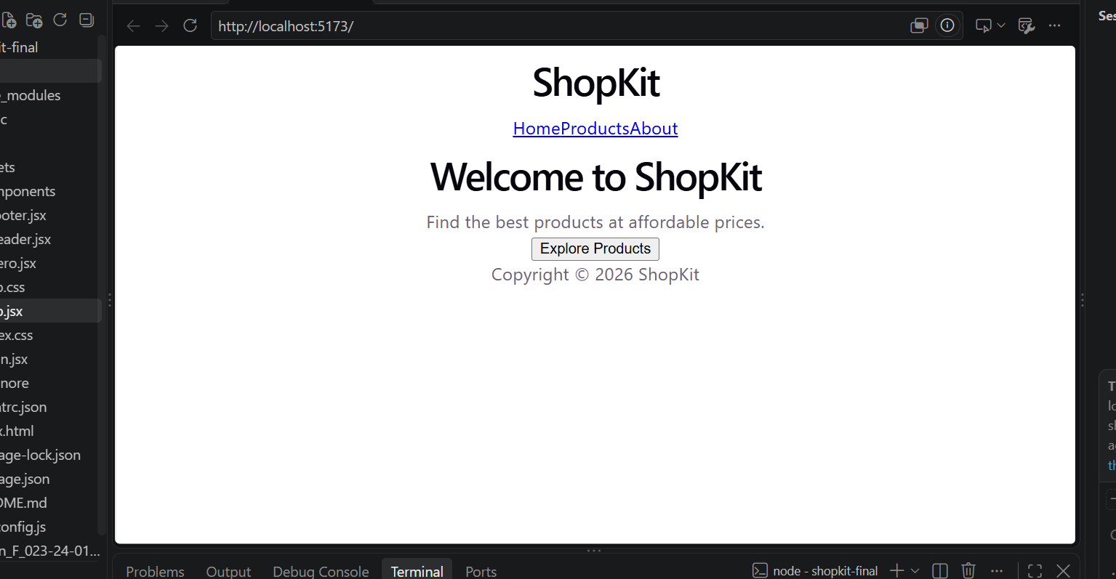
Class Activity-D
function ProductCard() {
const product = {
title: "Mechanical Keyboard",
price: 12500,
inStock: true
};

return (
<article>
<h3>{product.title}</h3>
<p>Rs {product.price}</p>
<p>{product.inStock ? "In Stock" : "Out of Stock"}</p>
<button disabled={!product.inStock}>
Add to Cart
</button>
</article>
);
}

export default ProductCard;
OUTPUT:

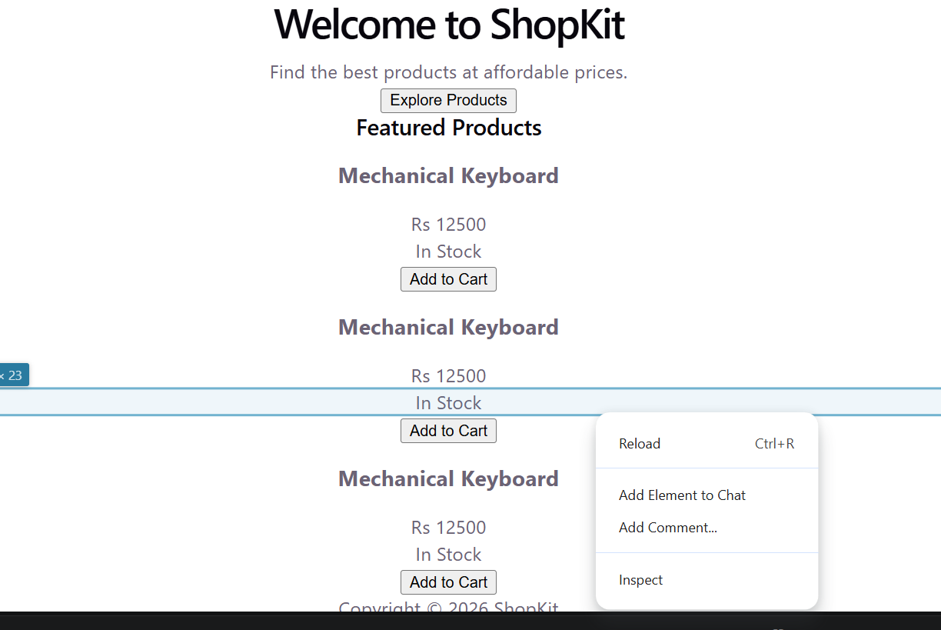

After Applying CSS:
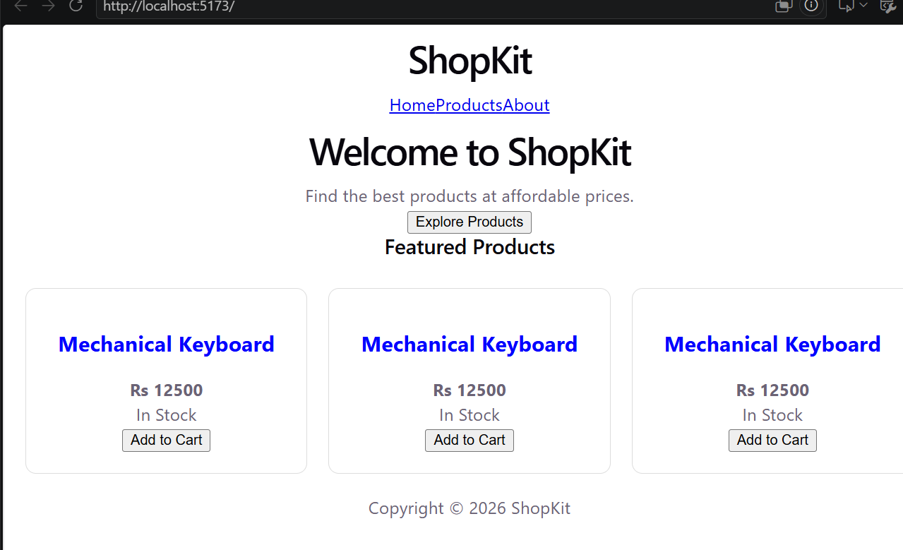

HOMEWORK ACTIVITIES:
NOTE: Zip file is given


