**Problem Statement**we have an excel sheet, which needs to be converted into JSON with a different schema than excel rows and push JSON array to Dynamo DBTable

**Solution**we are going to create a Lambda function that will trigger on S3 put event. Whenever we will upload an excel file to the s3 bucket, it will trigger our lambda function. Lambda Function will read an excel file, converts its data into a JSON array, and push it to the designated Dynamo DB Table. (If Primary Key exists it will update the record)

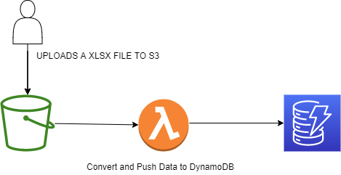

**S3 put event will trigger lambda function, which will read uploaded excel file from using Python’s Pandas library, converts it into desired JSON format and upload it to Dynamo DB Table.**

**AWS Components**1- S3 Bucket  
2- Lambda Function  
3- Dynamo DB  
4- Python 3.9 as Lambda function’s language

**Manual Triggering Lambda Function In case of Failure**

In case of failure data load after s3 upload, you don’t have to upload that file again. I have configured a test event in Lambda Function .All you need to do is go to AWS console and select lambda function from overview window select code you will get a test button there .Click on downwards arrow there and select ManualTriggerEvent, Edit JSON with bucket name and key (under the name file has been uploaded to S3 ),save it .Now Click on Test . You will get a message Data has been inserted in case of success.