-- Q1. Are poor-performing nodes actually overloaded, or are they performing poorly despite having available capacity?
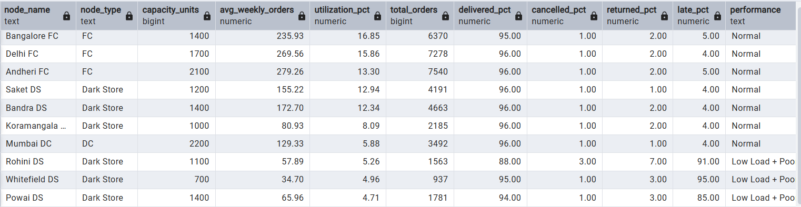

-- Q2. Are nodes with poor delivery performance also experiencing picking workload or quality problems?
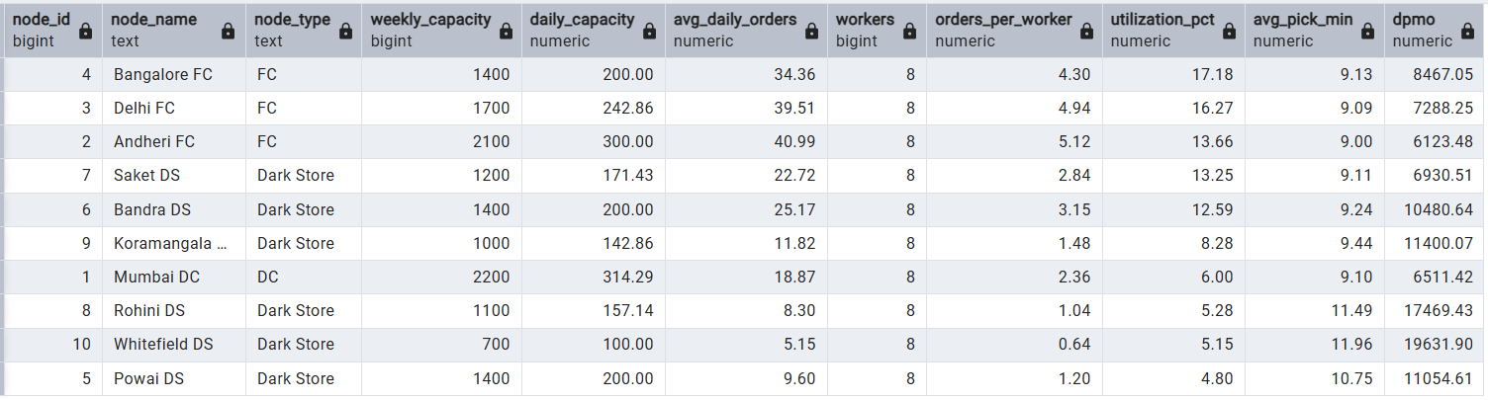

-- Q3. Which workers consistently generate the highest picking errors and DPMO?
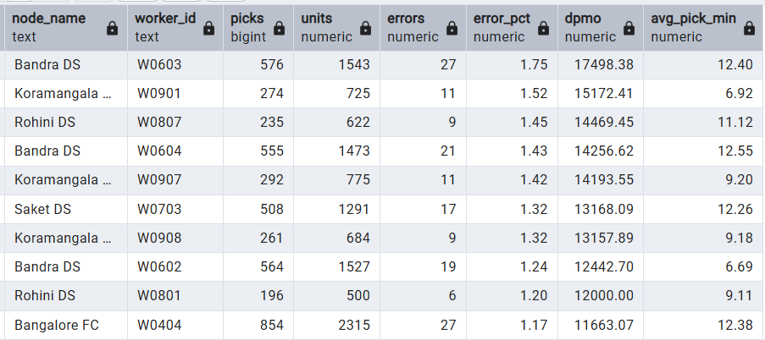

-- Q4. Which nodes have the largest inventory shortages and accuracy problems?
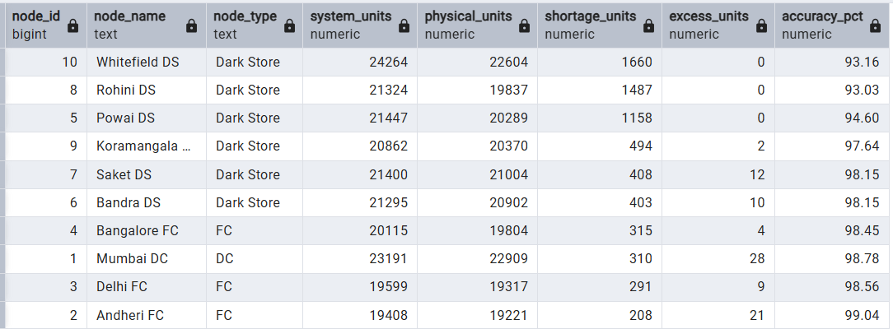

-- Q5. Which carriers are good overall but perform poorly on specific Dark Store routes?
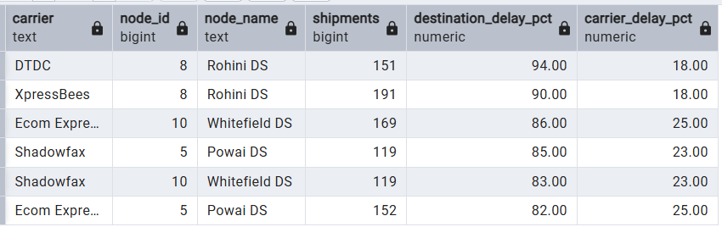
-- Q6. Which nodes have the highest cost per order, and which cost category drives that spending?
