

**DEPARTMENT OF COMPUTER SCIENCE**

FALL 2022-23

DATABASE FINAL PROJECT REPORT

|  |  |  |  |  |  |
| --- | --- | --- | --- | --- | --- |
| COURSE | INTRODUCTION TO DATABASE | SECTION | G | GROUP | 09 |

**GROUP MEMBERS:**

|  |  |
| --- | --- |
| NAME | STUDENT ID |
| SAMIUL ALAM RAFI | 21-45400-3 |
| MD. SHADMAN TAHSIN KHAN | 21-45796-3 |
| MEHEDI HASAN TURJOY | 22-46646-1 |
| MD. MASUM BILLAH NABIL | 22-47031-1 |

**Title:**

Hostel Management Database

**CASE STUDY:**

For accommodating students, a university has various halls. Each hall is identified by a hall number and has its own name. The database also contains additional data, like the street, block, the number of seats available, and the number of students in each hall. The rooms of each hall are identified by a unique room no. Hall no of each room is stored in the database to easily find that room. The rooms have categories. The categories are single bedroom and double bedroom. Rents of single bedroom ranges between 3000 and 5000 and for double bedroom it ranges from 7000 and 9000 taka. Only one student can live in the single rooms and 2 students can live in the double bedrooms. There may be some students in the rooms or no students at all. Each student has unique student id. The student id along with their first name, last name, phone number, their department, their guardian’s name, guardian’s phone number and room number are stored in the ‘Student’ table. Students eat meals. Students are given unique meal pass separate from their student id to keep track of their meal counts and meal off dates. Students parks their vehicles in the parking of the hostel. Some students may have multiple vehicles. But not all students own a vehicle. The information about student’s vehicles is stored in the ‘Parking’ table which consists of a unique parking pass similar to that meal pass along with vehicle type, license no and student id. Parking pass is different for each vehicle even if it belongs to the same student. Hall staffs keep the hostels functioning. There are four offices of employees which are ‘Administration’, ‘Security’, ‘Maintenance’ and ‘Kitchen’. Each office has a department no. and is stored in the ‘Department’ table. The ‘Employee’ table stores information about hall staffs. The ‘Employee’ table is made up of unique employee no, first name, last name, positions, manager, salary, department no and which hall they work in. The ‘Managing Director’ and ‘Food Board Manager’ are in the management of all the halls. So, they don’t have any hall no. And the other positions are ‘Coordinator’, ‘Assistant Coordinator’, ‘Chef’ and ‘Watchman’.

**ER Diagram:**

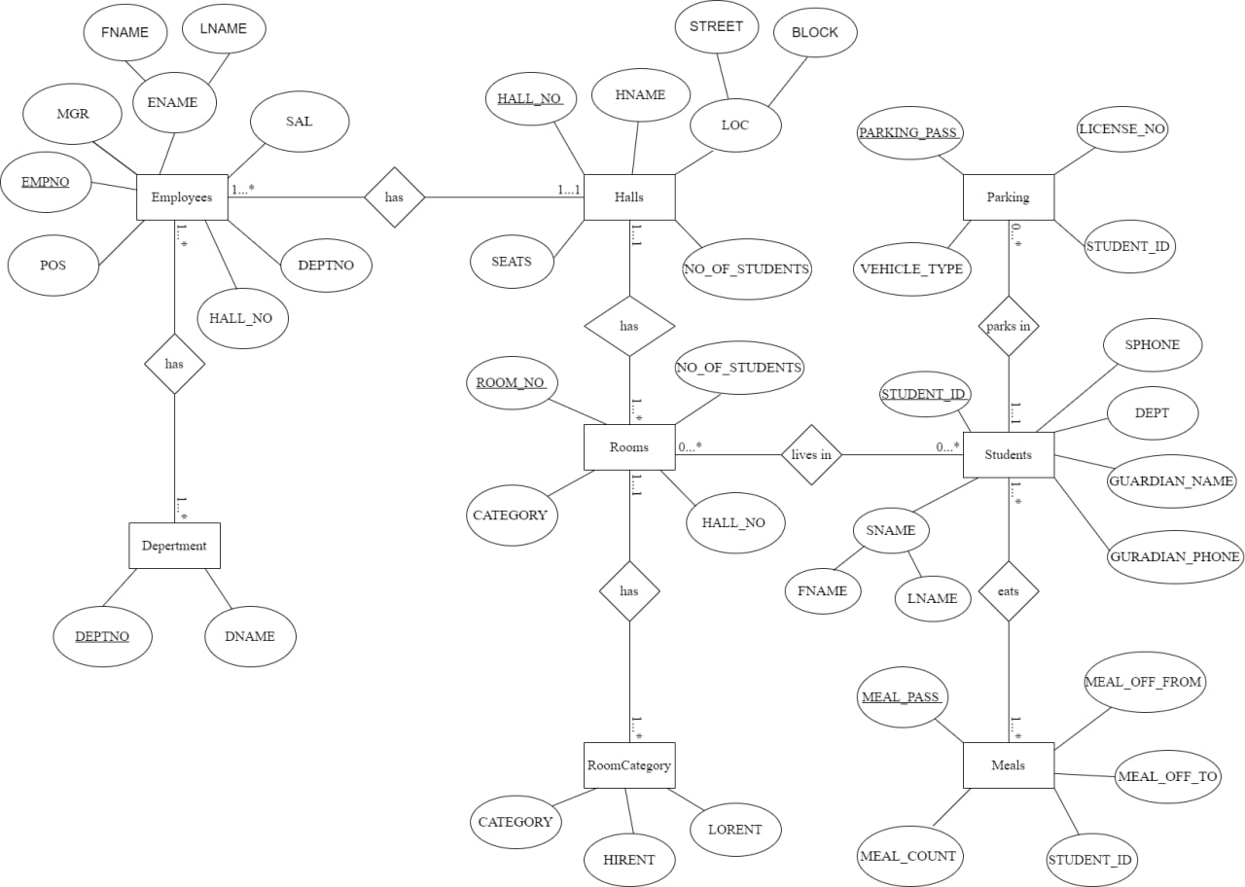

**NORMALIZATION:**

The primary key is shown as red color

Foreign key is shown as blue color

Halls-Rooms Relationship {Has} (hall_no, hall name, street, block, seats, number of students, room_no, hall_no, category, Number of student)

1NF: No multivalued attribute

1. hall_no, hall name, street, block, seats, number of students, room_no, hall_no, category, Number of students.

2NF:

1. hall_no, hall name, street, block, seats, number of students
2. room_no, category, Number of students, hall_no.

3NF:

1. hall_no, hall name, street, block, seats, number of students
2. room_no, hall_no, category, Number of students.
3. street, block, hall_no

Table:

1. hall_no, hall name, street, block, seats, number of students
2. room_no, hall_no, category, Number of students.
3. street, block, hall_no

Student-Room Relationship {lives in} (student_id, FNAME, LNAME, dept, sphone, guardian name, guardian phone, room_no, room_no, hall_no, category, Number of student)

1NF: No multivalued attribute

1. student_id, FNAME, LNAME, dept, sphone, guardian name, guardian name, room_no, room_no, hall_no, category, Number of students.

2NF:

1. student_id, FNAME, LNAME, dept, sphone, guardian name, room_no
2. room_no, hall_no, category, Number of students.

3NF:

1. student_id, FNAME, LNAME, dept, sphone, guardian name, room_no
2. room_no, hall_no, category, Number of students.
3. FNAME, LNAME, student_id

Table:

1. student_id, FNAME, LNAME, dept, sphone, guardian name, room_no
2. room_no, hall_no, category, Number of students.
3. FNAME, LNAME, student_id

Student-Meals Relationship {Eats} (student_id, FNAME, LNAME, dept, student phone, guardian name, guardian phone, room_no, meal_ pass, meal_count, meal_off_from, meal_off_to, student_id )

1NF: No multivalued attribute

1. student_id, FNAME, LNAME, dept, guardian name, room_no, meal_ pass, meal_count, meal_off_from, meal_off_to, student_id

2NF:

1. student_id, FNAME, LNAME, dept, guardian name
2. meal_ pass, meal_count, meal_off_from, meal_off_to, student_id

3NF:

1. student_id, FNAME, LNAME, dept, guardian name, room_no
2. meal_ pass, meal_count, meal_off_from, meal_off_to, student_id
3. FNAME, LNAME, student_id

Table:

1. student_id, FNAME, LNAME, dept, guardian name, room_no
2. meal_ pass, meal_count, meal_off_from, meal_off_to, student_id
3. FNAME, LNAME, student_id

Student-Parking Relationship {Parks in} (student_id, FNAME, LNAME, dept, student phone, guardian name, guardian phone, room_no, parking pass, vehicle_type, license_no, student_id)

1NF: No multivalued attribute

1. student_id, FNAME, LNAME, dept, guardian name, room_no, parking pass, vehicle_type, license_no, student_id.

2NF:

1. student_id, FNAME, LNAME, dept, guardian name, room_no
2. parking pass, vehicle_type, license_no, student_id.

3NF:

1. student_id, FNAME, LNAME, dept, guardian name, room_no
2. parking pass, vehicle_type, license_no, student_id.
3. FNAME, LNAME, student_id

Table:

1. student_id, FNAME, LNAME, dept, guardian name, room_no
2. parking pass, vehicle_type, license_no, student_id.
3. FNAME, LNAME, student_id

Halls-Employees Relationship {Employs} (hall_no, hall name, street, block, seats, number of students, empno, FNAME, LNAME, position, MGR, salary, hall_no, deptno)

1NF: No multivalued attribute

1. hall_no, hall name, street, block, seats, number of students, empno, FNAME, LNAME, position, MGR, salary, hall_no, deptno

2NF:

1. hall_no, hall name, street, block, seats, number of students
2. empno, FNAME, LNAME, position, MGR, salary, hall_no, deptno

3NF:

1. hall_no, hall name, street, block, seats, number of students
2. empno, employee name, position, MGR, salary, hall_no, deptno
3. FNAME, LNAME, empno.
4. street, block, hall_no

Table:

1. hall_no, hall name, street, block, seats, number of students
2. empno, FNAME, LNAME, position, MGR, salary, hall_no, deptno
3. FNAME, LNAME, empno
4. street, block, hall_no

Employees-Department Relationship {Works in} (empno, FNAME, LNAME, position, MGR, salary, hall_no, deptno, department name, deptno)

1NF: No multivalued attribute

1. empno, FNAME, LNAME, position, MGR, salary, hall_no, deptno, department name, deptno

2NF:

1. empno, FNAME, LNAME, position, MGR, salary, hall_no, deptno
2. department name, deptno

3NF:

1. empno, FNAME, LNAME, position, MGR, salary, hall_no, deptno
2. department name, deptno
3. FNAME, LNAME, empno

Table:

1. empno, FNAME, LNAME, position, MGR, salary, hall_no, deptno
2. department name, deptno
3. FNAME, LNAME, empno

Room-RoomCatagory {has} (room_no, category, no_of_students, hall_no, category, hirent, lorent)

1NF: No multivalued attribute

1.(room_no, category, no_of_students, hall_no, hirent, lorent)

2NF: 1. room_no, category, no_of_students, hall_no,

2. hirent, lorent, room_no

3NF:

1. room_no, category, no_of_students, hall_no,
2. hirent, lorent, category, room_no
3. hirent, lorent, room_no

Table:

1. room_no, category, no_of_students, hall_no,
2. hirent, lorent, category, room_no
3. hirent, lorent, room_no

**Total Table:**

1. hall_no, hall name, street, block, seats, number of students
2. room_no, hall_no, category, Number of students.
3. street, block, hall_no
4. student_id, FNAME, LNAME, dept, sphone, guardian name, room_no
5. room_no, hall_no, category, Number of students.
6. FNAME, LNAME, student_id
7. student_id, FNAME, LNAME, dept, sphone, guardian name, room_no
8. meal_ pass, meal_count, meal_off_from, meal_off_to, student_id
9. FNAME, LNAME, student_id
10. student_id, FNAME, LNAME, dept, sphone , guardian name, room_no
11. parking pass, vehicle_type, license_no, student_id.
12. FNAME, LNAME, student_id
13. hall_no, hall name, street, block, seats, number of students
14. empno, FNAME, LNAME, position, MGR, salary, hall_no, deptno
15. FNAME, LNAME, empno
16. street, block, hall_no
17. empno, FNAME, LNAME, position, MGR, salary, hall_no, deptno
18. department name, deptno
19. FNAME, LNAME, empno
20. room_no, category, no_of_students, hall_no,
21. hirent, lorent, category, room_no
22. hirent, lorent, room_no

**Final Table:**

1. hall_no, hall name, street, block, seats, number of students
2. room_no, hall_no, category, Number of students.
3. street, block, hall_no
4. student_id, FNAME, LNAME, dept, sphone, guardian name, room_no
5. FNAME, LNAME, student_id, empno
6. meal_ pass, meal_count, meal_off_from, meal_off_to, student_id
7. parking pass, vehicle_type, license_no, student_id.
8. empno, FNAME, LNAME, position, MGR, salary, hall_no, deptno
9. department name, deptno
10. room_no, category, no_of_students, hall_no,
11. hirent, lorent, category, room_no
12. hirent, lorent, room_no

**Constrain Table:**

1. Halls

Constrains:

1. HALL_NO (primary key)
2. Rooms

Constrains:

1. ROOM_NO (primary key)
2. HALL_NO (foreign key)
3. RoomCategory

Constrains:

1. No constrains
2. Students

Constrains:

1. STUDENT_ID (primary key)
2. ROOM_NO (foreign key)
3. Meals

Constrains:

1. MEAL_PASS (primary key)
2. STUDENTD_ID (foreign key)
3. Parking

Constrains:

1. PARKING_PASS (primary key)
2. STUDENT_ID (foreign key)
3. Employees

Constrains:

1. EMPNO (primary key)
2. HALL_NO (foreign key)
3. Department

Constrains:

1. DEPTNO (primary key)

**TABLE CREATION:**

**DEPARTMENT TABLE:**

CREATE TABLE DEPARTMENT(

DEPTNO NUMBER(2,0),

DNAME VARCHAR2(14),

PRIMARY KEY (DEPTNO)

);

DESC DEPARTMENT;

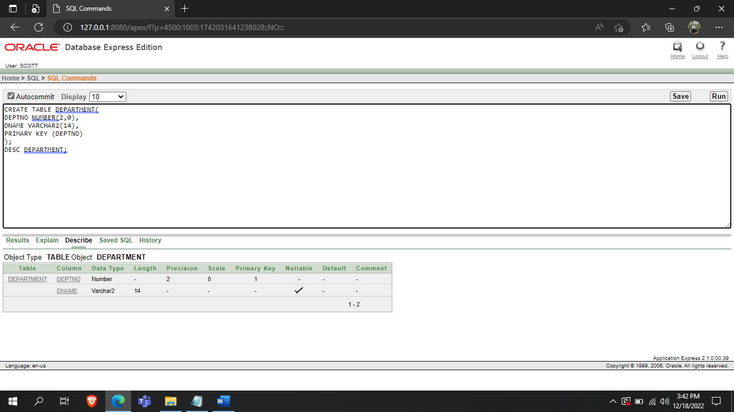

**HALL TABLE:**

CREATE TABLE HALLS(

HALL_NO NUMBER(2),

HNAME VARCHAR2(500),

BLOCK VARCHAR2(500),

STREET VARCHAR2(500),

SEATS NUMBER(4),

NO_OF_STUDENTS NUMBER(4),

PRIMARY KEY (HALL_NO)

);

DESC HALLS;

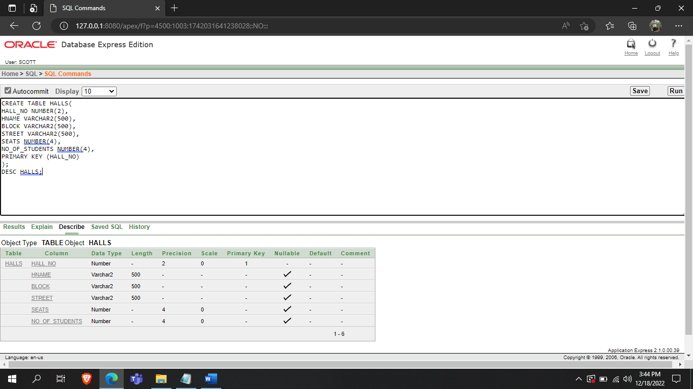

**EMPLOYEES TABLE:**

CREATE TABLE EMPLOYEES (

EMPNO NUMBER(4,0),

FNANE VARCHAR2(10),

LNANE VARCHAR2(10),

POS VARCHAR2(20),

MGR NUMBER(4,0),

SAL NUMBER(7,2),

DEPTNO NUMBER(2,0),

HALL_NO NUMBER(2),

PRIMARY KEY (EMPNO),

FOREIGN KEY (DEPTNO) REFERENCES DEPARTMENT (DEPTNO),

FOREIGN KEY (HALL_NO) REFERENCES HALLS (HALL_NO)

);

DESC EMPLOYEES;

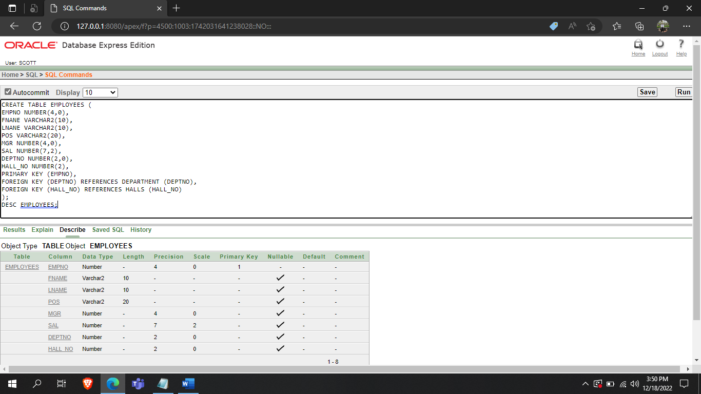

**ROOMS TABLE:**

CREATE TABLE ROOMS(

ROOM_NO VARCHAR2(10),

HALL_NO NUMBER(2),

CATEGORY VARCHAR2(10),

NO_OF_STUDENTS NUMBER(2, 0),

PRIMARY KEY(ROOM_NO),

FOREIGN KEY(HALL_NO) REFERENCES HALLS(HALL_NO)

);

DESC ROOMS;

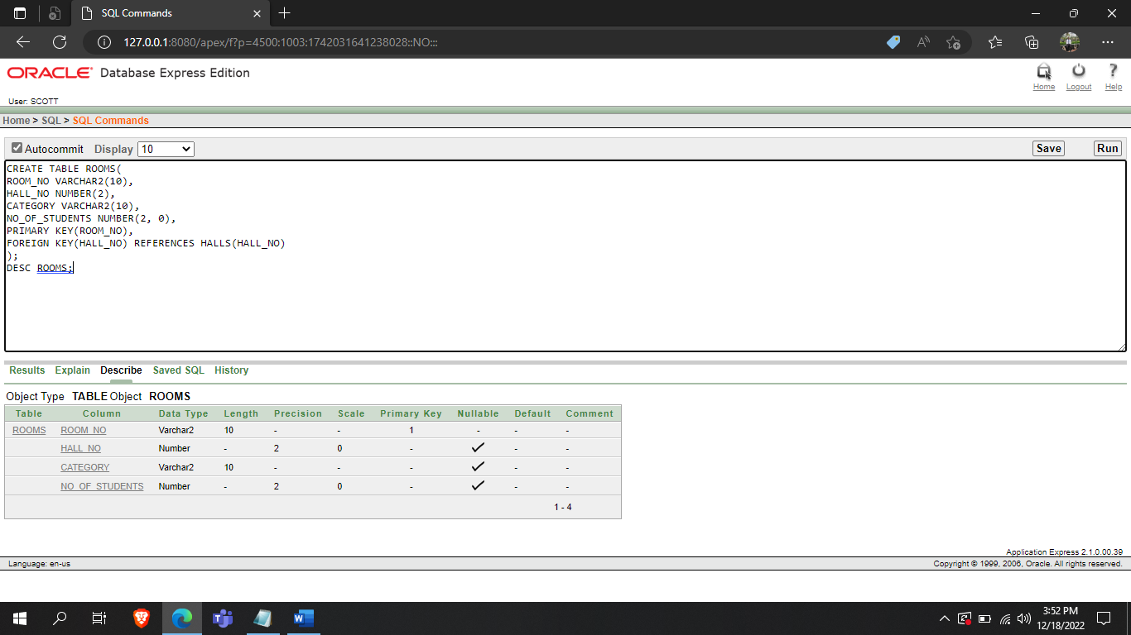

**ROOMCATEGORY TABLE:**

CREATE TABLE ROOMCATEGORY(

CATEGORY VARCHAR2(10),

HIRENT NUMBER,

LORENT NUMBER

);

DESC ROOMCATEGORY;

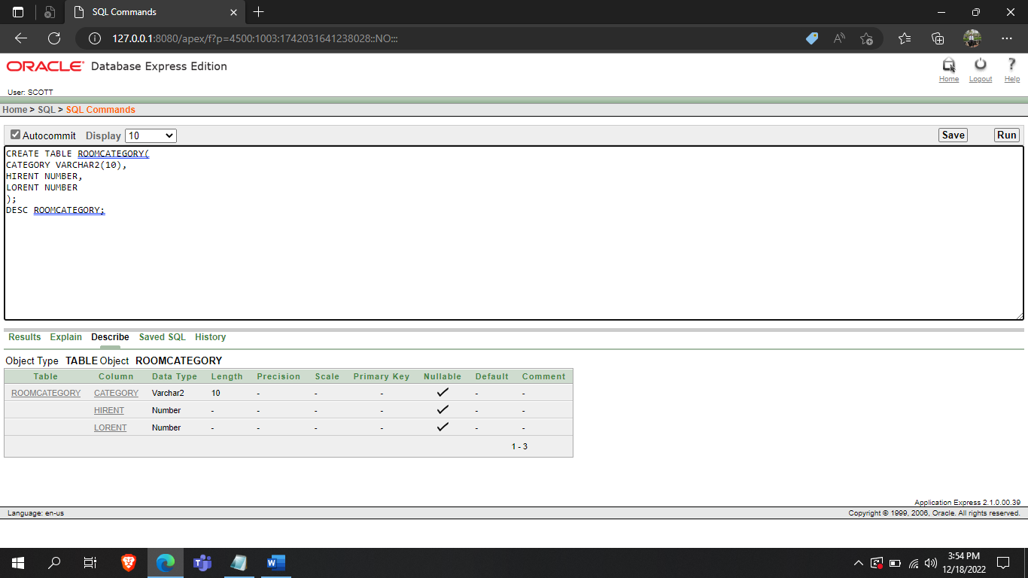

**STUDENT TABLE:**

CREATE TABLE STUDENTS(

STUDENT_ID NUMBER(4,0),

FNAME VARCHAR2(255),

LNAME VARCHAR2(255),

DEPT VARCHAR2(255),

SPHONE NUMBER(11, 0),

GUARDIAN_NAME VARCHAR2(255),

GUARDIAN_PHONE NUMBER(11,0),

ROOM_NO VARCHAR2(255),

RENT NUMBER(4,0),

PRIMARY KEY(STUDENT_ID),

FOREIGN KEY(ROOM_NO) REFERENCES ROOMS(ROOM_NO)

);

DESC STUDENTS;

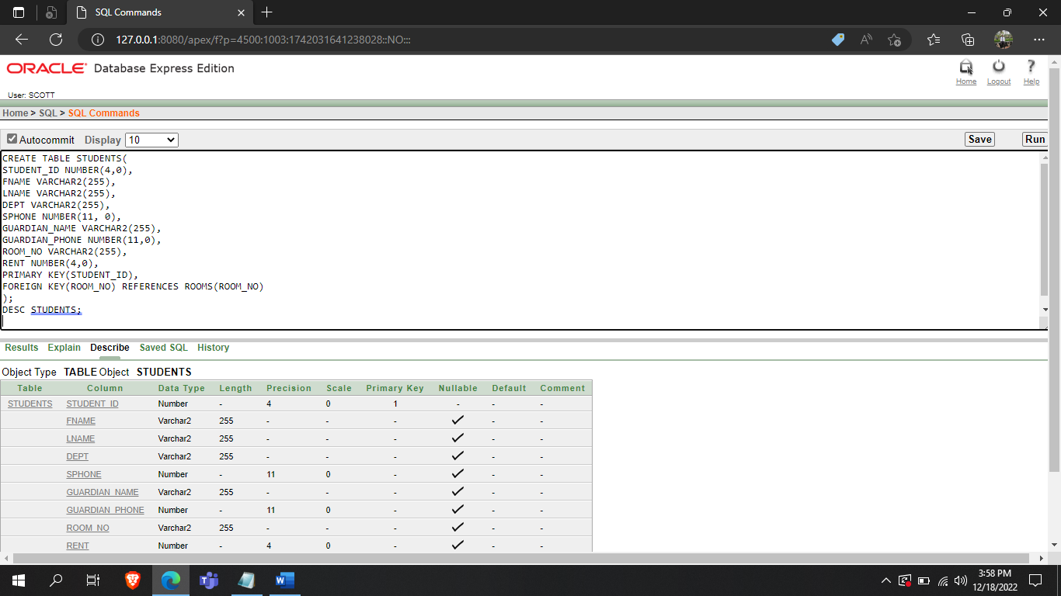

**MEALS TABLE:**

CREATE TABLE MEALS(

MEAL_PASS VARCHAR2(10),

MEAL_COUNT NUMBER(2,0),

MEAL_OFF_FROM DATE,

MEAL_OFF_TO DATE,

STUDENT_ID NUMBER(4,0),

PRIMARY KEY (MEAL_PASS),

FOREIGN KEY (STUDENT_ID) REFERENCES STUDENTS(STUDENT_ID)

);

DESC MEALS;

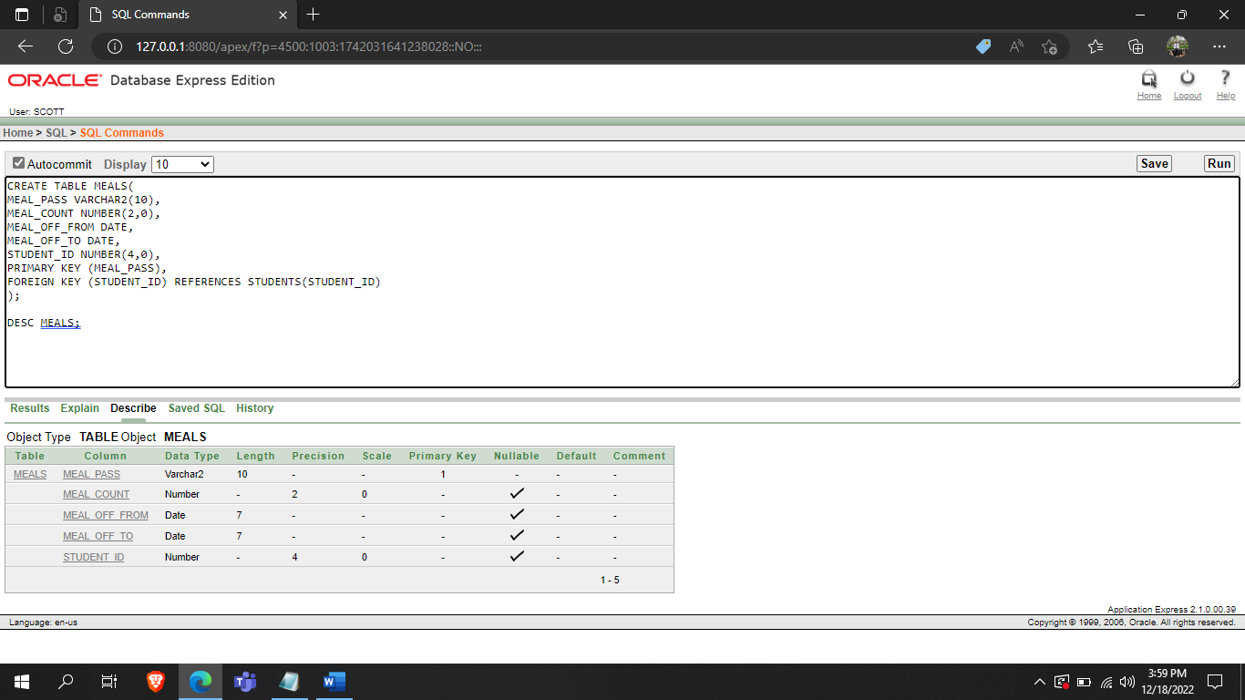

**PARKING TABLE:**

CREATE TABLE PARKING(

PARKING_PASS VARCHAR2(10),

VEHICLE_TYPE VARCHAR2(255),

LICENSE_NO VARCHAR2(255),

STUDENT_ID NUMBER(4,0),

PRIMARY KEY(PARKING_PASS),

FOREIGN KEY(STUDENT_ID) REFERENCES STUDENTS(STUDENT_ID)

);

DESC PARKING;

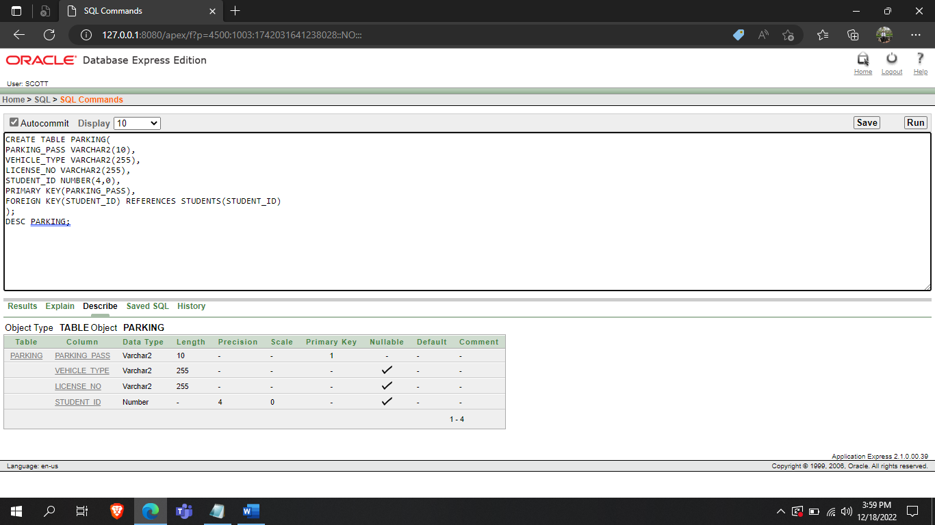

**DATA INSERTION:**

**DEPERTMENT TABLE:**

INSERT INTO DEPARTMENT VALUES(10, 'ADMINISTRATION');

INSERT INTO DEPARTMENT VALUES(20, 'SECURITY');

INSERT INTO DEPARTMENT VALUES(30, 'MAINTAINANCE');

INSERT INTO DEPARTMENT VALUES(40, 'KITCHEN');

SELECT *

FROM DEPARTMENT;

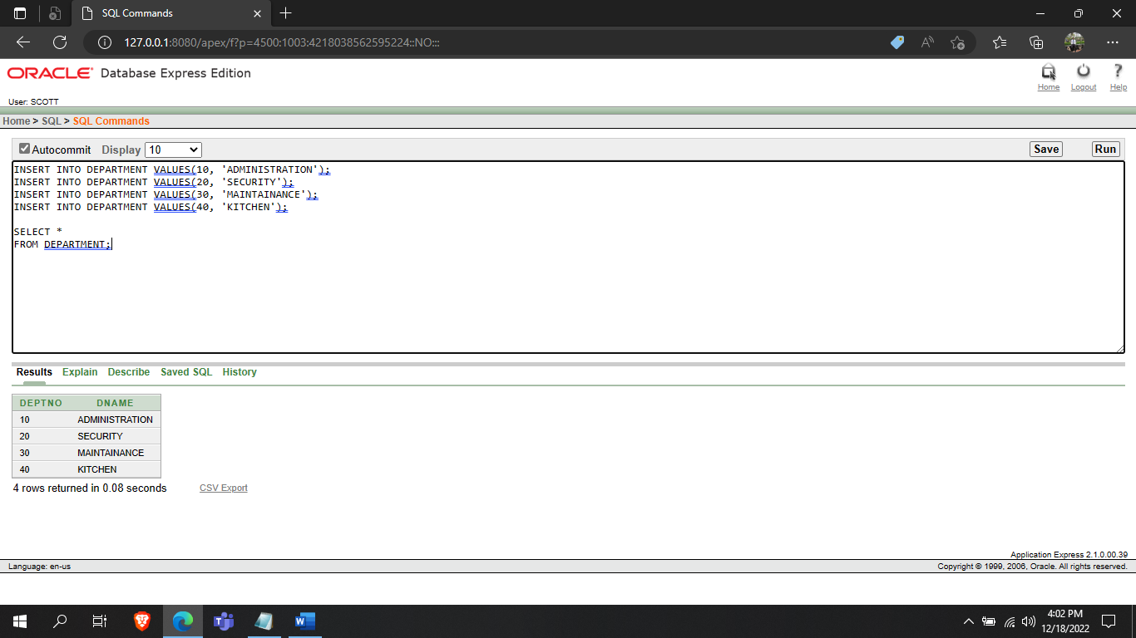

**HALLS TABLE:**

INSERT INTO HALLS VALUES(01, 'A HALL', 'K BLOCK','ROAD NO 11', 1800, 1600);

INSERT INTO HALLS VALUES(02, 'B HALL', 'L BLOCK','ROAD NO 12', 1400, 1200);

INSERT INTO HALLS VALUES(03, 'C HALL', 'J BLOCK','ROAD NO 13', 1000, 900);

INSERT INTO HALLS VALUES(04, 'D HALL', 'N BLOCK','ROAD NO 14', 800, 650);

INSERT INTO HALLS VALUES(05, 'E HALL', 'M BLOCK', 'ROAD NO 15',1300, 1200);

INSERT INTO HALLS VALUES(06, 'F HALL', 'Z BLOCK','ROAD NO 16', 1500, 1400);

SELECT *

FROM HALLS;

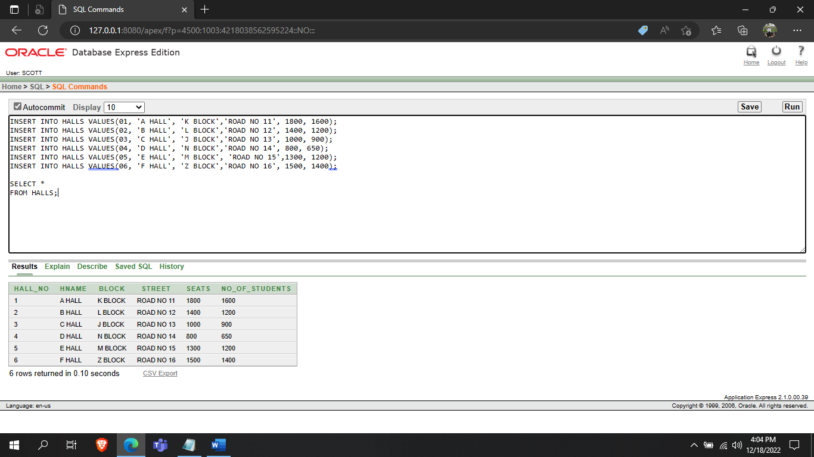

**EMPLOYEES TABLE:**

INSERT INTO EMPLOYEES VALUES(9000, 'TREVER','NOAH', 'MANAGING DIRECTOR', NULL,10000, 10, NULL );

INSERT INTO EMPLOYEES VALUES(5011, 'THOMAS','SHELBY', 'FOOD BOARD MANAGER', 9000,5000, 40, NULL);

INSERT INTO EMPLOYEES VALUES(7600, 'AURTHUR','KYLE', 'RESIDENT MANAGER', 9000,5000, 10, 03);

INSERT INTO EMPLOYEES VALUES(6600, 'WALTER','WHITE', 'RESIDENT MANAGER', 9000,5000, 10, 05);

INSERT INTO EMPLOYEES VALUES(5110, 'BRUCE','WAYNE', 'CHEF', 5011,4000, 10, 04);

INSERT INTO EMPLOYEES VALUES(2020, 'LOUIS','ADAM', 'CHEF', 5011,4100, 10, 02);

INSERT INTO EMPLOYEES VALUES(6800, 'RACHEL','PARKER', 'COORDINATOR', 7600,4500, 10, 06);

INSERT INTO EMPLOYEES VALUES(8090, 'JASON','WILLIUM', 'COORDINATOR', 7600,4500, 10, 01);

INSERT INTO EMPLOYEES VALUES(8104, 'CHRIS','SIMON', 'ASSISTANT', 8090,4400, 40, 02);

INSERT INTO EMPLOYEES VALUES(5108, 'NANCY','ADAMS', 'ASSISTANT', 8090,4400, 40, 06);

INSERT INTO EMPLOYEES VALUES(4450, 'MARY','ANNE', 'WATCHMAN', 8090,4300, 40, 03);

INSERT INTO EMPLOYEES VALUES(4660, 'ERIC','STUART', 'WATCHMAN', 8090,4300, 40, 01);

SELECT *

FROM EMPLOYEES;

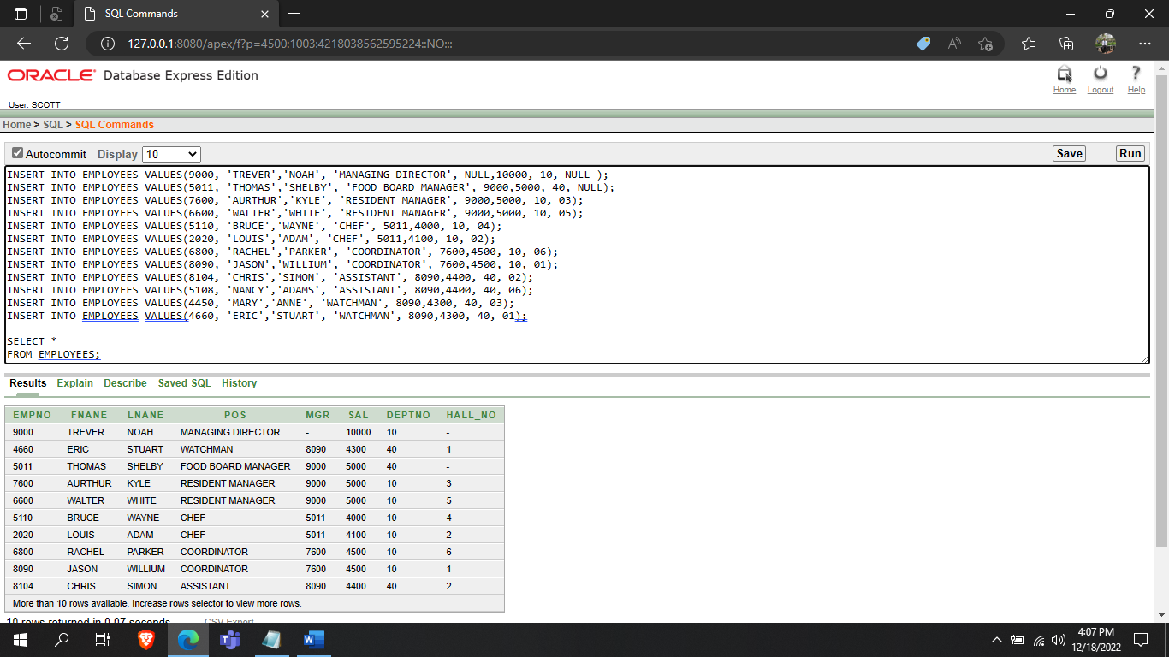

ROOMS TABLE:

INSERT INTO ROOMS VALUES ('E11', 05, 'SINGLE', 01);

INSERT INTO ROOMS VALUES ('E24', 05, 'MASTER', 01);

INSERT INTO ROOMS VALUES ('D43', 04, 'MASTER', 03);

INSERT INTO ROOMS VALUES ('D44', 04, 'MASTER', NULL);

INSERT INTO ROOMS VALUES ('C14', 03, 'MASTER', 03);

INSERT INTO ROOMS VALUES ('C19', 03, 'SINGLE', 01);

INSERT INTO ROOMS VALUES ('A15', 01, 'SINGLE', 01);

INSERT INTO ROOMS VALUES ('A14', 01, 'SINGLE', 01);

SELECT *

FROM ROOMS;

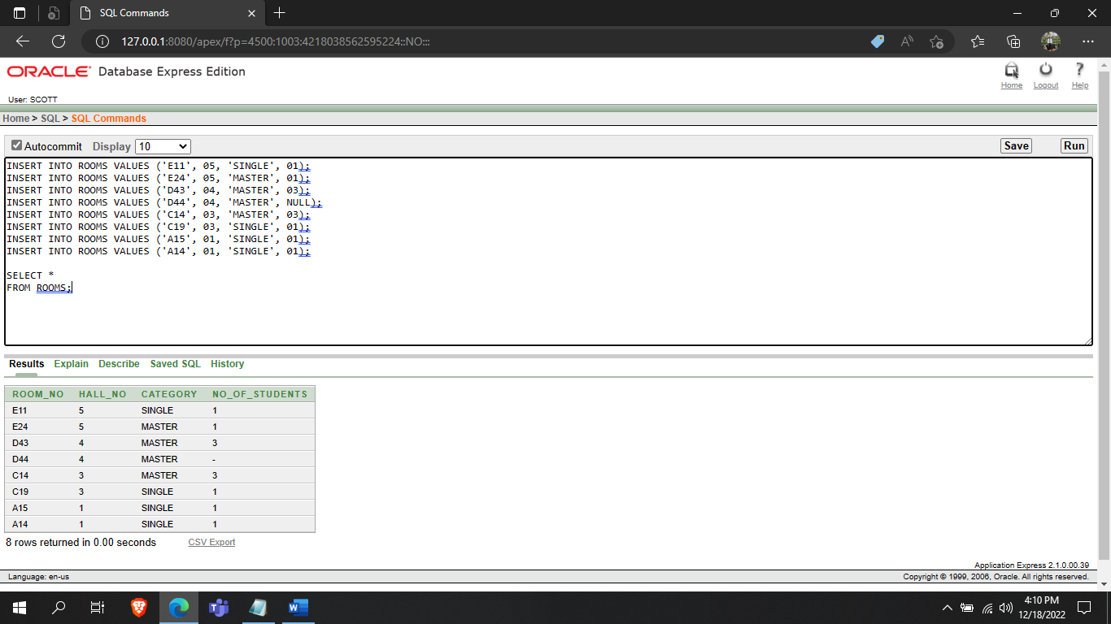

**ROOMCATEGORY TABLE:**

INSERT INTO ROOMCATEGORY VALUES('SINGLE', 3000, 5000);

INSERT INTO ROOMCATEGORY VALUES('MASTER', 7000, 9000);

SELECT *

FROM ROOMCATEGORY;

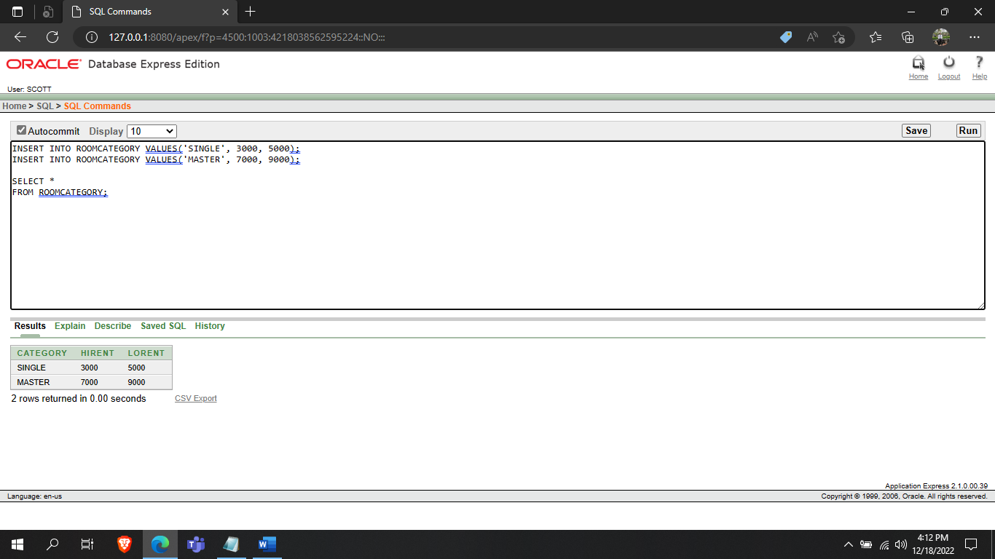

**STUDENTS TABLE:**

INSERT INTO STUDENTS VALUES (678, 'STEVE','SMITH' ,'CSE', 01234567890, 'STUART WHITE', 021046678901, 'E24', 7000);

INSERT INTO STUDENTS VALUES (890, 'ADAM','SMITH', 'CSE', 02114567890, 'ADAM JOHN', 021045678901, 'D43', 8000);

INSERT INTO STUDENTS VALUES (231, 'HARRY','RICHARD', 'CSE', 02124567890, 'CHRIS HARRY', 021095678901, 'D44', 8000);

INSERT INTO STUDENTS VALUES (456, 'RICHARD','JOHN', 'CSE', 02144567890, 'KYLE SMITH', 021045658901, 'C14', 8000);

INSERT INTO STUDENTS VALUES (245, 'PHILIP','ADAM', 'CSE', 02154567890, 'WAYNE TREVOR', 021045618901, 'E11', 4000);

INSERT INTO STUDENTS VALUES (312, 'JOHN','STEVE', 'CSE', 02104967890, 'ERIC WILLIAM', 01754279110, 'C19', 3500);

INSERT INTO STUDENTS VALUES (888, 'STUART','PARKER', 'CSE',02104867890, 'KYLE HARRY',02344278884,'A15', 3000);

INSERT INTO STUDENTS VALUES (828, 'KYLE','WHITE', 'CSE', 021045678901, 'MIKE KANE',02344256186,'A14', 5000);

SELECT *

FROM STUDENTS;

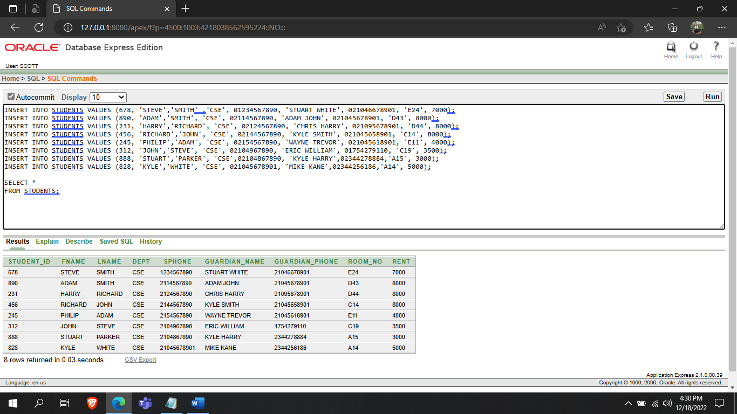

**MEALS TABLE:**

INSERT INTO MEALS VALUES('AA11', 10, TO_DATE('20-10-2022','DD-MM-YYYY'), TO_DATE('30-10-2022', 'DD-MM-YYYY'), 890);

INSERT INTO MEALS VALUES('AA40', 13, NULL, NULL, 678);

INSERT INTO MEALS VALUES('EE80', 11, TO_DATE('14-10-2022','DD-MM-YYYY'), TO_DATE('25-10-2022', 'DD-MM-YYYY'), 245);

INSERT INTO MEALS VALUES('EE10', 14, NULL, NULL, 312);

INSERT INTO MEALS VALUES('CC20', 6, NULL, NULL, 231);

INSERT INTO MEALS VALUES('CC41', 12, TO_DATE('19-10-2022','DD-MM-YYYY'), TO_DATE('28-10-2022', 'DD-MM-YYYY'), 456);

INSERT INTO MEALS VALUES('BB88', 10, NULL, NULL, 888);

INSERT INTO MEALS VALUES('BB68', 11, NULL, NULL, 828);

SELECT *

FROM MEALS;

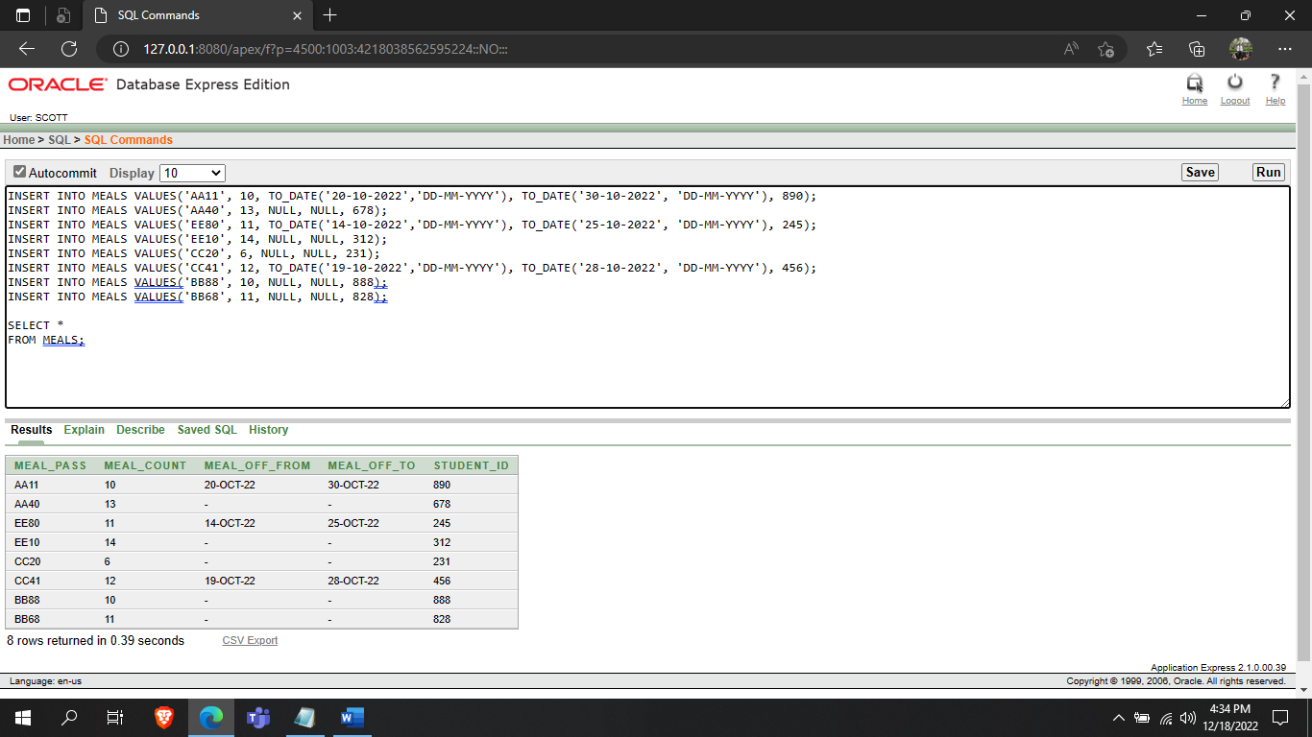

**PARKING TABLE:**

INSERT INTO PARKING VALUES('XY111', 'CAR', 'AB-2000', 890);

INSERT INTO PARKING VALUES('XY881', 'BIKE', 'NM-2010', 678);

INSERT INTO PARKING VALUES('ZY400', 'BIKE', 'KL-5060', 245);

INSERT INTO PARKING VALUES('ZY200', 'CAR', 'GH-2050', 312);

INSERT INTO PARKING VALUES('QY480', 'BIKE', 'VB-1008', 231);

INSERT INTO PARKING VALUES('QY600', 'CAR', 'TO-8060', 888);

SELECT *

FROM PARKING;

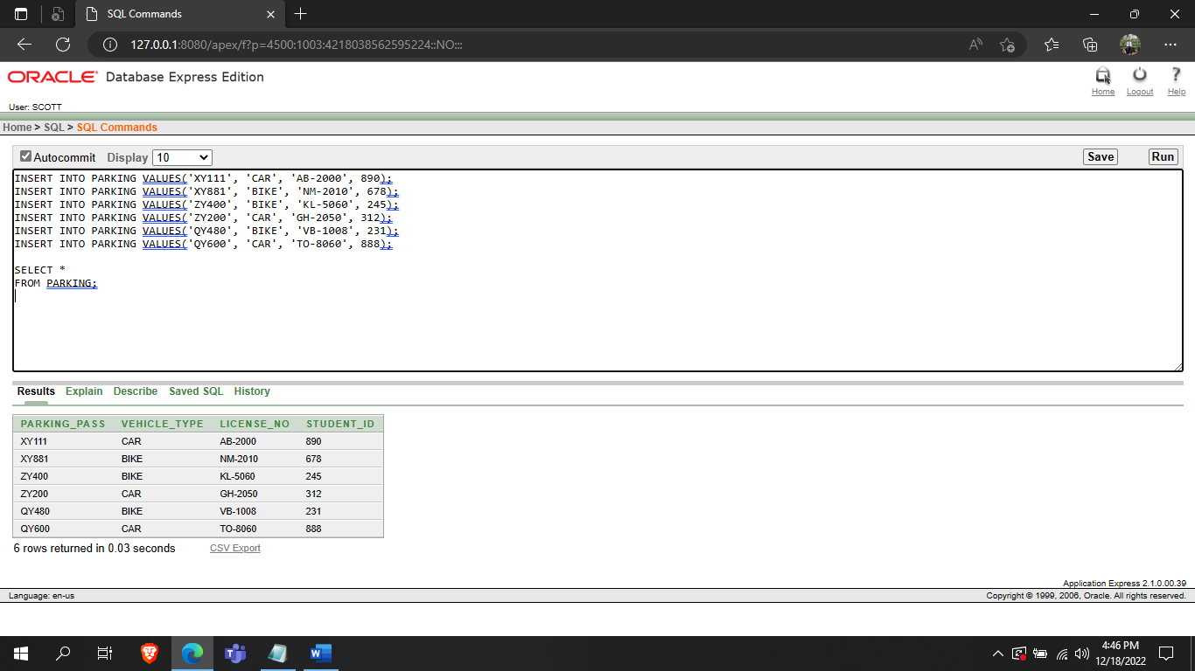

**Queries:**

**2 simple queries with simple conditions:**

(a) Display Hall Number, name and capacity of first hall

SELECT HALL_NO, HNAME, SEATS

FROM HALLS

WHERE HALL_NO = 1;

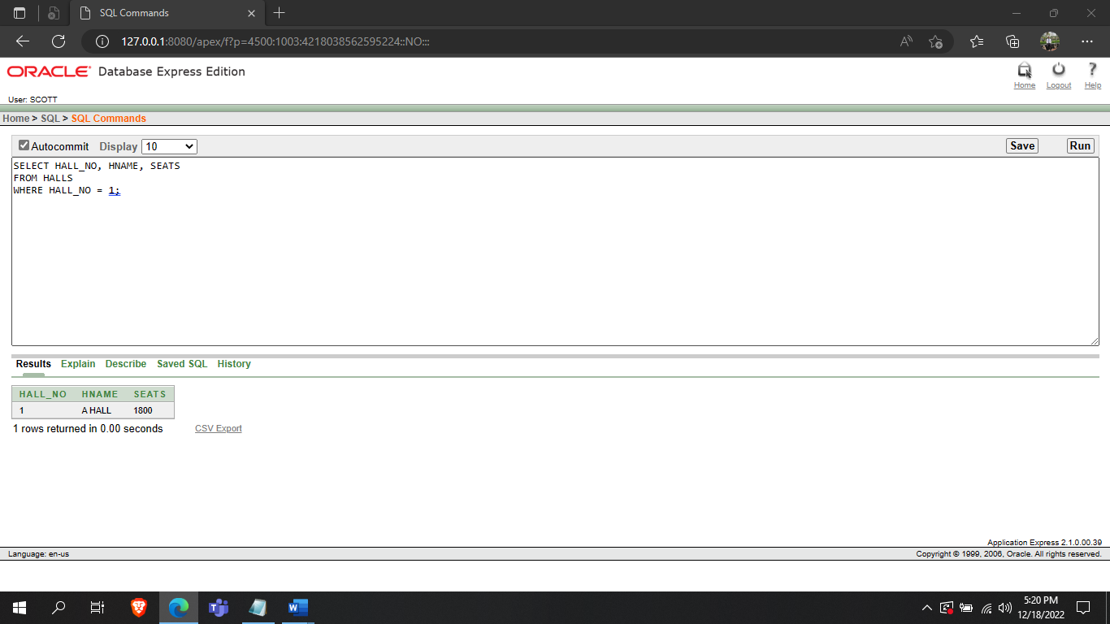

(b) Display Student's Name, Department, Room No of student with id 888.

SELECT FNAME, LNAME, DEPT, ROOM_NO

FROM STUDENTS

WHERE STUDENT_ID = 888;

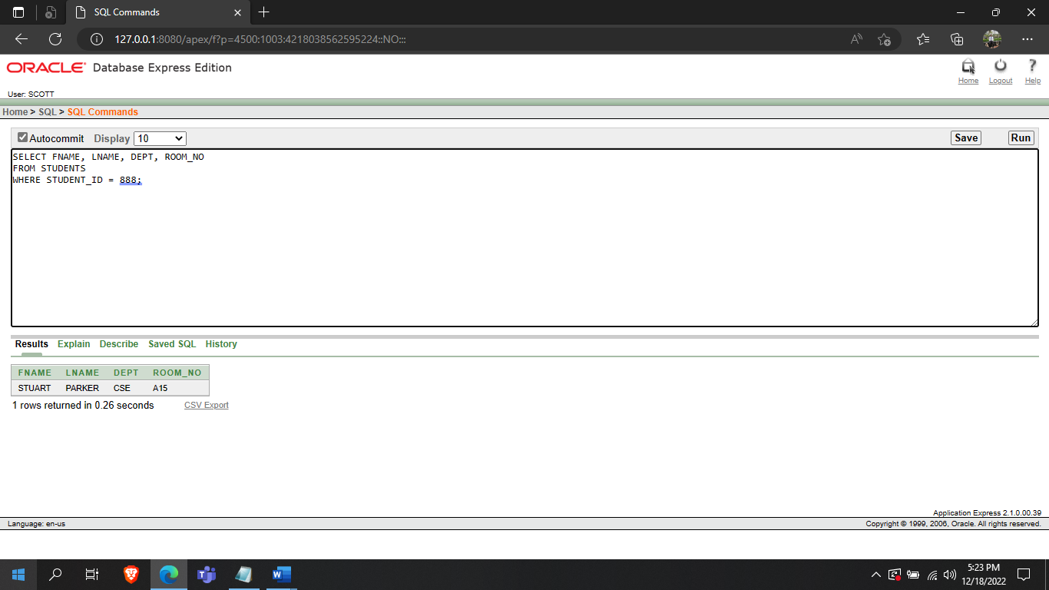

**2 single row function queries:**

(a)Display information of the room with no student.

SELECT ROOM_NO, NVL(TO_CHAR(NO_OF_STUDENTS),'EMPTY') AS STUDENTS

FROM ROOMS

WHERE NO_OF_STUDENTS IS NULL;

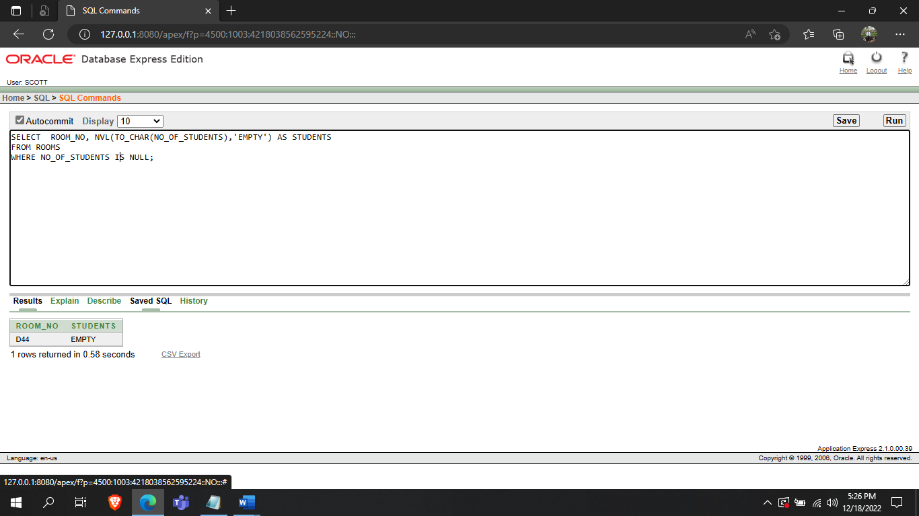

(b)Display employee number and name of employee working as Food board Manager using case conversion function.

SELECT EMPNO, FNAME, LNAME

FROM EMPLOYEES

WHERE LOWER(POS) = 'food board manager';

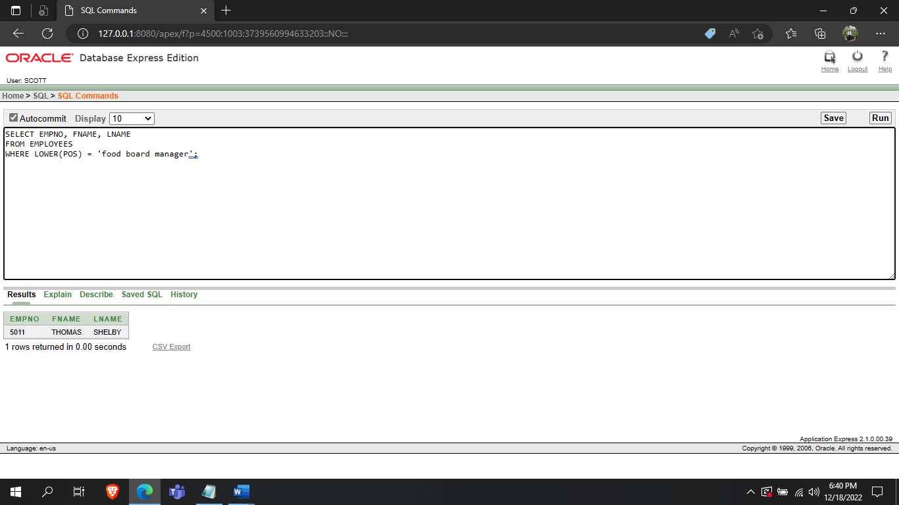

**2 multi row sub queries:**

(a)Display information of all employees of Department 40 who has salary less than their manager.

SELECT *

FROM EMPLOYEES

WHERE DEPTNO=40

AND SAL<ALL(SELECT SAL FROM EMPLOYEES WHERE POS='FOOD BOARD MANAGER');

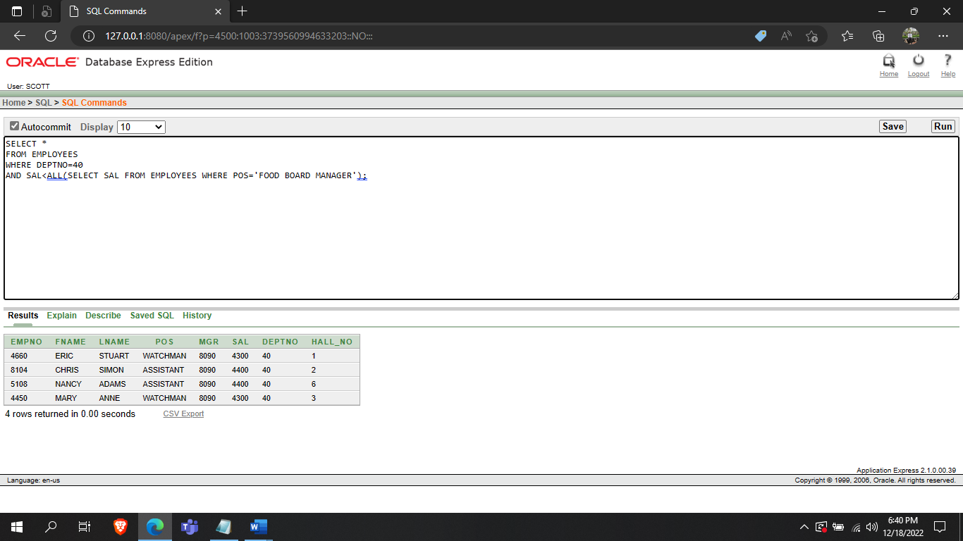

(b)Display Information of all employees who works in Halls located at L BLOCK.

SELECT *

FROM EMPLOYEES

WHERE HALL_NO IN (SELECT HALL_NO FROM HALLS WHERE BLOCK='L BLOCK');

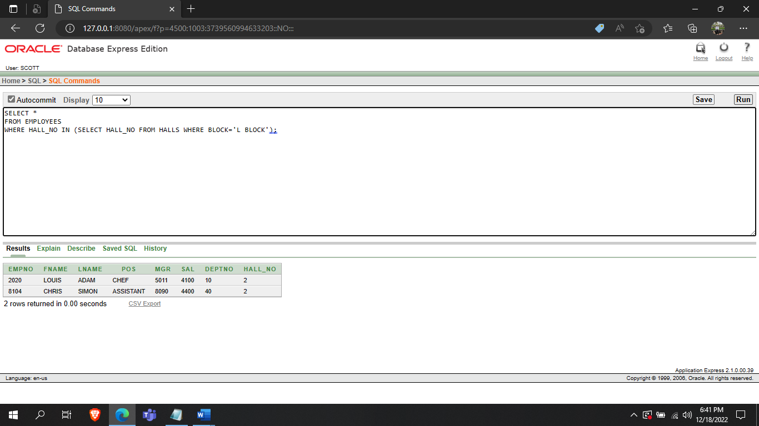

**2 equijoin queries:**

(a)Display information about students who live in the single bedrooms.

SELECT S.STUDENT_ID, S.FNAME, S.LNAME, S.ROOM_NO, R.CATEGORY

FROM STUDENTS S, ROOMS R

WHERE S.ROOM_NO = R.ROOM_NO

AND R.CATEGORY = 'SINGLE';

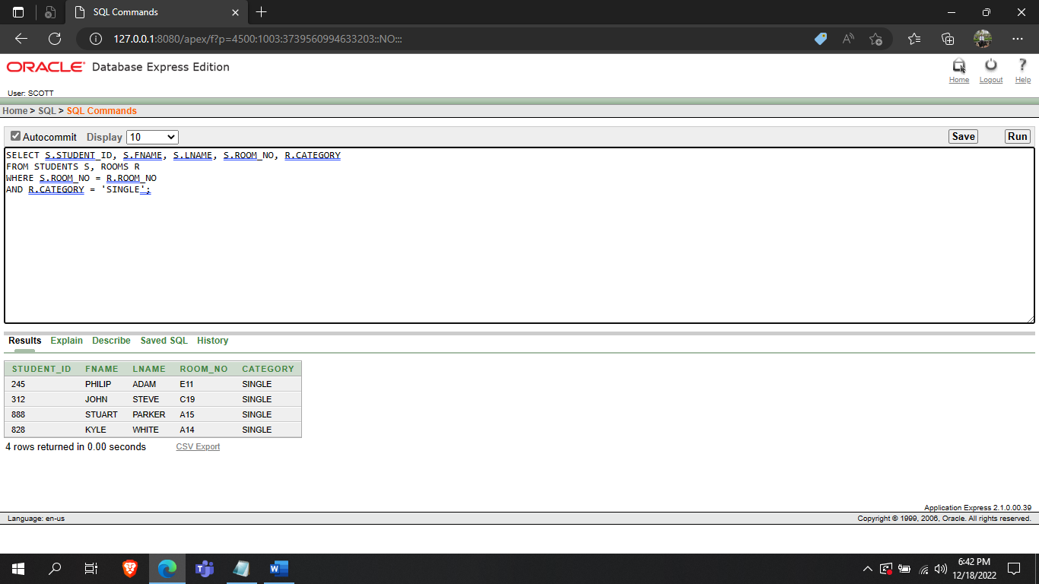

(b)Display meal information about student with student id 888

SELECT M.MEAL_PASS, M.MEAL_COUNT, S.STUDENT_ID

FROM MEALS M, STUDENTS S

WHERE S.STUDENT_ID = M.STUDENT_ID

AND M.STUDENT_ID = 888;

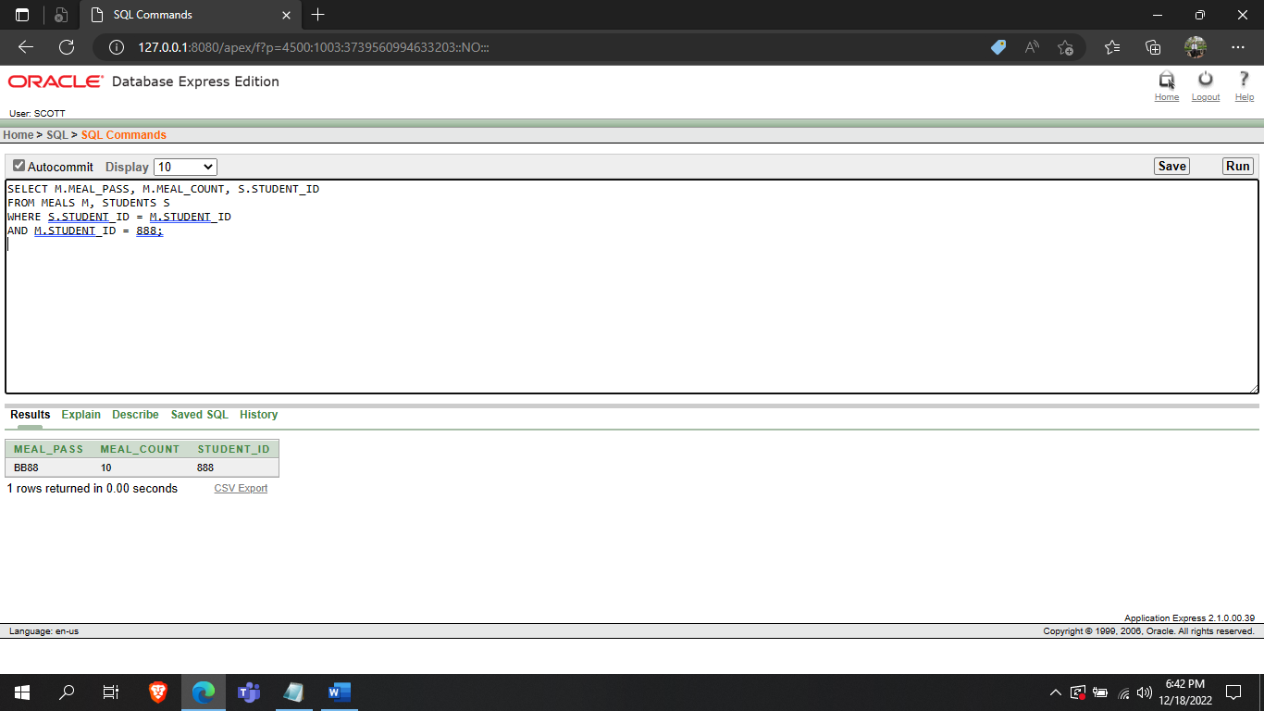

**2 non-equijoin:**

1. Display information about students who share the rent of the room

SELECT S.FNAME,S.LNAME, S.ROOM_NO, R.CATEGORY

FROM STUDENTS S, ROOMCATEGORY R

WHERE S.RENT*3 BETWEEN R.HIRENT

AND R.LORENT;

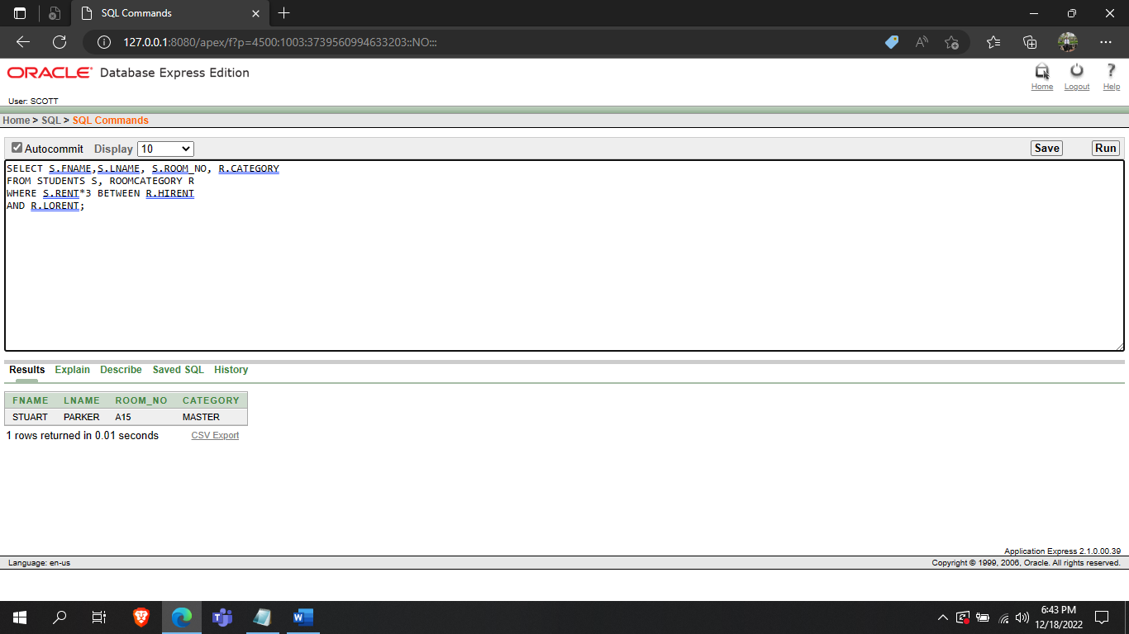

(b).Display information about students who pays the room rent alone

SELECT S.FNAME,S.LNAME, S.ROOM_NO, R.CATEGORY

FROM STUDENTS S, ROOMCATEGORY R

WHERE S.RENT BETWEEN R.HIRENT AND R.LORENT;

**2 self-join**

1. Display information of all the students who live in the same room as STEVE

SELECT S.STUDENT_ID, S.FNAME,S.LNAME, S.ROOM_NO

FROM STUDENTS S, STUDENTS T

WHERE S.ROOM_NO = T.ROOM_NO AND T.FNAME = 'STEVE';

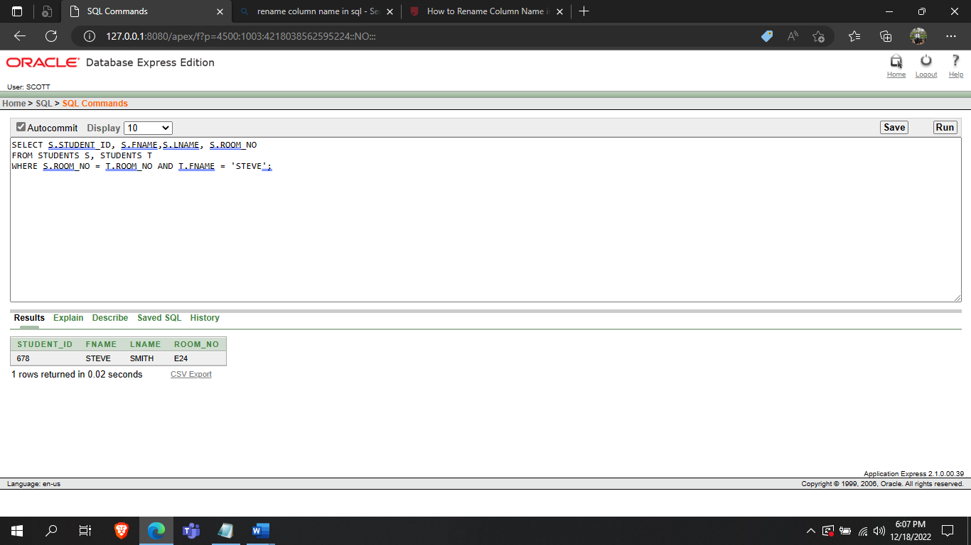

(b)Display information of all the employees who work in the same position as BRUCE

SELECT E.FNAME, E.LNAME, E.SAL, E.POS

FROM EMPLOYEES E, EMPLOYEES M

WHERE E.POS = M.POS AND M.FNAME = 'BRUCE';

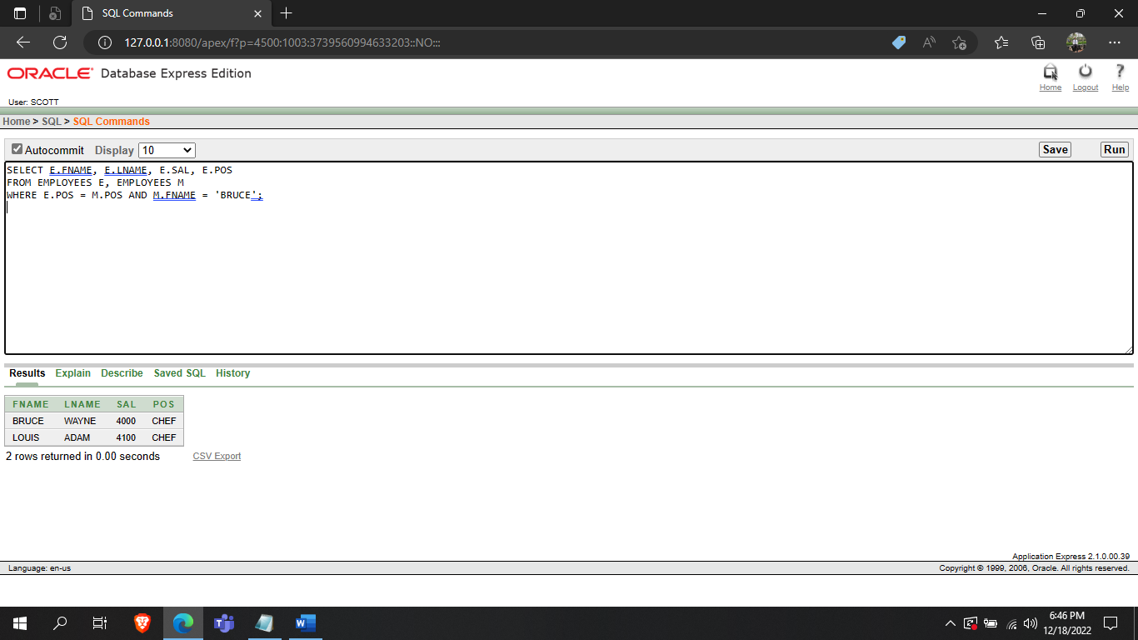

**2 outer-join queries:**

**(a)**

SELECT R.ROOM_NO, R.CATEGORY, STUDENT_ID, NVL(TO_CHAR(FNAME),'-') AS SNAME

FROM ROOMS R, STUDENTS S

WHERE S.ROOM_NO(+)=R.ROOM_NO;

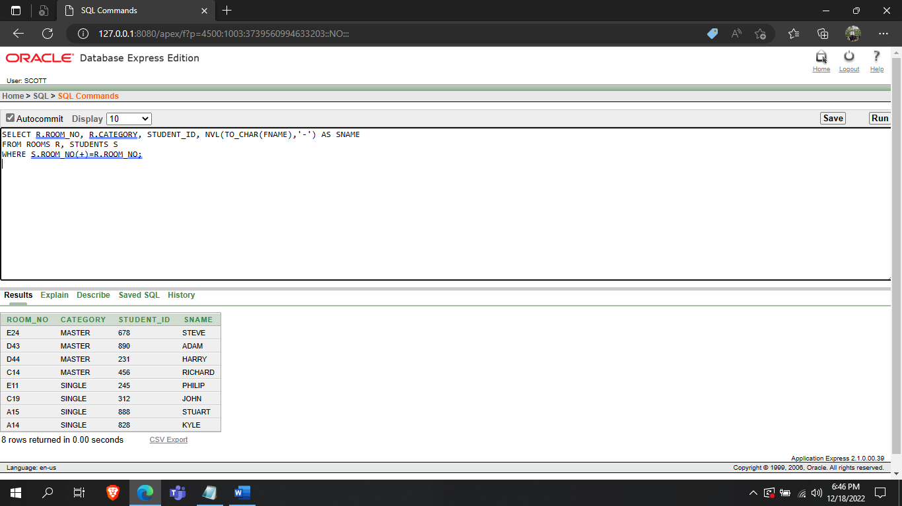

(b)

SELECT D.DEPTNO, D.DNAME, E.EMPNO, NVL(TO_CHAR(FNAME),'VACANT') AS ENAME

FROM DEPARTMENT D, EMPLOYEES E

WHERE E.DEPTNO(+)=D.DEPTNO;

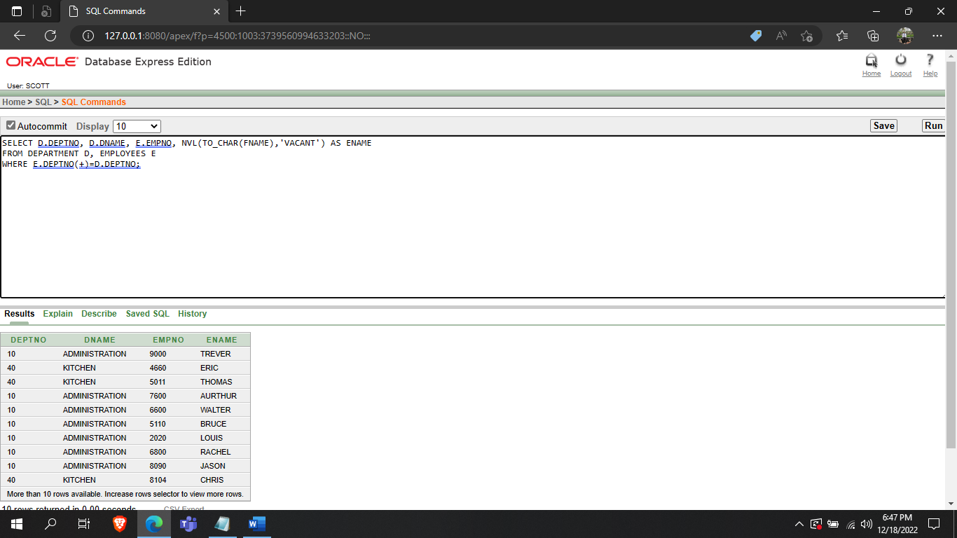

**2 simple views:**

**(a)**

CREATE VIEW EMPVIEW10 AS SELECT EMPNO, POS, FNAME, LNAME

FROM EMPLOYEES

WHERE DEPTNO = 10;

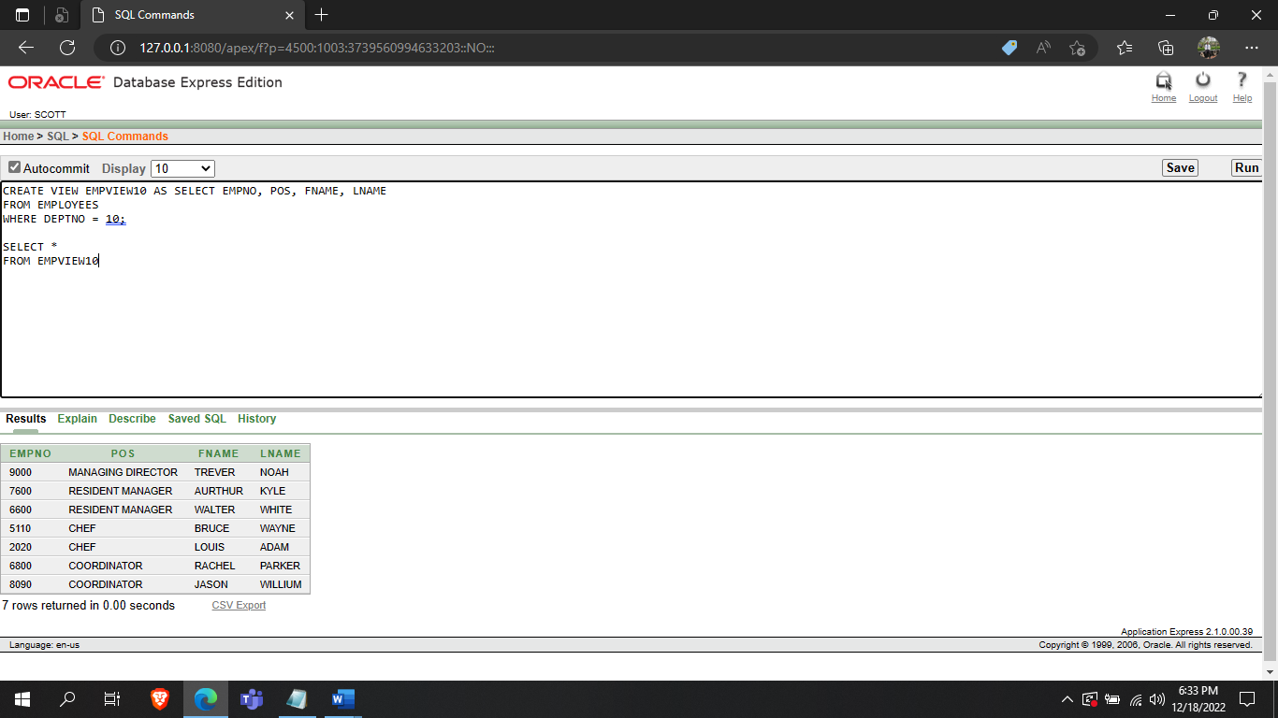

(b)

CREATE VIEW HALLVIEW10 AS SELECT HNAME, LOC

FROM HALLS

WHERE HALL_NO IN (2, 3, 4);

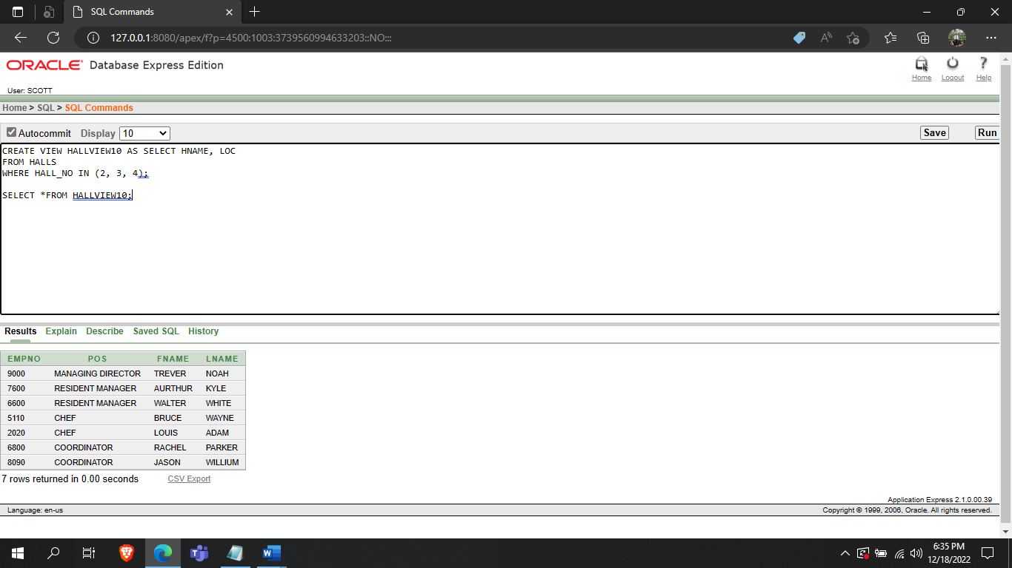

THANK YOU