Project Title: RentZ – Web-Based House Renting Management System
Group No: 8 Lab Section: 17
ID | Name | Contribution
22201344 | Tahsin Raihan Robbani | Profile Management; Public Landing & Home Pages; Flat Search & Filter; Flat Management UI (CRUD & To-Let posts); Owner Dashboard (income & tenant lists)
22201205 | Samura Huda | Rental Request & Approval Workflow (UI/API); Online Rent Payment & Late-Payment Tracking (UI/API); Complaint/Memo System (UI/API)
24241354 | Nishat Tasnim Luba | User Registration & Login (UI/API); Rules & Agreement Page (UI/API); Source-Repo Setup & CI; Auto-Eviction & To-Let Auto-Management Scheduler

Table of Contents
Section No | Content | Page No
1 | Introduction | 1
2 | Project Features | 2
3 | ER/EER Diagram | 3
4 | Schema Diagram | 4
5 | Frontend Development | 5
6 | Backend Development | 6
7 | Source Code Repository | 7
8 | Conclusion | 8
9 | References | 9

1. Introduction
RentZ is a full-stack MERN (Next.js + MongoDB) application that streamlines residential flat rentals. It connects Owners—who list and manage flats—with Customers—who browse, request, and pay rent online. An Admin role oversees overall rules, authentication, and complaint resolution. Core modules include user management, flat listing, rental workflows, payments, dashboard reports, complaint handling, and a static rules page. Our goal is a seamless, responsive UI built in Next.js with Tailwind CSS, robust validation via Zod, secure authentication with NextAuth, and flexible data storage in MongoDB.

2. Project Features
- User Registration & Authentication – Sign up / Sign in (NextAuth + MongoDB adapter) – Role-based dashboards (Owner vs. Customer)
- Flat Listing & Search – Browse available flats with filters (area, price range, number of rooms) and keyword search
- Flat Management (Owner) – CRUD operations on flats (images, descriptions, status) and “To-Let” post creation
- Rental Request & Approval Workflow – Customer requests → Owner approves/rejects, creating rental records and updating flat status
- Online Rent Payment & Late-Payment Tracking – Payment form records transaction ID, date, amount; flags late payments and triggers eviction
- Auto Eviction & To-Let Auto-Management – Cron logic to terminate rentals after overdue threshold and re-list flats automatically
- Dashboard & Reporting – Owner: monthly income, tenant list, due-rent alerts; Customer: current rental status, payment history
- Complaint / Memo System – Customers lodge complaints; Owners/Admins respond via memos with status tracking
- Rules & Agreement Page – Static site-wide page with tenancy rules, non-editable by any user
- Source Code Management & Deployment – Hosted on GitHub; build & serve via next build / next start

3. ER/EER Diagram
Figure 1: ER/EER Diagram for RentZ
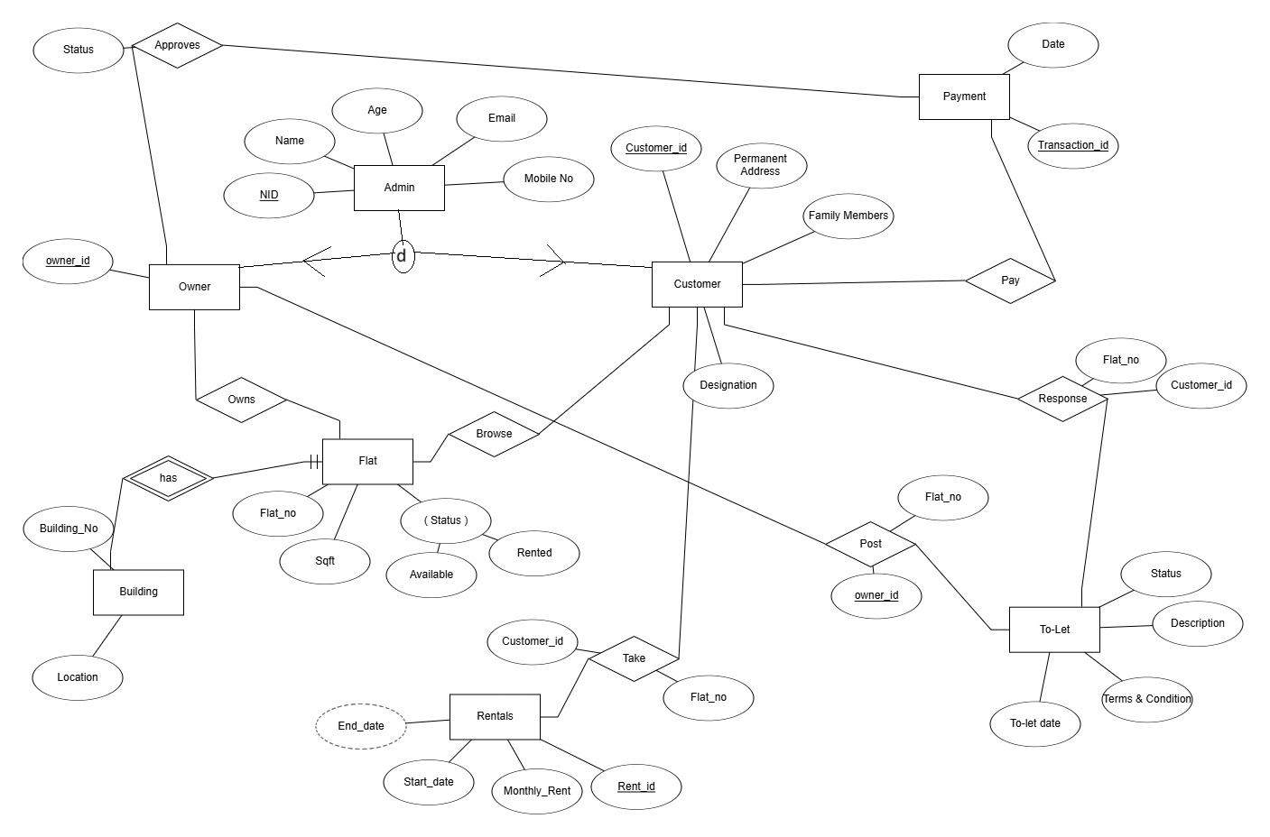

4. Schema Diagram
Figure 2: Schema Diagram (collections, fields, FK references)
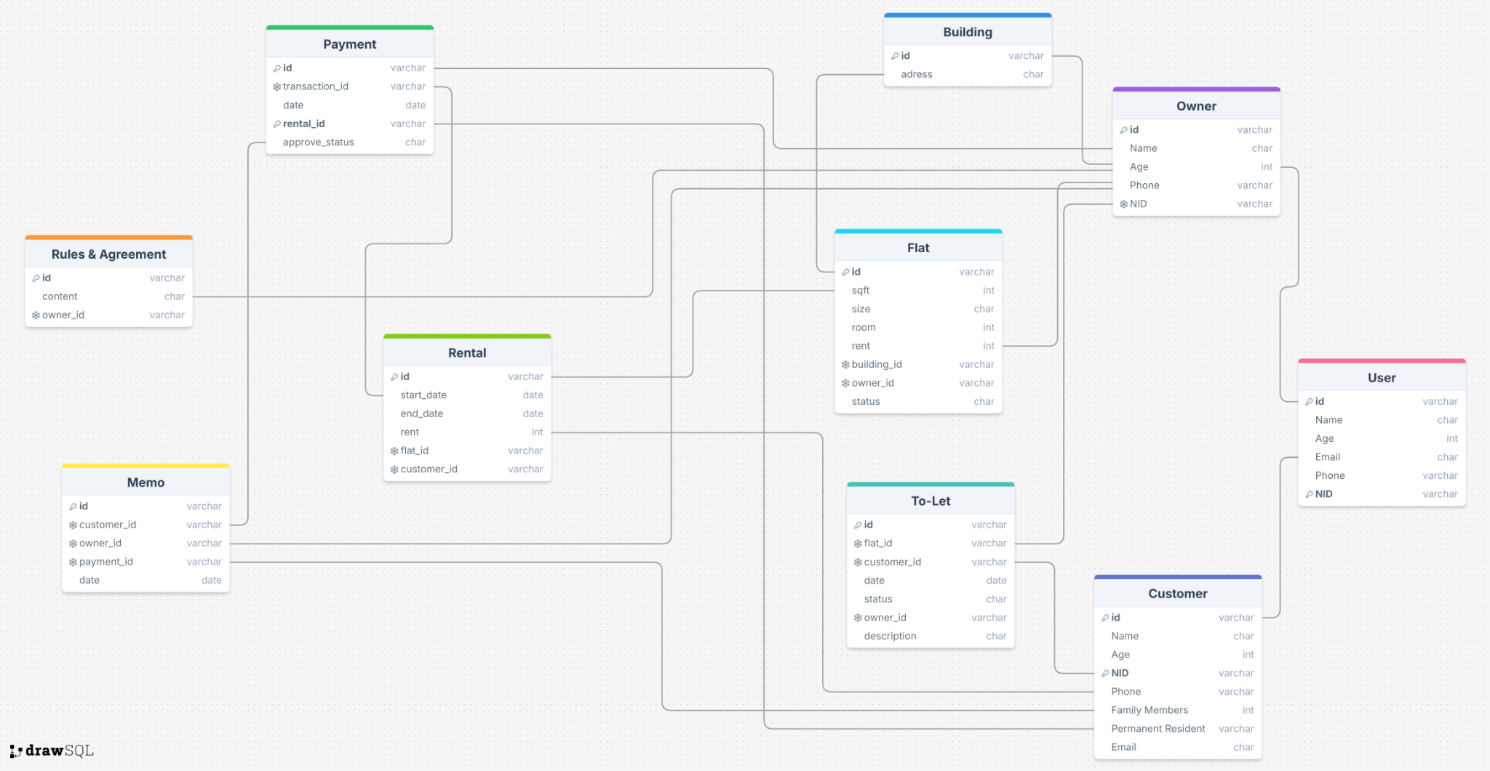

5. Frontend Development

Member Contributions

Member 1: Tahsin Raihan Robbani (ID: 22201344)
- Profile page (view & edit)
- Landing & Home pages (static hero, featured flats)
- Browse/Search components (area, price, rooms filters)
- Flat Management UI: Owner’s CRUD forms for flats & To-Let posts
- Owner Dashboard: Tables & simple charts for income & tenant lists

Member 2: Samura Huda (ID: 22201205)
- Rental Request form & owner-approval UI
- Payment form with Zod validation; due-status indicators & red-mark alerts
- Complaint/Memo submission & status-tracking components
- Secured dashboard routes via NextAuth client

Member 3: Nishat Tasnim Luba (ID: 24241354)
- Login/Signup pages (NextAuth workflows, signup & signin forms)
- Rules & Agreement static page
- Source-Repo setup & GitHub Actions CI workflow
- Auto-Eviction & To-Let Auto-Management scheduler

6. Backend Development

Member Contributions

Member 1: Tahsin Raihan Robbani (ID: 22201344)
- User Profile API (view/update routes)
- Flat & ToLet Models & CRUD routes (/api/flats, /api/tolets)
- Dashboard endpoints: income summary & due-rent stats

Member 2: Samura Huda (ID: 22201205)
- Rental API: create requests & owner approval logic
- Payment API: record transactions & flag late payments
- Memo API: lodge/respond to complaints
- Zod schemas & error handling

Member 3: Nishat Tasnim Luba (ID: 24241354)
- Auth API: NextAuth configuration & sign-in/sign-up handlers
- Rules API: read-only tenancy rules route
- Auto-Eviction scheduler (cron job) & Auto-ToLet re-publish logic
- CI Setup: GitHub Actions workflow & README documentation

7. Source Code Repository
All source code is publicly available at https://github.com/YourOrg/RentZ
Clone the repo, run `pnpm install`, then `pnpm dev` to start the application.

8. Conclusion
RentZ delivers a comprehensive rental management system with balanced contributions from all group members. Users can register, browse and manage flats, submit rental requests, pay rent, and lodge complaints, while owners can approve requests, manage listings, track income, and handle evictions. The project demonstrates full-stack MERN capabilities and sets a solid foundation for future enhancements, such as real-payment integration and real-time notifications.

9. References
- Next.js Documentation. https://nextjs.org/docs
- React Documentation. https://reactjs.org/docs/getting-started.html
- MongoDB Manual. https://docs.mongodb.com/
- NextAuth.js Docs. https://next-auth.js.org/
- Zod Validation Library. https://github.com/colinhacks/zod
- Tailwind CSS Docs. https://tailwindcss.com/docs
- DrawSQL: RentZ Schema Diagram. https://drawsql.app/
- CSE370 Lab Manual: Database Systems, Spring 2025

