CSE-420: Compiler Design
Department of Computer Science and Engineering
BRAC University
Assignment 01
Spring 2026
Question 1: Direct Method (Syntax-Tree Based) DFA Construction
Regular Expression: (a|b)*cb
Submitted By
[Your Name]
Student ID: [Your ID]
Section: [Your Section]
Submission Deadline: July 5, 2026

CSE-420 Compiler Design — Assignment 01
Question 1: Direct Method (Syntax-Tree Based) DFA Construction
Regular Expression: (a|b)*cb
Step 1 — Augmentation
The regular expression is augmented with a unique end-marker #, concatenated at the end. This guarantees that every accepting state of the DFA corresponds to a position that includes the end of a valid string.

(a | b)* c b #
Step 2 — Syntax Tree, Nullable, Firstpos, Lastpos
Each leaf symbol is labeled with a unique position number (shown in gray beneath each leaf). Nullable (N), firstpos (FP), and lastpos (LP) are computed bottom-up for every node, following the standard rules for concatenation (.), union (|), and Kleene star (*).

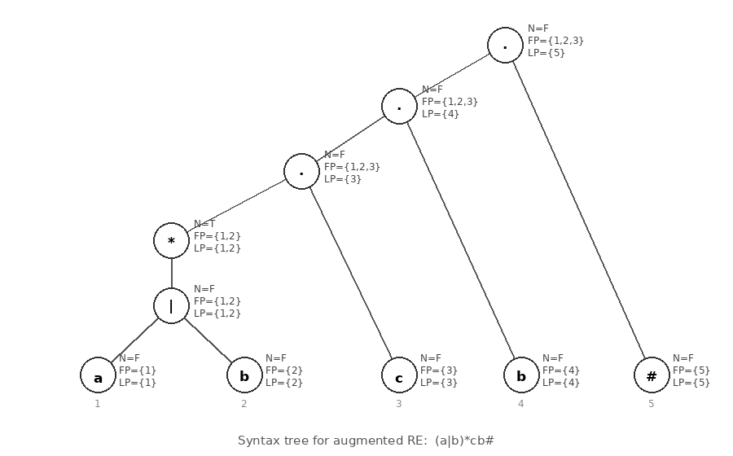
Summary table:
Node | Nullable | Firstpos | Lastpos
a (1) | F | {1} | {1}
b (2) | F | {2} | {2}
(a|b) | F | {1, 2} | {1, 2}
(a|b)* | T | {1, 2} | {1, 2}
c (3) | F | {3} | {3}
(a|b)*c | F | {1, 2, 3} | {3}
b (4) | F | {4} | {4}
(a|b)*cb | F | {1, 2, 3} | {4}
# (5) | F | {5} | {5}
Root: (a|b)*cb# | F | {1, 2, 3} | {5}

Step 3 — Followpos
Followpos is computed using two rules:
Rule 1 (star node): if n is a star node, then for every position i in lastpos(n), firstpos(n) is added to followpos(i).
Rule 2 (concatenation node): if n = c1·c2, then for every position i in lastpos(c1), firstpos(c2) is added to followpos(i).

Position | Symbol | Followpos
1 | a | {1, 2, 3}
2 | b | {1, 2, 3}
3 | c | {4}
4 | b | {5}
5 | # | { } (end-marker, no followpos)

Step 4 — DFA State Construction (Subset Construction on Followpos)
Start state = firstpos(root) = {1, 2, 3} → State A. For a state S and input symbol x, D(S, x) = union of followpos(p) for every position p in S whose symbol is x. A new DFA state is created whenever a new subset of positions appears. Any state whose subset contains position 5 (the end-marker) is an accepting state.

From state | On a | On b | On c
A = {1, 2, 3} | {1,2,3} → A | {1,2,3} → A | {4} → B
B = {4} | dead | {5} → C | dead
C = {5} (accepting) | dead | dead | dead

Step 5 — Final DFA
States: A (start), B, C (accepting — contains position 5). The DFA accepts exactly the strings over {a, b, c} that end in "cb", confirming it correctly recognizes the language of (a|b)*cb.

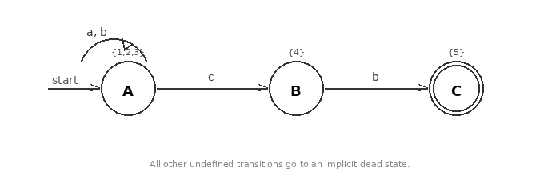

Verification: Trace "acb": A →(a) A →(c) B →(b) C (accept). Trace "cb": A →(c) B →(b) C (accept). Trace "cbb": A →(c) B →(b) C →(b) dead (correctly rejected, since "cbb" does not match (a|b)*cb). The DFA behaves as expected.

