BRAC UNIVERSITY
Department of Computer Science and Engineering

CSE 420: Compiler Design
Assignment 01
Summer 2026

Construction of a DFA from a Regular Expression
using the Direct Method

Name | [Your Full Name]
Student ID | [Your Student ID]
Section | [Your Section]
Course | CSE 420 - Compiler Design
Deadline | 5 July, 2026 (11:59 PM)

Question 1
For the given regular expression, convert it into a DFA using the Direct Method. Show all the steps: augmentation, syntax tree generation, firstpos and lastpos, followpos, state transition table, and the DFA.
Regular Expression: (a | b)* c b

Step 1: Augmentation
The given regular expression is augmented by concatenating a unique end-marker '#' to it. This guarantees that every string accepted by the DFA ends at a state that has no outgoing transitions on a real input symbol, and it lets us identify accepting states cleanly (any state whose position-set contains the position of '#').
Augmented Regular Expression: (a | b)* c b #

Step 2: Syntax Tree Construction
Each leaf of the syntax tree is a symbol of the augmented expression, labeled with a unique position number (left to right). Internal nodes represent the operators: concatenation ( • ), union ( | ), and Kleene star ( * ).
Leaf position numbering:
• a → position 1
• b → position 2
• c → position 3
• b → position 4
• # → position 5
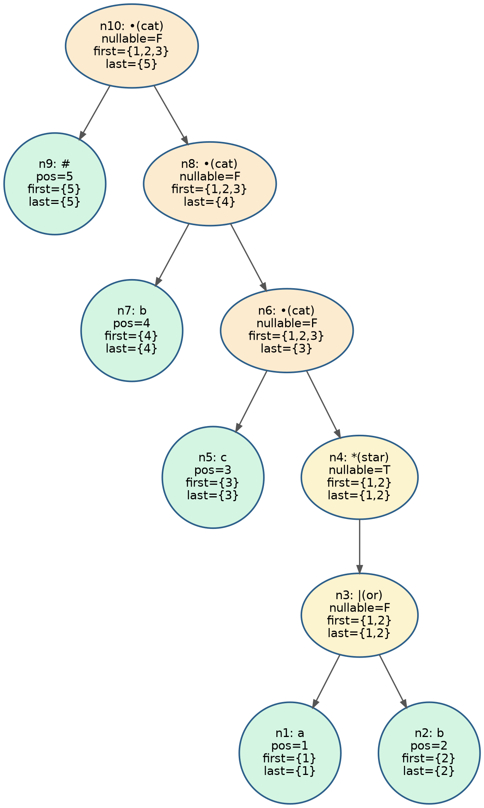
Each node in the tree above is annotated with its computed nullable, firstpos, and lastpos values (derived in Step 3).

Step 3: Nullable, firstpos, lastpos
Rules used:
Node type | nullable(n) | firstpos(n) | lastpos(n)
Leaf (symbol ≠ ε) | False | { position of leaf } | { position of leaf }
n = c1 | c2 (or) | nullable(c1) or nullable(c2) | firstpos(c1) ∪ firstpos(c2) | lastpos(c1) ∪ lastpos(c2)
n = c1 • c2 (cat) | nullable(c1) and nullable(c2) | if nullable(c1): firstpos(c1) ∪ firstpos(c2)  else: firstpos(c1) | if nullable(c2): lastpos(c1) ∪ lastpos(c2)  else: lastpos(c2)
n = c1* (star) | True | firstpos(c1) | lastpos(c1)

Applying these rules bottom-up on every node of the syntax tree:
Node | Expression | nullable | firstpos | lastpos
n1 | a (pos 1) | F | {1} | {1}
n2 | b (pos 2) | F | {2} | {2}
n3 | n1 | n2 | F | {1,2} | {1,2}
n4 | n3* | T | {1,2} | {1,2}
n5 | c (pos 3) | F | {3} | {3}
n6 | n4 • n5 | F | {1,2,3} | {3}
n7 | b (pos 4) | F | {4} | {4}
n8 | n6 • n7 | F | {1,2,3} | {4}
n9 | # (pos 5) | F | {5} | {5}
n10 (root) | n8 • n9 | F | {1,2,3} | {5}

Step 4: followpos computation
followpos is computed only at cat ( • ) and star ( * ) nodes, using the following two rules:
• Cat node n = c1 • c2 : for every position i in lastpos(c1), firstpos(c2) is added to followpos(i).
• Star node n = c1* : for every position i in lastpos(c1), firstpos(c1) is added to followpos(i).

Node | Rule applied | Contribution to followpos
n4 = n3* (star) | for i in lastpos(n3)={1,2}: followpos(i) += firstpos(n3)={1,2} | followpos(1) += {1,2}  followpos(2) += {1,2}
n6 = n4 • n5 (cat) | for i in lastpos(n4)={1,2}: followpos(i) += firstpos(n5)={3} | followpos(1) += {3}  followpos(2) += {3}
n8 = n6 • n7 (cat) | for i in lastpos(n6)={3}: followpos(i) += firstpos(n7)={4} | followpos(3) += {4}
n10 = n8 • n9 (cat) | for i in lastpos(n8)={4}: followpos(i) += firstpos(n9)={5} | followpos(4) += {5}

Final followpos table:
Position | Symbol | followpos
1 | a | {1, 2, 3}
2 | b | {1, 2, 3}
3 | c | {4}
4 | b | {5}
5 | # | { } (empty — end marker)

Step 5: Construction of DFA states (subset construction using followpos)
Start state = firstpos(root) = {1, 2, 3} → call this state A.
For each state, and for each input symbol, we collect the positions in the state that carry that symbol, then take the union of followpos over those positions to get the next state:
• State A = {1,2,3} (positions 1=a, 2=b, 3=c)
• on 'a': position with symbol a in A → {1}; followpos(1) = {1,2,3} ⇒ A --a--> {1,2,3} = A
• on 'b': position with symbol b in A → {2}; followpos(2) = {1,2,3} ⇒ A --b--> {1,2,3} = A
• on 'c': position with symbol c in A → {3}; followpos(3) = {4} ⇒ A --c--> {4} = B (new state)

• State B = {4} (position 4 = b)
• on 'a': no position with symbol a ⇒ B --a--> Dead
• on 'b': followpos(4) = {5} ⇒ B --b--> {5} = C (new state)
• on 'c': no position with symbol c ⇒ B --c--> Dead

• State C = {5} (position 5 = #) → C contains the position of the end-marker, so C is the accepting state.
• on 'a', 'b', 'c': no positions with these symbols in C ⇒ C --a,b,c--> Dead

• Dead state: a trap state added for completeness; every symbol loops back to Dead.

No further new states are generated, so the subset construction terminates with 4 states: A, B, C, Dead.

State transition table:
State | Position set | a | b | c | Accepting?
A (start) | {1, 2, 3} | A | A | B | No
B | {4} | Dead | C | Dead | No
C | {5} | Dead | Dead | Dead | Yes (contains pos. of #)
Dead | — | Dead | Dead | Dead | No

Step 6: DFA Diagram
States: A (start state), B, C (accepting state — double circle), and Dead (trap state).
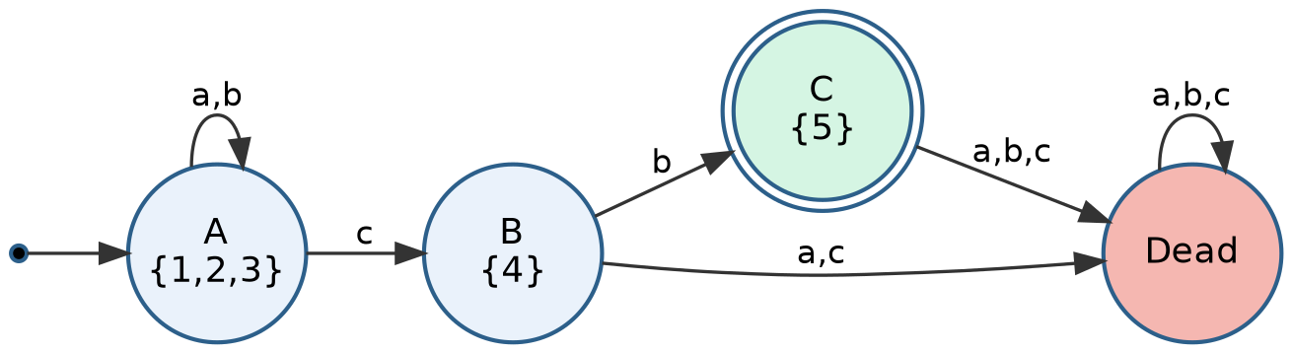
Formal definition of the DFA:
• Q (states) = { A, B, C, Dead }
• Σ (alphabet) = { a, b, c }
• q0 (start state) = A
• F (accepting) = { C }
• δ (transitions) = as shown in the table in Step 5 and the diagram above

Verification (sanity check)
The language of (a|b)*cb is: any string of a's and b's, followed by exactly 'c' then 'b'. Tracing a few strings through the DFA confirms correctness:
• "cb" : A --c--> B --b--> C (accepting) ✓
• "acb" : A --a--> A --c--> B --b--> C (accepting) ✓
• "babcb" : A --b--> A --a--> A --b--> A --c--> B --b--> C (accepting) ✓
• "cbb" : A --c--> B --b--> C --b--> Dead (rejected, correctly — extra symbol after cb) ✓
• "ab" : A --a--> A --b--> A (state A is non-accepting, correctly rejected) ✓
All traces match the expected language, confirming the DFA is correctly constructed.

