Binomial:
A polynomial equation with two terms usually joined by a plus or minus sign is called a binomial. Binomials are used in algebra. Polynomials with one term will be called a monomial and could look like 7x. A polynomial with two terms is called a binomial; it could look like 3x + 9. It is easy to remember binomials as bi means 2 and a binomial will have 2 terms.
A classic example is the following: 3x + 4 is a binomial and is also a polynomial, 2a(a+b) ² is also a binomial (a and b are the binomial factors).
The above are both binomials.
When multiplying binomials, you'll come across a term called the FOIL method which is often just the method used to multiply binomials.
For instance, to find the product of 2 binomials, you'll add the products of the First terms, the Outer terms, the Inner terms, and the Last terms.
When you're asked to square a binomial, it simply means to multiply it by itself. The square of a binomial will be a trinomial. The product of two binomials will be a trinomial.

Example of Multiplying Binomials
(5 + 4x) x (3 + 2x)
(5 + 4x)(3 + 2x)
= (5)(3) + (5)(2x) + (4x)(3) + (4x)(2i)
= 15 + 10x + 12x + 8(x)2 = 15 + 22x + 8(-1)
= 15 + 22x - 8 = (15 - 8) + 22x = 7 + 22x
Once you begin taking algebra in school, you'll be doing a great many computations that require binomials and polynomials.
The formal expression of the Binomial Theorem is as follows:
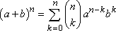

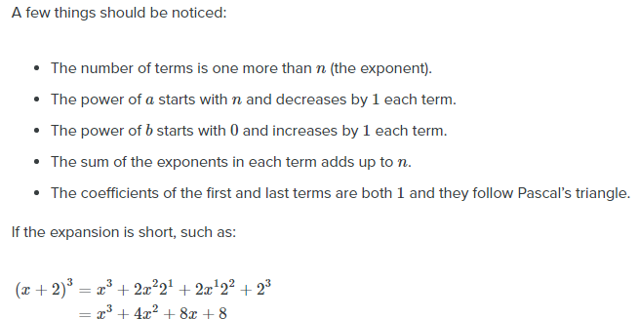
Multinomial:
The multinomial theorem provides a formula for expanding an expression such as (x₁ + x₂ +⋯+ x_{k})^{n} for integer values of n. In particular, the expansion is given by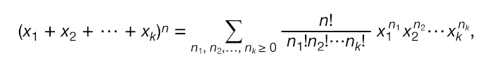where n₁ + n₂ +⋯+ n_{k} = n and n! is the factorial notation for 1 × 2 × 3 ×⋯× n.
For example, the expansion of (x₁ + x₂ + x₃)³ is x₁³ + 3x₁²x₂ + 3x₁²x₃ + 3x₁x₂² + 3x₁x₃² + 6x₁x₂x₃ + x₂³ + 3x₂²x₃ + 3x₂x₃² + x₃³.

Coefficients:
In algebra, one of the first things you learn how to do is read algebraic equations. An algebraic equation consists of a number of terms added and/or subtracted together. Each of these terms has two parts to it: variables and coefficients.

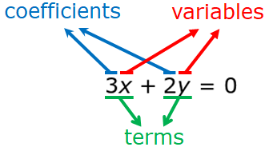
This diagram shows the difference between terms, coefficients, and variables in an equation.

In statistics, we are introduced to a new type of coefficient known as the multinomial coefficient. In this lesson, you will learn what a multinomial coefficient is and how it is used in statistics.

Multinomial Coefficient
The multinomial coefficient gets its name from the multinomial series raised to the nth power, as seen below.

In a series like this, the x's represent terms, the k represents the number of elements in the series, and n is the positive integer power to which the series is raised. How a series like this is expanded is told to us by the multinomial theorem.

In the multinomial theorem, the sum is taken over n₁, n₂, ... ,n_{k} such that n₁ + n₂ + ... + n_{k} = n.
The multinomial theorem gives us a sum of multinomial coefficients multiplied by variables. In other words, it represents an expanded series where each term in it has its own associated multinomial coefficient. The multinomial coefficient itself is expressed in terms of factorials.
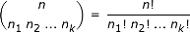

Multinomial Coefficient Example 1
To better understand how the multinomial coefficient works, let's work though an example together where we find the multinomial coefficient of one term of an expanded multinomial series.
Given the following multinomial series:

What is the coefficient of the a³c² term in the expanded series?
In order to solve this problem we'll be working with the multinomial theorem.
Starting by comparing the series in this problem to the left side of the multinomial theorem equation, we can see that x₁ = a, x₂ = 2b, x₃ = 3c, and n = 5.
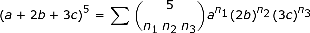
Here, k = 3 since there are 3 elements (a, b, c) in the series. This is the formula for the full expansion of our series, but we're only looking for the coefficient of one term of the series. To do this, we're going to look at the right side of the equation without the sum, and identify n₁, n₂, and n₃.
These values of n are given by the powers in our given term a³c². The a is raised to the third power, which gives us n₁ = 3, and c is raised to the second power, giving us n₃ = 2.
We see b is absent in this term. This is the equivalent of b^{x} = 1, which occurs when x = 0. Therefore, n₂ = 0.
With all the values of n found, we now have everything we need to find the coefficient a³c².

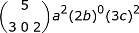

First, we write the multinomial coefficient out as factorials.
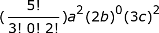

Then, all that's left to do is work out the basic arithmetic.
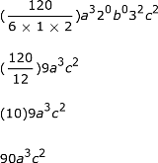

With this we've found that the coefficient of a³c² is 90.

