CSE230: Discrete Mathematics

Practice Sheet 4 — Set Theory
Complete Worked Solutions

Q1 — Determine whether each pair of sets is equal
a) {1,3,3,3,5,5,5,5,5} vs {5,3,1}: A set only records distinct elements — duplicates are ignored and order doesn't matter. {1,3,3,3,5,5,5,5,5} = {1,3,5}, and {5,3,1} = {1,3,5}. EQUAL.
b) {{1}} vs {1,{1}}: {{1}} has exactly ONE element, namely the set {1}. {1,{1}} has TWO elements: the number 1, and the set {1}. NOT EQUAL.
c) ∅ vs {∅}: ∅ is the empty set (0 elements). {∅} is a set containing one element (namely ∅), so it has cardinality 1. NOT EQUAL.

Q2 — Cardinality of power sets (|P(S)| = 2^|S|)
a) P({a, b, {a,b}}): the set {a, b, {a,b}} has 3 distinct elements (a, b, and the set {a,b}, which is a distinct object from a and b). So |P(S)| = 2³ = 8.
b) P({∅, a, {a}, {{a}}}): this set has 4 distinct elements (∅, a, {a}, {{a}} are all different objects). So |P(S)| = 2⁴ = 16.
c) P(P(∅)): P(∅) = {∅}, which has 1 element. So P(P(∅)) = P({∅}) has 2¹ = 2 elements.

Q3 — List all subsets
a) {1,2,3} (8 subsets): ∅, {1}, {2}, {3}, {1,2}, {1,3}, {2,3}, {1,2,3}
b) {φ,λ,Δ,μ} (16 subsets): ∅, {φ}, {λ}, {Δ}, {μ}, {φ,λ}, {φ,Δ}, {φ,μ}, {λ,Δ}, {λ,μ}, {Δ,μ}, {φ,λ,Δ}, {φ,λ,μ}, {φ,Δ,μ}, {λ,Δ,μ}, {φ,λ,Δ,μ}
c) {∅} (2 subsets): ∅, {∅}

Q4 — Cardinality of each set
Set | Cardinality | Reason
{a} | 1 | one element: a
{{a}} | 1 | one element: the set {a}
∅ | 0 | the empty set has no elements
{∅} | 1 | one element: ∅
{∅,{∅}} | 2 | two distinct elements: ∅ and {∅}
{∅,{∅},{∅,{∅}}} | 3 | three distinct elements: ∅, {∅}, and {∅,{∅}}

Q5 — Power sets
a) {q}: P({q}) = { ∅, {q} }
b) {p,q}: P({p,q}) = { ∅, {p}, {q}, {p,q} }
c) {∅,{∅}}: P({∅,{∅}}) = { ∅, {∅}, {{∅}}, {∅,{∅}} }

Q6 — True or False
a) 7 ∈ {6,7,8,9}: TRUE (7 is listed in the set).
b) 5 ∉ {6,7,8,9}: TRUE (5 is not in the set).
c) {2} ⊈ {1,2}: FALSE. Since 2 ∈ {1,2}, we actually have {2} ⊆ {1,2}, so the negation ⊈ is false.
d) ∅ ⊈ {α,β,x}: FALSE. The empty set is a subset of every set, so ∅ ⊆ {α,β,x} is true, making ⊈ false.
e) ∅ = {∅}: FALSE. ∅ has 0 elements; {∅} has 1 element (namely ∅). They are different sets.

Q7 — Set operations
A={1,5,31,56,101}, B={22,56,5,103,87}, C={41,13,7,101,48}, D={1,3,5,7,9,...} (all positive odd integers)
a) A∩B = {5, 56} (the only elements common to both A and B)
b) C∪A = {1, 5, 7, 13, 31, 41, 48, 56, 101}
c) C∩D: D contains only odd numbers. Checking C={41,13,7,101,48} — 41,13,7,101 are odd, 48 is even. So C∩D = {7, 13, 41, 101}.
d) (A∪B)∪(C∪D): A∪B = {1,5,22,31,56,87,101,103} — of these, the even ones (22, 56) are not in D. C∪D adds 48 (even) to D. So the final union is: D ∪ {22, 48, 56}, i.e., all positive odd integers together with 22, 48, and 56.

Q8 — Fill in the most appropriate symbol (universal set = ℤ)
A={−7,−5,−3,−1,1,3,5,7}; B={x∈ℤ | x²<9} = {−2,−1,0,1,2}; C={2,3,4,5,6}; D={x∈ℤ | x≤9}
# | Statement | Reasoning
i | A ⊂ D | Every element of A is ≤9 so A⊆D; since D has infinitely many other elements, A is a proper subset.
ii | 3 ∉ B | B = {−2,−1,0,1,2}; 3 is not in this list.
iii | 9 ∈ D | D = {x ≤ 9}, and 9 ≤ 9 is true.
iv | 2 ∉ Cᶜ | Since 2 ∈ C, 2 is NOT in the complement of C. (Interpreting the element as 2, not the singleton {2}.)
v | ∅ ⊂ D | ∅ is a subset of every set; since D is non-empty, ∅ is a proper subset.
vi | A ≠ C | Neither set contains the other (A has negative numbers not in C; C has 2,4,6 not in A); they share only 3,5.
vii | B ≠ C | B={−2,−1,0,1,2}, C={2,3,4,5,6}; they share only the element 2, so neither is a subset of the other.
viii | C ⊂ D | All elements of C are ≤9 so C⊆D; D has infinitely many other elements, so C is a proper subset.
ix | 0 ∉ (A∩D) | A∩D = A (since A⊆D); 0 is not an element of A.
x | 0 ∈ (A∪D) | A∪D = D (since A⊆D); 0 ≤ 9, so 0 ∈ D.

Q9 — Set operations on letter sets
A={r,e,a,s,o,n,i,g}, B={m,a,t,h,e,i,c,l} (duplicate 't' removed), C = vowels = {a,e,i,o,u}
a) A∪B∪C = {a, c, e, g, h, i, l, m, n, o, r, s, t, u} (14 distinct letters)
b) A∩B = {a, e, i} (letters common to both words)
c) Cᶜ (complement of vowels, relative to the 26-letter English alphabet) = {b,c,d,f,g,h,j,k,l,m,n,p,q,r,s,t,v,w,x,y,z} (the 21 consonants)

Q10 — Venn diagrams for A → B and A ↔ B
A → B = {x∈U | x∈A → x∈B}. By the truth table for implication, this is false only when x∈A and x∉B; true everywhere else. So A→B = Aᶜ ∪ B (shade everything except the part of A outside B).
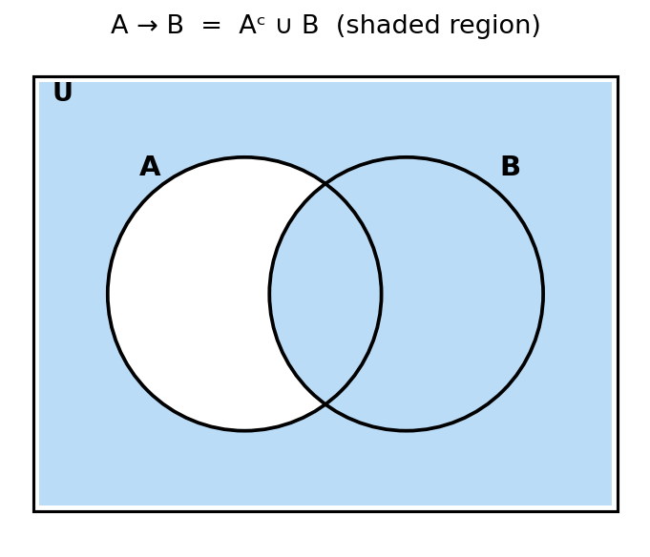
A ↔ B = {x∈U | x∈A ↔ x∈B}. This is true exactly when x∈A and x∈B are both true, or both false. So A↔B = (A∩B) ∪ (Aᶜ∩Bᶜ) (shade the overlap of A and B, plus the region outside both).
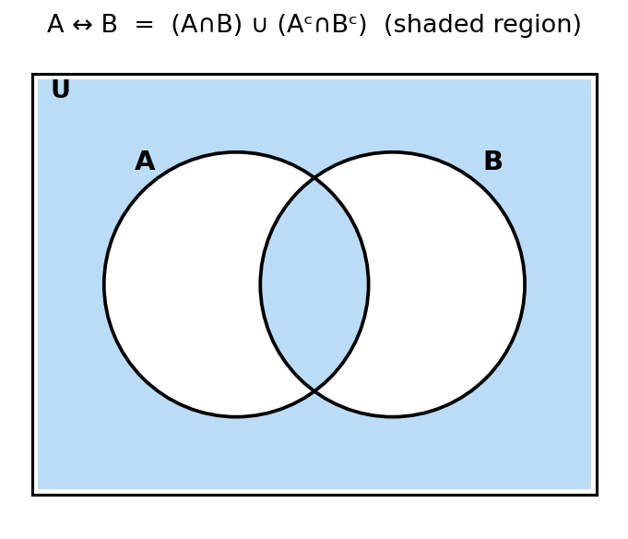

Q11 — Find A³
a) A = {0}: A³ has 1³ = 1 element: A³ = { (0,0,0) }
b) A = {0,a}: A³ has 2³ = 8 elements:
A³ = { (0,0,0), (0,0,a), (0,a,0), (0,a,a), (a,0,0), (a,0,a), (a,a,0), (a,a,a) }

Q12 — Cartesian products
A={a,b,c}, B={x,y}, C={0,1}
a) A×B×C (12 triples):
{(a,x,0),(a,x,1),(a,y,0),(a,y,1),(b,x,0),(b,x,1),(b,y,0),(b,y,1),(c,x,0),(c,x,1),(c,y,0),(c,y,1)}
b) C×B×A (12 triples):
{(0,x,a),(0,x,b),(0,x,c),(0,y,a),(0,y,b),(0,y,c),(1,x,a),(1,x,b),(1,x,c),(1,y,a),(1,y,b),(1,y,c)}
c) C×A×B (12 triples):
{(0,a,x),(0,a,y),(0,b,x),(0,b,y),(0,c,x),(0,c,y),(1,a,x),(1,a,y),(1,b,x),(1,b,y),(1,c,x),(1,c,y)}
d) B×B×B (8 triples):
{(x,x,x),(x,x,y),(x,y,x),(x,y,y),(y,x,x),(y,x,y),(y,y,x),(y,y,y)}

Q13 — A×B and B×A, where A={1,2,3}, B={x,{y}}
A×B = {(1,x),(1,{y}),(2,x),(2,{y}),(3,x),(3,{y})} — 6 ordered pairs
B×A = {(x,1),(x,2),(x,3),({y},1),({y},2),({y},3)} — 6 ordered pairs
Are A×B and B×A equal? NO. Ordered pairs are direction-sensitive: (1,x) ∈ A×B but (1,x) ∉ B×A (since B×A's pairs have their first coordinate from B, and 1 ∉ B). In general A×B = B×A only when A = B.
Cardinality of B×A = |B| × |A| = 2 × 3 = 6.

Q14 — Venn diagram illustrating A ⊆ B and B ⊆ C
Since every element of A is in B, and every element of B is in C, we draw A nested completely inside B, which is nested completely inside C (allowing the possibility that A=B or B=C, since ⊆ permits equality).
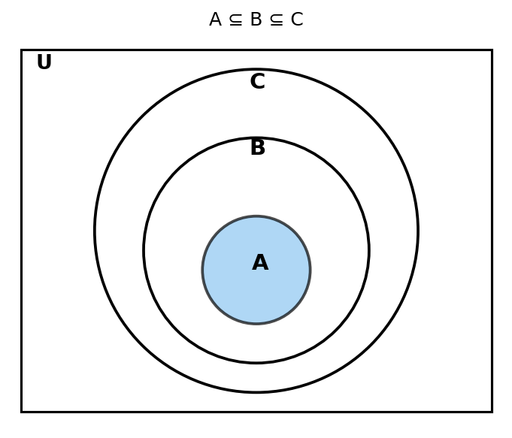

Q15 — Venn diagram illustrating A ⊂ B and B ⊂ C
This is the same nested structure as Q14, but now each containment is strict: A is a proper subset of B (A≠B), and B is a proper subset of C (B≠C) — so each inner circle must be strictly smaller and cannot coincide with the one enclosing it.
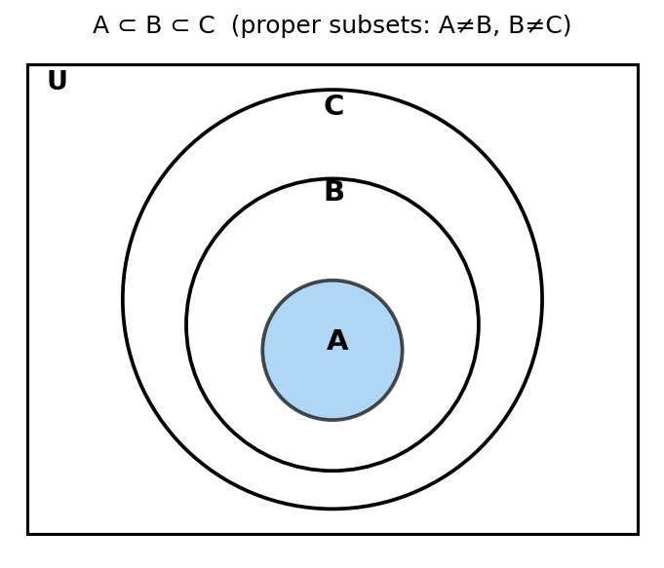

Q16 — Show that if A ⊆ B and B ⊆ C, then A ⊆ C
Proof technique: Direct Proof
Let x be an arbitrary element of A (i.e., suppose x ∈ A).
Since A ⊆ B, every element of A is an element of B; in particular, x ∈ B.
Since B ⊆ C, every element of B is an element of C; in particular, x ∈ C.
Since x was an arbitrary element of A, we have shown that every element of A is also an element of C. By the definition of subset, A ⊆ C. ∎

Q17 — A={1,2,3,4,5}, B={0,3,6}
a) A∪B = {0, 1, 2, 3, 4, 5, 6}
b) A∩B = {3}
c) A−B = {1, 2, 4, 5}
d) B−A = {0, 6}

Q18 — A={a,b,c,d,e}, B={a,b,c,d,e,f,g,h}
a) A∪B = {a,b,c,d,e,f,g,h} = B (since A ⊆ B)
b) A∩B = {a,b,c,d,e} = A (since A ⊆ B)
c) A−B = ∅ (every element of A is also in B)
d) B−A = {f, g, h}

Q19 — Prove the second De Morgan Law: (A∪B)ᶜ = Aᶜ∩Bᶜ

a) Showing each side is a subset of the other
(⊆) (A∪B)ᶜ ⊆ Aᶜ∩Bᶜ:
Let x ∈ (A∪B)ᶜ. Then x ∉ A∪B, which means x ∉ A AND x ∉ B (if x were in A or in B, it would be in A∪B). So x ∈ Aᶜ and x ∈ Bᶜ, hence x ∈ Aᶜ∩Bᶜ.
(⊇) Aᶜ∩Bᶜ ⊆ (A∪B)ᶜ:
Let x ∈ Aᶜ∩Bᶜ. Then x ∈ Aᶜ and x ∈ Bᶜ, meaning x ∉ A and x ∉ B. Since x is in neither A nor B, x ∉ A∪B, so x ∈ (A∪B)ᶜ.
Since each side is a subset of the other, (A∪B)ᶜ = Aᶜ∩Bᶜ. ∎

b) Membership table
A | B | A∪B | (A∪B)ᶜ | Aᶜ | Bᶜ | Aᶜ∩Bᶜ
1 | 1 | 1 | 0 | 0 | 0 | 0
1 | 0 | 1 | 0 | 0 | 1 | 0
0 | 1 | 1 | 0 | 1 | 0 | 0
0 | 0 | 0 | 1 | 1 | 1 | 1

(Here 1 means "is a member," 0 means "is not a member.") The columns for (A∪B)ᶜ and Aᶜ∩Bᶜ are identical in every row, confirming (A∪B)ᶜ = Aᶜ∩Bᶜ. ∎

Q20 — Membership table: A∩(B∪C) = (A∩B)∪(A∩C)
A | B | C | B∪C | A∩(B∪C) | A∩B | A∩C | (A∩B)∪(A∩C)
1 | 1 | 1 | 1 | 1 | 1 | 1 | 1
1 | 1 | 0 | 1 | 1 | 1 | 0 | 1
1 | 0 | 1 | 1 | 1 | 0 | 1 | 1
1 | 0 | 0 | 0 | 0 | 0 | 0 | 0
0 | 1 | 1 | 1 | 0 | 0 | 0 | 0
0 | 1 | 0 | 1 | 0 | 0 | 0 | 0
0 | 0 | 1 | 1 | 0 | 0 | 0 | 0
0 | 0 | 0 | 0 | 0 | 0 | 0 | 0

The columns for A∩(B∪C) and (A∩B)∪(A∩C) match in all 8 rows, confirming the distributive law A∩(B∪C) = (A∩B)∪(A∩C). ∎

Q21 — Using set identities, show (A∪(B∩C))ᶜ = (Cᶜ∪Bᶜ)∩Aᶜ
(A∪(B∩C))ᶜ = Aᶜ ∩ (B∩C)ᶜ [De Morgan's Law, treating X=A, Y=(B∩C)]
= Aᶜ ∩ (Bᶜ∪Cᶜ) [De Morgan's Law applied to (B∩C)ᶜ]
= Aᶜ ∩ (Cᶜ∪Bᶜ) [Commutative Law: Bᶜ∪Cᶜ = Cᶜ∪Bᶜ]
= (Cᶜ∪Bᶜ) ∩ Aᶜ [Commutative Law for ∩]
This is exactly the right-hand side, so (A∪(B∩C))ᶜ = (Cᶜ∪Bᶜ)∩Aᶜ. ∎

Q22 — Prove the Complement Laws using a membership table
Here 1 = member of U (true), 0 = not a member (false). Since A ∪ Aᶜ should equal U (always true, i.e. 1) and A ∩ Aᶜ should equal ∅ (always false, i.e. 0):
A | Aᶜ | A∪Aᶜ | A∩Aᶜ
1 | 0 | 1 | 0
0 | 1 | 1 | 0

a) The column for A∪Aᶜ is always 1 in every row, meaning A∪Aᶜ contains every element of U — i.e., A∪Aᶜ = U. ∎
b) The column for A∩Aᶜ is always 0 in every row, meaning A∩Aᶜ contains no elements — i.e., A∩Aᶜ = ∅. ∎

Q23 — n(A)=20, n(B)=28, n(A∪B)=36. Find n(A∩B).
Using the Inclusion-Exclusion Principle:
n(A∪B) = n(A) + n(B) − n(A∩B)
36 = 20 + 28 − n(A∩B)
n(A∩B) = 48 − 36 = 12
Answer: n(A∩B) = 12

Q24 — Show the following subset relations
a) (A∪B) ⊆ (A∪B∪C)
For any sets X and Y, X ⊆ X∪Y (since every element of X is trivially in X∪Y). Applying this with X=(A∪B) and Y=C: (A∪B) ⊆ (A∪B)∪C = A∪B∪C. ∎
b) (A∩B∩C) ⊆ (A∩B)
Let x ∈ A∩B∩C. Then x ∈ A, x ∈ B, and x ∈ C. In particular, x ∈ A and x ∈ B, so x ∈ A∩B. Since x was arbitrary, A∩B∩C ⊆ A∩B. ∎
c) (A−B)−C ⊆ A−C
Let x ∈ (A−B)−C. Then x ∈ (A−B) and x ∉ C. Since x ∈ (A−B), we know x ∈ A and x ∉ B. So we have x ∈ A and x ∉ C (regardless of whether x ∈ B or not), meaning x ∈ A−C. Since x was arbitrary, (A−B)−C ⊆ A−C. ∎

Q25 — 200 students; leadership=85, team-building=50, both=15
Exactly one activity = (only leadership) + (only team-building)
Only leadership = 85 − 15 = 70
Only team-building = 50 − 15 = 35
Exactly one activity = 70 + 35 = 105
Answer: 105 students are involved in exactly one of the two activities.

Q26 — Cardinalities from the given Venn diagram (sets R, E, N)
Note: This question refers to a diagram embedded as an image in the original file. The specific numeric labels inside each region of that diagram could not be reliably extracted through automated image analysis on our end. Below is the complete method to solve it — please substitute the exact numbers shown in your diagram into this framework to get the final values (or share the numbers/a clearer image and we'll compute the exact answers).
General method for a 3-set Venn diagram (sets R, E, N) with all 8 regions labeled (only-R, only-E, only-N, R∩E only, R∩N only, E∩N only, R∩E∩N, and outside-all-three):
Requested quantity | How to compute it from the diagram
n(N) | Add every region that lies inside circle N: (only N) + (N∩R only) + (N∩E only) + (R∩E∩N).
n[(R∩E)∪N] | Add: (R∩E only) + (R∩E∩N) + all regions inside N [i.e., n(N) from above] — being careful not to double-count the R∩E∩N region, which lies in both parts.
n(E′) | n(U) − n(E), i.e., total number of elements minus everything inside circle E.
n(E\R) | Elements in E but not in R: (only E) + (E∩N only) — i.e., n(E) − n(E∩R).
n(U) | The total count shown for the universal set/rectangle in the diagram (sum of all 8 regions, including outside-all-three).
n(R∪E∪N) | n(U) − (outside-all-three region), i.e., every region inside at least one circle.

Q27 — Shading Venn diagrams for set expressions
Note: The specific expressions to be shaded in this question were given as labels inside an embedded image, which could not be reliably read through automated extraction. Below are worked, fully-shaded examples for the most common such expressions (as typically assigned in this type of exercise), demonstrating the exact shading method — the same process applies to whatever expressions are specified in your diagram.
General shading method (for any set expression):
1. Shade each individual set/complement mentioned in the expression separately (as a first pass, mentally or on scratch paper).
2. Apply intersection (∩) by keeping only the overlap of the shaded regions; apply union (∪) by combining (adding together) the shaded regions.
3. Apply complement (′ or ᶜ) by shading everything outside the specified region, within the universal rectangle.
Worked example — A′ ∩ B (shade the part of B that is outside A):
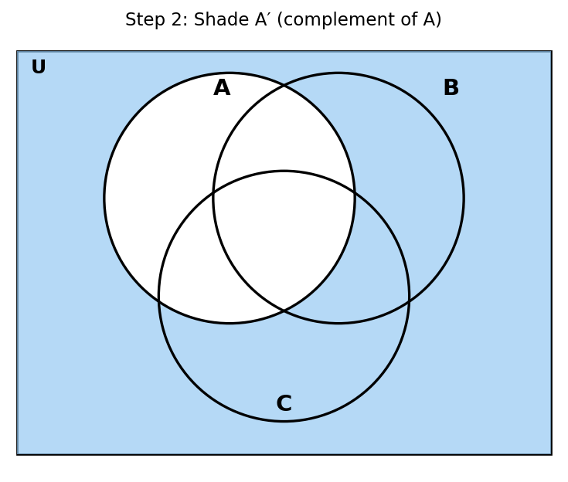
(This shows A′ alone; intersecting with B would keep only the part of this shaded region that also lies inside circle B.)

Q28 — Use the Venn diagram to work A′ ∪ (B ∩ C) in three steps
Step 1 — Shade B ∩ C:
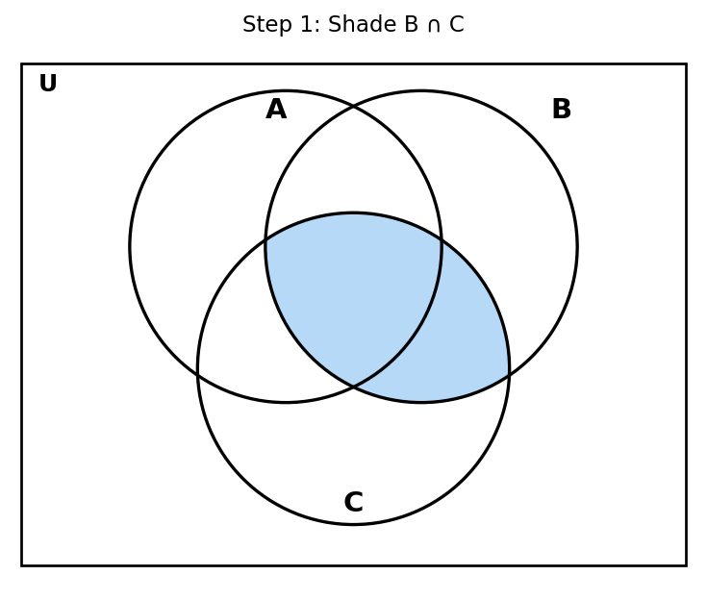
Step 2 — Shade A′ (everything outside circle A):
Step 3 — Combine (union) the shaded regions from Steps 1 and 2:
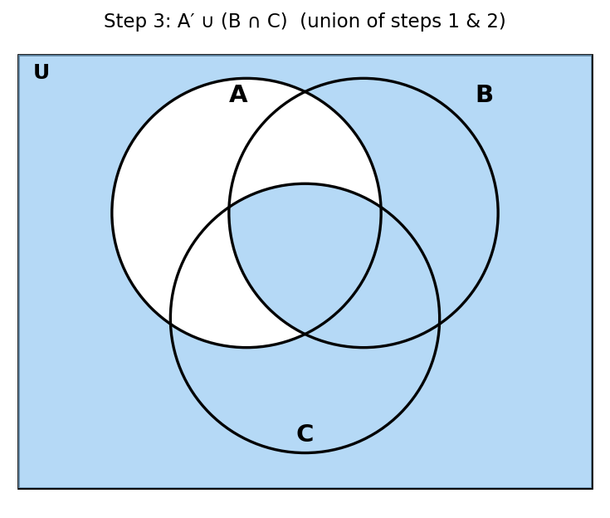
The final shaded region (Step 3) represents A′ ∪ (B∩C) — every point that is either outside A, or inside both B and C (or both conditions).

Q29 — Venn diagram: 43 students, Flash cards (F), Notes (N), Review (R)
Given: F=24, N=14, R=27, R∩F=12, R∩N=9, F∩N=7, all three (F∩N∩R)=5.
We fill the diagram from the innermost region outward:
Region | Calculation | Value
All three (F∩N∩R) | given | 5
F∩R only (not N) | 12 − 5 | 7
F∩N only (not R) | 7 − 5 | 2
N∩R only (not F) | 9 − 5 | 4
Only F | 24 − (7+2+5) | 10
Only N | 14 − (2+4+5) | 3
Only R | 27 − (7+4+5) | 11
None of the three | 43 − (10+3+11+7+2+4+5) | 1

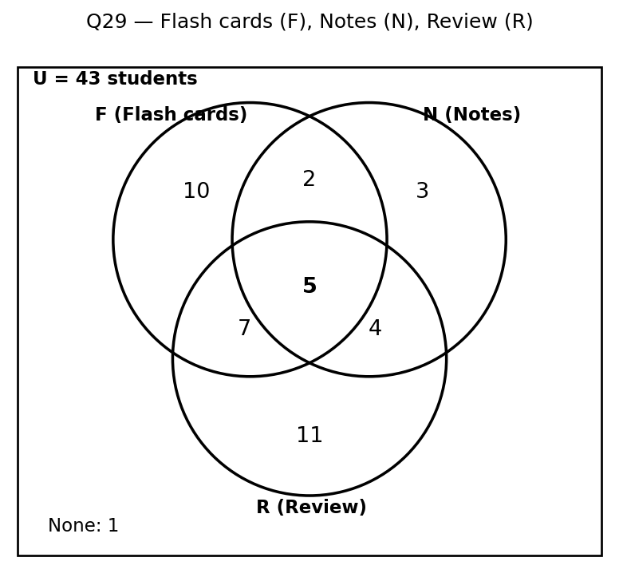

Q30 — Deer survey (running, staring into headlights, nibbling)
Note: This question refers to a Venn diagram image showing survey results for deer activities (R = running, S = staring into headlights, N = nibbling), with specific counts in each region. Automated extraction confirmed the set labels (R, S, N) but could not reliably read the numeric values inside each region of the diagram. Below is the complete method for each part — please substitute your diagram's actual region values to get final numeric answers (or share the numbers/a clearer image and we'll compute them for you).
Part | What to compute
a) Enjoy running or staring into headlights | n(R∪S) = n(R) + n(S) − n(R∩S)
b) Enjoy nibbling and running | n(N∩R) — read directly from the overlapping region(s) of circles N and R
c) Enjoy exactly one activity | (only R) + (only S) + (only N) — the three non-overlapping region values
d) Enjoy staring into headlights but not running | n(S) − n(S∩R), i.e., all of S excluding the overlap with R
e) Enjoy nibbling | n(N) — sum of every region inside circle N
f) Don't enjoy any activity | read directly from the region outside all three circles
g) Enjoy exactly two activities | sum of the three "exactly-two" overlap regions (R∩S only, R∩N only, S∩N only), excluding the all-three region

Q31 — Venn diagram with 3 sets Q, T, P (none pairwise disjoint, P∩Q∩T≠∅)
A general 3-set Venn diagram (with all pairwise and triple overlaps non-empty) has 2³ = 8 disjoint regions:
1. Outside all three sets (none of P, Q, T)
2. Only P
3. Only Q
4. Only T
5. P∩Q only (not T)
6. P∩T only (not Q)
7. Q∩T only (not P)
8. P∩Q∩T (all three)
So there are 8 disjoint regions in total.
Which regions fall under (T∩Q)ᶜ − P?
(T∩Q)ᶜ − P means: NOT in (T∩Q), AND NOT in P. Checking each region against these two conditions:
• Region 1 (outside all three): not in P ✓, not in T∩Q ✓ → INCLUDED
• Region 3 (only Q): not in P ✓, not in T∩Q (since it's not in T) ✓ → INCLUDED
• Region 4 (only T): not in P ✓, not in T∩Q (since it's not in Q) ✓ → INCLUDED
• Regions 2, 5, 6, 8 (all contain P) → EXCLUDED (fail the "not in P" condition)
• Region 7 (Q∩T only): fails the "not in T∩Q" condition (it IS in T∩Q) → EXCLUDED
Answer: (T∩Q)ᶜ − P consists of Region 1 (outside all three), Region 3 (only Q), and Region 4 (only T).

Q32 — 1200 people: soccer=670, basketball=510, baseball=760, all three=320, none=45
At least one sport = 1200 − 45 = 1155.
By Inclusion-Exclusion: n(S∪B∪Ba) = n(S)+n(B)+n(Ba) − [pairwise sums] + n(all three)
1155 = 670+510+760 − (pairwise sum) + 320
1155 = 1940 − (pairwise sum) + 320 ⟹ pairwise sum = 1940+320−1155 = 1105
a) Exactly two sports:
exactly two = (pairwise sum) − 3×(all three) = 1105 − 960 = 145
b) At least two sports:
at least two = exactly two + all three = 145 + 320 = 465
c) Exactly one sport:
exactly one = (at least one) − (at least two) = 1155 − 465 = 690
Answers: a) 145 b) 465 c) 690

Q33 — 300 users: WhatsApp(W)=180, Instagram(I)=160, Telegram(T)=150, W∩I=90, W∩T=75, I∩T=70, none=22
At least one platform = 300 − 22 = 278.
By Inclusion-Exclusion: 278 = (180+160+150) − (90+75+70) + g, where g = all three.
278 = 490 − 235 + g ⟹ g = 278 − 255 = 23 (all three platforms)
Breaking into exact regions: W∩I only = 90−23=67, W∩T only = 75−23=52, I∩T only = 70−23=47.
Only W = 180−(67+52+23) = 38. Only I = 160−(67+47+23) = 23. Only T = 150−(52+47+23) = 28.
Part | Answer | Calculation
I. At least one platform | 278 | 300 − 22
II. Exactly one platform | 89 | 38 + 23 + 28
III. Instagram or Telegram but not WhatsApp | 98 | (only I)+(only T)+(I∩T only) = 23+28+47
IV. Instagram and Telegram but not WhatsApp | 47 | I∩T only region
V. At least two platforms | 189 | (67+52+47) + 23
VI. Ratio exactly-one : exactly-two | 89 : 166 | 166 = 67+52+47 (sum of exactly-two regions); gcd(89,166)=1, already in lowest terms
VII. WhatsApp but not Telegram | 105 | n(W) − n(W∩T) = 180 − 75

Q34 — A={x∈ℕ | x even, 2x²+3x<100}, B={x∈ℤ | |x|∈{0,2}}, U=A∪B
I. Compute A and B:
Testing even positive integers in 2x²+3x<100: x=2→14 ✓, x=4→44 ✓, x=6→90 ✓, x=8→152 ✗. So A = {2, 4, 6}.
B = {x∈ℤ : |x|=0 or |x|=2} = {−2, 0, 2}.
II. Find (A∪B), (A−B), (A−B)ᶜ, (B−A):
A∪B = {−2, 0, 2, 4, 6} (= U)
A−B = {4, 6} (remove 2, which is common to both)
(A−B)ᶜ = U − {4,6} = {−2, 0, 2}
B−A = {−2, 0} (remove 2, which is common to both)
III. Determine P(B) − P(B−A):
P(B) (8 subsets, since |B|=3): ∅,{−2},{0},{2},{−2,0},{−2,2},{0,2},{−2,0,2}
P(B−A) (4 subsets, since |B−A|=2): ∅,{−2},{0},{−2,0}
P(B) − P(B−A) = {{2}, {−2,2}, {0,2}, {−2,0,2}} (all subsets of B that contain the element 2)

Q35 — U = odd naturals; A={x∈ℕ:2≤x≤7}, B={x∈ℕ:3<x<6}, C={x∈ℕ:x²>5, x³<130}
A = {2,3,4,5,6,7}. B = {4,5}. C: x²>5 means x≥3; x³<130 means x≤5 (5³=125<130, 6³=216 too big); so C = {3,4,5}.
a) Aᶜ and (C−B):
Aᶜ (relative to U = all odd naturals): remove from U any elements shared with A (the odd elements of A are 3,5,7). So Aᶜ = U − {3,5,7} = {1, 9, 11, 13, 15, ...} (all odd naturals except 3, 5, and 7).
C − B = {3,4,5} − {4,5} = {3}
b) B×C and P(A∩C):
B×C = {(4,3),(4,4),(4,5),(5,3),(5,4),(5,5)}
A∩C = {3,4,5}. P(A∩C) = { ∅, {3}, {4}, {5}, {3,4}, {3,5}, {4,5}, {3,4,5} }
c) Is C a subset of A?
C={3,4,5}, A={2,3,4,5,6,7}. Every element of C is in A, so C ⊆ A. Since A contains elements (2, 6, 7) not in C, we have C ≠ A, so C is in fact a PROPER subset of A: C ⊂ A.

Q36 — 374 coffee drinkers: only sugar=64, only cream=82, neither=65
Total = (only sugar) + (only cream) + (both) + (neither)
374 = 64 + 82 + both + 65 ⟹ both = 374 − 211 = 163
Part | Answer | Calculation
a) Sugar and cream (both) | 163 | 374 − 64 − 82 − 65
b) Cream (total) | 245 | only cream + both = 82 + 163
c) Neither sugar nor cream | 65 | given
d) Exactly one addition | 146 | 64 + 82
e) At least one addition | 309 | 374 − 65

Q37 — 67 students: Math(M)=33, Science(S)=45, English(E)=40, S∩E only=17, M∩S(total)=16, all three=14, exactly-two total=25
Let x = M∩S only. Since M∩S(total)=16 includes the all-three region: x = 16−14 = 2.
Exactly two total = 25 = x + y + z, where y = M∩E only, z = S∩E only = 17. So y = 25−2−17 = 6.
M∩E (total, includes all three) = y + 14 = 6+14 = 20 → Answer to (a)
Solving for the 'only' regions using M=33, S=45, E=40:
only M = 33 − (2+6+14) = 11; only S = 45 − (2+17+14) = 12; only E = 40 − (6+17+14) = 3
Part | Answer | Calculation
a) Math and English | 20 | M∩E only (6) + all three (14)
b) Science or English but not Math | 32 | (only S)+(only E)+(S∩E only) = 12+3+17
c) At most one subject | 28 | (only M+only S+only E) + none = 26 + 2 [none = 67 − 65 = 2]

Q38 — U={x∈ℤ:−8≤x≤8}; A={even, x²<50}; B={mult. of 2, not mult. of 4}; C={0<x²−4<30}
I. Is ∅ a subset of every set? Is it a proper subset of every set?
Yes, ∅ is a subset of every set (vacuously true — there are no elements to violate the condition). However, ∅ is a PROPER subset of every set EXCEPT itself — ∅ is not a proper subset of ∅, since a proper subset requires the two sets to be unequal.
II. Compute A, B, C; then (A∩B) and A∪(B∩C):
A = {−6,−4,−2,0,2,4,6} (evens in U with x²<50; ±8 excluded since 64≥50)
B = {−6,−2,2,6} (evens not divisible by 4)
C = {−5,−4,−3,3,4,5} (0<x²−4<30 means 4<x²<34, i.e. 2<|x|<5.83, so |x|∈{3,4,5})
A∩B = B = {−6,−2,2,6} (every element of B is also in A)
B∩C = ∅ (B and C share no elements)
A∪(B∩C) = A∪∅ = A = {−6,−4,−2,0,2,4,6}
III. Find (B−A)ᶜ and {m,n}×(A∩B):
B−A = ∅ (since B⊆A)
(B−A)ᶜ = U − ∅ = U = {−8,−7,−6,−5,−4,−3,−2,−1,0,1,2,3,4,5,6,7,8}
{m,n}×(A∩B) = {m,n}×{−6,−2,2,6} = {(m,−6),(m,−2),(m,2),(m,6),(n,−6),(n,−2),(n,2),(n,6)} (8 ordered pairs)

Q39 — 280 participants, languages Bangla/English/Arabic: 120 don't speak Bangla, 165 don't speak English, 190 don't speak Arabic, 20 speak none, 65 speak exactly two
Speak Bangla = 280−120=160. Speak English = 280−165=115. Speak Arabic = 280−190=90.
At least one language = 280 − 20 = 260.
260 = (160+115+90) − (pairwise sum) + g ⟹ 260 = 365 − (pairwise sum) + g ⟹ (pairwise sum) − g = 105 ...(i)
Also, exactly two = (pairwise sum) − 3g = 65 ...(ii)
From (i): pairwise sum = 105+g. Substituting into (ii): 105+g−3g=65 ⟹ 105−2g=65 ⟹ g=20.
Part | Answer | Calculation
a) At least one language | 260 | 280 − 20
b) Exactly one language | 175 | 260 − (65 + 20)
c) All three languages | 20 | solved above from the two equations

Q40 — A={x∈ℤ:−10≤x≤10, 40<x²<50}; B={4th prime number}; C={multiples of 5, |x|≤15}
A = {−7, 7} (7²=49, the only integers in range with 40<x²<50)
B = {7} (primes: 2,3,5,7,... → the 4th prime is 7)
C = {−15,−10,−5,0,5,10,15}
I. P(B), P(A), and whether P(B) ⊂ P(A):
P(B) = {∅, {7}} (2 subsets, since |B|=1). P(A) = {∅, {−7}, {7}, {−7,7}} (4 subsets, since |A|=2).
Every element of P(B) (∅ and {7}) is also in P(A), so P(B) ⊆ P(A). Since P(A) has extra elements ({−7} and {−7,7}) not in P(B), P(B) ≠ P(A). So YES, P(B) ⊂ P(A) is TRUE (a proper subset).
II. (A×B)−C and (B×A)−C — are they equal?
A×B = {(−7,7), (7,7)}
B×A = {(7,−7), (7,7)}
Since C contains only plain integers (not ordered pairs), none of the ordered pairs in A×B or B×A can equal any element of C. So subtracting C removes nothing:
(A×B)−C = {(−7,7),(7,7)} (B×A)−C = {(7,−7),(7,7)}
These are NOT equal: (−7,7) ≠ (7,−7) as ordered pairs (order matters), so (A×B)−C ≠ (B×A)−C. They only share the pair (7,7).
III. U = A∪B∪C. Compute Bᶜ∩A:
U = {−15,−10,−7,−5,0,5,7,10,15}
Bᶜ = U − {7} = {−15,−10,−7,−5,0,5,10,15}
Bᶜ∩A = {−7,7} ∩ Bᶜ = {−7} (7 is excluded from Bᶜ since 7∈B)
IV. |P(A)| − |P(C)|:
|A|=2 → |P(A)|=2²=4. |C|=7 → |P(C)|=2⁷=128.
|P(A)| − |P(C)| = 4 − 128 = −124

