

NATIONAL TUBERCULOSIS AND LEPROSY MANAGEMENT GUIDELINES
Zimbabwe National TB Control Programme

6th Edition; May 2023

Foreword
Tuberculosis (TB) is a communicable disease that is a major cause of ill health and one of the leading causes of death worldwide. Until the coronavirus (COVID-19) pandemic, TB was the leading cause of death from a single infectious agent, ranking above HIV/AIDS. Without treatment, the death rate from TB disease is high (about 50%), but with currently-recommended treatment, about 85% of people can be cured.
An estimated 10.6 million people fell ill with TB in 2021 globally, a 4.5% increase from 10.1 million in 2020. The TB incidence rate rose by 3.6% between 2020 and 2021, reversing declines of about 2% per year for most of the previous two decades. The burden of drug-resistant TB (DR-TB) is also estimated to have increased between 2020 and 2021, with 450 000 new cases of rifampicin resistant TB (RR-TB) in 2021. In Zimbabwe, the TB epidemic is largely fueled by the parallel HIV epidemic, with TB-HIV co-infection as high as 50% among notified cases, as in other countries in the region. The country’s healthcare system has been facing challenges in recent years, with the advent of COVID-19 further worsening the plight. The disruptive impact of the pandemic led to a decline in TB case detection, with an estimated 14,000 missed incident cases in 2021. There were an estimated 780 incident cases of drug resistant TB (DR-TB) in 2021, against 243 (31%) detected cases. While treatment success rate for drug-susceptible TB cases has sustained an upward trajectory to 88% in 2020, outcomes for DR-TB patients have worsened over time, to 43% in the latest cohort of 2019.
The focus of TB prevention, care and control is to detect all TB cases early, particularly the bacteriologically positive cases, and provide them with effective treatment in a patient-centred manner, so as to reduce associated morbidity and mortality as well as the risk of development of drug resistance. Zimbabwe last updated the national TB management guidelines in 2016. Notably, the landscape has significantly shifted in recent years in the field of TB prevention and care, with existing guidelines no longer fit for purpose in providing the most up to date guidance in the care of TB patients. A range of new rapid molecular diagnostic tests have become increasingly available, including shorter treatment options for both drug susceptible and drug resistant TB, necessitating updating of these important guidelines.
This document will provide standardized guidance to health care workers across all levels, in both the public and private sector in the care of TB clients.

A. J. V. Maunganidze (Dr) Secretary for Health and Child Care

Acknowledgements
The Ministry of Health and Child Care (MoHCC) congratulates the National Tuberculosis and Leprosy Control Program (NTLP) under the able leadership of Dr Fungai Kavenga for successfully coordinating the updating of these important guidelines. Many in country partners and stakeholders participated in the guidelines review and development process, a gesture that the MoHCC highly appreciates. Special acknowledgment is given to the core writing team led by Dr Mxolisi Ngwenya and technical assistance from the Union Zimbabwe Trust (UZT) led by Dr Ronald Thulani Ncube. Generous funding support was from the Global Fund to Fight AIDS, Tuberculosis and Malaria. Below is a non-exhaustive list of members, among many other stakeholders, who supported this important undertaking;

Name | Organization | Designation
Dr Fungai Kavenga | MoHCC-NTLP | Acting Deputy Director AIDS & TB
Dr Mxolisi Ngwenya | MoHCC-NTLP | TaS4TB Technical Lead/Childhood  TB Focal Person
Dr Ronald T. Ncube | Union Zimbabwe Trust | Lead Consultant
Dr Sithabiso Dube | Union Zimbabwe Trust | Consultant
Dr Rutendo C. Manyati | Union Zimbabwe Trust | Consultant
Dr Tawanda Mapuranga | Union Zimbabwe Trust | Consultant
Dr Mkhokheli Ngwenya | WHO | National Professional Officer
Mr Andrew Nyambo | MoHCC-NTLP | ACSM Officer
Mr Nicholas Siziba | MoHCC-NTLP | Senior M & E Officer
Mr Kwenziweyinkosi  Ndlovu | MoHCC-NTLP | Community TB Care Officer
Mr Masimba Dube | MoHCC-DPS | TB Medicines Focal Person
Ms Regina Mubau | MoHCC-NTLP | National TB Control Program  Officer
Mr Peter T. Shiri | MoHCC-NTLP | National TB Control Program  Officer
Dr Manners Ncube | MoHCC-NTLP | TB-HIV Officer
Dr Tendai Nkomo | MoHCC-NTLP | PMDT Officer
Mr Robson Mukwiza | MoHCC-NTLP | Data Manager
Mr Newton Muzungu | MoHCC-ATP | Assistant ART Training Officer
Mr Vincent Kampira | MoHCC-DLS | Acting National TB Labs  Coordinator
Mr Stewart Manyumbu | MoHCC-NTLP | Administration Officer
Dr Nathan Chiboyiwa | MoHCC-NTLP | Public Health Officer
Ms Tariro Mando | MoHCC-NTLP | Public Health Officer
Mr Norbert  Karumazondo | MoHCC-NTLP | GIS Officer
Dr Wenceslas  Nyamayaro | MoHCC-NCDs | Chief Director Non-Communicable  Diseases
Mr Victor K Nyamandi | MoHCC- Environmental  Health | Director Environmental Health  Services
Dr Maphios  Siyamuchembu | MoHCC-PMD Bulawayo | Provincial Medical Director
Dr Farai Chitiyo | MoHCC-PMD Harare | Provincial Maternal & Child Health  Officer

Dr Chris Chivinge | MoHCC-PMD Mash East | Government Medical Officer
Dr Budirirai W.  Gwagwa | MoHCC-PMD Mash Central | Medical Superintendent Bindura
Mr Emmanuel Mare | MoHCC – PMD  Chitungwiza | Provincial TB and Leprosy  Coordinator
Ms Sithembinkosi  Nkomo | MoHCC- PMD Mat South | Provincial TB and Leprosy  Coordinator
Me Maikoro Charamba | MoHCC-PMD Masvingo | District TB & Leprosy Coordinator  Masvingo
Mr Antony Matadi | National Aids Council | Community TB Care Officer
Ms Nicole Kawanza | CHAI | Program Manager, TB Programs
Mr Kenny Sithole | CHAI | Study Coordinator, TB Programs
Ms Bongani Dube | CHAI | Analyst, TB Programs
Mr Hebert Mutunzi | IDDS | Country Director
Dr Pugie T  Chimberengwa | OPHID | Technical Director
Dr Vitalis Guvava | JF Kapnek | Technical Officer
Ms Eunice Garanganga | HOSPAZ | Executive Director
Ms Julieth Musengi | HOSPAZ | Programme Officer
Dr Simba Mashizha | EGPAF | Senior Technical Lead
Dr Eltony Mugomeri | Africa University | TIFA Project Manager
Mr Peter Dube | JHWO | Programs Manager
Ms Naomi Nkiwane | JHWO | Programme Officer
Mr Ronald Rungoyi | Stop TB-Partnership | Chairman
Ms Orippa Muzvidziwa | BOHS | Senior Occupational Health Nurse
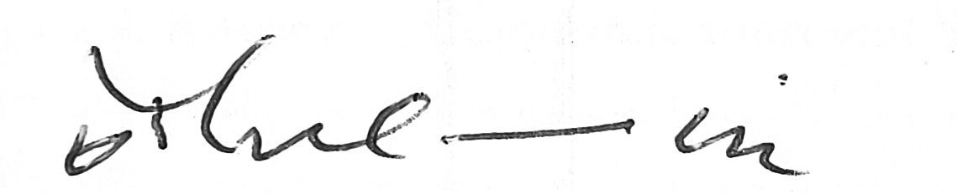
Dr Owen Mugurungi
Director HIV, AIDS, STI & TB Programs – MOHCC

Table of Contents

Foreword 2
Acknowledgements 3
List of Figures 7
Abbreviations 9
Definition of terms 12
Rationale for updating TB management guidelines 13
What is NEW? 13
Part 1: Tuberculosis Overview and Organization of National TB services 16
Chapter 1: Basics of Tuberculosis and its Pathogenesis 17
Causative agent 17
Transmission of Mycobacterium tuberculosis 17
Pathogenesis of TB 18
Chapter 2: Epidemiology of Tuberculosis 21
Global burden of disease 21
Tuberculosis in Zimbabwe 21
Principles of Tuberculosis Prevention, Care and Control 21
Chapter 3: Organisation of TB Services in Zimbabwe 24
The National Tuberculosis Control Strategy 24
Strategic framework 24
Structure and roles of the NTLP at various levels 24
Engaging all care providers 26
National Tuberculosis Control Programme Recording and Reporting Process 31
Research and Innovation to Enhance Programme Performance 42
Chapter 4: Advocacy, Communication and Social Mobilization 43
Introduction 43
Advocacy 43
Communication 44
Social Mobilization 44
Basic health education messages 45
Part 2: Finding Tuberculosis 46
Chapter 5: Tuberculosis Screening and Diagnosis 47
Introduction 47
Screening for TB in health care settings 47
Diagnosis of PTB in adults 49
Procedure for sputum production 49
National TB Diagnostic algorithm 51
Interpretation of Laboratory Results 47
Diagnosis of Extra Pulmonary TB (EPTB) 47
Diagnosis of TB in children 48
Chapter 6: Systematic Screening of at risk / vulnerable populations 53
Introduction 53
Screening interventions for various TB risk groups 53
TB screening in correctional facilities and police holding cells 54
TB screening in miners and ex-miners 54
TB screening in diabetic persons and other risk groups 54
Chapter 7: Contact investigation and management 56
Introduction 56
Key definitions in TB contact investigation 56
Rationale for Contact investigation 56
Aims of TB Contact Investigation 56
Process of TB Contact Investigation 57
Key steps in TB contact investigation process 57
TB Contact Investigation Data Flow 59
Part 3: Treating Tuberculosis 60
Chapter 8: Management of Drug Susceptible Tuberculosis 61
Introduction 61
Policy framework 61
Treatment of drug susceptible TB 61
Treatment of TB in special situations 65
Treatment Monitoring (Case holding) 66
Post TB treatment care 71
Chapter 9: Drug Resistant TB; Programmatic and Clinical Management 73
Introduction 73
Principles of the care and control of DR-TB 73
What is Drug resistant TB 73
Factors Contributing to DR-TB 73
Diagnosis of DR-TB 74
DR-TB Treatment 74
Prevention of DR-TB 75
Chapter 10: Pharmacovigilance 76
Key Definitions 76
Rationale of pharmacovigilance for TB medicines 76
Prevention and management of adverse drug reactions 76
Adverse drug reactions induced by 1st line anti-TB medicines 77
Approach to management of adverse drug reactions 78
Drug interactions with 1st line anti-TB medicines 80
Patient information about ADRs and interactions 81
Reporting of ADRs to first line TB medicines 82
Managing, monitoring and reporting adverse events due to 2nd line anti- TB medicines 82
Chapter 11: Community Engagement 84
Introduction 84
Aims of Community TB Care 84
Community TB Care activities 84
Approaches to community TB screening 84
TB treatment support 84
Community-led monitoring 85
Civil society roles in the national TB response 86
Integrating Palliative Care in TB management for Improved Quality of Care and Treatment Outcomes 86
Chapter 12: Confronting Zoonotic TB 89
Introduction 89
Epidemiology 89
Transmission of zoonotic TB to humans 89
Risk factors 89
Clinical management of zoonotic TB 89
Chapter 13: Managing Mycobacteria other than TB 91
Introduction 91
Clinical Presentation 91
Diagnosis of MOTT 92
Treatment of MOTT 92
Part 4: Preventing TB and TB/HIV Collaboration 94
Chapter 14: Managing TB-HIV Co-infection 95
Introduction 95
Clinical Presentation of TB in PLHIV 95
Components of the TB/HIV Collaborative framework 95
Managing HIV in TB patients co –infected with HIV 97
Managing TB-HIV Co-infection in Children 97
Considerations for ART and TB treatment 97
Considerations for ART in XDR/MDR TB 98
Chapter 15: TB Preventive Therapy 100
What is Latent TB infection (LTBI)? 100
Diagnosis of LTBI 100
Management of LTBI 100
Bacillus Calmette-Guérin (BCG) Prevention 106
Chapter 16: TB Infection Prevention and Control 108
Introduction 108
Hierarchy of TB infection prevention and control measures 108
TB Infection Control Planning in Healthcare Settings 110
Consideration for special settings - prisons, holding cells and other congregated settings 111
Community Household TB-IPC 111
Considerations of TB-IPC in construction of health facilities 112
Part 5: Leprosy “Hansen’s Disease” 113
Chapter 17: Enhancing and sustaining efforts to eliminate Leprosy 114
Introduction 114
Objectives of the Leprosy Control Program 114
Basic Facts about Leprosy 114
Leprosy Classification 116
Leprosy complications 116
Treatment of Leprosy 117
Management and Prevention of Disabilities 118
Enhanced leprosy case finding 119
Monitoring and Evaluation/Surveillance 119

List of Figures
Figure 1: Scanning electron micrograph (SEM) of M. tuberculosis bacteria 17
Figure 2: Mechanism of transmission of M. tuberculosis 18
Figure 3: The anatomy of the respiratory system 18
Figure 4: Zimbabwe TB and HIV PPP Coordination framework, 2021-2025 30
Figure 5: National Tuberculosis Control Programme Data Flow 31
Figure 6: Simplified algorithm for screening and diagnosis of TB 48
Figure 7: Picture showing most common macroscopic appearances of sputa 51
Figure 8: Diagnostic and treatment algorithm for presumptive TB patients 52
Figure 9: Flow chart for PTB diagnosis in children at clinic level 50

Figure 10: Flow chart for TB diagnosis in a child at a referral facility 51
Figure 11: Mobile truck equipped with X-ray and Xpert laboratory for Targeted active TB cases finding in Zimbabwe 53
Figure 12: Data flow management in TB Contact investigation 59
Figure 13: Factors associated with development of DR-TB 74
Figure 14: A diagrammatic representation of the movement of the ADR form once completed 82
Figure 15: Algorithm for LTBI testing and TB preventive treatment in individuals at risk 101
Figure 16: KN95, N95 respirators and medical mask respectively 110
Figure 17: Optimizing sitting arrangements to promote TB IPC 111

List of Tables
Table 1: Illustrative icons used to highlight sections of emphasis 14
Table 2: Factors that Determine the Probability of Transmission of M. tuberculosis 18
Table 3: Differences between LTBI and Active TB disease 19
Table 4: Different service providers and their roles in TB-HIV Prevention, Treatment, Care and Support PPM Framework 28
Table 5: Recording and reporting tools and key roles and responsibilities in TB Recording and reporting 32
Table 6: Reporting timelines for TB surveillance data reporting 33
Table 7: Example of applying a Root cause analysis to a Programme gap 34
Table 8: Different uses of data across different levels 34
Table 9: Clinical symptoms and signs and specimen selection for diagnosis of EPTB 48
Table 10: Summary of recommended frequency of TB screening and approaches for various at-risk populations 55
Table 11: Recommended regimen for treatment of DS-TB in adults 61
Table 12: Weight-based dosing of 1st line TB medicines (FDCs) for adults 62
Table 13: Weight-based dosing of 1st line TB medicines for Children and Adolescents 63
Table 14: Recommended doses and indications for adjuvant steroid therapy 64
Table 15: Recommended regimen for treatment of DS-TB in Adults with Chronic Liver Disease 66
Table 16: Recommended Dose & Frequency for Patients with creatinine clearance <30ml /min or patients receiving haemodialysis 66
Table 17: Management of patients who interrupt treatment but are retrieved back to care 68
Table 18: Schedule of sputum smear microscopy for monitoring patients on TB treatment 70
Table 19: Common chronic complications of TB and their management 71
Table 20: Persons at increased risk of adverse events 77
Table 21: Symptom-based approach to identifying and managing ADRs due to 1st line anti-TB medicines 77
Table 22: The standard approach to re-introduction of anti-TB medicines after an ADR 79
Table 23: Alternate regimen when specific medicines cannot be used 80
Table 24: Recommended Regimen for Treatment of M. bovis 90
Table 25: Recommended drug regimen and doses for the treatment of MAC 92
Table 26: Recommended Treatment adjustments in patients receiving Rifampicin 98
Table 28: Recommended regimens for TPT in Zimbabwe 103
Table 29: TPT and Pyridoxine Dosing 103
Table 30: TPT Adverse Drugs Reaction Symptoms and Management 105
Table 31: Recommended MDT regimens for the treatment of leprosy 117
Table 32: Common adverse events from Leprosy treatment & their management 118
Table 33: Classification of leprosy disabilities 118

Abbreviations
ACSM Advocacy, communication and social mobilization
ADR Adverse Drug Reaction aDSM active Drug Safety Monitoring AE Adverse Event
AFB Acid Fast Bacilli
ART Anti- Retroviral Therapy
ATZ/r Atazanavir/ritonavir
BB Borderline – Borderline (for leprosy)
BCG Bacillus Calmette-Guerine
BDQ Bedaquiline
BL Borderline -lepromatous
BMI Body Mass Index
BT Borderline Tuberculoid (for leprosy) CBOs Community Based Organization CFR Case Fatality Ratio
CFZ Clofazimine
CI Contact Investigation
CKD Chronic Kidney Disease
CP Continuation Phase (of anti –TB treatment)
CPT Cotrimoxazole Preventive Therapy COPD Chronic Obstructive Pulmonary Disease CTBC Community TB care
CSOs Civil Society Organizations
CXR Chest X- ray
DDI Didanosine
DHE District Health Executive
DHIS.2 District Health Information System.2
DMO District Medical Officer DOT Directly observed treatment DR-TB Drug Resistant Tuberculosis DST Drug Susceptibility Testing
DTLC District TB and Leprosy Coordinator
DTG Dolutegravir
E Ethambutol
EHF Eye –Hand – Foot (score for leprosy)
EFV Efavirenz
ENL Erythema Nodosum Leprosum EPTB Extra –Pulmonary Tuberculosis FAO Food and Agricultural Organization FBOs Faith based organization
FDC Fixed Dose Combination
FLDs Fine Line Drugs
FNA Fine Needle Aspirate
GoZ Government of Zimbabwe
H Isoniazid
HCWs Health Care Workers
HIV Human Immuno-deficiency Virus
IGRA Interferon Gamma Release Assay

INH Isoniazid
INR International Normalized Ratio IPC Infection Prevention and Control IPT Isoniazid Preventive Therapy
IRIS Immune Reconstitution Inflammatory Syndrome
ISTC International Standards for Tuberculosis care
LF-LAM Lateral Flow – Urinary Lipoarabinomannan assay
LFTs Liver Function Tests
LFx Levofloxacin
LL Lepromatous –lepromatous
LPA Line Probe Assay
LPV/r Lopinavir/ritonavir
LTBI Latent Tuberculosis Infection MABC Mycobacterium Abscessus Complex MAC Mycobacterium Avium Complex MB Multi- bacillary (for leprosy)
MCAZ Medicines Control Authority of Zimbabwe
MDR-TB Multi – Drug Resistant TB MoHCC Ministry of Health and Child Care MOTT Mycobacteria Other Than TB MoU Memorandum of Understanding MTB Mycobacterium tuberculosis MUAC Mid-Upper Arm Circumference NAC National AIDS Council
NCDs Non-Communicable Diseases
NGA Naso –gastric aspirate
NGOs Non-governmental organization
NLTP National Leprosy and TB Control Program
NPA Naso –pharyngeal aspirate NTM Non –Tuberculous Mycobacteria NVP Nevirapine
OC Out of Control
OIE World Organization for Animal Health
OPD Outpatient department
PB Pauci-bacillary (for leprosy)
PHC Primary Health Care
PHEs Provincial Health Executives
PIs Protease Inhibitors PLHIV People Living with HIV PMD Provincial Medical Director
PMDT Programmatic Management of Drug Resistant TB
PP Private (health) provider
PPD Purified Protein Derivative
PPE Personal Protective Equipment
PPM Public –Private Mix (for TB care and prevention)
PTB Pulmonary Tuberculosis
PTLC Provincial TB and Leprosy Coordinator
PZA Pyrazinamide
R Rifampicin
RR-TB Rifampicin Resistant TB

R&R Recording and Reporting
Rif Rifampicin
SAE Serious Adverse Event
SAT Self-Administered Treatment SDGs Sustainable Development Goals SLI Second Line Injectable
SL-LPA Second Line (medicine) – Line Probe Assay
SMS Short Message Service
TB Tuberculosis
TB-DRS Tuberculosis – Drug Resistance Survey
TB-IPC Tuberculosis Infection Prevention and Control
TB-LAMP TB –Loop Mediated Isothermal Amplification Assay
TBM Tuberculous Meningitis
TPT Tuberculosis Preventive Therapy
TnC Treatment not completed (a leprosy outcome)
TS Treatment Success
TST Tuberculin Skin Test
TT Tuberculoid- Tuberculoid (for leprosy)
VM-ST Voluntary Motor- Sensory Test WHO World Health Organization XDR-TB Extensive Drug Resistant TB Z Pyrazinamide
ZN Ziehl – Nielsen (staining)

Definition of terms
The definitions given below apply to the terms as used in the context of these guidelines. The terms may have different meanings in other contexts.
Adolescent: refers to a person in the 15 -18-year age group.
Child: refers to a patient in the 0-14-year age group.
Adult: refers to a patient who is 15 years and older
Tuberculosis (TB) Infection: with Mycobacterium tuberculosis (MTB) may occur following exposure to a TB case and means that the person carries the bacteria inside the body. Many people have TB infection and remain well, while others develop disease. When infection has occurred, but the infected individual is showing no signs or symptoms of disease from the standpoint of clinical recognition or diagnostic detection, the term latent TB infection (LTBI) is often used.
Presumptive TB case: any person who presents with symptoms or signs suggestive of TB, the most common being a productive cough for more than 2 weeks (or of any duration for persons living with HIV), which may be accompanied by other respiratory symptoms (shortness of breath, chest pains, haemoptysis) and/or constitutional symptoms (loss of appetite, weight loss, fever, night sweats, and fatigue).
Case of TB: a definite case of TB (defined below) or one in which a health worker has diagnosed TB and decided to treat the patient with a full course of TB treatment. NB: Any person given treatment for TB should be recorded as a TB case and “Trial” of TB treatment is discouraged and should never be given as a method for diagnosis.
Definite case of TB: a patient with MTB complex identified from a clinical specimen, either by culture or newer method such as rapid molecular assay.
Pulmonary Tuberculosis (PTB): refers to any bacteriologically confirmed or clinically diagnosed case of TB involving the lung parenchyma or the tracheobronchial tree.
Extra-pulmonary tuberculosis (EPTB): refers to any bacteriologically confirmed or clinically diagnosed case of tuberculosis (TB) involving organs other than the lungs, e.g. pleura, lymph nodes, abdomen, genitourinary tract, skin, joints and bones, meninges. Tuberculous intrathoracic lymphadenopathy (mediastinal and/or hilar) or tuberculous pleural effusion, without radiographic abnormalities in the lungs, constitutes a case of EPTB. A patient with both pulmonary and EPTB should be classified as a case of PTB.
Miliary TB: is classified as PTB because there are lesions in the lungs.

Rationale for updating TB management guidelines
The Zimbabwe NTLP last updated national TB management guidelines in 2016. Notably, the landscape has significantly shifted in recent years in the field of TB prevention and care, with existing guidelines no longer sufficient to provide most up to date guidance in the day to day care of TB patients. A range of new rapid molecular diagnostic tests have become increasingly available, including the most recent near point of care Truenat test and Xpert MTB/XDR assay that allows for faster detection of mutations associated with resistance towards isoniazid (INH), fluoroquinolones (FLQ), second-line injectable drug (SLID) (amikacin, kanamycin, capreomycin) and ethionamide (ETH) in a single test.

Findings from Prevalence surveys have zoomed a spotlight on subclinical TB, defined as “disease due to viable M. tuberculosis that does not cause clinical TB-related symptoms but causes other abnormalities that can be detected using existing radiologic or microbiologic assays” To date, very few interventions have attempted to identify and treat such individuals and more attention has been paid to reducing patient delays in care seeking after symptoms develop. It is plausible that subclinical TB could be potentially driving a substantial fraction of transmission at population level. More sensitive screening tools such as use of chest radiography to detect subclinical disease are increasingly becoming important as critical innovations if the global aspiration to end TB by 2030 is to be a reality

Finally, there has been a quantum leap in the development of new medicines for TB in recent years, which has seen the introduction of two completely new medicines, Bedaquiline and Delamanid, while a number of repurposed medicines including the fluoroquinolones, Linezolid and Clofazimine have found an increasingly important role in the treatment of especially Drug-resistant TB. There have also been changes in global TB indicators with WHO recommending that countries adopt a set of ten key indicators to monitor the national TB response to ensure alignment with the global End TB Strategy. Updating the national TB management guidelines is thus an imperative, to ensure global best practice is incorporated as standard of clinical care.

What is NEW?

Enhanced readability
These new guidelines have been divided into five broad colour coded thematic sections to enhance readability and ease the pain of flipping between different chapters to locate a particular theme of interest. The five sections include;
- Part 1: Tuberculosis Overview and Organization of National TB services - Chapter headings for this section including page edging has been colour coded light blue for ease of identification
- Part 2: Finding TB - Chapter headings for this section including page edging has been colour coded gold
- Part 3: Treating TB - Chapter headings for this section including page edging has been colour coded
green
- Part 4: TB Prevention and TB-HIV collaboration - Chapter headings for this section including page edging has been colour coded purple
- Part 5: Leprosy “Hans Disease” - Chapter headings for this section including page edging has been colour coded dark red
- Important sections of emphasis have been marked with distinct icons as text inserts in colour coded boxes. The icons used are illustrated in the Table below;

Table 1: Illustrative icons used to highlight sections of emphasis

Item | Icon
Practice Recommendation/s | 
Key Notes | 
Further Reading | 
Frequently Asked Questions/FAQ | 
Policies | 
Considerations for Children | 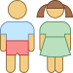
Community | 
Pharmacovigilance | 

Material changes in NEW Guidelines

TB Screening and Diagnostic landscape
- Emphasis on use of radiology, with artificial intelligence as a more sensitive screening tool for detection of sub-clinical TB in persons 15 years and above
- Use of stool as a diagnostic sample for detection TB in children 10 years and younger
- Introduction of X-pert XDR reflex testing for 2nd line Drug susceptibility testing on all bacteriological confirmed samples on molecular WHO Rapid Diagnostic assays (mWRDs) such as Xpert MTB/RIF Ultra and/or Truenat MTB/MTB Plus.

TB Treatment landscape
- A 4-month treatment regimen (2HRZ(E)/2HR) for children and adolescents between 3 months and 16 years of age with non-severe TB

 | - Non-severe TB is defined as; peripheral lymph node TB; Intrathoracic lymph node TB without airway obstruction; Uncomplicated TB pleural effusion or paucibacillary TB; non-cavitary disease confined to one lobe of the lungs & without a military pattern
- All oral shorter regimens for treatment of Drug resistant TB (DR-TB)
- Integrating palliative care in the management of TB patients

TB-HIV co-management
- Use of Lateral flow urine lipoarabinomannan (LF-LAM) assay for the diagnosis of active tuberculosis in persons with advanced HIV disease
- The new preferred regimens for TB Preventive therapy (TPT) are 3HP (3 months of Isoniazid and Rifapentine)
and 3RH (3 months of Isoniazid and Rifampicin)
- The preferred first line regimen for Persons living with HIV (PLHIV) is TDF/3TC/DTG

Treatment of Leprosy

- Use of a 3-drug regimen for paucibacillary leprosy taken for 6 months

Part 1: Tuberculosis Overview and Organization of National TB services
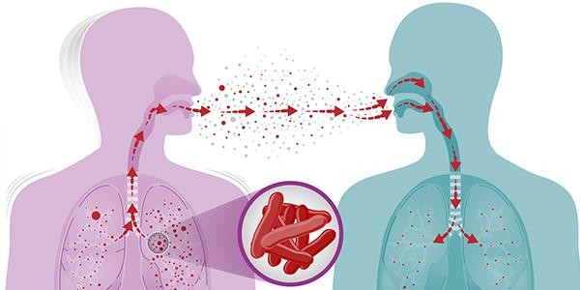

Chapter 1: Basics of Tuberculosis and its Pathogenesis

Causative agent
Tuberculosis (TB) is an airborne disease caused by bacteria belonging to the Mycobacterium tuberculosis complex (Figure 1). The M. tuberculosis complex consists of M. tuberculosis and seven very closely related mycobacterial species (M. bovis, M. africanum, M. microti, M. caprae, M. pinnipedii, M. canetti and M. mungi). Most, but not all, of these species have been found to cause disease in humans but most TB disease is caused by M. tuberculosis.
Figure 1: Scanning electron micrograph (SEM) of M. tuberculosis bacteria
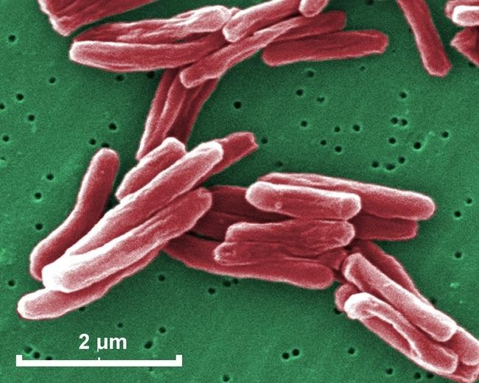
- A Gram-positive bacterium, which is an obligate aerobic organism

- It can only survive in an environment containing oxygen

- It ranges in length between 2 - 4µm, and a width between 0.2 - 0.5µm.
Photo Credit: CDC/Janice Haney Carr

Transmission of Mycobacterium tuberculosis
Tuberculosis is carried in airborne particles, called droplet nuclei. Infectious droplet nuclei are generated when persons who have pulmonary or laryngeal TB disease cough, sneeze, shout or sing. Depending on the environment, these tiny particles can remain suspended in the air for several hours. Transmission occurs when a person inhales the droplet nuclei containing M. tuberculosis. The infectiousness of a person with TB disease is directly related to the number of bacilli they expel into the air. When a person breathes in TB bacteria, the bacteria can settle in the lungs and begin to grow. From there, they can move through the blood to other parts of the body, such as the kidney, spine, and brain. TB disease in the lungs or throat can be infectious, meaning that the bacteria can spread to other people in close contact with someone with TB disease. These include family members, friends, co-workers or schoolmates.

Figure 2: Mechanism of transmission of M. tuberculosis.
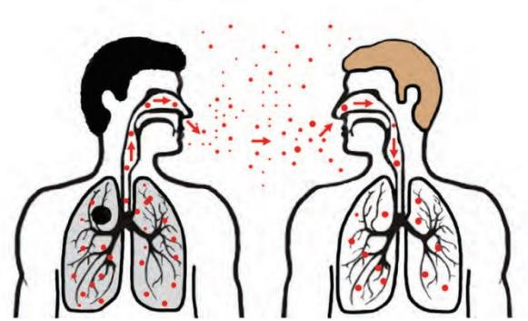
- TB is spread from person to person through the air.

- The dots in the air represent droplet nuclei containing tubercle bacilli.

Various factors determine the probability of transmission. These include host factors many of which are poorly understood, factors related to the pathogen and environmental factors. Table 1 below summarizes what is currently known about transmission of M. tuberculosis.

Table 2: Factors that Determine the Probability of Transmission of M. tuberculosis

Factor | Description
Susceptibility | Immune status of the exposed individual
Infectiousness | Number of tubercle bacilli expelled into the air by the infectious individual
Environment | Sum total of the surroundings of a living organism, which include the  concentration of infectious droplet nuclei, space, ventilation, air circulation, lighting, air pressure and specimen handling in laboratory and related settings
Exposure | Duration, proximity and frequency of exposure to an infectious individual
Transmission of M. tuberculosis is facilitated by exposure to a greater volume of droplet nuclei in small enclosed spaces with poor lighting and ventilation, as well as long duration of contact and closer proximity to an infectious person.

Pathogenesis of TB
When a person inhales air that contains droplets containing M. tuberculosis, most of the larger droplets become lodged in the upper respiratory tract (the nose and throat), where infection is unlikely to develop. However, smaller droplet nuclei may reach the small air sacs of the lung (the alveoli), where infection is more likely to become established. (See Figure below).

Figure 3: The anatomy of the respiratory system
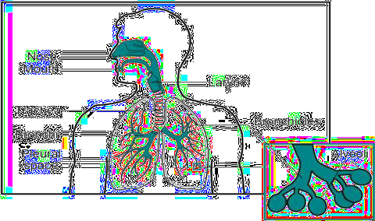
- In the alveoli, some of the tubercle bacilli are killed,

- A few multiply, enter the bloodstream, spread and may reach any part of the body.

- In a small proportion of people, the bacilli are expelled and the individual remains healthy.
Within 2 to 8 weeks of entry of the bacilli into the body, the immune system usually intervenes, halting

multiplication and preventing further spread of the tubercle bacilli. When infection is established, but the TB bacilli are not actively replicating and there is no apparent disease, the person is said to have Latent TB Infection (LTBI). LTBI is a function of a complex host–pathogen relationship not well understood. In simple terms during LTBI the individual’s immune system is able to keep the infecting bacilli under control and inactive. People who have LTBI are NOT infectious i.e. cannot spread the infection to other people. These people usually have a normal chest x-ray. It is important to remember that LTBI is not considered a case of TB. Major similarities and differences between LTBI and TB disease are shown in Table 2 below.

Table 3: Differences between LTBI and Active TB disease

Person with LTBI (Infected) | Person with TB Disease
Small amount of TB bacteria in his/her body that are  alive, but inactive | Large amount of active TB bacteria in his/her body
Cannot spread TB bacteria to others | May spread TB bacteria to others
Does not feel sick, but may become sick if bacteria  become active in his/her body | May feel sick with symptoms such as cough, fever,  and/or weight loss
Usually has TB skin test or blood test reaction  indicating TB infection | Usually has a TB skin test or TB blood test reaction  indicating TB infection
Chest X-ray typically normal | Chest X-ray may be abnormal
Sputum smears and cultures are negative | Sputum smears and cultures may be positive
Consider treatment for LTBI to prevent TB disease | Needs treatment for TB disease
Not a TB case | A TB case

In general, it is accepted that persons who progress from LTBI to active TB have failure of immunological mechanisms to prevent multiplication of M. tuberculosis. Without treatment, approximately 5% of persons who have been infected with M. tuberculosis will develop disease in the first year or 2 after infection, and another 5% will develop disease sometime later in life. Thus, without treatment, approximately 10% of persons with normal immune systems who are infected with M. tuberculosis will develop TB disease at some point in their lives. Active TB disease that develops within a few months or years (1-2) after infection is labelled primary TB disease, while disease that develops many years (>2 years) after infection is called post primary or reactivated TB.

Anyone who has LTBI can develop TB disease, but some people are at higher risk than others. HIV infection is the greatest risk factor for the development of TB disease in persons with LTBI, due to a weakened immune system. The risk of developing TB disease is 7% to 10% each year for persons who are infected with both M. tuberculosis and HIV and who are not receiving highly active treatment for HIV; it is 10% over a lifetime for persons infected only with M. tuberculosis. Children younger than 5 years of age are also at increased risk for progression of LTBI to TB disease. Other risk factors of progressing to TB disease are summarized below.

 | - Persons living with HIV;  - Extremes of age (Children younger than 5 years of age and elderly)  - Persons recently infected with M. tuberculosis (within past 2 years);  - Persons with history of untreated or inadequately treated TB disease, including persons with fibrotic lung changes on chest radiograph;  - Persons receiving immunosuppressive therapy;  - Persons with silicosis, diabetes mellitus, chronic renal failure, leukemia, or cancer of the head, neck, or lung;  - Persons who have had a gastrectomy or jejunoileal bypass;  - Persons who weigh less than 90% of their ideal body weight;  - Cigarette smokers and persons who abuse drugs and/or alcohol;  - Populations defined as medically underserved and/or low-income populations.

 | - https://www.cdc.gov/tb/education/corecurr/pdf/chapter2.pdf

Chapter 2: Epidemiology of Tuberculosis

Global burden of disease

According to the 2022 World Health Organization (WHO) Global TB report, it is estimated that 10.6 million people fell ill with TB worldwide in 2021, representing a 4.5% increase from 10.1 million the previous year, reversing many years of a sustained decline, on account of the disruptive impact of COVID-19. Similarly, the TB incidence rate (new cases per 100 000 population per year) is estimated to have increased by 3.6% between 2020 and 2021, following a 2% annual decline for most of the last two decades. Among all TB cases, 6.7% were among people living with HIV. Geographically, most TB cases in 2021 were in the WHO regions of South-East Asia (45%), Africa (23%) and the Western Pacific (18%), with smaller shares in the Eastern Mediterranean (8.1%), the Americas (2.9%) and Europe (2.2%).

The burden of drug-resistant TB (DR-TB) is also estimated to have increased between 2020 and 2021, with 450 000 estimated new cases of rifampicin resistant TB (RR-TB) in 2021. Other negative impacts of COVID- 19 on TB include a 17% fall between 2019 and 2020 in the number of people provided with treatment for RR-TB and multidrug-resistant TB (MDR-TB) (from 181 533 to 150 469, about 1 in 3 of those in need), with a 7.5% partial recovery to 161 746 in 2021. Global spending on essential TB services declined (from US$ 6.0 billion in 2019 to US$ 5.4 billion in 2021, less than half of actual need), with likely diversion of resources to respond to the COVID-19 pandemic

Tuberculosis in Zimbabwe
Zimbabwe's healthcare system has been facing challenges in recent years, with the advent of COVID-19 further worsening the health systems plight. The disruptive impact of the pandemic led to a decline in TB case detection, to an estimated treatment coverage of 54% in 2021, with 14,000 estimated missed cases, from incidence estimates of 190 per 100,000 population. Despite the country’s removal from the list of top 30 high burdened countries for TB in recent years, finding missed cases remains an area of priority focus, to avert sliding back in ranking. In addition, the country has maintained top 30 ranking of high burdened countries for both TB-HIV co-infection, with 50% of notified TB cases in 2021 co-infected with HIV, and high burdened countries for drug resistant TB, with 780 estimated incident cases in 2021, against 243 (31%) detected cases.

Treatment success rate for drug-susceptible TB cases has sustained an upward trajectory to 88% in 2020, up from 84% in 2018, while treatment outcomes for DR-TB patients have worsened over time, to 43% in the latest cohort of 2019. This has been compounded by the disproportionate burden of out of pocket expenditure incurred by TB patients in accessing care, estimated at 80% of TB patients in the last patient cost survey of 2018. This highlights the need for robust social safety measures to mitigate against such catastrophic costs, an important barrier to accessing life-saving treatment.

Principles of Tuberculosis Prevention, Care and Control
The overarching principles informing the core intervention package to end TB in Zimbabwe are aligned to the Global End TB Strategy as summarized below;

- Principle 1: Government stewardship and accountability, with monitoring and evaluation.
- Principle 2: Strong coalition with civil society organizations and communities.
- Principle 3: Protection and promotion of human rights, ethics and equity.
- Principle 4: Adaptation of global best practice and targets at country level

Three pillars of the strategy bring together critical interventions to ensure that all people with TB have equitable access to high-quality diagnosis, treatment, care and prevention, without facing catastrophic expenditure or social repercussions.

Pillar 1: Integrated, Patient-centred Care and Prevention

- This pillar puts patients at the heart of service delivery, focusing on early detection, treatment and prevention for all TB patients including children.
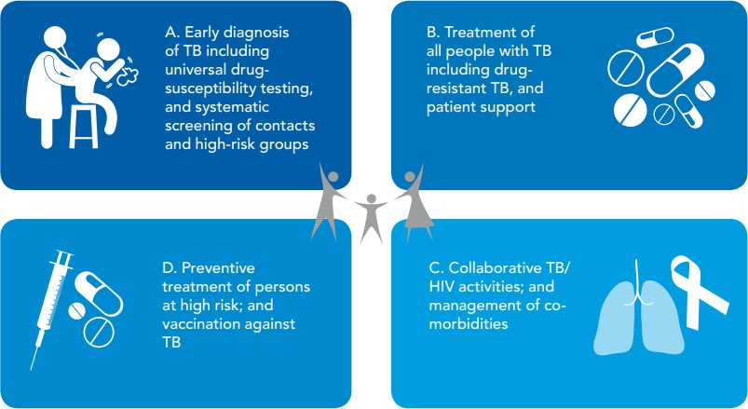
- Pillar aims to ensure all TB patients have equal, unhindered access to affordable services,

- Are engaged in their care.

Pillar 2: Bold Policies and Supportive Systems
- This pillar requires intense participation across government, communities and private stakeholders
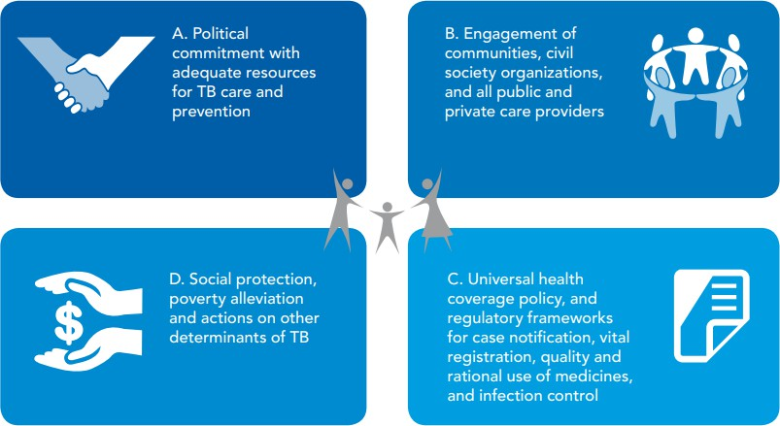
- Strengthen health & social sector policies & systems to end TB.

- Support universal health coverage & strengthened regulatory frameworks.

Pillar 3: Intensified Research and Innovation
- This pillar aims to intensify research and promote effective adoption and roll out of new tools and innovation.
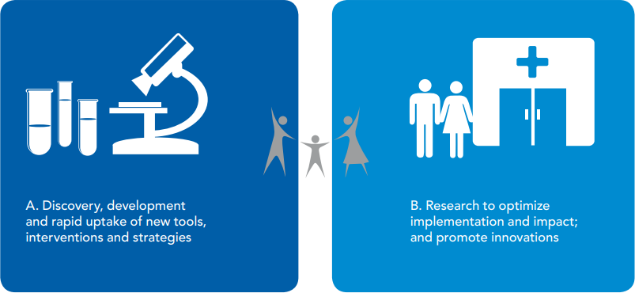
- Operational research for implementation, & scale-up of new tools & innovations.

- Global Tuberculosis Report, World Health Organization, 2022
- The End TB Strategy, World Health Organization, 2015

Chapter 3: Organisation of TB Services in Zimbabwe

The National Tuberculosis Control strategy
The National TB and Leprosy Programme recently pieced together an addendum to the existing National Strategic Plan for Tuberculosis and Leprosy (TB-NSP), covering the period (2023-2026). This has been necessitated by the need to align with global best practice in accelerating the agenda to end TB by 2030. In this addendum, attention is drawn to important priorities espoused in the 2022 midterm external programme review with focus placed on improving coverage of TB case finding interventions and enhancing quality of care to optimize treatment outcomes

Strategic framework

Vision:

A TB-free Zimbabwe

Goals:

- By 2026 to have reduced the incidence of all forms of TB by 80% from 242/100,000 in 2015 to 48/100,000
- By 2026 to have reduced mortality of all forms of TB by 80% from 40/100,000 in 2015 to 8/100,000.

Strategic Objectives:

- To increase the treatment coverage of drug susceptible TB from 83% in 2018 to 90% by 2026
- To increase the treatment success rate of patients with drug susceptible TB from 83% in 2017 to 90% by 2026
- To achieve universal HIV testing and ART coverage for TB cases by 2021 and sustain coverage through to 2026
- To cumulatively detect 2,680 patients with RR/MDR TB between 2021 and 2026
- Increase the treatment success rate of patients with RR/MDR TB from 57% (2016) to 75% by 2026
- Decrease the proportion of households facing catastrophic costs due to TB from 80% in 2019 to 50% by 2026
- Scale up leprosy prevention alongside integrated active case detection
- Strengthen Programme coordination, management and enhance accountability

Structure and roles of the NTLP at various levels.

The Central Level

The central unit of the NTLP falls under the Directorate of the Aids and TB Programme. This unit coordinates policy formulation and resource mobilization for TB prevention and care. The interventions pursued by the NTLP are guided by a strategic plan updated every 3-5 years in line with international best practice. The NTLP has strategic, managerial, leadership and technical roles to guide the implementation of the programme. These roles include but are not limited to:

  - Development of national policies, strategies and interventions for TB care and prevention.
  - Identifying and mobilizing resources, including financial and human resources for TB prevention and

care.
  - Programme supervision, monitoring and evaluation of programme implementation, including TB research priorities.
  - Coordination and harmonization of efforts by partners.
  - Strengthening collaboration between TB, NCD and HIV & AIDS programmes to ensure integrated management of patients.

The NTLP works closely with various directorates in the MoHCC, such as laboratory, pharmacy and environmental health to ensure a comprehensive health sector response to TB.

Central Hospitals

These are referral institutions that manage complicated TB cases needing specialized diagnostic and treatment services. All central hospitals should manage all complicated TB cases, including those with complicated co- morbidities until they are clinically stable, before down-referral back to lower level facilities for follow-up care. They may, however, also serve as the health facilities where surrounding communities first seek care when they are unwell.

 | - Most Infectious Disease Hospitals managed by Local authorities are not adequately resourced to manage complicated TB cases.  - All such patients should be managed at a Central hospital by Specialist Physicians until they are stable, before being referred to any facility including Infectious Disease Hospitals for follow- up care

- All central hospitals should keep records of TB patients managed. This is best done by an appointed TB focal person at the institution responsible for coordinating TB services
- All central hospitals should develop & implement a clear referral plan to ensure patients do not get lost when referred to lower levels.
- The TB focal person must closely work with respective district/provincial coordinators to ensure 1) all TB cases diagnosed are notified; 2) treatment continuation is guaranteed upon discharge; 3) contact investigation & management is instituted.

The Provincial Level and Metropolitan Cities

The Provincial Medical Director (PMD) is accountable for the TB programme at sub-national level. The Provincial TB and Leprosy Coordinator, with technical and management support from the Provincial Maternal and Child Health/TB-HIV Medical Officer, coordinates TB control activities at provincial level. In the case of urban municipalities, public health service delivery including TB control is under the jurisdiction of a Directorate of Health Services with support from an appointed TB focal person or coordinator.

- All provincial health executive teams should develop quarterly, and annual TB operational plans contextualized to local settings and aligned to national plans

The District Level

The District Health Executive (DHE) under the leadership of the District Medical officer (DMO) supervises the delivery of all health care services in district hospitals and primary health facilities. The DMO working

with the District TB and Leprosy Coordinator (DTLC) has overall responsibility for the organization and implementation of TB prevention, care and treatment activities in the district.

- All district health executive teams should develop quarterly, and annual TB operational plans contextualized to local settings and aligned to provincial plans

Primary Health Care (PHC) Level

This is the most peripheral and first point of contact with the health delivery system. The centre/clinic is manned by a nurse, supported by an Environmental Health Technician. The clinic initiates investigation of presumptive TB clients, initiating TB treatment and follow-up care. Bacteriologically negative presumptive TB clients are referred to the next district level for clinical review by a medical doctor. The clinic also maintains facility TB records as well as supervises treatment supporters or community-based health workers

- The PHC facility is the interface with the community on health issues.
- All organizations working or planning to work in the community should ensure the respective PHC facility is fully engaged throughout the development & implementation of community health interventions.

The Community Level

A community-based approach remains a key pillar in the National Health Strategic framework. The community-based approach is undertaken by both government and non- government actors. At the community level community health workers and volunteers work with communities to
- Raise awareness on TB and thus reduce associated stigma and discrimination;
- Promote appropriate early health seeking behavior;
- Identify presumptive clients for early referral and linkage to care;
- Support patients on treatment to adhere to treatment;
- Identify and retrieve persons who have interrupted treatment;
- Identify and screen contacts of persons diagnosed with TB.

Engaging all care providers
Public-Private Mix for TB prevention and care (PPM) is the involvement of all health care providers, public and private as well as formal and informal providers in the provision of TB care, in line with International Standards for TB Care (ISTC). The ISTC defines a set of standards which should be applied and adhered to by all health care providers who manage persons with presumed or confirmed TB. In most low resource settings, like Zimbabwe, provision of TB and HIV prevention, care and treatment services are primarily the responsibility of government with minimal participation of the private sector. With diminishing and finite resources competing for a wide array of public health priorities, it has become critical to involve more players in the provision of TB and HIV care services. A number of opportunities exist for enhanced partnerships to increase access to healthcare for the Zimbabwean population. Zimbabwe has a relatively robust, decentralized private health infrastructure which can be utilized to increase access to HIV and AIDS as well as TB services. In addition, well established and emerging health insurance schemes provide an opportunity for possible financing of services which should be extended to include the informal sectors. In 2020, the Government of Zimbabwe conducted a TB Diagnostic Network Assessment (TB-DNA) which recommended that including private sector in provision of TB and HIV care services may help to significantly increase access for TB/HIV presumptive and confirmed clients.

The Ministry of Health and Child Care, with support from the USAID Infectious Diseases Detection & Surveillance (IDDS) project recently updated the framework for Private Public Partnerships (PPPs) for TB and HIV prevention, treatment, care and support to align with latest developments.

Goal of PPM
To contribute to the reduction of morbidity and mortality among people infected with TB and PLHIV in line with Zimbabwe's commitment to improve quality of life through provision of comprehensive HIV and TB services

Objectives of PPM
- To strengthen an enabling legal, policy and regulatory environment for PPP in the provision of comprehensive quality HIV, AIDS and TB services.
- To expand access to comprehensive quality HIV and TB services through effective public private partnerships, including strengthening their capacity to build, promote and sustain partnerships.
- To leverage resources (financial and non-financial) from public and private sector towards universal access to comprehensive quality services for HIV, AIDS and TB services.
- To strengthen strategic information management, monitoring and evaluation (M&E) and research.

Roles and Responsibilities

- The MoHCC through the AIDS and TB Programme (ATP) will provide the stewardship, financing and development of policy guidelines for the PPM effort. In addition, the ATP will routinely provide training and mentorship of private providers through basic management units (BMU) or professional associations.
- Large private hospitals have been providing some form of TB and HIV care services and these will need strengthening through formalized Memoranda of Agreement.
- The public health laboratory and national tuberculosis reference laboratory will be responsible for providing quality assurance for HIV testing and TB diagnosis respectively to the private laboratories.
- The Provincial Medical Directorate/City Health Directorate will work with the ATP to ensure that PPM national policy guidelines and recommended practices are adopted, appropriately adapted and implemented.
- Mapping of the private practitioners will be done at district level, which will in turn report to the provincial level for a consolidated list of all private practitioners in the respective province.

Defining the role of the private health care provider

Diverse care providers, may not have the capacity to undertake all the TB-HIV related tasks. It is useful to map different providers, identify capacities of the various providers to undertake various TB-HIV tasks and allocate such tasks as appropriate. These are summarized in the Table below;

Table 4: Different service providers and their roles in TB-HIV Prevention, Treatment, Care and Support PPM Framework

Tasks |  | Government facilities  including Faith Based Organizations |  |  |  | Private health care  providers including private laboratories |  |  |  | Traditional Health Practitioner | Regulatory Professional Body | Medical Insurance Company
 |  | ATP | Hospital | Health centre | Village Health Worker | Hospital | General Practitioners | RP | Laboratory | Traditional Health Practitioner | Regulatory Professional Body | Medical Insurance Company
Clinical | Identify presumptive cases | X | X | X | X | X | X | X |  | X
Clinical | Collect sputum samples | X | X | X | X | X | X
Clinical | Record & refer presumptive TB cases | X | X | X | X | X | X
Clinical | Carry out smear microscopy | X | X | X |  | X |  |  | X
Clinical | GeneXpert testing | X | X | X |  | X |  |  | X
Clinical | Culture and DST | X | X |  |  |  |  |  | X
Clinical | HIV testing and counselling | X | X | X |  | X | X
Clinical | Diagnose TB, NCDs &/or HIV | X | X | X |  | X | X
Clinical | Initiate TB, NCDs &/or HIV  treatment | X | X | X |  | X | X
Clinical | Initiate RR/MDR-TB treatment | X | X |  |  | X
Public Health | Patient education and awareness | X | X | X | X | X | X |  |  | X
Public Health | Notify TB and HIV cases | X | X | X |  | X | X | X
Public Health | Provide treatment support | X | X | X | X | X | X | X |  | X
Public Health | Contact tracing and investigation | X | X | X | X | X | X
Public Health | Training of providers | X | X |  |  |  |  |  |  |  | X
Public Health | Support and supervision | X | X
Public Health | Quality assurance of laboratories | X
Public Health | Program monitoring and evaluation | X
Public Health | Drugs and other commodities supply  management | X
Public Health | TB advocacy and social mobilization | X
Public Health | Enforcement of policies | X |  |  |  |  |  |  |  |  | X
Public Health | Regulation | X |  |  |  |  |  |  |  |  | X
Public Health | Financing | X |  |  |  |  |  |  |  |  |  | X

Key: ATP – AIDS and TB Programme; RP – retail pharmacist;

Certification of Private for-profit Health Care Providers

Certification is the process by which the national control program will officially document that a private provider has met the appropriate criteria to provide the services being certified. Before certification, the ATP together with members of the provincial team will assess private health care provider’s capacity to provide

the service allocated to them and thereafter train and support the provider to be able to provide the highest possible quality for that service. Once a certain quality of care is achieved based on clear quality indicators, that provider will be certified as a provider for that specific task.

Memorandum of Understanding (MoU) between the MoHCC and private providers

In order to manage expectations and clearly define roles and responsibilities, the MoHCC will enter into formal MoUs will willing private health care providers. These MoU will spell;

- the tasks that the Private Provider (PP) has been allocated,
- support the PP should expect to receive from the MoHCC,
- commodities that will be provided and how the PP should manage these commodities, including reporting requirements.

The MoU will also highlight the obligations of the MoHCC to include providing training and technical support and ensuring commodities and other supplies are continuously available to the PP. It must be noted that the MoHCC has legal and regulatory mandates to protect public health and therefore from time to time may invoke these mandates to compel PPs to carry out tasks considered essential to the promotion or preservation of public health. These measures may include, for example, ministerial decrees on mandatory TB case notification.

PPM program enablers

For successful implementation of the PPM, the MoHCC will provide the engaged PPs with program “enablers” to ensure that the TB services provided by the PPs are adherent to national norms and the ISTC. These will include BUT will not be limited to:
  - Practice guides in user friendly formats.
  - Training the health care practitioners on TB case management.
  - IEC materials.
  - TB medicines.
  - Laboratory equipment and supplies in selected situations.
  - Data collection/M&E tools.

Payment of enablers or re-imbursement of costs incurred by the private providers will also be borne through the BMU and ATP, upon satisfactory acquittal of number of patients being followed up and/or notified or samples processed by the private laboratory. The NTLP will also, disseminate lists of PPs that are engaged in the TB response and organize events in which the best performing PPs are recognized and/or awarded resources permitting.

Supply of medicines and other consumables

Anti-TB medicines for all Zimbabweans will be available to PPs who have partnered with the MoHCC. Engaged PPs will have to make a commitment, that they will pass on these medicines to their patients for “FREE” save for nominal administrative overheads on a cost recovery basis. The administrative fees charged will be negotiated and agreed upon and documented in the MoU. The anti-TB medicines supply system that will be used will be the same as the one in use for supplying commodities and supplies to public health care facilities. As in the public sector, PPs receiving anti-TB medicines will be expected to report on their consumption of anti-TB medicines and other consumables monthly, using the current reporting formats used by the MoHCC.

Coordination of PPM Activities

All private providers will be reporting through the local TB BMU, or district hospital. For providers in urban settings, they will report through the local authority as illustrated in Figure below.
Figure 4: Zimbabwe TB and HIV PPP Coordination framework, 2021-2025
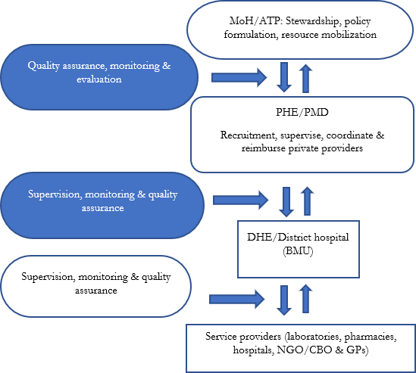
- Practical tools to facilitate the process of implementing, monitoring and evaluation of PPM initiatives will be developed & distributed by NTLP

- These will include; referral for-treatment forms, feedback or back-referral, transfer forms, monthly reporting forms etc.

Monitoring and Evaluation

It is essential to continuously monitor and evaluate PPM in order to assess the impact of this intervention on TB control targets. The key indicators that the NTLP will be monitoring include:
  - The proportion of notified TB cases that are referred by PPs.
  - The treatment success rate of TB patients treated by PPs.
  - The proportion of TB patients managed by PPs who are tested for HIV and the proportion of HIV infected TB patients managed or treated by PPs who are placed on ART.
  - Public Private Mix coverage, defined as the proportion of identified PPs in a given geographic area (district, province or national level) linked with the NTLP, with linkage defined as the referral or treatment of at least one presumptive or confirmed TB case in a quarter.
  - The proportion of presumptive TB cases managed in the private sector tested with a WHO recommended rapid diagnostic test.
  - The NTLP will also keep track of the number of PPs trained and/or supervised.

 | - Timire C, et al. Catastrophic costs among tuberculosis patients in Zimbabwe: a national health facility- based survey. 2020  - Strategic Framework for Public-Private Partnerships for TB & HIV Prevention, Treatment, Care & Support: 2014 – 2016, MoHCC  - WHO - The PPM national PPM situation analysis  - Engaging all health care providers in TB control guidance on implementing public-private mix approaches  - Zimbabwe - Strategic Framework for Tuberculosis and Human Immunodeficiency Virus (TB/HIV) Prevention, Treatment, Care and Support Public-Private-Partnership, 2021-2025

National Tuberculosis Control Programme Recording and Reporting Process

Introduction
Good recording practices are necessary for effective patient management. Assessment of programme performance and epidemiological trends provides the basis for programmatic and policy development. Zimbabwe has a comprehensive TB surveillance system starting from the community level. Data at all levels are captured using paper-based tools and aggregated into monthly reporting forms from various registers. These are in turn entered into the electronic District Health Information Software (DHIS2.3). Once the data is entered into DHIS2.3, it is reviewed online at district and provincial level for accuracy, consistency and completeness. Any discrepancies on the TB data are corrected and in addition routine and targeted supervisory visits are used to rectify programmatic data issues identified.

The recording and reporting system for TB allows for individualized follow-up to help patients who do not make satisfactory progress, and for rapid managerial assessment of the overall performance of each institution, district, and provinces. A robust system of accountability involving cross-checks between reports, registers and forms should minimize any risk of false reporting. Data quality audit tools standardize to cross-check between reports, registers and forms. Data verification through cross-checking requires regular print-outs of DHIS2:3 reports and comparing them with monthly reports and registers supported by a proper paper-based archiving system.

Figure 5: National Tuberculosis Control Programme Data Flow
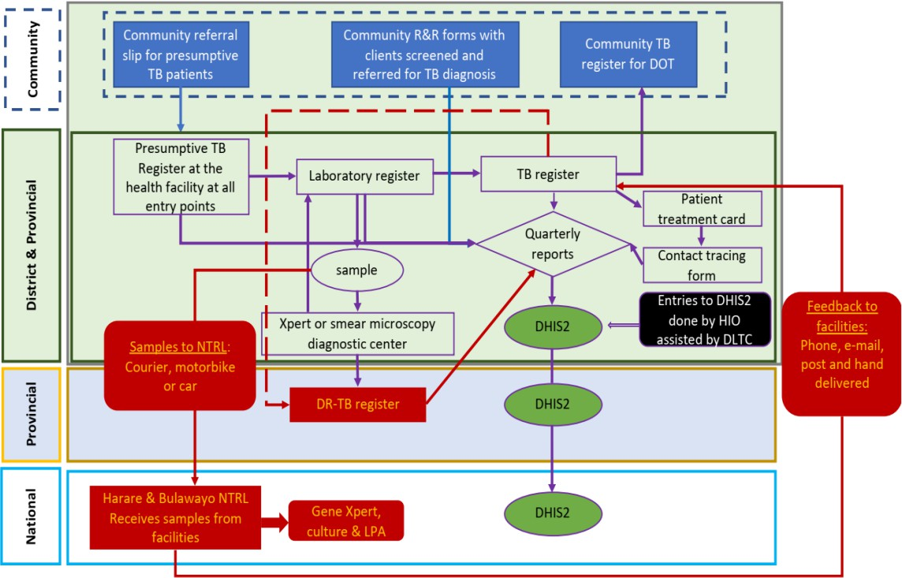

The DHEs and PHEs working with Tuberculosis and Leprosy Coordinators play a key role in the coordination of implementation of TB interventions, both at health facility and community level. The different recording and reporting tools as well as roles and responsibilities in TB recording and reporting are summarized in the Table below;

Table 5: Recording and reporting tools and key roles and responsibilities in TB Recording and reporting

Level | Reporting tools and Key Responsibilities
Community Level | Community Health Workers: keep the community TB register to register TB patients in  their catchment areas and they use referral slips for referring presumptive cases to the local health facility.
Health Facility Level | Presumptive Register: The recording system of TB patient (patient registration) at health  facility starts with presumptive TB register where records of all symptomatic patients to be tested for TB are documented. The presumptive register is placed at all entry points and is maintained by nurses.
Health Facility Level | Laboratory Specimen Examination Request Form: is filled for every specimen that is  submitted to the laboratory for TB diagnosis and for follow-up for routine treatment monitoring. The form is used to report back results to the facility which requested the test.
Health Facility Level | Laboratory register: is used to record patients’ details and test results.
Health Facility Level | Health Facility TB Register: is used to register all types of TB patients, and their  treatment outcomes
Health Facility Level | Drug Resistant TB Register: is for registering patients confirmed with drug resistant TB  and their treatment outcomes.
Health Facility Level | TB Patient Treatment Card: is issued to drug sensitive TB patients and is kept by the patient. The TB outpatient treatment card is also used by the patients to access treatment  and by DOT observers to monitor patients’ compliance/adherence to treatment.
Health Facility Level | Drug Resistant TB patient Clinical Booklet: is opened for each drug resistant TB patient  and is kept at the health facility. The card and booklet are used to record basic epidemiological and clinical management information, drug administration monitoring as well as follow-up tests.
Health Facility Level | TB Notification Form: is filled-in for all patients diagnosed with TB regardless of type and  site. The Notification form is used by health facilities to notify the District Medical Officer about any newly diagnosed TB patients.
Health Facility Level | Notice of transfer of TB Patients Form: is used to transfer patients to other health  facilities within or outside the district.
Health Facility Level | TB Contact Tracing Form: is used to line list all the identified contacts of each TB index  case.
Health Facility Level | Contact Tracing Register: is for recording all TB contacts and their status for screening  and diagnosis. Contact investigation should be done within 72 hrs of notifying an index case.
Health Facility Level | TB Preventive Therapy Register: is used to record all HIV patients and TB contacts  eligible and initiated on TB preventive therapy.
Health Facility Level | TB Treatment Outcome Request Form: is used to request treatment outcomes for  patients who were transferred to other health facilities within the districts in the same province or outside province.
District Level | District TB register: is used to record all TB patients notified within the district and their treatment outcomes. It is kept and used by the District TB coordinator to monitor patients and to provide the district managers with rapid feedback on the district TB programme  performance.
District Level | Districts: are responsible for verifying and validating data uploaded into DHIS2.3
Provincial Level | Validate data in DHIS 2.3 for accuracy, completeness and consistency
National Level | Validate data in the DHIS 2.3 for accuracy, completeness and consistency

Reporting Timelines

The DHE and the District Tuberculosis and Leprosy Coordinator (DTLC) under the guidance of the DMO ensure that all the diagnosing and treatment sites submit monthly reports which are verified and validated at local level. TB reporting is done monthly by health facilities. The data is verified and validated by health facility team before submitting to the district level. At the district level, the reports from health facilities are verified and validate by the DTLC before and after they are entered into the DHIS2:3 system. The Health Information

Officer enters all verified and validated reports into DHIS2-3. At national level the data manager verifies and validates the data in DHIS2:3 before it is used to generate official reports. The reporting timelines are summarized in the Table below;

Table 6: Reporting timelines for TB surveillance data reporting

Health Facility to District | 7th of the following month: the district is able to use the data after the 14th after the data has  been verified and validated by the DTLC.
Districts to Province | 14th of the following month: the district is able to use the data after the 28th after when the  data has been verified and validated by the PTLC.
Province to the National  level | 28th of the following month the district is able to use the data after the 28th after when the  data has been verified and validated by the PTLC.

Data Quality dimensions
Data reported should be of good quality measured against the six key data quality dimensions as summarized below;

Quality Dimension | Definition
Accuracy | Refers to the degree to which information accurately reflects an event described. For example,  if a clients’ age is 32 years, but the system says she’s 34, that information is inaccurate
Completeness | Data is considered “complete” when it fulfils expectations of comprehensiveness.
Consistency | If the same information is reported in more than one place and matches, it’s considered  “consistent.”
Timeliness | If the information is reported according to the specified timelines.

Data Analysis
Health managers are encouraged to analyze data as a team at the end of each month and use the data for planning and decision making. This facilitates generation of feedback reports to the health facilities, district and province. It is important that at each level, data is analyzed and utilized to allow for quick action in order to improve programme performance. The type of analyses that can be performed on TB data include;
Cohort analysis: - which refers to the systematic analysis of standard outcomes of treatment. A cohort is a group of patients diagnosed and registered for treatment during a specific time period, usually the same quarter in a calendar year. Cohort analysis is a key management tool for evaluating the performance of the NTLP. It allows for the identification of problems with patient retention in care, so that the NTLP can institute appropriate action to overcome them and improve programme performance. A typical cohort of TB patients consists of patients registered during a certain time period (i.e. 1 January–31 March, 1 April–30 June, 1 July–31 September and 1 October–31 December).

Cascade Analysis: - Cascades are frameworks for monitoring gaps between linked services (e.g. the number of clients screened for TB should cascade to the number of clients presumed with TB; followed by the number of clients who had their sputum specimen collected; followed by the number who had their sputum specimen sent to the laboratory and the number who received results).
Root Cause Analysis: - The root cause analysis is the most effective tool to identify the real cause of the problem to be solved. The root cause analysis is used to prioritize challenges according to the weight/impact of the problem and proffer effective interventions as exemplified below;

Table 7: Example of applying a Root cause analysis to a Programme gap
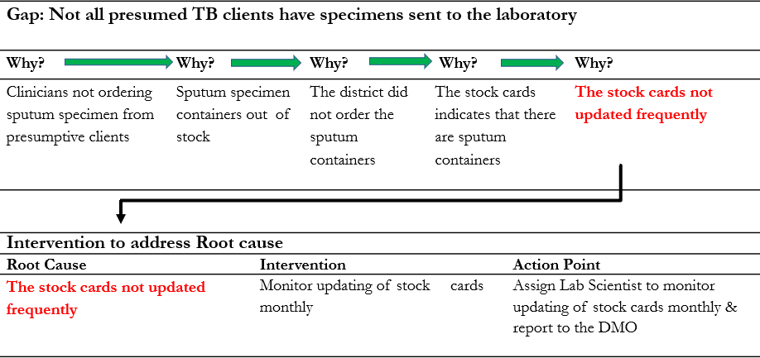
Emphasis on practical interventions within locus of control

Data Utilization

A data-driven performance review meeting: - is a meeting where mangers together with implementers review programme, to understand the drivers of performance on high priority topics. It is a platform to share challenges, successes and identify gaps where action is needed. Managers and implementers make evidence- based decisions using the program data and information reviewed during such meetings.

Data-driven support and supervision: - are regularly scheduled, structured site support visits used by organizational leaders and managers, prioritizing sites with program gaps as informed by routine data. Below is a summary of how programme data can be used at the different levels;

Table 8: Different uses of data across different levels

Level | Use of Data
Health facility | Data is used for evaluation of case detection and case management. The data is also used to rapidly assess programme performanceat the facility using quarterly reports compiled from the health facility level as well as individual patient records to assess for gaps in sputum examination, treatment follow-  up, HIV testing, ART initiating, Contact investigation and treatment outcomes.
District | Data is used to compare performance across different health facilities in a district in order to identify  health facilities with programme gaps and also to inform allocation of resources to health facilities in greatest need
Province | Data is used to compare performance across different districts in a province in order to identify  districts with programme gaps and also toinformallocation of resources to districtswith greatest need
National | Data is used to compare performance across different provinces in order to identify provinces with  programme gaps and also toinformallocation of resources to provinceswith greatest need
National | Data is also used for resource mobilization, international reporting requirements, formulation of  TB policies and intervention strategies and advocacy for political commitment to the TB response

Key Programme Definitions in Recording and reporting

Disease category | Term | Definition
Presumptive TB | Presumptive TB case - previously called “TB suspect” | Any person who presents with symptoms or signs suggestive of TB, in particular cough of two weeks or of any duration in a person living with HIV
TB case categories
By Diagnosis | Bacteriologically diagnosed TB case | A patient with a biological specimen that is positive by culture or WHO-approved rapid diagnostics (such as Xpert

MTB/ RIF Ultra). Such cases should be notified, whether
TB treatment was started or not.
 | Clinically diagnosed TB case | A patient who does not fulfil the criteria for bacteriological confirmation but has been diagnosed with active TB. This definition includes cases diagnosed on the basis of X-ray abnormalities or suggestive histology and extra-pulmonary cases. Clinically diagnosed cases subsequently found to be bacteriologically positive (before or after starting treatment) should be re-classified as bacteriologically confirmed.
By Site | Pulmonary TB (PTB) patient | Any bacteriologically confirmed or clinically diagnosed case of TB involving the lung parenchyma or the tracheobronchial tree. Tuberculous intra-thoracic lymphadenopathy (mediastinal and/or hilar) or tuberculous pleural effusion, without radiographic abnormalities in the lungs, constitutes a case of extra pulmonary TB. A patient with both pulmonary and extra- pulmonary TB should be  classified as a case of PTB.
By Site | Extra pulmonary TB patient | Refers to any bacteriologically confirmed or clinically diagnosed patient with TB involving organs other than the lungs, e.g. pleura, lymph nodes, abdomen, genitourinary tract, skin, joints, bones and meninges.
By History of previous treatment | New TB patient | A patient who has never had treatment for TB or who has taken anti-TB drugs for less than one month.
By History of previous treatment | Previously treated patient | A patient who has received one month or more of anti-TB medicines in the past. They are further classified by the outcome of their most recent course of treatment  (described below)
By History of previous treatment | Relapse patients | A patient who has previously been treated for TB, was declared cured or treatment completed at the end of their most recent course of treatment, and who is now diagnosed  with a recurrent episode of TB.
By History of previous treatment | Retreatment after lost to follow up | A patient who has been previously treated for TB and was declared lost to follow-up at the end of their most recent course of treatment. (These were previously known as treatment after default patients.)
By History of previous treatment | Retreatment after treatment failure | A patient who has previously been treated for TB and whose treatment failed at the end of their most recent course of  treatment.
By History of previous treatment | Other previously treated patients | A patient who has previously been treated for TB but whose outcome after their most recent course of treatment  is unknown or undocumented.
By HIV status | HIV-positive TB patient | Any bacteriologically confirmed or clinically diagnosed case of TB who has a positive HIV test result from the time of TB diagnosis or other documented evidence of enrolment  in HIV care.
By HIV status | HIV-negative TB patient | Any bacteriologically confirmed or clinically diagnosed case of TB who has a negative HIV test result at the time of TB diagnosis. Any HIV-negative TB patientsubsequently found to be HIV-positive should be reclassified accordingly.
By HIV status | HIV status un- known TB patient | Any bacteriologically confirmed or clinically diagnosed case of TB who has no result of HIV testing and no other documented evidence of enrolment in HIV care. If the patient’s HIV status is subsequently determined, he or she

 |  | should be reclassified accordingly.
Treatment outcome categories (Drug susceptible and Drug resistant TB)
By Treatment outcome categories | Treatment failed | A patient whose treatment regimen needed to be terminated or permanently changed to a new regimen or  treatment strategy.
By Treatment outcome categories | Cured | A patient with PTB with bacteriologically confirmed TB at the beginning of treatment who completed treatment  with evidence of bacteriological response & no  evidence of failure.
By Treatment outcome categories | Treatment completed | A patient who completed treatment but whose outcome does not meet the definition for cure or treatment failure.
By Treatment outcome categories | Died | A patient who died for any reason before starting treatment or during the course of treatment.
By Treatment outcome categories | Lost to follow-up (Previously  called “defaulted”) | A patient who did not start treatment or whose treatment was interrupted for 2 consecutive months or more.
By Treatment outcome categories | Not evaluated | A patient for whom no treatment outcome was assigned. This includes cases transferred out to another treatment unit as well as cases for whom the treatment outcome is  unknown to the reporting unit.
By Treatment outcome categories | Treatment success | Equals the sum of cured and treatment completed

Definitions of Key Programme monitoring and evaluation indicators

An Indicator in a TB programme is defined as measurable information obtained from routine TB recording and reporting that is monitored over time. The measure provides information on how well a certain aspect in TB control is functioning. The different types of Indicators is as defined below;

- Process indicators: - refer to indicators that measure whether planned activities took place. Examples include holding of meetings, conduct of training courses, distribution of medicines, development and testing of health education materials.
- Output indicators: - add more details in relation to the product “output” of the activity, e.g. the number and categories of health providers trained in case management or communications skills, the number and type of radio spots produced and broadcast.
- Outcome indicators: - refer more specifically to the objectives of an intervention, that is its ‘results’ or outcome. These indicators refer to the reason why it was decided to conduct certain interventions in the first place. They are the result of both the “quantity” (“how many”) and quality (“how well”) of the activities implemented. Examples of such indicators include; Case detection rates, Treatment outcome rates, etc
- Coverage indicators: - measure the extent to which the target population (e.g. children under-five) has received and therefore has been reached by an intervention. These indicators, therefore, allow us to know whether the desired outcome has been generated.
- Impact indicators: - refer to the health status of the target population. These do not show progress over relatively short periods of time. Examples include; Prevalence and incidence and mortality.

Below is a list of key indicator definitions in TB;

Indicator | Definition
Case notification Rate | The number of TB cases reported to the NTLP per year per 100,000 population. Case notification rates are usually calculated for new bacteriologically confirmed  pulmonary TB cases and all forms of TB cases
Treatment success rate | Percentage of TB cases registered in a specified period and who completed treatment,  whether with bacteriologic evidence of success (“cured”) or without (“treatment

 | completed”)
Treatment failure rate | Percentage of TB cases registered in a specified period who are smear positive at 5 months or later after initiating treatment
Lost to follow- up rate  (Previously called “Default”  rate) | Percentage of TB cases registered in a specified period who did not start treatment or whose treatment was interrupted for two consecutive months or more.
Not evaluated rate | Percentage of TB cases registered in a specified period who were not evaluated for an outcome.

National Tuberculosis Control Programme Performance Framework

An Indicator Target is the value of an indicator that the NTLP sets as the goal to be reached by the end of a defined period. Targets are defined to focus efforts to improve TB control.

Impact Indicators
Indicator | Indicator description source &  frequency of reporting | Numerator & Denominator | Target
TB incidence rate per 100,000  population | The indicator is used to project the  burden of TB in the country's population and is reported annually in the WHO. It is a national level  indicator | Numerator: Estimated number  of new TB cases per given period x 100,000
TB incidence rate per 100,000  population |  | Denominator: Total population  in the country
TB mortality rate per 100,000  population | The indicator is used to assess the  magnitude of TB mortality among HIV negative patients and is reported annually to WHO. It is a national level indicator | Numerator: Number of deaths  attributed to TB-related causes in a year x 100,000.
TB mortality rate per 100,000  population |  | Denominator: Total population  at risk
TB/HIV mortality rate per  100,000 population | The indicator is used to assess the  magnitude of TB mortality among HIV co-infected patients and is reported annually to WHO. It is a  national level indicator | Numerator: Number of deaths  attributed to TB-related causes in a year x 100,000
TB/HIV mortality rate per  100,000 population |  | Denominator: Total population  at risk
Outcome Indicators
Case notification rate of all forms  of TB per 100,000 population - bacteriologically confirmed plus clinically diagnosed, (New and relapse case) | The indicator is used to monitor  case detection and notification of TB cases. The indicator is reported annually using routine surveillance data. Data source: (DHIS 2.3) | Numerator: Number of TB  cases notified x 100,000 (All forms of TB includes new smear-positive, new smear- negative, extra-pulmonary, relapses & other retreatments.)
Denominator: Total population
of the catchment area
Treatment success rate of all  forms of TB - bacteriologically confirmed plus clinically diagnosed, new and relapse case | The indicator is used to monitor  outcomes of treatment of all types of registered drug susceptible TB patients. A successful evaluation of treatment outcomes of TB cases is used to determine the quality and effectiveness of DOT implementation at sub-national level. The indicator is reported annually using routine surveillance  data. Data source: (DHIS 2.3) | Numerator: Number of TB  cases, all forms, bacteriologically confirmed plus clinically diagnosed, successfully treated (cured plus  treatment completed) | 90%
 |  | Denominator: Total number of  registered drug susceptible TB patient. | 90%
Treatment success rate of RR TB  and/or MDR-TB: Percentage of | The indicator is a measure of the  capacity of the national program to | Numerator: Patients initiated  both on the short & long-term | 75%

cases with RR and/or MDR-  TB successfully treated | successfully treat RR/MDR TB  cases. The indicator is reported annually using routine surveillance data. Data source: (DHIS 2.3) | regimen. Number of  RR/MDR TB cases cured plus RR/MDR cases completed treatment among those started on treatment 12 months ago.
cases with RR and/or MDR-  TB successfully treated |  | Denominator: Patients initiated  both on the short & long-term regimen: All RR/MDR TB cases who started treatment 12 months ago.
TB treatment coverage: Percentage of new & relapse notified & treated among the estimated number of incident TB cases in the same year (all form of TB - bacteriologically confirmed plus clinically  diagnosed) | The indicator is used to monitor progress in identifying TB cases and initiating them on treatment. The indicator is reported annually based on the Global TB report. It is reported at national level indicator | Numerator: Number of new and relapse cases that were notified  and treated | 90%
 |  | Denominator: Estimated number  of incident TB cases in the same year (all form of TB - bacteriologically confirmed  plus clinically diagnosed). | 90%
Percentage of notified cases of  bacteriologically confirmed, drug resistant RR-TB and/or MDR- TB as a proportion of all estimated RR-TB and/or MDR-TB case | The indicator is a measure of the  capacity of the national program to identify RR/MDR TB cases. This indicator measures number of RR/MDR cases notified in the routine TB. The indicator is reported annually by sub national level using routine surveillance data. Data source: (DHIS 2.3) | Numerator: Number of  RR/MDR TB cases notified (All forms of TB includes new smear-positive, new smear- negative, extra-pulmonary, relapses & other retreatments.)
Denominator: Projections from
WHO estimates of annual new RR/MDR TB cases.
Treatment success rate of RR TB  and/or MDR-TB: Percentage of cases with RR and/or MDR- TB successfully treated | The indicator is a measure of the  capacity of the national program to successfully treat RR/MDR TB cases. The indicator is reported annually using Routine surveillance data. Data source: (DHIS 2.3) | Numerator: Patients initiated  both on the short & long-term regimen. Number of RR/MDR TB cases cured plus RR/MDR cases completed treatment among those started  treatment 24 months ago. | 75%
 |  | Denominator: Patients initiated  both on short & long-term regimen: All RR/MDR TB Cases who started treatment 24 months ago. | 75%
Coverage indicators
Number of TB cases with RR-  TB and/or MDR-TB notified | The indicator measures capacity of  the program to identify bacteriologically confirmed RR-TB and/or MDR-TB cases and notify all identified cases. The indicator is reported quarterly using routine surveillance data. Data source: (DHIS 2.3) The Indicator is disaggregated by age (0-14 years and 15 and above) gender (Female  and male) | Number of TB cases with  Rifampicin-resistant (RR-TB) and/or MDR-TB notified
Number of cases with RR-TB  and/or MDR-TB that began second-line treatment | This indicator measures capacity of  the program to initiate newly diagnosed RRR/MDR TB cases on treatment. The indicator is | Number of RR-TB and/or  MDR-TB cases (presumptive or confirmed) registered & started on a prescribed MDR-

 | reported quarterly using routine  surveillance data. Data source: (DHIS 2.3) | TB treatment regimen during  the period of assessment
Percentage of confirmed  RR/MDR-TB cases tested for resistance to second-line drugs | This indicator measures capacity of  the program to ensure quality second-line drug susceptibility testing for diagnosed TB patients. The indicator is reported quarterly using routine surveillance data.  Data source: (DHIS 2.3) The target is to perform second line DST on all patients diagnosed with  RR/MDR TB. | Numerator: Number of RR-TB  and/or MDR-TB with 2nd line DST results in the previous notification period x 100 (Reference Labs Register) | 100%
 |  | Denominator: Number of RR/MDR TB cases notified in the period. (District TB Register) | 100%
Percentage of registered new and  relapse TB patients with documented HIV status | This indicator monitors TB/HIV  collaborative activities. The indicator is reported quarterly using routine surveillance data. Data source: (DHIS 2.3) | Numerator: Number TB  patients with documented HIV test results x 100 | 100%
 |  | Denominator: Total number of  TB patients notified in the same period. | 100%
Percentage of HIV-positive new  and relapse TB patients on ART during TB treatment | This indicator monitors TB/HIV  collaborative activities. The indicator is reported quarterly using routine surveillance data. Data source: (DHIS 2.3) To ensure comprehensive and quality TB/HIV care, all HIV co-infected TB patients should be initiated on  ART. | Numerator: Number TB  patients with positive HIV test results started on ART x 100 | 100%
 |  | Denominator: Number TB patients with positive HIV test results | 100%
Number of people in contact with  TB patients who began preventive therapy | This indicator will report on the  number of children under 15 years who were initiated on TPT which is the priority contact group for TPT that will be tracked from 2021.The indicator measures the Data Source:  Routine surveillance data (DHIS 2). | Number of children who are  initiated on TPT as a measure of preventing active TB disease among child and adult contacts of TB cases. | 90%
Number of notified cases of all  forms of TB (i.e. bacteriologically confirmed + clinically diagnosed), new and relapse case | The indicator is used to monitor  TB case finding efforts through mandatory notification of TB cases identified. Number of TB cases notified (All forms of TB including new bacteriologically confirmed, clinically diagnosed PTB, extra- pulmonary, relapses and other retreatments.) Disaggregated by age, gender, HIV test status.  Reported at sub-national level | Number of TB cases notified at  given time
Proportion of notified TB cases (all forms) contributed by non- national TB program providers – community referral | This indicator measures the contribution of communities in identifying TB cases. It is a proportion of the actual notified cases. The indicator is reported quarterly using routine surveillance data. Data source: (DHIS 2.3) | Numerator: number of TB cases diagnosed through community referral and/or non-TB programme providers during  the period | 15%
 |  | Denominator: total number of  notified TB cases diagnosed during the period | 15%

Percentage of health facilities with  tracer medicines for the three diseases available on the day of the visit or day of reporting | This indicator measures availability  of the FDC-RHZE for the treatment of drug susceptible TB on the day of reporting. The indicator is monitored to ensure continuous access to life saving treatment for patients and enhance quality outcomes. Data source: the indicator is tracked quarterly using ZAPS reports | Numerator: number of health  facilities with FDC-RHZE available at the time of reporting. | 100%
Denominator: total number of
health facilities, based on health facilities with comprehensive TB diagnostic services (Xpert MTB/Rif testing and Radiography) in the public sector.
Percentage of new and relapse  TB patients tested using WHO recommended rapid tests at the time of diagnosis | This indicator measures access to  WHO recommended Rapid Diagnostics for TB e.g. X pert MTB/RIF & is reported quarterly using routine surveillance data.  Data source: (DHIS 2.3) | Numerator: Number of newly  notified TB patients diagnosed with results from WHO recommended rapid TB  diagnostics x 100 | 100%
 |  | Denominator: Total number of  new & relapse TB patients. | 100%
Percentage of health facilities  providing diagnostic services with tracer items available on the day of the visit or day of reporting | This indicator measures availability  of Xpert MTB/Rif diagnostic cartridges at health facilities with Gene X pert machines on day of reporting under the Zilacods distribution system. The indicator is tracked quarterly for public sector facilities. Data source: Zilacods reports. | Numerator: number of health  facilities with X pert MTB/Rif cartridges available at the time of reporting | 100%
 |  | Denominator: total number of health facilities with laboratories providing X pert MTB/Rif diagnostic services. | 100%
Percentage of laboratories  showing adequate performance in external quality assurance for smear microscopy among the total number of laboratories that undertake smear microscopy during the reporting period | This indicator monitors the quality  of diagnostic services across the laboratory network. The indicator is reported semesterly through EQA reports. Data source: External Quality Assurance reports. | Numerator: number of  laboratories that had satisfactory performance on EQA for smear microscopy x  100 | 100%
 |  | Denominator: total number of  laboratories in the TB diagnostic network. | 100%
TB-Treatment Coverage | This indicator estimates the  proportion (%) of new & retreatment cases detected & treated in a given year, compared to the estimated incident TB cases in the same year. | Numerator: total number of new  & retreatment cases detected & treated in a given year x 100 | >90%
TB-Treatment Coverage |  | Denominator: estimate incident cases in the given year | >90%
Percentage of TB-affected households that experience catastrophic costs due to TB | This is defined as the proportion of TB patients who incur catastrophic costs (total costs, consisting of direct medical & non-medical costs & indirect costs net of social assistance) exceeding 20% of annual household income)  This indicator is estimated through a population-based Patient cost survey | Numerator: total number of TB patients incurring catastrophic  cost | 0%)
 |  | Denominator: total number of  patients being treated for TB | 0%)
LTBI-Treatment Coverage | Proportion of PLHIV newly  enrolled in HIV care & children <5 years who are household contacts | Numerator: number of PLHIV  newly enrolled in care & children <5 years who are | >90%

 | of cases started on LTBI treatment,  of all those eligible for LTBI treatment (expressed as a % & separate for the two groups) | household contacts of cases  started LTBI treatment x 100
Denominator: number eligible
for treatment expressed as a percentage
Contact Investigation Coverage | Proportion of contacts of people  with bacteriologically-confirmed TB who were evaluated for TB, of all contacts of bacteriologically- confirmed TB, expressed as a percentage | Numerator: number of contacts  of people with bacteriologically confirmed TB, who were evaluated for TB x 100 | >90%
Contact Investigation Coverage |  | Denominator: total number of  contacts of bacteriologically confirmed TB cases | >90%
Drug-Susceptibility Testing  Coverage for TB Patients | Proportion of TB patients with  DST results for at least rifampicin of all notified (new & retreatment) cases in the same year, expressed as a percentage. DST coverage includes results from molecular as well as conventional phenotypic  DST | Numerator: number of TB  patients with DST results for at least rifampicin x 100 | 100%
Drug-Susceptibility Testing  Coverage for TB Patients |  | Denominator: total number of  notified (new and retreatment) cases in the same year | 100%
Case Fatality Ratio (CFR) | The TB CFR is defined as the  proportion of TB patients dying due to TB | Numerator: number of TB  deaths (from national Vital Registration system) | <5%
Case Fatality Ratio (CFR) |  | Denominator: estimated incident  cases in the same years, expressed as a percentage | <5%
Treatment Outcome indicators for drug sensitive TB
Indicator | Numerator and Denominator |  | Target
Cure rate | Numerator: Number of new pulmonary bacteriologically confirmed TB patients declared cured at the end of treatment x 100 |  | 90%
Cure rate | Denominator: Number of new bacteriologically confirmed pulmonary  TB cases registered |  | 90%
Treatment completed | Numerator: Number of new pulmonary bacteriologically confirmed Patients declared as treatment completed at the end of treatment x 100 |  | 90%
Treatment completed | Denominator: Number of new pulmonary bacteriologically confirmed  cases registered |  | 90%
Failure rate | Numerator: Number of new pulmonary, bacteriologically confirmed TB patients declared as treatment failure at the end of treatment x 100 |  | <5%
Failure rate | Denominator: Number of new pulmonary, bacteriologically confirmed  cases registered
Death rate | Numerator: Number of deaths of all forms of TB during/before treatment x 100 |  | 0%
Death rate | Denominator: Number of all forms of TB cases registers |  | 0%
Lost to follow-up rate | Numerator: Number of all forms TB cases who were lost to follow-up during/before treatment x 100 |  | <5%
Lost to follow-up rate | Denominator: Number of all forms of TB cases registered |  | <5%
Not evaluated rate | Numerator: Number of all forms of TB cases who do not have an outcome documented in the district TB register at the end of treatment x 100 |  | 0%
Not evaluated rate | Denominator: Number of all forms of TB cases registered |  | 0%
Treatment success rate | Numerator: Number of all forms of TB cases who successfully completed treatment (Cured and treatment completion) at the end |  | 90%

treatment x 100%
Denominator: Number of all forms of TB cases registered

 | - Monitoring and Evaluation Plan (2021 – 2025)  - Making Sense of TB Data – Data Collection Analysis and Use of TB Data, 2nd Edition

Research and Innovation to Enhance Programme Performance

Introduction

The third pillar of the End TB strategy focuses on innovation and intensified research, essential for the achievement of set targets. During the life of the End TB Strategy and the current TB management guidelines, Zimbabwe will advance TB knowledge through research to enhance the TB response. A needs-based national TB research agenda will be updated from time to time to inform research priorities towards advancing evidence-based policy and practice, as well as contributing to the body of global literature on what works within programme settings.

Coordination of TB research

The NTLP will work with all relevant stakeholders to form and support an all-inclusive national TB research network, whose task will be to revise and or develop a national TB research agenda, mobilize financial and other resources for implementing the TB research agenda as well as enhancing the capacity for the undertaking of high-quality TB research.

The National TB Research Agenda

During the life span of these guidelines, there will be an annual review of the national TB research agenda based on a comprehensive appraisal of routine programme data as well as emerging global best practice. Currently the TB research agenda has identified research priorities categorized into six thematic areas:

- Community and Health systems strengthening
- Management and Preventive therapy of HIV associated TB and other co-morbidities
- Childhood TB
- Public Private mix
- TB Case finding
- TB Medicines, Commodities & Supply Chain Management

Enhancing capacity for TB research

The national TB research network will be responsible for identifying TB research capacity gaps and implementing interventions to close such gaps. This will include mobilizing financial resources, training and re–training of human resources, and developing the infrastructure needed to enable research.

Chapter 4: Advocacy, Communication and Social Mobilization

Introduction
Advocacy, communication and social mobilization (ACSM) involves activities targeted at different audiences.
- Advocacy is directed towards changing the behavior of leaders, politicians, and decision-makers at all levels. It involves mobilizing political commitment and resources for TB prevention and care.

- Communication aims to change knowledge, attitudes and practices among various groups of people that result in positive behavior change.

- Social mobilization is targeted at communities to strengthen community participation for self-reliant and sustainable responses.

Advocacy and communication are very important in TB prevention and care as it helps to address the following through appropriate messaging:
- Improving TB prevention
- Improving case detection
- Positive treatment outcomes
- Combating stigma and discrimination

- For standardization & accountability, the NTLP provides stewardship required to undertake TB advocacy and communication activities & coordinate partners and stakeholders engaged in this area of work.

Advocacy
Advocacy for TB is a broad set of coordinated interventions, designed to place TB high on the political and development agenda. It is directed at influencing policy makers, funders and decision-making bodies both locally and internationally to increase and sustain financial and other resources for TB prevention and care. The NTLP and its partners will continue to advocate for a strong commitment from the Government of Zimbabwe to support and sustain TB prevention and care efforts until the TB ceases to be a public health concern in the country.
There are different types of advocacy that the NTLP and partners utilize, which include:
- Policy advocacy which informs politicians and senior administrators how an issue will affect the country, and outline actions to take to improve to create an enabling legal framework.

- Programme advocacy targets opinion leaders at the community level on the need for local action towards the creation of an enabling environment in the communities for both TB patients and those affected.

- Media advocacy amplifies the TB program by putting issues on the public agenda and encourage the media to cover TB-related topics regularly and in a responsible manner so as to raise awareness about TB, the challenges facing the country and possible solutions.

Activities for advocacy

The NTLP and its partners will continue to focus on administrative and corporate mobilization through:

- Policy dialogues with parliamentarians, policy makers, community, business and religious leaders
- Press conferences and media briefings
- Radio and TV talk shows
- Publishing articles in the print media
- Summits, conferences and symposia, partnership meetings
- Use of celebrity spokespersons and TB champions
- Meetings with various government ministries and departments, civil organizations, business entities
- Official memorandum of understanding meetings with patient groups and health-care providers

The NTLP will continue to highlight the challenge of TB in the country and its socio-economic impact to decision makers and community leaders so as to strengthen and sustain political commitment for TB prevention and care.

Communication
Communication can be used to inform the public of the services that exist for diagnosis and treatment of TB and relay a series of messages about the disease. The NTLP and its partners will use effective channels and messages primarily to inform, create awareness and improve knowledge among the general public about TB and related health services. It will also seek to improve interpersonal communication between patients and health-care workers, contributing to behavior change. Communication should, however, convey more than medical facts as these on their own do not motivate individuals to seek health services. Rather, an attempt should be made to explore the reasons why people do or do not act on information received. The focus should be on changing behavior by addressing social norms and personal attitudes. Various communication channels will be utilized to relay messages to the public and HCWs. These will include:
- Mass media: use of radio, TV, print media as distance-learning tools.
- Social media platforms such as Facebook, twitter, WhatsApp, YouTube, SMS, etc.
- Interpersonal communication includes peer education, traditional folk media, community drama and poems, health education sessions at health facilities or in the community
- IEC and promotional materials for mass distribution.
- Meetings and gatherings.
- Edutainment such as roadshows.

Social Mobilization
Social mobilization is sometimes used interchangeably with community engagement. Social mobilization believes a single effort has less impact than collective effort. It is the process of bringing together “allies” to raise awareness of and create demand for TB prevention, care and treatment services. It also assists in the mobilization and delivery of resources and services and empowering communities to participate and be self- reliant in confronting TB.

Strategies for social mobilization

Building partnership and networking - The NTLP will create alliances with organized institutions/groups, such as decision- makers, policy-makers, NGOs, CBOs, professional and religious groups, corporate bodies, development partners, the media, communities and individuals.

 | - Community players such as CBOs & other development partners should engage with TB patients & affected communities to promote community participation,  - Communities should be placed in the forefront and must be engaged from planning, implementation to monitoring and evaluation.

Resource mobilization - The NTLP and its partners will mobilize resources from domestic and external sources through the development of concept notes, proposals and dialogue with multiple partners to find the resources (financial, material resources, food and other inputs) needed, for effective social mobilization to create and sustain a social movement directed at ending TB.

Basic health education messages
Health education message

- Basic TB knowledge: TB is an infectious disease caused by the bacteria called M. tuberculosis
- It commonly affects the lungs & other parts of the body such as the bones, brain, spine & abdomen may also be affected.

 | - Signs and Symptoms: A person with TB commonly presents with a cough of at least 2-3 weeks or any duration if living with HIV, fever, night sweating & loss of weight. There may be a history of contact with a person who had TB  - If you have any one of the symptoms, you are encouraged to visit your nearest health care facility

- Mode of Transmission: TB is spread through small droplets in the air when people with infectious TB cough, sneeze, talk or sing.

- Prevention: Treat all TB cases; Contacts of a confirmed positive TB case must get screened for TB.
- All TB patients should cover their mouths & noses when coughing or sneezing.
- Households with TB patients are encouraged to open windows at all times.
- Individuals, families & communities should practice good cough hygiene at all times.
- Prevent severe forms of TB by vaccinating your child with BCG at birth.
- Child contacts of adults with TB positive must receive TPT if they do not show symptoms or signs of active TB.

- Treatment and Care: TB is curable & treatment is available at every health facility in Zimbabwe.
- TB treatment is FREE in Zimbabwe.
- Fixed dose combination (FDCs) of anti-TB medicines means one now takes much fewer tablets at a time.
- It is important to complete your treatment even if you feel much better to avert developing drug resistant TB.
- Should you develop adverse effects of TB medication, visit the nearest health facility immediately

- Diagnosis: All people with symptoms and signs of TB should be investigated for TB at the nearest health centre.
- TB investigation is FREE in Zimbabwe.

Part 2: Finding Tuberculosis

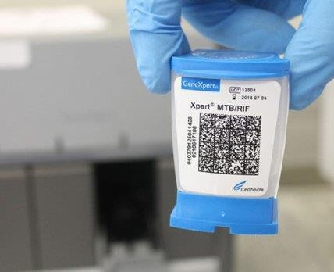

Chapter 5: Tuberculosis Screening and Diagnosis

Introduction
Systematic screening for TB in public health facilities is crucial for ensuring early TB detection and prompt treatment initiation. This serves to prevent further transmission of TB disease and resultant reduction in morbidity and mortality due to TB in health care settings including the community. This chapter describes screening methods and diagnostic approaches for both TB disease and latent TB infection.

Screening for TB in health care settings
To forestall health system delays in TB diagnosis, the NTLP recommends provider initiated routine screening for TB among all patients in contact with the health care system for early detection of the disease. The following are important high-risk groups, where heightened surveillance and index of presumption should be sustained:
- Household members and close contacts of bacteriologically confirmed pulmonary TB patients
- Children under the age of 15 years
- People living with HIV
- Miners exposed to silica dust
- Prisoners
- Malnourished people
- Diabetics
- Leukemia or other mailignancy
- People with history of previous TB or chronic lung disease
- Urban poor, refugees, migrants, homeless, or other marginalized groups

Three screening techniques can be used in parallel and results of one or any combination of techniques used to make decision for further TB investigation. While many patients with PTB will have a cough, fever, night sweats and loss of weight, these symptoms have less sensitivity and specificity for TB in general. Use of Body Mass Index (BMI) with a cut-off point of 17 kg/m² may increase the sensitivity of symptom screening and allow optimization of the use of molecular WHO-recommended Rapid Diagnostic (mWRDs) assays. Early use of CXR in TB screening maximizes case detection, particularly among people with asymptomatic or subclinical TB disease due to its high sensitivity. Computer aided diagnosis (CAD) has been integrated into TB screening where human interpretation of CXR is not available or to be used alongside trained readers to reduce workload.

Figure 6: Simplified algorithm for screening and diagnosis of TB
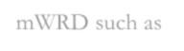

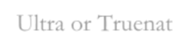
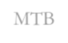


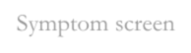
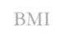



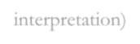
+/or
+/or
BMI
Symptom screen
CXR (+/- CAD
interpretation)
mWRD such as Xpert MTB/Rif Ultra or Truenat MTB-RIF

- Provider initiated screening for TB for all patients presenting to health facilities using a symptom enquiry of any of the following; cough lasting greater or equal to 2 weeks & of any during for PLHIV, fever, night sweats and loss of weight
- Body mass index (BMI) measured as weight in kilograms/square of the height in meters (BMI=weight/height2)
- Chest radiography (CXR) with computer-aided diagnosis (CAD) applications where available.
- A presumptive TB case is someone with a positive symptom screen &/or low BMI (<17 kg/m²) &/or abnormal CXR (+/- CAD interpretation)
In Zimbabwe, the following scenarios for the use of CXR/CAD are recommended:
- Initial screen, with any abnormal result by CAD (i.e. score above pre-determined threshold) referred to a human reader for secondary interpretation before diagnostic testing for TB
- Initial screen, with all individuals with a CAD abnormality score above pre-determined threshold referred for diagnostic testing for TB. Periodically, all CXR images with abnormal CAD reading & 10% of images with normal CAD reading should be validated by a human reader.
- Initial screen, with all individuals with a CAD abnormality score referred for diagnostic testing for TB, replacing a human reader entirely.
- Parallel CAD and human reader screening, with an abnormal reading from either reading referred for diagnostic testing for TB.

In order to enable successful screening of patients presenting at health care facilities, the NTLP will work with health facility managers to ensure that:
- Facility HCWs are trained on TB case management
- Screening tools are available to facilitated patient registration and triaging.
- Scale up access to portable CXRs with integrated CAD
- TB diagnostic tests are always available or easily accessible.

Situations where this practice recommendation may not apply

- The provision of emergency care in patients presenting with life threatening conditions should not be

delayed because of TB screening. TB screening and/or testing should be carried out when patients have been stabilized.
- CAD should be omitted in situations where access to this tool will entail a significant cost or time burden to the patient and could result in delays in confirming a diagnosis of TB.

Diagnosis of PTB in adults
Use of mWRD assays such as Xpert MTB/RIF Ultra/ Truenat MTB/MTB Plus have a high sensitivity and specificity for the diagnosis of TB disease compared to microscopy. They provide information on both the presence of TB bacilli and rifampicin resistance, allowing patients to be promptly initiated on an appropriate treatment regimen. A presumptive TB case identified through any one or combination of screening techniques should be investigated for TB using a mWRD assay.

- All adults with a positive symptom screen &/or low BMI &/or abnormal CXR (+/- CAD interpretation) should have ONE spot sputum &/or early morning sputum sample sent for mWRD assay such as Xpert MTB/RIF Ultra/ Truenat MTB/MTB Plus.

- The following are situations requiring collection of a 2nd specimen:
- 1) MTB detected trace on Xpert MTB/RIF Ultra/ Truenat MTB/MTB Plus; 2) Error/no result/invalid test; 3) MTB detected Rifampicin resistance indeterminate (take early morning & another one after 2 hours) 4) MTB detected Rifampicin resistance detected (take early morning sputum for culture & DST)
- NB: Early morning sputum samples should be collected and sent to the nearest reference laboratory every month during the course of treatment

 | Q: What is the role of CAD AI in TB?  A: CAD is recommended for TB screening in place of human readers. It shows the probability that an X-ray is suggestive of TB

Procedure for sputum production
Mycobacteria have the capacity to affect all organs of the body but most cases of TB are PTB, requiring sputum specimen for diagnosis.

Patient preparation

No special preparation of patients is required, but prior to collection of the sputum the patient must be advised to rinse his/her mouth thoroughly with water (preferably sterile to exclude non-tuberculous mycobacteria), before coughing out sputum for laboratory examination. The patient is advised to take a deep breath and cough out sputum and NOT saliva.

Sample collection timing

The early morning sputum collected within two hours after the patient rises from bed is the best sample with highest concentration of MTB (having accumulated in night secretions), making it easy to see on microscopy

and isolate on culture. However, on-spot collection of sputum is also acceptable, with an effort made to collect a second early morning sputum sample if the first one is negative.

Specimen/sample containers

The NTLP advises use of 50 ml mouthed screw-capped, leak-proof conical shaped disposable plastic containers (e.g. conical Falcon tubes). These are large enough to allow processing of sputum in the same container to increase recovery of bacilli, as well as minimize sputum transfer to other containers, re-enforcing safety to laboratory staff. Use of other sputum containers/mugs is acceptable but they must be screw capped, transparent and leak-proof. Other types of containers can only be used with the approval from NTLP, otherwise the laboratory reserves the right to reject samples in unapproved containers.

Steps in ensuring good quality sputum collection

  - If a good specimen is to be obtained, patients must be instructed in how to produce one. Give each patient a new sputum container. If two samples are required, give two separate containers. Sputum containers or mugs should never be re-used.
  - Demonstrate to the patient how to open and close the sputum container so there are no leaks or smearing on the exterior of the container.
  - Give the patient instructions and demonstrate how she or he can produce and collect a good quality sputum. This includes; taking three deep inhalations and exhalations and on the third exhalation or when a strong cough reflex arises, accompanying it with a deep cough.
  - The patient should spit the sputum into the sputum container, avoiding spills or soiling the outer side of the container, and then close the screw cap tightly.
  - Ideally, a sputum specimen should be a minimum of 5mls in volume, although smaller quantities are acceptable if the quality is satisfactory.
  - Emphasize that saliva is not sputum and may be misleading in diagnosis. However, if the only sample the patient can produce is salivary, do submit it to the laboratory as it can still yield useful results.
  - Encourage the patient to bring the collected specimen back to the unit as quickly as possible.
  - Fill in the standard TB request form and complete all the details required and submit together with the sample to the laboratory for testing.

Specimen Quality Check

  - A good specimen should be approximately 3–5 mls.
  - It is usually thick, mucoid, yellowish, sometimes blood-streaked, purulent, brought up from the lungs after a deep productive cough.
  - It may be fluid and contain pieces of purulent material.
  - The colour may vary from opaque white, yellow to green.
  - Bloody specimens will appear reddish or brown.
  - Saliva or nasal discharge is not suitable as a TB specimen. The figure below are images of the most common macroscopic appearance of sputa

Safety precaution

- Do not collect sputum samples in the laboratory, clinic examination rooms or in the patient/client waiting area
- Always instruct patient to go outside in an open well-ventilated area, away from other persons to minimize risk of transmission to others

Figure 7: Picture showing most common macroscopic appearances of sputa

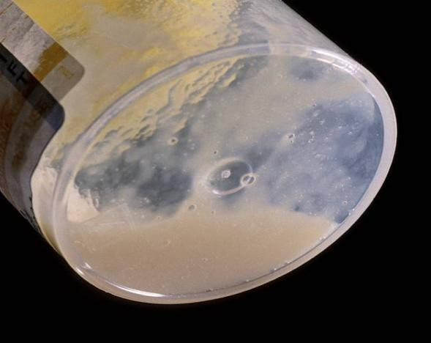 | 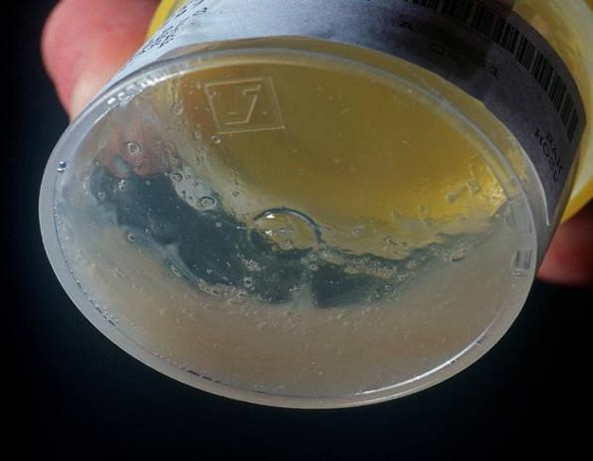
Mucoid | Purulent
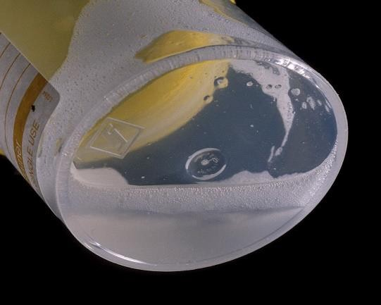 | 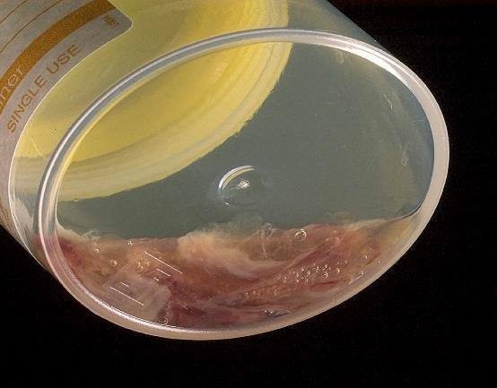
Salivary | Blood stained

National TB Diagnostic algorithm
The figure below summarizes the National TB diagnostic algorithm using mWRD, such as Xpert MTB/RIF Ultra/ Truenat MTB/MTB Plus. There are a number of possible results each with follow-up intervention or interpretation.

Figure 8: Diagnostic and treatment algorithm for presumptive TB patients
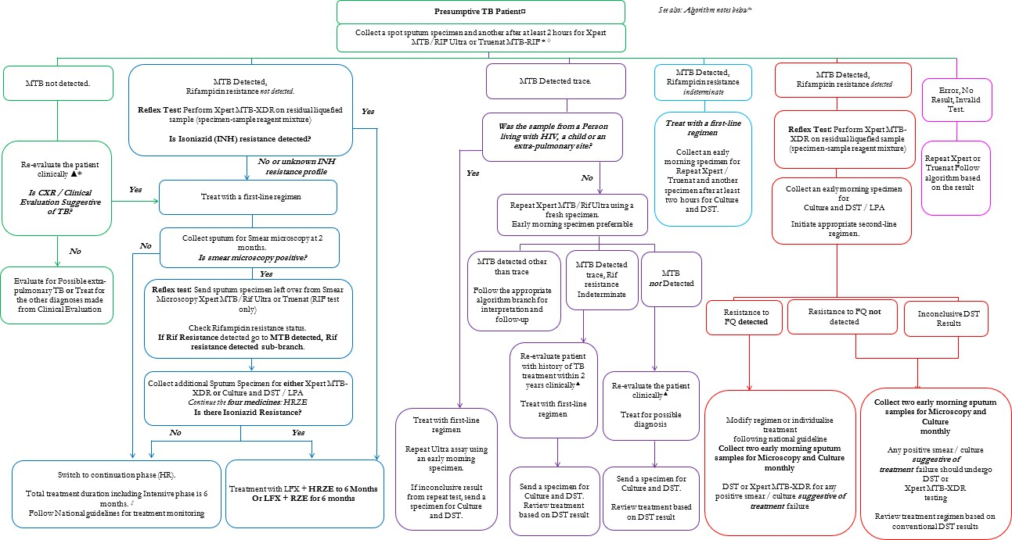

Algorithm Notes

* Perform Urine Lateral Flow Lipoarabinomannan Assay (LF-LAM) for People Living with HIV with advanced HIV disease in addition to sputum collection described here. Advanced HIV disease defined as CD4
<200, Severely ill, or any stage 3 or 4 opportunistic infections.
‡. Rifampicin sensitive, INH resistant TB (HrTB) initiate on treatment with HRZE + LFX or RZE + LFX for a total duration of 6 months. If the diagnosis/results of Hr-TB comes > 1 month after treatment initiation with HRZE, continue the HRZE for a total of 6-months (without adding Lfx).
- Stool Samples, Nasogastric / Nasopharyngeal Aspirates may be collected for Xpert MTB/RIF Ultra/Truenat MTB/MTB Plus from children (below 5 years of age) unable to produce sputum. CSF, Pleural, Peritoneal fluid may also be collected for Xpert assay informed by clinical presentation.
▲Further investigations may include chest x-rays (if not already done), additional clinical assessments, other biological specimens (tissue aspirates (e.g. Bone Marrow Aspirates) and biopsies for histological assessment or culture and DST), clinical response following treatment with broad spectrum anti-microbial agents

Interpretation of Laboratory Results
Discordance in laboratory results may occur when comparing culture-based phenotypic DST with molecular testing. In addition, some tests can detect TB bacilli or M. Tuberculosis DNA while other detection tests might give negative results. Each discordant result will therefore need to be investigated, on a case- by-case basis if discordant results are reported between rapid diagnostic tests and any other diagnostic test. The focus should be on the clinical history of the patient (e.g., TB treatment history, close contacts) and the response to current treatment to make decisions about further management. The case history can also be discussed within the district TB clinical team.

Q: In which patients do we collect a sample for XDR testing?

A: All patients with RR TB diagnosed on Xpert MTB/RIF Ultra/ Truenat MTB/MTB Plus or any other mWRD assay

Diagnosis of Extra Pulmonary TB (EPTB)

- All patients presenting with non-respiratory symptoms especially in the presence of a fever, night sweats and/or loss of weight should be evaluated for TB.

A high index of clinical suspicion is required for the diagnosis of EPTB. Symptoms of EPTB will vary with the organ involved, however, many patients will also experience generalized systemic or constitutional symptoms such as fever, night sweating and loss of weight. The presence of such symptoms, especially in a patient with symptoms lasting several weeks should alert the clinician to the possibility of TB as the underlying diagnosis. An evaluation for TB should be therefore be carried out on all patients presenting with generalized or systemic symptoms, with or without organ specific symptoms. EPTB carries a poor prognosis especially if it occurs in HIV infected persons and must be diagnosed early for prompt initiation of life-saving treatment. The table below shows the most common forms of EPTB and the preferred sample to collect for TB diagnostic testing.

Table 9: Clinical symptoms and signs and specimen selection for diagnosis of EPTB

Typical Clinical Presentation |  | Investigations
TB adenitis | Asymmetrical, painless non-tender lymph  node enlargement usually for > 1month,  +/- discharging sinus, especially in the neck | Fine needle aspiration (FNA) for mWRDs or  cytological examination. Node biopsy can also be sent for mWRDs, TB culture & histological examination
Pleural TB | Chest pain, shortness of breath, reduced breath sounds & stony dullness on percussion | CXR to confirm pleural effusion; thoracocentesis (pleural fluid aspiration) & pleural fluid analysis (biochemistry & cell analysis); pleural biopsy submitted in saline & formalin for mWRDs, TB culture & histological  examination
TB meningitis | Headache, irritability/ abnormal behaviour,  confusion, vomiting), lethargic/reduced level of consciousness, convulsions, neck stiffness, bulging fontanelle in young children, cranial nerve palsies, plus the  constitutional symptoms of TB | Lumbar puncture to obtain CSF for  biochemistry, mWRDs; microscopy, culture & sensitivity for other causes of meningitis
Miliary TB/  Disseminated TB | Non-specific, lethargic, persistent fever,  wasting | Chest radiography and lumbar puncture to  obtain CSF for biochemistry, mWRDs assay; blood for TB culture; liver and or splenic aspirates and other tests
Abdominal TB/ Peritoneal TB | Abdominal swelling with ascites or abdominal masses | Abdominal ultrasound and ascitic tap for biochemistry, mWRDs assay; ultrasound guided abdominal mass or organ sampling for cytological and bacteriologic testing including  mWRDs
Osteo- articular  including spinal TB | Swelling of the end of long bones with  limitation of movement/ anterior collapse of vertebra on x-ray, para-spinal abscesses, cold psoas abscess /unilateral effusion of usually knee or hip joint | Radiography of joint or bone or spine; joint  effusion (if joint effusion) tap or synovial biopsy for mWRDs assay, biochemistry and cytology
Pericardial TB | Cardiac failure, distant heart sounds Apex  beat difficult to localise, large and globular heart on the CXR | Echocardiography/Ultrasound; peri-cardial tap  for mWRDs assay, biochemistry & cytology.

- Where a facility does not have expertise to collect specimens for bacteriologic confirmation for TB in patients presumed with EPTB, these should be referred to the nearest facility where such capacity exists.

Diagnosis of TB in children
Clinical signs and symptoms for TB are generally non-specific in children. HCWs should therefore have a high index of suspicion, particularly among children with identified risk factors. Constitutional symptoms such as cough, fever and/or night sweats may also present in children as in adults. Nutritional assessment including review of Child Health Card helps to detect failure to gain weight and/or loss of weight. Other signs and symptoms to look out for in a child include; fatigue/tiredness or reduced playfulness. A history of contact with an individual with TB or chronic cough is essential in aiding TB diagnosis in a child.

- Risk factors for TB in children include; 1) Household or close contact with a case of bacteriologically confirmed PTB.
- 2) Age less than 5 years
- 3) HIV infection
- 4) Severe malnutrition
- 5) Diabetes mellitus
- 6) Recent episode of measles

- All children presenting to health care facilities should be screened for TB using a symptom enquiry (current cough, fever and/or night sweats, failure to gain weight and/or loss of weight, fatigue/reduced playfulness and history of contact with an individual with TB or chronic cough.
- A comprehensive nutritional assessment should be done; (weight for height, height for age, weight for age, Mid Upper Arm Circumference (MUAC)) as well as review of the Child Health Card to assess for growth faltering.
- Where available, a chest x-ray (+/- CAD interpretation) can be performed to aid diagnosis

All children presumed with TB (i.e. those with a positive symptom enquiry and/or under nourishment and/or positive history of contact with TB and/or abnormal chest x-ray) should be investigated for TB:

- One sputum (or induced sputum) or a naso-pharyngeal/naso- gastric aspirate or stool specimen of the child should be obtained and tested for TB using the mWRDs assay such as Xpert MTB/RIF Ultra/Truenat MTB/MTB Plus.

A Tuberculin Skin Test (TST) and CXR are useful to support a diagnosis of TB in a child with suggestive clinical features who have a negative bacteriologic test for TB or who cannot produce sputum. A sputum (or induced sputum) sample is preferable. However, a naso-pharyngeal/naso-gastric aspirate or stool specimen from a child under the age of 10 years should be obtained, should the child be unable to produce a sputum.

 | - TB diagnosis in children relies on a thorough assessment of all evidence derived from a careful history of exposure, clinical examination & relevant investigations.  - A positive TST only indicates that infection with MTB occurred & should be interpreted with other clinical features (signs and symptoms) to imply TB disease.  - CXR carries diagnostic value in children who have clinical features but without bacteriological confirmation

Figure 9: Flow chart for PTB diagnosis in children at clinic level
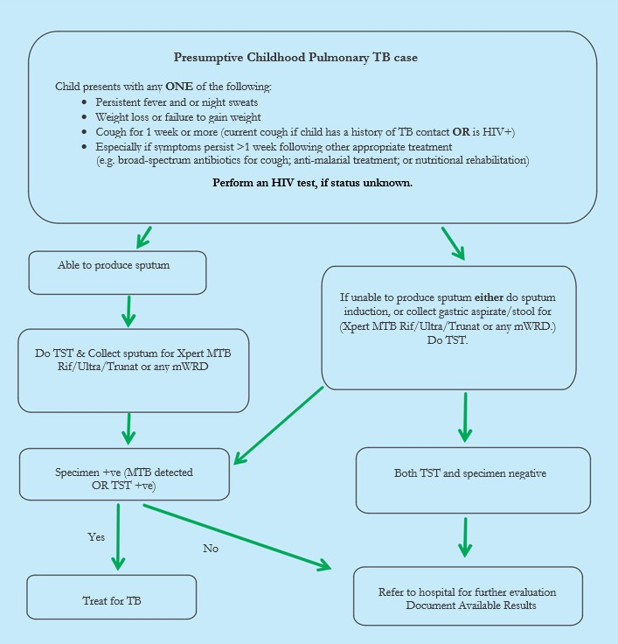

Figure 10: Flow chart for TB diagnosis in a child at a referral facility
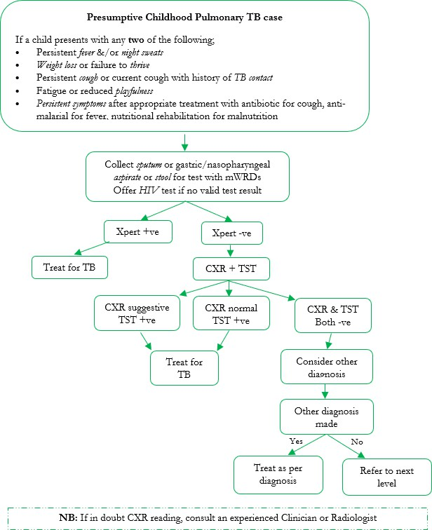

Q: How do we collect stool in children?

A: The first stool of the day is collected. For children in nappies or pampers, collect the surface part (exclude the nappy material). The stool should be a pea sized amount, and be put in a clean container

- United States Centers for Disease Control and Prevention (CDC). Tuberculosis Education Curriculum. https://www.cdc.gov/tb/education/corecurr/pdf/ chapter2.pdf
- Improving the diagnosis of smear negative pulmonary and extra pulmonary tuberculosis among adults and adolescents (Recommendations for HIV prevalent and resource constrained settings – by Stop TB Department of HIV/AIDS WHO.2006
- Diagnosis and Treatment of EPTB by Ji Yeon Lee published; 2015
- Tuberculosis; Practical guide for clinicians, nurses, Laboratory Technicians and Medical auxiliaries, 2023 Edition MSF.
- HIV Prevention, Testing and Treatment of HIV Guidelines in Zimbabwe, 2022
- Guidelines for Community & Health facility Based Hybrid Model for Tuberculosis Contact Investigation in Zimbabwe 2020

Chapter 6: Systematic Screening of at risk / vulnerable populations

Introduction
While no person can be considered immune from TB infection and disease, this illness is known to disproportionately affect certain groups of people either because they are more likely to be exposed to infection or they have immune function defects that allow acquired infection to progress to disease. These people are collectively called TB risk groups or vulnerable populations.

Screening interventions for various TB risk groups

Targeted TB screening approach
Until recently, TB case detection in Zimbabwe has been largely passive, among persons presenting themselves to health facilities. This strategy has worked sub-optimally and contributed to the current case detection gap, particularly in certain vulnerable populations. Targeted Screening for Active TB (TaS4TB) among high risk groups has been implemented in Zimbabwe since 2018, with gradual decentralization of the intervention in an effort to find missed TB cases.

Figure 11: Mobile truck equipped with X-ray and Xpert laboratory for Targeted active TB cases finding in Zimbabwe
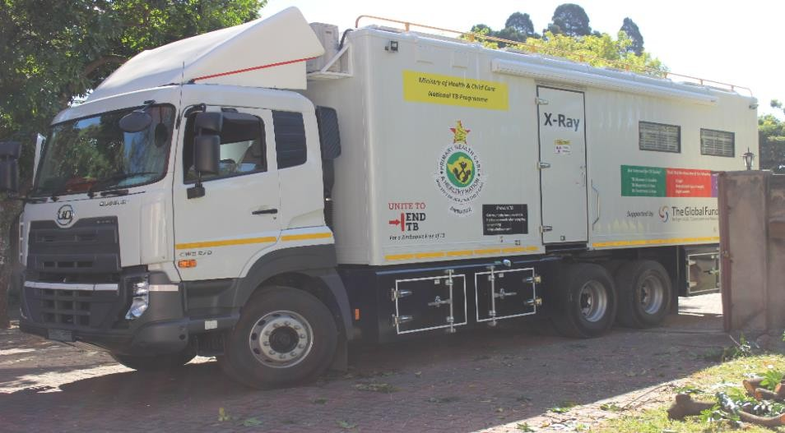
The intervention involves use of mobile x-ray trucks equipped with laboratory diagnostic equipment onsite and implemented as a community outreach service. Screening of other conditions is also integrated into the service. These include, but not limited to, HIV testing, screening for diabetes, hypertension and identification of patients eligible for common cancer screening (breast, prostate and cervical cancers). COVID 19 screening has also been integrated into the intervention package.

Objectives of targeted screening of TB risk populations
- To increase awareness and generate demand for TB screening among communities with high risk for TB.
- To screen and diagnose TB in communities that have a high risk of TB.
- To link all people diagnosed with TB and all miners diagnosed with silicosis with primary health care services and ensure that they are promptly initiated on appropriate TB treatment and TPT.
- To reduce transmission of TB through early detection of active TB cases and prompt TB treatment.

Key principles of targeted screening
- Systematic and targeted screening of TB should be tailored to specific risk groups that are known to have high rates of TB.
- Ensure high-quality TB diagnosis, treatment, care, management and support for patients and the capacity for scale up is in place before screening is initiated in order to match the potential rise in case detection with the screening.
- Continuous prioritization of risk groups is preferable versus indiscriminate mass screening. Examination of rates of TB in the risk group, feasibility and yield of various approaches (number needed to screen to identify a case of TB) and the cost effectiveness of screening approaches are scientific considerations for prioritization.
- TB screening should follow established ethical principles for screening for infectious diseases, observe human rights, and be designed to minimize the risk of discomfort, pain, stigma and discrimination.
- TB screening approach should be implemented in a way that optimizes synergies with the existing health care and social services and be in keeping with regional and international best practices.
- A screening strategy should be monitored and reassessed continually in order to inform re-prioritization of risk groups, adoption and re-adaptation of evidence-based approaches.

TB screening in correctional facilities and police holding cells.
In correctional facilities, similar approaches as in the community will be used however, with ease owing to the captive nature of this important high-risk population.

- Screen all admissions to correctional facilities for TB at entry, monthly during confinement and at discharge using TB symptom enquiry & BMI & CXR +/- CAD performed annually.
- All presumptive cases identified will be tested using mWRDs such as Xpert MTB/Rif Ultra assay.

A similar approach will be applied to those in police holding cells. However, it is noted that the screening program may be modified because of variable duration and frequency of movement of people in and out of these cells.

- Officers working in correctional facilities should be systematically screened for TB every 6 months using symptoms inquiry, BMI and CXR.
- Presumptive TB cases identified should be investigated for TB using mWRDs

TB screening in miners and ex-miners
Formal mining populations can be screened using similar strategy as those in correctional facilities i.e. at recruitment, routinely during employment upon discharge/dismissal. Ex-miners can be screened routinely, just like those in active mining, but being actively invited for screening at the health facility using local health services. Both ex-miners and artisanal miners can as well benefit from community mobile TaS4TB since they are a key risk group under this strategy.

TB screening in diabetic persons and other risk groups
People with DM have a 2-3 times higher risk of developing TB. It is therefore recommended that a TB symptom screen is used to identify presumptive TB clients among patients attending diabetes care or are newly diagnosed as diabetic patients. Persons with suggestive TB symptoms should then be referred for TB investigation. Where feasible, TB patients on the other hand, should be screened for diabetes using common

symptoms and random blood sugar levels. Those with TB-DM comorbidity should be managed for TB and linked to diabetes care. The table below summarizes screening frequencies for the different TB high risk groups.
Table 10: Summary of recommended frequency of TB screening and approaches for various at-risk populations

TB Risk Group | Screening Frequency
Congregated settings (miners, residents at correctional  facilities, military and police cantonments) | Baseline and then Six monthly
Persons infected with human immunodeficiency virus  (HIV). | At diagnosis then at every health care visit
Contacts of TB patients including children* under 5 years | At point of diagnosis or within 3 days diagnosis of index  case
Persons with medical risk factors for progression from  TB infection to disease (people with chronic kidney  disease, diabetes, gastrectomy, receiving immunosuppressive treatment, others) | At every clinic visit
Clients with history of previous TB (those who remain in  care and have abnormal chest x-ray) | Annually
Health Care Workers | At entry into service, six-monthly, and at termination of  service

Chapter 7: Contact investigation and management

Introduction
TB Contact investigation is a systematic process of identifying undiagnosed cases of TB among contacts of index cases through integrating community and facility-based models. The model is implemented by HCWs, primarily environmental health technicians (EHTs) and community health workers (CHWs) engaged by government and other partners. EHTs with the support of CHWs are responsible for case finding of TB cases in the community and supporting those cases that are on treatment. CHWs are also responsible for giving palliative care to TB patients as per need.

Key definitions in TB contact investigation
Index case (index patient): the initially identified case of new or recurrent pulmonary TB, in a person of any age, in a specific household or other comparable setting in which others may have been exposed. An index case is the case around which contact investigation is centred.
Close contact: a person who shared an enclosed space, such as a social gathering place, workplace, or facility, with the index case for extended periods during the 3 months before the start of the current treatment episode.
Household contact: a person who shared the same enclosed living space as the index case for one or more nights or for frequent or extended day time periods during the 3 months before the start of the current treatment episode.
Source case or patient: The case or person who was the original source of infection for secondary cases or contacts. This may be but is not necessarily, the index case.
Contact: Someone who has been exposed to MTB by sharing air space with a person with infectious TB. The type of contact depends on the closeness and duration of exposure to the index case.

Rationale for Contact investigation
Each person with infectious TB has on average 5 contacts, of which 20%–30% have LTBI, and 3% have TB disease. Among contacts that will ultimately develop TB disease, approximately 50% develop disease in the first year after exposure. Contacts of TB patients should therefore be investigated for the presence of TB infection and/or disease.

Priority is given to:
- ALL household contacts of bacteriologically confirmed PTB patients, regardless of age.
- Children under the age of 5 years are particularly vulnerable to TB and contact investigation helps identify adults likely to have transmitted TB to the child.

Close contacts may also be found in aggregate settings such as workplace, schools (dormitories and classrooms), hostels and health facilities thus, persons with prolonged contact with an index case beyond the household should also be identified.

- Contacts of Pulmonary clinically diagnosed TB index cases are NOT considered high priority in our setting, given our resource constraints & the relatively lower yield in finding TB among such contacts.
- These should NOT be prioritized at the expense of bacteriologically confirmed PTB index clients.

Aims of TB Contact Investigation
The specific aims of Contact investigation are to;
- Detect active TB disease among contacts of TB patients and institute early treatment
- Stop further community transmission of TB through early detection and treatment of possible secondary cases.
- Detect and treat or monitor latent TB infection among contacts of TB and DR-TB with no evidence of active TB disease
- Provide counselling and health education to families and individuals on TB infection prevention and control
- Document all processes for evidence generation to inform improved TB programming

Process of TB Contact Investigation
The index case should be interviewed to identify contacts and the location(s) of such contacts. Information gathered should be confirmed by a home, school or workplace visit as may be appropriate. Every effort should be made to screen all identified and prioritized contacts through symptom enquiry at the point of identification. Where feasible, contacts should be invited to the health facility for TB investigation, including use of chest X-ray and mWRDs assays. Alternatively, sputum or stool samples (for child contacts) may be collected from contacts at home, school, workplace or other settings by EHTs, CHWs and/or volunteers.
All children and PLHIV should be assessed for TB more thoroughly, including for extra pulmonary disease. Children under 5 years and those at high risk of progressing to TB disease should have a chest x-ray done if available. The likelihood of other medical conditions and social factors that increase the risk of TB should be determined. Below is a summary of the flow of events of key steps in the process of conducting TB contact investigation.

Key steps in TB contact investigation process
Step one: after diagnosing an index case, the clinician must line list all contacts of the index case in the TB contact tracing form. This should leverage on the rapport already created during diagnostic and treatment work-up with the patient.
Step two: the clinician should then submit the TB contact tracing form with a list of all possible contacts to be investigated to the EHTs with or without a prior booking for a home visit.
Step three: the EHT records all the contacts to be investigated in the TB Contact Investigation Register, which he maintains and updates regularly.
Step four: for the initial screening of contacts the EHT;
- Visits the household or workplace within three days (72 hours) of diagnosis of an index case.
- Verifies the TB contacts in the contacts list against those found at home and screens them using a symptom screening tool.
- Contacts with a positive symptom enquiry or risk factors for progression to disease are invited to the health facility for an assessment (BMI, Chest x-ray and sputum or other specimen i.e. stool for children) for TB testing using the mWRDs such as Xpert MTB/RIF Ultra/ Truenat MTB/MTB Plus.
- TB contacts with a negative screen for TB, regardless of age must be provided with TPT or referred to health facility if eligible
- Home assessment is done for infection prevention and control measures as well as other health education
NB: In the absence of an EHT, the nurse gives the CHW the TB contact tracing form to conduct contact tracing on behalf of the EHT and thereafter submit the completed form to the EHT.
After the initial screening of TB contacts, the CHW will:
- Follow up screening of same TB contacts after every two months.
- Verify whether those who were referred to the facility visited the facility
- Verify if those eligible for TPT are taking their medicines as prescribed and
- Report all follow-up visits and procedures to the EHT.

Step five: in the absence of an EHT or upon delegation, the CHW;
- Conducts contact investigation to screen contacts using the TB screening tool,
- Refers asymptomatic contacts to the local clinic for investigations
- Provides TB and TPT related health education and distribute relevant IEC material to the community.

NB: For asymptomatic adults, primary risk assessment should be done by the EHT or CHWs and high-risk clients referred for TPT eligibility (e.g. PLHIV, unknown HIV status, diabetes mellitus and silicosis).

Step six: upon screening contacts, the EHT collects the specimen from symptomatic contacts and ferries the specimen to the health facility. Through the Integrated Specimen Transport system, all specimens are ferried from facilities to laboratories and/or hubs and subsequently to reference laboratories as appropriate.

Step seven: recording and reporting of TB contact investigation is as follows;
- EHT updates the Contact investigation register according to the comments on the Contact tracing form.
- Clinician updates the presumptive TB register and the health facility TB register.

  - Contact section is updated by the Nurse/EHT
  - Periodically the EHT verifies and validates the figures in the TB Contact Investigation Register, Presumptive Register and the Health Facility Register

NB: Re-assess contacts not diagnosed with TB every 6 months regardless of TPT initiation. For children < 5 years of age, contacts who are HIV+ and index TB patients who are still smear positive at 2 months of treatment; follow up visits should be done 3 months from the initial evaluation.

- All adults aged 15 years and above who are household or close contacts of a person with bacteriologically confirmed PTB or of a child with any form of TB with a negative symptom screen &/or normal CXR should receive three months of rifapentine and isoniazid (3HP) even if HIV negative.
- Six months of isoniazid is a suitable alternative where 3HP is contraindicated or unavailable.

- All children <15 years who are household or close contacts of persons with bacteriologically confirmed PTB
& have a negative symptom screen &/or normal CXR should receive three months of rifampicin & isoniazid if HIV negative.
- Six months of isoniazid or three months of rifapentine & isoniazid should be given if living with HIV &
depending on ART regimen

TB Contact Investigation Data Flow
For effective implementation of contact investigation, both facility and CHWs have roles and responsibilities in data flow management as illustrated in the flow chart below.
Figure 12: Data flow management in TB Contact investigation










EHT updates Contact Investigation, Presumptive & Facility TB Registers
Nurses complete Contact tracing forms & submit them to EHT
EHT fills information from Contact tracing form into Contact Investigation register
EHT receives completed forms from CHWs & consolidates them
EHT conducts Contact tracing or distribute Contact tracing forms to CHWs
https://www.ncbi.nlm.nih.gov/pmc/articles/PMC3724886/ https://onlinelibrary.wiley.com/doi/full/10.1111/tmi.13392 https://stacks.cdc.gov/view/cdc/121802

Part 3: Treating Tuberculosis

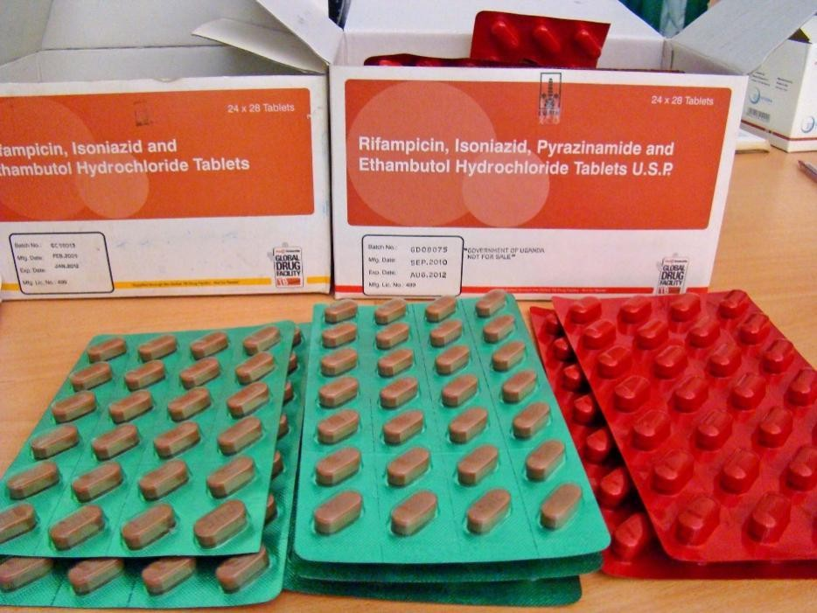

Chapter 8: Management of Drug Susceptible Tuberculosis

Introduction
This chapter provides guidance on the management of drug susceptible tuberculosis (DS-TB). Outlined are the aims and principles of treatment, standardized treatment regimens for all forms of DS-TB, and important considerations for special populations. The chapter also provides guidance on the use of adjuvant therapy to manage severe forms of TB, recommendations for patient treatment monitoring and case holding strategies that are hinged on the creation of an enabling environment for TB patients through support systems that promote treatment adherence and provide for post-TB treatment care. The aims of treatment of TB in any situation are to:

- Cure the patient and ensure return to a full quality of life;
- Prevent death from active TB or its complications;
- Prevent relapse of TB;
- Stop transmission of TB to others;
- Prevent the development and transmission of drug resistant TB;
- Prevent and/or mitigate the development of post TB sequelae.

Policy framework

- Diagnosis & treatment of TB is FREE of charge, including screening using chest X-ray;
- Treatment should be supervised “Directly observed treatment” for duration of treatment;
- Fixed dose combination of anti-TB medicines should be used as standardized of care;
- All patients on treatment need to be routinely monitored both clinically & bacteriologically;
- Documentation of every step of the management process is a standard requirement.

Treatment of drug susceptible TB
Patients who are confirmed to have TB bacteriologically or clinically should be started on the appropriate treatment by the clinician (doctor or nurse) at the site of diagnosis for the patient’s convenience. The patient must be notified and registered in the facility TB register. Treatment should be initiated immediately upon making a diagnosis of TB and all patients should be monitored and followed up as recommended. Doses of anti-TB medicines are weight based and must be adjusted when the weight band changes during treatment.

Treatment regimen for adults
Table 11: Recommended regimen for treatment of DS-TB in adults

Phase of treatment | Recommended regimen
Intensive phase | 2RHZE
Continuation phase | 4RH
Key: R: Rifampicin; H: Isoniazid; Z: Pyrazinamide; E: Ethambutol

- All new or re-treatment DS-TB cases must be treated for SIX months with a 1st line regimen of 2RHZE/4RH
- All treatment should be ideally ambulatory (administered as an outpatient) or community based, except for special situations requiring admission.

Weight based dosing of the 6-month adult DS-TB regimen
The dose of anti-TB medicines is based on the WEIGHT of the patient. Note: Adjust dosage as soon as the patient weight band changes to avoid under- or over-dosage. The table below gives estimates of number of FDCs per KG body weight:

Table 12: Weight-based dosing of 1st line TB medicines (FDCs) for adults

Patient’s weight | Intensive phase (2 months) RHZE  daily | Continuation phase (4 months) HR  daily
25-39 KG | 2 | 2
40-54 KG | 3 | 3
55-70 KG | 4 | 4
70 KG + | 5 | 5
FDCs for DS-TB treatment in adults exist as follows:
- RHZE: (Isoniazid 75mg + Rifampicin 150mg + pyrazinamide 400mg + Ethambutol 275mg)
- HR: (Isoniazid 75mg+ Rifampicin 150mg)

Considerations for adoption of the shorter duration treatment regimen for DS-TB in adults
The NTLP recognizes recent recommendations for a 4-month regimen for the treatment of DS-TB in persons 12 years and above, using high-dose rifapentine (P), moxifloxacin (M), isoniazid (H) and pyrazinamide (Z). The country has not yet adopted the programmatic use of this new regimen and the following are the key considerations for adoption;

- Universal access to DST for FQ resistance
- Availability of fixed dose formulations for HPZM and HPM
- Comparatively competitive cost of the regimen to the 6-month HRZE/HR regimen

HCWs will be advised through established communication lines when the new regimen is adopted and the implementation modalities thereof.

Treatment for Extra-pulmonary TB (EPTB)
Evidence to guide the choice of treatment regimens for EPTB is still evolving. The most widely recommended treatment regimen for most forms of EPTB is 2RHZE/4RH, except for patients with meningo-cerebral or skeletal TB. In these situations, treatment may be extended up to 12 months. This is primarily a result of poor penetration of most TB medicines to these disease sites, but may also be a consequence of either treatment failure or recurrent disease when disease is insufficiently treated. The NTLP recommends the treatment of intracranial and skeletal TB with an 8-month regimen consisting of 2RHZE/6RH with provision for clinicians to extend treatment beyond 8-months if, in the judgement of the clinician an adequate response to treatment has not been achieved by the end of the 8th month. In children aged 3 months to 19 years, with suspected DS meningo- cerebral TB, a 6-month regimen of 6HRZ(Eto) may be used.

- All patients with severe forms of EPTB e.g. meningo-cerebral TB or skeletal TB, should be treated for at least
8-months using the regimen 2RHZE/6RH with room for extended treatment for up to 12 months if clinical evaluation at the end 8-months is indicative
- All other cases of EPTB are treated with the 6-month 2RHZE/4RH regimen

Dosages for the 8-month regimen for DSTB meningitis
- Isoniazid (INH): 10-15 mg/kg (maximum 300 mg) per day
- Rifampicin (RIF): 10-20 mg/kg (maximum 600 mg) per day
- Pyrazinamide (PZA): 25-35 mg/kg (maximum 2 g) per day
- Ethionamide (Eto): 15-20mg/kg (maximum 1g) per day

Treatment of TB in Children and Adolescents
Children with drug susceptible TB (new or retreatments) are treated with 1st line drugs, using the regimen of 2RHZE/4RH. A new 4-month regimen of 2HRZE/2HR is recommended for use in children with ‘non-severe’ DS-TB. Monthly weight should be documented on the TB treatment card and child road to health card (U5s). Failure to gain weight may indicate poor response to therapy. The treatment doses should be adjusted as soon as the child’s weight band changes. The care giver of the child should receive comprehensive information and education including the reasons why the child must take the full course of

treatment even if they are feeling better. Some children require to be hospitalized and others require pyridoxine supplementation during treatment. Monitoring of TB treatment for children entails assessment of resolution of symptoms and weight gain. Children weighing 25 kg and more should be treated using the adult formulation. Children with severe malnutrition should be closely monitored for hepatotoxicity

- Children are considered to have non-severe TB in the following circumstances:
- Intrathoracic lymphadenopathy without involvement of the airways as seen on CXR
- Uni-lobar disease confined to less than one full lobe with no miliary disease as seen on CXR
- Uncomplicated pleural effusion as seen on CXR
- Isolated peripheral lymphadenopathy with no signs of TB disease elsewhere
- NB: a chest X-ray is necessary for one to classify TB as non-severe

When to use the 4-month DS-TB regimen in Children and Adolescents

Age group | Condition(s)
3 months – 16 years | - Uni-lobar disease confined to less than one full lobe with no miliary disease  - Isolated peripheral lymph node disease  - Uncomplicated pleural effusion  - Intrathoracic lymphadenopathy without involvement of the airways
Weight based dosing of DS-TB treatment for Children and Adolescents
Tuberculosis in children is treated in a similar way to that in adults with a few exceptions. The dose per kilogram in children is higher than in adults. The recommended daily dosage (range) are as follows:

- Rifampicin: 15 mg/kg/d (10-20 mg/kg/day)
- Isoniazid: 10 mg/kg/d (10-15 mg/kg/day)
- Pyrazinamide: 35 mg/kg/d (30-40 mg/kg/day)
- Ethambutol: 20 mg/kg/d (15-25 mg/kg/day)

Table 13: Weight-based dosing of 1st line TB medicines for Children and Adolescents

Weight Band | Recommended Regimen
Weight Band | Intensive Phase |  | Continuation Phase
Weight Band | RHZ (75/50/150) | E (100) | RH (75/50)
4-7kg | 1 | 1 | 1
8-11kg | 2 | 2 | 2
12-15kg | 3 | 3 | 3
16-24kg | 4 | 4 | 4
≥25kg | As for Adults
Formulations for FDCs for DS-TB treatment in children exist as follows:
- RHZ: (Isoniazid 50mg + Rifampicin 75mg + pyrazinamide 150mg)
- HR: (Isoniazid 50mg+ Rifampicin 75mg)
- E: (Ethambutol 100mg)

- In children with TB meningitis, osteo-articular TB & miliary TB, the continuation phase is prolonged for
10 months of 2RHZE/10RH.
- In children with TB meningitis, a 6-month regimen of HRZ(Eto) may be used where available with high dose H and R.
- Commencement of treatment should be documented on the child’s health card for children under 5 years
of age

Reasons for hospitalization in children and adolescents
Children and adolescents with the following conditions should be hospitalized;

- Severe forms of TB such as TB meningitis.
- Severe malnutrition requiring in-patient based nutritional rehabilitation.
- Signs of concomitant severe pneumonia such as chest in-drawing.
- Other co-morbidities e.g. severe anemia.
- Social reasons likely to interfere with adherence to treatment e.g. severe alcoholism in a parent or guardian or lack of appropriate social support in the home environment.
- Neonates
- Severe (or risk of) adverse reactions such as hepatotoxicity.

Pyridoxine Supplementation
Isoniazid (INH) may cause symptomatic pyridoxine deficiency, which manifests as peripheral neuropathy. All patients including children on INH as part of the TB treatment regimen or for TPT should receive pyridoxine and monitored for peripheral neuropathy.

Adjuvant Therapy
Steroids are beneficial as adjuvant therapy in some forms of TB disease. They work by targeting the host immune response, dampening it and thus reducing pathogen induced, host driven damage to the affected organ. On the other hand, corticosteroid therapy used in patients with TB without concurrent effective anti-TB therapy is hazardous. Steroid use must be under the guidance of a specialist. The following are the common indications for use steroids during TB treatment;

- TB meningitis.
- TB pericarditis.
- Massive lymphadenopathy with pressure effects.
- Severe hypersensitivity reactions to anti-TB medicines.
- More rarely: hypo-adrenalism, renal tract TB (to prevent ureteric scarring), TB laryngitis with life-threatening airway obstruction.

For large TB pleural effusion with severe symptoms, urgent referral to a facility where the effusion can be drained using a chest drain and under water seal drainage system is critical. Drainage using needle and syringe should be avoided because of the risk of introducing air and infectious agents into the thoracic cavity. If the patient already has an empyema when the initial thoracocentesis is done, chest drain placement with under water seal drainage system should be carried out in addition to consultation with a surgeon for consideration of a decortication procedure to prevent massive pleural thickening and chest wall restriction.

Table 14: Recommended doses and indications for adjuvant steroid therapy

Indication | Prednisolone treatment
TB meningitis | 60 mg/d for 4 weeks then taper off.
Alternatively - Dexamethasone 8-12mg/d intra-muscular, tapered over 6-8 weeks in cases of patients who cannot swallow
prednisolone
TB pericarditis | 60 mg/d for 4 weeks, then 30 mg/d for 4 weeks then taper off over  several weeks
Hypersensitivity reaction to TB medicines | 20-80mg (average 60mg)/d tapering off over 2-8 weeks

- For children the dose of prednisolone is 1-2mg/kg for 4 weeks with appropriate dose tapering thereafter over 2-4 weeks.

Treatment of TB in special situations

Pregnant women
All pregnant women with TB should be treated in a similar way to non-pregnant women. First-line anti-TB medicines are safe in pregnancy, except for streptomycin (less often used as a 1st line medicine) which is ototoxic to the foetus.

- TB in pregnancy is associated with increased risk of premature birth, low birth weight & perinatal death.
- For these reasons, women who develop TB should be strongly encouraged not to become pregnant while on treatment & should be provided with appropriate contraception

- All pregnant women with TB should be treated with a similar regimen to women who are not pregnant (2RHZE/4RH) & 1st line anti-TB medicines are considered safe in pregnancy.

Breastfeeding women
TB treatment is safe, and is the best way to prevent transmission of TB to the baby.

- 1st line anti-TB medicines are safe in breast-feeding mothers
- Breast feeding babies whose mothers are on treatment for PTB should be screened for TB & initiated on TPT if active TB has been excluded.

Women taking hormonal contraceptives
Rifampicin reduces the efficacy of contraceptive pills through induction of the liver enzymes (cytochrome P450) which enhances the metabolism of many medicines including hormonal contraceptives. Therefore, providing additional contraception (dual protection,) preferably a barrier method is recommended during TB treatment. However, this must be balanced against potential harms such as greater risk of acquisition of HIV with intrauterine implants/devices.

Patients with liver disorders and established chronic liver disease
Provided there is no clinical evidence of chronic liver disease which is associated with increased risk of anti-TB medicines induced hepatitis, patients with the following conditions can receive the usual treatment:

- hepatitis virus carriage,
- past history of acute hepatitis,
- excessive alcohol consumption.

Patients with chronic liver disease should not receive pyrazinamide (PZA). These may receive less hepatotoxic medicines such as INH and Rifampicin but must be clinically and biochemically monitored with (AST, ALT and bilirubin) and medicines promptly stopped if there is evidence of worsening liver disease. If INH and Rifampicin are used without PZA, the treatment should be extended to 9 months, as 2RHE/7RH. If PZA, INH and Rifampicin cannot be used because of severe existing liver disease, an individualized regimen, containing 1st and 2nd line medicines may be used with the treatment lasting up to 9-12 months. These patients should ideally be managed in consultation with Specialist care. NB: Watch out for overlapping symptoms of adverse events from Cycloserine and hepatic encephalopathy.

Table 15: Recommended regimen for treatment of DS-TB in Adults with Chronic Liver Disease

Phase of treatment | Recommended regimen
Intensive phase | 2RHE
Continuation phase | 7RH

- TB patients with pre-existing liver disease should be managed under the care or guidance of a specialist physician

Acute hepatitis (e.g. acute viral hepatitis)

It may be prudent to defer treatment in some cases, while in others it may be necessary to continue with anti-TB treatment. All such patients should be managed with guidance or consultation with a specialist.

Patients with renal failure

Isoniazid, rifampicin and pyrazinamide are excreted almost entirely by the hepatobiliary system or metabolized into non-toxic compounds. However, the metabolites of PZA are excreted by the kidneys and therefore dose adjustment is necessary for PZA in patients with chronic kidney disease (CKD). In severe renal failure, pyridoxine should be given to prevent INH-induced peripheral neuropathy. Ethambutol is excreted by the kidneys, and should be avoided in renal disease or used under specialist care. The regimen of choice to patient with CKD and drug susceptible TB remains 2HRZE/4HR but the dosing frequency for PZA and Ethambutol is adjusted to three times a week and not daily. The table below shows the dose adjustments that should be made when treating patients with CKD for TB.

Table 16: Recommended Dose & Frequency for Patients with creatinine clearance <30ml /min or patients receiving haemodialysis
Drug | Change in Frequency | Recommended Dose & Frequency
INH | No | 300 mg once daily
Rif | No | 600 mg once daily
PZA | Yes | 25-35 mg/Kg/dose 3 times/week (not daily)
Ethambutol | Yes | 20-25 mg/Kg/dose 3 times/week (not daily)
Levofloxacin | Yes | 750 -1000 mg/dose/ 3 times/week (not daily)
Moxifloxacin | No | 400 mg once daily
Cycloserine | Yes | 250 mg once daily or 500 mg/dose 3 times/week
Ethionamide | No | 250-500 mg/dose daily
PAS | No | 4g/dose twice daily

- Patients with CKD, on dialysis & following transplantation are at increased risk of TB.
- TB patients with CKD should be managed by specialist physicians
- For patients on hemodialysis &/or creatinine clearance ≤30 ml/min, dosing intervals for ethambutol, pyrazinamide & aminoglycosides should be increased to three times weekly to reduce risk of drug accumulation & toxicity.
- Anti-TB medicines should be given after dialysis to avoid rapid clearance during dialysis.
- Rifampicin can interact with immunosuppressive medicines increasing the chance of graft rejection, & doses of mycophenolate mofetil, tacrolimus & cyclosporin may need adjustment during TB treatment.
- Corticosteroid doses should be doubled in patients receiving rifampicin.

Treatment Monitoring (Case holding)
Following diagnosis and initiation of appropriate anti-TB treatment, it is the responsibility of HCWs to retain patients in care until they finish their treatment successfully. All TB patients must be enrolled, recorded and reported through the recording and

reporting (health information and management) system. TB is a disease requiring long duration of treatment. Thus, in order to keep track of every patient and to report on him/her appropriately, every step of the management process should be documented. The TB treatment card should be used for this purpose. The following key information must be captured for each patient:

- Personal details of the patient
- Information about the diagnosis and classification of TB
- Details of the treatment regimen and actual doses prescribed
- Details of all clinical events that the patient experiences such as adverse events, inter-current illness, medication use, adherence to treatment, changes in medicine doses or dosing frequency etc.

Directly Observed Treatment (DOT)

Treatment of TB should be supervised throughout its duration through DOT. The DOT observer should be chosen by the patient in consultation with the HCW. The selected DOT observer should be a person who is trusted, reliable and acceptable to the patient and who is committed to supporting the patient over the entire period of treatment. In addition, the DOT observer should, if he or she is not a HCW, be willing to be trained and accept supervision by the HCW from the treating health facility. Video assisted DOT and smart medication containers where available are acceptable innovative methods of implementing DOT.

Patient Health Education

Adequate information about TB should be provided regularly to TB patients at diagnosis, prior to treatment initiation and during follow up visits as they receive their treatment. The information enhances their understanding of TB disease, helps them cope with the disease and its treatment and thus remain in care. The information that should be provided to patients should focus on facts about TB to help dispel myths and misconceptions and should be guided by the patient’s needs and questions.

Managing adverse events

Identification and management of adverse events due to anti-TB medicines must be regularly carried out at every encounter with the patient through symptom enquiry and physical examination. This includes asking if the patient is nauseated or has vomited and looking at the eyes to see if there is jaundice. Patients must regularly be re-assured about adverse events so that they can sustain confidence in the treatment and the ability of the HCW and health care system to “take care of things” should adverse events occur.

Adherence follow-up

Each patient must take the right regimen at the right dose for the right duration until end of treatment. It is not only the duty of the patient to take his/ her medicines but it is also the duty of the health care system, particularly the facility HCWs who are treating the patient, to ensure this. Adherence to medicines is an important issue the patient must be continually reminded of and supported to achieve. Every health care worker must use every contact with a TB patient to ensure that adherence to medicines is as near 100% as possible. At every contact with the patient it is important to assess and support adherence by doing the following:

- Ask the patient if he/she is taking the medicines.
- Carry out a pill count: ask the patient how many pills are left, request to see the tablets he/she has brought in and count them and compare with what was dispensed and what is expected to be remaining.
- Ask what time he/she takes each medicine and whether he/she takes the medicines before meals or after meals.
- Check and see if the patient is regularly obtaining treatment: review his/her TB treatment card and see if medicines were collected and taken at the scheduled times.

Immediate follow up measures for all loss to follow up patients must be instituted for those patients who miss their appointments or discontinue treatment for whatever reason. Actions to take include: reminder telephonic messages (SMS); direct phone calls and home visits by HCWs or community health workers to establish the reasons for the missed appointment or treatment interruption. All these interventions depend on obtaining and recording detailed information about the patient in

the TB treatment card. In spite of efforts to prevent interruption of treatment, a proportion of patients (which should be minimal in a well- functioning TB program) will still interrupt treatment for various reasons. A proportion of these patients will come back to care either on their own or following retrieval efforts by HCWs.

Management of patients who interrupt treatment but retrieved back to care

Establish the reason for interruption of treatment. The most common reasons for treatment interruption include poor understanding of TB and its treatment, difficulties with coping with treatment schedules, especially health facility-based DOT. This may be related to distances and associated transport costs, negative attitudes of HCWs. The patient might be feeling much better and therefore assume that treatment is no longer needed, there could be perceived or experienced stigma and discrimination, adverse reactions/events and work schedule factors/impediments. When a patient has interrupted treatment, it is important to;

- Re-inforce patient education on TB and its treatment with an emphasis on adherence to treatment.
- Continue treatment if treatment interruption lasted less than a month

If the treatment interruption lasted more than a month, collect a sputum specimen and send it to the laboratory for smear microscopy, mWRD and 2nd line DST.

- If result comes back positive for MTB but with no Rifampicin resistance, re-start treatment with 1st line medicines, recording this patient in the register as a re–treatment case.
- If result comes back positive for MTB and with Rifampicin resistance, start treatment for RR/MDRTB using the recommended short RR/ MDRTB treatment regimen as results of the 2nd line DST are awaited. Treatment should be adjusted accordingly when the 2nd line DST results are received.
- If result comes back negative for MTB, consider the initial test result, the amount of treatment that the patient had received and thus the time point when treatment interruption occurred. Patients who had a negative mWRD result at the beginning of treatment should not be continued on treatment but be investigated for other diseases. Those who have received more than 4 months of treatment may also not be re-treated while patients who have a negative mWRD result but have clinical symptoms and/or radiological features compatible with TB should be re initiated on treatment and recorded as clinically diagnosed re treatment cases of TB.
The table below is a summary of the recommended approach to managing patients who interrupt treatment but retrieved back into care.

Table 17: Management of patients who interrupt treatment but are retrieved back to care

Duration of interruption | Sputum microscopy | Molecular DST or Culture & DST | Treatment way forward | Changes in outcome to be entered in the TB register | Re- registration
Less than 4 weeks | No need | None | Continue as before, extend total duration by number of days  missed | None | No
4-8 weeks | Needed | Both Needed | Continue as before for negative results, & extend duration by adding total days missed.  Adjust as per culture/DST results | None | No
Longer than | Needed | Both | Re-start treatment | Enter as lost to | Yes, as re-

8 weeks |  | Needed | with 1st line if  positive with NO resistance or if clinically TB.  Start 2nd line if resistance is identified.  If negative, consider 1st test results & time during treatment at which interruption occurred | follow up | treatment

Ensure patient centered support systems are in place throughout the course of treatment. All patients on treatment for tuberculosis should have a psycho-social and economic assessment done to identify those who need to be provided with psychological and social support such as transport and food to prevent treatment interruption and to reduce treatment associated costs.

- All TB patients should receive treatment under DOT.
- Adequate information about TB should be provided regularly to TB patients.
- Identifying & managing adverse events due to anti-TB medicines must be prioritized.
- Immediate follow up measures for all patients who interrupt treatment must be instituted.
- Ensure patient centered support systems are in place throughout the course of treatment.

Monitoring of treatment response

Once a patient with TB is started on treatment, he/she must be followed up regularly. The frequency of monitoring depends on the level of care. At the health facility level, this is usually at every visit (two-weekly or monthly depending on medicines refill schedules) At the community level, the treatment supporter should monitor the patient daily during the intensive phase and at least weekly during the continuation phase.

The primary aim of treatment is to cure the patient. Treatment should result in improvement of patient symptoms, resolution of documented fever and gain in weight if there was significant weight loss due to the disease. These improvements should in most patients, begin to occur within two weeks of treatment. Most patients will be almost completely well within 1-2 months of being on treatment and any patient whose symptoms have not subsided and clinical status has not improved within that time should be evaluated for either a concurrent disease (such as, diabetes), a complication of the disease, poor treatment adherence or drug resistance. Meanwhile, clinicians should review results of the diagnostic tests and ensure that the diagnosis is correct. Monitoring the response to treatment involves clinical monitoring and bacteriological monitoring.

Clinical monitoring

Clinical monitoring must be done for all patients. For cases of TB where bacteriological monitoring cannot be done such as in most forms of EPTB, this is the only way of monitoring response to treatment. Clinical monitoring consists of re-taking the clinical history and performing physical examination as appropriate. Check the weight of the patient, ask about his/her well- being and ask if the previous symptoms are still present. A patient who is doing well will progressively have increased energy, increased appetite, gain weight and a decrease or disappearance of symptoms.

Bacteriological monitoring

This is done using sputum smear microscopy, to monitor the response to treatment. In drug resistant TB cases, mycobacterium culture is also used for bacteriological monitoring. Examination of sputum smears for conversion from positive to negative is

the best indicator that the treatment is being taken regularly and that it is effective. After 2 months of chemotherapy, more than 80% of new pulmonary bacteriologically confirmed cases should be smear-negative (sputum-conversion) and after 3 months, the rate should increase to at least 90%.

A positive sputum at the end of the intensive phase should trigger a review of the quality of supervision and support provided by the programme and adherence to treatment by the patient. If needed, should trigger the provision of an appropriate remedy. This may however lead to prolongation or continued use of ALL four medicines used in intensive phase treatment awaiting results of repeat mWRD test or DST. The schedule of sputum smear examination, what the results mean and what to do with the results is summarized in the table below:

Table 18: Schedule of sputum smear microscopy for monitoring patients on TB treatment

Category | Sputum examination, interpretation & action to take
All Pulmonary TB cases, resistance ruled out on FLD- DST | Examine sputum at end of months 2, 5 & 6 with smear microscopy If positive at end of month 2 then:  - Continue RHZE.  - Assess & address issues with adherence.  - Send sputum specimen for culture & DST.  - Repeat mWRD test looking out for rifampicin resistance & send a specimen for 2nd line DST.  - Refer to the Clinical Guidelines for the Management of Drug Resistant TB for INH mono- resistance  If positive at end month 5 or 6:  - Assess & record outcome as treatment failure.  - Close current patient’s treatment card.  - Assess and address issues with adherence.  - Send sputum specimen for culture and DST.  - Send specimen for repeat mWRD test; looking out for rifampicin resistance.  - Switch to an appropriate 2nd line treatment regimen depending on DST results.
Extra-pulmonary TB cases, with no  resistance suspected | - Clinical monitoring.  - If no change, investigate for other condition
Children | - Examine sputum with direct smear microscopy at the end of months 2, 5, 6 in children who produce sputum.  - For children who cannot produce sputum, treatment monitoring is clinical for resolution of symptoms & weight gain  - Manage as for adults above.

Adverse drug events monitoring

All patients on TB treatment must be monitored and managed appropriately for emerging adverse drug events. Refer to chapter on Pharmacovigilance for more details on management of adverse events.

Outcome assessment and recording

The performance of the TB programme may be assessed in various ways and at different levels but of paramount importance is the ability of the program to assess and record outcomes of every patient diagnosed. Every patient must be accounted for and a treatment outcome recorded in the patient treatment card and facility register. Treatment outcome assessment must be done for all patients at the end of the treatment. Accurate and complete recording of all treatment outcomes enables the NTLP to monitor progress of individual patients, performance of individual health care facilities, districts and provinces and track Zimbabwe’s performance towards achieving national and international targets to which the country has committed.

Death audits

All TB deaths should be audited within 7 days at the facility where the patients were being treated and reported to the next level. The district level should report to the provincial level within 7 days of receiving the death audit report from the health care

facility while the provincial level should compile all the data and report quarterly to the national level. The NTLP will provide death audit forms and the reporting format to be used. Refer to chapter on Organization of TB Services in Zimbabwe under the section on recording and reporting for outcome case definitions.

- Xpert MTB/RIF Ultra/Truenat MTB/MTB Plus assay is only used for diagnosis of TB and is not recommended for monitoring treatment response.
- Routine use of chest radiographs in monitoring patient response to treatment is unnecessary, a waste of resources & is not recommended.

Post TB treatment care
While for a large proportion of TB patients, the experience of the TB episode will lead to no significant illness after the TB is cured, for a significant proportion of patients, the episode of TB becomes the beginning of a journey characterized by chronic ill health and in some patients, premature death. National TB Control programs have not paid attention to the group of patients who develop long term complications of TB. Tuberculosis is associated with multiple, acute and chronic complications that are the result of structural, metabolic and vascular changes due to the disease. Despite successful cure of TB, chronic complications can arise such as lung scarring (fibrosis), bronchiectasis, chronic pulmonary aspergillosis, airway stenosis, chronic obstructive pulmonary disease (COPD), skeletal deformities, genito-urinary complications or focal neurologic deficits from healed tuberculomas.

Little is known about what drives the long-term complications of TB. While delays in TB diagnosis may be associated with these complications, it appears that in some patients an exuberant and destructive immune response, determined by host- pathogen relationship may be playing a role. It is for this reason that several research groups are studying the immunological response to MTB and testing various host directed therapies to attempt to modify the immune response to MTB and make it less destructive. While this is going on, NTLPs need to play their role by identifying patients who, at the end of TB treatment, require continued care to manage long term complications of TB. The Zimbabwe NTLP is among the pioneer TB control programs in the region to make a commitment to begin a systematic evaluation of patients at the end of TB treatment to identify patients who may be at risk of chronic morbidity post TB treatment. At this stage the burden and type of disease and/or disability post-TB treatment is not known and therefore elaborate plans for testing and providing care to these patients cannot be made. The table below provides a summary of the common chronic complications of TB that have been cited in literature.
Table 19: Common chronic complications of TB and their management

Complication post TB  treatment | Investigation | Common clinical  features | Proposed management
COPD | Lung function test (spirometry) | Shortness of breath, cough and wheeze | Bronchodilators (Long Acting Beta Agonists / Long Acting Muscarinic Agents  (LABA/LAMA)
Bronchiectasis | CXR Lung function test  (spirometry) High Resolution Chest CT Scan where  available | Persistent productive cough  which is copious & purulent Recurrent hemoptysis; | Physiotherapy; broad  spectrum antibiotics when exacerbated by bacterial  infection
Chronic Pulmonary  Aspergillosis (CPA) | CXR Chest CT Scan (where  available) Aspergillus precipitins serology | Aspergilloma (mycetoma) in  the residual cavities; Malaise, cough, recurrent hemoptysis | Antifungal drugs e.g.  itraconazole Surgical excision
Constrictive pericarditis | CXR, ECHO | Dyspnoea, oedema, fatigue,  pleural calcification on CXR, changes in cardiac chamber sizes on ECHO | Refer for surgery e.g.  pericardiectomy
Intracranial tuberculoma | Brain CT scan | Stroke; epileptic seizures; cranial nerve palsies, motor deficits; cognitive impairment;  hydrocephalus in children; etc. | Consider surgery/ anti- convulsant;

Obstructive uropathy | U&E+ creatinine; USS | Genitourinary symptoms of  obstruction | Surgical treatment by  urologists
Osteo-articular deformities | Clinical evaluation | Various deformities | Physiotherapy

- PTB patients with significant lung damage & cavitations on initial chest X-ray should have a follow up X-ray at the end of treatment.
- Where available, a spirometric lung function test should be performed on patients whose X-ray shows significant lung damage at the end of treatment.
- Appropriate plans should be made to link patients who have significant lung damage by X-ray or lung function test at the end of treatment to chronic respiratory care.
- Patients with TB pericarditis should have a chest X-ray & echocardiogram performed.
- Patients with TB meningitis associated with neurological deficits should have a brain CT scan performed.
- Patients with osteo-articular TB should be evaluated for physical function to identify the need for rehabilitation.
- Patients with genito-urinary TB should have urea, electrolytes & creatinine performed & an ultrasound scan where available.

Chapter 9: Drug Resistant TB; Programmatic and Clinical Management

Introduction
Drug-resistant Tuberculosis (DR-TB) strains are more difficult to treat than drug-susceptible ones, and present a major challenge for patients, HCWs and health care services. The increase of DR-TB threatens global progress towards targets and milestones set by the End TB Strategy. This chapter presents the core concepts of the programmatic and clinical management of drug resistant TB (P/C-MDT). Please refer to the Clinical Management of Drug Resistant Tuberculosis guidelines for further information.

Principles of the care and control of DR-TB
- Early detection of DR-TB cases
- Prompt initiation on appropriate 2nd line treatment
- Prevention of further spread of DR-TB strains
- Selection of medicines and regimens for the treatment of DR-TB in a manner that prevents emergence of further resistance to anti-TB medicines.

What is Drug resistant TB
Drug-resistant tuberculosis refers to a strain of M. tuberculosis that is resistant to one or more medicines used to treat TB. Cases are classified in categories based on DST results of clinical isolates confirmed to be M. tuberculosis as summarized below:

- Mono-drug resistant tuberculosis: a clinical isolate confirmed to be MTB that is resistant to one first-line anti-TB drug only.
- Poly-drug resistant tuberculosis (PDR-TB): a clinical isolate confirmed to be MTB that is resistant to more than one first-line anti-TB drug (other than both isoniazid and rifampicin).
- Rifampicin-resistant tuberculosis (RR-TB): a clinical isolate confirmed to be MTB that is resistant to rifampicin detected using phenotypic or genotypic methods, with or without resistance to other anti-TB drugs. It includes any resistance to rifampicin, whether monoresistance, multi-drug resistance, poly-drug resistance or extensively-drug resistance.
- Multi-drug resistant tuberculosis (MDR-TB): a clinical isolate confirmed to be MTB that is resistant to at least both isoniazid and rifampicin.
- Fluoroquinolone-resistant RR-TB (FLQ-RRTB): a clinical isolate confirmed to be MTB that is resistant to at least rifampicin and any of the fluoroquinolones.
- Pre-extensively-drug resistant tuberculosis (pre-XDR-TB): a clinical isolate confirmed to be MTB that is resistant to both isoniazid and rifampicin and additionally resistant to a fluoroquinolone.
- Extensively-drug resistant tuberculosis (XDR-TB): a clinical isolate confirmed to have MTB that is resistant to any fluoroquinolone and to at least one other medicine in group A.

Factors Contributing to DR-TB
The development and/or amplification of resistance to anti-tuberculosis medicines can be attributed to patient or system related factors. DR-TB may be transmitted in the community or in health-care settings in ways similar to drug-susceptible tuberculosis. Drivers of DR-TB are schematically illustrated in the figure below;

Figure 13: Factors associated with development of DR-TB
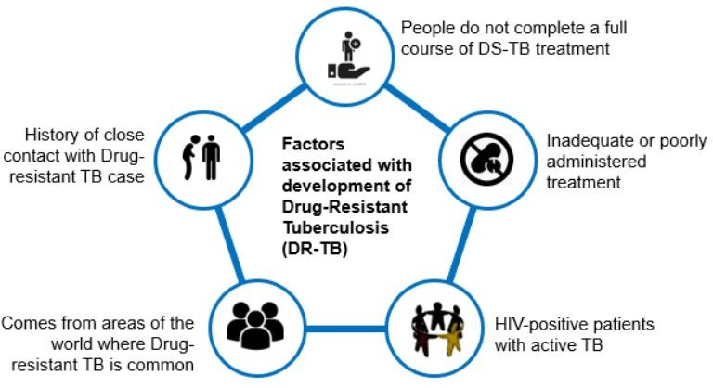

Diagnosis of DR-TB
All patients presenting to health facilities with signs and symptoms suggestive of TB should undergo a WHO recommended rapid molecular testing (Xpert MTB/RIF Ultra or Truenat), as the initial preferred TB diagnostic test. A chest x-ray should also be performed, especially among high-risk groups for TB. Health care workers should be aware that obtaining a CXR should not place an undue time or cost burden on the patient or create a delay in confirming a diagnosis of TB or initiating treatment. All adult patients with a positive symptom screen and/or a low BMI (<17kg/m2) and/or an abnormal CXR should have two sputum samples collected. Ideally the two samples should be collected one on the spot and the other as an early morning sample. If this is not possible, the two sputum samples can be collected at least two hours apart and sent to the nearest Xpert/Truenat site. One of the samples is tested for TB using the Xpert MTB/RIF Ultra/ Truenat MTB/MTB Plus assay. If MTB is detected, perform Xpert MTB-XDR (if available) on residual liquefied sample (specimen sample reagent mixture) within 4 hours or the second sample is sent to Xpert MTB/XDR site for reflex testing. If MTB is detected with rifampicin resistance, the patient is requested to produce an early morning specimen which is forwarded to the reference laboratory for culture and DST. Refer to detailed diagnostic algorithm.

DR-TB Treatment
There are six regimens used in Zimbabwe for RR/MDR-TB: 4 shorter regimens and 2 longer regimens.

- A majority of patients (14 years and above) should be treated with BPaL(M) all-oral, short regimen for 6 months in duration. It is a combination of Bedaquiline, Pretomanid, Linezolid and Moxifloxacin.
- Patients with FQ-resistant TB should receive BPaL regimen (6 months in duration); a combination of Bedaquiline, Pretomanid and Linezolid.
- Children (ages 0-14 years) should be treated with a modified all-oral shorter regimen for 9-12 months.
- Persons with a history of previous treatment, who are not responding to treatment, that have bone or central nervous RR-
TB, or patients who have not had a successful treatment outcome will receive an “individualized regimen”.
- The regimen for Isoniazid Resistant TB (Hr-TB) is 6 months of RHZE+LFX (Rifampicin, Isoniazid, Pyrazinamide, Ethambutol and Levofloxacin) or 6months of RZE+LFX if available. For comprehensive treatment regimens, refer to the Zimbabwe DRTB Guidelines (2023).

Patient Education

Adequate patient education and measures surrounding infection control include:

- Education on cough hygiene, including use of surgical masks by patients.
- Suspension of school or work attendance until culture conversion or first two months of intensive phase.

- Ensure measures for adequate ventilation in the home.
- Community and family education.
- Nutrition education.

Decision making in DR-TB management MUST always be made by the district team led by the DMO. The model of care for each patient must be regularly reviewed as there maybe changes in the clinical condition or social circumstances.

Patient Support systems

All patients on DR-TB treatment should have a psycho-social and economic assessment to identify those who need to be provided with psychological and social support such as transport and food to prevent treatment interruption and reduce treatment associated costs.

Monitoring Therapy

All patients with DR-TB should have a clinical evaluation at baseline (at treatment initiation), two-weeks after treatment initiation and monthly until treatment completion. In addition to clinical evaluation, laboratory, radiological and other investigations should be performed systematically, depending on the medicines the patient is taking to timely detect and manage adverse drug reactions as part of active Drug Safety Monitoring and Management. For the full schedule of monitoring tests, please refer to the Clinical Management of Drug Resistant Tuberculosis Guidelines.

DR-TB Concilia

DR-TB concilia are a multi-specialty consultation body with different competencies and perspectives aimed at improving the quality of care and clinical outcomes for DR-TB patients. The concilia, apart from supporting the clinical management of enrolled cases, also support the follow up of and assignment of treatment outcomes.

Prevention of DR-TB
Treating a case of DR-TB is more than 25 times the cost of treating an uncomplicated DS-TB. In the Zimbabwean high HIV burden setting, an untreated case of DR-TB can infect large numbers of individuals, rapidly leading to significant outbreaks of DR-TB with high case fatality. Prevention of DR-TB therefore depends on:

- A robust TB control program that is able to treat successfully the largest possible proportion of identified new, previously untreated cases with 1st line medicines (the target is a treatment success rate of at least 90% for DS-TB cases)
- Rational use of anti-microbial medicines in general and anti-TB medicines in particular in both the public and the private sector.
- Ensuring the highest possible quality of all anti-TB medicines used in the program in addition to optimized storage conditions.
- Ensuring every effort is made to promote and support full adherence to treatment for all patients treated with anti-TB medicines, both for first- and second-line medicines.
- Prompt identification of patients with DR-TB and initiation on treatment with appropriate regimens and doses.
- Screening of household contacts and dissemination of appropriate health education and implementation of appropriate infection control measures.
- DR-TB contacts should be traced and screened for active TB disease. On ruling out TB, DR-TB contacts should be offered appropriate TPT depending on the type of exposure and monitored every six months for at least 2 years.

- World Health Organization Treatment Guidelines for Drug Resistant Tuberculosis – 2022 Update
- Guidelines for the Programmatic Management of Drug Resistant Tuberculosis in Zimbabwe – 2023 Edition
- Definitions and reporting framework for tuberculosis: 2013 revision (updated December 2014 and 2020). Geneva: World Health Organization; 2013

Chapter 10: Pharmacovigilance

Key Definitions
Pharmacovigilance is the science and activities relating to the detection, assessment, understanding and prevention of adverse effects or any other drug-related problem.

Active Drug Safety Monitoring (aDSM) is the active and systematic clinical and laboratory assessment of patients on treatment using new anti-TB drugs, novel MDR-TB regimens or XDR-TB regimens to detect, manage, and report suspected or confirmed drug toxicities.

Adverse Drug Reaction (ADR) is a response to a medicine that is noxious and unintended, and which occurs at doses normally used in humans.

Adverse Event (AE) is any untoward medical occurrence that may present in a patient during treatment with a pharmaceutical product, but which does not necessarily have a causal relationship with this treatment.

Serious Adverse Event (SAE) is an adverse event which either leads to death or a life-threatening experience such as hospitalization, prolongation of hospitalization, persistent or significant disability a congenital anomaly. SAEs that do not immediately result in one of these outcomes but that require an intervention to prevent it from happening are included. SAEs may require a drastic intervention, such as termination of the drug suspected of having caused the event.

Causal relationship is a relationship between an exposure (A) and an event (B) in which A precedes and causes B. This may refer to the causal association between an exposure to a medicine and the occurrence of an adverse reaction.

Causality assessment is the evaluation of the likelihood that a medicine was the causative agent of an observed adverse reaction.

Therapeutic drug monitoring is a branch of clinical chemistry and clinical pharmacology that specializes in the measurement of medication concentrations in blood.

Rationale of pharmacovigilance for TB medicines
The medicines used in the treatment of drug susceptible TB have been on the market for decades now. Clinicians and TB programmes around the world have an idea of the ADRs anti-TB medicines induce and the frequencies. However, in Zimbabwe, locally generated data on the ADRs induced by these medicines are limited. Local data is crucial given that the occurrence and frequency of ADRs can be influenced by demographic, genetic and nutritional patterns. Some of the medicines used in the treatment of MDR/RR-TB are new or repurposed molecules whose ADR induction profile is not well understood. Moreover, studies have shown that patients on MDR/RR-TB treatment experience at least one ADR during the duration of treatment. Systematically collecting data on ADRs and using the information to inform clinical practice helps to improve patient outcomes and promoting patient confidence in the health care system.

Prevention and management of adverse drug reactions
All health staff should be able to recognise and manage the common ADRs of 1st line anti-TB medicines. TB patients should always be informed on starting treatment about the possibility of adverse reactions and what to do if they develop.

Patients at increased risk of ADRs

There are certain groups of patients who are at increased risk of medicine adverse effects as summarized in the table below: There is need to carefully evaluate such patients before starting anti-TB treatment. It is crucial to ensure that the medicine dosage is according to the weight of the patient in all cases. There may be need to reduce the dose of the medicines in some cases, such as renal failure and the elderly. It is important to inform the patient and relatives on the possibilities of ADRs and advise the patient to report to a clinician immediately when an ADRs is suspected.

Table 20: Persons at increased risk of adverse events

- The elderly | - Diabetics
- The malnourished | - Patients with CKD
- Those who consume excessive alcohol (≥14 units per week  &/or binge drink) | - HIV infected individuals
- Pregnant and nursing mothers | - Those with severe TB
- Persons with liver failure | - Patients with Anaemia
- Persons with a family history of ADRs | - Atopic persons
- Patients on other medicines | - Patients with renal failure

Adverse drug reactions induced by 1st line anti-TB medicines
Adverse drug reactions to anti-TB medicines can be classified into major and minor ones and are shown in the table below. The table summarizes a symptom-based approach to the diagnosis and management of ADRs.

Table 21: Symptom-based approach to identifying and managing ADRs due to 1st line anti-TB medicines

Adverse Drug Reaction | Drug probably  responsible | Management approach
Minor |  | Continue anti-TB medicines, check medicine doses
Anorexia, nausea, abdominal pain | Pyrazinamide Rifampicin | Even though the NTLP recommends DOT for all TB patients in Zimbabwe, patients experiencing these minor AEs should be advised to take the medicines at night preferably with family member DOT.  Ranitidine, omeprazole, or an antacid may also be prescribed.
Joint pains | Pyrazinamide | Give nonsteroidal anti-inflammatory drugs (NSAIDS) e.g. Aspirin or  Ibuprofen
Burning sensation in feet | Isoniazid | Give Pyridoxine 100 mg daily
Skin rash with mild itchiness, no mucous membrane involvement or  blisters | Rifampicin, Isoniazid & Pyrazinamide | Chlorpheniramine 4 mg TDS or Promethazine 25-50 mg at night. Aqueous cream, Calamine skin lotion.
Peripheral neuropathy | Isoniazid | Pyridoxine 50 mg 1-2 times daily
Orange/red urine | Rifampicin | Reassure patient. Let patient know this at the beginning of treatment  (before the first dose is taken).
Major |  | Stop responsible medicines. Refer patient to a medical officer and/or  arrange admission to hospital.
Itching of skin with rash, mucous membrane  involvement, blistering | Rifampicin, Isoniazid & Pyrazinamide | Stop anti-TB drugs. Refer to the next level ifyou cannot manage. Wait until the rash has resolved and resume medication at a hospital as  advised below.
Jaundice (other causes  should be excluded) | Most anti-TB medicines  (especially Pyrazinamide, Rifampicin, and Isoniazid) | Stop anti-TB drugs. Do liver function tests. (See below)  Test for Hepatitis A, B and C
Vomiting & confusion: suspect drug-induced acute  liver failure | Most anti-TB medicines (especially Pyrazinamide,  Rifampicin, and Isoniazid) | Refer to hospital for admission. Stop anti-TB medicines, do urgent liver function tests; Check for the presence of hepatitis viruses (A, B and C)  and check the prothrombin time/International Normalized Ratio (INR)
Visual impairment (other  causes excluded) | Ethambutol | Stop Ethambutol/ Refer to an eye specialist.  Modify TB treatment as guided in Table XX below.
Shock, purpura (bleeding  under the skin), acute renal failure | Rifampicin | Stop Rifampicin

Approach to management of adverse drug reactions
The first step in managing a patient with ADRs is to evaluate the severity of the adverse reaction, i.e. determine whether it is a minor or a major ADR. A patient who develops minor adverse effects should continue the anti-TB treatment, usually at the same dose while the ADR is treated symptomatically e.g. with an anti-histamine for itching or anti-emetic for nausea and vomiting. If a patient experiences a major adverse event, treatment with the suspecting offending medicine should be stopped immediately. Further management depends on the nature of the adverse reaction and is shown in the table above. Patients with major adverse reactions should be managed in a hospital. TB treatment should be withheld until the affected organ or system returns to normal, which usually takes 2-3 weeks. After the adverse reaction has resolved a cautious reintroduction of the treatment should be attempted. This may be done using a desensitization approach.

Management of skin reactions

If a patient develops itching without a rash and there is no obvious cause, the recommended approach is to try symptomatic treatment with anti-histamines, continue anti-TB treatment and observe the patient closely. However, if a skin rash develops, then all anti-TB medicines must be stopped. Once the reaction has resolved, anti-TB medicines can be cautiously re-introduced.

If a patient develops itching with a rash and fever, it is essential to stop all anti-TB medicines at once. Do not wait to see a widespread rash with peeling skin, blisters or raised red spots of a severe allergic reaction called Steven Johnson’s syndrome. The eyes and/or mucous membranes may also be affected. Patients with Steven Johnson’s syndrome are usually very ill with fever, hypotension and should be treated as a medical emergency. Such a patient may need intravenous fluids and high dose steroids (60 mg prednisolone a day). In view of the gravity of this severe ADR, all health workers should take the presence of a generalized itchy skin rash in a patient receiving anti-TB medicines seriously and stop all medicines as indicated above. Chloramphenicol eye ointment should be applied to the patient’s eyes if they are involved, in addition to giving a course of antibiotics (e.g. amoxicillin plus clavulanic acid) if the blisters look infected. Anti-TB treatment is only restarted once the skin reaction has completely resolved, which usually takes up to 4 weeks or more depending on the severity of the reaction.

Management of drug-induced hepatitis

Anti-TB medicines can damage the liver. Isoniazid, pyrazinamide and rifampicin are most commonly responsible and rarely Ethambutol. When a patient develops hepatitis during anti-TB treatment, it may be due to the anti-TB treatment or another cause. It is important to rule out other possible causes before deciding that the hepatitis is drug-induced. If the diagnosis is drug- induced hepatitis, then the anti- TB medicines should be stopped, and the liver function tests checked regularly. After the hepatitis has resolved, the same regimen can often be re-introduced.

If drug-induced hepatitis is severe, it is advisable to avoid pyrazinamide, rifampicin and isoniazid. Refer the patient to a Medical Officer and preferably a Physician for specialist care. An individualized regimen, containing 1st and 2nd line medicines may be used with the treatment lasting up to 9-12 months. Note that the effectiveness of some of the individualized regimens has not been assessed in clinical trials, therefore, it is important that patients are closely monitored for clinical and bacteriological improvement. Patients should also be monitored for relapse post treatment completion.

Re-introduction of anti-TB medicines and desensitization following an adverse drug reaction.
The reintroduction of treatment and desensitization should not be attempted in patients who have developed severe toxic reactions. In such cases that are life threatening, a new regimen not including the implicated medicine in the reaction should be used. Do not reintroduce treatment in HIV co-infected cases.

The principles and steps for re-introduction of anti-TB medicines and desensitization following an adverse drug reaction are:

- Reintroduce the treatment, medicine by medicine (one medicine at a time), in progressively increasing dose.
- Start with the drug least likely to have caused the ADR. Add the other medicines from least to most likely to have caused the ADR.
- Start with low dose of the medicine, often a sixth of the total dose and gradually increase the dose, for example, double the

dose each day until the full dose is reached. This usually takes up to 4-6 days for full reintroduction of each drug, a time too short for the selection of resistant strains to the particular medicine.
- When the full dose of a particular medicine is introduced without any ADR, then an additional medicine should be reintroduced in the same way as the previous medicine.

All reintroduction and desensitization must be done in a hospital setting under the care of an experienced medical officer. Before attempting to reintroduce treatment and desensitization, a plan should be established on how to proceed in the event of the adverse reaction reoccurring. Some recommend treating with prednisolone 40-60 mg for three days before re-introducing the medicine and continuing with the steroid for 2 weeks after reintroduction of anti-TB medicines. The table below shows the standard approach to re-introducing anti-TB medicines after a drug reaction. The medicine least likely to produce the side effect is started first and when its regular dose is achieved without any side effects the next less likely drug is introduced as shown in table below.

Table 22: The standard approach to re-introduction of anti-TB medicines after an ADR

Drug | Day | Formulation to use
Day 1 | INH 25mg | ¼ of INH 100mg dispersible tablet
Day 2 | INH 50mg | ½ of INH 100mg dispersible tablet
Day 3 | INH 100mg | INH 100mg dispersible tablet
Day 4 | INH 300mg | INH 300mg tablet
Day 5 | INH 300mg + R 150mg | 2-FDC: Rifampicin/Isoniazid 150mg/75mg tablets x 1  + 2¼ of INH 100mg dispersible tablet
Day 6 | INH 300mg + R, 300mg | 2-FDC: Rifampicin/Isoniazid 150mg/75mg tablets x 2  + ½ of INH 300mg tablet
Day 7 | INH 300mg + R 450mg | 2-FDC: Rifampicin/Isoniazid 150mg/75mg tablets x 3  + ¾ of INH 100mg dispersible tablet
Day 8 | INH 300mg +R 600mg (depends on weight) | 2-FDC: Rifampicin/Isoniazid 150mg/75mg tablets x 4
Day 9 | INH 300mg + R 600mg + E 400mg | 2-FDC: Rifampicin/Isoniazid 150mg/75mg tablets x 4  + Ethambutol 400mg tablet
Day 10 | INH 300mg +R 600mg + E 800mg | 2-FDC: Rifampicin/Isoniazid 150mg/75mg tablets x 4  + Ethambutol 400mg tablet x 2
Day 11 | INH 300mg +R 600mg + E 1.2g  (depends on weight) | 2-FDC: Rifampicin/Isoniazid 150mg/75mg tablets x 4  + Ethambutol 400mg tablet x 3
Day 12 | INH 300mg +R 600mg + E 1.2g + Z  400mg | 2-FDC: Rifampicin/Isoniazid 150mg/75mg tablets x 4  + Ethambutol 400mg tablet x 3  + Pyrazinamide 400mg tablet
Day 13 | INH 300mg + R 600mg + E 1.2g + Z 800g | 2-FDC: Rifampicin/Isoniazid 150mg/75mg tablets x 4  + Ethambutol 400mg tablet x 3  + Pyrazinamide 400mg tablet x 2
Day 14 | INH 300mg + R 600mg + E 1.2g + Z 1.2g | 2-FDC: Rifampicin/Isoniazid 150mg/75mg tablets x 4  + Ethambutol 400mg tablet x 3  + Pyrazinamide 400mg tablet x 3
Day 15 | INH 300mg + R 600mg + E 1.2g + Z | 4-FDC: Rifampicin/ Isoniazid/

 | 1.6g (depends on weight) | Pyrazinamide/ Ethambutol 150mg/  75mg/ 400mg/ 275mg tablets x 4

The last medicine to be re-introduced before the recurrence of a reaction is likely the cause of the reaction and that medicine should be replaced. This may require a decision by a medical officer with extensive experience in management of TB.

Alternate regimens when first-line medicines cannot be used

It becomes extremely complicated when any of the 1st line treatment medicines cannot be used. For this reason, it is advised that an experienced medical officer, be the one to take care of patients in whom one or more of the 1st line medicines cannot be used. The principle is to use as many first-line medicines as possible in any treatment regimen. If one first-line medicine cannot be used, due for example to severe drug adverse effects to one medicine, the recommended regimens are shown in table below:

Table 23: Alternate regimen when specific medicines cannot be used

Medicine that cannot be used | Alternate Regimen
Pyrazinamide | 2HRE/7HR
Isoniazid | 6REZLfx
Rifampicin | 2HEZLfx/10HE
Ethambutol | 2HRZLfx/4HR
Ethambutol | 2HPMZ/2HPM

- There is limited experience on the programmatic use of the above regimens. Therefore, it is important that patients are closely monitored for clinical and bacteriological improvement. Patients should also be monitored for relapse post treatment completion.
- The recommended regimen above for situations where Rifampicin cannot be used refers to a state where there is intolerance to Rifampicin. In the event of resistance to Rifampicin, patient should be managed with the recommend regimen for DR-TB.

Managing ADRs when FDCs are used.

AEs are not any more common when FDCs are used compared to single drug formulations. However, an ADR to one of the components in a FDC is suspected, there will be a need for single-drug formulations. Limited stocks of single-drug formulations will be available in district/provincial/ referral hospitals where patients experiencing severe adverse event will be managed under supervision.

Drug interactions with 1st line anti-TB medicines
Isoniazid interacts with anticonvulsants and may cause their concentration in the body to increase to toxic levels. It is advisable to monitor serum concentration levels of anticonvulsant medicines, if possible. If this cannot be done, it may be necessary to reduce the dosage of anticonvulsant medicines during treatment with an isoniazid-containing regimen.

The absorption of isoniazid is decreased by aluminium hydroxide. Medicines containing aluminium hydroxide should be taken at least 1 hour before or 2 hours after taking isoniazid containing treatment.

Rifampicin induces several liver enzymes of the cytochrome P-450 system that metabolise medicines thereby reducing their blood levels. This results in faster elimination and lower blood concentrations of many medicines ranging from anti- coagulants, cardiac medications to hormones, anti-fungals, oral anti-diabetics and antiretroviral drugs (see TB/HIV chapter). Treating patients with rifampicin and these other medicines at the same time would result in lower blood levels and therefore loss of efficacy of these medicines.

Rifampicin and contraceptive methods

The effects of rifampicin on contraceptives are summarized in table below. Dual protection should be recommended for all patients receiving rifampicin and hormonal contraceptives concurrently.

Contraceptive method | Interaction with Rifampicin | Recommendation
Oral contraceptives containing < 50 mcg of Ethinylestradiol | Efficacy reduced By rifampicin and  pregnancy may occur | Change to high-dose OC, Depo- Provera or IUCD and use condoms correctly and consistently
Progestin-only-pill | Efficacy reduced by rifampicin and  pregnancy may occur | Change to high-dose OC, Depo-Provera  or IUCD and use condoms correctly and consistently
Depo medroxyprogesterone (Depo-  Provera®) | No known interaction | HIV Dual protection necessary
Hormonal implant | Efficacy reduced by rifampicin and  pregnancy may occur | Use IUCD concomitantly or use  condoms correctly and consistently
Hormonal implant | Efficacy reduced by rifampicin and  pregnancy may occur | Use IUCD concomitantly or use  condoms correctly and consistently
Intrauterine  contraceptive device (hormone releasing or not) | No known interaction | May increase transmission of  HIV Dual protection necessary necessary

Patient information about ADRs and interactions
To ensure good compliance during treatment, it is essential for patients, treatment supporters and family members to know basic facts about anti-TB medicines, their side effects and what to do in case of the occurrence of an ADR.

Because TB patients are seen daily for directly observed treatment, at least during the initial (intensive) phase of treatment, health staff are encouraged to use more than one consultation to explain the symptoms of side effects and check that patients have understood. It is also important to ask and look for any possible signs of side effects.

‘Ready-made’ messages adapted for local situations should be used as much as possible. The box below presents several
examples of actual messages used in Bulawayo as an illustration.

Note to Health Care workers:
- If your patient is female and has had secondary amenorrhoea in spite of not being pregnant, inform her that it is likely that her monthly periods will start again as she recovers from TB.
- If your patient is female and is on modern contraception, find out what method she is using and discuss what additional method she should use during anti-TB treatment. Remember the importance of dual protection.
- Talk with all female TB patients about their reproductive plans and advise them about the benefits of starting to use contraception if she is not planning a pregnancy. This is particularly important if your patient is also HIV-positive.
- If your patient is taking anti-epileptic drugs: check what medication s/he uses and explain that the effect of anti-epileptic medication may be decreased. Suggest that the patient keeps a seizure diary, and s/he reports to you immediately if an increase in seizures is observed.
- If your patient is HIV-positive and is also on antiretroviral treatment: check what medication s/he uses and explain that added toxicities could occur and that it is important for the patient to contact you if nausea, vomiting, abdominal pain, skin rash or jaundice appears.

Example of health education messages

- If you take all the anti-TB treatment for the recommended period, you are going to get better. You will stop
coughing, you will feel less tired, regain your appetite & gain weight.
- It is very important to continue taking all the medications, even when you start feeling very well for all TB germs to be killed and for you to be permanently cured.
- TB can be cured even if you are HIV-positive.
- Anti-TB medicines can also cause side effects.
- Common side effects include nausea, vomiting, abdominal pain, discomfort, joint pains, itching, skin rash, numbness, tingling or loss of sensation or burning sensation in feet and hands, yellow discolouration of eyes. Contact the clinic without delay and tell the doctor or nurse if you develop any of these symptoms.
- Rifampicin colours all body fluids red or orange. This is not dangerous.

- At every contact with a TB patient, ask about symptoms, such as nausea, vomiting, abdominal pains or discomfort, itching, joint pains, numbness, tingling or burning sensation or loss of sensation in hands & feet
- At every contact with a TB patient, look for skin rash, jaundice with continued nausea & vomiting.
- If an ADR occurs diagnose it promptly followed by appropriate management.

Reporting of ADRs to first line TB medicines
Spontaneous ADR reporting is recommended for ADRs suspected to be caused by first line anti-TB medicines. In spontaneous ADR reporting, reporting is the initiative of HCWs. HCWs are encouraged to report all suspected adverse events.

How to report suspected ADRs and ADR reporting tools
An ADR report should be submitted to the Medicine Control Authority of Zimbabwe (MCAZ), as soon as possible after the reaction. To report an ADR, the MCAZ e-ADR reporting platform (https://e-pv.mcaz.co.zw/) can be used. A standard ADR reporting form can also be completed, and submitted to MCAZ. All ADR reports once submitted, are treated in an anonymous manner i.e. information of both patient and reporting HCW are kept confidential.

Figure 14: A diagrammatic representation of the movement of the ADR form once completed
Health Facility staff
District Pharmacy Manager
Provincial Pharmacist
Medicines Control
A
uthority of Zimbabwe

Managing, monitoring and reporting adverse events due to 2nd line anti- TB medicines
Refer to the latest guidelines for the Clinical Management of Drug Resistant TB for detailed information on the detection and management of adverse events due to 2nd line medicines. The WHO recommends use of aDSM for the continuous monitoring and reporting of adverse events induced by 2nd line TB medicines. The term ‘active TB drug-safety monitoring and management’ defines active and systematic clinical and laboratory assessment of patients while on treatment. Health programmes that systematically monitor patient safety are at an advantage to prevent and manage ADRs, as well as improve health-related quality of life and treatment outcomes. National tuberculosis programmes that actively pursue drug safety monitoring and management are also better prepared to introduce new TB drugs and novel regimens. The primary difference with the spontaneous adverse event reporting system described earlier is that, with aDSM the health worker assesses meticulously for any perceived adverse events. The frequency of clinical and laboratory assessments to be done are described in the Clinical Management of Drug Resistant TB Guidelines. To report any adverse events to the MCAZ please use the ADR forms as described previously.

•
www.who.int/medicines/areas/quality_safety/safety_efficacy/pharmvigi/
November 2016)
(Accessed
- A practical handbook on the pharmacovigilance of medicines used in the treatment of tuberculosis:
enhancing the safety of the TB patient (WHO 2012)
- Active tuberculosis drug-safety monitoring and management (aDSM): Framework for implementation (WHO,2015)

Chapter 11: Community Participation

Introduction
Community tuberculosis care (CTBC) refers to the provision of TB care and treatment services outside of healthcare facility,
i.e. in the community where patients or clients live and work. CTBC involves engaging community members, such as community health workers, to identify and refer individuals with TB symptoms for diagnosis and treatment, provide support to patients throughout their treatment journey through directly observed treatment support (where a trained community member observes and documents a patient's medication intake to ensure adherence to the treatment regimen.) This approach is often used in settings where access to healthcare facilities is limited or where patients face social or economic barriers to accessing care. CTBC has been shown to improve treatment outcomes, reduce transmission of TB, and increase patient satisfaction.

Aims of Community TB Care
- To improve cooperation and foster shared partnership between NTLP, NGOs, CSOs and communities for patient and community empowerment.
- To facilitate access to health services and bring TB services to where people live.
- To create an enabling environment in which community members express their responsibility towards those affected by TB.

Community TB Care activities
The following are some of the activities that should be implemented at community level:

- Awareness-raising, health education and community mobilization.
- Contact investigation.
- Symptom screening for TB and TB-related morbidity (e.g. HIV and diabetes mellitus) for early referral.
- Facilitating access to diagnostic services (e.g. sputum or specimen collection and transport).
- Initiation and provision of TB prevention measures.
- Referral of community members for diagnosis of TB and related diseases.
- Treatment adherence support through peer support, education and individual follow-up.
- Social and livelihood support (e.g. food supplementation, income-generation activities).
- Home-based palliative care for TB and related diseases.
- Community-led local advocacy activities

Approaches to community TB screening.
TB screening at the community level should be carried out by community health care workers and or volunteers recognized by the MoHCC/NTLP. Symptoms enquiry should be regularly carried out when doing targeted TB screening at the community level. The following are specific actions for community TB screening

- Administration of the symptom screening tool to members of the community.
- Identifying presumptive TB clients who should then be referred using the NTLP recommended referral slips to the nearest health facility for TB testing.
- Screening of contacts of prioritized index cases identified at the local clinic as part of contact investigation.
- Tracking referral linkage of all presumptive clients referred to health facility for further evaluation, to ensure referral pathway is completed.
- Communicate with client on the results of the TB investigation.
- Upon TB diagnosis, referred clients should be clearly recorded in the health facility TB register as community referrals to facilitate the reporting of community contribution to TB case notifications.

TB treatment support
A patient’s adherence to treatment is an important factor for successful treatment. This is achieved through directly observing

treatment (DOT), either at a health facility or community level (observing the patient swallow every scheduled dose at the health facility or by a trained community DOT observer.) Before the patient is sent home upon diagnosis, the HCW must educate the patient about the importance of adhering to treatment. For TB patients who live or work close to a health facility, a HCW may directly observe their treatment (health facility-based DOT). However, for patients who live far from the health facility, a treatment supporter in the community is needed to directly observe treatment at a place and time convenient for the patient (community-based DOT).

Identifying a community TB treatment supporter
The patient and treatment supporter should enjoy a supportive relationship that motivates the patient to complete his/her treatment. A negative or non-supportive relationship can cause a patient to interrupt treatment. The community treatment supporter should listen empathetically to the patient’s concerns and encourage the patient to complete treatment. The treatment supporter must be able to manage the patient’s medicines and have access to the health facility for reporting and obtaining resupply of medicines.

Options for treatment supporter in order of preference:
- A health facility member of staff.
- A trained community/village health worker.
- A volunteer in the community or workplace.
- Or a family member, as the last resort.

Once identified, the treatment supporter gets oriented on how to provide and document DOT and meets up with patient and agree on support logistics such as place and time for taking medicines

Roles of the Community TB Treatment Supporter

The community TB treatment supporter performs many functions with the overall aim of enabling the patient to complete treatment. These include:

- Observing patient swallow medicines.
- Recording on the patient’s TB treatment card.
- Collecting resupply of drugs on behalf of the TB patient, if the patient is unable to do so by him or herself.
- Following up on patients that miss an appointment or dose.
- Monitoring the TB patient’s progress and making enquiries about any side effects.
- Referring the patient to the health facility for further information, management or review.
- Informing and educating the patient, family and community about TB and related conditions.
- Reporting any problems related to the patient to the health facility.

Supervision of the community TB treatment supporter

The Treatment supporter should bring the TB patients’ treatment cards for review and updating to the facility. In the event this does not happen and an appointment review is missed, the HCW should contact the treatment supporter or even through a home visit to ascertain any challenges that may need to be resolved. The HCW should also contact the patient to discuss the quality of care (appropriateness and timeliness) being provided by the treatment supporter and find out if they want to continue the engagement with the assigned treatment supporter.

- The TB treatment supporter should visit the health facility once every month to report on and discuss progress of patients under their care

Community-led monitoring
Community-led monitoring (CLM) is a valuable approach that the country adopted to enable communities to take an active role

in monitoring and improving the quality of TB care and services offered to them at all levels of care by ensuring accountability by the health services delivery system. For CLM to be implemented, communities are engaged and capacitated on TB basics, monitoring services which are due to them, information capturing and utilization/analysis, reporting and managing feedback. The data they analyse will be used by the community in collaboration with health providers to advocate for improved TB services and at the same time holding service providers and policymakers accountable for their commitments.

Implementation of CLM using OneImpact platform
OneImpact is a digital platform that can be used to implement community-led monitoring for tuberculosis (TB) programs. The platform enables community members to collect and report data on TB service delivery and provides a mechanism for analyzing and sharing this data with relevant stakeholders. For OneImpact Zimbabwe application to be implemented, community users will need the OneImpact application downloaded and set up on their mobile phones, trained on how to use the application to collect and report data on various aspects of TB service delivery, such as availability of drugs and diagnostics, quality of care, and patient satisfaction. They can analyze and use the data for advocacy and towards programme improvement. Successful implementation will ensure that TB services are responsive to the needs of the community and delivered in a way that is respectful, effective, and equitable.

Civil society roles in the national TB response
Below is the summary of the roles that civil society organizations (CSOs) can play in the TB response:

- Advocacy: CSOs can advocate for policies and programs to prevent and control TB. They can work to raise awareness of TB among the general public, health professionals, and policymakers, and advocate for increased funding and resources for TB prevention, diagnosis, and treatment.

- Community engagement: CSOs can engage with communities affected by TB to improve awareness, reduce stigma, and increase access to TB services. They can work to empower patients, families, and communities to become advocates for their own health and demand better quality and more accessible TB care.

- Service delivery: Some CSOs provide TB services directly to patients, including counseling, testing, treatment adherence support, and psychosocial support. They can also provide support for TB research and innovation.

- Monitoring and accountability: CSOs can monitor the TB response to ensure that policies and programs are implemented effectively and that resources are used efficiently. They can also hold governments and other stakeholders accountable for their commitments to TB control.

- Research and innovation: Some CSOs engage in research and innovation to generate new knowledge and approaches to TB prevention and control. They can work to identify best practices and promote their adoption in TB programs.

 | - Civil society plays a crucial role in TB response by bringing the voices of affected communities to the forefront, advocating for the rights of patients, and pushing for policies and programs that are responsive to the needs of those affected by TB.

Integrating Palliative Care in TB management for Improved Quality of Care and Treatment Outcomes.
WHO defines palliative care as an approach that improves the quality of life of patients (adults and children) and their families facing the problems associated with life-threatening illnesses (such as TB, HIV, diabetes, cancer and other communicable and non-communicable diseases), through the prevention and relief of suffering by means of early identification and correct assessment and treatment of pain and other problems, whether physical, emotional, social or spiritual (2015). The goal of palliative care is promoting a comprehensive approach to quality care, from diagnosis of chronic and life-threatening illness (such as TB), to dealing with loss and grief for bereaved family members, across the continuum of care. In line with Universal Health Coverage, integrating palliative care in TB management will result in improved access to health services, enhanced quality

of care and patient outcomes whilst maintaining the cost of delivery.

- Palliative care is a central component of integrated person-centred care.
- It is about identifying, assessing and addressing the needs of the patient in a holistic manner; regardless of whether the needs are physical, emotional, social or spiritual in nature.
- It is applicable from diagnosis throughout the course of illness in conjunction with other therapies & investigations intended to improve quality of life
- It offers a support system to help patients live as actively as possible
- Provides relief from pain and other distressing symptoms
- It is applicable in the home care setting or any other models of care and uses a team approach to comprehensively address needs of patients and their families using available resources

Where can Palliative care be provided?

- Palliative care is provided in any setting at various delivery sites, such as hospitals, clinics/facilities and home. The models of delivering palliative care are based on these settings.

Who provides palliative care?
- A palliative care trained multidisciplinary team comprising doctors, nurses, pharmacists, nutritionists, environmental health technicians, rehabilitation technicians, social workers, counsellors and spiritual leaders.
- Each facility should have a palliative care committee to ensure effective provision of palliative care services
- Palliative care trained CHWs should conduct home visits at least weekly or fortnightly for the management of TB patients.

Relevance of Palliative Care in TB Management
- TB is the leading cause of death (though considered a curable infection) in patients infected with HIV and other co- morbidities.
- This calls for intensified case finding and treatment support including palliative care to promote successful completion of treatment while addressing all potential distressing symptoms and provision of emotional and spiritual support especially to those with advanced TB or co-morbidities such as HIV, Diabetes, and Silicosis.
- Palliative care comes in handy to deal with specific problems related to DS-TB and DR-TB patients’ high level of infectiousness, treatment adherence challenges and management of severe side effects associated with the disease and its treatment.

Which TB Patients are Eligible for Palliative Care?

TB patients with the following signs and symptoms will be eligible for palliative care upon diagnosis:

- Dyspnea; persistent joint pains >2 weeks; severe neuropathy; hemoptysis; severe anemia; intractable nausea and vomiting
>1 week; renal failure; fever > 1 week; BMI <17kg/sqm; anxiety and depression; loss of memory; comorbidities e.g. HIV, diabetes mellitus, cancer, hypertension, cardiovascular disease, silicosis, COVID-19; as well as children diagnosed with TB; the elderly diagnosed with TB; DR-TB patients.

Domains of palliative care

Palliative care involves taking care of issues beyond physical symptoms. The package of services provided should be guided by the patients’ identified needs and unique context. Once a TB patient has been diagnosed the facility must link them to palliative care services within the most appropriate setting, where they will receive a cocktail of services tailor-made to meet their identified needs. The basic palliative care package for patients with TB is comprised of:

Physical care:
- Symptom management – pain, cough, dyspnea, fever, tiredness etc. using pharmacologic, non-pharmacologic and

complimentary strategies as appropriate
- Providing support for treatment adherence and dealing with side effects of some medicines
- Meeting the patients’ hygiene needs – bath, mouthcare, hair care etc.
- Providing nutritional support – balanced nutritious meals
- Dealing with care at end-of-life – labored breathing, and other symptoms of impending death

Emotional Support:
- Assisting patient and family to understand and cope with diagnosis and prognosis
- Dealing with fears, worries, sadness, anger and other emotional issues that may arise from the illness itself.
- Providing support for depression and anxiety and any other unresolved mental health issues
- Helping them to address unfinished issues of life
- Providing bereavement support

Social Support:
- Dealing with family relationship issues
- Providing family support for identified social, economic and general welfare issues
- Dealing with ethical and legal aspects of care
- Assisting in dealing with work-related issues,
- Planning for the future – child custody, inheritance, housing, and other legal issues
- Referral to appropriate services

Spiritual Support:
Making connections with community, spiritual/religious groups or individuals as desired by patient and family, who maybe dealing with religious, spiritual and existential issues of life including:
- Questioning issues relating to their belief system and values
- Finding the meaning of life and their purpose in life
- Finding peace, through forgiving others and being forgiven

Q: What is the relevance of palliative care in TB management?
A: It is designed to ensure that patients are cared for respectfully, paying attention to controlling distressing symptoms & providing emotional and spiritual support. It also helps to ensure treatment adherence for better outcomes.

Q: Which TB patients should receive palliative care?
A: All TB patients are eligible for palliative care. Each patient should be assessed and provided with a tailor-made package of palliative services.

Q: Where can one find the OneImpact digital application?
A: OneImpact application for Zimbabwe can be freely downloaded from the Play Store (for android users) &Apple Store (for iPhone users)

- Engage TB operational guidelines, WHO, 2012
- Patient centred Approach Strategy, USAID- TB CAP
- National Guidelines for Community Engagement in TB prevention and care, MoHCC, Harare 2014
- https://www.who.int/tb/publications/2018/community-led-monitoring-tb-programmes/en/
- https://www.stoptb.org/assets/documents/resources/publications/acsm/Stop_TB_Partnership_Framework
_for_Community_Led_Monitoring_of_TB_Programs.pdf
- https://www.theglobalfund.org/media/10162/guideline_communityledmonitoring_tb_en.pdf

Chapter 12: Confronting Zoonotic TB

Introduction
Zoonotic tuberculosis (TB) is a form of human TB caused by Mycobacterium bovis, which belongs to the M. tuberculosis complex. Cattle are the most important animal reservoir for M. bovis, but virtually all warm-blooded animals are susceptible to infection with M. bovis to a variable degree.

Epidemiology
It is difficult to estimate how many of the total TB cases are zoonotic TB, as it is not always distinguished from other types of TB. Zimbabwe is one of the African countries where zoonotic TB has been reported. However, there is limited data available on the exact number of cases and deaths due to zoonotic TB in the country. Overall, zoonotic TB remains a significant public health concern in many regions of the world, particularly in areas where people are in close contact with animals such as livestock and wildlife.

Transmission of zoonotic TB to humans
There are three routes of infection with M. bovis in human hosts namely; ingestion, inhalation or direct contact.

- Oral transmission: traditionally, the consumption of contaminated unpasteurized milk from infected cows has been the main vehicle of M. bovis infection in humans. In theory, the consumption of undercooked or raw meat from animals with M. bovis could also present a risk of transmission of M. bovis to humans.

- Respiratory transmission: involves inhalation of aerosolized bacilli excreted from the respiratory tract of infected animals. This is the most efficient method of transmission and the infectious dose is much lower than that through the oral route. A potential risk therefore exists for people who handle animals infected with M. bovis or their carcasses. M. bovis is therefore an occupational zoonotic disease.

- Cutaneous transmission: involves the traumatic inoculation of M. bovis into the skin during manipulation of carcasses or direct contact with infected animals, resulting in localized skin, tendon, mucosal or lymph node lesions.

Risk factors
- Consumption of unpasteurized milk and untreated animal products.
- Consumption of raw or undercooked meat from animals with M. bovis.
- Direct contact with infected animals or contaminated animal products.

Clinical management of zoonotic TB

Clinical features

Bovine TB often affects sites other than the lungs (extra-pulmonary), such as lymph nodes of the neck and gastrointestinal tract. Bovine TB should therefore be considered in persons who present with neck and or abdominal swellings and masses. However, it is important to note that in many cases bovine TB is clinically indistinguishable from TB caused by M. tuberculosis with typical symptoms that include a persistent cough, fever, night sweats and weight loss.

Laboratory diagnosis

Smear microscopy with Ziehl – Nielsen (ZN) staining and the rapid Xpert MTB/Rif or Truenat assay; the most commonly used tests for the diagnosis of TB, do not differentiate between M. tuberculosis and M. bovis. The relative lack of a specific and rapid test for M. bovis leads to under-diagnosis of zoonotic TB. When zoonotic TB is suspected, send a tissue biopsy/sample to the TB

reference laboratories for culture and DST. Serological tests such as IGRA, detect antibodies against TB bacteria in the patient's bloodstream, and are not diagnostic of M. bovis.

Treatment of disease by M. bovis
Table 24: Recommended Regimen for Treatment of M. bovis

Phase of treatment | Recommended regimen
Intensive phase | 2RHE
Continuation phase | 7RH

Health care implications
Several clinical features of zoonotic tuberculosis present special challenges for patient treatment and recovery.

- M. bovis infection and zoonotic tuberculosis in human beings is often associated with extra-pulmonary tuberculosis that might be misdiagnosed or undiagnosed, and therefore initiation of treatment can be delayed.
- M. bovis is naturally resistant to pyrazinamide, one of the four medications used in the standard 1st line anti- TB treatment regimen. As most TB patients begin treatment without DST, the risk of inadequate treatment of patients with M. bovis infection is thus exacerbated.

- Olea-Popelka F, et al, Zoonotic tuberculosis in human beings caused by Mycobacterium bovis—a call for
action. Lancet Infect Dis 2016
- WHO Global Tuberculosis Report 2022
- Zinsstag J, et.al. One Health: the theory and practice of integrated health approaches. Oxfordshire: CABI, 2015. http://www. onehealthinitiative.com
- https://www.cdc.gov/onehealth/basics/zoonotic-diseases.html

Chapter 13: Managing Mycobacteria other than TB

Introduction
Mycobacteria other than those comprising the M. tuberculosis complex are called non-tuberculous mycobacteria (NTM) or mycobacteria other than tuberculosis (MOTT). The organisms are commonly referred to as MOTT and the laboratories use this term when reporting culture results. These ubiquitous environmental organisms, usually found in water and soil, have emerged as important opportunistic pathogens of human beings in recent years. They may cause human disease, but they do not cause TB. They are not transmitted from one person to another.

These mycobacteria may cause pulmonary disease resembling TB and most commonly affect people with an underlying lung disease, such as chronic obstructive pulmonary disease, bronchiectasis, cystic fibrosis, primary ciliary dyskinesia, and alpha-1- antitrypsin disease. Individuals with no prior history of lung disease can also be affected. MOTT can also affect other organs. It is important to note that infection with MOTT also may produce AFB-positive sputum smear results and positive Mantoux skin test readings, mimicking M. tuberculosis. While GeneXpert MTB/Rif Ultra or Truenat assay can detect MOTT, it is culture which can distinguish between M. tuberculosis and MOTT.

The list of MOTTs that can cause human disease is long. However, Mycobacterium avium complex (MAC) predominates in most countries followed by M. gordonae, M. xenopi, M. abscessus complex (MABC) and M. kansasii. In Zimbabwe MAC is the most common MOTT that has been isolated.

Clinical Presentation
The symptoms of pulmonary disease due a MOTT are often nonspecific and include:

- Chronic cough
- Increased sputum production
- Dyspnoea
- Low-grade fever
- Malaise and weight loss

These symptoms overlap significantly with the clinical characteristics of pulmonary TB.

Radiological Findings

Radiological imaging is important when MOTT lung disease is suspected, which has two major manifestations:

- The fibro-cavitary form which resembles pulmonary TB and typically affects elderly men with underlying lung disease. This form is characterized by cavities with areas of increased opacity, usually located in the upper lobes. Pleural thickening and volume loss resulting from fibrosis with traction bronchiectasis are frequent.
- The nodular bronchiectatic form shows bilateral, multi-lobar bronchiectasis, especially in the middle and lower lung fields, with small nodules on chest radiography and high-resolution computed tomography (HRCT) scanning. This pattern of MOTT lung disease occurs predominantly in elderly non-smoking women without underlying lung disease, and appears more commonly in those with a thin body habitus.

The clinical and radiological picture of a MOTT lung disease are largely indistinguishable from those due to disease caused by
M. tuberculosis.

Laboratory Findings
Staining with ZN for Acid Fast Bacilli (AFB) on smear microscopy cannot differentiate between M. tuberculosis and MOTT. Culture remains the gold standard for laboratory confirmation of MOTT and is required for genotypic identification and DST. The culture media used for MOTT are similar to those used for M. tuberculosis. Since treatment and outcomes differ depending on the MOTT species, MOTT identification is clinically important. The role of DST is to guide the design of optimal treatment

regimens. However, the DST for MOTT is difficult and controversial because of discrepancies between in vitro and in vivo clinical outcomes, with the exception of macrolides and amikacin.

Diagnosis of MOTT
Diagnosis of MOTT lung disease requires the clinician to integrate clinical, radiographic, and microbiological data. Diagnosis can be confirmed by:

- at least two positive cultures from sputum, or
- one positive culture in the case of bronchoscopic wash or lavage, or
- A transbronchial or other lung biopsy with a positive culture for MOTT or compatible histopathological features such as granulomatous inflammation or stainable AFB and one positive sputum or bronchial wash culture for MOTT regardless of the mycobacterial strain.

Without detailed clinical information, differentiating between contamination of specimens, colonization/infection, and disease is difficult. Laboratory reports of isolates do not always reflect the true incidence of disease. To determine if lung disease is present, the following are needed: -

- Sputum specimens, (often) a bronchoscopic sample of a patient’s lower respiratory tract should be collected
- Computed tomography scanning of the chest
- Careful clinical evaluation by expert clinician’s

Accurate epidemiologic data is lacking globally because the investigative processes to determine the presence of clinical disease are costly to the healthcare system and the patient

Treatment of MOTT

Guiding Principles of treatment
- The management of MOTT lung disease should be undertaken by experienced clinicians backed by reliable laboratory services for mycobacterial cultures and in vitro DST, as it requires prolonged use of costly combinations of multiple drugs with a significant potential for toxicity.

- The diagnosis of MOTT lung disease does not obligate the initiation of therapy against MOTT species and a decision must be made based on the potential risks and benefits of therapy for individual patients.

- Clinicians may observe patients with minimal symptoms and stable radiographic disease closely without invasive workups or treatment, provided the patients do not have decreased host immunity towards MOTT and the patient is educated to avoid aggravating factors such as tobacco smoking. Once the clinician decides to start treatment, the goal of curative therapy in MOTT lung disease is 12 months of culture negativity, and therefore, frequent sputum sampling every 1–2 months is needed.

Treatment of Mycobacterium Avium Complex (MAC)
MAC is by far the most common MOTT in Zimbabwe. Initial therapy should be triple oral therapy as detailed in the table below.

Table 25: Recommended drug regimen and doses for the treatment of MAC

TB Medicine | Dose
TB Medicine | Adults | Children
Rifampicin | 450mg od (if <50kg) orally 600mg od (if  >50kg) orally | 10mg/kg (max 600mg) od orally

Azithromycin | 7.5mg/kg (max 500mg) bd orally 500mg od orally | 10mg/kg (max 500mg) od orally
Ethambutol | 15mg/kg (max 1.5gms) od orally | 15mg/kg (max 1.5gms) od orally

Counselling
The following points must be covered: -

- Patients must be counselled about the disease and its treatment including the regimens, potential benefits and adverse effects.
- They must be advised that treatment will be a minimum of 18 months or until they have been culture negative for a period of 12 months.
- Patients must be advised that they will receive regular monitoring throughout the duration of treatment.
- Female patients of child bearing age must be advised to prevent pregnancy until cured.
- Patients must be advised to report any side effects of treatment as soon as possible.

Treatment Monitoring
Full blood count and the patient’s renal and hepatic function must be checked prior to initiating treatment. Renal and liver function should be checked at 12 weekly intervals. Management of abnormal results should follow the same principles used in management of MTB.

Treatment of other MOTT
Treatment of other MOTT should be guided by in vitro sensitivities of the organism to commonly used anti- TB medicines and should include a combination of at least 3 medicines.

- The national TB reference laboratories in Harare and Bulawayo have the capacity to isolate, speciate and carry out DST for MOTT
- When a MOTT is isolated in the laboratory, the clinical significance of the isolate should be established by a clinical & radiological review of the patient & where necessary repeat sampling & testing.
- Repeated isolation of MOTT increases the confidence with which MOTT lung disease is diagnosed.
- When clinical disease by the MOTT isolate is considered highly likely, appropriate treatment should be provided based on DST results.
- All patients with suspected pulmonary MOTT disease should, where feasible be reviewed by a multi- disciplinary team that includes a specialist physician & laboratory scientist to make a treatment decision & select an appropriate regimen

- Maiga M, Siddigui S, Diallo S, Dirra B, Traore B, et al. (2012) Failure to Recognise Nontuberculous Tuberculosis Leads to Misdiagnosis of Chronic Pulmonary Tuberculosis. PLOS ONE 7(5): e36902, doi:101371/ journal.pone. 0036902
- Greif, G., Coitinho, C., van Ingen, J., & Robello, C. (2020). Species Distribution and Isolation Frequency of Nontuberculous Mycobacteria, Uruguay. Emerging Infectious Diseases, 26(5), 1014-1018. https://doi.org/10.3201/eid2605.191631
- Yew W, Chiang C, Lumb R, Islam T. (2015) Are Pulmonary Non-tuberculous Mycobacterium of Concern in the Western Pacific Region? Int. J Tuberc. Lung Dis. 19(5):499-500, http://dx.doi.org/10.5588/ijtld.15.0118

Part 4: Preventing TB and TB/HIV Collaboration

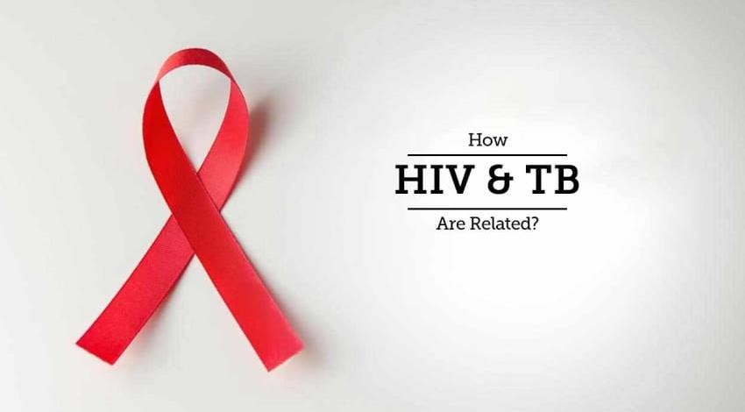

Chapter 14: Managing TB-HIV Co-infection

Introduction
Tuberculosis is a leading killer of HIV-positive people (PLHIV). In HIV positive persons, the risk of developing active TB disease is 18 times more than in those who are HIV negative. In 2021, 50% of notified TB patients in Zimbabwe were co-infected with HIV with 1 in 3 HIV reported deaths resulting from TB.

Clinical Presentation of TB in PLHIV
The clinical presentation of TB in PLHIV depends on the degree of immunosuppression. In persons with relatively well-preserved immune function and high CD4 T cell count, TB presents in a similar manner as in persons not infected with HIV. As immune function deteriorates, typical presentations become less common. In PLHIV, TB may present with
- more middle and lower lobe disease in the lung as opposed to upper lobe disease
- less cavitation on the chest X-ray
- a higher frequency of intrathoracic lymph node enlargement
- higher rates of extra-pulmonary TB, including pleural, pericardial and disseminated disease

In the pre-ART era, TB in PLHIV carried a very high mortality. This mortality risk still persists today but has significantly been reduced by ART even though early mortality in HIV infected TB patients remains a major clinical and public health challenge. The risk of active TB is highest in HIV co-infected patients who are not on ART and in those who have recently been enrolled in HIV care. The TB risk decreases significantly as the person’s immune function recovers but it does not decline back to the same level as that of HIV negative persons.

Components of the TB/HIV Collaborative framework
To mitigate the dual burden of TB/HIV in populations at risk of or affected by both diseases, the Stop TB Department and the Department of HIV/AIDS of the WHO published policy guidance on 12 collaborative TB/HIV interventions widely adopted as best practice particularly in high TB/HIV burden settings. These are summarized in the Table below;

A. Strengthening the mechanisms for delivering integrated TB and HIV services
A1 | Strengthening coordinating bodies for collaborative TB/HIV activities functional at all levels
A2 | Determining HIV prevalence among TB patients and TB prevalence among people living with HIV
A3 | Carrying out joint TB/HIV planning to integrate the delivery of TB and HIV services
A4 | Monitoring and Evaluating collaborative TB/HIV activities
B. Reducing burden of TB in people living with HIV & initiate early antiretroviral therapy (3 I’s for HIV/TB)
B1 | Intensifying TB case-finding and ensure high quality anti-tuberculosis treatment
B2 | Initiating TB preventive therapy and early antiretroviral therapy
B3 | Ensuring control of TB Infection in health-care facilities and congregate settings
C. Reducing the burden of HIV in patients with presumptive and diagnosed TB
C1 | Providing HIV testing and counselling to patients with presumptive and diagnosed TB
C2 | Providing HIV prevention interventions for patients with presumptive and diagnosed TB
C3 | Providing cotrimoxazole preventive therapy for TB patients living with HIV
C4 | Ensuring HIV prevention interventions, treatment and care for TB patients living with HIV
C5 | Providing antiretroviral therapy for TB patients living with HIV

Strengthening the mechanisms for delivering integrated TB and HIV services

Both the NTLP and the NAP will continuously work towards strengthening TB/HIV coordinating committees at national, provincial and district levels to support the integrated delivery of high-quality TB and HIV services. These committees are responsible for joint planning, coordinating implementation, surveillance, monitoring and evaluation as well as support and supervision across the two disease programmes.

- Both NTLP and NAP should ensure there is a functional TB/HIV coordinating mechanism across all levels for joint planning and implementation of TB/HIV collaborative interventions

Reducing the burden of TB in people living with HIV and initiate early antiretroviral therapy

Commonly known as the Three I’s, the principles of reducing the burden of TB in PLHIV involve Intensified TB case-finding among PLHIV, Initiating TB preventive therapy (TPT) and ensuring Infection prevention and control measures are institutionalized.

- Adults & adolescents living with HIV should be screened for TB & those who report any one of the symptoms
of current cough, fever, weight loss or night sweats should be evaluated for TB & other diseases
- All newly diagnosed HIV positive patients should submit one spot sputum for a WRD test regardless of negative symptom screen
- Adults, adolescents & children living with HIV who screen negative for active TB disease should be offered
TPT
Symptomatic enquiry can be done with measurement of BMI at every encounter with a health care worker and an annual CXR or as indicated. If the BMI is less than 17 kg/m2 and/or abnormal CXR, a specimen collected and submitted to the laboratory for WRD test such as Xpert MTB/RIF Ultra/Truenat MTB/MTB Plus. Urine LF-LAM can be used only in advanced HIV disease to assist in the diagnosis of TB

- The absence of a CXR should not be an access barrier for investigating one presumed to have TB

In health-care facilities and congregate settings where people with TB and HIV are frequently crowded together, the risk of infection with TB is increased. At facility level, measures to reduce TB transmission include administrative, environmental and personal protection controls, which are aimed at reducing exposure of health-care workers, prisons and any other persons living or working in congregate settings to M. tuberculosis.

Reduce the burden of HIV in patients with presumptive and diagnosed TB

People living with HIV may not know their HIV status when seeking health care. HIV testing and counselling for people with diagnosed or presumptive TB offers an entry point for a continuum of prevention, care, support and treatment for HIV and for TB. Evidence from observational studies shows that testing patients with presumptive and diagnosed TB and their contacts for HIV yields a high number of new diagnoses of HIV infection, as prevalence of HIV is higher than among the general adult population.

Q: In which groups do we use urine LF-LAM?

A: LF LAM is useful as a test for assisting in the diagnosis of TB among PLHIV who are either symptomatic or have Advanced HIV Disease (AHD)

- Advanced HIV Disease is defined as 1) HIV+ children < 5 years or 2) WHO Stages 3 or 4 or 3) PLHIV unable
to walk unaided, temperature ≥38 0C, respiratory rate >28/min or 4) CD4 count less than 200)

- Routine HIV testing should be offered to all patients with presumptive and diagnosed TB

Managing HIV in TB patients co –infected with HIV
Antiretroviral therapy greatly improves the survival and the quality of life of TB patients living with HIV, prevents HIV transmission and should be considered part of HIV and TB treatment and prevention. HIV programmes and TB-control programmes should ensure that TB patients diagnosed with HIV infection are offered ART as early as possible, preferably within integrated services or within TB health facilities. Evidence from randomized controlled trials shows that early initiation of ART during anti-tuberculosis treatment is associated with reduced mortality rates, especially in patients with profound immunosuppression. The CAMELIA trial showed that mortality was reduced by 34% when ART was initiated 2 weeks vs 8 weeks after onset of anti-tuberculosis treatment. The STRIDE and SAPIT trials found similar results of reduced deaths and AIDS-related events, by 42% and 68% respectively. Based on these trials, ART should be started as a matter of emergency (within 2 weeks after the onset of anti-tuberculosis treatment).

- ART should be started in all TB patients living with HIV irrespective of their CD4 counts
- Anti-TB treatment should be initiated first, followed by ART as soon as possible within the first 8 weeks of treatment & within 2 weeks for those with profound immunosuppression (e.g. CD4 counts <50 cells cells/mm3)
HIV care should be provided preferably under the same setting and patients transferred for continuation of HIV care to the OI/ART clinic after completion of TB treatment. All presumptive and diagnosed TB patients who test negative for HIV should be linked with HIV prevention services.

- A Dolutegravir (DTG)-based ART regimen is recommended choice for PLHIV with active TB

In HIV infected persons with intracranial TB, anti-TB treatment should be initiated promptly and ART initiation delayed until after 4 weeks of commencement of TB treatment to reduce the risk of intracranial TB – Immune Reconstitution Inflammatory Syndrome (IRIS), which could be fatal. All HIV infected TB patients should be given cotrimoxazole preventive therapy (CPT).

Managing TB-HIV Co-infection in Children
HIV infected children are at higher risk for progression to TB disease than HIV uninfected children. HIV makes the diagnosis and management of TB in children more difficult because HIV-associated pulmonary disease and TB disease present in a similar way. Generally, the tuberculin skin test (Mantoux) is less reliable in the presence of HIV infection. All children who are presumed to have TB should be screened for HIV with adherence to the same principles of counselling, consent or assent and confidentiality as in adults. It is recommended that all HIV infected children receiving treatment for TB should also receive supplementary pyridoxine.

- Children living with HIV with any of the following symptoms – poor weight gain, fever or current cough or contact history
with a TB case should be evaluated for TB & other conditions.
- Recommendations for ART initiation in HIV infected children being treated for TB remain the same as for adults

Considerations for ART and TB treatment
Drug–drug interactions can complicate TB and HIV treatment. The rifamycin-based drugs used in TB treatment (Rifampicin, Rifabutin and Rifapentine) are hepatic enzyme inducers and lower the serum concentration of many medicines used to treat HIV. Rifampicin is known to significantly lower plasma concentrations of DTG. When super boosting, clinicians should be aware that increasing doses is associated with increased risk of adverse drug reactions. The recommendations around rifamycin use is as follows:

- Patients receiving TB treatment with a Rifampicin based regimen, the dose of DTG should be increased from
50 mg once daily to 50 mg twice daily (12 hourly)
- Patients receiving Protease Inhibitors (PIs) for the treatment of HIV, Rifabutin given at a dose of 150 mg 3 times a week on alternate days, should be substituted for Rifampicin
- If Rifabutin is not available, the doses of Ritonavir boosted Lopinavir (LPV/r) should be doubled or the doses of Ritonavir increased to 400 mg twice daily (super boosting)
- In the rare circumstances where EFV 400mg is used among TB patients on ART, there is no need for dose
adjustment for Rifampicin

The following table below details the recommendations for adjusting treatment in patients receiving rifampicin
Table 26: Recommended Treatment adjustments in patients receiving Rifampicin

ART Regimen | What to do when TB treatment is started
DTG based regimen | DTG dose is doubled (Should be taken 12hrly)
LPV/r regimen | Transition to DTG-based regimen (with appropriate dose  adjustment) is preferable, and if not possible, LPV/r dose is doubled
ATV/r regimen | Change of regimen needed: replace ATV/r with DTG if DTG naïve (with appropriate dose adjustment)  with LPV/r if DTG experienced with appropriate dose adjustment
TAF-containing regimen | Change of regimen needed: TAF to be replaced by ABC or TDF
DRV/r-based regimen | Change of regimen needed: replace DRV/r with DTG if DTG naive, with LPV/r if DTG  experienced with appropriate dose adjustment. For patient on third line ART, substitute rifampicin with rifabutin
EFV-400 based regimen | No dose adjustment is necessary

- Children being treated for TB with a Rifamycin-based regimen, using a triple NRTI regimen e.g.,
AZT+3TC+ABC may be considered.
- This regimen may however be inferior in children with high plasma viral loads

Considerations for ART in XDR/MDR TB
Bedaquiline is primarily metabolized by CYP3A4, therefore, its concomitant use with EFV and PIs for patients with XDR/MDR TB can interfere with drug concentrations and should be undertaken with extreme caution and close clinical, bacteriological and virological monitoring. Therapeutic drug monitoring should be considered in these patients.

- WHO policy on collaborative TB/HIV activities Guidelines for national programmes & other stakeholders, Geneva, 2012
- Zimbabwe Final HIV Prevention, Testing and Treatment Guidelines (2022)
- François-Xavier B, Thim S, Didier L. et.al. Earlier versus Later Start of Antiretroviral Therapy in HIV- Infected Adults with Tuberculosis. N Engl J Med 2011; 365:1471-81. https://www.nejm.org/doi/pdf/10.1056/NEJMoa1013911?articleTools=true
- Luetkemeyer AF, Kendall MA, Nyirenda M, et.al. Tuberculosis immune reconstitution inflammatory syndrome in A5221 STRIDE: timing, severity, and implications for HIV-TB programs. J Acquir Immune Defic Syndr. 2014 Apr 1;65(4):423-8. https://www.ncbi.nlm.nih.gov/pmc/articles/PMC3943693/
- Salim S, Abdool K, Kogieleum N. et.al. Integration of Antiretroviral Therapy with Tuberculosis Treatment. N Engl J Med 2011;365: 1492-501.
https://www.nejm.org/doi/pdf/10.1056/NEJMoa1014181?articleTools=true

- Q: What is the link between HIV and TB?

- A: HIV infection is the greatest risk factor for progression from LTBI to active TB disease. The risk of developing TB disease is 7-10% each year for persons not receiving ART compared to 10% over a lifetime for persons infected only with M. tuberculosis but not HIV.

Chapter 15: TB Preventive Therapy

What is Latent TB infection (LTBI)?
LTBI is defined as a state of persistent immune response to stimulation by M. tuberculosis antigens, with no evidence of clinically manifest active TB. These bacilli may “reactivate” years after infection to cause active symptomatic and often transmissible TB disease. It is estimated that about a quarter of the world’s population is infected with TB. TB preventive treatment (TPT) is one of the key interventions recommended by WHO to achieve the End TB Strategy targets. Concomitant infection with HIV is a leading risk factor for progression from LTBI to active disease. The rate of progression to active TB disease is 7–10% per year among HIV infected patients compared with a 10% lifetime risk in the general population. Hence prevention of progression to active TB disease among those with LTBI remains a high priority in TB/HIV care.

Screening for TPT eligibility
- Adults and adolescents living with HIV should be screened for TB according to a clinical algorithm below. Those who do not report any of the symptoms of current cough, fever, weight loss or night sweats are unlikely to have active TB and should be offered preventive treatment, regardless of their ART status.
- Infants and children living with HIV who have poor weight gain, fever or current cough or who have a history of contact with a person with TB should be evaluated for TB and other diseases that cause such symptoms. If TB disease is excluded, these children should be offered TPT, regardless of age.
- Chest radiography may be offered to people living with HIV on ART and TPT given to those with no abnormal radiographic findings.

Exclusion criteria for TPT

Adults and adolescents living with HIV should be screened for TB and those who do not report any one of the symptoms of current cough, fever, weight loss or night sweats are unlikely to have active TB and should be offered TPT. The following patients should be excluded:
  - Patients who have symptoms and signs suggestive of active TB
  - Patients on treatment for TB
  - Completion of TPT within the past 3 years

Figure 15: Algorithm for LTBI testing and TB preventive treatment in individuals at risk
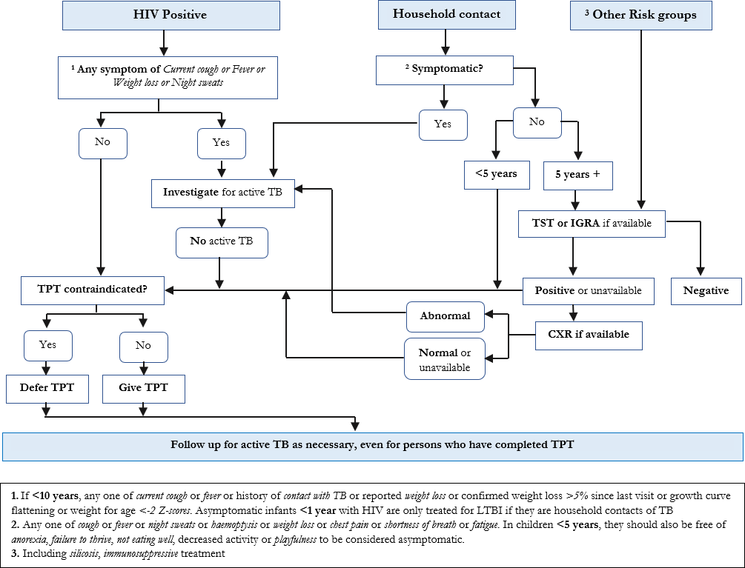

Testing for LTBI
LTBI testing is desirable whenever feasible, to identify persons at highest risk for developing active TB, but should never be a limiting step in access to TPT for clients eligible. Either a tuberculin skin test (TST) or interferon-gamma release assay (IGRA) can be used to test for LTBI.

The tuberculin skin test (TST)

The TST measures the delayed type hypersensitivity response to a purified protein derivative (PPD) from tubercle bacilli also known as tuberculin. A positive TST indicates infection with M. tuberculosis and not necessarily the presence of TB disease. TST, if available should be done using the Mantoux technique, where 0.1ml of PPD is injected intra-dermally on the volar aspect of the left forearm. In children and persons from low TB incidence countries (who may be visiting Zimbabwe for example) with clinical and or radiological features of TB disease a positive TST may provide supportive evidence of TB disease, but it should never be used as a test for active TB or interpreted to mean the presence of TB disease.

Interpretation of the TST result: Following BCG vaccination, a reaction to tuberculin usually persists for a few years. This reaction is usually weaker (diameter of skin induration is often less than 10 mm) than the reaction to natural infection with M. tuberculosis. A TST is usually considered significant or ‘positive” when the diameter of skin induration is at least 10 mm in HIV negative persons or 5 mm in HIV infected or severely malnourished persons.

A negative tuberculin skin test is when the diameter of skin induration is less than 10 mm in HIV negative persons (or less than 5 mm in an HIV infected or severely malnourished persons) regardless of whether the person had BCG vaccination or not. A negative TST does not exclude TB.

- Conditions that may suppress the TST include: HIV infection; disseminated TB or TB meningitis; severe
malnutrition; cancers; severe bacterial infection, including TB, viral infections;
- Immunosuppressive drugs; recent exposure to TB (2–3 months delay in conversion)
- Incorrect injection technique or storage of tuberculin

Interferon Gamma Release Assay (IGRA) tests

IGRA assays are used for the diagnosis of LTBI. The main advantage of IGRA is the high specificity compared to TST. This significantly eliminates false positive results in BCG-vaccinated individuals and therefore avoids the costs and toxicity associated with unnecessary treatment. The sensitivity of IGRA tests is similar to that of TST. These tests measure interferon gamma released in response to stimulation of sensitized T-cells by mycobacterial antigens. Two tests are currently available:
  - QuantiFERON Gold in Tube Test (QGIT)
  - T-SPOT. TB Test

- IGRA tests are expensive & unlikely to become routinely available in low resource limited settings such as
Zimbabwe
- Where resources are available, the following high-risk groups may be considered for testing with IGRA prior to TPT initiation: 1) prisoners; 2) healthcare workers 3) people who use drugs

Management of LTBI
Among people living with HIV, the combined use of TB preventive treatment (TPT) and ART has been shown to benefit both TB prevention and mortality, including among people with a higher CD4 cell count. In the absence of contraindications, TPT must be initiated at the time of ART initiation.

Eligibility for TPT among PLHIV
- Adults and adolescents living with HIV who are unlikely to have active TB should receive TPT as part of a comprehensive package of HIV care. Treatment should also be given to those on antiretroviral treatment, to pregnant women and to those who have previously been treated for TB, irrespective of the degree of immunosuppression and even if LTBI testing is unavailable.
- Infants aged < 12 months living with HIV who are in contact with a person with TB and who are unlikely to have active TB on an appropriate clinical evaluation should receive TPT.
- Children aged ≥ 12 months living with HIV who are considered unlikely to have active TB on an appropriate clinical evaluation should be offered TPT as part of a comprehensive package of HIV prevention and care, regardless of contact with TB.
- All children living with HIV who have successfully completed treatment for TB disease may receive TB preventive treatment.

- Both ART and TB Preventive Therapy (TPT) are effective in preventing HIV-associated TB individually and with additive effects when combined.
- Similarly, to prevent early HIV associated TB mortality, early initiation of ART in HIV-infected TB patients is a key imperative.

Other priority groups for TPT
- Contacts of bacteriologically confirmed PTB patients as described in Chapter 7.
- People on immunosuppressive treatment, or receiving dialysis, or preparing for an organ or haematological transplant, or who have silicosis should be systematically tested and treated for LTBI.
- Systematic LTBI testing and treatment may be considered for prisoners, health workers, immigrants from high TB burden countries, homeless people and people who use drugs.

Treatment regimens for LTBI

The options for the treatment of LTBI are recommended regardless of HIV status. The Table below details the recommended regimens for TPT in Zimbabwe. These are;
  - daily dose of isoniazid given for 6 months (6H)
  - 3 months weekly doses of Isoniazid and Rifapentine (3HP)
  - 3 months daily doses of Rifampicin and Isoniazid (3RH)
  - 1-month daily doses of Isoniazid and Rifapentine (1HP)
  - 4 months daily doses of Rifampicin (4R)
  - 6 months daily doses of Levofloxacin (6LFX) in RR/MDR TB

- Zimbabwe has currently adopted and is implementing 3HP, 6H, 3RH and 6LFX
- The country currently re-doses PLHIV including children every 3 years after completing TPT, and TB contacts after every exposure
Table 27: Recommended regimens for TPT in Zimbabwe

Population Group | Preferred Treatment | Alternative
Adults
PLHIV on EFV and DTG based regimen | Three months of weekly Rifapentine and  Isoniazid (3HP) | Six months of daily Isoniazid alone (6H)
PLHIV on TAF, PIs and NVP based  regimen | Six months of daily Isoniazid alone (6H) | -
HIV negative contacts (adults and  adolescents > 15 years) | Three months of weekly Rifapentine and  Isoniazid (3HP) | Six months of daily Isoniazid alone (6H)
Children
CLHIV on EFV-based regimen  (Adolescents, children > 2 years) | Three months of weekly Rifapentine and  Isoniazid (3HP) | Six months of daily Isoniazid alone (6H)
CLHIV on DTG, PIs and NVP based  regimen | Six months of daily Isoniazid alone (6H) | -
HIV negative contacts (Children under 15  years) | Three months of daily Rifampicin and  Isoniazid (3RH) | Six months of daily Isoniazid alone (6H)
Special Groups
MDR-TB Contacts | Six months of daily Levofloxacin (6LFX) | -
Pregnant women | Six months of daily Isoniazid alone (6H) | -

TPT and Pyridoxine

Pyridoxine (vitamin B6 supplements) should be dispensed together with isoniazid-containing regimens to individuals at risk for peripheral neuropathy, such as those with malnutrition, chronic alcohol dependence, HIV infection, renal failure or diabetes, or who are pregnant or breastfeeding. However, pyridoxine unavailability should not be a barrier for 3HP and 3RH initiation. If pyridoxine is not available, 3HP and 3RH should be administered without it. The dosing for pyridoxine in TPT is described below.
Table 28: TPT and Pyridoxine Dosing

Regimen | Dose | Maximum Dose
Pyridoxine | Individuals aged 2–14 years: 12.5 mg  Individuals aged ≥ 14 years: 25 mg | 100 mg
Rifapentine plus isoniazid [3HP] | Weekly for 3 months (12 doses) Isoniazid  10-15 kg = 300 mg  15.1-23 kg = 500 mg  23.1-30 kg = 600 mg  >30.1= 900 mg | Isoniazid, 900mg  Rifapentine, 900mg

Rifapentine:
10-15 kg = 300 mg
15.1-23 kg = 450 mg
23.1-30 kg = 600 mg
>30.1= 900 mg
Isoniazid alone [6H] | Daily for 6 months  Adults: 5 mg/kg  Children: 10 mg/kg (range 7-15 mg/kg) | 300 mg
Isoniazid plus rifampicin [3RH] | Daily for 3 months Isoniazid:  Children: 10 mg/kg (range, 7-15 mg/kg) Rifampicin:  Children, 15 mg/kg (range, 10-20 mg/kg) | Isoniazid, 300 mg  Rifampicin, 600 mg
Levofloxacin [6LFX] | Levofloxacin:  5-9 kg: 150 mg  10.1-15 kg: 250 mg  15.1-23 kg: 350 mg  23.1-30 kg: 500 mg  30.1-50 kg: 625 mg  >50 kg: 750 mg | Levofloxacin, 750mg

Monitoring Schedule

Healthcare workers (HCWs) are required to monitor client performance once initiated on TPT. During every visit or scheduled review, HCWs should assess for adverse drug reactions. Clients must be assessed at least once every month using telehealth models. Monitoring visits for TPT should be aligned with ART refill dates for PLHIV, considering multi-month refills, remote follow-up for side effects, adherence and completion. However, clients should be encouraged to urgently report to the health facility whenever they experience undesirable side effects. Multi-month refills of TPT may be given. For INH (6H), three- or six- monthly refills should be provided and the full three months of 3HP may be given at initiation. The full course of TPT should be assigned to any recipient of care initiated on TPT to avoid treatment interruption.

- The recommended monitoring schedule follow up for patients on TPT is: 1) For 3HP - follow-up call at week 2, month 1, month 3 – document completion; These should be synchronized with scheduled ART refills
- 2) For 6H - follow-up call at week 2, month 1, month 3, month 6 – document completion

Adverse Event Monitoring

Clients on TPT may develop adverse drug reactions. All HCWs and patients are required to report all suspected adverse drug reactions to TPT and complementary medicines to the Medicines Control Authority of Zimbabwe (MCAZ). Spontaneous reporting should be done using the current MCAZ adverse reporting form.

Drug-Drug Interactions

Isoniazid is an enzyme inhibitor. As such, it increases the drug concentrations of drugs metabolized by the affected liver enzymes. Drugs from the following classes are affected
  - anticonvulsants (e.g. carbamazepine and phenobarbitone)
  - anticoagulants (e.g. heparin and warfarin)
  - anti-retroviral (e.g. Efavirenz)
  - some Selective Serotonin Reuptake Inhibitors (SSRIs) (e.g. sertraline).

Rifapentine and Rifampicin are enzyme inducers, as such, they decrease drug concentrations of drugs metabolized by the affected liver enzymes. Affected drug classes are
  - hormonal contraceptives

  - anti-retrovirals (e.g. protease inhibitors and Dolutegravir)
  - antifungals
  - anti-diabetics (sulfonylureas)
  - cardiac glycosides (e.g. digoxin)
  - steroids (e.g. betamethasone, beclomethasone, hydrocortisone)
  - anti-malarial (e.g. Artemisinin-based Combination Therapy (ACT)
  - anti-psychotics (e.g. chlorpromazine, haloperidol).

Drugs for the treatment of adverse events
Facilities should at least keep the minimum stocks of medicines that are required to manage adverse drug reactions from TPT medicines at any point in time.

TPT Adverse Drug Reactions Symptoms and Management

The Table below is summary of potential ADRs associated with TPT and their management;

Table 29: TPT Adverse Drugs Reaction Symptoms and Management

Adverse Drug Reaction | Likely Drug  responsible | Management
Minor |  | Medical Officer assessment is recommended & appropriate  management according to guidelines
Anorexia, nausea, abdominal pain | Rifampicin, Rifapentine | Continue anti-TB medicines. Check medicine doses. Even  though the NTLP recommends DOT for all TB patients in Zimbabwe, patients experiencing these minor AEs should be advised to take the medicines at night, preferably with a family member providing DOT. Ranitidine, omeprazole, or an antacid may also be prescribed.
Skin rash with mild itchiness, no mucous  membrane involvement or blisters | Rifampicin, Rifapentine  Isoniazid | Chlorpheniramine 4 mg tds or Promethazine 25-50 mg at  night. Aqueous cream, Calamine skin lotion.
Peripheral neuropathy/Burning sensation  in feet | Isoniazid | Pyridoxine 25 mg 2-3 times daily. Maximum daily dose for  Pyridoxine is 100mg.
Orange/red urine | Rifampicin | Reassure patient. Let patient know this at the beginning of  treatment (before the first dose is taken).
Major |  | Stop responsible medicines. Refer patient to a medical  officer and/or arrange admission to hospital.
Itching of skin with rash, mucous  membrane involvement, blistering | Rifampicin, Rifapentine  Isoniazid | Stop anti-TB drugs. Refer to the next level if you cannot  manage. Wait until the rash has resolved and resume medication at a hospital.
Hepatotoxicity Jaundice (other causes should be excluded) | Rifampicin, Rifapentine and  Isoniazid | Stop anti-TB drugs. Do liver function tests. Test for Hepatitis A, B and C
Vomiting and confusion: suspect drug-  induced acute liver failure | Rifampicin, Rifapentine  and Isoniazid | Refer to hospital for admission. Stop anti-TB medicines  and urgently do a liver function test. Check for the presence of hepatitis viruses (A, B and C) and check the prothrombin time/International Normalized Ratio (INR)
Shock, purpura (bleeding under the skin),  acute renal failure | Rifampicin | Stop Rifampicin

Laboratory Testing

Baseline laboratory testing (measurements of serum AST, ALT, and bilirubin) is not routinely necessary

Patient Education

The following patient education messages must be delivered during TPT administration:

  - Explain the disease process and rationale for medication in the absence of symptoms or radiographic abnormalities.
  - Emphasize the importance of completing TPT.
  - Discuss possible side effects of LTBI medications that may include
    - Fever; Unexplained anorexia; Dark urine (colour of coffee or cola); Jaundice; Rash;
    - Persistent paresthesia of hands and feet; Persistent fatigue or weakness lasting 3 or more days
    - Abdominal tenderness, especially in right upper quadrant; Easy bruising or bleeding; Arthralgia; Nausea and Vomiting
  - Discuss management of common adverse effects and the need to report to the health care provider.

Assessing Adherence
Many variables affect a patient’s adherence to TPT. Episodes of non-adherence should be recognized and addressed as soon as possible.

- Both ART and TB Preventive Therapy (TPT) are effective in preventing HIV-associated TB individually and with additive effects when combined.
- Similarly, to prevent early HIV associated TB mortality, early initiation of ART in HIV-infected TB patients
is a key imperative.

- Q: Can TPT worsen the TB drug-resistance problem in the world?
- A: There is no evidence of association between TB drug resistance and TPT given to treat LTBI. It is however important to exclude active TB disease before TPT is prescribed. Regular follow-up is also required to ensure people who develop active TB while receiving TPT are identified early.
- Q: Should pregnant women living with HIV take TPT?
- A: Pregnant women living with HIV are at risk of TB, which can have devastating consequences for both the mother & their unborn child. Pregnancy is not a contraindication for receiving TPT.

Bacillus Calmette-Guérin (BCG) Prevention
The BCG vaccine is made from a weakened strain of TB bacteria. Because the bacteria in the vaccine is weak, it triggers the immune system to protect against the infection but does not give one TB. It provides consistent protection against the most severe forms of TB, such as TB meningitis in children. It's however less effective in preventing TB that affects the lungs in adults and so has limited impact on the spread of TB. The vaccine is given as an injection into the left upper arm and usually leaves a small scar.

- In Zimbabwe the vaccine is given at birth or at the earliest contact with the health system.
- BCG is however contraindicated in children infected with HIV

BCG in children born to mothers with bacteriologically confirmed PTB

If the mother has PTB, the baby should receive TPT of INH (10 mg/kg for 6 months) and pyridoxine after ruling out active TB disease. A repeat assessment to exclude active TB should be done at 2 months using symptoms and a Tuberculin Skin Test (TST). If negative, INH is continued until 6 months of INH is completed. Upon completion, BCG vaccination should be provided (if

not yet vaccinated). The mother and baby should not be separated on account of TB. As far as possible, the mother and child should stay together for the duration of treatment. Should the child be deemed to have active TB at any point during TPT, they should be initiated on appropriate TB treatment.

Chapter 16: TB Infection Prevention and Control

Introduction
TB prevention and control consists of a combination of measures designed to minimize the risk of M. tuberculosis transmission within populations. A three-level hierarchy of controls comprising administrative controls, environmental controls and respiratory protection has been shown to reduce and prevent the risk of transmission and exposure to M. tuberculosis. Effective TB infection prevention and control (TB-IPC) measures are a critical part of the quality of health service delivery to achieve people-centred, integrated universal health coverage.

Hierarchy of TB infection prevention and control measures

Administrative controls

These are the first and most important level of the hierarchy. These are management measures that are intended to reduce the risk of exposure to persons with infectious TB. They include triage and patient separation systems (i.e. management of patient flows to promptly identify and separate presumptive TB cases), prompt initiation of effective treatment and respiratory hygiene.

  - Triage of people with TB signs and symptoms, or with TB disease, is recommended as an administrative control to reduce
M. tuberculosis transmission to health workers (including community health workers), persons attending health care facilities or other persons in settings with a high risk of transmission. Implementation of any triage system needs to be focused on fast-tracking of presumed TB cases and on minimizing time in the facility. In addition, community health workers are key to promptly identifying presumptive TB cases at the community level and making use of referral systems, to fast-track TB diagnosis and facilitate the implementation of other interventions.

  - Respiratory separation/isolation of people with presumed or demonstrated infectious TB is recommended to reduce M. tuberculosis transmission to health workers or other persons attending health care facilities. Health care systems must however prioritize available patient care and support measures before resorting to isolation of any person. In situations where isolation is required, this should be decided in consultation with the patient, and carried out in medically appropriate settings.

  - Prompt initiation of effective TB treatment of people with TB disease is recommended to reduce M. tuberculosis transmission to health workers, persons attending health care facilities or other persons in settings with a high risk of transmission. Evidence continues to mount that delays in initiation of effective TB treatment increase the probability of onward transmission of the disease

  - Respiratory hygiene (including cough etiquette) in people with presumed or confirmed TB is recommended to reduce M. tuberculosis transmission to health workers, persons attending health care facilities or other persons in settings with a high risk of transmission. Respiratory hygiene is defined as the practice of covering the mouth and nose during breathing, coughing or sneezing (e.g. wearing a surgical mask or cloth mask, or covering the mouth with tissues, a sleeve, or a flexed elbow or hand, followed by hand hygiene) to reduce the dispersal of airborne respiratory secretions that may contain M. tuberculosis bacilli. The use of respiratory hygiene measures applies to individuals with confirmed or presumed TB in all health care settings, as well as to such individuals in other settings with a high risk of M. tuberculosis transmission (including households and non-health care congregate settings such as correctional facilities). Respiratory hygiene must be implemented at all times. The use of surgical masks, in particular, is of utmost importance in waiting rooms, during patient transport and in any situation, which can lead to temporary exposure to M. tuberculosis.

- The greatest risk of transmission occurs when TB patients remain undiagnosed and untreated.
- The most critical element of infection control therefore is early diagnosis and prompt initiation of effective TB treatment.

Environmental controls

To reduce the risk of transmission of M. tuberculosis, air can be made less infectious through the use of three principles: dilution, filtration and disinfection. Environmental controls are aimed at reducing the concentration of infectious droplet nuclei in the air. This is achieved by using special ventilation systems to maximize airflow rates or filtration, or by using germicidal ultraviolet (GUV) systems to disinfect the air. Upper-room GUV systems rely on air mixing between the upper and lower parts of a room. Thus, when implementing this intervention, it is essential to consider factors that may affect the vertical air movement and transport of the infectious microorganisms to the upper portion of the room (e.g. use of simple fans to facilitate air movement in a room).

Ventilation systems can also be used to control the direction of airflow to reduce the spread of infection; for example, through the use of exhaust fans to generate negative pressure gradients. The use of poorly designed or poorly maintained ventilation systems, leading to inadequate airflow, can result in health care associated transmission of M. tuberculosis. When a decision has been made to use a ventilation system, it is essential to ensure sustained use of systems that can provide sufficient dilution and removal of infectious particles. This can be achieved through proper commissioning of ventilation systems.

- Natural ventilation is the preferred ventilation system in resource-limited settings where there is high risk of
M. tuberculosis transmission. It is also preferred in settings with no constant electricity
- Use of mixed-mode ventilation, mechanical ventilation or high-efficiency particulate air (HEPA) filters may be more appropriate in settings where natural ventilation is not suitable because of other constraints.

- Measures to optimize ventilation include maximizing natural ventilation by keeping facility windows and doors open at all times when providing care to patients even during winter & at night
- Promoting cross ventilation (opening of windows or doors on opposite walls)
- Using open-air shelters with a roof to protect patients from sun & rain as waiting areas.
- Avoiding patients crowding in narrow, poorly ventilated and lighted corridors as they wait for services.
- Organizing sitting arrangements in consultation rooms to avoid airflow from patient to HCW.
- Being mindful of the direction of airflow to ensure the patient is closest to the exhaust fans and the HCW is closest to the clean air source
- Controlling the direction of airflow e.g. with strategically placed fans.
- Utilizing an open plan in patient waiting areas and wards to let in sunlight.

Respiratory protection control

This is the third level of the hierarchy. It consists of the use of personal protective equipment in situations that pose a high risk of exposure to M. tuberculosis. Respiratory protection controls are designed to further reduce the risk of exposure to M. tuberculosis (and other airborne pathogens) for HCWs in special areas and circumstances. Inadequate implementation of respiratory protection programmes may lead to a false sense of security and therefore increase the risk to HCWs. Use of particulate respirators (N95 Respirators), within the framework of a respiratory protection programme, are recommended to reduce M. tuberculosis transmission to HCWs, persons attending health care facilities or other persons in settings with a high risk of transmission.

Use of particulate respirators for HCWs is recommended only when a respiratory protection programme can be put in place. Attempting to establish one without the other may lead to overreliance on respirators, and give a false sense of protection. When setting up respiratory protection programmes, it is important to also consider the provision of respiratory protection to community health workers at risk of exposure to individuals with TB

Figure 16: KN95, N95 respirators and medical mask respectively
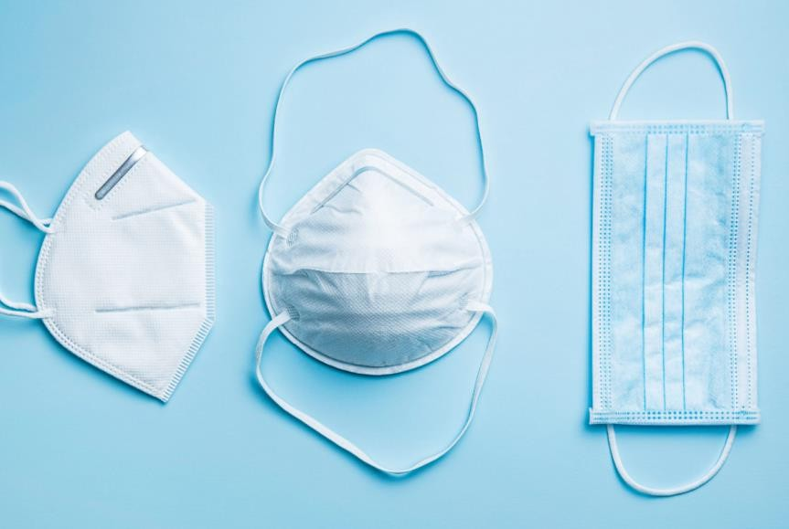
Performing a N95 fit test - Hold the Respirator in the palm of hand, with the cup facing upwards; place the respirator on face covering the nose and mouth and secure the mask using elastic bands. The top metallic margin should be above the nasal bridge; adjust the metallic section to tightly fit. Cup both hands over the mask gently and test the seal by exhaling forcefully after a deep breath. For a well-fitting respirator, pressure build-up with no air blowing to your eyes or ears through the margins of mask should be felt. The mask should collapse on forceful inhalation.

- Respirators should be worn by all personnel entering high-risk areas, in particular by HCWs living with HIV, given the increased risk of developing TB disease if exposed in the workplace.

- The use of PPE should never replace, prioritization of the less expensive, administrative control measures

TB Infection Control Planning in Healthcare Settings
Health facility specific TB infection control plans should be part and parcel of the overall facility infection prevention and control (IPC) programme. The plan should be guided by the Zimbabwe National Infection Prevention and Control policy. All health care facilities should develop and implement a facility specific TB infection control plan, designed to:
  - Ensure prompt identification of presumptive cases of TB.
  - Appropriate, non-stigmatizing, immediate separation of presumptive cases or infectious TB cases from other patients.
  - Prompt testing of presumptive cases of infectious TB with WRDs such as the Xpert MTB/Rif Ultra assay.
  - Prompt initiation of treatment of bacteriologically confirmed cases of infectious TB
  - Appropriate and sustained implementation of simple but effective environmental infection transmission prevention measures.
  - Judicious use of personal protective equipment
  - Continuous monitoring and periodic evaluation of the TB-IPC plan and its implementation.

To develop a TB-IPC plan, it is critical to carry out a baseline TB infection control risk assessment to identify the risk areas and what needs to be done in the various units or departments of the facility, using a standardized TB-IPC risk assessment tool. The task of developing, implementing and monitoring the TB-IC plan should be done by the IPC Committee of the health facility.

Figure 17: Optimizing sitting arrangements to promote TB IPC
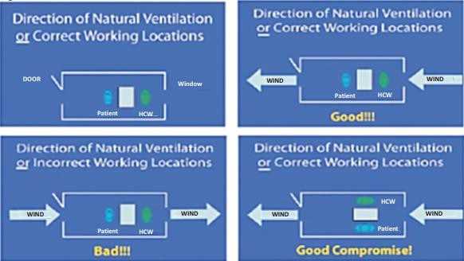
Health care worker screening for TB should be free of charge and preferably as part of routine medical evaluation within a comprehensive health worker wellness program, which should include HIV testing and counselling services as well as screening for non-communicable diseases such as cancers, diabetes mellitus and hypertension. All health facility staff, including medical and administrative staff, should be targeted for periodic screening.

- All HCWs should be screened for TB using a symptom screen, BMI and CXR on an annual basis and
symptomatically at least every six months as part of workplace wellness.

Consideration for special settings - prisons, holding cells and other congregated settings
All the TB infection control measures described in this guideline apply also to medical services in refugee camps, correctional facilities and other congregated settings. This is because the spread of TB is worsened by the often-poor living conditions in these settings such as overcrowding, malnutrition and HIV. It is recommended that the following measures are routinely carried out:
  - Regular TB screening of inmates and refugees to ensure early diagnosis of active TB and prompt initiation on appropriate treatment.
  - Screening of all new inmates and new arrivals at a refugee camp using the TB screening tool and CXR (where available). All presumptive TB cases should submit a spot sputum sample for TB testing with WRD test
  - Encouraging all staff and their dependents working in congregate settings to undergo six monthly symptom screening and annual CXR screening as part of a comprehensive workplace wellness programme.
  - Separating inmates diagnosed with active TB from other inmates to prevent further transmission. Similar measures with appropriate modification may be carried out in refugee camps.
  - Improving the living conditions for inmates with special attention to reducing overcrowding.
  - Offering TB information and HIV testing and counselling to all staff and inmates.
  - Particular attention paid to integrating prison and civilian TB services so that there is continuation of care after discharge from correctional facilities.

Community Household TB-IPC
TB contact investigation should be undertaken as described in chapter x. Information, education and communication messages including basic TB-IPC behavior-change should be provided. Coughing etiquette and respiratory hygiene in the household before and after diagnosis of TB should be emphasized. Stigma reduction should not be forgotten. Environmental control measures to reduce exposure should be emphasized. Natural ventilation should be improved in households particularly in rooms where people with TB spend much time. Bacteriologically confirmed PTB patients in the first 2-4 weeks of treatment should spend as much time as possible outdoors, stay in a well-ventilated room, if possible, and spend as little time as possible in congregate settings.

Children less than 5 years old should spend as little time as possible in the same living spaces as persons with bacteriologically confirmed PTB patients. Child contacts of MDR-TB patients should be followed up regularly with TB screening and if possible culture and DST. Home environment assessments should be conducted for TB-IPC adequacy to inform appropriateness of the home for TB care and to provide health education to families.

- The period of household transmission is greatest before the diagnosis & initiation of TB treatment.
- Early case detection and prompt treatment is the key to reducing the risk of household Tb transmission.

Considerations of TB-IPC in construction of health facilities
A multidisciplinary team should coordinate health facility demolition, construction, and renovation projects. During the developmental stages of health facility construction or renovation projects, the MoHCC should work closely with the Ministry of Public Works to proactively embed TB transmission minimizing designs for the new or renovated facilities. The engagement of the NTLP in this process is essential to ensure TB infection prevention experts are part of the team.

- WHO guidelines on tuberculosis infection prevention and control, 2019 update, Geneva: World Health Organization; 2019. https://apps.who.int/iris/bitstream/handle/10665/311259/9789241550512-eng.pdf

Part 5: Leprosy “Hansen’s Disease”

Chapter 17: Enhancing and sustaining efforts to eliminate Leprosy

Introduction
Zimbabwe aligns with the WHO global leprosy strategy (2021-2030) towards zero leprosy: zero infection and disease, zero disability, zero stigma and discrimination and the elimination of leprosy (defined as interruption of transmission). Zimbabwe reached the WHO target of elimination of leprosy in 1987, defined as less than one case per 10,000 population. However total eradication of the disease remains elusive. A strong surveillance system is required to maintain leprosy control at the elimination phase. Leprosy continues to be a serious cause of morbidity and disability and the social stigma associated with the disease further complicates its control. The generation of new evidence and innovations for leprosy control continues to be limited despite the apparent re-emergence of the disease.

Objectives of the Leprosy Control Program
  - To detect leprosy cases before they develop grade two disabilities.
  - To treat all diagnosed PB/MB leprosy cases using effective MDT.
  - To develop and distribute data recording and reporting tools to all levels and integrate leprosy surveillance into the DHIS2 system.
  - To prevent at least 95% of leprosy cases developing disabilities during treatment.

Basic Facts about Leprosy
  - Leprosy is a chronic infectious disease (also known as Hansen’s Disease) caused by a type of bacteria, Mycobacterium leprae (M. leprae).

  - The disease predominantly affects the skin, mucosa of the upper respiratory tract, and the eyes and peripheral nerves (sensory, motor and autonomic nerves). Left untreated, the disease may cause progressive and permanent disabilities.

  - The bacteria are transmitted via droplets from the nose and mouth during close and frequent contact with untreated cases. The skin is the second portal of entry. Prolonged, close contact over months with someone with untreated leprosy is needed to catch the disease. The disease is not spread through casual contact with a person who has leprosy like shaking hands or hugging, sharing meals or sitting next to each other. A patient stops transmitting the disease when they begin treatment.

  - Leprosy is curable with multidrug therapy (MDT) and treatment in the early stages can prevent disability.

  - It is reported from all the six WHO Regions with majority of annual new case detections from South-East Asia.

Susceptibility to infection

Most people are not susceptible to leprosy and only a very small proportion of those exposed develop the disease. There are several factors that increase an individual’s risks to developing leprosy. These include older age which may reflect either a weaker immune system or the increased likelihood of lifetime exposure to a multi- bacillary (MB) case.

Clinical features of leprosy

Manifestations of Leprosy depend on the infected person’s immune response to the bacterium. In many patients, at the time of presentation there will often be signs of nerve damage such as weakness or anaesthesia due to a peripheral nerve lesion or a blister, burn or ulcer in an anaesthetic hand or foot.

Leprosy case finding

Case finding is primarily passive and HCWs should have a high index of suspicion to rule out leprosy in all patients presenting with dermatological lesions. HCWs should also ensure that, ALL household contacts of leprosy cases are traced and screened for leprosy and those who do not have symptoms or signs of the disease placed on surveillance for at least 5 years.

Diagnosis of Leprosy
A complete history and physical examination in addition to laboratory tests are essential for the diagnosis of leprosy. The main components of the clinical assessment are:

  - History
  - Skin examination
  - Nerve palpation
  - Nerve function impairment (NFI) assessment: voluntary motor sensory test (VM- ST)
  - Eye examination
  - Deformity, disability and psychological assessment

- The three cardinal signs of leprosy include:
- Definite loss of sensation in a pale (hypo-pigmented) or reddish skin patch.
- A thickened or enlarged peripheral nerve with loss of sensation and/or weakness of muscles supplied by the affected nerve.
- The presence of acid -fast bacilli (AFB) in a slit skin smear.

Leprosy Classification

Leprosy is classified into two treatment groups:

  - PB (Pauci-bacillary): usually the PBs have one to five lesions and the skin smear is usually not required because most smears are always negative. These cases are diagnosed clinically based on the characteristic clinical presentation

  - MB (Multi-bacillary): MBs have more than six lesions and the skin smear is usually positive. The diagnosis of MBs is more bacteriological than clinical.

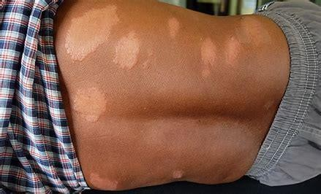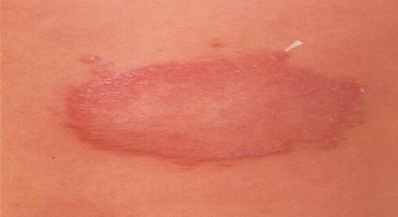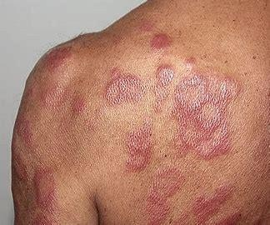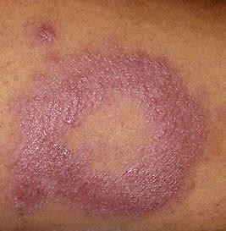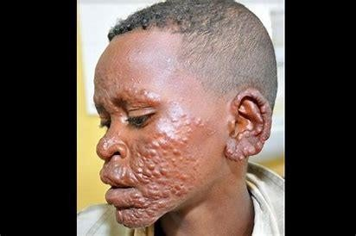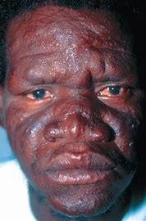
Tuberculoid Leprosy: One or a few well-demarcated, hypo- pigmented & anesthetic skin lesions, frequently with active, spreading edges & a clearing center. Peripheral nerve swelling or thickening also may occur.
Border Line Leprosy: Lie in the middle of the polar TT to LL spectrum. This form is seen in those people with limited or variable resistance to M. leprae. Skin & nerve involvement is commonly seen, with only rare involvement of other structures
Lepromatous Leprosy: A number of erythematous papules & nodules or an infiltration of the face, hands & feet with lesions in a bilateral & symmetrical distribution that progress to thickening of the skin.

Leprosy complications
Leprosy reactions are immunologically mediated episodes of acute or sub-acute inflammation and are classified as either Type 1 (reversal) reactions or Type 2 (erythema nodosum leprosum (ENL) reactions. They occur more commonly in MB leprosy than PB leprosy patients.

Type 1 (reversal or upgrading) reactions are due to a delayed hypersensitivity response to M. leprae antigens, occurring in borderline lepromatous (BL), borderline borderline (BB) or borderline tuberculoid (BT) cases. They are characterized by acute neuritis and/or acutely inflamed skin lesions. Usually with onset of type 1 reactions, there is an associated change in Ridley- Jopling classification towards the tuberculoid end of the spectrum. There is nerve tenderness with loss of sensory and motor functions. Redness and swelling in pre-existing skin lesions occur, and lesions which have not been visible may appear. Fever, malaise and peripheral oedema are additional features if the reaction is severe. Onset may be spontaneous though it is commonest after starting treatment.

- Type 1 reactions should be treated by experienced clinicians using prednisolone 40mg, 30mg, 20mg, 15mg, 10mg, & 5mg daily, in this order, each dose for 2 weeks.
- Whenever prednisolone is being used, precautions & prior screening for opportunistic infections must be done.
Type 2 (erythema nodosum leprosum or ENL) reactions are an immune complex response that develops due to an imbalance of the humoral immune system. They are the most serious complication of leprosy and occur in about 15% of patients with MB

disease (LL and BL). Reactions may occur spontaneously or while on treatment. There is a sudden appearance of superficial or deep crops of new, tender, subcutaneous nodules on the back, the dorsum of the hands or the extensor aspects of the forearms and thighs that generally last for about 3 days. The whole episode usually lasts 2 weeks though it may be prolonged or recurrent over several years. ENL is commonly associated with systemic symptoms including:

  - High fever peaking in the evenings
  - Neuritis
  - Leucocytosis
  - Orchitis
  - Nephritis
  - Periostitis
  - Iridocyclitis (eye inflammation)
  - Joint inflammation (arthritis)

Treatment of Leprosy
Leprosy patients should be referred to the district hospital for further management if they have complications or if they require specialized services such as

  - Management of adverse reactions to anti-leprosy medicines.
  - Management of lepromatous reactions
  - Management of deep ulcers
  - Rehabilitation services

In 2017, the Global Leprosy Program (GLP) recommended use of a 3-drug regimen of rifampicin, dapsone and clofazimine for all leprosy patients, with a duration of treatment for 6 months for PB leprosy and 12 months for MB leprosy. The recommended regimens, doses and frequencies are shown in the Table below.

Table 30: Recommended MDT regimens for the treatment of leprosy

Age group | Drug | Dosage & frequency | Duration
Age group | Drug | Dosage & frequency | MB | PB
Adult | Rifampicin | 600 mg once a month | 12 months | 6 months
Adult | Clofazimine | 300 mg once a month and 50 mg daily | 12 months | 6 months
Adult | Dapsone | 100 mg daily | 12 months | 6 months
Children  (10–14 years) | Rifampicin | 450 mg once a month | 12 months | 6 months
Children  (10–14 years) | Clofazimine | 150 mg once a month, 50 mg on  alternate days | 12 months | 6 months
Children  (10–14 years) | Dapsone | 50 mg daily | 12 months | 6 months
Children <10 years  old or <40kg | Rifampicin | 10 mg/kg once month | 12 months | 6 months
Children <10 years  old or <40kg | Clofazimine | 100 mg once a month, 50 mg twice  weekly | 12 months | 6 months
Children <10 years  old or <40kg | Dapsone | 2 mg/kg daily | 12 months | 6 months

If drug-resistant leprosy is suspected or confirmed, at least two of the following second-line medicines should be used: clarithromycin, minocycline, or a quinolone (ofloxacin, levofloxacin or moxifloxacin), plus clofazimine daily for 6 months, followed by clofazimine plus one of the second-line drugs daily for an additional 18 months. In case of rifampicin plus ofloxacin resistance, a quinolone should not be chosen; and the recommended regimen is clarithromycin, minocycline and clofazimine for 6 months followed by clarithromycin or minocycline plus clofazimine for an additional 18 months.

Treatment Case holding
Medication should initially be dispensed weekly until full adherence with and understanding of the regimen is assured, and then a 4-weekly cycle of DOT and examination is established. Failure to attend a single 4-weekly DOT session requires an immediate

effort to trace the patient and find an explanation. HCWs at the local health facility should provide medication, assess adherence, monitor nerve function and trace patients who interrupt treatment. Patients on leprosy treatment should be reviewed every 3 months by a medical officer.

Adverse events of anti- leprosy medicines

Outlined below are the common adverse reactions of anti-leprosy medicines and the actions to be taken when they occur.

Table 31: Common adverse events from Leprosy treatment & their management

Adverse Event | Description & Action
Jaundice | The cause is usually Rifampicin. All anti-leprosy medicines should be stopped immediately and the  patient referred to the district hospital.
Anaemia | Anemia may be caused by Rifampicin and or dapsone. Other causes of anemia such as parasites and  malaria among many others should be ruled out.
Exfoliative dermatitis | This is usually caused by dapsone. The skin is itchy, and later peels off. The patient may be very ill. All  anti-leprosy medicines should be stopped immediately and the patients referred to the district hospital
Fixed drug eruption | A fixed drug eruption is an allergic reaction to a medicine that characteristically recurs in the same site or sites each time a particular drug is taken. This is usually caused by dapsone. The dapsone should be  stopped immediately. The eruption will slowly clear after dapsone treatment is stopped.

Contact tracing

Case detection and treatment with MDT alone have proven insufficient to interrupt transmission. To boost the prevention of leprosy, with the consent of the index case, WHO recommends tracing household contacts along with neighborhood and social contacts of each patient, accompanied by the administration of a single dose of rifampicin as preventive chemotherapy.

Stigma and Discrimination

People affected by leprosy are often subject to discrimination and stigmatization. This situation has negative effects on access to diagnosis, outcome of treatment and care, in addition to violation of civil, political and social rights. Ending discrimination, stigma and prejudice is fundamental to ending leprosy. Psychosocial support is needed for the leprosy patients to deal with the discrimination and stigma.

Management and Prevention of Disabilities
Disability grading (0, 1, or 2) is carried out for the purposes of patient management, reporting to WHO and monitoring program objectives. The highest value for any body part is taken as the overall disability grading for the patient, e.g. if hands, feet, and left eye are graded 0, but the right eye is graded 2, then the overall grading for the patient is 2. It is sometimes expressed as an Eye- Hand-Foot (EHF) score where each hand, foot, and eye is graded 0, 1 or 2, and these grades are summed bilaterally for a maximum score of 12. The table below shows the classification of leprosy disabilities.

Table 32: Classification of leprosy disabilities

Hands and Feet
Grade Disability
- No anaesthesia, no visible deformity or damage
- Anaesthesia present, no deformity or damage
- Visible deformity or damage
Eyes
Grade Disability
- No eye problems due to leprosy; no evidence of visual loss
- Eye problems due to leprosy, vision not severely affected (6/6 or better), can count fingers at six meters
- Severe visual impairment (vision worse than 6/60, inability to count figures at six meters)

  - Dry skin due to lack of sensation should be treated by soaking body part in water, followed by rubbing with emulsifying ointment or an oil based topical preparation.
  - Ulceration and fissures (due to loss of protective sensation) lead to deep infection and osteomyelitis if not managed early, and loss of digits or limbs can result. These should be covered to allow them to heal.
  - Joint contractures can occur when muscles are paralysed and active and passive exercises should be taught to patients to prevent this result. Involvement of specialist physiotherapy and orthopaedic care may be required.
  - Eye damage occurs because eyes are vulnerable to corneal sensory loss (trigeminal neuropathy) or lagophthalmos (facial neuropathy). Eyes should be inspected in a mirror daily for redness. Redness or visual deterioration should be assessed promptly by health staff. Use of lubricating eye drops or ointment should be encouraged where there is weakness in lid closure.

Daily regimen for the management of anaesthetic limbs
HCWs should teach patients on management of anaesthetic limbs and emphasize the following;

  - Look for reddened inflamed skin (hot-spots), blisters or ulceration of anaesthetic areas. Inspect footwear for foreign bodies with the potential to damage feet e.g. pebbles in shoe and nails in sole.
  - Soak feet and hands if there is sensory loss, dryness, fissuring, callosity, or ulcer in water for 10-15 minutes daily.
  - Pare after soaking, abraded areas of built up callus or hardened skin around an ulcer with a scotch-brite pad or pumice stone, until normal tissue is reached. (Health staff can assist this process periodically using a scalpel blade).
  - Oil after soaking and paring to keep the skin supple and retain moisture. Eucerin, vitamin A, lanolin or vegetable oil are suitable types of emollient.
  - Rest where hot-spots or blisters have occurred, avoid pressure to the affected part, e.g. rest with leg elevated or avoid another long walk until healed. Health staff may assist healing where ulceration has occurred by providing a sling, crutches, or a Bohler walking iron with plaster of paris cast or newer alternatives.

Enhanced leprosy case finding
To enhance case finding (complete and early case finding) the NTLP developed a leprosy screening tool that should be administered to all patients in districts where leprosy is endemic and to all patients presenting with skin lesions in the other districts. This tool allows HCWs to ask patients presenting to health care facilities several questions including the following:

  - Does the patient have skin lesions?
  - Is there loss of sensation in the skin lesion?
  - Is there evidence of nerve damage?

If the answer is yes to any of these questions the patient should be considered a presumptive case of leprosy and should be tested for leprosy using skin slit smear microscopy or referred to a clinician familiar with leprosy for further clinical evaluation. All contacts of patients with leprosy should be identified, screened and tested for the disease if there are symptoms and signs compatible with leprosy. Those with no symptoms or signs of leprosy should be placed under surveillance with 6 monthly reviews or earlier if they become symptomatic, for a minimum of 5 years.

Monitoring and Evaluation/Surveillance
The health staff in charge of the TB or leprosy clinic is responsible for filling in and maintaining records and registers used for case reporting, analysis of treatment and defaulter tracing. Leprosy returns should be submitted quarterly in sync with the National Health Information System timelines.

- https://www.who.int/news-room/fact-sheets/detail/leprosy#-2023
- World Health Organization, Regional Office for South-East Asia. Enhanced Global Strategy for Further Reducing the Disease Burden due to Leprosy (Plan period: 2011-2015). 2009. http://www.searo.who
- Guidelines for the diagnosis, treatment and prevention of leprosy, WHO 2018 https://apps.who.int/iris/bitstream/handle/10665/274127/9789290226383-eng.pdf

Annex 1: Laboratory Request/Report Form


ZIMBABWE NATIONAL TB AND LEPROSY PROGRAMME
Laboratory Request/Report Form
Health Facility Code
Referring Health Facility/Department: □□□□□□
Date Specimen Collected:
Patient’s Full Name ID Number DOB: Age: Sex: M [ ] F [ ] Patient Contact Number Complete Physical Address: Next of Kin Full Name: Contact number:

Presumptive TB or TB number:

HIV Status:

Code 0 | Code 1 | Unknown 9

Specimen Type: Sputum [ ] Other (specify)
TB Risk Group Codes
(Circle all that apply)
- Health Worker
- Miners and ex-miners
- Contact
- Prisoner 5_._D_i_abeti_c

- Child Under 5 yrs.
- 60yrs +
- HIV+
- Drink alcohol excessively
- Malnourished
- Congregate settings
- History of Residents in another Country
- Other (Specify)

Examination(s) Required: Xpert MTB/Rif [ ] Smear Microscopy [ ]

Reason for Examination (tick box)
Initial diagnosis: [ ] Specimen (indicate by ticking) Spot [ ] Early Morning [ ] Follow-up: [ ] End of intensive phase [ ] End of 5 months [ ] End of Continuation phase [ ] Month for DR-TB Patients [ ]
Requested by (Full Name): Phone: Email Address:

RESULTS (to be completed in the laboratory)
Laboratory Serial No. Date Specimen Received:
XPERT MTB/RIF (for results tick appropriate)
Date Examined | Visual Appearance* | MTB not  detected | MTB detected/  Rif Resistance NOT Detected | MTB detected /  Rif Resistance Detected | MTB detected/  Rif Resistance Indeterminate | Not  done | Invalid/E  rror/No Result
SMEAR MICROSCOPY (for results tick appropriate)
Date Examined | Visual Appearance* | SMEAR RESULT (tick one)
Date Examined | Visual Appearance* | Negative | Positive
Date Examined | Visual Appearance* | Negative | 1 - 9 | + | ++ | +++
*M = mucoid, MP = mucopurulent, SLV = salivary, S = saliva, MS = mucosalivary, BS = blood stained and P = purulent. +FP = with food particles
Examined by (Full Name) Date result released
Approved by (Full Name) Signature Date
The completed form (with results) should be sent promptly to the requesting health facility

Clinical Section:
This section is to be completed by the clinician/ nurse who is requesting for the sputum examination
PURPOSE | The form is a laboratory request form for Xpert MTB/Rif and direct smear microscopy  investigations for TB
Places where it is used | At all departments were samples for TB investigations are collected e.g. TB room, wards and OI
Where is it kept | This form is kept at all entry points at health facilities and the bulk is kept at Stores dept
Referring health facility and code | Write the name of the health facility and the code e.g. Guruve District Hospital Code 02030B
Date specimen collected | Write the date the specimen was collected e.g. 01/06/2017
Time specimen collected | Write the time the specimen was collected e.g. 0600hrs
Patient’s Full Name | Write the patient's name in full e.g. Tafara Siboniso Ndlovu
Date of birth | Write the date of birth of patient (e.g. 28 /01/1987)
Age | Write the age of the patient (the actual number of years completed e.g. 30 years)
Sex | Tick under M for Male or F for Female
Complete Physical Address | Write the patient's actual physical address in full to facilitate patient follow-up e.g. House No.  2222, Murara Street, Mufakose, Harare or if it is a rural address, write the actual homestead  e.g. Near Diptank, Village A, Kraalhead Y, Near Sabanu Secondary School, Chief X. Include phone number if available
Patient Contact Number | Write the telephone number of the patient preferably the cell phone number
Next of kin full name | Write the full name of the next of kin supplied by the patient
Contact Number | Write the telephone number of the next of kin preferably the cell phone number
TB presumptive number or TB  number | Write the presumptive TB number (for diagnosis) or registration number (follow-up) as it appears  in the presumptive TB register or if it is the TB registration number from the patient’s treatment  card
Type of Presumptive | Write the type of presumptive TB patient e.g. if the presumptive TB patient is a DR-TB  presumptive patient tick under DR-TB
HIV Status | Write 1 for positive, 0 for negative and 9 for unknown
TB Risk Group | Circle all risk groups that are applicable to the patient
Examination Required | Tick the appropriate test required; either Xpert MTB/Rif or smear microscopy. If both tests  are required use one form and sent it to the laboratory.
Diagnosis | Tick the appropriate box for specimens for diagnosis. For diagnosis with direct smear  microscopy two specimens should be collected as per national TB control guidelines. Each specimen should be accompanied by a separate laboratory request/report form
Follow up | Tick the appropriate box for patients on treatment e.g. if the patient is submitting specimen after  intensive phase of treatment tick in the End of Intensive Phase box
Requested by | Write the name of the person requesting the tests in full
Phone | Write the phone number of the person requesting the tests
Laboratory Section:
This section is to be completed by the laboratory staff who examines the sputum
Laboratory Serial number | Each specimen should be given a separate laboratory number as per the TB lab register
Date specimen received | Write the date the specimen is received in the laboratory
Name of Laboratory | Indicate the name of the testing laboratory
Time specimen received | Write the time the specimen is received in the laboratory
Date specimen examined | Write the date the specimen is examined in the laboratory
Specimen No. | Indicate 1 for the first and 2 for the second specimen
Visual Appearance | Write the appearance of the sputum e.g. M = mucoid, MP = mucopurulent, S = salivary, MS =  Mucosalivary, BS = blood stained and P = purulent. Note blood stained specimens are not recommended for Xpert MTB/Rif testing
Smear Results | Tick under the appropriate box according to the WHO/The Union grading system.
Xpert MTB/Rif Result | Tick the appropriate box for the result generated
Name and Signature of Person who  examined the specimen | The person who has examined the slide should write his/her name and put a signature

Annex 2: Tuberculosis Notification Form


NATIONAL TB & LEPROSY PROGRAMME
TUBERCULOSIS NOTIFICATION FORM
Date of Notification |  |  |  |  | D | D | M | M | Y | Y
Surname |  |  |  |  |  |  |  |  |  | First name |  |  |  |  |  |  |  |  |  |  |  | Sex | Male Female
ID Number |  |  |  |  |  |  |  |  |  |  |  |  |  |  |  |  | Age |  |  |  |  | DOB |  | D | D | M | M | Y | Y
Occupation
Physical Address |  |  |  |  |  |  |  |  |  |  |  |  |  |  |  |  |  |  |  |  | Phone number
Chief |  |  |  |  |  |  | Kraal |  |  |  |  |  |  | Village |  |  |  |  |  |  | Nearest school/diptank
Name & Physical Address of employer/School |  |  |  |  |  |  |  |  |  |  |  |  |  |  |  |  |  |  |  |  | Telephone number
Name of next of kin |  |  |  |  |  |  |  |  |  |  |  |  |  |  |  |  |  |  |  |  | Phone number
Physical Address (next of kin)
Date of diagn |  |  | D | D | M | M | Y | Y |  |  |  |  |  |  |  | HIV status |  |  |  | 0 |  | 1 |  | U
 |  |  | Diagnosis and type
Pulmonary bacteriologically conf |  |  |  |  |  |  |  |  | Pulmonary Clinically |  |  |  |  |  |  |  |  |  |  | Extra pulmonary bacteriologically &  clinically diagnosed
New |  |  |  |  |  |  |  |  | New |  |  |  |  |  |  |  |  |  |  | New
Relapse |  |  |  |  |  |  |  |  | Relapse |  |  |  |  |  |  |  |  |  |  | Relapse
Previously treated excluding relapse |  |  |  |  |  |  |  |  | Previously treated excluding relapse |  |  |  |  |  |  |  |  |  |  | Previously treated excluding relapse
Previously treated history unknown |  |  |  |  |  |  |  |  | Previously treated history unknown |  |  |  |  |  |  |  |  |  |  | Previously treated history unknown
DR Interpretation |  |  |  |  |  |  |  |  |  |  |  |  | Rif mono |  |  |  |  |  |  | PDR |  |  |  | MDR |  |  | XDR
TB number |  | P | P | D | D | H | H | Y | Y | Y | Y | T | # | # | # | # |  | Date of Notification |  |  |  |  |  | D | D | M | M | Y | Y
Reporting officer
Name |  |  |  |  |  |  |  |  |  | Designation |  |  |  |  |  |  |  |  |  | Signature |  |  |  |  |  | Date

Annex 3: Notice of Transfer Form

NATIONAL TUBERCULOSIS PROGRAMME
NOTICE OF TRANSFER OF A PATIENT
(This notice is written in triplicate and sent to referring (new) health facility/district/province by post and the other with the patient, the third is filed at notifying centre).
From: (Hosp/Clinic/HP) Phone:
To: (Hosp/Clinic/HP) Phone:

Please accept (name of patient) Sex Age Treatment Category in your health

facility for follow up and treatment. TB No: …………………………TB Diagnosis……………Type of patient................................
New (physical address & telephone number of the patient) .

Physical address & telephone number of next of kin

Name: …………………………… Signature: …………………Date ----/ ----/ Phone:

Tear off here
RESPONSE TO A TRANSFER OF A TB PATIENT
From: (Hosp/Clinic/HP) Phone:

To: (Hosp/Clinic/HP) Phone:

We have received the transfer form and the patient (name of patient) Sex Age
Treatment Category . TB No: …………………………TB Diagnosis………….................Type of patient................................
Transferred to our hospital by
(Name hospital)
The patient has/has not yet arrived.
New (physical address & telephone number of the patient)

Physical address & telephone number of next of kin

Name:……………………………. Signature: …………… Date --/----/ Phone:
This form is filled in triplicate. First copy is given to the patient, second copy is posted to the receiving centre and third
copy is filed in the patient’s file. The receiving centre should respond after a month of receiving the patient

Annex 4: Community Level Quarterly TB Reporting Form
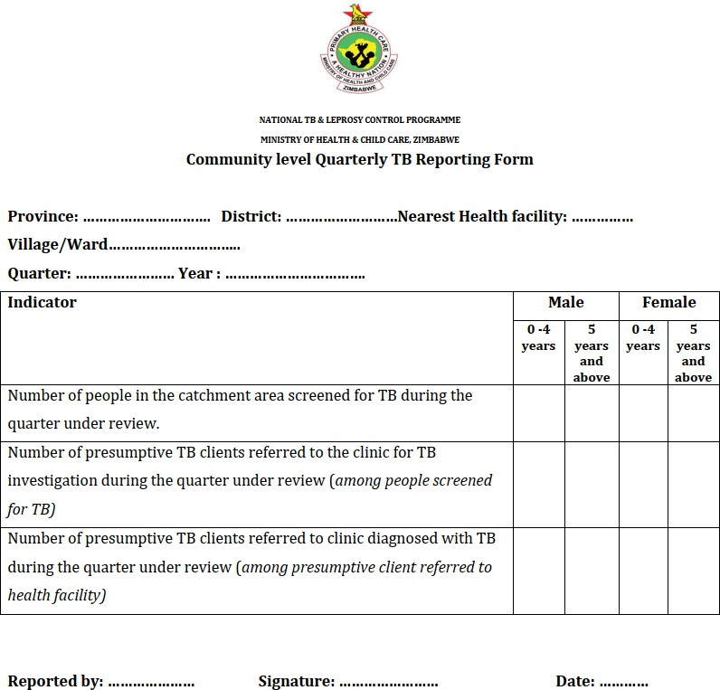

Annex 5: Spontaneous Adverse Drug Reaction Report Form
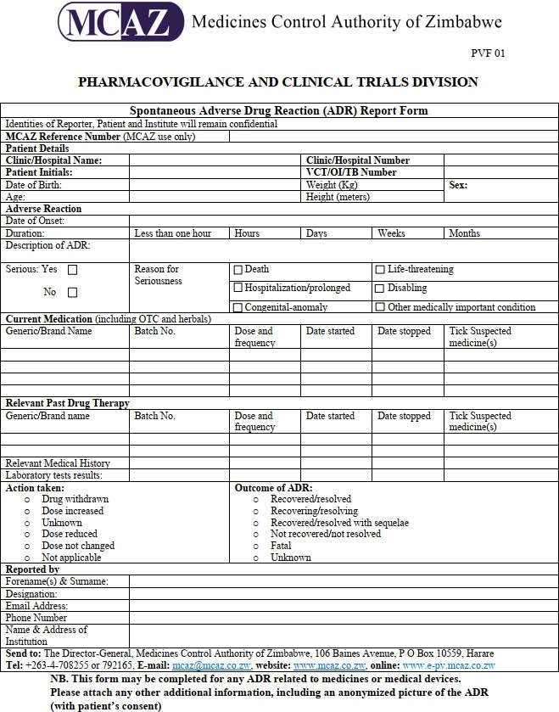

Annex 6: Patient Treatment Card
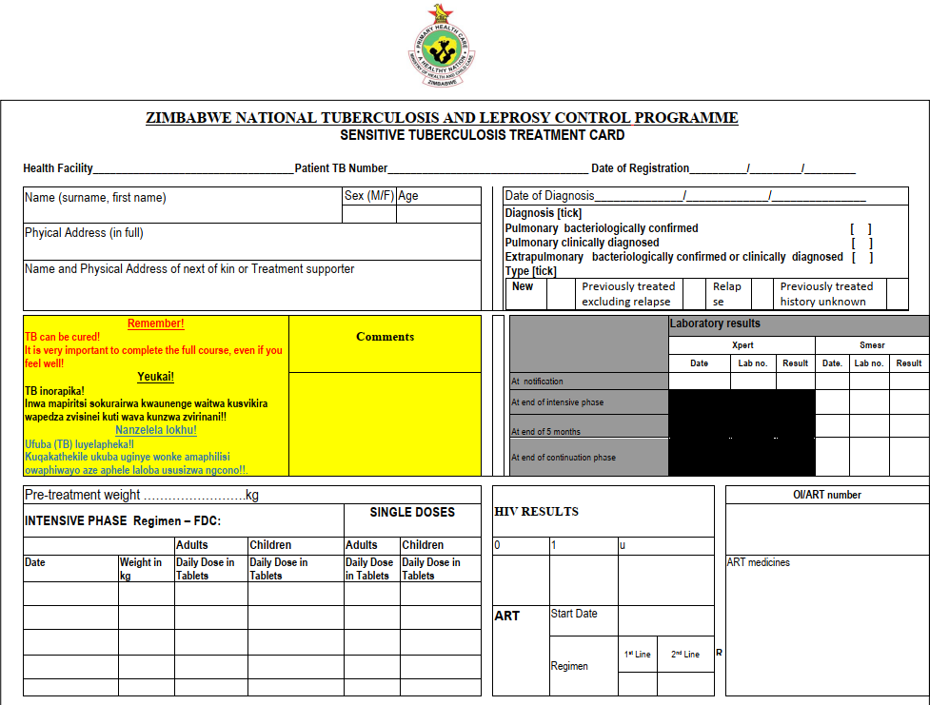

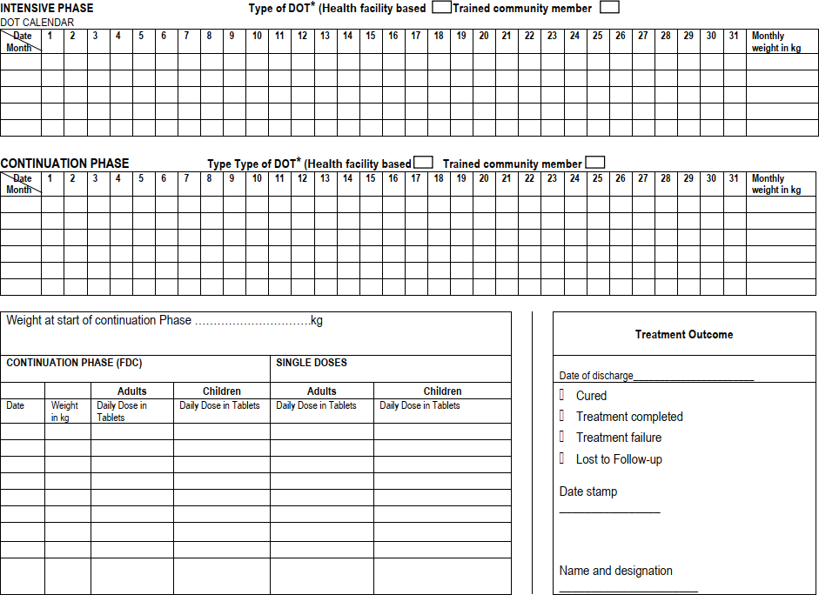

Annex 7: TB/DR-TB Contact Tracing Form


TB/DR-TB Contact Tracing Form
Province District Health Facility

Index case Details

Surname First name Age Sex TB/DR TB no. Physical Address (Place
of residence/work): Phone number: Chief Village Head Nearest school/Dip tank
Diagnosis: 1. Clinically diagnosed Sensitive TB 2. Bacteriologically confirmed Sensitive TB 3. DR-TB
Category of the Index Case Risk Group (Tick in the space provided) Risk Group Codes: 1. Health Worker ------ 2. Miners/household members ----- 3. Ex-miners/ household members ----- 4. Contact of a TB patient ------ 5. Prison community ------ 6. Diabetic patient ------ 7. Child Under 5yrs ------ 8. 60 yrs + ----- 9. HIV + ----
10. Drinking alcohol excessively -----11. Malnourished ----12. Presumptive case from Pvt Sector -----13. Other (specify) Type -----
1. Details of contacts
First name | Surname | Age | Sex | Physical Address | Investigation Outcome |  |  | Diagnosis of TB |  |  | Treatment of TB
 |  |  |  |  | TB presumed  (Y/N) | Sputum collected  (Y/N) | Sputum results | Diagnosed TB (either bacteriologically or clinically)  (Y/N) | Type of TB  - Drug sensitive  - Drug resistant  - N/A |  | Date TB treatment Started  N/A where not applicable | TB/DR TB  number  N/A where not applicable | IPT for Under 5s (Date IPT started) N/A- where not applicable
The officer conducting contact tracing should carry with him/her sputum containers to collect spot sputum specimens
Comments

Tracing Officer Designation Signature Date

Instructions on how to feel the contact tracing form

Purpose: This form serves to capture contacts of index cases and the subsequent tracing activities until those diagnosed with TB or latent TB are linked into care. It is also the source document for contact tracing indicators for reporting.
Who keeps/maintains the form: This form is kept by TB focal nurse in all health facilities. This form will be filled in triplicate. Two tear offs are taken by the tracer for tracing activity and brings one tear off back to health facility while he/she keeps one in his/her file. The third non-tear off carbon copy is retained by the facility and will be updated.
Who fills in this form? Nurses and contact tracers (e.g. EHT)

ITEM |  | INSTRUCTION/DEFINITION
(To be filled in by HCW at health  facility) Province | Province | Record the name of the province where contact tracing is being initiated
(To be filled in by HCW at health  facility) Province | District | Record the name of the district
(To be filled in by HCW at health  facility) Province | Health facility | Record the name of the health facility
Index case details (To be filled in by HCW at health facility)
Index case |  | - The first case or patient who comes to attention as indicator of a potential public health problem.  - All pulmonary bacteriologically confirmed TB cases should be regarded as index cases and their contacts investigated for TB.  - All children with TB irrespective of bacteriologic status or site of disease should be considered index cases. Since children are most often recipients of TB infection the purpose of contact investigation in children is to identify the source of TB transmission to them.
First name |  | Record the first name of the Index case including the nick name
Surname |  | Record the surname of the Index case
Age |  | Record the age of Index case in completed years
Sex |  | Record the sex of the Index case. M- male; F- female
TB/DR-TB number |  | Record the TB/DR TB number of the Index case as recorded in the TB register
Physical address |  | Record the physical address of the Index case to include phone number, chief, village head, nearest school/ dip  tank
Diagnosis |  | Tick the appropriate diagnosis in the spaces provided, the diagnosis is as per what is recorded in the TB register
Details of contacts (To be filled in by HCW at health facility)
Contact |  | - Someone who has been exposed to M. tuberculosis by sharing air space with a person with infectious TB. The type of contact depends on the closeness and duration of exposure to the index case.  - Household contacts, particularly, children less than 5 years of age should be assessed for TB.  - High priority should also be given to those who are HIV positive and those with other underlying risk factors for TB such as alcoholism, diabetes, etc.  - Contacts may also be found in aggregate settings such as workplace, schools (dormitories and classrooms), hostels, health facilities, prisons if prolonged contact with an index case has taken place.

Surname | Record the surname of the contact
First name | Record the first name of the contact including nick name
Age | Record the age of the contact in years
Sex | Record the sex of the contact (M/F)
Physical address | Record the physical address of contact
Investigation outcome (to be filled in by contact tracer except for presumptive TB number)
TB presumed | Record Yes if the TB contact screening revealed that the contact was eventually a presumptive TB client. Record  No, if the screening did NOT point to signs and symptoms suggestive of TB disease.
Sputum collected | Record YES if sputum specimen for examination was collected from the client presumed of TB and NO if  sputum specimen was not collected by the contact tracer
Sputum results  (To be filled in by HCW at health facility) | Record the results of the investigation done on sputum for the client. Record as they appear from laboratory  form
Diagnosis of TB (To be filled in by HCW at health facility)
Diagnosed TB  (either bacteriologically or clinically) | Record Yes if the patient was eventually diagnosed with TB either bacteriologically or clinically and No if TB was  not eventually diagnosed
Type of TB  - Drug sensitive  - Drug resistant  - N/A | Record 1. If the diagnosed TB is drug sensitive. Record 2. If the diagnosed TB is drug resistant. Record 3. If TB  diagnosis was eventually not made and for those who were not presumed initially.
Treatment of TB (To be filled in by HCW at health facility)
Date TB treatment started | Record the date when TB treatment was started. Write N/A for cases not applicable
TB/ DR TB number | Record the TB or DR-TB number which was assigned to this patient in the facility TB/ DR TB register. Write  N/A where not applicable i.e. those not diagnosed with TB and therefore not started on TB treatment.
IPT for under 5’s | IPT stands for Isoniazid Preventive Therapy and is given for SIX months to ALL under 5 years TB contacts who  had thorough screening for TB done and did NOT show signs and symptoms suggestive of active TB  *NB. Not to be administered to DRTB patient contacts
Date IPT started | Record the date when IPT was started for the under 5 child who was screened negative for TB. Write N/A where  not applicable i.e. for under 5s evaluated as having active TB and for all those above 5 years.
Comments | Record any comments as deemed relevant by the tracer
Details of tracer | Contact tracer to record his/her name, designation, signature and date when tracing activity was carried out.  Preferably this section to be recorded before the tracer tears off copies.

