Name: Tai Chuan David Png

Student ID: 301447497

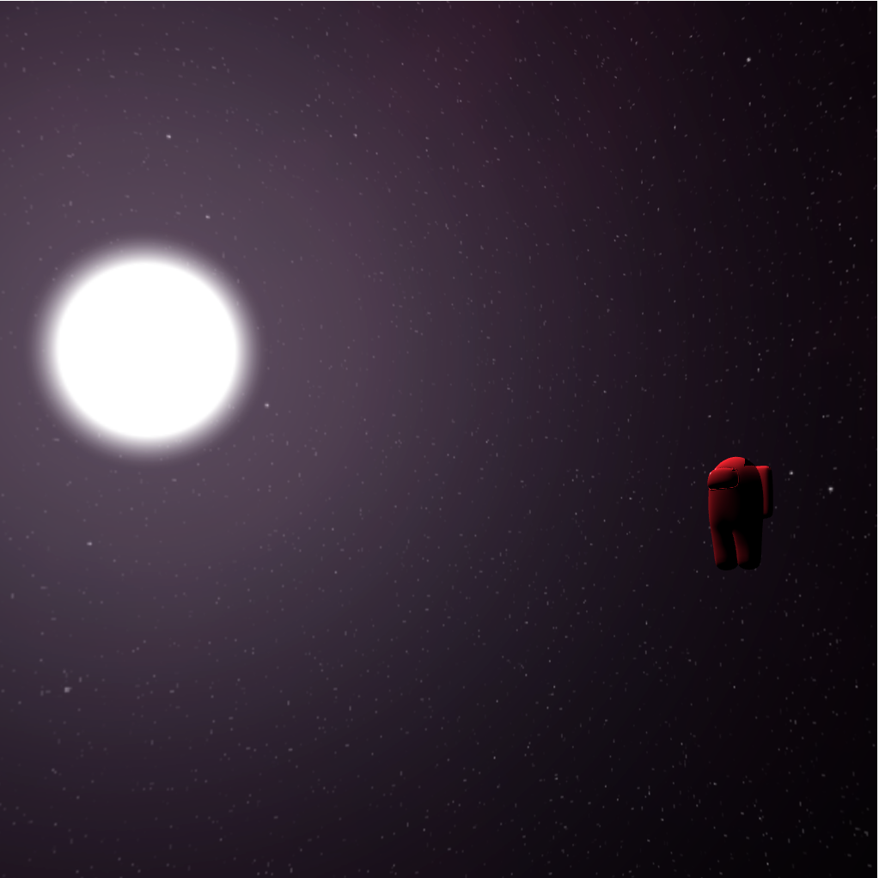

Help used :

1. <https://webglfundamentals.org>
2. Classmate Matteo Bir

How to use the program:

1. Enable the local host by running server.py
2. Open google chrome and enter the local host url
3. Press WASD keys to translate the camera along the X and Z axis
4. Press the UP and DOWN arrow keys to translate the camera along the Y axis
5. Hold the left mouse button and drag the cursor to rotate the camera

# Inspiration

This projects inspiration was from one of my favourite video games and holds a lot of meaning to me, Among Us. It really helped me connect with my friends during COVID and made me feel less lonely and honestly improved my mental health, so it holds a special place in my heart. Which is why I decided to use it as inspiration for this project.

The lore behind this scene is that the red character was thrown out the spaceship because he is an impostor, which is why he is floating in the vast emptiness of space.

# Cool features

* The most impressive feature of this scene is the OBJ parser. This program can parse any .OBJ file you want, meaning that if someone had a .OBJ file of a planet, moon, spaceship, or anything, it could be loaded into the scene very easily.
  + The OBJ parser extracts all the vertex positions, texture coordinates, and normal calculations from the .OBJ file and loads them into the program
  + Then buffers are created and populated to render the model
* Some cool features which I spent a long time on was the free cam because the inspiration behind this scene was a video game.
  + There are already instructions on how to use the free cam above
* The skybox loader is another impressive feature that adds a lot of immersion and realism to the scene. I put the skybox as the deep space and a very bright sun so that I can show off the light reflections and shaders in action.
  + If you want to replace the skybox, all you have to do is replace the front, back, left, right, top and bottom image files.
* When the OBJparser and skybox loader are paired together, this program can actually render any scene with ease, the hardest part is finding the .OBJ files and textures.
* The sun is to the left of the model which can be seen if you rotate the camera. The sun can be seen reflecting off the model and even has specular highlights. Phong illumination and Lambertian lighting was used. I also added some ambient light so the model wasn’t completely dark on the right side