【Unit 1】
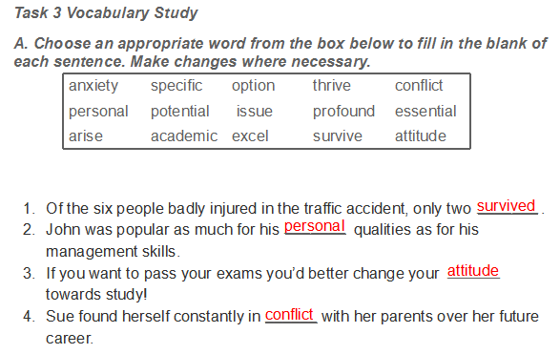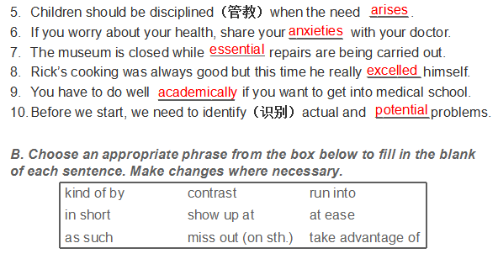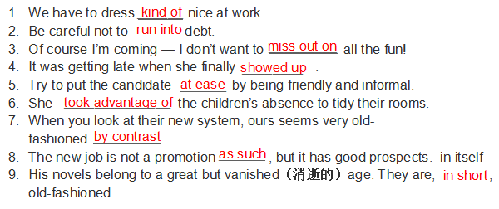
1. Go to all orientations. Yes, that’s right — it really is necessary to attend all the school orientations.
参加所有熟悉校园环境的活动。是的，没错——的确很有必要参加所有的熟悉校园环境的活动。

2. Armed with a thorough understanding of all aspects of campus life — or, at least, those aspects you can glean from orientation — you will feel more at ease when issues arise, as they always do.
有了对校园生活方方面面的彻底了解—或者至少是那些从活动中所能搜集到的诸多信息的了解，那么，当层出不穷的问题出现时，你便能从容应对。

3. Often it is tempting to sleep through early morning class or skip it altogether — resist temptation. Make it a priority to attend all of your classes on time.
通常，逃掉大清早的课睡个懒觉，或者干脆逃掉所有的课很具诱惑力—务必抵制住这种诱惑。准时上所有的课，使之成为头等大事。

4. That being said, be careful of taking too much time for yourself.
话虽这么说，注意别给自己太多的时间。

【Unit 2】
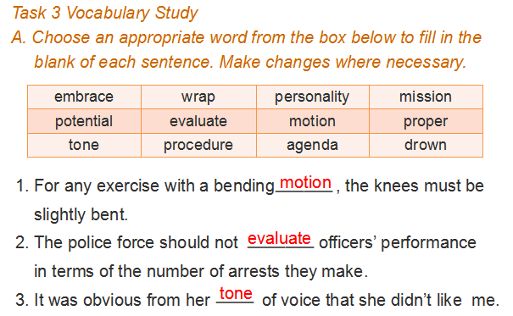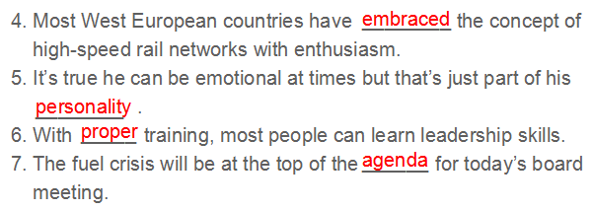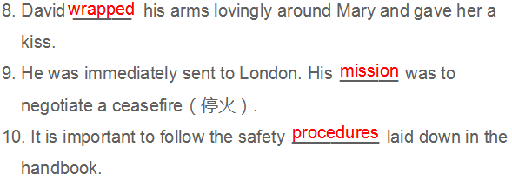
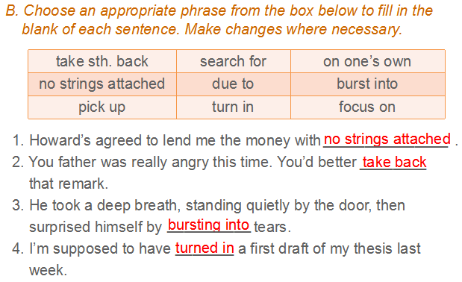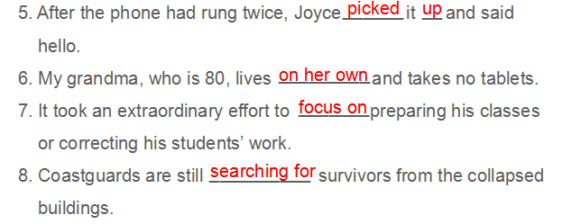
1.Mrs. Smith performed classroom procedures as though she had repeatedly practiced each one determined to achieve perfection.
史密斯太太上课有板有眼，好像每一个步骤都在课前演练过多次一样，力求精益求精。

2. She rarely grinned without providing some sort of manual or verbal gesture.
她大笑时总是伴有话语或手势.

3. Even Shakespeare himself could not have put my sixth-grade essay to shame.
我甚至觉得哪怕和莎士比亚相比，我这篇六年级的作文也毫不逊色。

4. If only she could understand how I truly admired and viewed her as a “teacher,” someone who earned and deserved that special title.
当时我是那么崇拜她，觉得她无愧于“教师”这个神圣称号。要是她知道这一点该有多好啊！

【Unit 3】
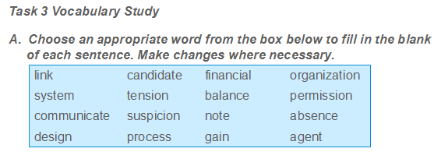
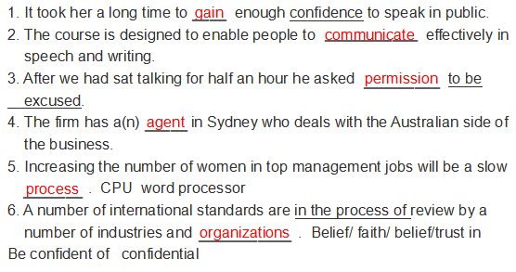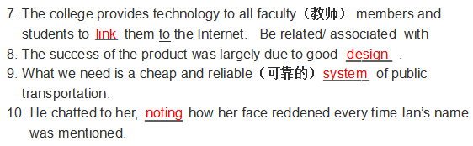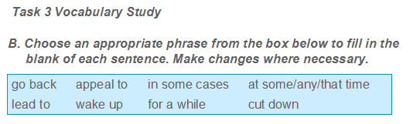
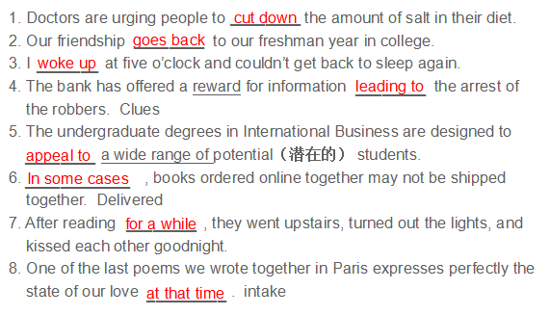
1. Then came the 1990s, and the rise of the personal computer and the Internet. Today, telecommuting is gaining much wider acceptance.
进入20世纪90年代，个人计算机和因特网出现了。今天，居家办公正越来越受到青睐。

2. Experts say telecommuting can help organizations keep good workers who live far from the office, or want to move out of the area.
专家们认为居家办公能帮助机构留住那些居住地远离办公地点或想搬离办公地的好员工。

3. People who might make others sick if they came to work might still be well enough to work from home.
有些人来上班也许会使他人不悦。但他们如果在家上班仍可以很好地工作。

4. He led the design process for several space vehicles and communications systems for NASA and the Air Force.
他负责领导为国家航空航天局和空军的一些飞行器和通讯系统设计程序。

【Unit 4】
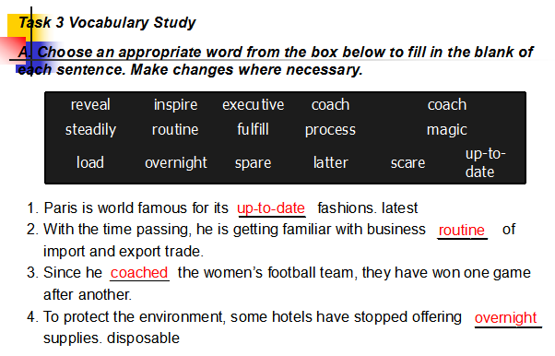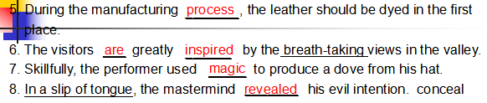
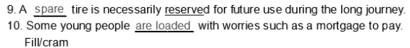
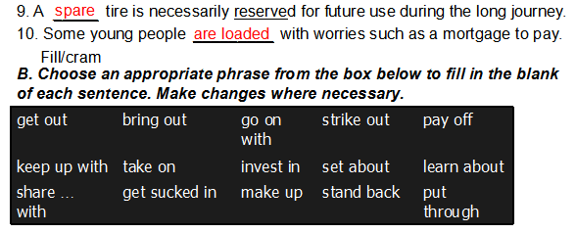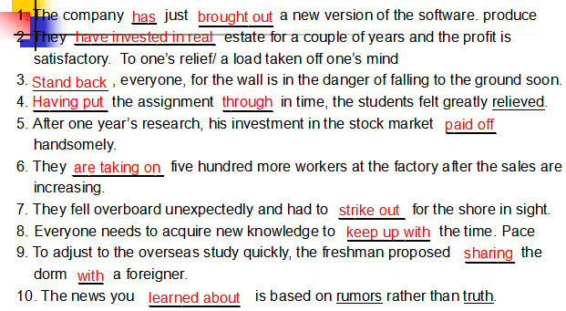
1. I spent a month trying to find another salaried job. Nothing.
我用了一个月的时间努力去找份带薪的工作，结果一无所获。

2. I used books, business coaches, and seminars.
我使用书本，请教做经商培训的行家们，还参加了研讨会。

3. Don’t get sucked in by schools or course ‘sellers’ who tell you that if you increase your mastery your business will magically increase.
学校或课程“推销者们”告诉你，如果你增长了掌控做生意的知识，那么生意会奇迹般地上升，对此不要轻易相信。

4. For a parent the freedom that comes from running your own business — especially one where you work from home with huge flexibility — is priceless.
对家长来说，自己经商带来的自由，尤其是在家工作带给你的无比灵活是弥足珍贵的。

【Unit 5】
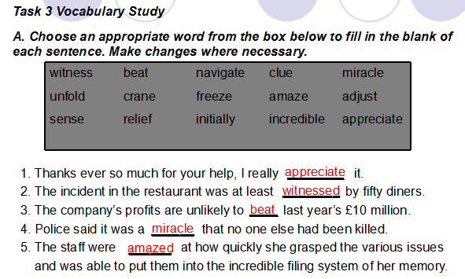
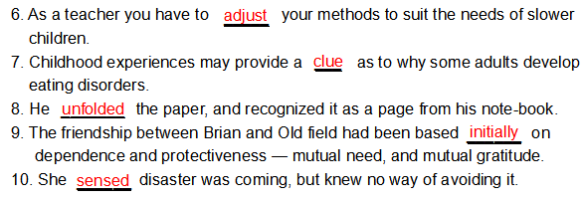
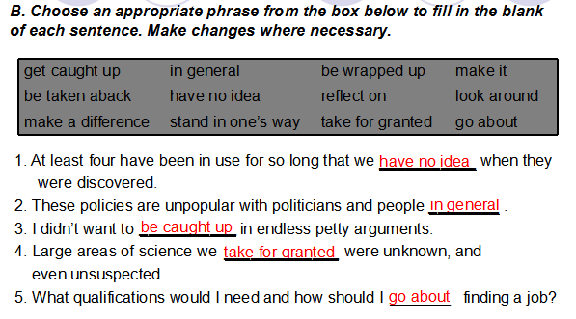
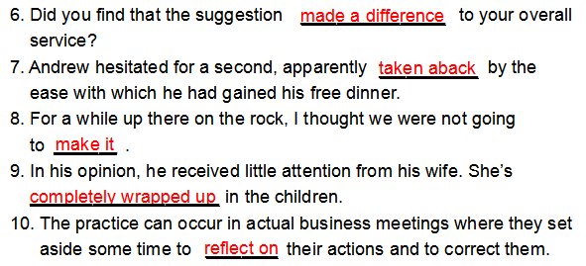
1.A short time ago, however, I witnessed an event that showed me how being wrapped up in my own little world has kept me from being fully aware of the bigger world picture around me.
然而就在不久前，我亲眼目睹了一件事让我明白，沉浸在自己生活的小世界中妨碍了我全面观察我周围一个更大的世界。
2. My mind and car were in auto pilot, ready to go when suddenly my trance was broken by an unforgettable sight.
我的心仿佛和汽车一样都挂在自动档，随时准备开动，突然一幕令人难忘的情景让我从神思恍惚中惊醒。

- My thought was quickly interrupted by horror when I saw that the couple was not walking in the crosswalk, but was instead veering diagonally, directly toward the middle of the intersection.
我的思想很快被恐惧打断：我突然看到这对夫妇没走在人行横道上，而是在改变方向，斜穿马路直接向十字路口当中走去。

- Never skipping a beat, the couple adjusted their course as they followed the coaching.
这对夫妇并没有三步并作两步，而是按照他人的指点，调整了自己的路线。
- Do this and you will realize that this moment is all there is, more importantly, this moment is all that you have to make a difference in life.
如果你能做到这一点，那么你就会认识到那一刻存在的真正含义，更重要的是，这一刻会对你一生产生很大影响。
【Unit 6】
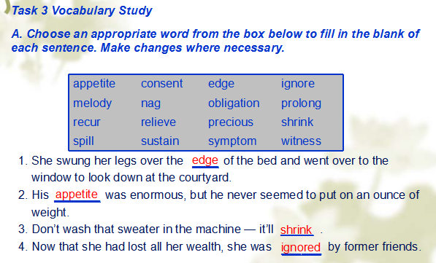
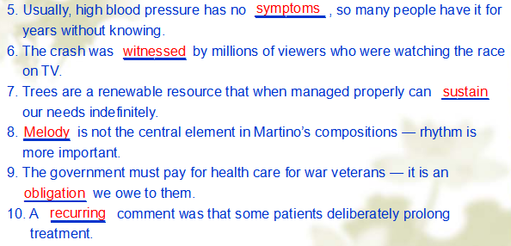
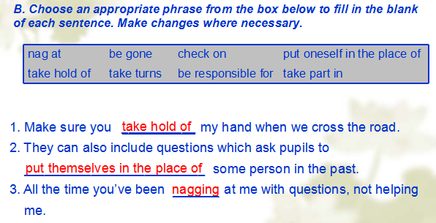
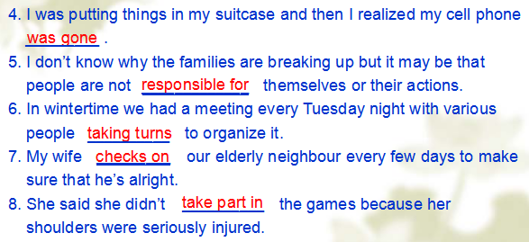
1. Realizing that death is a certainty and as much a part of life as being born, if the time comes when I can no longer take part in decisions for my own future, I wish this statement to stand as an expression of my wishes while still of sound mind….
我意识到死亡是不可避免的，和出生一样是生命的一部分。因此当我无法参与决定我的未来时，我希望在我头脑还清醒时用这份声明来表达我的愿望……

2. I request that I be allowed to die with dignity and not be kept alive by artificial means or "heroic measures."
我恳求允许我带着尊严死去，而不是靠人为的手段或“孤注一掷的措施”活着。

3. The sun had just set, and the sky was a melody of color. Just for him, I thought, to celebrate his freedom.
太阳刚落山，天空色彩斑斓。我想，这一切专门是献给他的，以庆祝他的解脱。

4. But most of all he instilled in me a sense of honor that keeps me true to my convictions and faithful to my obligations.
但最重要的是他给我灌输的荣誉感，使我坚定信念，忠于责任。

大学英语A1 复习参考

题型：

词汇与语法
阅读理解
完型填空
翻译

考题来源：21世纪大学英语读写译教程、练习册及其它

复习范围参考：1-6单元
词汇与语法：每单元课后词汇练习（以第一单元为例：教材第9——10页，Task 3 Vocabulary Study A部分和B部分）
阅读理解：练习册（以第一单元为例：练习册第6——12页）
完形填空：练习册（以第一单元为例：练习册第12——13页，Passage IV）
翻译：每单元课后英译汉练习（以第一单元为例：教材11页，Task 5 Translation B部分）

