Purpose:
The purpose of this program is to complete CRUD operations to a MongoDB database using python. It also incorporates user authentication to ensure only authorized individuals can complete CRUD operations on the database.
How the CRUD module should be used:
To interface with the MongoDB database correctly the PyMongo library was used. It is industry best practice to use this driver to complete CRUD operations.
To use the CRUD methods, instantiate an AnimalShelter object with the correct user name and password as the parameters. With that object you can complete CRUD operations by using the methods create(), read(), update(), and remove(). Below is an example for the create method by passing a dictionary data (Not provided):
DB = AnimalShelter(username, Password)
DB.create(data)

To use the create() method, a dictionary needs to be passed for a parameter. This will add that dictionary to the database.
To use the read() method, a key value pair needs to be passed to the method for the query. The first parameter is the key and the second parameter is its value. They should both be strings.
To use the update() method 4 string parameters should be passed. The first two are the query, strings representing key value pairs. The last two string parameters is the key value pair to be updated. The key is the field that will be updated and the value is the new value it will be updated to.
To use the remove() method a key value pair is used to delete documents. It is very similar to the read() method. This method requires a key value pair. Both parameters are strings.
An example of the read() method:
DB = AnimalShelter(username, Password)
DB.read(“key”, “value”)

Demonstration:
Below is a screen shot of a MongoDB import to import a csv file used for the CRUD operation.
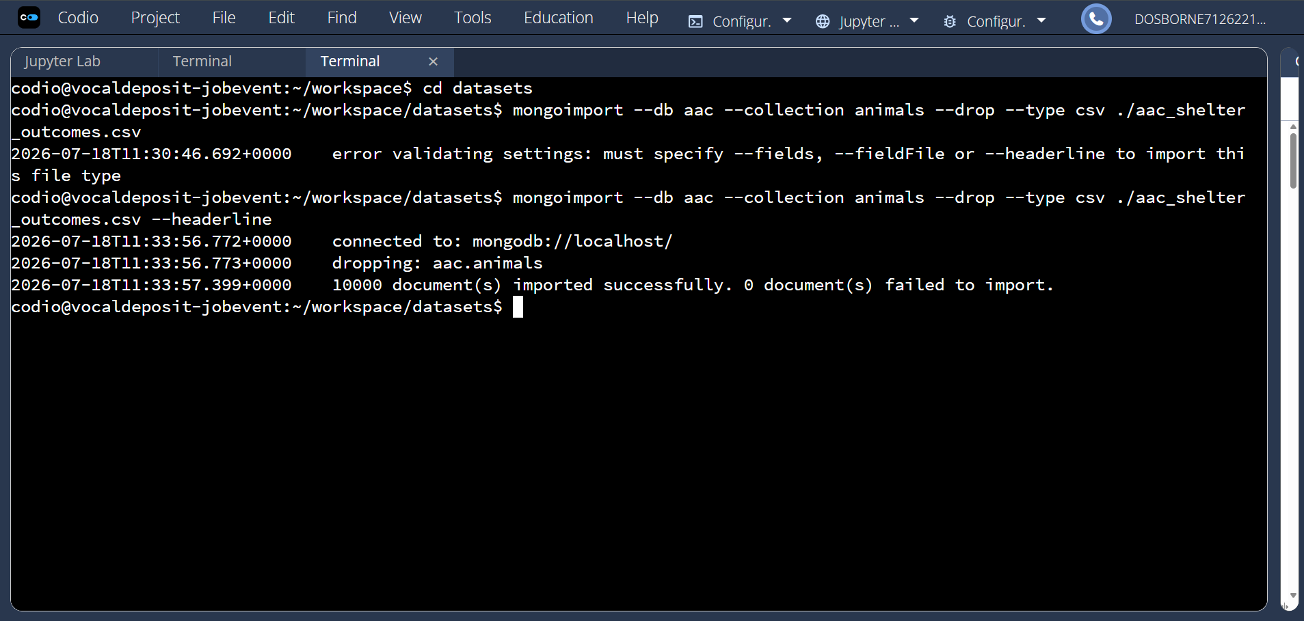

Below is the screenshots for the user authentication. I created a user account and tested that I could connect to the database with the credentials:
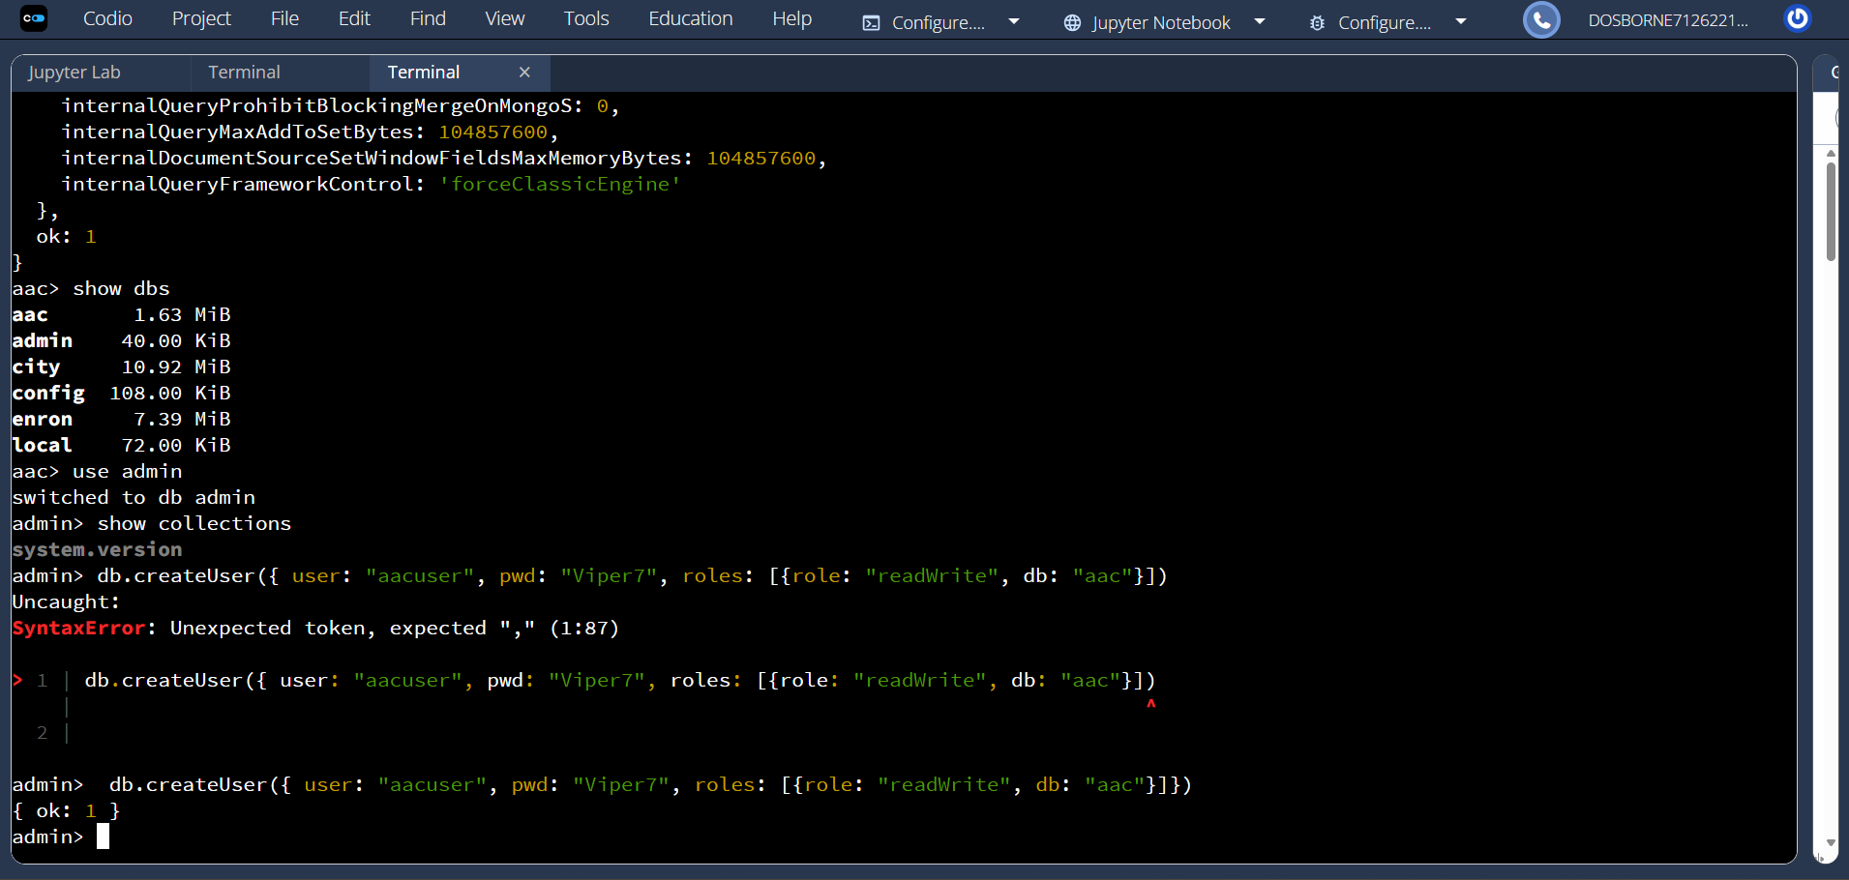
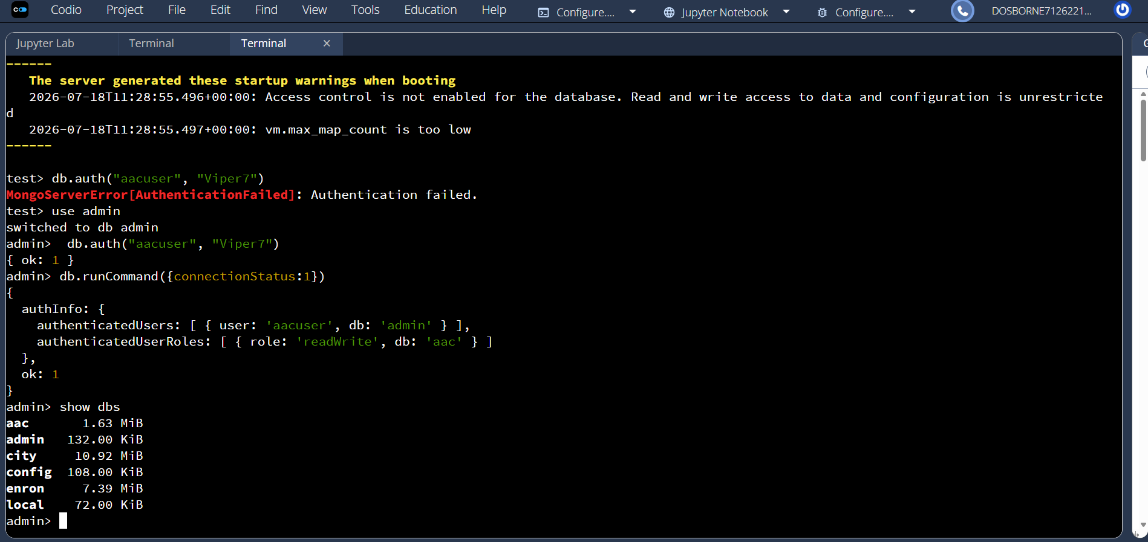

Below is an example of using all of the CRUD operations: 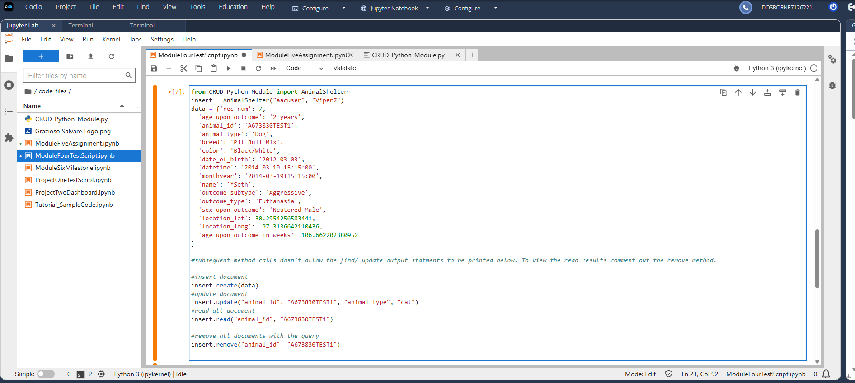
Create and update document. The 1 shows that one document was modified. 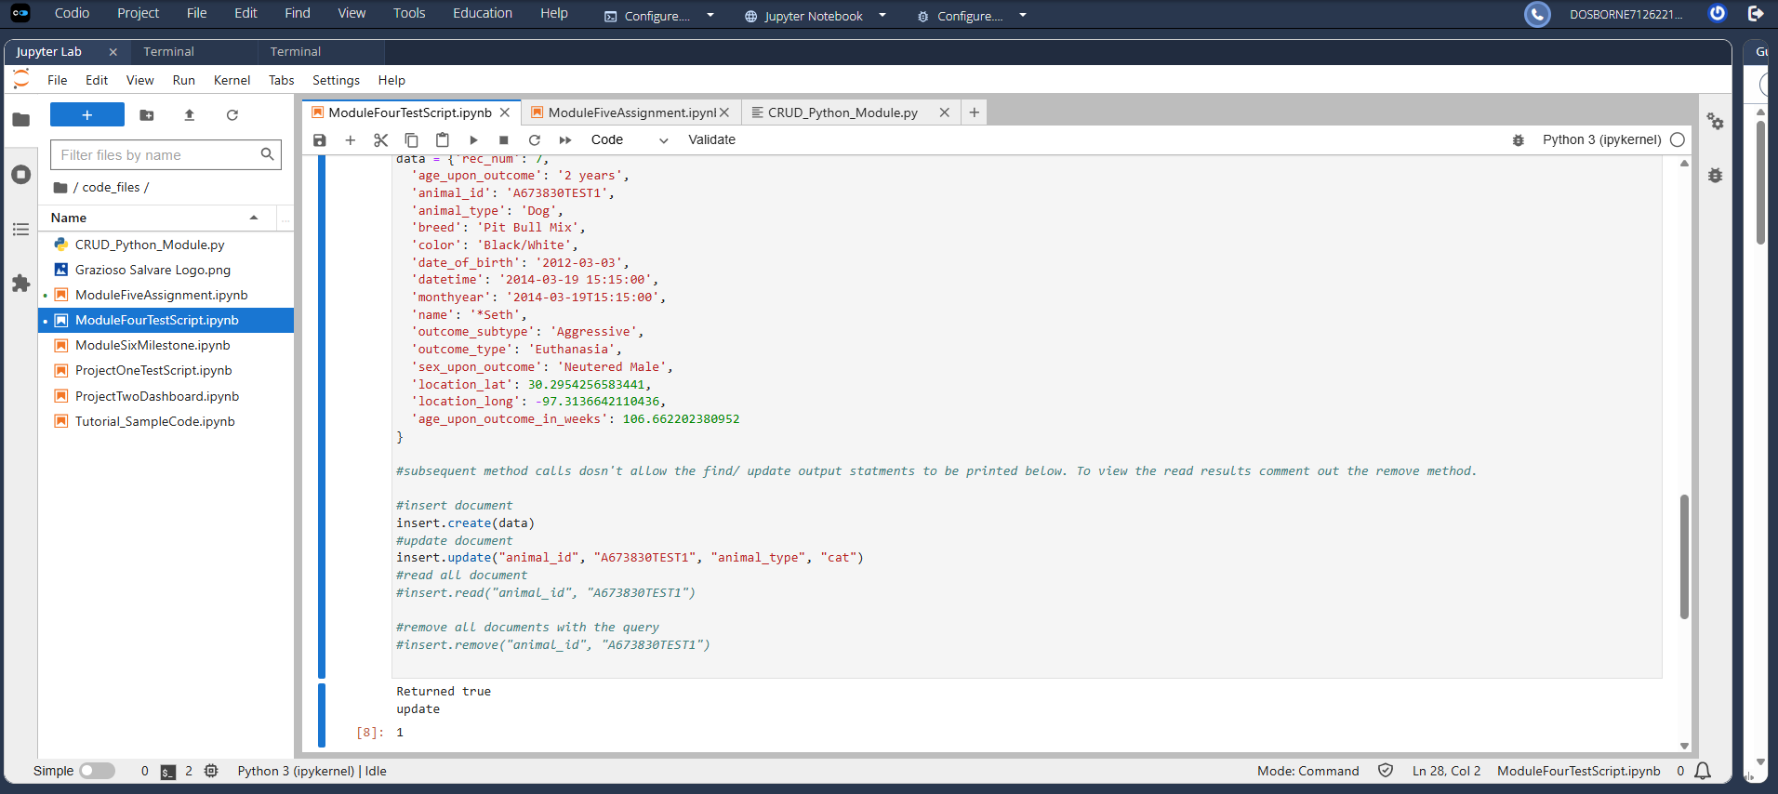
Below the read method is executed. With this you can see that the animal type was changed to cat.
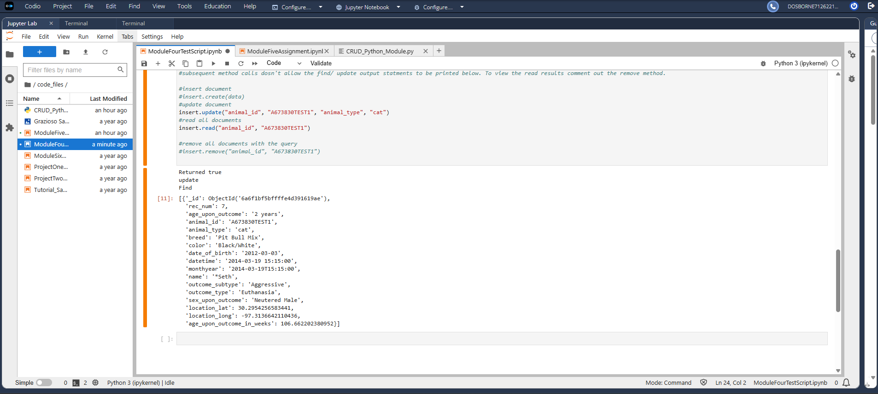
Below the remove method is executed and it shows that 1 document was deleted. 