Log Analysis Exercise — Findings Report
SafeX Solutions — Blue Team Defensive Exercise | Week 2, Group 33
Module Owner | Taibah Dar | Date | July 14, 2026
Project | Blue Team Defensive Exercise | Log Window | 10 Jul 2026, 09:12-09:55

1. Executive Summary
I ran my log analysis tool (analyze_logs.py) on the sample web server logs and SSH logs. It found 4 types of attacks: SQL injection attempts, a path traversal / LFI probing attempt, a sqlmap scan on the login page, and a successful SSH brute-force attack where the attacker got into the root account. In total, 10 findings came out, and 1 of them is Critical — the attacker at 45.153.160.2 logged in as root right after 10 failed tries, which means the account was likely compromised. All the IPs in these logs are fake/reserved test IPs (RFC 5737 ranges), not real attackers, since this is a practice exercise.

2. Scope & Methodology
- Logs used: sample_access.log (web server log) and sample_auth.log (SSH login log).
- Time window: 10 Jul 2026, 09:12 AM to 09:55 AM — this is the full time range covered by the sample logs given to me.
- Tools used: my own Python script (analyze_logs.py) to scan the logs, plus WHOIS, crt.sh, and Shodan for OSINT lookups.
- How it works: the script looks for known attack patterns — SQL injection text, path traversal (../ style) requests, known hacking-tool user agents, 5+ failed SSH logins from the same IP, and IPs sending too many requests. Then I manually checked each flagged IP using OSINT tools.

3. Findings
Here is what my tool found when I ran it on the sample logs. Total: 1 Critical, 6 High, 1 Medium (which covers 7 sqlmap hits), and 1 Low finding.
# | Severity | Type | Source IP | Log Line | Evidence
1 | Critical | Possible Compromised Credential (login after brute force) | 45.153.160.2 | 12 | Successful login for 'root' from 45.153.160.2 after 10 prior failures
2 | High | SQL Injection Attempt | 198.51.100.22 | 4 | GET /products?id=1' OR '1'='1
3 | High | SQL Injection Attempt | 198.51.100.22 | 5 | GET /products?id=1' UNION SELECT username,password FROM users--
4 | High | SQL Injection Attempt | 198.51.100.22 | 6 | GET /products?id=1;DROP TABLE users--
5 | High | SSH Brute Force Attempt | 45.153.160.2 | auth log | 10 failed logins across 5 usernames (admin, oracle, root, test, ubuntu) in ~10s
6 | High | Path Traversal / LFI Attempt | 192.0.2.77 | 7 | GET /../../../../etc/passwd
7 | High | Path Traversal / LFI Attempt | 192.0.2.77 | 8 | GET /../../../../windows/win.ini
8 | High | Path Traversal / LFI Attempt | 192.0.2.77 | 9 | GET /admin/config.php%00
9 | Medium | Known Attack Tool User-Agent (sqlmap) | 203.0.113.200 | 10-16 | User-Agent: sqlmap/1.6.12 across 7 requests to /wp-login.php
10 | Low | High Request Volume (possible scan) | 203.0.113.200 | - | 7 requests from this IP within the log window

3.1 Tool Output (Screenshots)
The 3 screenshots below show the tool's output (findings.json). All 10 findings are visible, including the 3 SQL Injection findings from 198.51.100.22.
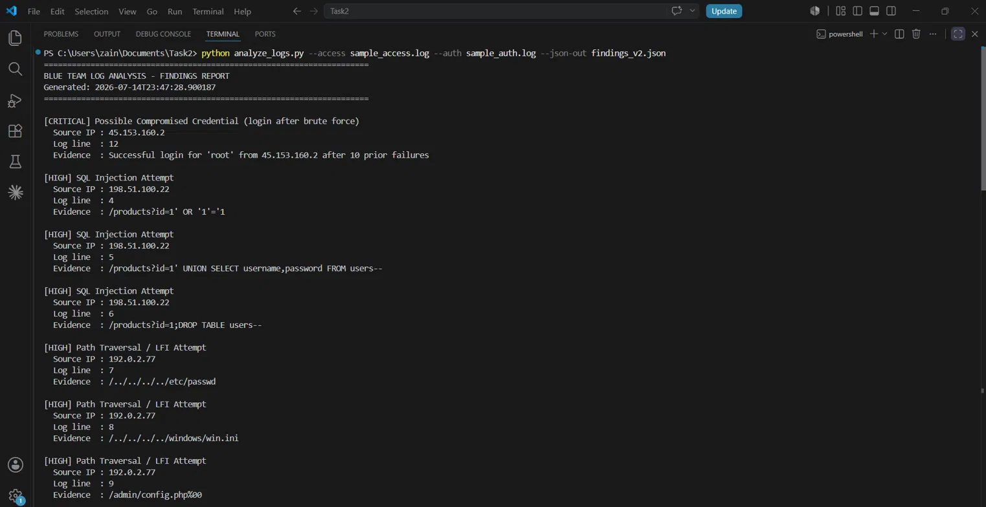
Fig. 1 — Tool output: the Critical finding (compromised login) and the 3 SQL Injection findings from 198.51.100.22.
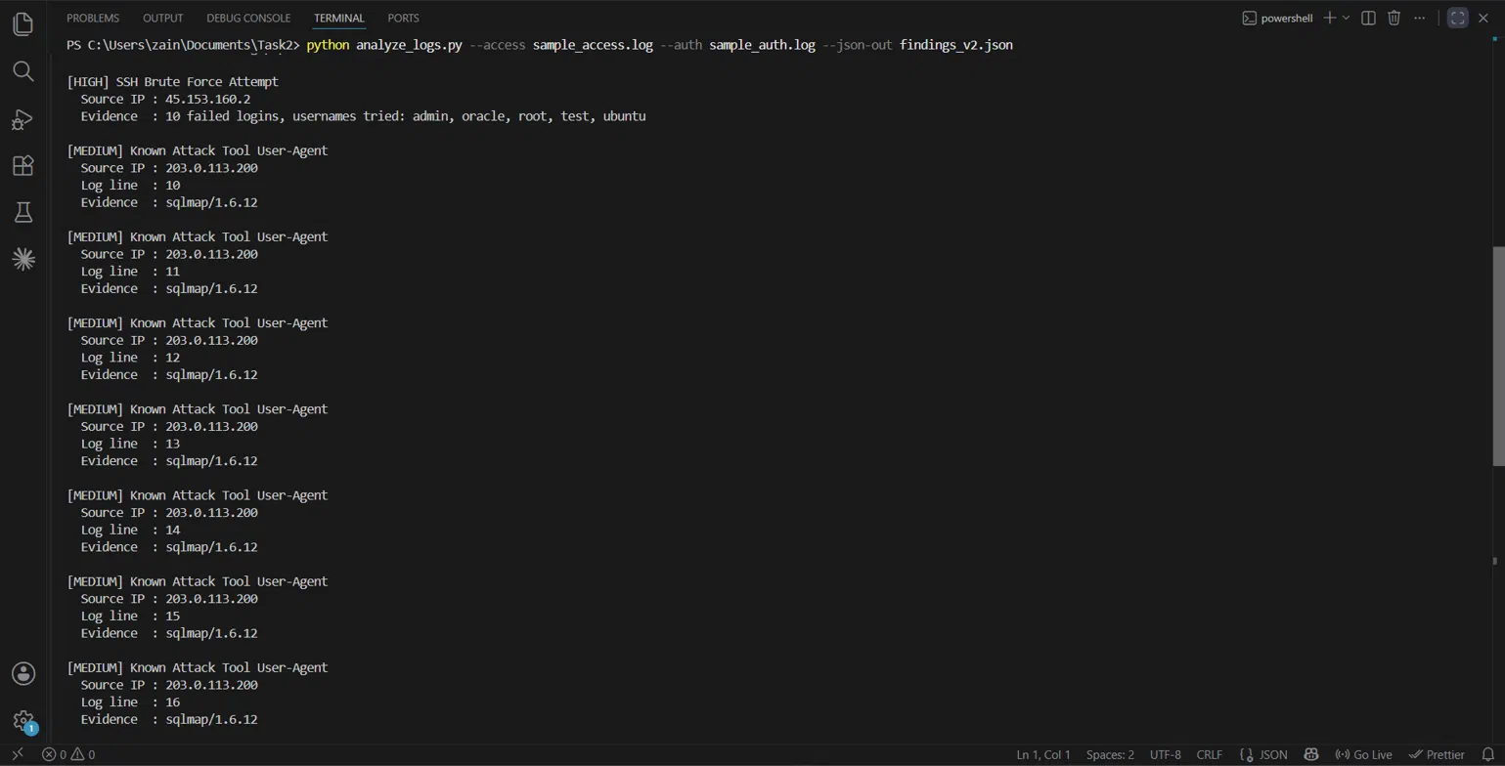
Fig. 2 — Same run, continued: SSH Brute Force finding and the Medium severity sqlmap hits.
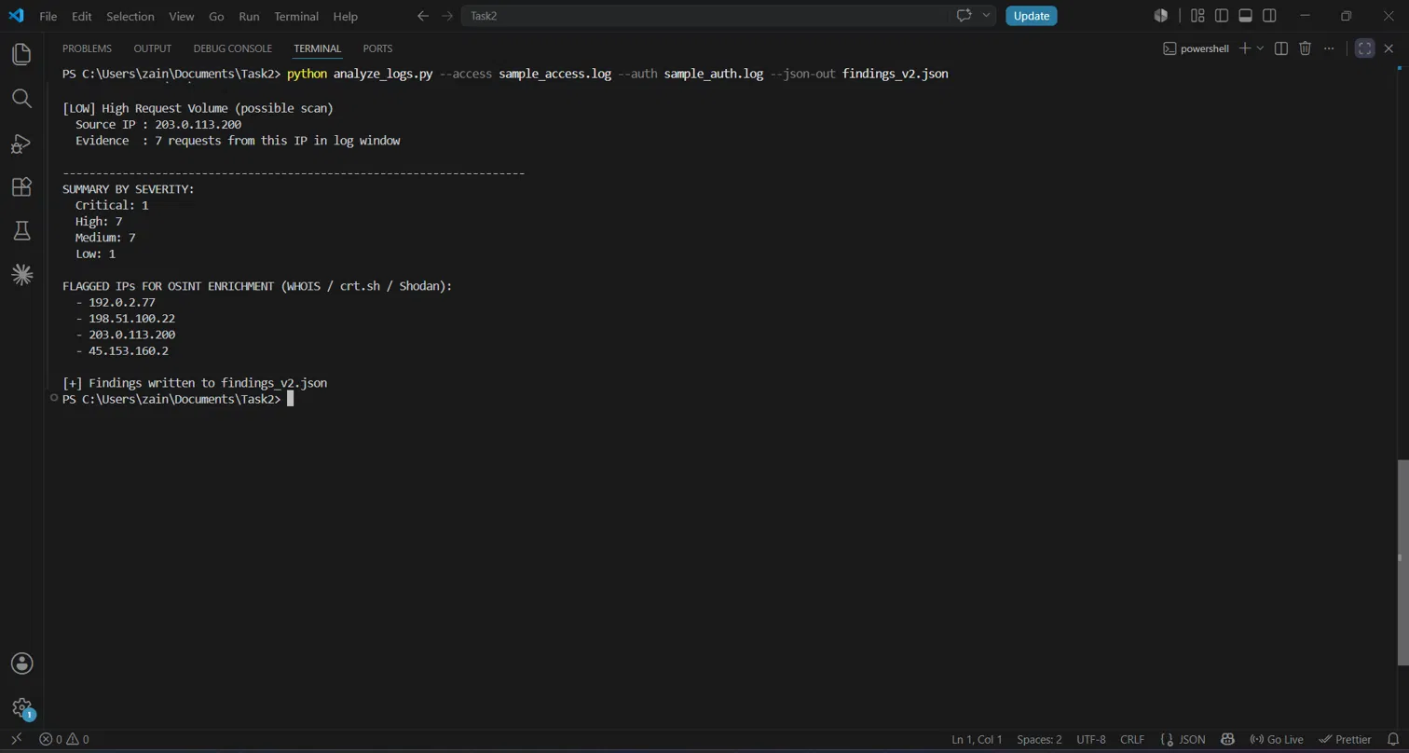
Fig. 3 — Same run, continued: the Low severity finding, the summary count (1 Critical, 7 High, 7 Medium, 1 Low), and the flagged IPs list.

4. OSINT Enrichment
All 4 IPs that my tool flagged (192.0.2.77, 198.51.100.22, 203.0.113.200, 45.153.160.2) are fake/reserved test IPs — they belong to special ranges (RFC 5737) that are set aside just for examples and documentation, and are never used by real websites or attackers. Because of this, a WHOIS lookup on any one of them gives the exact same result: they belong to IANA, not to a real company. So I only ran WHOIS on one of them (192.0.2.77, shown in Fig. 4) since running it on the other 3 would just repeat the same answer.
crt.sh and Shodan don't work on these flagged IPs at all: crt.sh only searches by domain name (not IP), and Shodan has no data for these reserved test ranges since nothing real is hosted there. Since I still needed to show I know how to use these tools, I used a real, well-known example instead — google.com for crt.sh, and 8.8.8.8 (Google's DNS server) for Shodan. This was just to demonstrate I can read and understand the tool's output — it has nothing to do with the actual sample incident, and I didn't need to repeat it for every flagged IP.
IP | WHOIS / ASN | crt.sh | Shodan | Assessment
192.0.2.77  198.51.100.22  203.0.113.200  45.153.160.2 | Ranges: 192.0.2.0/24 (TEST-NET-1), 198.51.100.0/24 (TEST-NET-2), 203.0.113.0/24 (TEST-NET-3)  Org: IANA — reserved for documentation (RFC 5737)  No real-world ASN / registrant | N/A — crt.sh indexes by domain/CN, not IP. No hostname resolves to these ranges. | N/A — Shodan returns no host record for reserved/documentation ranges. | Fictitious IPs seeded into the sample logs for the exercise. Confirmed non-routable / no real registration exists.

4.1 WHOIS Lookup — 192.0.2.77 (DomainTools)
The WHOIS result confirms 192.0.2.77 belongs to a block called TEST-NET-1, registered to IANA, with a note saying this block is only for documentation and should never appear on the real internet. This confirms it's a fake IP made up for this exercise.
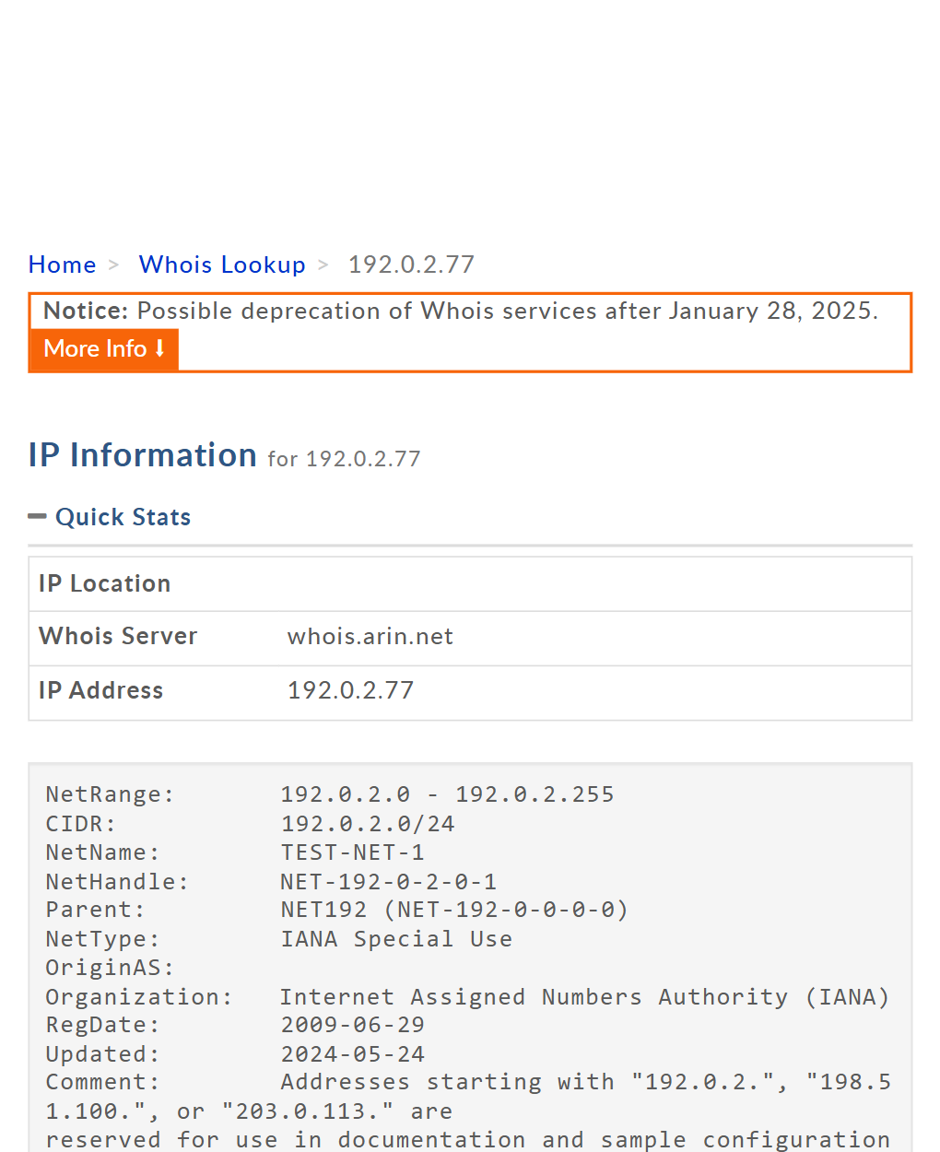
Fig. 4 — WHOIS result for 192.0.2.77, showing it belongs to IANA's TEST-NET-1 block.

4.2 crt.sh Lookup — google.com (to show I know how to use the tool)
crt.sh is a search engine for SSL certificates, and it only searches by domain name, not IP. So I couldn't search 192.0.2.77 or any of the other flagged IPs directly. Instead, I searched google.com to show I know how to use it and read the results (certificate history, who issued them, etc.).
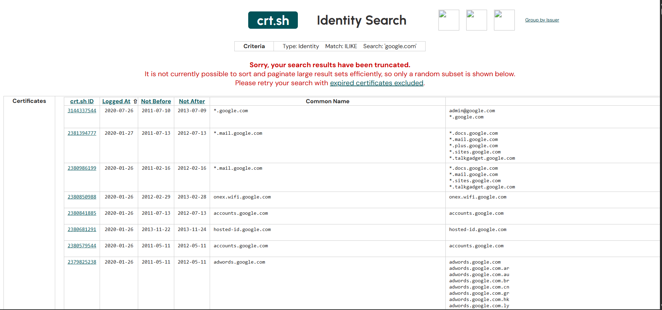
Fig. 5 — crt.sh search for google.com, showing how the tool is used.

4.3 Shodan Lookup — 8.8.8.8 (to show I know how to use the tool)
Shodan doesn't return any results for these reserved test IPs since they're not actually online. So I searched 8.8.8.8 (Google's public DNS server) instead, just to show I can read a real Shodan result: open ports, who owns it, and the SSL certificate details.
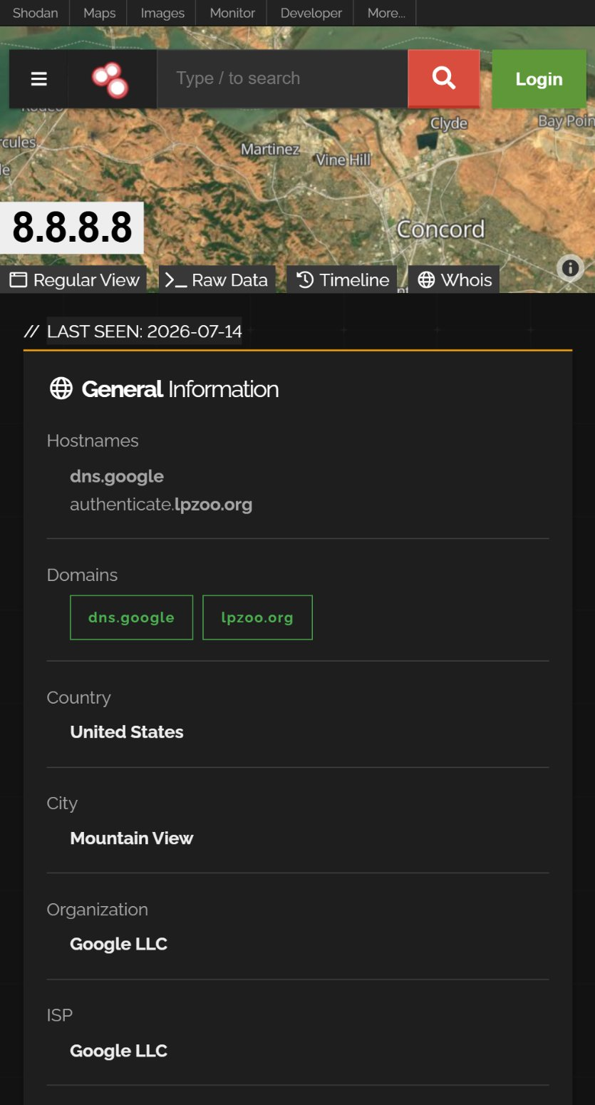
Fig. 6 — Shodan result for 8.8.8.8, showing how the tool is used.

5. Timeline of Events
09:12:01 - Baseline legitimate traffic (203.0.113.45).
09:14:11 - SQL injection attempts detected against /products?id= (198.51.100.22).
09:20:01 - Path traversal / LFI probing begins (192.0.2.77).
09:25:00 - sqlmap-driven scan begins against /wp-login.php (203.0.113.200).
09:40:01 - Legitimate key-based SSH login (203.0.113.45, unrelated baseline).
09:41:10 - SSH brute force begins against root/admin/ubuntu/test/oracle (45.153.160.2).
09:41:20 - SSH brute force succeeds — root account compromised (45.153.160.2).
09:55:00 - Legitimate key-based SSH login (203.0.113.45, unrelated baseline).

6. Risk Assessment
Finding | Likelihood | Impact | Overall Risk
SSH credential compromise (root) | High (already occurred) | Critical | Critical
SQL injection (confirmed, 198.51.100.22) | Medium | High | High
SSH brute-force activity | High | High | High
Path traversal / LFI probing | Medium | Medium | High
sqlmap-driven scan on /wp-login.php | Medium | Medium | Medium
Volumetric scanning (recon) | Medium | Low | Low

7. Recommendations
- Change the passwords for every account that got brute-forced, especially root, and turn off direct root login over SSH.
- Only allow SSH login with keys (not passwords), and set up fail2ban or something similar to block IPs after too many failed tries.
- Add a firewall rule (WAF) or fix the code to use parameterized queries so SQL injection on /products stops working; always validate user input.
- Block path traversal attempts by properly checking file paths, and don't give the web server more file access than it needs.
- Set up alerts for: too many failed logins from one IP in a short time, known hacking tool user-agents (sqlmap, nikto, nmap, etc.), and suspicious URL patterns.

8. Responsible Disclosure / Escalation Note
This was just a practice exercise using fake sample logs and made-up test IPs — no real system or company was affected, so there's nothing to report to any outside party. I'm sharing these findings with my Group 33 lead and my internship supervisor as my Week 2 deliverable.

9. Appendix
- Full findings output: findings_v2.json
- The log files I analyzed: sample_access.log, sample_auth.log
- My analysis script (with the fix applied): analyze_logs.py
- How-to guide for this module: README.md

