**Linux commands:**

•**ls**: Lists the contents of a directory.

* ls -l: Long listing format (detailed view).
* ls -a: Show hidden files.
* 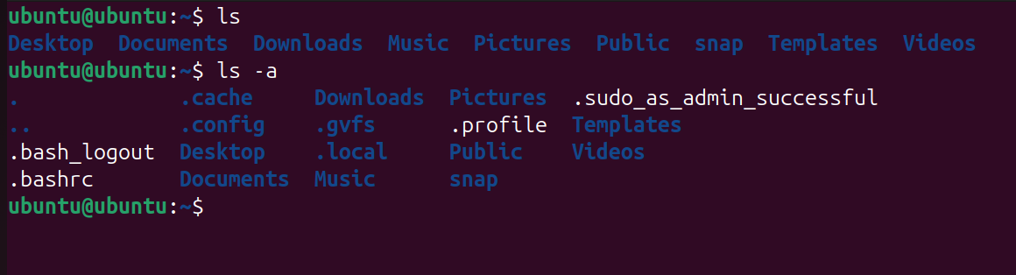

• **cd**: Changes the current directory.

* cd /path/to/directory: Change to the specified directory.
* cd ..: Move up one directory level.
* 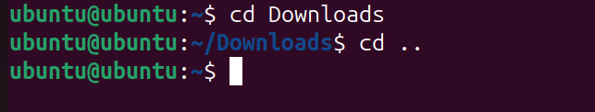

• pwd: Prints the current working directory.

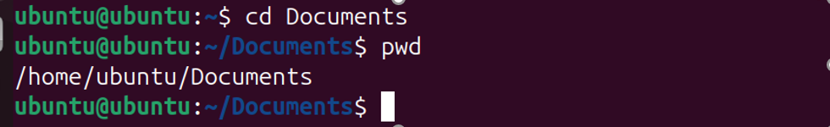

• **mkdir**: Creates a new directory.

* mkdir Taiba: Create a directory named Taiba.
* 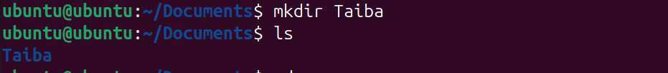

• **rmdir**: Removes an empty directory.

* rmdir new : Remove the specified empty directory named new.
* 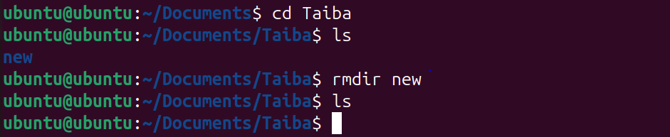

• **rm**: Removes files or directories.

* rm file_name: Remove a file.
* rm -r directory_name: Recursively remove a directory and its contents.

• **touch**: Creates an empty file or updates the timestamp of an existing file.

* touch new_file: Creates an empty file named new_file.
* 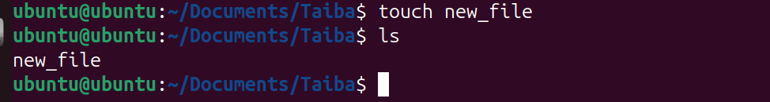

• **echo**: Displays a line of text.

* Writes the specified text to the file. If the file does not exist, it is created.
* 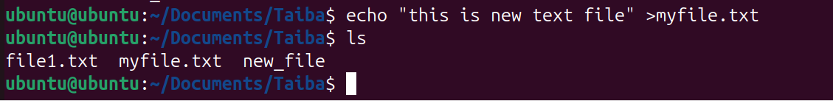

• **nano**: • Opens the text editor, where you can create and edit the file. Save with CTRL+O and exit with CTRL+X.

• 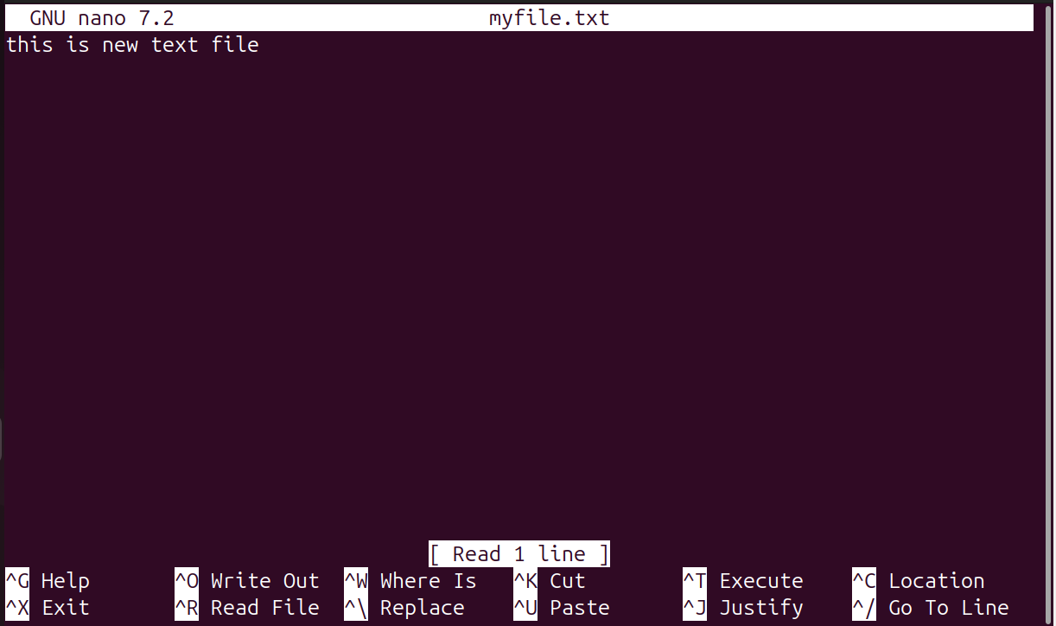

• **cp**: Copies files or directories.

* cp source_file destination_file: Copy a file.
* cp -r source_directory destination_directory: Copy a directory and its contents.
* 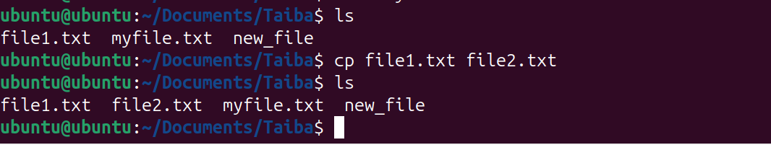

• **mv**: Moves or renames files or directories.

* mv old_name new_name: Rename a file or directory.
* mv file_name /path/to/destination: Move a file to a different directory.

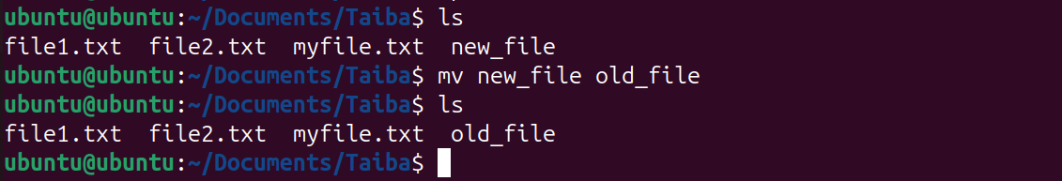

• **ping**: Tests network connectivity.

* ping google.com: Ping Google's server to check connectivity.

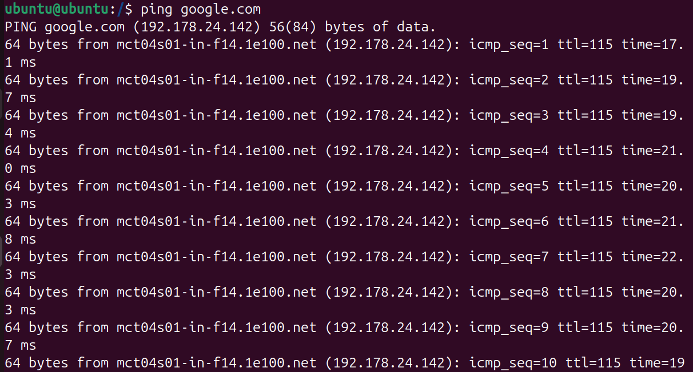

• **ifconfig**: Show network interfaces and their configuration.

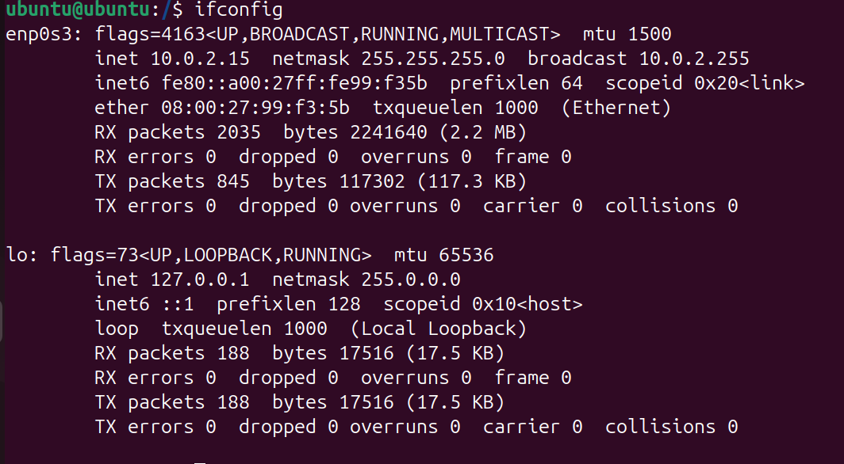

• **history**: Shows the command history.

* History: Displays the list of previously executed commands.
* 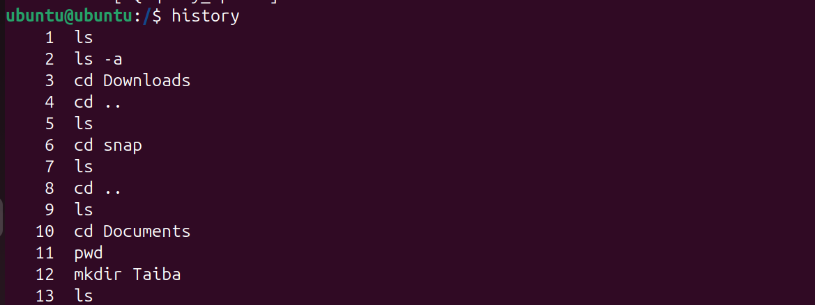

• **clear**: Clears the terminal screen.

* Clear: Clears all previous commands and output from the terminal display.