Error 1

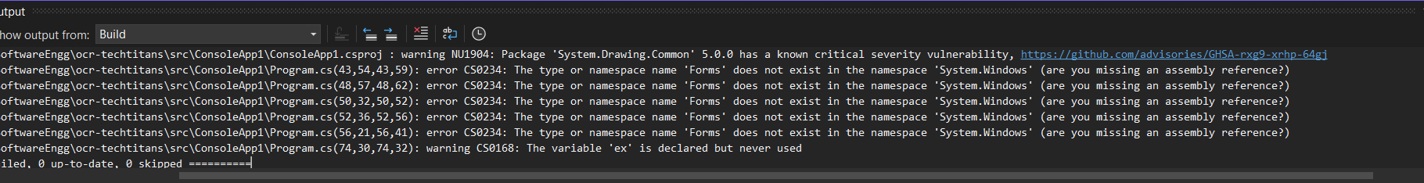

I was getting this error while executing

Resolution

Adding <UseWindowsForms>true</UseWindowsForms> in PropertyGroup

Error 2



C:\Program Files\dotnet\sdk\9.0.100\Sdks\Microsoft.NET.Sdk\targets\Microsoft.NET.Sdk.FrameworkReferenceResolution.targets(65,5): warning NETSDK1086: A FrameworkReference for 'Microsoft.WindowsDesktop.App.WindowsForms' was included in the project. This is implicitly referenced by the .NET SDK and you do not typically need to reference it from your project. For more information, see https://aka.ms/sdkimplicitrefs 1>C:\Program Files\dotnet\sdk\9.0.100\Sdks\Microsoft.NET.Sdk\targets\Microsoft.PackageDependencyResolution.targets(266,5): error NETSDK1005: Assets file 'C:\Users\mithi\OneDrive\Desktop\SoftwareEngg\ocr-techtitans\src\ConsoleApp1\obj\project.assets.json' doesn't have a target for 'net9.0-windows'. Ensure that restore has run and that you have included 'net9.0-windows' in the TargetFrameworks for your project.

Resolution

Removed <FrameworkReference Include="Microsoft.WindowsDesktop.App.WindowsForms" />

From .csproj file

Error 3

The type or namespace name 'Form' could not be found (are you missing a using directive or an assembly reference?)

Added <PackageReference Include="System.Reactive.Windows.Forms" Version="6.0.1" />

Error 4

Please make sure the TESSDATA_PREFIX environment variable is set to your "tessdata" directory. Failed loading language 'eng' Tesseract couldn't load any languages! Error in ExtractTextFromImage: Failed to initialise tesseract engine.. See https://github.com/charlesw/tesseract/wiki/Error-1 for details.

Resolution: Installed below nuget

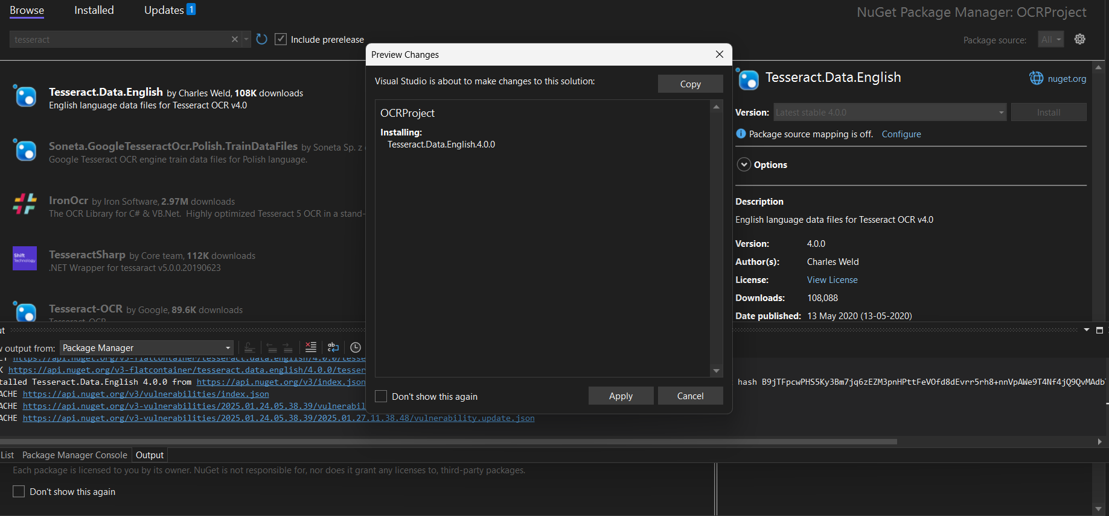

Error 5

Argument 1: cannot convert from 'System.Drawing.Image' to 'System.Drawing.Bitmap'

The inputImage is loaded as a Bitmap using new Bitmap(inputFilePath). This ensures compatibility with the transformation methods that expect a Bitmap. The GetImageFormat helper method ensures that the processed images are saved in the same format as the input.