**Android-related questions from StackOverflow**

**Cool feature**

This website could search for any topic you interested in, not just Android.

**Install Process**

1.Download ZIP and unzip.

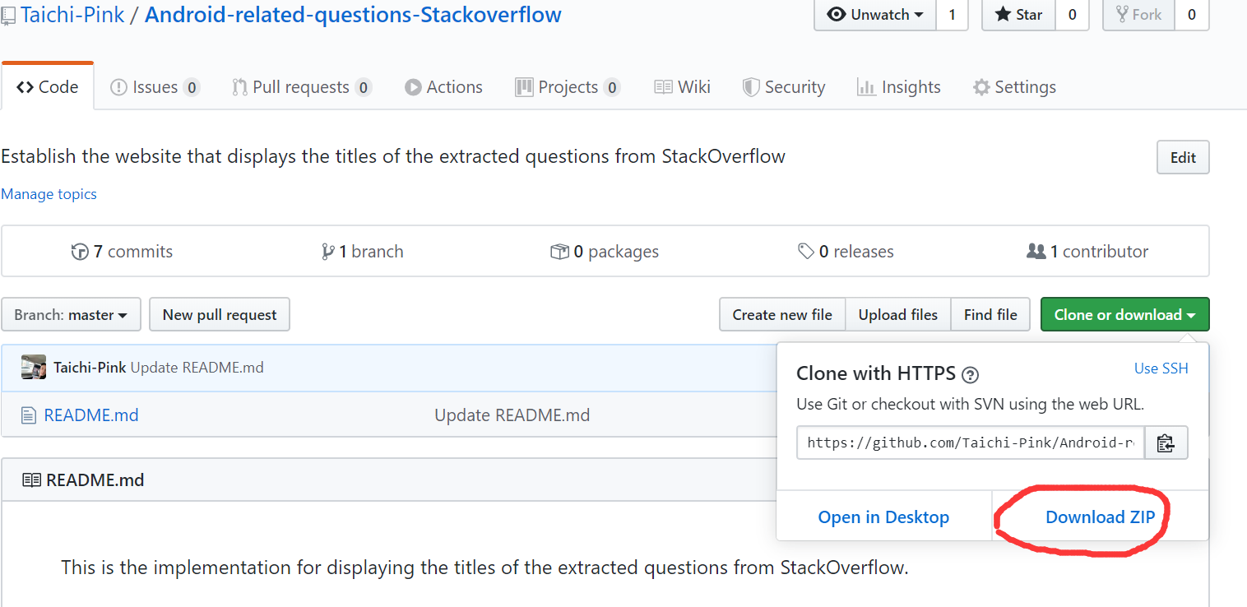

2.Open Pycharm and click the open button.Choose the project where it's downloaded.

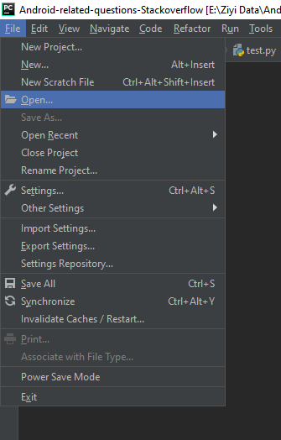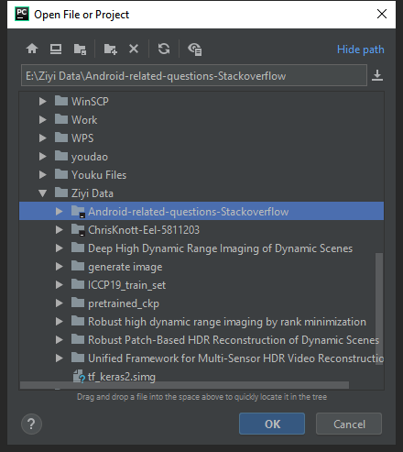

3.Open Settings to configure environment.

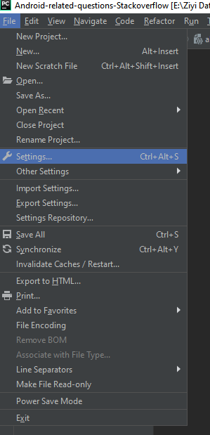

4.At the top of the right panel, click the gear icon to add a Python Interpreter with environment Python 3.7

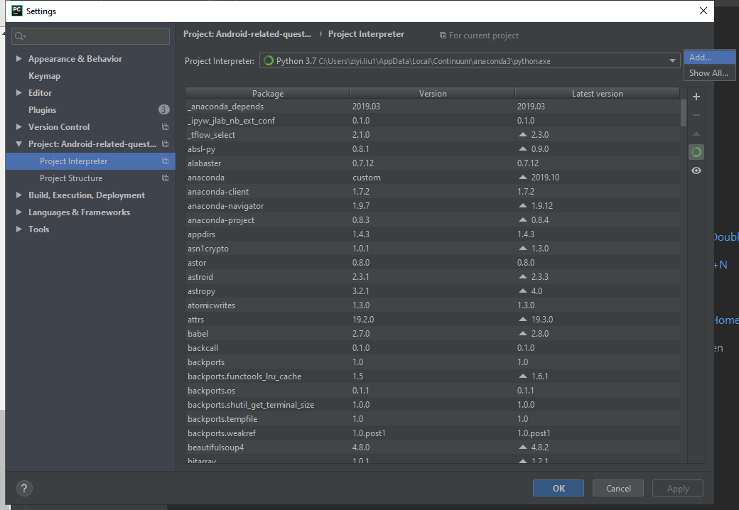

1. Click the add icon to add the related dependencies.

(eel v 0.12.2

json5 v 0.8.5

requests v 2.21.0

jinja2 v 2.11.1)

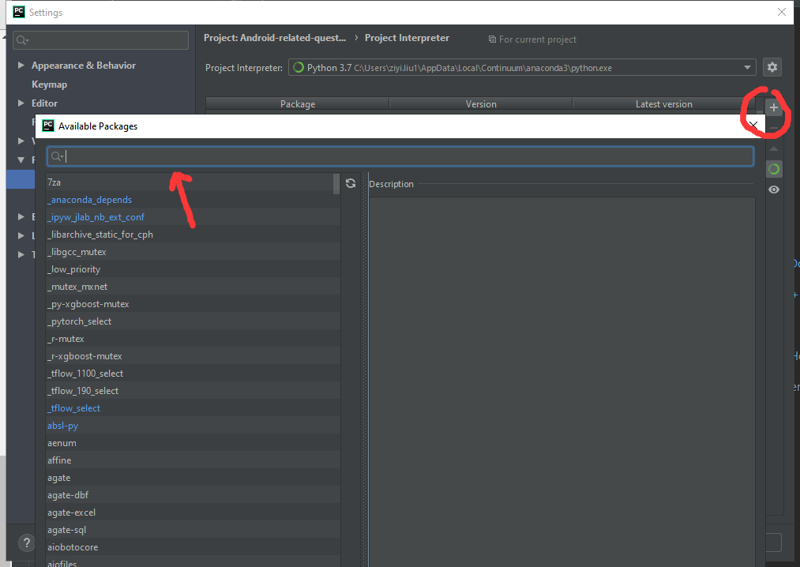

1. Open the ” /Android-related-questions-Stackoverflow/Web.py” file;Click the green Run Button

**Display Result**

1. Open the website
2. Search Results