Título del Trabajo
Tarea 2 - Fundamentos de la programación orientada a objetos

Estudiante
Juan Pablo Jurado Vasquez

Tutor
Juan Pablo Arango Cardona

Materia
Curso de Programación 2204 - 2026

Universidad Nacional Abierta y a Distancia UNAD
Escuela De Ciencias Básicas Tecnología e Ingneiria
ECBTI

Abstract
The development of modern software applications demands a comprehensive understanding of diverse programming paradigms and structural methodologies. This essay analyzes the architectural and logical foundations required to build a robust desktop application in Python, utilizing the specific case study of a computer maintenance registration system ("Ejercicio 2.py"). By dissecting the source code, this paper explores the intersection of foundational algorithmic logic, Object-Oriented Programming (OOP) principles, Graphical User Interface (GUI) design using the `tkinter` library, and stringent error-handling mechanisms. Ultimately, this analysis demonstrates that effective software development in Python transcends syntax, requiring a holistic approach that guarantees data integrity, responsive user experiences, and systemic resilience against runtime errors.

Introduction
In the contemporary landscape of software engineering, Python has solidified its position as one of the most versatile and widely used dynamic programming languages across science, education, and software development. Celebrated for its readability and extensive standard libraries, Python supports multiple paradigms, including both structured and object-oriented programming (Kte, 2024). However, mastering a programming language transcends the simple memorization of syntax; it requires a profound cognitive process aimed at analyzing real-world problems and translating them into a sequential, logical step-by-step format known as an algorithm (Dueñas Meza et al., 2021). The transition from theoretical algorithms to functional, interactive software requires the harmonious integration of multiple structural pillars.
The present essay analyzes the architectural and logical foundations required to build a robust desktop application, utilizing the specific case study of a computer maintenance registration system embodied in the script "Ejercicio 2.py". Through the dissection of this code, this paper will explore the implementation of foundational algorithmic logic and data traversal, the structural benefits of Object-Oriented Programming (OOP), the strict rules of Graphical User Interface (GUI) design using the `tkinter` library, and the critical necessity of exception handling. Ultimately, this essay demonstrates that effective software development demands a holistic approach to ensure data integrity, responsive user experiences, and systemic resilience against runtime errors.

Justification
Understanding the underlying mechanics of software architecture is essential for developing applications that are scalable, maintainable, and efficient. The justification for deeply analyzing the "Ejercicio 2.py" script lies in its comprehensive application of foundational programming concepts to solve a practical business problem: managing the entry, exit, and billing of computer maintenance services. The core of this functionality relies heavily on algorithmic logic and the manipulation of dynamic memory spaces known as variables. Variables are defined as designated memory locations, identified by unique names, that store data susceptible to change during the program's execution (Dueñas Meza et al., 2021). In the application, structural variables like `self.matriz_computadores` act as dynamic lists, storing the entirety of the registered objects.
Furthermore, transitioning from basic sequential logic to Object-Oriented Programming (OOP) is a crucial evolutionary step justified by the need for data encapsulation. OOP allows developers to model real-world entities—such as a computer in a repair shop—by encapsulating both attributes (data) and methods (actions) within a single structural blueprint, the class (Van Rossum & Drake, 2024). In the analyzed code, the `ComputadorMantenimiento` class serves this exact purpose. When a new computer is instantiated, Python evaluates the external input variables and passes their raw values into the class constructor (`__init__`). Here, the keyword `self` plays an indispensable role; it represents the specific, individual object being born in memory. By executing assignments like `self.hora_entrada = _hora_entrada`, the program guarantees that the incoming data is permanently anchored to that specific object's internal, exclusive memory.
This OOP architecture justifies the way data is traversed and retrieved later in the code. To review the registered computers, the algorithm utilizes a `for` loop, a cyclical instruction that repeats a specific number of times to extract data sequentially (Dueñas Meza et al., 2021). By writing `for pc in self.matriz_computadores:`, the program extracts each object one by one, temporarily assigning it to the `pc` variable. Because `pc` represents a fully formed object, the dot notation (`.`) acts as a bridge to access its internal memory. The developer can retrieve a static attribute directly (e.g., `pc.hora_entrada`) or invoke an active getter method (e.g., `pc.obtener_codigo()`). This flexible architecture ensures that each computer's data remains isolated and secure, preventing variables from overlapping.

Objectives
The primary objective of this analysis is to demonstrate how to bridge the gap between complex background logic and the end-user through a functional Graphical User Interface (GUI), while simultaneously ensuring the software's systemic robustness against user errors. Achieving these goals requires strict adherence to library-specific rules and the implementation of defensive programming techniques.
The first specific objective is the correct implementation of GUI dynamics using the standard `tkinter` library. Developing interfaces introduces unique architectural rules, particularly concerning widget memory management. A critical rule discovered during the development of "Ejercicio 2.py" is the mandatory separation of widget instantiation from its geometric packing. When creating interactive elements, developers must write `self.boton_menu = tkinter.Button(...)` on one line and `self.boton_menu.pack()` on the subsequent line. If these instructions are combined into a single line, the variable loses the physical widget object and instead stores the empty `None` value returned by the `.pack()` action. Separating them ensures that the `self` variable retains permanent control over the physical button or text box, allowing the program to read user inputs or hide the widget later without triggering an `AttributeError`.
The second specific objective is ensuring systemic robustness through error handling. A professional application must anticipate and gracefully handle unexpected inputs without abruptly terminating (Van Rossum & Drake, 2024). In a GUI context, blindly trusting user input is highly dangerous. If a user inadvertently types text into a box intended for numeric data, attempting to convert it using `int()` or `float()` will trigger a `ValueError`, crashing the application entirely. To shield the program, a `try... except ValueError` block is implemented. This structural shield instructs Python to attempt the mathematical conversion; if it encounters incompatible text, it intercepts the crash, bypasses the failure, and safely triggers a visual warning label instead. Furthermore, calculations are refined using formatted strings with the `:.2f` syntax (e.g., `${valor_final:.2f}`). This forces Python to display mathematical results with exactly two decimal places, guaranteeing a clean, professional financial presentation regardless of the raw calculation's length.

Code screenshots
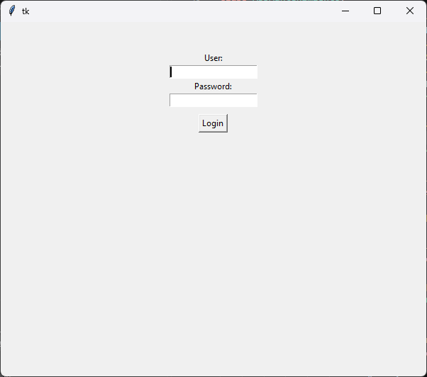
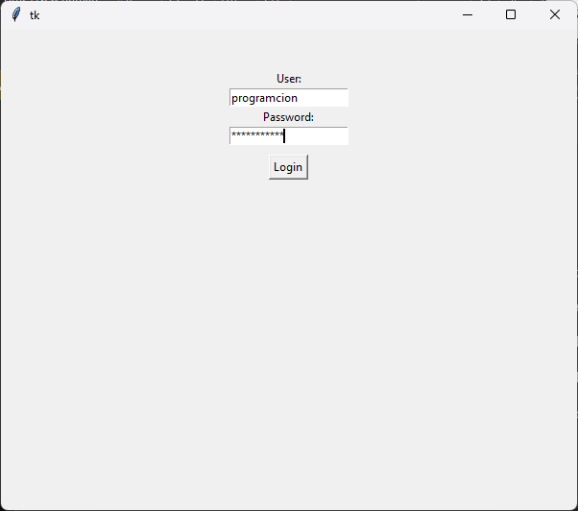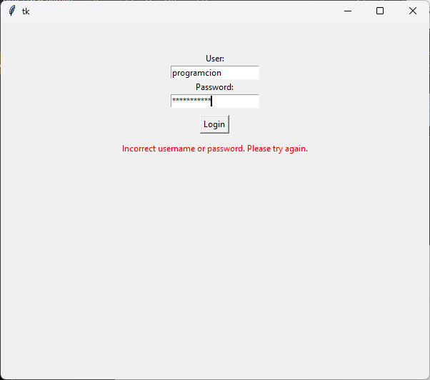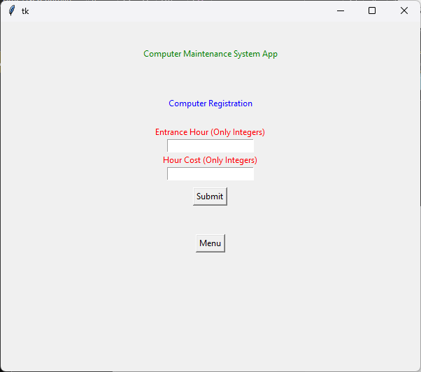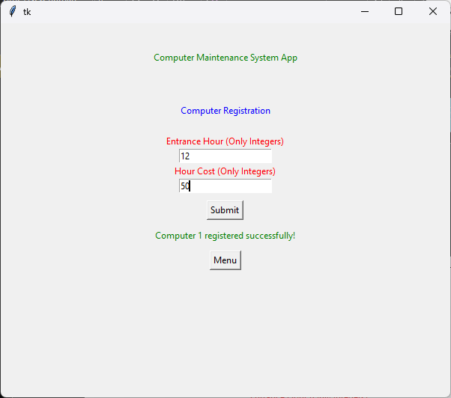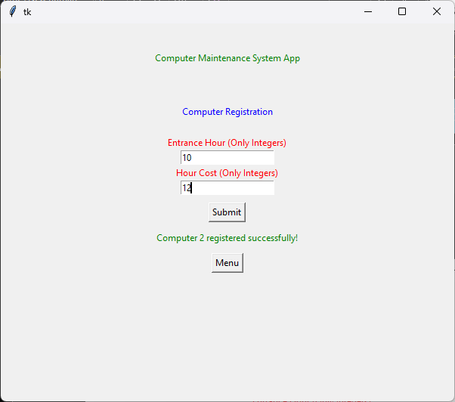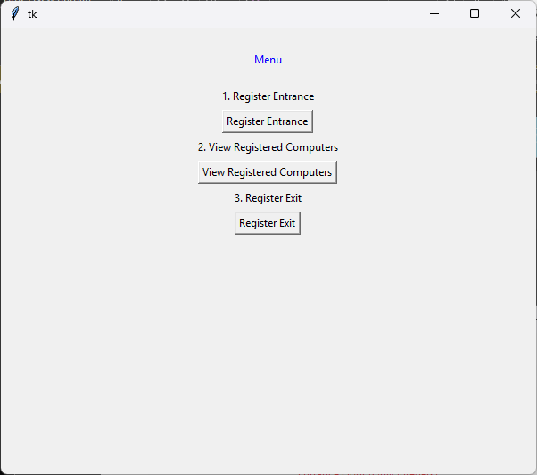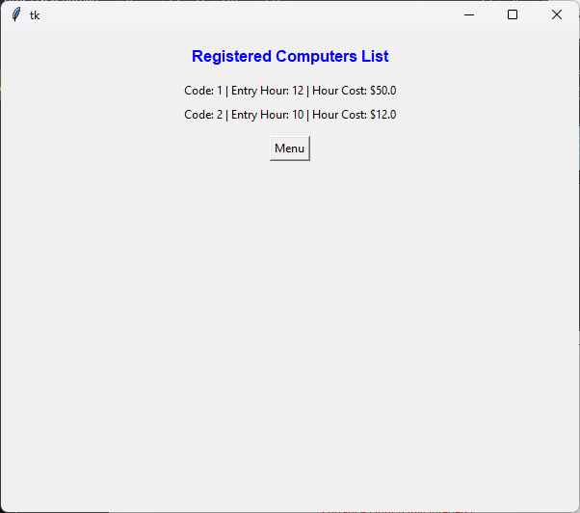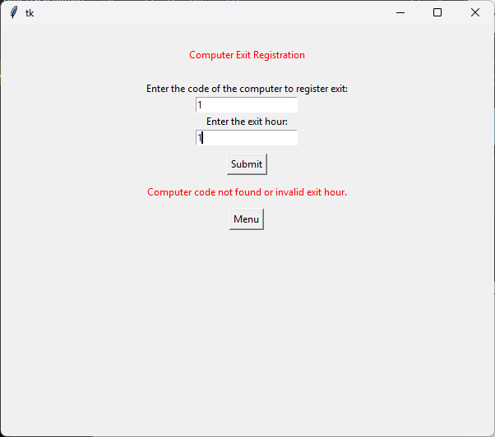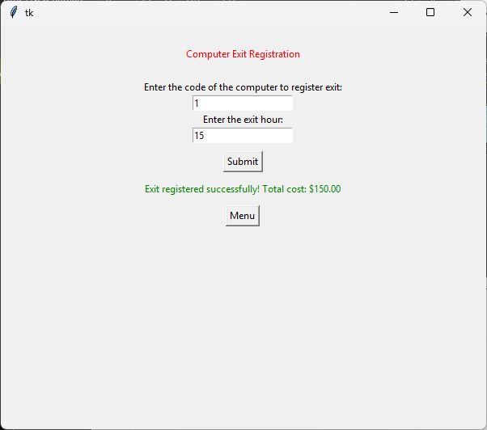

Code
import tkinter

# Clase usuario

class Usuario:
def __init__(self):
self.usuario = "programacion"
self.password = "programacion"
# Metodo para validar el usuario y la contraseña

def validar(self, usuario_ingresado, password_ingresado):
if self.usuario == usuario_ingresado and self.password == password_ingresado:
return True
else:
return False

# Clase ComputadorMantenimiento

class ComputadorMantenimiento:

def __init__(self, _codigo, _hora_entrada, _valor_hora):
self.codigo = _codigo
self.hora_entrada = _hora_entrada
self.valor_hora = _valor_hora
self.hora_salida = 0

# Método registrar_entrada(hora)
def registrar_entrada(self, hora):
self.hora_entrada = hora

# Método registrar_salida(hora)
def registrar_salida(self, hora):
self.hora_salida = hora

# Método calcular_valor(hora_salida)
def calcular_valor(self, hora_salida):
self.hora_salida = hora_salida
horas_totales = self.hora_salida - self.hora_entrada
valor_final = horas_totales*self.valor_hora
return valor_final

# Método obtener_codigo()
def obtener_codigo(self):
return self.codigo

class AppMantenimiento:
def __init__(self, ventana):
self.ventana = ventana
self.ventana.geometry("600x500")

# variable para asignar un consecutivo a cada computador como su codigo
self.contador_computador = 0
# variable para almacenar los computadores en una lista
self.matriz_computadores = []
# instanciamos la clase usuario para poder usarla
self.usuario = Usuario()

# Creamos un frame de login para manejar la interfaz grafica por frames
self.frame_login = tkinter.Frame(self.ventana)
self.frame_login.pack(pady=40)

# etiquetas y cajas de texto para el login
tkinter.Label(self.frame_login, text="User:").pack()
self.caja_usuario = tkinter.Entry(self.frame_login)
self.caja_usuario.pack()

tkinter.Label(self.frame_login, text="Password:").pack()
self.caja_contraseña = tkinter.Entry(self.frame_login, show="*")
self.caja_contraseña.pack()

# botón de inicio de sesión
tkinter.Button(self.frame_login, text="Login",
command=self.iniciar_sesion).pack(pady=10)
self.mensaje_error_login = tkinter.Label(
self.frame_login, text="", fg="red")
self.mensaje_error_login.pack()

# Creamos el frame registro de entrada, que estará oculto hasta que el usuario inicie sesión correctamente
self.frame_registro_entrada = tkinter.Frame(self.ventana)

tkinter.Label(self.frame_registro_entrada,
text="Computer Maintenance System App", fg="green").pack(pady=30)
tkinter.Label(self.frame_registro_entrada,
text="Computer Registration", fg="blue").pack(pady=20)
tkinter.Label(self.frame_registro_entrada,
text="Entrance Hour (Only Integers)", fg="red").pack()
self.caja_hora = tkinter.Entry(self.frame_registro_entrada)
self.caja_hora.pack()
tkinter.Label(self.frame_registro_entrada,
text="Hour Cost (Only Integers)", fg="red").pack()
self.caja_valor = tkinter.Entry(self.frame_registro_entrada)
self.caja_valor.pack()
tkinter.Button(self.frame_registro_entrada, text="Submit",
command=self.registrar_pc_GUI).pack(pady=10)
self.etiqueta_estado_registro = tkinter.Label(
self.frame_registro_entrada, text="", fg="black")
self.etiqueta_estado_registro.pack()
tkinter.Button(self.frame_registro_entrada, text="Menu",
command=self.mostrar_menu_registro_entrada).pack(pady=10)

# Creamos el frame del menú, que estará oculto hasta que el usuario haga clic en el botón "Menu"
self.frame_menu = tkinter.Frame(self.ventana)
tkinter.Label(self.frame_menu, text="Menu", fg="blue").pack(pady=20)
tkinter.Label(self.frame_menu, text="1. Register Entrance").pack()
tkinter.Button(self.frame_menu, text="Register Entrance",
command=self.mostrar_registro_entrada).pack(pady=5)
tkinter.Label(self.frame_menu,
text="2. View Registered Computers").pack()
tkinter.Button(self.frame_menu, text="View Registered Computers",
command=self.mostrar_ver_computadores).pack(pady=5)
tkinter.Label(self.frame_menu, text="3. Register Exit").pack()
tkinter.Button(self.frame_menu, text="Register Exit",
command=self.mostrar_registro_salida).pack(pady=5)

# Creamos el frame para ver los computadores registrados, que estará oculto hasta que el usuario haga clic en la opción correspondiente del menú
self.frame_ver_computadores = tkinter.Frame(self.ventana)

# Creaamos el frame para registrar la salida de los computadores, que estará oculto hasta que el usuario haga clic en la opción correspondiente del menú
self.frame_registro_salida = tkinter.Frame(self.ventana)

tkinter.Label(self.frame_registro_salida,
text="Computer Exit Registration", fg="red").pack(pady=20)
tkinter.Label(self.frame_registro_salida,
text="Enter the code of the computer to register exit:").pack()
self.caja_codigo_salida = tkinter.Entry(self.frame_registro_salida)
self.caja_codigo_salida.pack()
tkinter.Label(self.frame_registro_salida,
text="Enter the exit hour:").pack()
self.caja_hora_salida = tkinter.Entry(self.frame_registro_salida)
self.caja_hora_salida.pack()
tkinter.Button(self.frame_registro_salida, text="Submit",
command=self.registrar_salida_GUI).pack(pady=10)
self.etiqueta_estado_salida = tkinter.Label(
self.frame_registro_salida, text="", fg="red")
self.etiqueta_estado_salida.pack()

tkinter.Button(self.frame_registro_salida, text="Menu",
command=self.mostrar_menu_registro_entrada).pack(pady=10)

def iniciar_sesion(self):
usuario_ingresado = self.caja_usuario.get()
password_ingresado = self.caja_contraseña.get()

if self.usuario.validar(usuario_ingresado, password_ingresado):
self.frame_login.pack_forget() # Ocultar el frame de login
self.frame_registro_entrada.pack(
pady=5) # Mostrar el frame principal
else:
self.mensaje_error_login.config(
text="Incorrect username or password. Please try again.")

def registrar_pc_GUI(self):
hora_entrada = self.caja_hora.get()
valor_hora = self.caja_valor.get()

if 0 <= int(hora_entrada) <= 23 and 0 < float(valor_hora):
try:
hora_entrada = int(hora_entrada)
valor_hora = float(valor_hora)
self.contador_computador += 1
nuevo_computador = ComputadorMantenimiento(
self.contador_computador, hora_entrada, valor_hora)
self.matriz_computadores.append(nuevo_computador)
self.etiqueta_estado_registro.config(
text=f"Computer {self.contador_computador} registered successfully!", fg="green")
except ValueError:
self.etiqueta_estado_registro.config(
text="Please enter valid numbers for hour and cost.", fg="red")
else:
self.etiqueta_estado_registro.config(
text="Please fill in all fields with valid values.", fg="red")

def mostrar_menu_registro_entrada(self):
# Ocultar el frame de registro de entrada
self.frame_registro_entrada.pack_forget()
# Ocultar el frame de ver computadores
self.frame_ver_computadores.pack_forget()
# Ocultar el frame de registro de salida
self.frame_registro_salida.pack_forget()
self.frame_menu.pack(pady=5) # Mostrar el frame del menú

def mostrar_registro_entrada(self):
self.frame_menu.pack_forget() # Ocultar el frame del menú
# Mostrar el frame de registro de entrada
self.frame_registro_entrada.pack(pady=5)

def mostrar_ver_computadores(self):
self.frame_menu.pack_forget() # Ocultar el frame del menú
# Mostrar el frame de ver computadores
self.frame_ver_computadores.pack(pady=5)

for widget in self.frame_ver_computadores.winfo_children():
widget.destroy()

tkinter.Label(self.frame_ver_computadores, text="Registered Computers List", font=(
"Arial", 12, "bold"), fg="blue").pack(pady=10)

if len(self.matriz_computadores) == 0:
tkinter.Label(self.frame_ver_computadores,
text="No computers registered yet.", fg="red").pack(pady=10)
else:
for pc in self.matriz_computadores:
texto_pc = f"Code: {pc.obtener_codigo()} | Entry Hour: {pc.hora_entrada} | Hour Cost: ${pc.valor_hora}"
tkinter.Label(self.frame_ver_computadores,
text=texto_pc).pack(pady=2)

tkinter.Button(self.frame_ver_computadores, text="Menu",
command=self.mostrar_menu_registro_entrada).pack(pady=10)

def mostrar_registro_salida(self):
self.frame_menu.pack_forget() # Ocultar el frame del menú
# Mostrar el frame de registro de salida
self.frame_registro_salida.pack(pady=5)

def registrar_salida_GUI(self):
codigo_salida = self.caja_codigo_salida.get()
hora_salida = self.caja_hora_salida.get()

if codigo_salida and hora_salida:
try:
codigo_salida = int(codigo_salida)
hora_salida = int(hora_salida)

# Buscar el computador por su código
computador_encontrado = None
for pc in self.matriz_computadores:
if pc.obtener_codigo() == codigo_salida:
computador_encontrado = pc
break

if computador_encontrado and computador_encontrado.hora_entrada < hora_salida:
valor_final = computador_encontrado.calcular_valor(
hora_salida)
self.etiqueta_estado_salida.config(
text=f"Exit registered successfully! Total cost: ${valor_final:.2f}", fg="green")
else:
self.etiqueta_estado_salida.config(
text="Computer code not found or invalid exit hour.", fg="red")
except ValueError:
self.etiqueta_estado_salida.config(
text="Please enter valid numbers for code and exit hour.", fg="red")
else:
self.etiqueta_estado_salida.config(
text="Please fill in all fields.", fg="red")

raiz = tkinter.Tk()
app = AppMantenimiento(raiz)
raiz.mainloop()

Conclusions
The comprehensive development of the "Ejercicio 2.py" computer maintenance system serves as a practical testament to the multifaceted nature of modern software engineering. It clearly demonstrates that effective programming requires the convergence of diverse logical disciplines. The application begins with the abstract understanding of algorithmic logic and data structures, utilizing lists and cyclical `for` loops to effectively store and traverse information. This logic is then structurally secured through the principles of Object-Oriented Programming, utilizing the `self` parameter to encapsulate and anchor unique data within individual, independent objects in memory.
Moreover, the software takes interactive visual form through the precise, two-step management of `tkinter` widgets, ensuring that variables correctly retain their physical interface elements by strictly separating instantiation from the `.pack()` method. Above all, the software is operationally shielded by anticipating human error. The implementation of structural validations, existence checks, and `try-except ValueError` blocks guarantees continuous, resilient operation without catastrophic runtime failures. Ultimately, mastering these foundational pillars—algorithms, OOP, GUI management, and exception handling—empowers developers to build applications that are not merely functional, but highly professional, scalable, and secure.

References
- Dueñas Meza, J. M., Valdés Benjumea, J. J., & Rodríguez Niño, M. C. (2021). Didáctica para el aprendizaje de algoritmos (19 - 23). Sello Editorial UNAD. https://doi.org/10.22490/9789586517799
- Hinojosa Gutiérrez, Á. (2015). Python paso a paso. RA-MA Editorial.
- Kte, pi, B. (2024). Python (programming language). Salem Press Encyclopedia of Science.
- Van Rossum, G., & Drake Jr, F. L. (2024). El tutorial de Python. Python Software Foundation. https://docs.python.org/es/3.12/tutorial/index.html

