Bài 01:

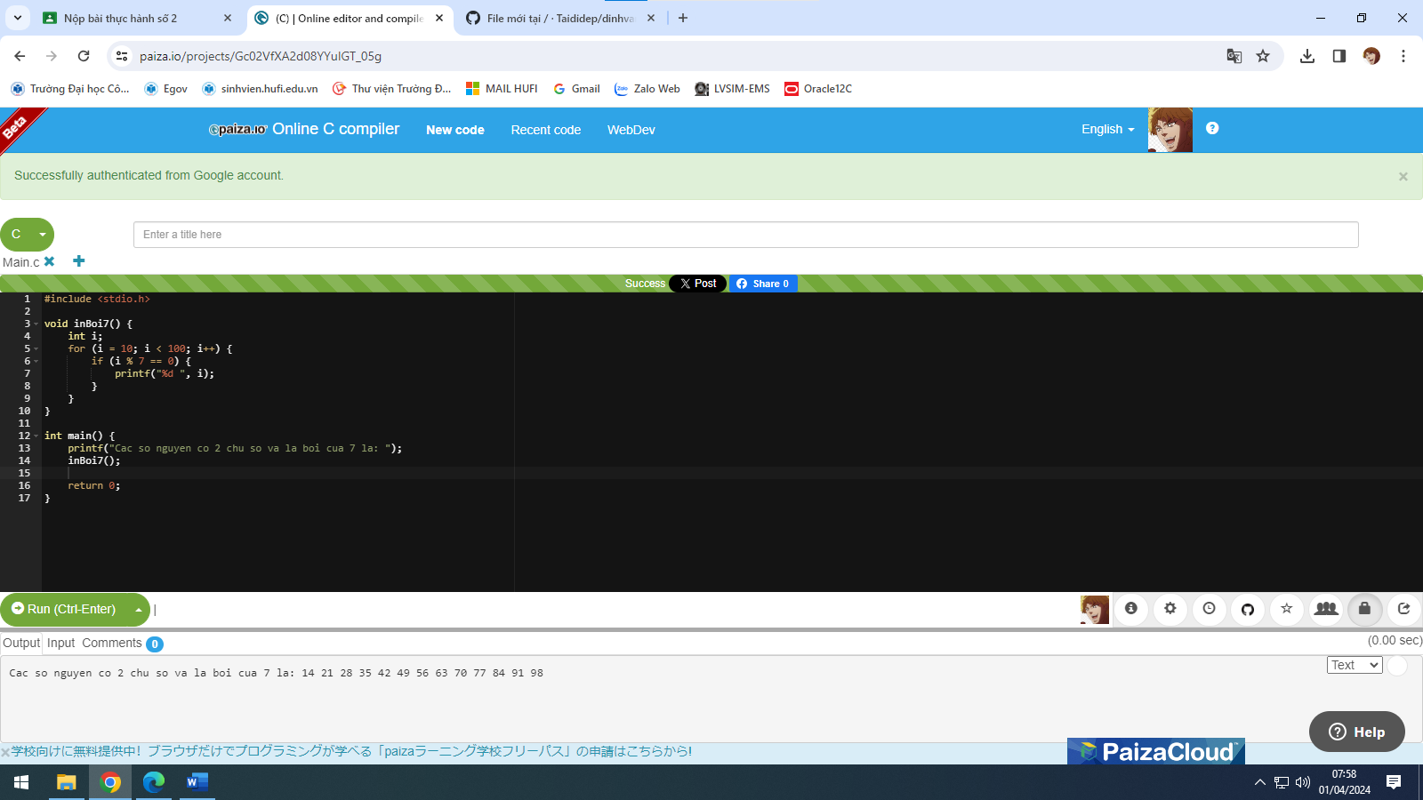

Bài 02:

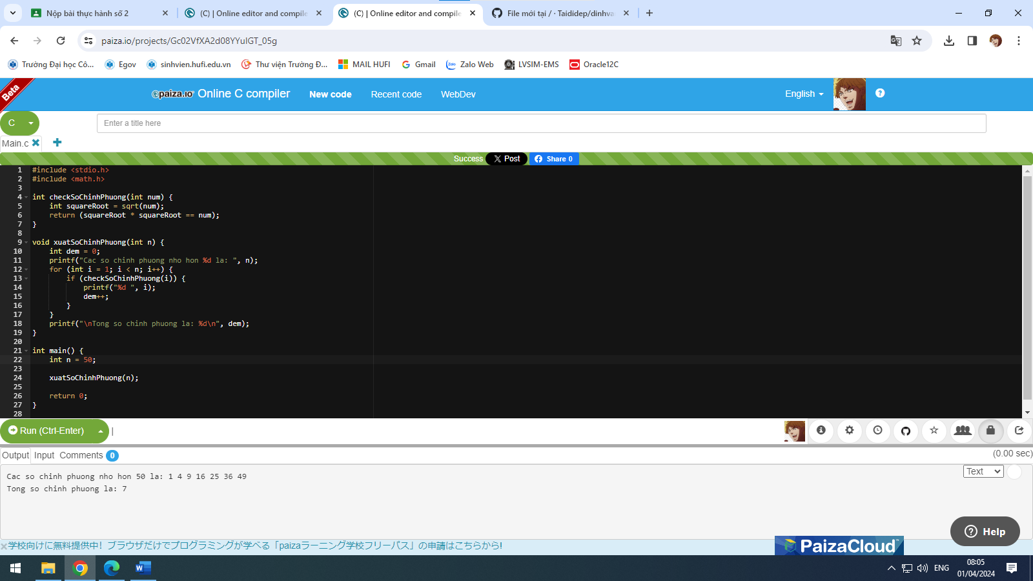

Bài 03:

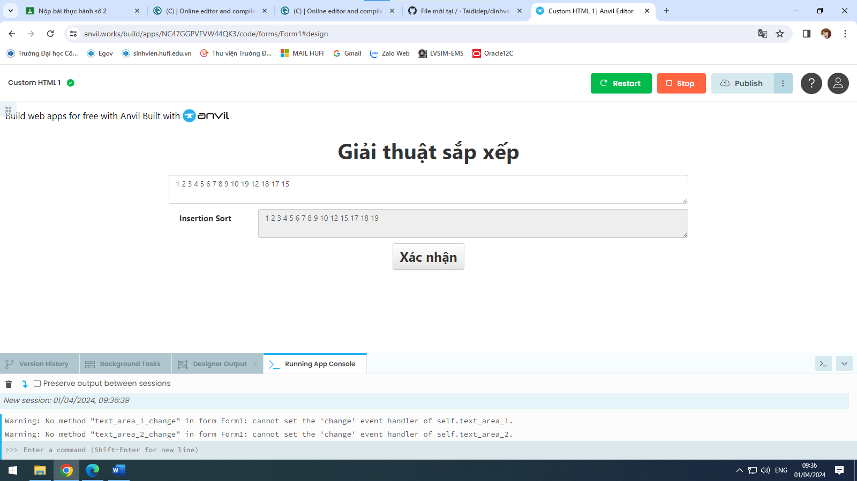

Github: <https://github.com/Taididep/dinhvantai>

Anvil.works: <https://dinhvantaidz.anvil.app>