Summary

An organized, kind-hearted, and hard-working individual with a passion for programming and strong English speaking and writing abilities. Equipped with exceptional communication, problem-solving, and time management skills, as well as strong organizational, coordination, and leadership abilities. Comfortable working in high-pressure environments and committed to continuous learning and personal growth.

Experience

01/2023 - Current

Joint Programming Secretary

Green University Computer Club - Permanent Campus | Dhaka, Bangladesh

Ex Teaching Assistant on Algorithms

• Executed engaging lessons aligning with university philosophy and mission.

• Prepared and duplicated teaching materials to enhance student understanding.

• Provided motivating learning environments, inspiring student engagement.

• Built positive relationships with students and responded to classroom needs.

• Supplied teachers with regular feedback on student achievement, progress, and issues.

Education

2024

Green University of Bangladesh | Purbachol American City, Dhaka, Bangladesh

Bachelor of Science: Computer Science & Engineering

2019

Jalalabad Cantonment Public School and College | Boteswar, Sylhet

Higher Secondary Certificate

### Contact

#### +88 01304039967

#### taiefsiddik2@gmail.com

<https://www.linkedin.com/in/taief-siddik-31a998212/>

<https://github.com/TaiefSiddique>

### Highlights

* Teaching and Learning
* Mutual Communication
* Public Speaking
* Study material management
* Data confidentiality
* Motivational Strategies

### Achievements

* Vice Chancellor’s Award – 5 times
* Dean’s Award – 1 time
* CGPA – 3.95 (Current)

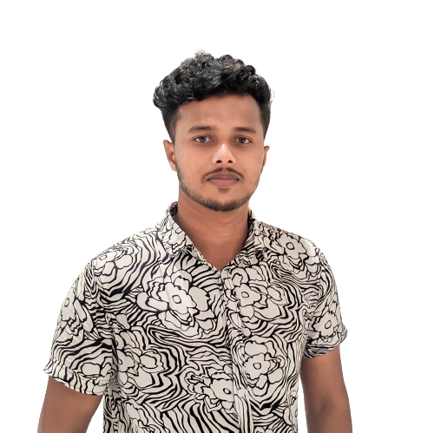

MD. ABU TAIEF SIDDIQUE