STAT448 Final Project Report
Taiga Hasegawa (taigah2)

Introduction

Our group used data set created by IBM data scientists which aims to uncover the factors that lead to employee attrition and explore important questions of employee performance. Following it the original dataset link:
https://www.ibm.com/communities/analytics/watson-analytics-blog/hr-employee-attrition/
My question is to find what cause wage gap and what kind of impact each variable has on wage. I used 'MonthlyIncome' as response variable because this variable represented the monthly income. Before starting to analyze, I omitted the Over18, Overtime, EmployeeNumber and EmployeeCount from the data because they had only one value and there was no variation in them. I made two models to analyze wage gap. First is the ANOVA model and second is the Linear Regression. ANOVA used only categorical variables as predictors but linear regression model used all variables including categorical, discrete and continuous variables.

Main Body
First I checked the features of monthlyincome. The Goodness of Fit and Test For Normality shows that MonthlyIncome doesn't follow the normal distribution. I might need to transform the monthlyincome later.
proc univariate data=attrition normal;
var monthlyincome;
histogram monthlyincome/normal;
ods select Histogram GoodnessOfFit TestsForNormality;
run;

Variable: MonthlyIncome

Tests for Normality
Test | Statistic |  | p Value
Shapiro-Wilk | W | 0.827907 | Pr < W | <0.0001
Kolmogorov-Smirnov | D | 0.168921 | Pr > D | <0.0100
Cramer-von Mises | W-Sq | 14.44355 | Pr > W-Sq | <0.0050
Anderson-Darling | A-Sq | 85.39056 | Pr > A-Sq | <0.0050

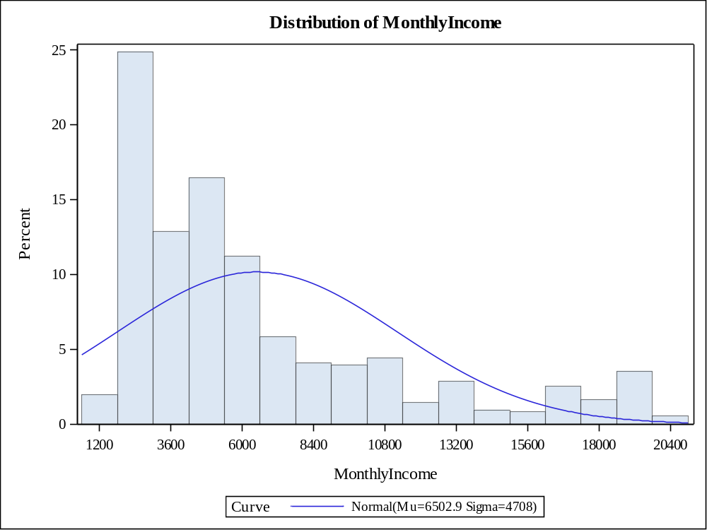

Fitted Normal Distribution for MonthlyIncome

Goodness-of-Fit Tests for Normal Distribution
Test | Statistic |  | p Value
Kolmogorov-Smirnov | D | 0.1689215 | Pr > D | <0.010
Cramer-von Mises | W-Sq | 14.4435549 | Pr > W-Sq | <0.005
Anderson-Darling | A-Sq | 85.3905578 | Pr > A-Sq | <0.005
ANOVA
At the beginning I used all the categorical variables in the model and selected variables by ss1 and ss3. Diagnostics shows that there are several points above the line in the Cook's distance but they don’t deviate from other points so much and we can ignore. QQplot is straight and seems to follow normal distribution. There appears to be a little bit decreasing variation in the residuals as the predicted value increases but it is still okay and so we don't have to use transformation.

proc glm data=attrition plots=diagnostics;
class BusinessTravel JobLevel Department Attrition EducationField Gender JobRole MaritalStatus Education EnvironmentSatisfaction JobInvolvement JobSatisfaction PerformanceRating RelationshipSatisfaction StockOptionLevel WorkLifeBalance;
model MonthlyIncome=BusinessTravel JobLevel Attrition Department EducationField Gender JobRole MaritalStatus Education EnvironmentSatisfaction JobInvolvement JobSatisfaction PerformanceRating RelationshipSatisfaction StockOptionLevel WorkLifeBalance/ ss1 ss3;
ods select OverallANOVA ModelANOVA DiagnosticsPanel;
run;

Dependent Variable: MonthlyIncome

Source | DF | Sum of Squares | Mean Square | F Value | Pr > F
Model | 47 | 30367735312 | 646122028 | 419.07 | <.0001
Error | 1422 | 2192439727 | 1541800
Corrected Total | 1469 | 32560175038

Source | DF | Type I SS | Mean Square | F Value | Pr > F
BusinessTravel | 2 | 49417572 | 24708786 | 16.03 | <.0001
JobLevel | 4 | 30078983322 | 7519745830 | 4877.25 | <.0001
Attrition | 1 | 6818661 | 6818661 | 4.42 | 0.0356
Department | 2 | 683556 | 341778 | 0.22 | 0.8012
EducationField | 5 | 1707626 | 341525 | 0.22 | 0.9534
Gender | 1 | 222953 | 222953 | 0.14 | 0.7038
JobRole | 7 | 189378946 | 27054135 | 17.55 | <.0001
MaritalStatus | 2 | 2034285 | 1017142 | 0.66 | 0.5172
Education | 4 | 13401088 | 3350272 | 2.17 | 0.0699
EnvironmentSatisfact | 3 | 1372974 | 457658 | 0.30 | 0.8277
JobInvolvement | 3 | 7454484 | 2484828 | 1.61 | 0.1848
JobSatisfaction | 3 | 4330945 | 1443648 | 0.94 | 0.4223
PerformanceRating | 1 | 231771 | 231771 | 0.15 | 0.6983
RelationshipSatisfac | 3 | 4022603 | 1340868 | 0.87 | 0.4562
StockOptionLevel | 3 | 5701363 | 1900454 | 1.23 | 0.2964
WorkLifeBalance | 3 | 1973162 | 657721 | 0.43 | 0.7340

Source | DF | Type III SS | Mean Square | F Value | Pr > F
BusinessTravel | 2 | 2806475 | 1403237 | 0.91 | 0.4027
JobLevel | 4 | 13572561310 | 3393140327 | 2200.77 | <.0001
Attrition | 1 | 3178729 | 3178729 | 2.06 | 0.1513
Department | 2 | 2573877 | 1286939 | 0.83 | 0.4342
EducationField | 5 | 1925336 | 385067 | 0.25 | 0.9400
Gender | 1 | 509061 | 509061 | 0.33 | 0.5656
JobRole | 7 | 185676275 | 26525182 | 17.20 | <.0001
MaritalStatus | 2 | 657365 | 328682 | 0.21 | 0.8080
Education | 4 | 13150187 | 3287547 | 2.13 | 0.0746
EnvironmentSatisfact | 3 | 1855384 | 618461 | 0.40 | 0.7522
JobInvolvement | 3 | 7906637 | 2635546 | 1.71 | 0.1632
JobSatisfaction | 3 | 4165731 | 1388577 | 0.90 | 0.4402
PerformanceRating | 1 | 365312 | 365312 | 0.24 | 0.6265
RelationshipSatisfac | 3 | 3913773 | 1304591 | 0.85 | 0.4686
StockOptionLevel | 3 | 5524948 | 1841649 | 1.19 | 0.3105
WorkLifeBalance | 3 | 1973162 | 657721 | 0.43 | 0.7340

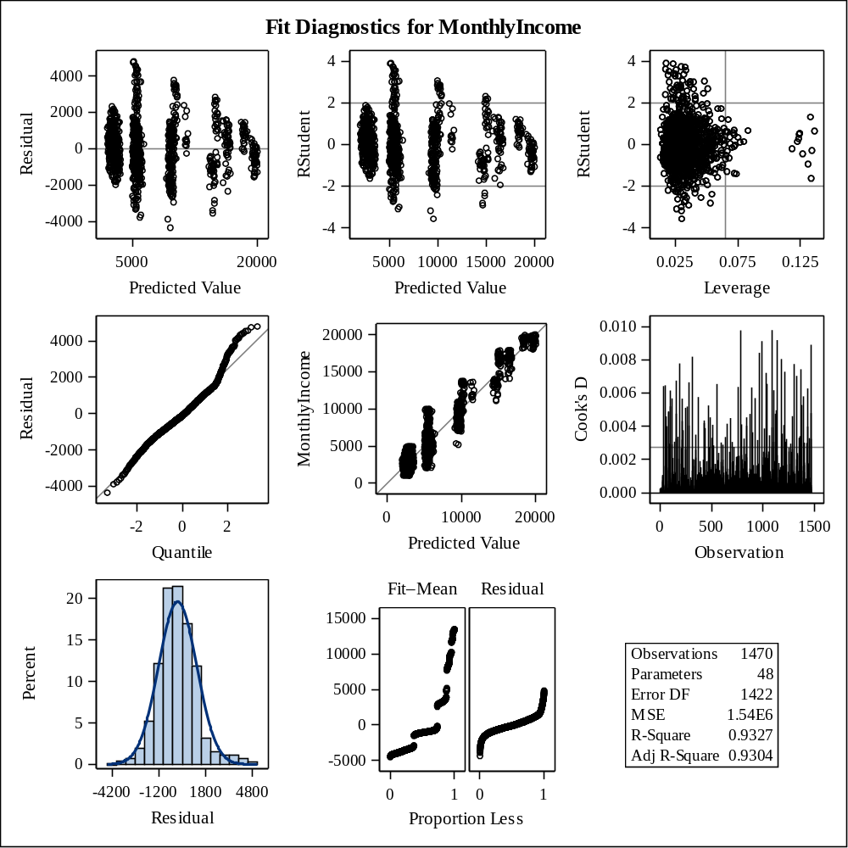
Based on the ss1 and ss3, Joblevel and JobRole are significant. Education also seems to be significant. I used variables that seemed to be significant in the next model.

proc glm data=attrition plots=diagnostics;
class JobLevel Education JobRole Attrition ;
model MonthlyIncome=Joblevel Education JobRole/ ss1 ss3;
lsmeans Joblevel Education JobRole/pdiff=all cl;
ods select OverallANOVA ModelANOVA LSMeans LSMeanDiffCL DiagnosticsPanel;
run;

Dependent Variable: MonthlyIncome

Source | DF | Sum of Squares | Mean Square | F Value | Pr > F
Model | 15 | 30330641276 | 2022042752 | 1318.68 | <.0001
Error | 1454 | 2229533763 | 1533379
Corrected Total | 1469 | 32560175038

Source | DF | Type I SS | Mean Square | F Value | Pr > F
JobLevel | 4 | 30124714118 | 7531178529 | 4911.49 | <.0001
Education | 4 | 14938796 | 3734699 | 2.44 | 0.0455
JobRole | 7 | 190988362 | 27284052 | 17.79 | <.0001

Source | DF | Type III SS | Mean Square | F Value | Pr > F
JobLevel | 4 | 13951018873 | 3487754718 | 2274.55 | <.0001
Education | 4 | 12967014 | 3241754 | 2.11 | 0.0768
JobRole | 7 | 190988362 | 27284052 | 17.79 | <.0001

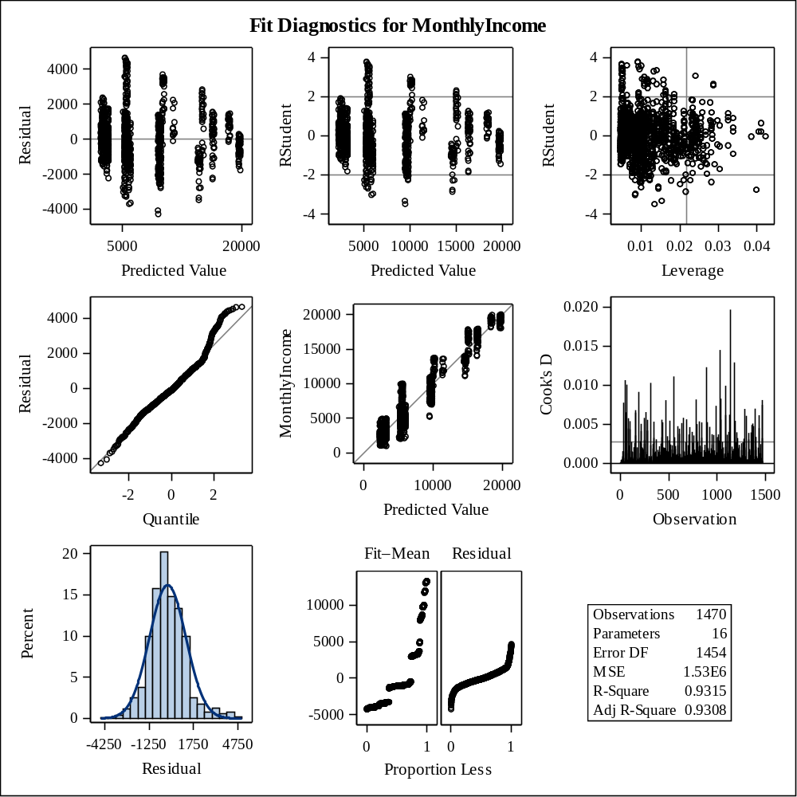

Least Squares Means
Adjustment for Multiple Comparisons: Tukey-Kramer

JobLevel | MonthlyIncome LSMEAN | LSMEAN Number
1 | 2905.2406 | 1
2 | 5688.6600 | 2
3 | 9894.1343 | 3
4 | 14862.6159 | 4
5 | 18173.4693 | 5

Least Squares Means for Effect JobLevel
i | j | Difference Between Means | Simultaneous 95% Confidence Limits for LSMean(i)-LSMean(j)
1 | 2 | -2783.419412 | -3082.461107 | -2484.377717
1 | 3 | -6988.893673 | -7346.261168 | -6631.526177
1 | 4 | -11957 | -12407 | -11508
1 | 5 | -15268 | -15806 | -14730
2 | 3 | -4205.474261 | -4482.157811 | -3928.790711
2 | 4 | -9173.955871 | -9599.815653 | -8748.096089
2 | 5 | -12485 | -13028 | -11941
3 | 4 | -4968.481610 | -5416.868435 | -4520.094784
3 | 5 | -8279.334987 | -8838.175502 | -7720.494472
4 | 5 | -3310.853377 | -3845.934316 | -2775.772438

Least Squares Means
Adjustment for Multiple Comparisons: Tukey-Kramer

Education | MonthlyIncome LSMEAN | LSMEAN Number
1 | 10423.1778 | 1
2 | 10201.6431 | 2
3 | 10240.3412 | 3
4 | 10418.0665 | 4
5 | 10240.8914 | 5

Least Squares Means for Effect Education
i | j | Difference Between Means | Simultaneous 95% Confidence Limits for LSMean(i)-LSMean(j)
1 | 2 | 221.534662 | -109.967100 | 553.036424
1 | 3 | 182.836600 | -114.400067 | 480.073267
1 | 4 | 5.111318 | -308.371613 | 318.594249
1 | 5 | 182.286376 | -378.283843 | 742.856594
2 | 3 | -38.698062 | -286.648301 | 209.252177
2 | 4 | -216.423344 | -480.627190 | 47.780502
2 | 5 | -39.248286 | -571.206827 | 492.710254
3 | 4 | -177.725282 | -400.134212 | 44.683648
3 | 5 | -0.550224 | -513.069412 | 511.968964
4 | 5 | 177.175057 | -343.080022 | 697.430137

Least Squares Means
Adjustment for Multiple Comparisons: Tukey-Kramer

JobRole | MonthlyIncome LSMEAN | LSMEAN Number
Healthca | 10092.1741 | 1
Human Re | 10154.6907 | 2
Laborato | 9962.4621 | 3
Manager | 11817.6618 | 4
Manufact | 9981.2487 | 5
Research | 10516.9146 | 6
Sales Ex | 10129.4437 | 7
Sales Re | 9783.9963 | 8

Least Squares Means for Effect JobRole
i | j | Difference Between Means | Simultaneous 95% Confidence Limits for LSMean(i)-LSMean(j)
1 | 2 | -62.516643 | -712.459347 | 587.426062
1 | 3 | 129.712051 | -344.239796 | 603.663899
1 | 4 | -1725.487742 | -2338.982334 | -1111.993150
1 | 5 | 110.925410 | -342.729805 | 564.580625
1 | 6 | -424.740542 | -865.314447 | 15.833364
1 | 7 | -37.269563 | -427.872394 | 353.333267
1 | 8 | 308.177790 | -294.787248 | 911.142828
2 | 3 | 192.228694 | -381.414313 | 765.871701
2 | 4 | -1662.971099 | -2409.260803 | -916.681395
2 | 5 | 173.442053 | -467.059991 | 813.944096
2 | 6 | -362.223899 | -922.613003 | 198.165205
2 | 7 | 25.247080 | -571.652485 | 622.146644
2 | 8 | 370.694433 | -301.781090 | 1043.169956
3 | 4 | -1855.199793 | -2447.979892 | -1262.419695
3 | 5 | -18.786642 | -479.917813 | 442.344530
3 | 6 | -554.452593 | -867.012068 | -241.893118
3 | 7 | -166.981614 | -564.423399 | 230.460170
3 | 8 | 178.465739 | -298.817291 | 655.748769
4 | 5 | 1836.413152 | 1231.251486 | 2441.574817
4 | 6 | 1300.747200 | 766.389228 | 1835.105173
4 | 7 | 1688.218179 | 1121.686237 | 2254.750121
4 | 8 | 2033.665532 | 1340.287277 | 2727.043787
5 | 6 | -535.665951 | -963.541742 | -107.790161
5 | 7 | -148.194973 | -524.530584 | 228.140638
5 | 8 | 197.252380 | -396.083895 | 790.588656
6 | 7 | 387.470978 | 26.760267 | 748.181690
6 | 8 | 732.918332 | 265.305668 | 1200.530996
7 | 8 | 345.447353 | -200.723703 | 891.618409
In the final model, Joblevel and JobRole are significant and we can also add Education as significant variables because p-value is 0.0455 in the type 1 SS and 0.0768 in the type 3 SS. Next I'll see the least squares means. We can know that as job level goes up, the monthly income is also increasing. 95% Confidence Limits of does not include 0 in Least Squares Means for Effect JobLevel. As to education, all 95% Confidence Limits includes 0 but we can clearly know that Education level 1 and 4 gets the higher salary than education level 2, 3, and 5. Level 1 means bellow college, level 2 means college level, level 3 means bachelor level, level 4 means master level, and level 5 means doctor level. Regarding JobRole, we can know that the monthly income is decreasing in the following order, Manager, Human Resources, Research, Sales Executive, Healthcare Representative, Manufacturing Director, Laboratory Technician, Sales Representative.

Linear Regression

First I used the linear regression to find the significant variables among all categorical, discrete and continuous variables but because proc reg didn't support categorical variables, I had to make the dummy variables for categorical variables by using proc glmmod.

proc glmmod data=attrition outdesign=attrition_dummy outparm=attritionParm noprint;
class BusinessTravel attrition JobLevel Department EducationField Gender JobRole MaritalStatus Education EnvironmentSatisfaction JobInvolvement JobSatisfaction PerformanceRating RelationshipSatisfaction StockOptionLevel WorkLifeBalance;
model MonthlyIncome=Age--YearsWithCurrManager;
run;

proc reg data=attrition_dummy;
model MonthlyIncome=Col1--Col54 Col56--Col77/ vif selection=stepwise sle=.05 sls=.05;
ods select SelectionSummary DiagnosticsPanel;
run;

Model: MODEL1
Dependent Variable: MonthlyIncome
Parameter Estimates
Variable | Label |  | DF | Parameter  Estimate |  | Standard  Error | t Value | Pr > |t| | Variance  Inflation
Intercept | Intercept |  | 1 | 2401.72023 |  | 76.75912 | 31.29 | <.0001 | 0
Col36 | JobLevel 2 |  | 1 | 2786.30658 |  | 86.40030 | 32.25 | <.0001 | 1.66386
Col37 | JobLevel 3 |  | 1 | 6909.72715 |  | 120.90129 | 57.15 | <.0001 | 1.77907
Col38 | JobLevel 4 |  | 1 | 11665 |  | 202.74184 | 57.54 | <.0001 | 2.65019
Col39 | JobLevel 5 |  | 1 | 14948 |  | 237.02042 | 63.07 | <.0001 | 2.42174
Col43 | JobRole Manager |  | 1 | 1795.73017 |  | 174.40014 | 10.30 | <.0001 | 1.89256
Col45 | JobRole Research |  | 1 | 502.54496 |  | 81.86678 | 6.14 | <.0001 | 1.22076
Col57 | NumCompaniesWorked |  | 1 | 33.22729 |  | 13.37145 | 2.48 | 0.0131 | 1.07437
Col70 | TotalWorkingYears |  | 1 | 15.98243 |  | 7.02986 | 2.27 | 0.0231 | 2.88104

Root MSE | 1235.11273 | R-Square | 0.9315
Dependent Mean | 6502.93129 | Adj R-Sq | 0.9312
Coeff Var | 18.99317

Model: MODEL1
Dependent Variable: MonthlyIncome

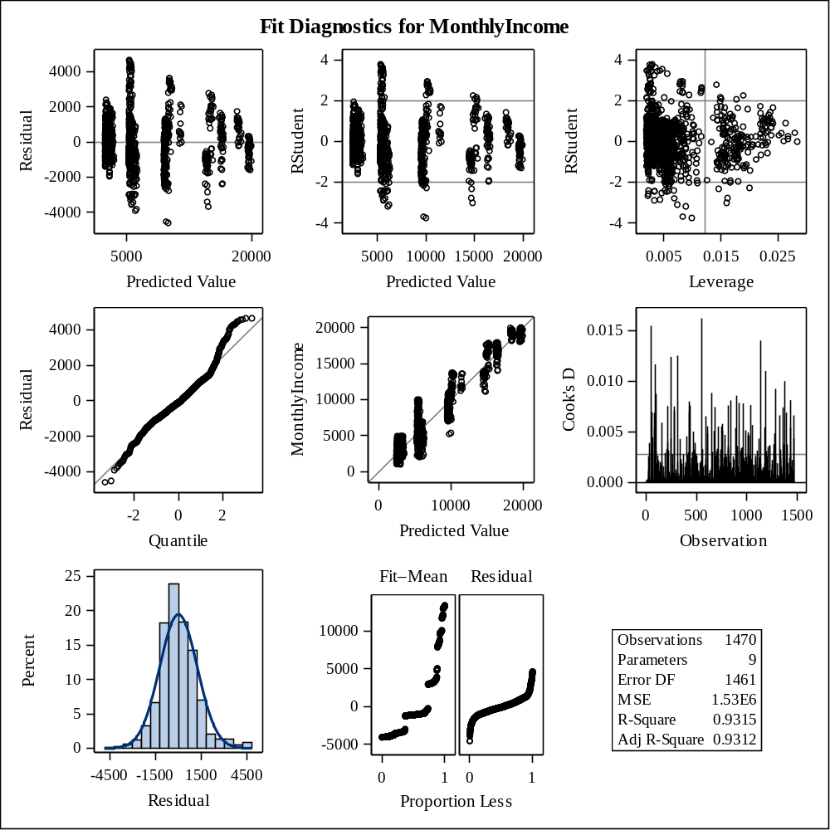
Stepwise selection was used to choose the significant predictors. 'Job level', 'Job Role', 'NumCompaniesWorked', and 'total working years' were chosen as significant variable and R square is 0.9315. It's pretty nice. Diagnostics were all good. There was no extreme point, QQplot was relatively straight, and predicted value vs monthly income scatter plot was relatively flat. VIF is all small and I can assume there is no collinearity.

Prediction
Finally, I tried to predict the monthly income. To make a test dataset, I splited the data into training data and test data. Training data used the 80% of the whole data and test data used the 20% of the whole data. Then I made the prediction model by using proc glmselect. I used stepwise selection and set the rejection level at α. I tried many α to choose the one which has the smallest average squared errors in the test dataset. The code is too long to show here. I put just result here.
Root MSE | 1241.25083
Dependent Mean | 6717.79832
R-Square | 0.9343
Adj R-Sq | 0.9317
AIC | 9097.91365
AICC | 9100.19836
PRESS | 955459479
SBC | 8606.23913
ASE (Train) | 1478558
ASE (Validate) | 1531577
ASE (Test) | 1720481
This is the result when α is 0.2. The average squared errors of the test data is 1720481.
Root MSE | 1253.73453
Dependent Mean | 6717.79832
R-Square | 0.9319
Adj R-Sq | 0.9303
AIC | 9101.12727
AICC | 9102.06844
PRESS | 959366370
SBC | 8569.95569
ASE (Train) | 1532224
ASE (Validate) | 1442458
ASE (Test) | 1709651
This is the result when α is 0.15. The average squared errors of the test data is 1709651.
Root MSE | 1255.05160
Dependent Mean | 6717.79832
R-Square | 0.9317
Adj R-Sq | 0.9301
AIC | 9101.40170
AICC | 9102.23072
PRESS | 960724849
SBC | 8565.84156
ASE (Train) | 1538092
ASE (Validate) | 1443109
ASE (Test) | 1693822
This is the result when α is 0.10. The average squared errors of the test data is 1693822.
Root MSE | 1255.05160
Dependent Mean | 6717.79832
R-Square | 0.9317
Adj R-Sq | 0.9301
AIC | 9101.40170
AICC | 9102.23072
PRESS | 960724849
SBC | 8565.84156
ASE (Train) | 1538092
ASE (Validate) | 1443109
ASE (Test) | 1693822
This is the result when α is 0.05. The average squared errors of the test data is 1693822.
It seems that the prediction model is the best when α is 0.05. Then I’ll look into the detail of this model.
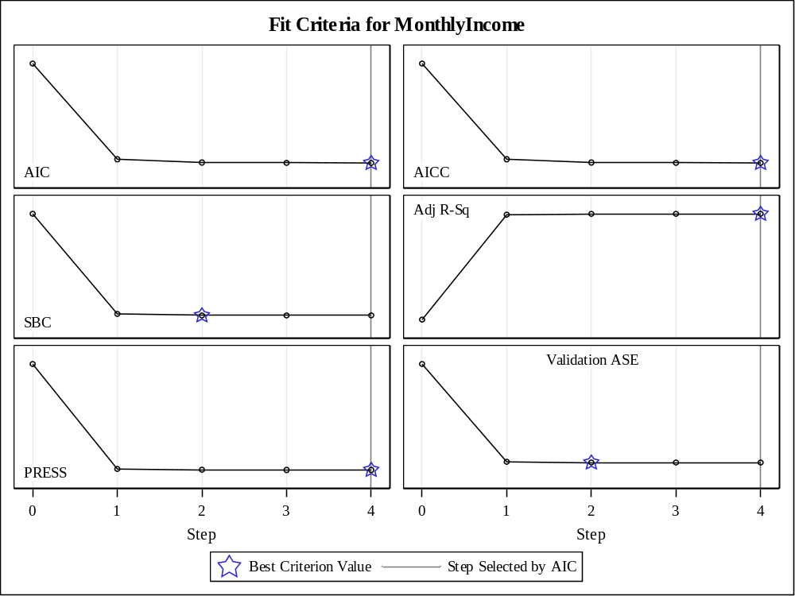
Root MSE | 1255.05160
Dependent Mean | 6717.79832
R-Square | 0.9317
Adj R-Sq | 0.9301
AIC | 9101.40170
AICC | 9102.23072
PRESS | 960724849
SBC | 8565.84156
ASE (Train) | 1538092
ASE (Validate) | 1443109
ASE (Test) | 1693822

Parameter Estimates
Parameter | DF | Estimate | Standardized  Estimate | Standard  Error | t Value
Intercept | 1 | 16517 | 0 | 491.763767 | 33.59
JobLevel 1 | 1 | -14300 | -1.427287 | 402.575292 | -35.52
JobLevel 2 | 1 | -11735 | -1.203497 | 363.932807 | -32.24
JobLevel 3 | 1 | -7373.573354 | -0.556879 | 344.817140 | -21.38
JobLevel 4 | 1 | -3197.261173 | -0.174501 | 310.000564 | -10.31
JobLevel 5 | 0 | 0 | 0 | . | .
JobRole Healthca | 1 | 271.970883 | 0.016330 | 317.085414 | 0.86
JobRole Human Re | 1 | 444.006088 | 0.018413 | 347.246126 | 1.28
JobRole Laborato | 1 | 132.844296 | 0.010168 | 261.873005 | 0.51
JobRole Manager | 1 | 2332.237853 | 0.129980 | 366.012663 | 6.37
JobRole Manufact | 1 | 103.989825 | 0.006501 | 312.632715 | 0.33
JobRole Research | 1 | 723.035951 | 0.066609 | 251.847137 | 2.87
JobRole Sales Ex | 1 | 326.063913 | 0.029008 | 286.617947 | 1.14
JobRole Sales Re | 0 | 0 | 0 | . | .
NumCompaniesWorked | 1 | 43.942982 | 0.023858 | 20.624272 | 2.13
TotalWorkingYears | 1 | 24.365547 | 0.040087 | 11.561532 | 2.11

The result showed that JobLevel, JobRole, NumCompaniesWorked and TotalWorkingYears were included in the prediction model. AIC, PRESS, AICC, Adjusted R square all prefer this model including 4 variables. Average squared errors of test dataset is 1693822 and that of training dataset is 1538092. We can say that this prediction model is good because average squared errors of test dataset is the smallest.
In this case I selected the model by AIC criteria. I also tried to select the model by SBC at 5% level.
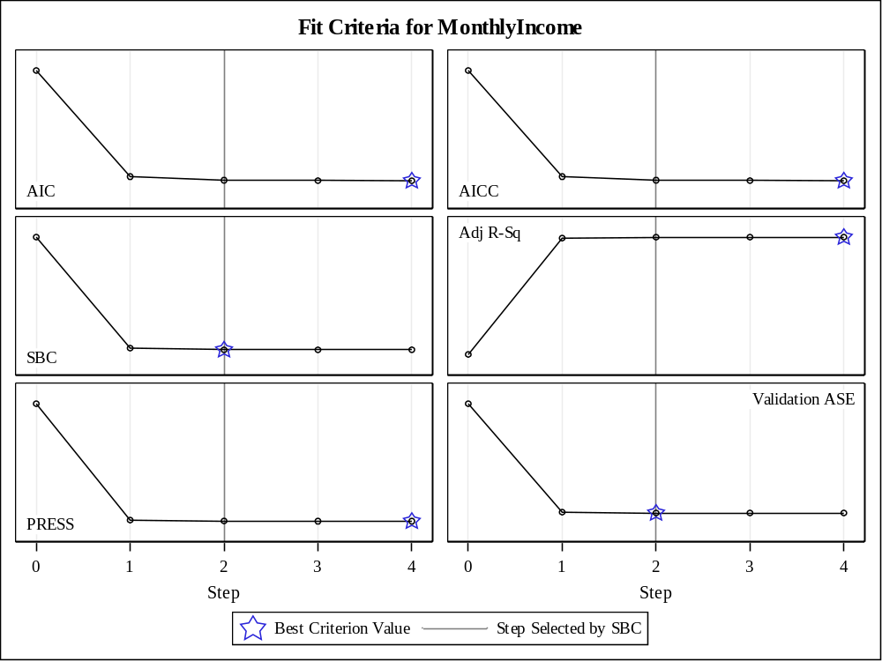
Root MSE | 1264.36516
Dependent Mean | 6717.79832
R-Square | 0.9304
Adj R-Sq | 0.9291
AIC | 9108.24459
AICC | 9108.87110
PRESS | 970738010
SBC | 8563.90733
ASE (Train) | 1566378
ASE (Validate) | 1442446
ASE (Test) | 1711939
This model prefers 2 steps, which means it has 2 variables. However, this model has larger average squared errors in test data than the model selected by AIC. We can conclude that model selected by AIC is the best prediction model.

Conclusion
Joblevel, JobRole, and Education were chosen as significant variables in the ANOVA. Joblevel, JobRole, NumCompaniesWorked, and TotalWorkingyears were chosen in the Linear Regression model and prediction model. Especially, Joblevel is the most significant predictor in the model. Even Joblevel itself has the 0.925 R square. JobRole is the second significant predictor. This means that this company put more emphasis on high job level and specific job role than on number of companies worked and total working years.
I was surprised the result that master level had the negative impact on monthly income when I controlled other variables and below college level had the positive impact. I suspected that there was a collinearity and I checked but there were no collinearity with other variables.

proc glm data=attrition;
class joblevel;
model monthlyincome=joblevel;
ods select FitStatistics;
run;

Dependent Variable: MonthlyIncome

R-Square | Coeff Var | Root MSE | MonthlyIncome Mean
0.925201 | 19.82726 | 1289.353 | 6502.931

