同济大学
计算机科学与技术系

计算机组成原理实验报告



学 号 1652228
姓 名 王哲源
专 业 计算机科学与技术
授课老师 陈永生
日 期 2018.3.30

- 实验目标
通过verilog语言实现32位无符号除法器和32位带符号除法器
- 模块建模
- 32位无符号除法器
被除数为dividend，除数为divisor，均为32位无符号数，将计算结果存在q中，余数存在r中
module DIVU(
input [31:0]dividend,
input [31:0]divisor,
input start,
input clock,
input reset,
output [31:0]q,
output [31:0]r,
output reg busy
);

reg [4:0]count;

reg [31:0]tmp_q, tmp_r, tmp_d;
reg r_sign;
assign q = tmp_q;
assign r = r_sign == 1 ? tmp_r + tmp_d : tmp_r;

wire [32:0]tmp_sub;
assign tmp_sub = r_sign ? {{tmp_r, q[31]} + {1'b0, tmp_d}} : {{tmp_r, q[31]} - {1'b0, tmp_d }};

reg pre_start;
always @(posedge clock or posedge reset or posedge start or negedge start)
begin
pre_start <= start;
if(reset == 1)
begin
busy <= 0;
count <= 0;
end
else if({pre_start, start} == 2'b10)
begin
tmp_d <= divisor;
tmp_q <= dividend;
tmp_r <= 32'b0;
r_sign <= 0;
busy <= 1;
count <= 0;
end
else if({pre_start, start} == 2'b00 && busy == 1)
begin
tmp_r <= tmp_sub[31:0];
r_sign <= tmp_sub[32];
tmp_q <= {tmp_q[30:0], ~tmp_sub[32]};
count <= count + 5'b1;
busy <= count == 5'd31 ? 0 : 1;
end
end
endmodule
- 32位带符号除法器
被除数为dividend，除数为divisor，均为32位带符号数，将计算结果存在q中，余数存在r中
module DIV(
input [31:0]dividend,
input [31:0]divisor,
input start,
input clock,
input reset,
output [31:0]q,
output [31:0]r,
output reg busy
);

reg [4:0]count;

reg [31:0]tmp_q, tmp_r, tmp_d;
reg r_sign, q_sign, d_sign;
assign q = q_sign == 1 ? -tmp_q : tmp_q;
assign r = r_sign == 1 ? (d_sign == 1 ? -(tmp_r + tmp_d) : tmp_r + tmp_d)
: (d_sign == 1 ? -tmp_r : tmp_r);

wire [32:0]tmp_sub;
assign tmp_sub = r_sign ? {{tmp_r, tmp_q[31]} + {1'b0, tmp_d}} : {{tmp_r, tmp_q[31]} - {1'b0, tmp_d }};

reg pre_start;
always @(posedge clock or posedge reset or posedge start or negedge start)
begin
pre_start <= start;
if(reset == 1)
begin
busy <= 0;
count <= 0;
end
else if({pre_start, start} == 2'b10)
begin
tmp_d <= divisor[31] == 1 ? -divisor : divisor;
tmp_q <= dividend[31] == 1 ? -dividend : dividend;
tmp_r <= 32'b0;
r_sign <= 0;
q_sign <= divisor[31] ^ dividend[31];
d_sign <= dividend[31];
busy <= 1;
count <= 0;
end
else if({pre_start, start} == 2'b00 && busy == 1)
begin
tmp_r <= tmp_sub[31:0];
r_sign <= tmp_sub[32];
tmp_q <= {tmp_q[30:0], ~tmp_sub[32]};
count <= count + 5'b1;
busy <= count == 5'd31 ? 0 : 1;
end
end
endmodule
- 测试模块设计
- 32位无符号除法器testbench
`timescale 1ns / 1ps
module DIVU_tb;
reg clk = 1, rst, st;
reg [31:0] dividend, divisor;
wire bsy;
wire [31:0] q, r;

DIVU uut(.clock(clk), .reset(rst), .start(st),
.dividend(dividend), .divisor(divisor),
.busy(bsy),
.q(q), .r(r));

always #5 clk = ~clk;
initial
begin
rst <= 0; st <= 1;
#3
rst <= 0;
dividend <= 32'd7;
divisor <= 32'd2;
#6 st <= 0;
#400 st <= 1;
#5
st <= 0;
dividend <= 32'hffffffff;
divisor <= 32'h55555555;
end
endmodule
- 32位带符号除法器testbench
`timescale 1ns / 1ps
module DIV_tb;
reg clk = 1, rst, st;
reg [31:0] dividend, divisor;
wire bsy;
wire [31:0] q, r;

DIV uut(.clock(clk), .reset(rst), .start(st),
.dividend(dividend), .divisor(divisor),
.busy(bsy),
.q(q), .r(r));

always #5 clk = ~clk;
initial
begin
rst <= 0; st <= 1;
#3
rst <= 0;
dividend <= 7;
divisor <= -2;
#6 st <= 0;
#400 st <= 1;
#5
st <= 0;
dividend <= -7;
divisor <= -2;
end
endmodule
- 实验结果
- 32位无符号除法器
  - modelsim仿真波形图
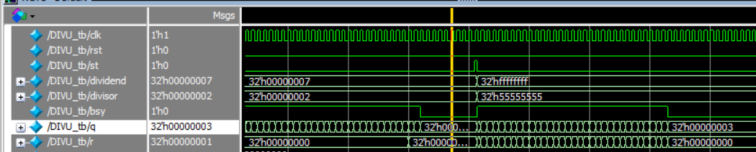
- 32位带符号除法器
  - modelsim仿真波形图
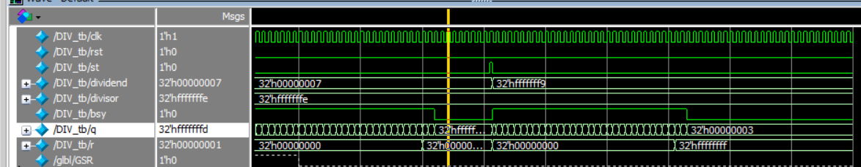
- 总结
- 32位无符号除法实现采用不恢复余数的方法进行，而32位带符号除法采用不恢复余数方法的时候中间判断较为繁琐，因此采用先将被除数与除数的符号记下用于判断余数与商的符号，再取绝对值后进行计算的方式
- 在计算带符号除法时，移位对余数进行补位的数值应当来源于取绝对值后的被除数

