同济大学计算机系

数字逻辑课程实验报告



学 号 1652228
姓 名 王哲源
专 业 计算机
授课老师 张冬冬

- 实验内容
- 使用Verilog HDL 语言实现3-8 译码器的设计和仿真
- 使用Verilog HDL 语言实现七段数码管的设计和仿真
- 使用Verilog HDL 语言实现8-3 编码器的设计和仿真
- 使用Verilog HDL 语言实现8-3 优先编码器的设计和仿真
- 硬件逻辑图
1.3-8译码器
逻辑表达式：
not Y0 = not(G1 and not G2 and not D2 and not D1 and not D0)
not Y1 = not(G1 and not G2 and not D2 and not D1 and D0)
not Y2 = not(G1 and not G2 and not D2 and D1 and not D0)
not Y3 = not(G1 and not G2 and not D2 and D1 and D0)
not Y4 = not(G1 and not G2 and D2 and not D1 and not D0)
not Y5 = not(G1 and not G2 and D2 and not D1 and D0)
not Y6 = not(G1 and not G2 and D2 and D1 and not D0)
not Y7 = not(G1 and not G2 and D2 and D1 and D0)
logisim逻辑图：
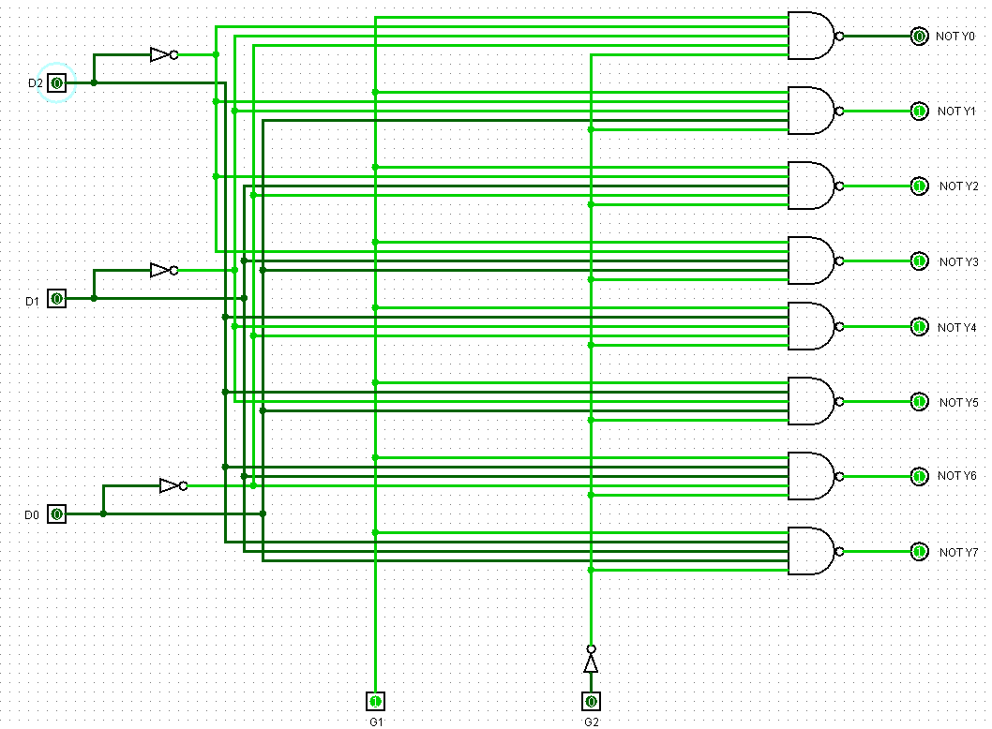

2.8-3编码器
逻辑表达式：
Y2 = ((D7 and not D6 and not D5 and not D4) or (not D7 and D6 and not D5 and not D4) or (not D7 and not D6 and D5 and not D4) or (not D7 and not D6 and not D5 and D4)) and (not D3 and not D2 and not D1 and not D0)
Y1 = ((D7 and not D6 and not D3 and not D2) or (not D7 and D6 and not D3 and not D2) or (not D7 and not D6 and D3 and not D2) or (not D7 and not D6 and not D3 and D2)) and (not D5 and not D4 and not D1 and not D0)
Y0 = ((D7 and not D5 and not D3 and not D1) or (not D7 and D5 and not D3 and not D1) or (not D7 and not D5 and D3 and not D1) or (not D7 and not D5 and not D3 and D1)) and (not D6 and not D4 and not D2 and not D0)
logisim逻辑图：
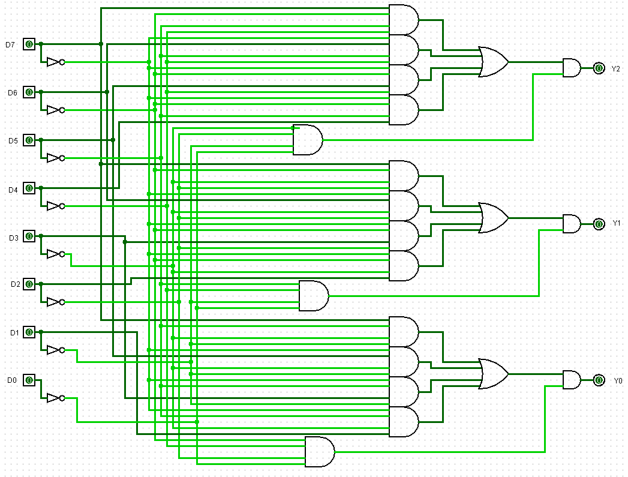
- 模块建模
1.3-8译码器
模块decoder 根据使能输入iEna判断译码器是否正确工作，当正确工作时，再根据输入的iData所表示的二进制数值输出对应的oData
module decoder(
input [2:0] iData,
input [1:0] iEna,
output reg [7:0] oData
);

always @(*)
begin
casex ({iEna[1], iEna[0]})
2'b10:
begin
oData = 8'b11111111;
case ({iData})
3'b000: oData[0] = 0;
3'b001: oData[1] = 0;
3'b010: oData[2] = 0;
3'b011: oData[3] = 0;
3'b100: oData[4] = 0;
3'b101: oData[5] = 0;
3'b110: oData[6] = 0;
3'b111: oData[7] = 0;
default: oData = 8'bxxxxxxxx;
endcase
end
2'b0x, 2'bx1:
oData = 8'b11111111;
default:
oData = 8'bxxxxxxxx;
endcase
end

endmodule

2.七段数码管
模块display7根据输入的iData值确定各数码管的高低电平，当iData为范围外值时，数码管显示为H
module display7(
input [3:0] iData,
output reg [6:0] oData
);

always @(*)
case({iData})
4'b0000: oData = 7'b1000000;
4'b0001: oData = 7'b1111001;
4'b0010: oData = 7'b0100100;
4'b0011: oData = 7'b0110000;
4'b0100: oData = 7'b0011001;
4'b0101: oData = 7'b0010010;
4'b0110: oData = 7'b0000010;
4'b0111: oData = 7'b1111000;
4'b1000: oData = 7'b0000000;
4'b1001: oData = 7'b0010000;
default: oData = 7'b0001001;
endcase

endmodule

3.8-3编码器
模块encoder83根据输入iData确定oData的值，但仅有在iData有且仅有一个值为高电平时所输出的结果才为正确的结果
module encoder83(
input [7:0] iData,
output reg [2:0] oData
);

always @(*)
case (iData)
8'b10000000: oData = 3'b111;
8'b01000000: oData = 3'b110;
8'b00100000: oData = 3'b101;
8'b00010000: oData = 3'b100;
8'b00001000: oData = 3'b011;
8'b00000100: oData = 3'b010;
8'b00000010: oData = 3'b001;
8'b00000001: oData = 3'b000;
default: oData = 3'bxxx;
endcase

endmodule

4.3-8优先编码器
模块encoder83_pri能在选通输入端为低电平时进行优先编码工作，根据输入iData中角标最高的低电平进行编码，输出对应的oData与EO
module encoder83_pri(
input [7:0] iData,
input iEI,
output reg [2:0] oData,
output reg oEO
);

always @(*)
begin
case (iEI)
1'b1:
case (iData)
8'b11111111:
begin
oData = 3'b111;
oEO = 1'b0;
end
default:
begin
oData = 3'bxxx;
oEO = 1'bx;
end
endcase
1'b0:
begin
oEO = 1;
casex (iData)
8'b0xxxxxxx: oData = 3'b000;
8'b10xxxxxx: oData = 3'b001;
8'b110xxxxx: oData = 3'b010;
8'b1110xxxx: oData = 3'b011;
8'b11110xxx: oData = 3'b100;
8'b111110xx: oData = 3'b101;
8'b1111110x: oData = 3'b110;
8'b11111110: oData = 3'b111;
default:
begin
oEO = 1'bx;
oData = 3'bxxx;
end
endcase
end
endcase
end

endmodule
- 测试模块建模
1. 3-8译码器
`timescale 1ns / 1ps
module decoder_tb;
reg [1:0] iEna;
reg [3:0] iData;
wire [7:0] oData;

decoder uut(
.iData(iData), .iEna(iEna),
.oData(oData));

initial
begin
iEna = 2'bx1;
#100 iEna = 2'b0x;
#100 iEna = 2'b10;
end

initial
begin
iData = 8'b101;
#50 iData = 2'b110;

#50 iData = 2'b111;
#50 iData = 2'b011;

#50 iData = 2'b000;
#50 iData = 2'b001;
#50 iData = 2'b010;
#50 iData = 2'b011;
#50 iData = 2'b100;
#50 iData = 2'b101;
#50 iData = 2'b110;
#50 iData = 2'b111;
end

endmodule

2.七段数码管
`timescale 1ns / 1ps
module display7_tb;
reg [3:0] iData;
wire [6:0] oData;

display7 uut(
.iData(iData),
.oData(oData));

initial
begin
iData = 4'b0000;
#50 iData = 4'b0001;
#50 iData = 4'b0010;
#50 iData = 4'b0011;
#50 iData = 4'b0100;
#50 iData = 4'b0101;
#50 iData = 4'b0110;
#50 iData = 4'b0111;
#50 iData = 4'b1000;
#50 iData = 4'b1001;
#50 iData = 4'b1010;
end
endmodule

3.8-3编码器
`timescale 1ns / 1ps
module encoder83_tb;
reg [7:0] iData;
wire [2:0] oData;

encoder83 uut(
.iData(iData),
.oData(oData));

initial
begin
iData = 8'b10000000;
#50 iData = 8'b01000000;
#50 iData = 8'b00100000;
#50 iData = 8'b00010000;
#50 iData = 8'b00001000;
#50 iData = 8'b00000100;
#50 iData = 8'b00000010;
#50 iData = 8'b00000001;
#50 iData = 8'b10101010;
end
endmodule

4.3-8优先编码器
`timescale 1ns / 1ps
module encoder83_pri_tb;
reg [7:0] iData;
reg iEI;
wire [2:0] oData;
wire oEO;

encoder83_pri uut(
.iData(iData), .iEI(iEI),
.oData(oData), .oEO(oEO));

initial
begin
iData <= 8'b11111111;
iEI <=1'b1;
#50
iEI <= 0;
iData <= 8'b01x01x00;
#50 iData = 8'b10x01x00;
#50 iData = 8'b11001x00;
#50 iData = 8'b11101x00;
#50 iData = 8'b11110x00;
#50 iData = 8'b11111000;
#50 iData = 8'b11111100;
#50 iData = 8'b11111110;
end
endmodule
- 实验结果
1.3-8译码器
1.1 logisim逻辑验证图
iEna = 00 使能无效 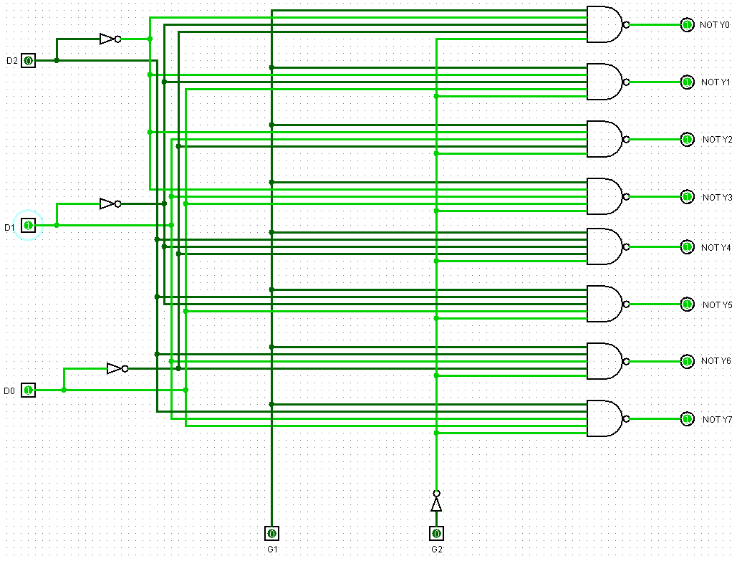
iEna = 01 使能无效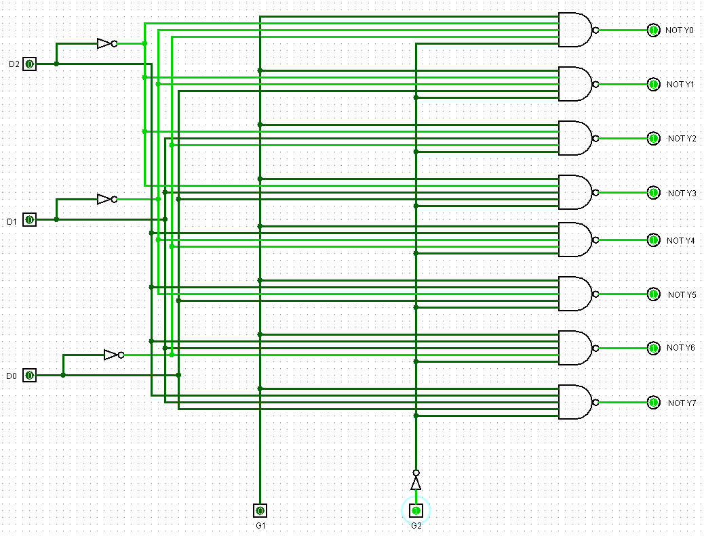
iEna = 11 使能无效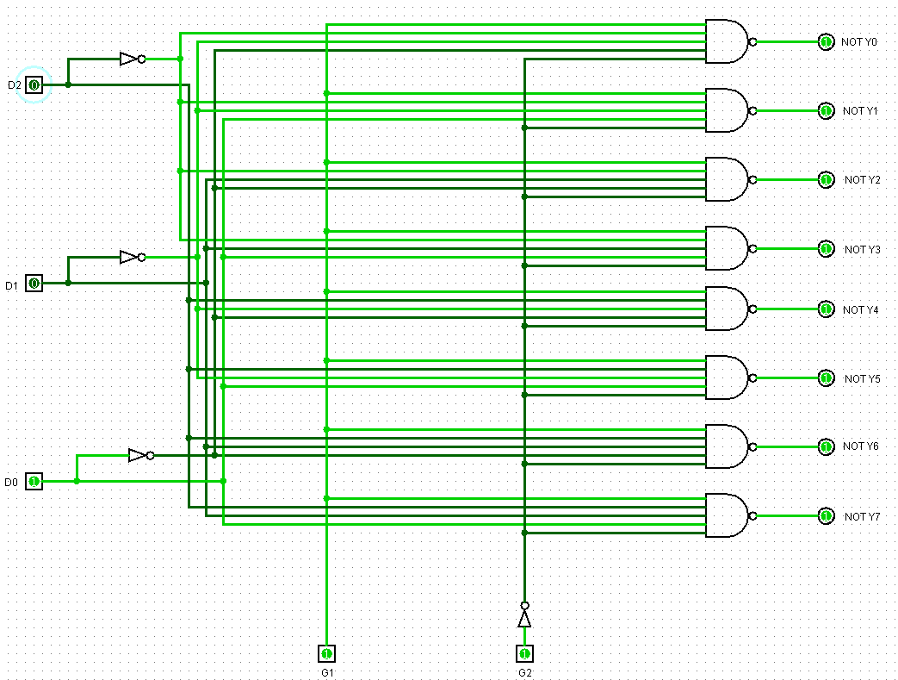
iEna = 10 iData = 101 使能有效，对101进行译码
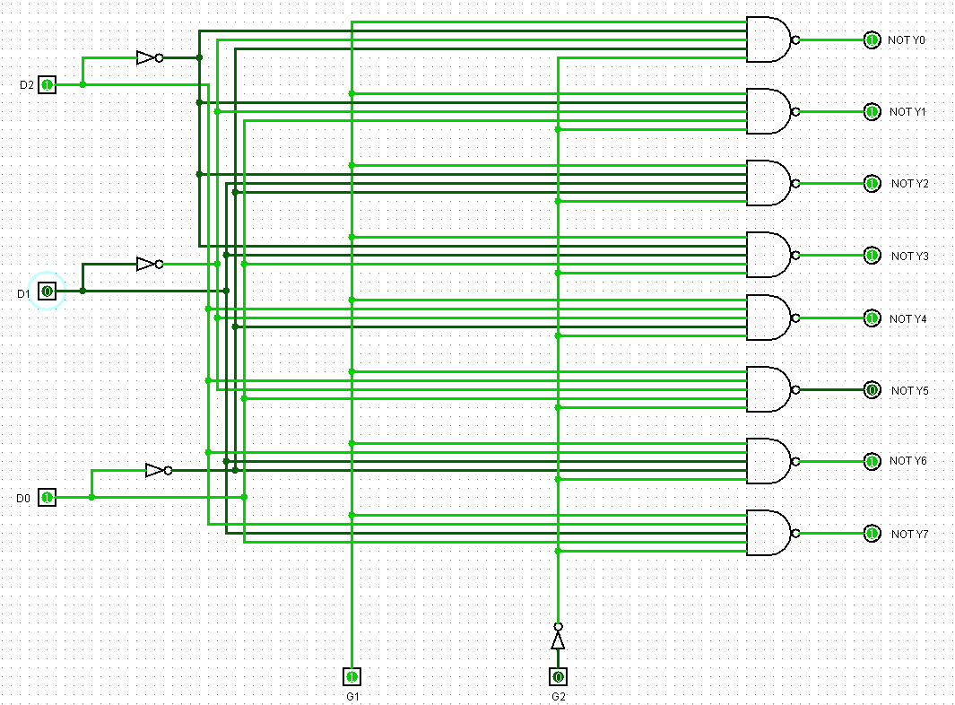
1.2 modelsim仿真图
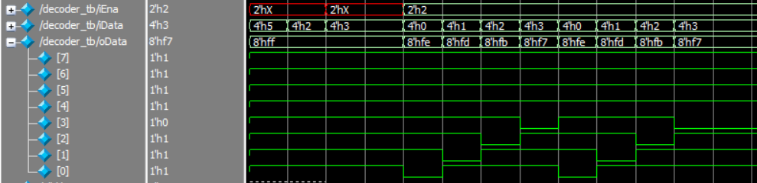
1.3综合下板
iEna=00使能无效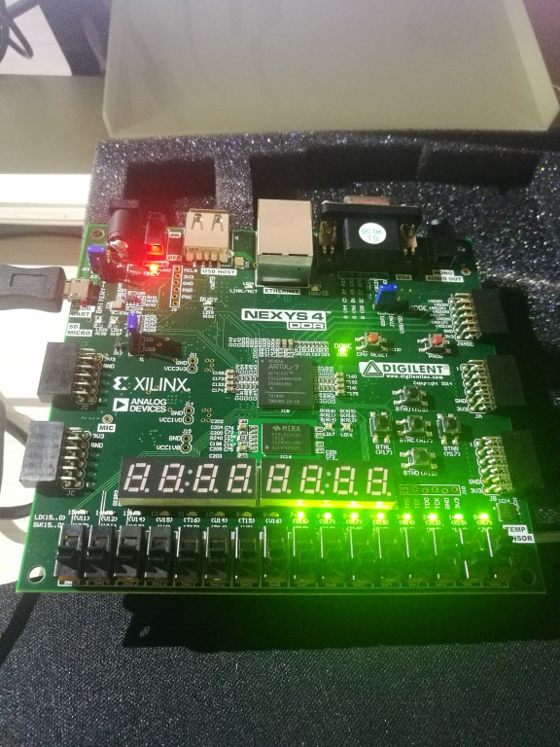 iEna=11使能无效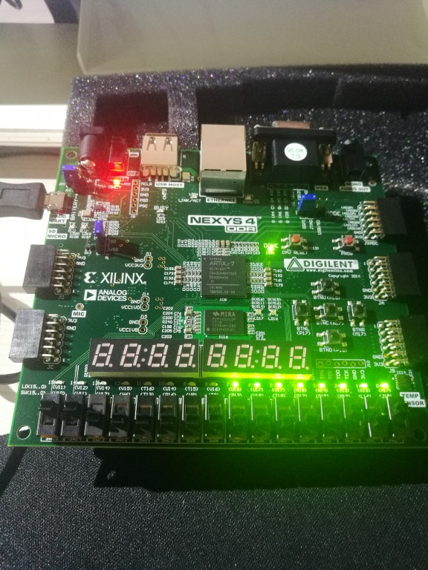
iEna=01使能无效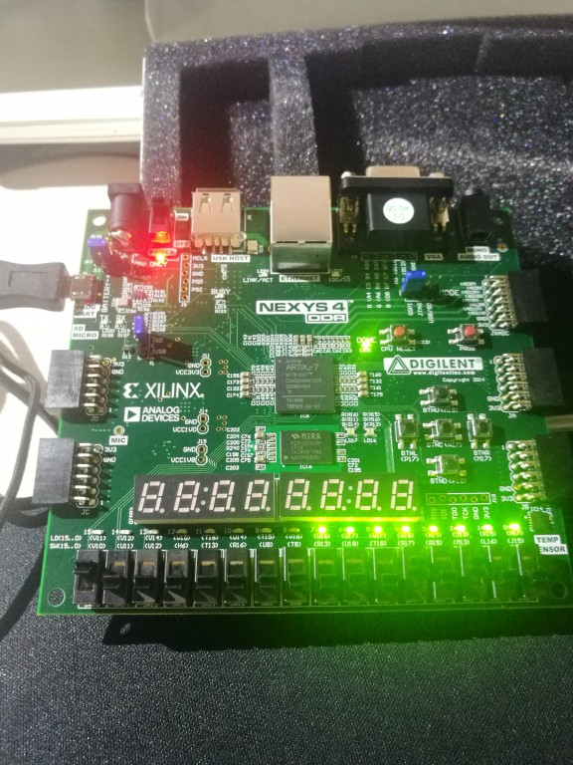
iEna=10使能有效，iData=101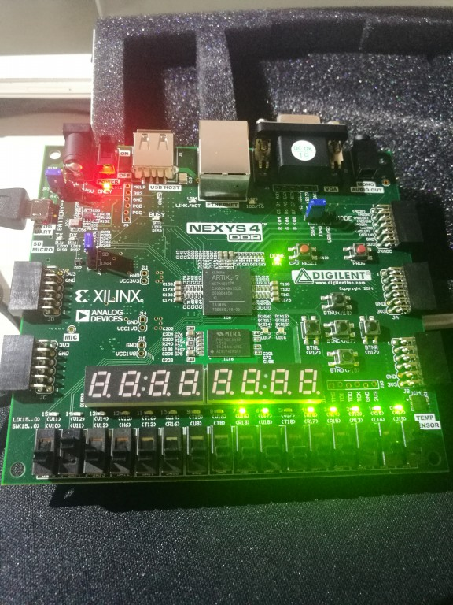

2.七段数码管
2.1 modelsim仿真图
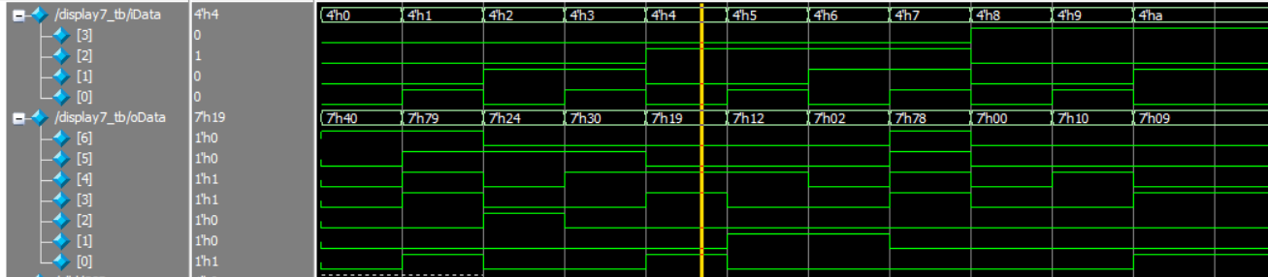
2.2综合下板
iData = 0001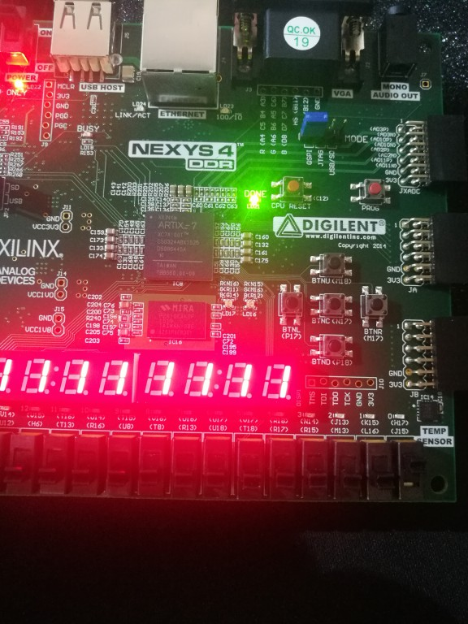
iData = 1001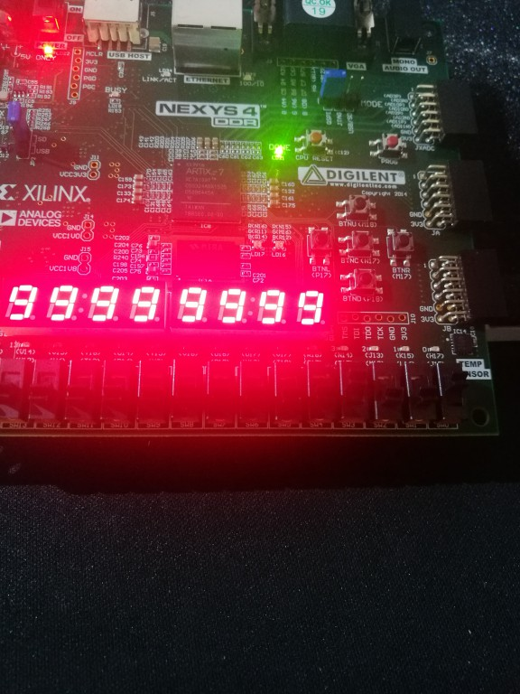
iData = 1011（超范围）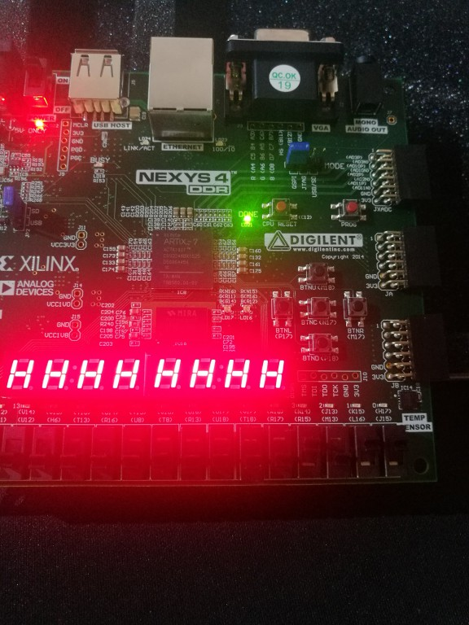

3.8-3编码器
3.1 logisim逻辑验证图
对0进行编码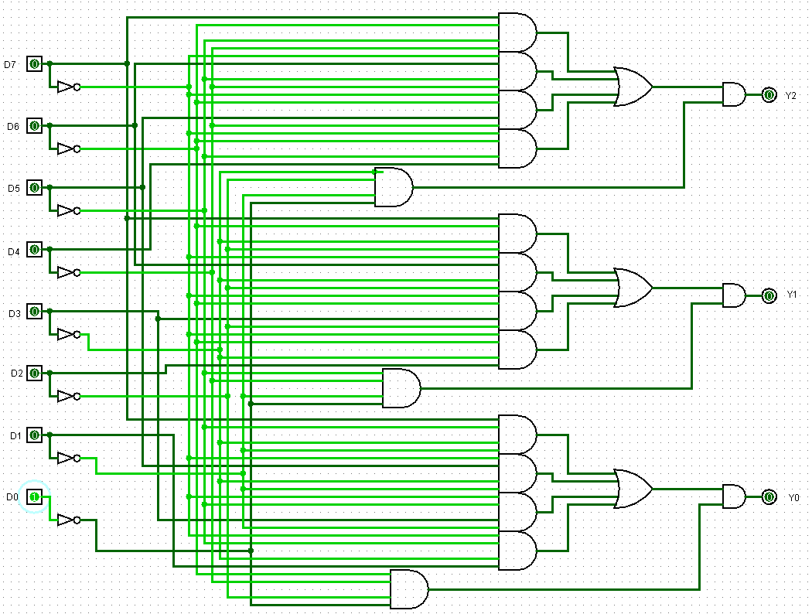
对3进行编码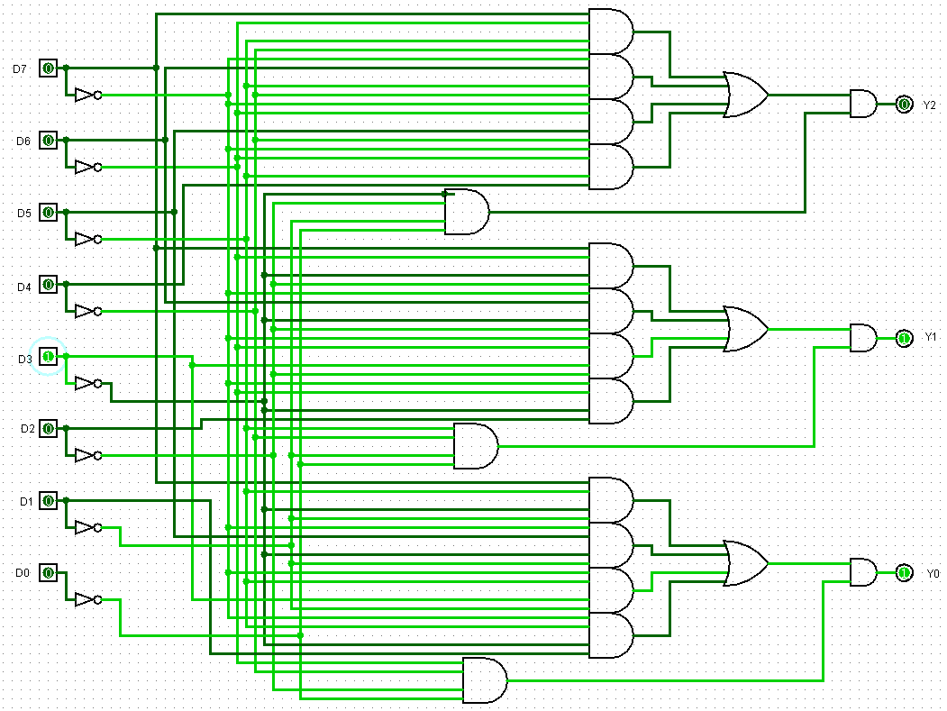
对6进行编码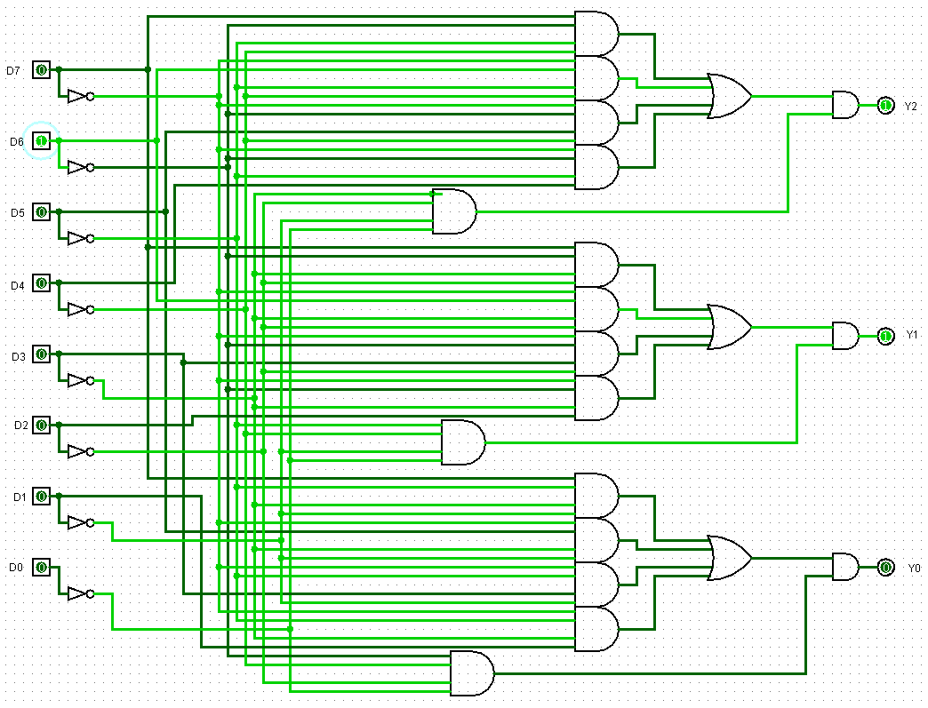
对7进行编码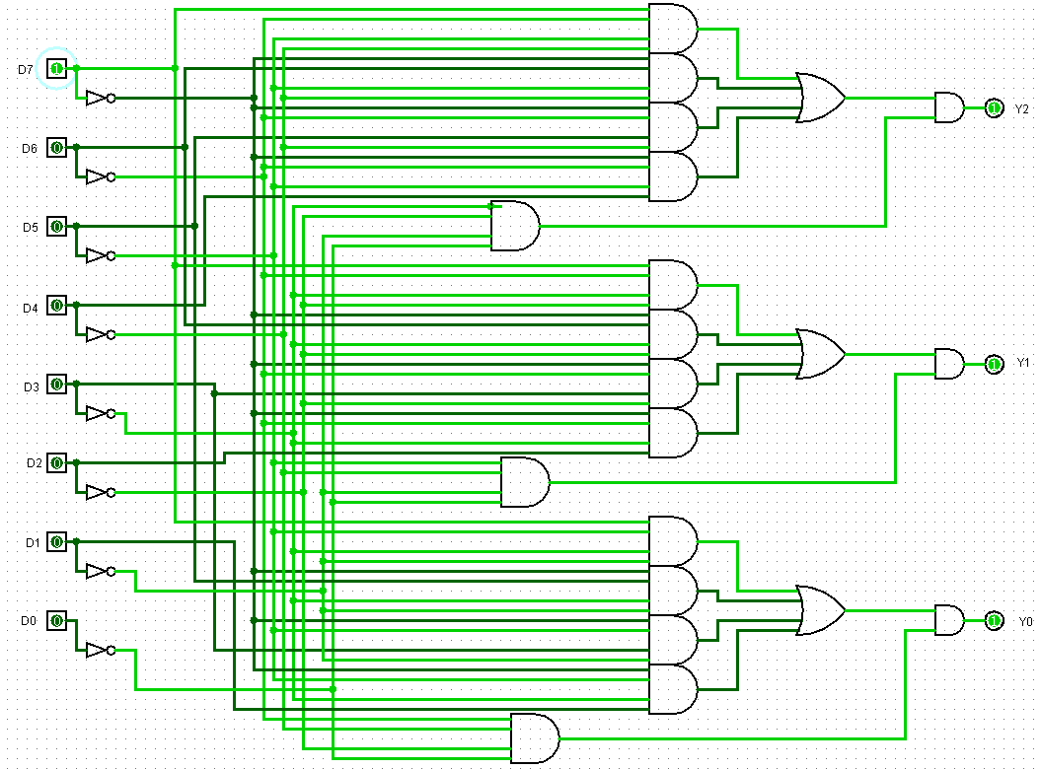
3.2 modelsim波形仿真图
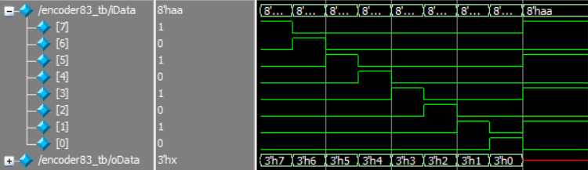
3.3 综合下板
iData[0] = 1 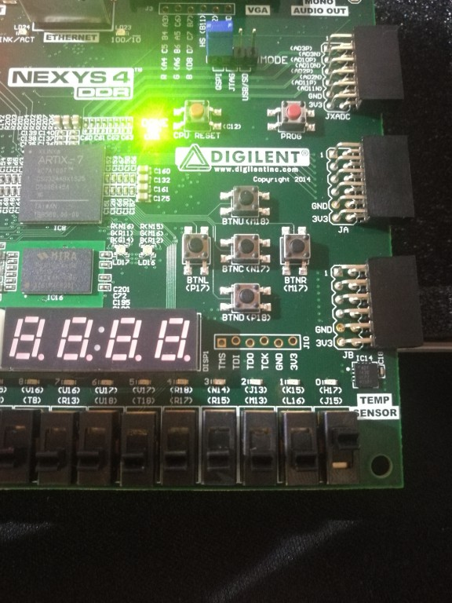
iData[6] = 1 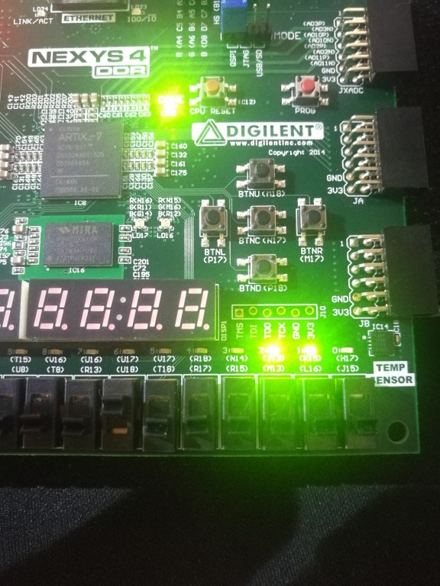
iData[3] = 1 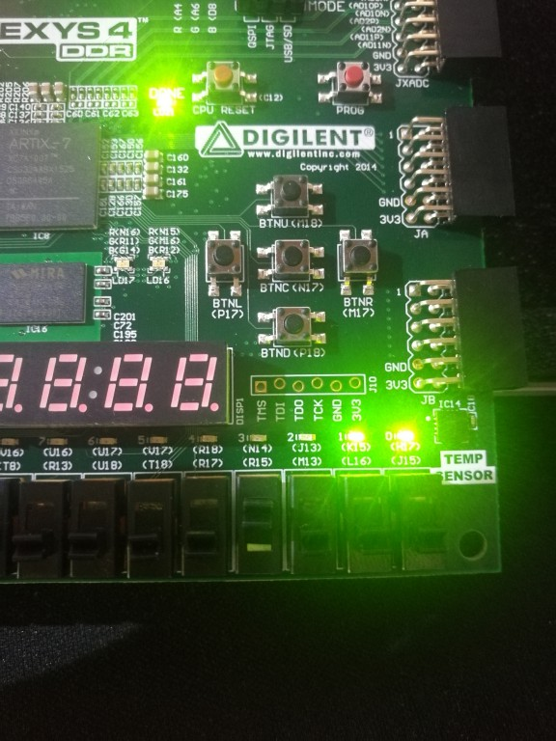
iData[7] = 1 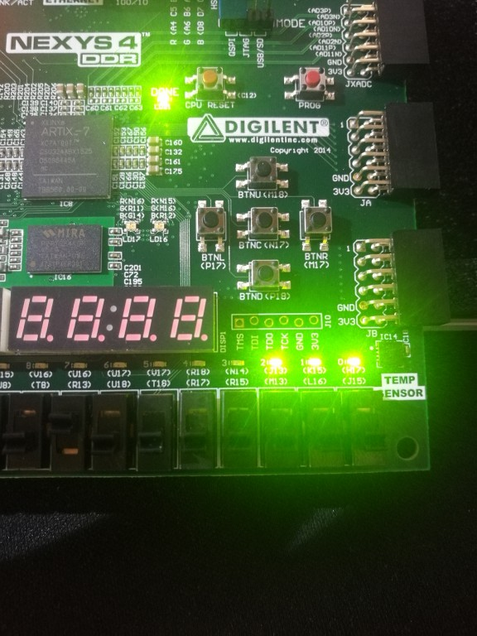

4.8-3优先编码器
3.1 modelsim波形仿真图
3.2 综合下板
EI = 0，对D0进行优先编码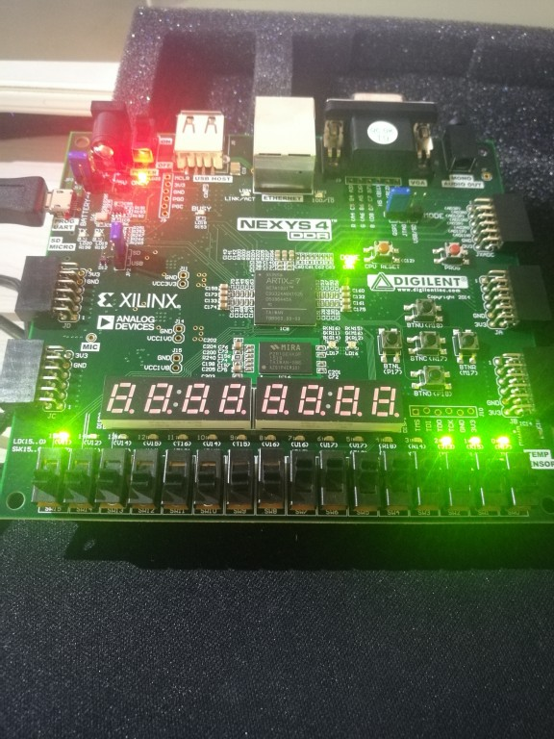
EI = 0，对D3进行优先编码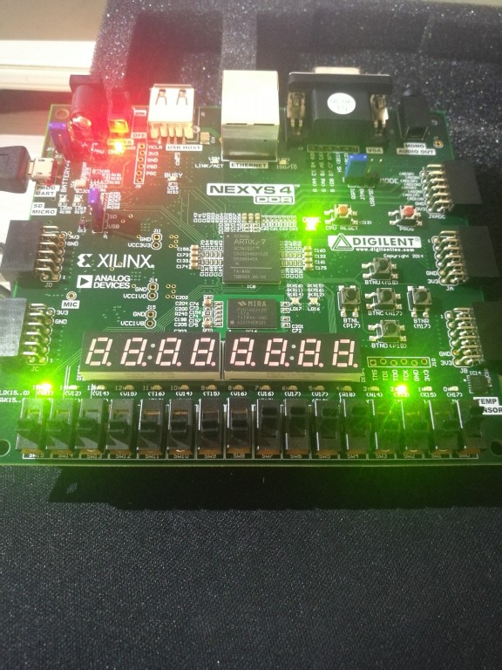
EI = 0，对D7进行有限编码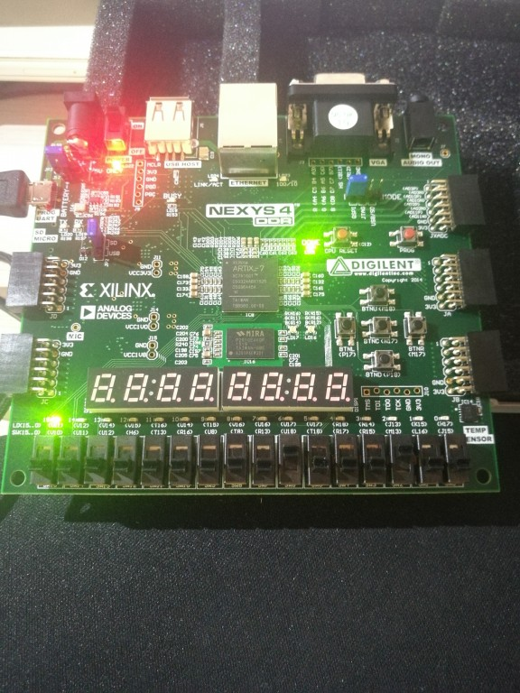
EI = 1，iData全为高电平，编码器不工作